**Fading Channels &Mobile Communications**

**IIT Kharagpur**

**Date: 6/Apr/2024**

**Exp9: Flat Fading**

**Name: XYZ**

**__________________________________________________________**

# Channel Prob vs Th (M=5)

|  |  |
| --- | --- |
| SC_Exp SC_Theor  MRC_Theor | MRC_Exp |

|  |  |
| --- | --- |
| SC_Exp SC_Theor  MRC_Theor | MRC_Exp |

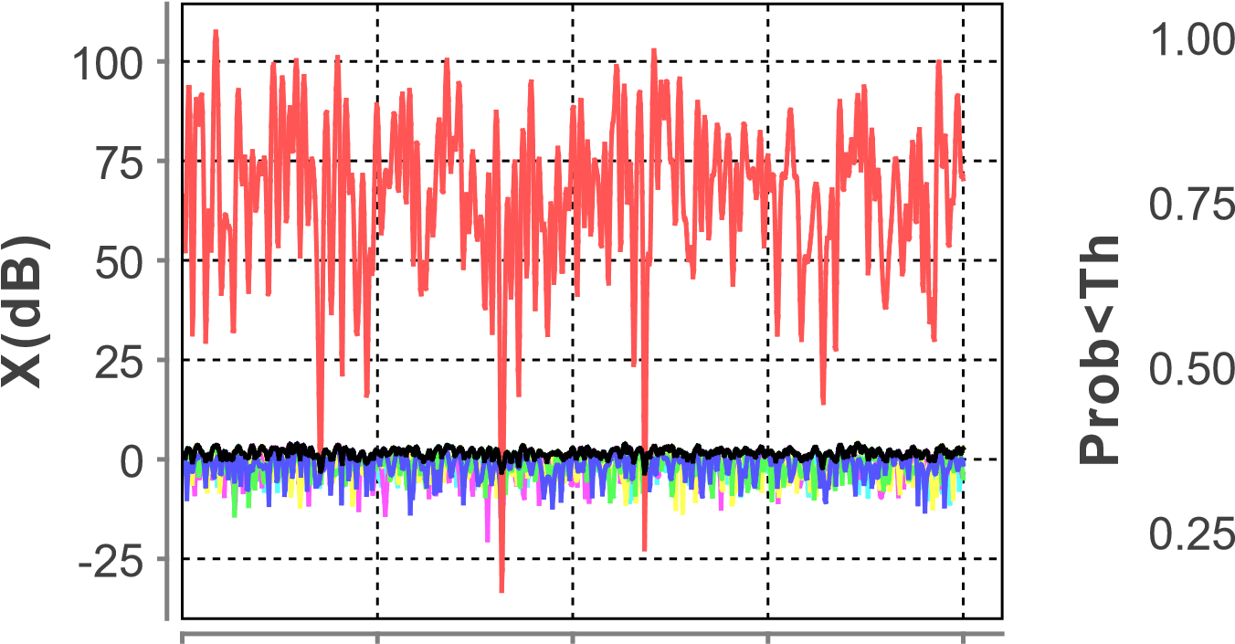 0.00 0.25 0.50 0.75 1.00 0.00

**time(sec)** -5 0 5 10 15 20

|  |  |
| --- | --- |
| SC | MRC |

## Threshold(dB)

SC

MRC

Ch0

Ch1

Ch2

Ch3

Ch4

# LCR vs Th ADF vs Th

0

25

50

75

**LCR**

0.00

0.25

0.50

0.75

1.00

**ADF**

-5 0 5 10 15 20 -5 0 5 10 15 20

## Threshold(dB) Threshold(dB)

|  |  |  |  |  |  |
| --- | --- | --- | --- | --- | --- |
| **Input Parameters** | | | | |  |
| **No.of Multipaths** | | | **10** | |  |
| **No.Samples** | | | **1000** | |  |
| **Sampling Time(sec)** | | | **0.0010** | |  |
| **fc(Hz)** | | | **1.0E9** | |  |
| **Velocity(mps)** | | | **20.0** | |  |
| **Threshold(dB)** | | | **5.0** | |  |
| **No.of Branches** | | | **5** | |  |
| **Avg SNR(dB)** | | | **10.0** | |  |
| **Results** | | | | |  |
| **Type** | **LCR(Exp)** | **LCR(Th)** | | **ADF(Exp)** | **ADF(Th)** |
| **SC(Actual)** | **0.0** | **0.0** | | **1.0** | **1.0** |
| **SC(Entered)** | **0.0** | **0.0** | | **0.0** | **0.0** |
| **MRC(Actual)** | **0.0** | **0.0090** | | **0.0** | **-** |
| **MRC(Entered**  **)** | **0.0** | **0.0** | | **0.0** | **-** |

**Discussion:**

Enter your discussion here...

(Signature of XYZ)

(Signature of Faculty)