**Auto Repair – Design**

The following document explains the design of the Offline mobile application:

* First of all the user need to select the operation on the Start screen.

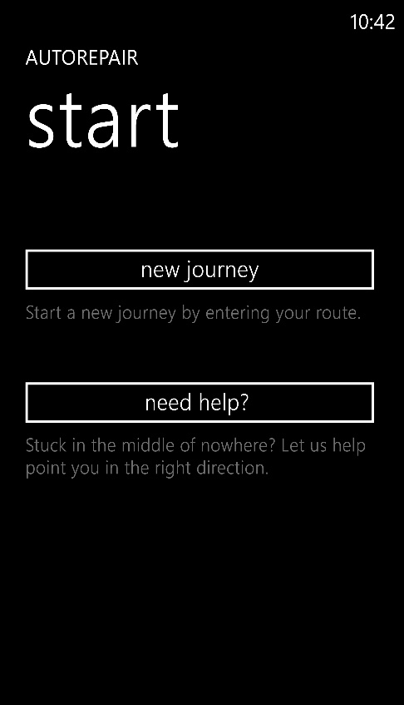

* Now the user has to input the start and the end locations of his journey and click on the submit button.

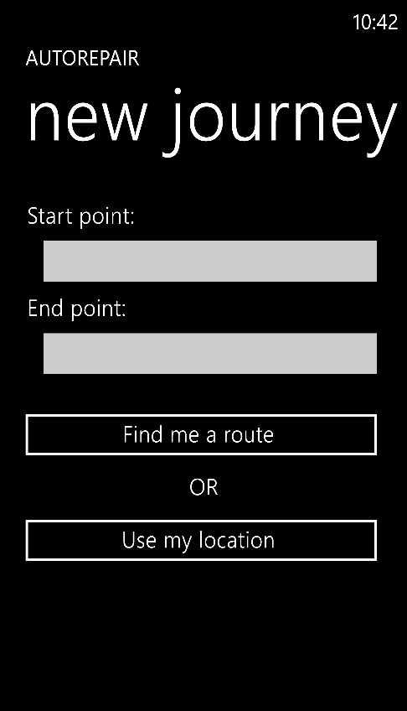

* If the user doesn’t want to to type, he can click on Use my location to select points on the map.

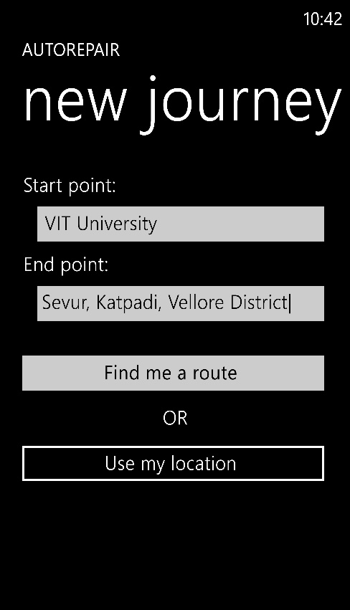

* On the next screen, the user can see the map and select the path and if wants to go by a different path then he/she can click on Alternate Route option.

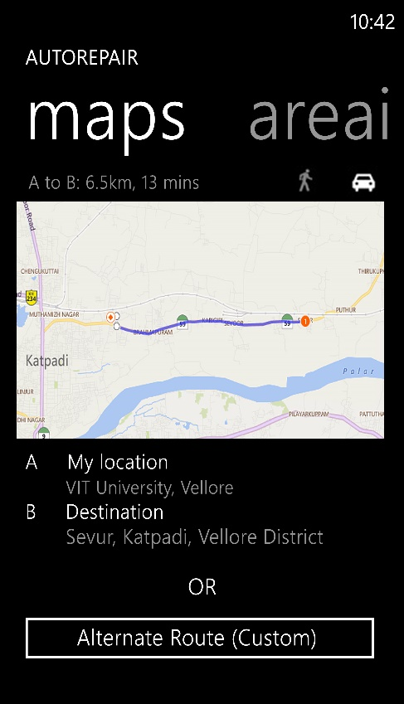

* Once the user clicks on the alternate Route option, a new page comes up wherein he can select from the various options or he canenter in a specific location thorigh which he wants to pass by.

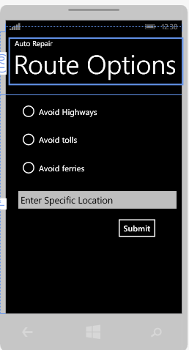

* Once the path is selected by the user, the next page shows the details like total distance, repair shops available on that route, hotels, etc.

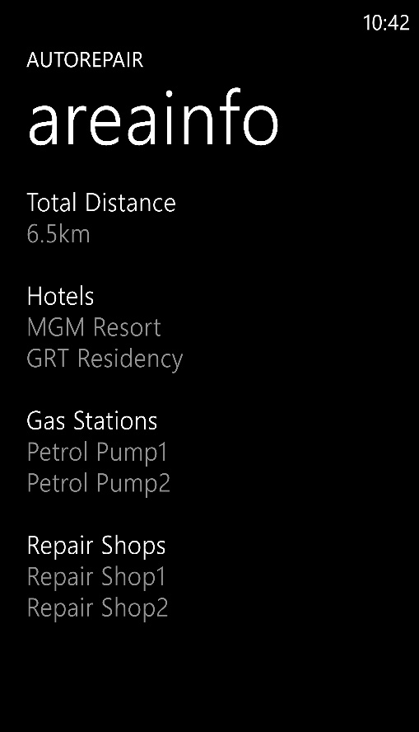

* The user can get details of the desired shop or hotel etc. by long pressing on the name.

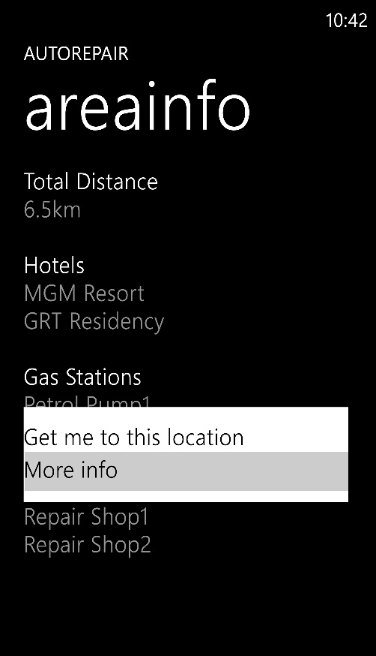

* If the user needs help in finding the repair shop or gas stations near by he can do so by clicking the need help option on the start sceern itself.

The next page will contain the map where the location pointers show the nearby shops, etc.

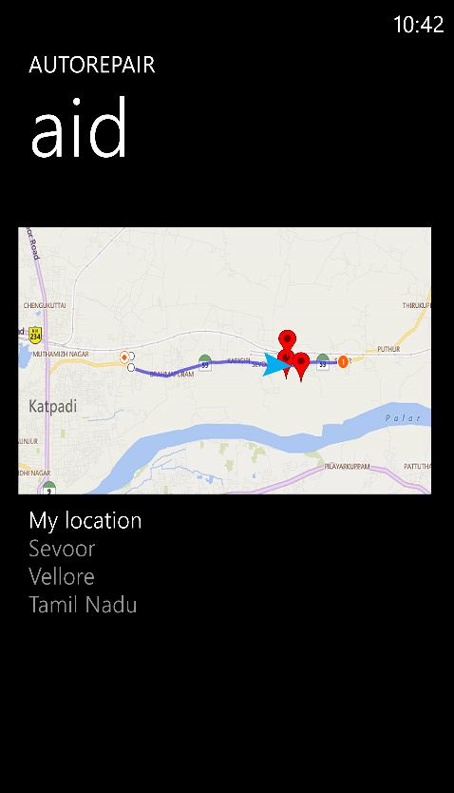

* By clicking on the location pointer of a specific shop the user gets the path from his current location to the shop he selected and he wants to see the details of the shop, he can do so by sliding the window which displays the shop details.

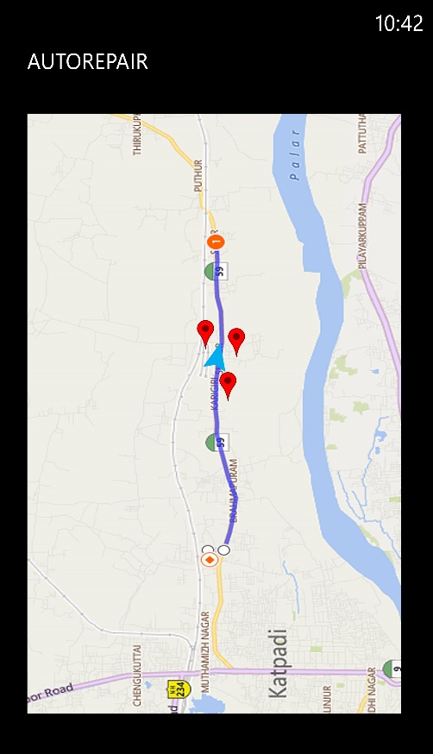

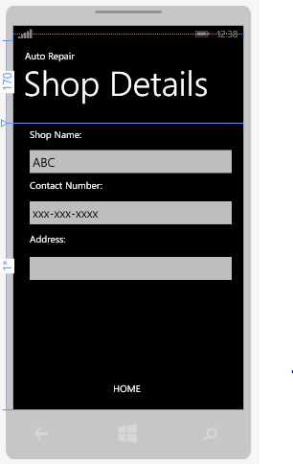

Tasks to be achieved:

* GUI
* Data Storage- minimize the space occupancy in the phone.
* Cleaning the data- deleting the data when the journey’s over.
* Processingt time- should find results in real time i.e. should be fast.

Queries:

* Should we add login and sign option for each user to get personal details like reviews, to get favourite routes, shops, etc.

This would help us in performing the analysis on the data that we collect and improvising the efficiency of the application.

* Offline Maps : As we went through the details of storing maps on the mobile phone we came across the offline map thing so can you provide details on how to embedd offline maps into our app.