# ASSIGNMENT-1

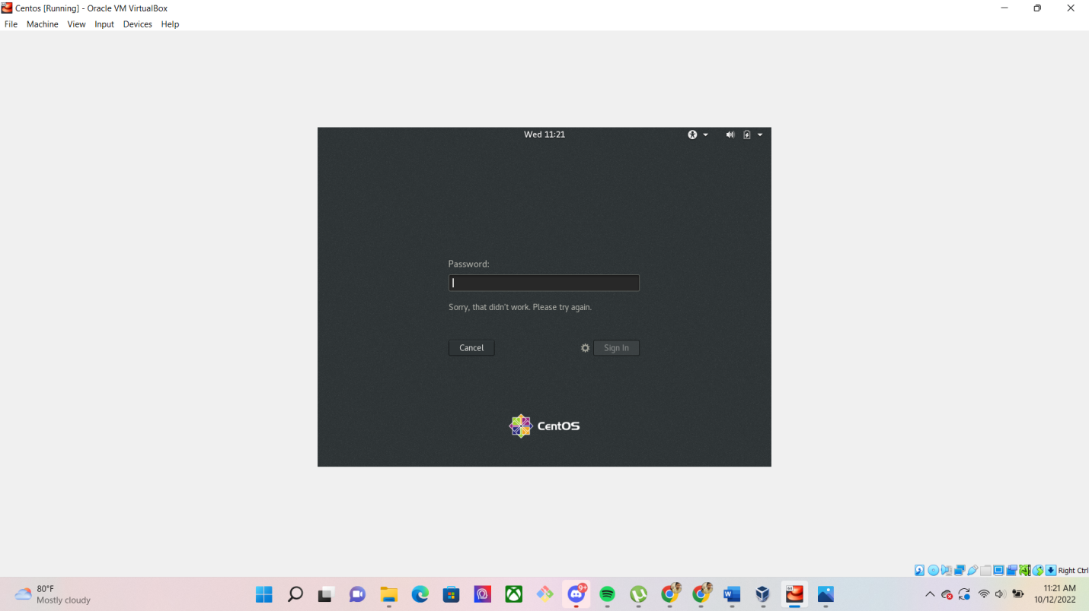

When we login a non existent user it asks us for the password after which we are asked for password and when we enter any password it displays, “Sorry,that didn’t work.Please try again”.

# ASSIGNMENT 2Screenshot (132).png

When I change the password using “passwd” command it ask me for my current password upon entering which I was asked to enter my new password. Once I entered my new password it displayed, “passwd: all authentication tokens updated successfully”.

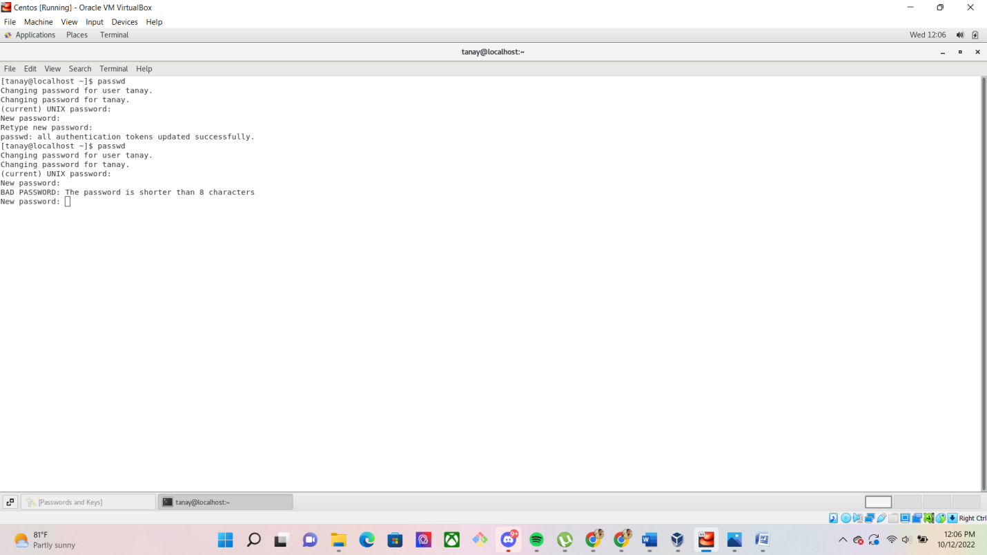



When I again tried to change my password to “1234” it displayed, “The password is shorter than 8 characters”.

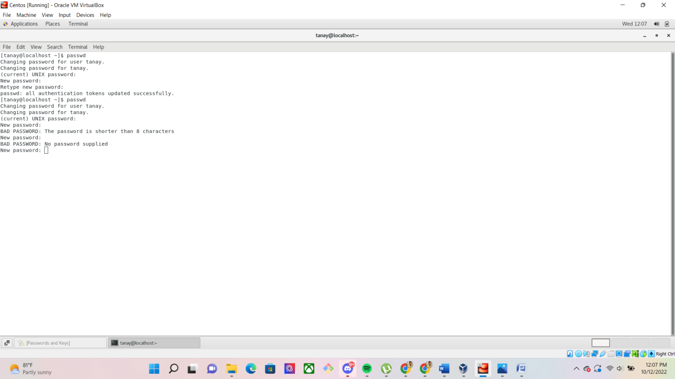

When I type empty password it displays, “No password supplied”.

## ASSIGNMENT-3

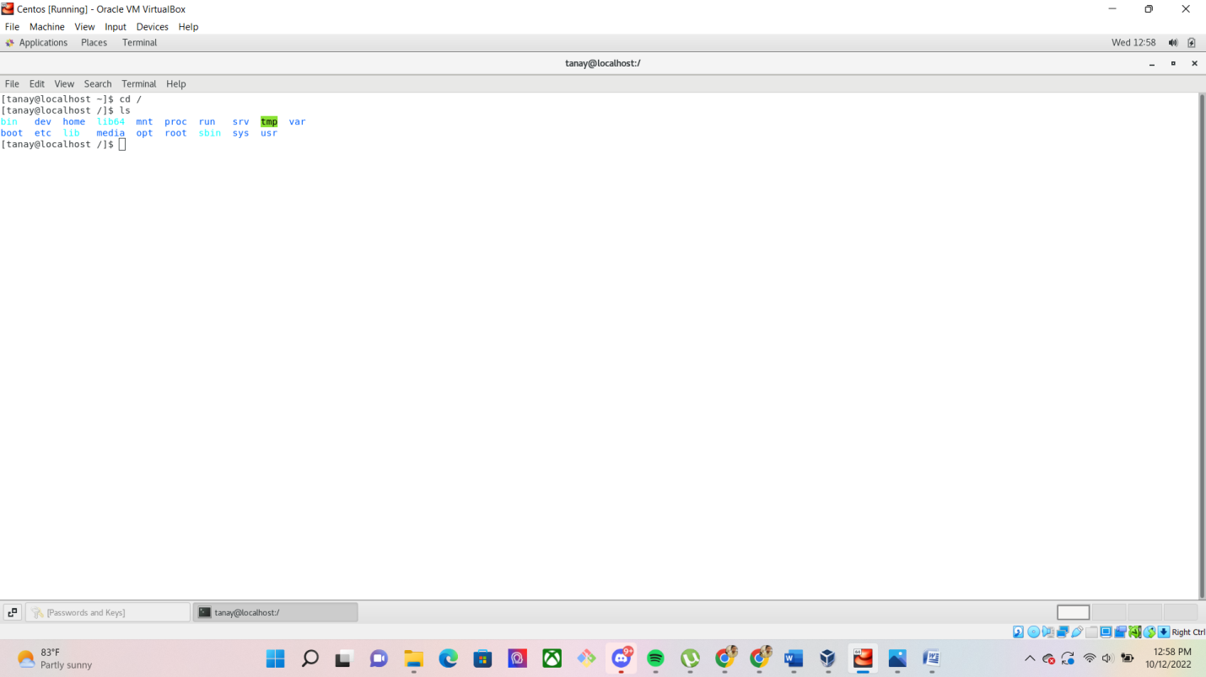

If we do “cd /” and then “ls” we get some list of directories.

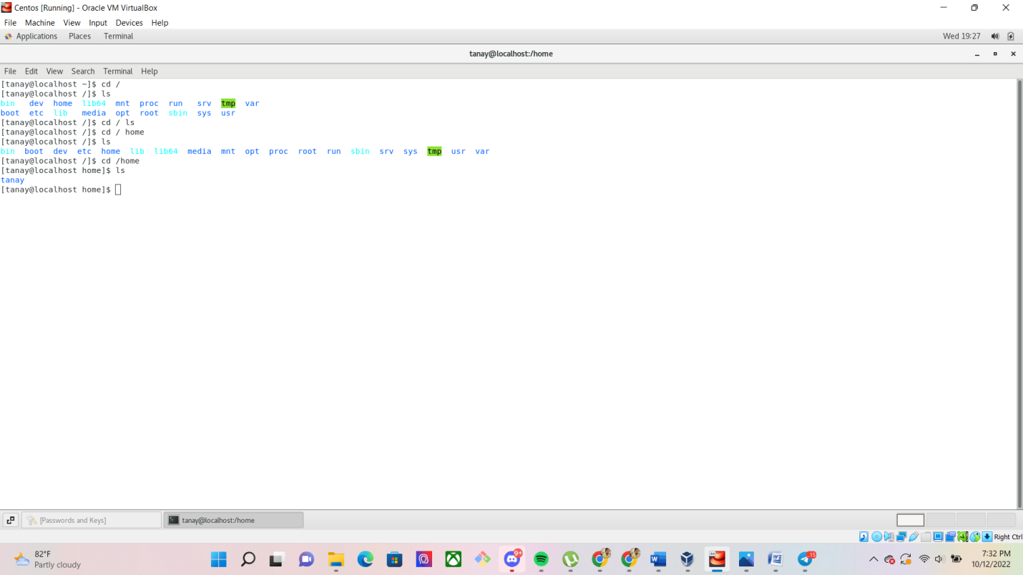

If we do cd /home and then do ls we get one directory “tanay” as output.

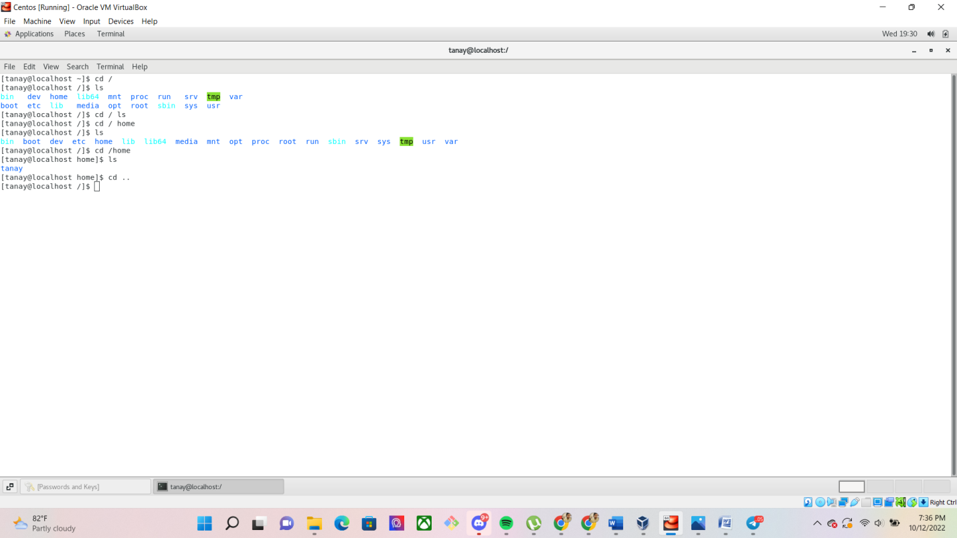

If we do cd .. then it will go one directory back.

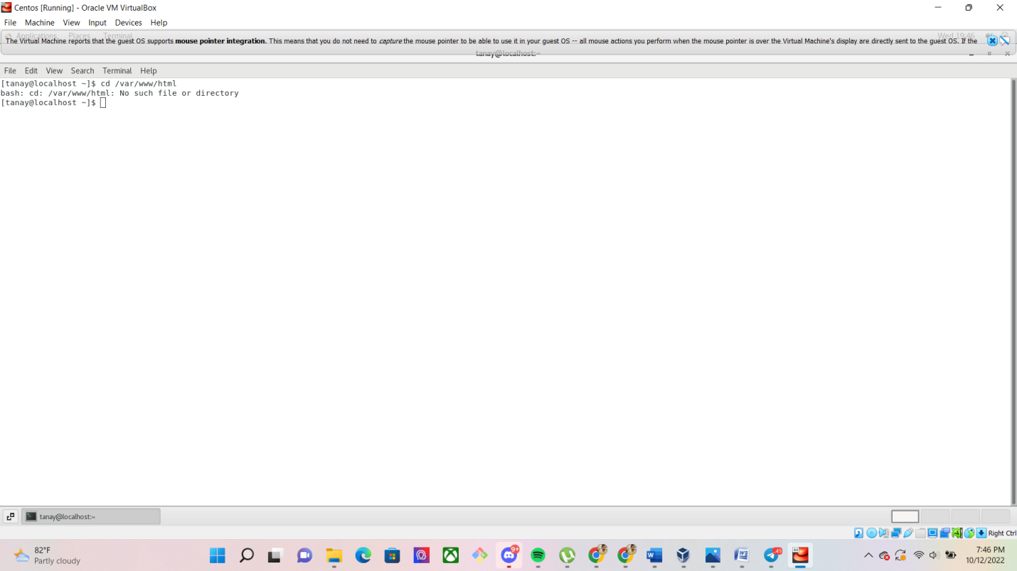

If we do cd/var/www/html then it will display, “No such file or directory”.

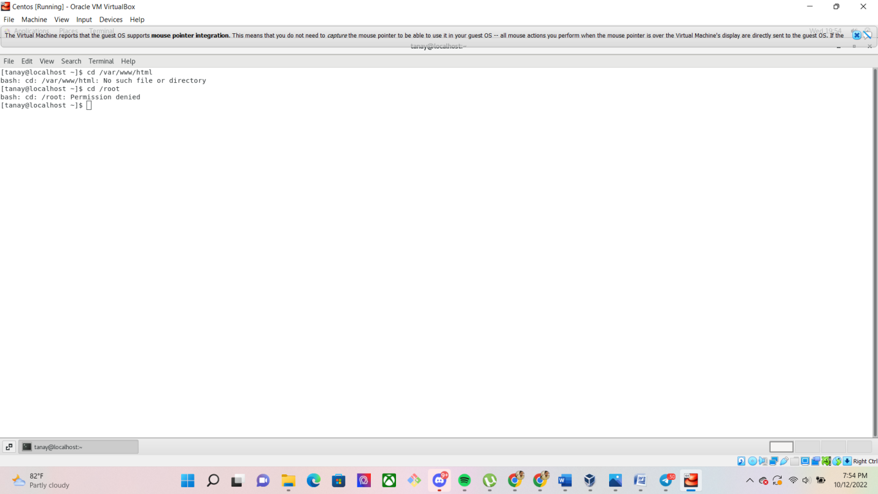

If we do cd /root then it will display, “Permission denied”.If we do ls then it will display below output:-

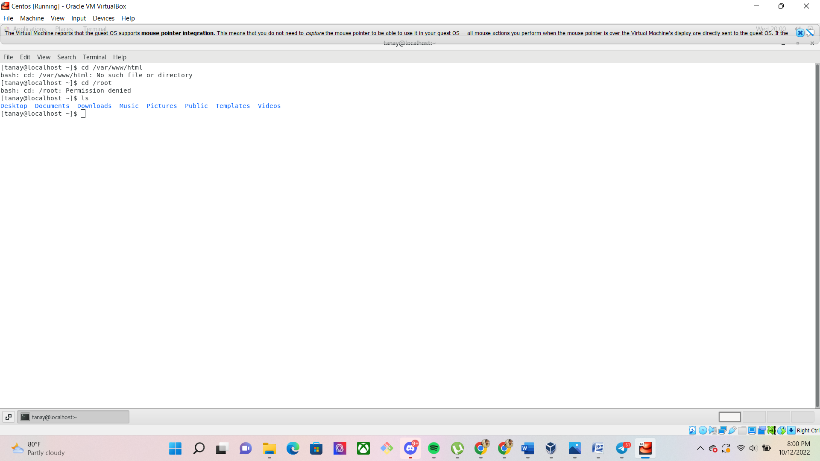

## ASSIGNMENT-4

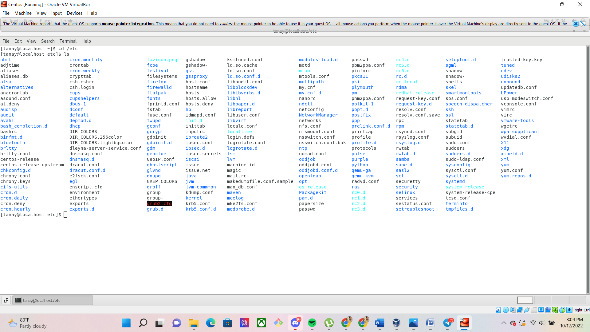

If we do cd /etc and then ls then we will get displayed above directories as output.

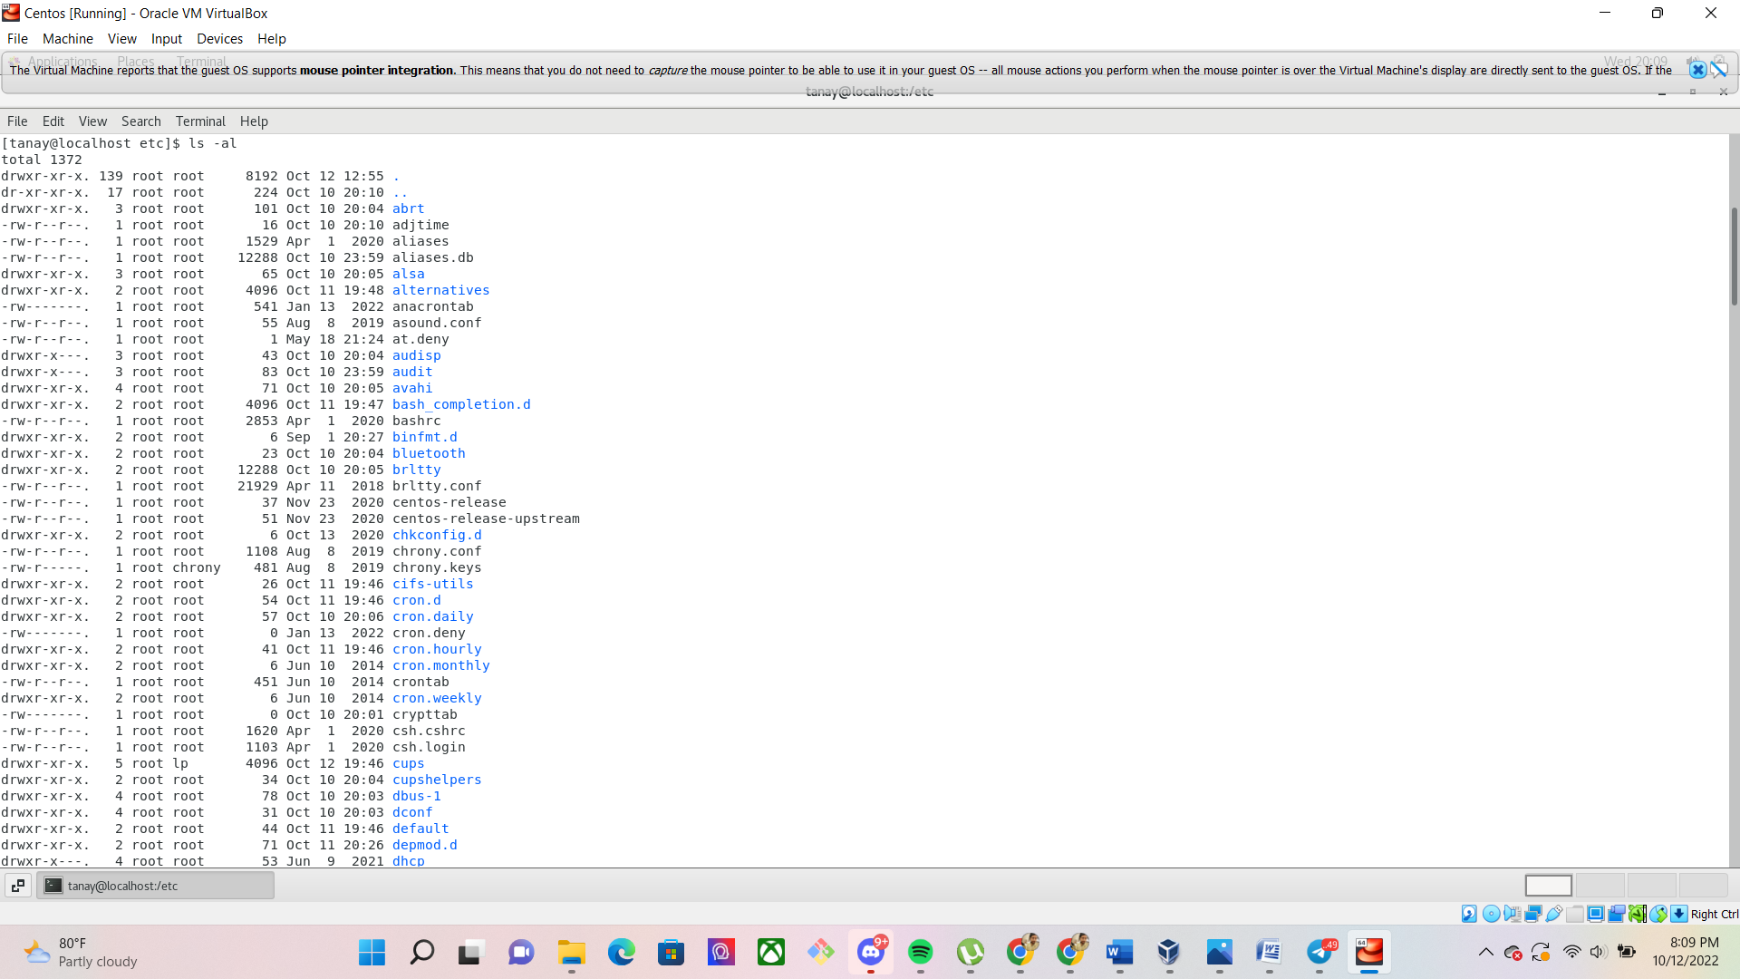

If we type ls –al then we get list of above directories as output.

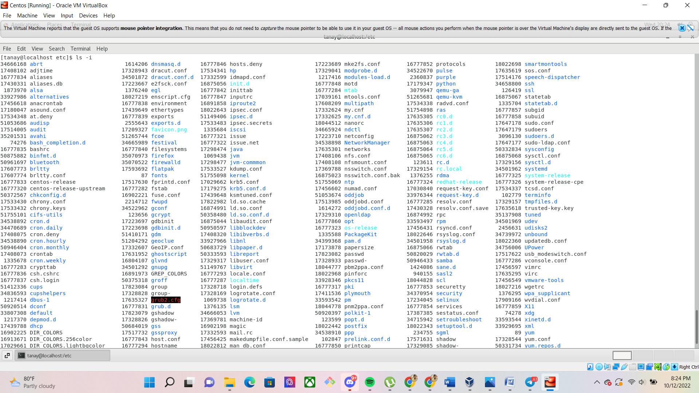

If we type ls -i we get a get a list of directories both rowwise as well as columnwise.

## ASSIGNMENT-5

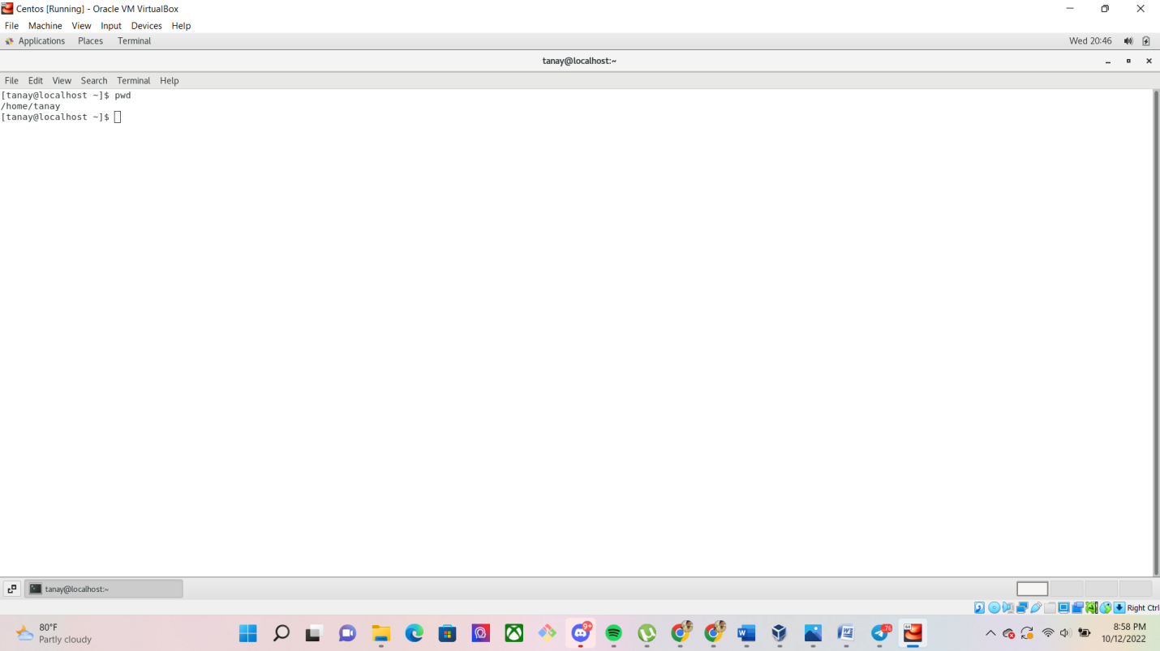

When we type pwd it prints the home directory in which we are currently in.

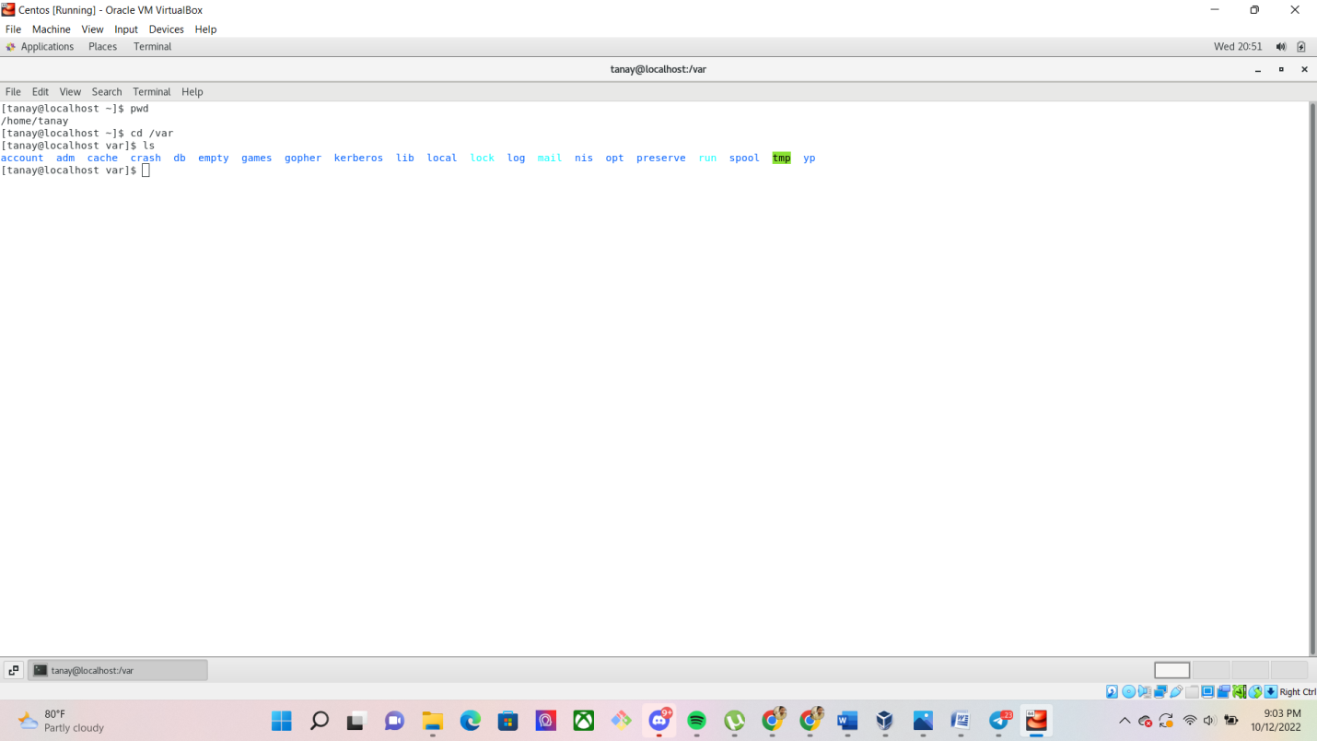

When we type cd /var and then type ls it will give a list of directories as stated above in the picture.