Report
Of
Development and Brand-Compliant Styling of a Financial Cybersecurity Awareness Web Page
(Commonwealth Bank – Introduction to Software Engineering Virtual Job Simulation, Forage)
Submitted
To
School of Computer Science and Engineering
IILM University, Greater Noida, U.P.

In partial fulfilment of the requirement of degree of
B.Tech CSE

By
Roll Number of Student: 25SCS1003004674
Name of Student: TANAY SETH
Batch: 2025-29
2026-27

CANDIDATE'S DECLARATION
I, TANAY SETH, do hereby declare that the internship report titled “Development and Brand-Compliant Styling of a Financial Cybersecurity Awareness Web Page” has been completed by me to fulfil the requirement for the award of the degree of Bachelor of Technology in Computer Science and Engineering. All the references have been quoted and I have not taken as such any material from any other source. I affirm that this report is my own and has not been submitted to any other institute for any degree/diploma requirement, and further I shall be solely responsible for any kind of copyright violation in this regard.
Signature
Student Name: TANAY SETH
Roll No: 25SCS1003004674

ACKNOWLEDGEMENT
I am using this opportunity to express my gratitude to everyone who supported me throughout this internship. I sincerely thank Commonwealth Bank of Australia and the Forage team for designing a well-structured, self-paced virtual job simulation that allowed me to experience the working style of a software engineering team, and for their pre-recorded guidance and example solutions that shaped every stage of this project.
I would also like to thank my faculty mentor and the School of Computer Science and Engineering, IILM University, Greater Noida, for their continuous guidance, constructive criticism and encouragement throughout the duration of this internship, and for providing me the opportunity to undertake and document this work as part of my academic curriculum.
Finally, I am sincerely grateful to my parents and friends for their constant support and encouragement.
Signature
Student Name: TANAY SETH
Roll No: 25SCS1003004674
INTERNSHIP COMPLETION CERTIFICATE



(This page carries no page number, as per the report formatting guidelines.)

TABLE OF CONTENTS
Candidate's Declaration i
Acknowledgement ii
Internship Completion Certificate —
List of Tables iv
List of Figures v
4. Project Description 1
4.1 Introduction 1
4.2 Organization Profile 1
4.3 Problem Statement 2
4.4 Project Objectives 2
4.5 Scope of the Project 3
4.6 Technologies and Tools Used 3
4.7 System Architecture 4
4.8 Methodology 4
4.9 Expected Outcomes 8
4.10 Certificates of Completion and Communication Proof 8
5. Bibliography / References 9

LIST OF TABLES
Table 4.1: Technologies and Tools Used 3
Table 4.2: Summary of Iterative Development Tasks 7

LIST OF FIGURES
Figure 4.1: Task 1 – Base version of the web page (3 tips) 5
Figure 4.2: Task 2 – Content-expanded version of the web page (5 tips) 6
Figure 4.3: Task 3 – Commonwealth Bank brand-styled version (excerpt) 7
Figure 4.4: Client-side system architecture of the web page 4

4. PROJECT DESCRIPTION
4.1 Introduction
Virtual job simulations have become a widely used way for students to gain applied, industry-relevant experience alongside their academic curriculum. Platforms such as Forage partner with global employers to design short, self-paced, task-based programs that mirror the kind of work a new team member would actually be asked to do, complete with pre-recorded briefings, real design/brand assets, and example solutions from the partner organisation's own team.
This report documents one such virtual job simulation – the “Commonwealth Bank: Introduction to Software Engineering” program, undertaken through Forage. In this simulation, the author took on the role of a software engineering team member at Commonwealth Bank of Australia and was tasked with building, from scratch, a client-facing web page that communicates financial cybersecurity tips to the bank's customers. The work was carried out iteratively across three linked tasks: building an initial working version of the page, expanding and refining its content, and finally re-styling the interface to strictly comply with Commonwealth Bank's visual brand and style guide before the page was prepared for public hosting.
The remainder of this chapter describes the organisation and platform involved, the problem the project addresses, its objectives and scope, the technologies used, the system architecture, the step-by-step methodology followed across the three tasks (illustrated with screenshots of each iteration), and the outcomes and skills gained from the internship.
4.2 Organization Profile
Forage. Forage is an online platform that offers free, self-paced “job simulations” built in collaboration with real companies across industries such as banking, technology, consulting and consumer goods. Each simulation is designed to replicate the day-to-day tasks of a specific team at the partner company, guided by short pre-recorded videos and example answers, and culminates in a shareable certificate of completion.
Commonwealth Bank of Australia (CommBank). Commonwealth Bank is described by the program as Australia's leading technology bank, processing millions of customer transactions every day; around 40% of all payments made by Australians pass through its systems, and its technology and engineering teams support more than 17 million customers, spanning both the customer-facing apps people use directly and the underlying systems that deliver them. This scale is the context for the simulation's Introduction to Software Engineering track, in which participants build and secure a small piece of customer-facing digital product – in this case, a financial cybersecurity awareness page – in the same way a real engineering team would.
4.3 Problem Statement
As banking moves increasingly online, customers are more exposed than ever to cyber threats such as phishing emails and texts, credential and password theft, unauthorized account access, and unsafe use of public networks for financial transactions. Banks therefore have a direct interest in proactively educating customers on simple, actionable security practices, both to reduce fraud losses and to reinforce customer trust in the brand.
From an engineering standpoint, the problem was to translate this communication need into a working, accessible, and visually on-brand web page – built using front-end web technologies – following the same iterative, feedback-driven process a real software engineering team would use: start with a minimal working version, expand it based on review, and then bring it into strict compliance with the organisation's design system before it is made publicly available.
4.4 Project Objectives
- Build a functional, semantically structured static web page listing key financial cybersecurity tips for bank customers, using HTML and CSS.
- Iteratively expand and refine the tip content – from a minimal 3-tip draft to a more complete, explanatory 5-tip version – based on simulated stakeholder/reviewer feedback.
- Apply Commonwealth Bank's official style guide (colour palette, typography and layout rules) to the page so that it is visually consistent with the bank's brand.
- Ensure the page is legible, well-structured and accessible (clear visual hierarchy, adequate contrast, large readable type).
- Prepare the finished static files so the page can be hosted and made accessible over the public internet.
- Develop a practical, hands-on understanding of how front-end engineers translate content and brand/design requirements into working code.
4.5 Scope of the Project
In scope:
- Front-end development of a single static web page (HTML5 structure and CSS3 styling).
- Authoring and iteratively refining the written content of five cybersecurity tips.
- Three progressive design iterations, culminating in full compliance with the Commonwealth Bank style guide.
- Preparing the static assets (index.html, index.css) for public hosting.
Out of scope:
- Backend/server-side logic, databases, or user authentication.
- Integration with any real Commonwealth Bank system, customer data, or production environment.
- This is a self-contained, sandboxed educational exercise – no real banking systems, accounts or customer data were used or accessed at any point.
4.6 Technologies and Tools Used
The project intentionally uses a lightweight, static front-end stack, appropriate for a single informational web page. The tools used are summarised in Table 4.1.
Table 4.1: Technologies and Tools Used
Tool / Technology | Purpose
HTML5 | Semantic structure and content of the web page (headings, sections, tip cards).
CSS3 (incl. Flexbox) | Visual styling, spacing, colour theming and responsive card layout.
Code editor (e.g., VS Code) | Writing and editing index.html and index.css.
Web browser | Rendering and manual testing of each iteration of the page.
Forage simulation platform | Task delivery, brand-guideline assets, pre-recorded briefings and example feedback.
Static web hosting (e.g., GitHub Pages) | Publishing the finished static files so the page is reachable over the internet.
4.7 System Architecture
Because the deliverable is a single informational page with no user accounts, data storage or server-side processing, the system uses a simple static client-side architecture rather than a multi-tier application design. There is no backend or database layer; the two artefacts that make up the whole system are index.html (structure and content) and index.css (presentation), served as static files. Figure 4.4 shows how a request for the page flows through these components in the browser.
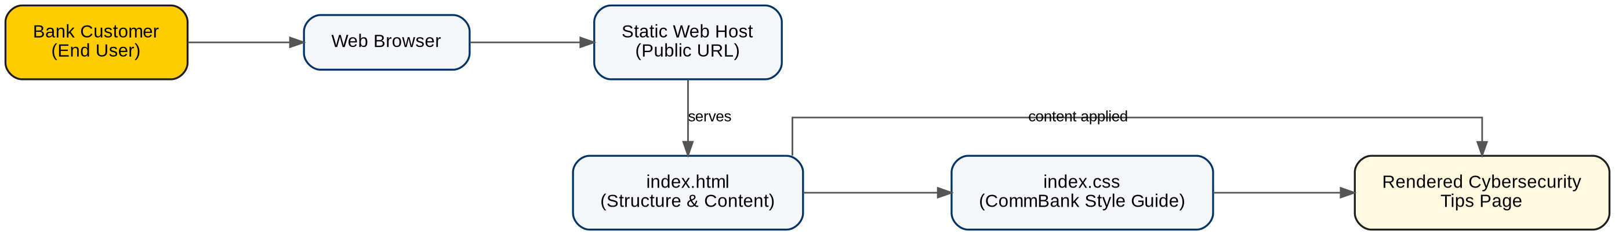
Figure 4.4: Client-side system architecture of the web page
index.html defines the document outline – in the final version this is a <header> banner, an introductory <section>, and a <main> content area containing a grid of <article> “tip-card” elements, each with a heading and a short explanation. index.css is entirely responsible for presentation: it defines the colour palette, font stack, spacing scale and the card-based layout, and in the final iteration encodes the Commonwealth Bank style guide as a set of reusable class modifiers (e.g., card-primary, card-dark, card-neutral, card-beacon) so that each tip card can be assigned a brand-approved colour treatment without duplicating styles. Because the page has no dynamic dependencies, it can be hosted on any static file host and requires no runtime beyond a standards-compliant web browser.
4.8 Methodology
The project followed the three linked tasks set out by the simulation, each building on the previous one – an approach that mirrors how a real front-end engineering task typically progresses from a minimal working version, through content and usability refinement, to final brand/design-system compliance and release.
Task 1 – Build the Base Web Page
A minimal semantic HTML5 structure was created – a page title, an introductory paragraph, and three “tip-card” blocks covering the most fundamental practices: using strong, unique passwords; enabling multi-factor authentication (MFA); and recognising phishing scams. A baseline stylesheet was then written to establish a clear visual hierarchy: a light neutral background, white card containers with a coloured accent border, a legible sans-serif font, and a consistent heading colour, so the information was easy to scan at a glance. Figure 4.1 shows this first working version.
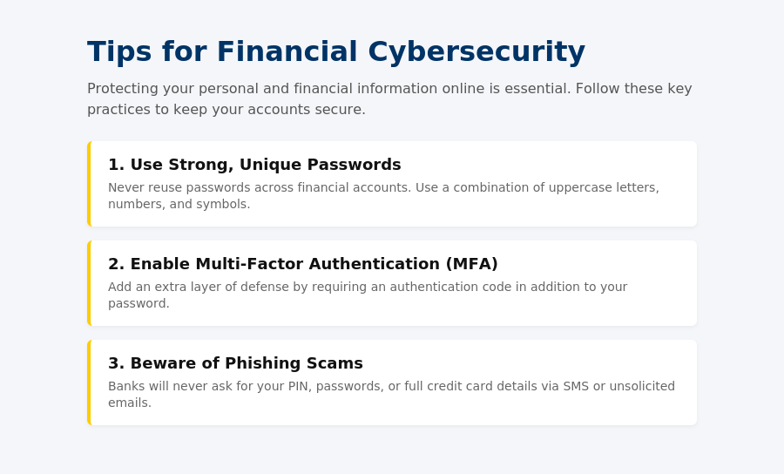
Figure 4.1: Task 1 – Base version of the web page (3 tips)
Task 2 – Expand and Refine the Content
The second task treated the base page as an early draft to be reviewed and improved, in the same way a product or content reviewer would give feedback on a first pass. The three original tips were rewritten with more explanatory depth – not just what to do, but why it matters and how to apply it – and two further, equally important tips were added: avoiding public Wi-Fi for financial transactions, and keeping devices updated while monitoring accounts for suspicious activity. The CSS was correspondingly refined – improved line-height, spacing and heading colour – to keep the longer content readable. Figure 4.2 shows the resulting five-tip version.
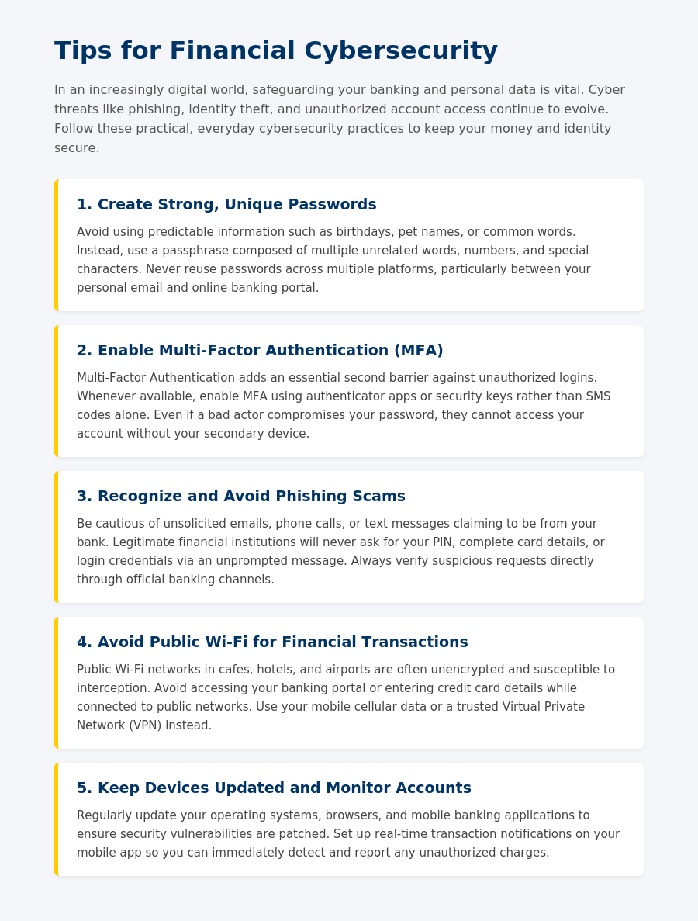
Figure 4.2: Task 2 – Content-expanded version of the web page (5 tips)
Task 3 – Apply the Commonwealth Bank Style Guide and Prepare for Hosting
The final task was to bring the page into full compliance with Commonwealth Bank's provided brand style guide. The HTML was restructured using proper landmark elements (<header>, <main>, <section>, <article>) and the layout was rebuilt around a bold header banner and a grid of tip cards. The CSS was then re-skinned entirely to the brand's colour tokens – Primary Yellow (#FFCC00), Beacon Yellow (#FFFF00), Neutral Gray (#BEBEB9) and Black (#1E1E1E) – and its specified typography stack (“Gill Sans”, “Lucida Sans”, “Trebuchet MS”), rendered at the mandated large-print scale (18pt body copy, 70pt main heading, 38pt card headings) for readability and accessibility. A specific brand rule – that any card using the black background must use white text for adequate contrast – was implemented as a dedicated card-dark modifier class and checked visually against the rest of the palette. With the styling validated against the guide, the static files were finalised and prepared for publishing to a static web host so the page would be reachable over the public internet. Figure 4.3 shows an excerpt of this final, brand-compliant version (header banner and first two tip cards, including the dark-card variant).
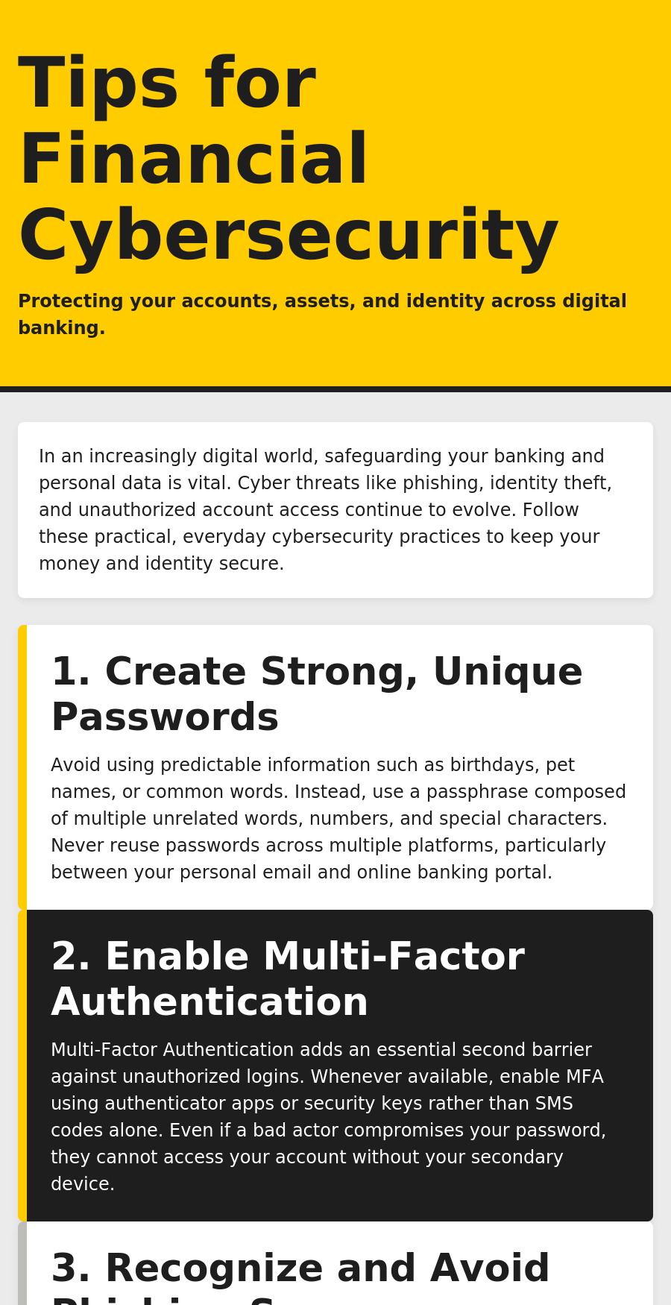
Figure 4.3: Task 3 – Commonwealth Bank brand-styled version (excerpt)
Table 4.2: Summary of Iterative Development Tasks
Task | Focus | Key Deliverable
Task 1 | Minimum viable page – structure and baseline styling | 3-tip web page (index.html, index.css)
Task 2 | Content depth and readability, based on review feedback | 5-tip web page with refined layout
Task 3 | Full Commonwealth Bank brand/style-guide compliance | Re-styled, brand-compliant page, ready for hosting
4.9 Expected Outcomes
By the end of the internship, the project was expected to deliver – and did deliver – the following outcomes:
- A working, easy-to-read financial cybersecurity awareness page covering five key customer-facing security practices.
- Full visual compliance with Commonwealth Bank's colour, typography and layout style guide, demonstrating the ability to faithfully implement a given design system.
- A static build ready to be hosted and made accessible over the public internet.
- Hands-on, practical experience of an iterative, feedback-driven front-end development workflow – build, review, refine, brand-align, release – as practised by real software engineering teams.
- A verifiable Forage certificate of completion for the “Introduction to Software Engineering” simulation, usable as a resume/LinkedIn credential.
- Strengthened personal skills in semantic HTML, CSS layout (including Flexbox-based card grids), accessibility-aware styling (colour contrast, large-print type), and working from a formal brand/style guide.
4.10 Certificates of Completion and Communication Proof
The Forage certificate of completion for the “Commonwealth Bank: Introduction to Software Engineering” virtual job simulation, along with any confirmation e-mail(s) received on completion of the program, should be attached here as proof of successful completion (in addition to the copy already placed after the Acknowledgement page, as required by the report format).



5. BIBLIOGRAPHY / REFERENCES
Forage. (2026). Commonwealth Bank – Introduction to Software Engineering Virtual Job Simulation. Retrieved from https://www.theforage.com/simulations/commonwealth-bank/intro-software-engineering-m2ma
Commonwealth Bank of Australia. Corporate overview and technology scale, as described on the Forage “Introduction to Software Engineering” program page (see reference above).
Mozilla Developer Network (MDN). HTML: HyperText Markup Language. Retrieved from https://developer.mozilla.org/en-US/docs/Web/HTML
Mozilla Developer Network (MDN). CSS: Cascading Style Sheets. Retrieved from https://developer.mozilla.org/en-US/docs/Web/CSS
National Institute of Standards and Technology (NIST). Digital Identity Guidelines – Authentication and Lifecycle Management, Special Publication 800-63B.
Reserve Bank of India. Guidelines and customer awareness material on safe digital banking and cyber-security practices. Retrieved from https://www.rbi.org.in
Australian Cyber Security Centre (ACSC). Guidance on multi-factor authentication and phishing awareness. Retrieved from https://www.cyber.gov.au

