**ICASE ASSIGNMENT**

**On**

**OTMC -SYSTEM**

DESIGNED BY:

TANAY KARMARKAR

**CONTENTS**

1. ASSUMPTIONS-------------------------------------------------3
2. USE CASE--------------------------------------------------------4
3. CLASS DIAGRAMS---------------------------------------------6
4. SEQUENCE DIAGRAMS--------------------------------------12
5. STATE DIAGRAMS--------------------------------------------13
6. ACTIVITY DIAGRAMS----------------------------------------14

**ASSUMPTIONS:**

Following assumptions have been kept in mind while designing the system:

1. Customer does not cancel subscription for a given time frame as the customer is satisfied with the product quality.
2. Customer have sufficient balance and good credit score and sufficient credit limit to make payment
3. New subtypes can be added to the class membership for future expansion.
4. Each department has its own supervisor.
5. Products in each membership is available in stock throughout the year.
6. Mailing service have an annual contract with OTMC.

**USE CASE**

ACTORS:

1. Client
2. Telephone Operator
3. Accounts Sections Supervisor
4. Bank
5. Mailing Service
6. Department Supervisor

USE CASES IDENTIFIED:

1. Enquiry
2. Place Order(optional)
3. Information
4. Transaction
5. Order

USE CASE DIAGRAM:

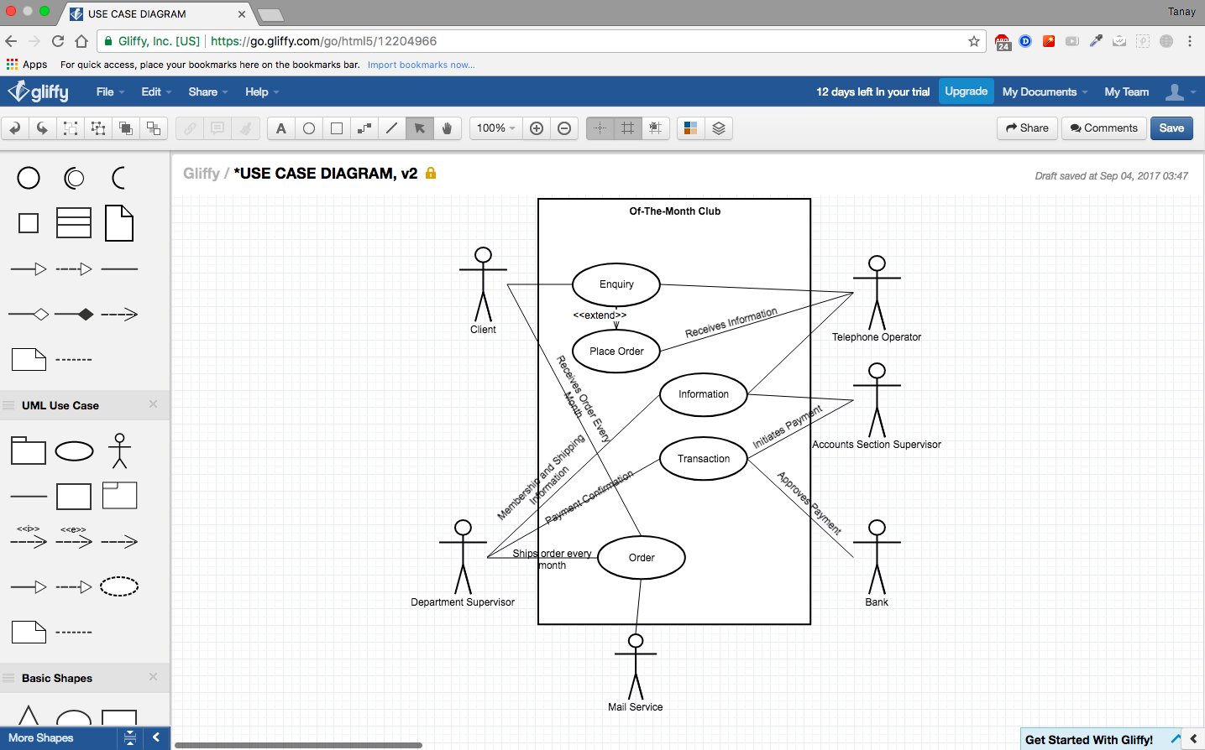

**CLASS DIAGRAMS:**

CLASS NAMES:

1. CLIENT:

Attribute-

* Name-string
* Address-String
* Credit Card Information-String
* Contact Number-Integer

Method-

* Enquire
* Term of Membership
* Number of Memberships
* Category Selection
* Order
* Feedback

1. TELEPHONE OPERATOR:

Attribute-

* Name-String
* Contact Number-Integer

Method-

* Provide Information
* Order Verification
* Take Customer Information
* Provide Order Confirmation
* Ask for feedback
* Generate reminders regarding the expiry and renewal
* Forward information to accounts department

1. BANK:

Attributes-

* Name

Method-

* Approves Payment

1. ORDER:

Attribute-

* Customer Information-String
* Date Received-String
* Starting Date-String
* Shipping Details-String

Method-

* Payment Confirmation
* Dispatch

1. MEMBERSHIP:

Attribute-

* Membership Terms

Method-

* Total Amount Calculation

1. Coffee:

Attribute-

* Brand-String
* Quantity (in Grams)-Integer
* Cost-Integer
* Terms and Conditions: String

Method:

* Cost

1. Wine:

Attribute-

* Brand-String
* Quantity (in ml)-Integer
* Cost-Integer
* Terms and Conditions: String

Method:

* Cost

1. Beer:

Attribute-

* Brand-String
* Pack of - Integer
* Quantity in Each (in Oz)-Integer
* Cost-Integer
* Terms and Conditions: String

Method:

* Cost

1. Cigars:

Attribute-

* Brand-String
* Pack of - Integer
* Size (Small or Large)-String
* Cost-Integer
* Terms and Conditions: String

Method:

* Cost

1. FLOWER:

Attribute-

* Brand-String
* Pack of-Integer
* Cost-Integer
* Terms and Conditions: String

Method:

* Cost

1. COMPUTER GAMES:

Attribute-

* Categories-String
* Age- Integer
* Cost-Integer
* Terms and Conditions: String

Method:

* Eligibility
* Cost

CLASS DIAGRAM:

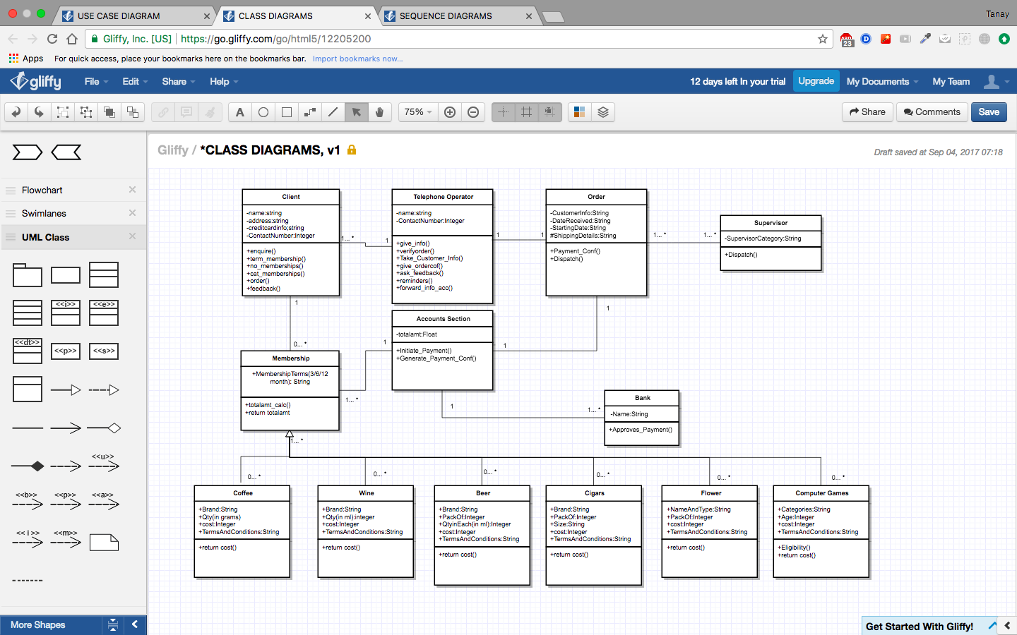

RELATIONSHIPS:

* “One to many” relationship from client to telephone operator.
* “Zero to many” relationship from membership to client.

**SEQUENCE DIAGRAMS:**

* Objects are Client, Telephone Operator, Bank, Accounts Section, Mailing Service, Department Supervisor.

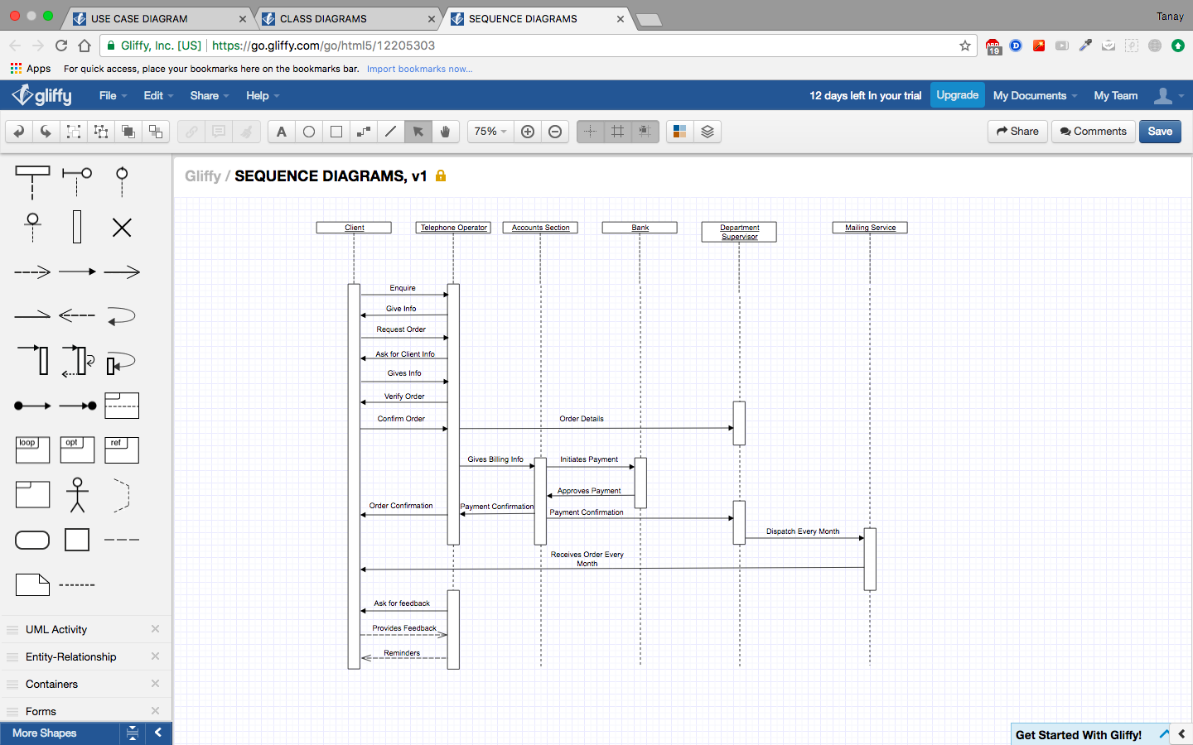

**STATE DIAGRAM:**

* New Customer can enquire and make selection for the memberships
* Existing Customer can either discontinue or renew or modify existing membership.

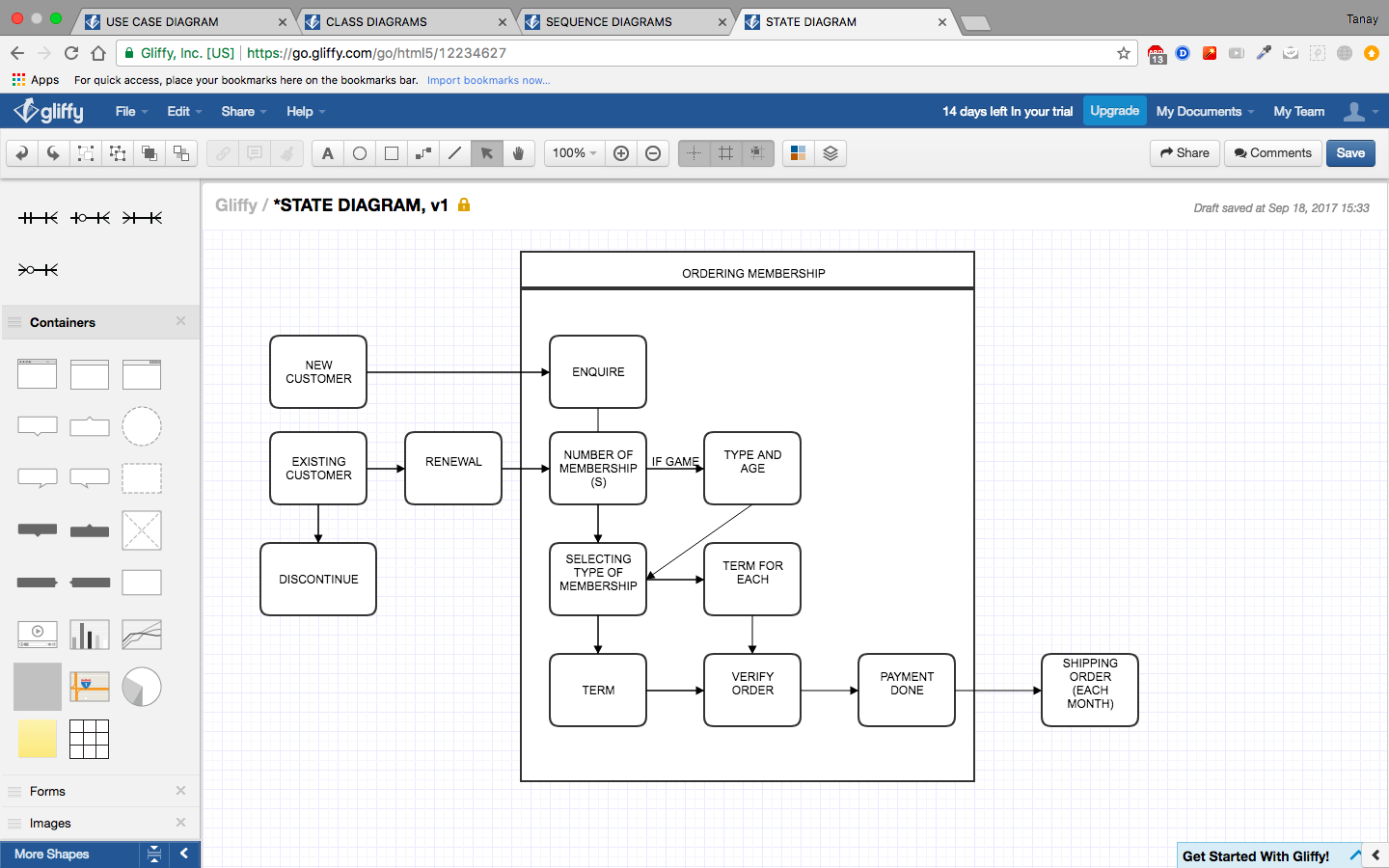

**ACTIVITY DIAGRAM:**

* Conditional operators have been put and the flow of the direction is indicated.

