# EDI Operational Analytics Dashboard

## Project Overview
Developed an automated EDI analytics dashboard to process EDI transaction files, extract purchase order data, monitor exceptions, and generate operational insights using Python and Power BI.

## Features
- EDI file parsing and extraction
- KPI monitoring dashboard
- Duplicate PO detection
- Invalid file monitoring
- Transaction trend analysis
- Interactive filtering
- CSV export functionality
- Power BI reporting dashboard

## Technologies Used
- Python
- Pandas
- Panel
- Matplotlib
- Power BI

## Workflow
EDI Files → Python Processing → CSV Output → Power BI Dashboard

## Screenshots

### Python Dashboard
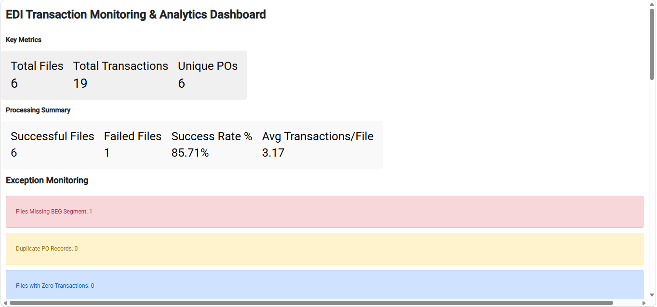
### Power BI Dashboard
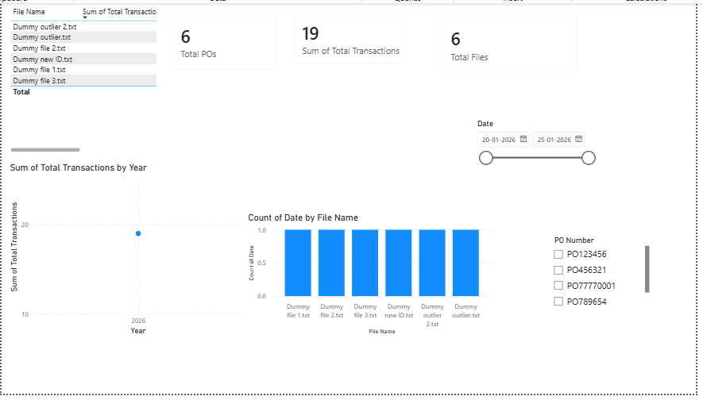
## Author
Tanaya Patil

