Few-Shot Temporal Subgraph Anomaly Detection and Structure-Aware Anomaly Generation in Functional Brain Networks for Autism Spectrum Disorder
Premanand Ghadekar  Vishwakarma Institute of Technology,  Pune, India  premanand.ghadekar@vit.edu |  | Harsh Patel  Vishwakarma Institute of Technology,  Pune, India  patel.harsh24@vit.edu |  | Tanaya Hartalekar  Vishwakarma Institute of Technology,  Pune, India  tanaya.hartalekar24@vit.edu
 | Hanil Shah  Vishwakarma Institute of Technology,  Pune, India  hanil.shah24@vit.edu |  | Shravani Dixit  Vishwakarma Institute of Technology,  Pune, India  shravani.dixit24@vit.edu

Abstract: Resting-state fMRI turns every scan into a brain network, but very few labelled scans exist. This study introduces a model that tracks small brain subgraphs over time and learns normal behavior from control scans only; unusual regions receive a high anomaly score. Real control scans then serve to generate structure-aware anomalies by gradient-guided edge-weight edits. Guided edits get detected far better than random edits: on 70 held-out control scans the AUROC is 0.906 against 0.491, and GIN + GRU detects them best among four encoder and predictor pairs. In few-shot adaptation, generated anomalies lift one-shot F1 from 0.006 to about 0.40, while AUROC stays near 0.5 because more patients get flagged without a better ranking. Direct ASD detection on ABIDE I stays at chance level (AUROC 0.453) and severity bands do not beat a majority-class guess; both stay as limits of the present data and features.
Keywords: brain networks, anomaly detection, temporal graphs, few-shot learning, autism spectrum disorder, resting-state fMRI
I. INTRODUCTION
Resting-state fMRI (functional MRI) is a technique used for examining brain function in a motionless state. The acquired data is processed in order to construct the brain network where each of its nodes represents a specific area of the brain and the links between the nodes demonstrate the correlation between the movement of the two brain regions together. Most studies in the field of deep learning process every scan image in such a way that the final brain network model developed accommodates whether autism spectrum disorder is present or not. Reports on the public ABIDE dataset reveal that results show slight differences in research as they depend on where the examination is carried out.
It should be taken into consideration that a brain network is not a stable construct. The network can change within a second. Therefore, the networks available in the scans may hide the brain areas with abnormal activity for a few seconds.
The analysis includes three main study questions. The first question (RQ1) is: does modeling a timeline help with just a single scanning (random) network? The second question (RQ2) is: do synthetic and real unusual things help each other? The third question (RQ3) is: can the scores reflect the severity of autism?
The contribution consists of five parts: (1) a temporal model that follows small brain subgraphs and learns normal behavior from controls only; (2) a structure-aware generator that edits real connections, with its anomalies detected far better than random edits (AUROC 0.906 against 0.491); (3) a model-wise comparison in which GIN + GRU is the strongest of four encoder and predictor pairs; (4) few-shot adaptation in which generated anomalies lift one-shot F1 from 0.006 to about 0.40; (5) a full mathematical description of every model used. This research makes no clinical claims.
II. LITERATURE REVIEW
The brain activity measures taken using fMRI can be transformed into a network form, and some techniques related to graphs can summarize brain activity in a straightforward way [1],[2]. The first works devoted to deep learning used feed connection values into traditional networks and achieved moderate precision on ABIDE [3]. Some graph-oriented models estimate the distance between brain networks thanks to graph convolution [4] that is based on the graph convolutional neural networks [5] principles.
Research in the area of sliding-window use has demonstrated that changes in connectivity occur over time [6], [7]. Other researchers in the dynamic network domain have focused on specific parts of the connectome considered as abnormal [8]. The aforementioned methods provide information about the groups or only one final decision per study, but do not specify which area of the brain was behaving abnormally.
Graph anomaly detection searches for strange nodes, edges, subgraphs, or graphs altogether, as reviewed in [9]. For dynamic graphs, static approaches include NetWalk and AddGraph that flag unordinary edges during the evolution of the network [10],[11]. Some models for brain data trained solely on the scans of the controls and then flagged different edges and hyperedges using synthetic anomalies for testing [12],[13]. The method used here builds on this idea of using only controls because it measures the error of forecasting the subsequent condition of the traced subgraph.
For analysing graphs, any recent presence of labelling of at least several anomalies can lead to improved identification of anomalies using cross network-based meta-learning [14]. In terms of brain studies, few-shot opportunities mostly serve supervised learning, e.g. few-shot categorization of individuals suffering from autism based on structural MRI [15]. This study builds on utilization of a small number of original brain scans obtained from individuals diagnosed with ASD together with instances of synthetic anomalies inside the anomaly scoring pipeline.
The concept of changing graph edges using gradients is already familiar from the area of adversarial attacks [16], [17]. This concept applies here to create anomalies, instead of attacking a model: the modifications stay confined by the existing connection weights and get validated using a random baseline.
No earlier publication known to the authors introduces the combination of (a) tracking small brain subgraphs over time with the prediction of future steps, (b) gradient-based alteration of the connection weights in order to generate anomalies, and (c) usage of few-shot adaptation for ASD. Authors of previous works either classify all the scans, consider dynamic processes at group level, find anomalies at edges or adapt few-shot classifiers. Each of these parts exist separately.
III. METHODOLOGY
A. Data acquisition and patient separation
ABIDE I [18] was applied: 871 checked scans (403 ASD, 468 controls) collected from 20 locations. Each scan gives the mean activity measurement from 360 brain regions according to the Glasser atlas [19]. The separation is based on individuals: 609 people go to training (328 controls and 281 ASD), 131 to validation, and 131 to testing, maintaining the ASD/control ratio. Each individual is unique for every split.
B. Brain graphs creation using the sliding-window method
Each scan is divided into 30-time-point windows with sliding of 10 points each time. In each window, correlations between each pair of regions get calculated, and the strongest 20% of connections stay, together with their sign. The result is a brain network extracted from each of the windows (from 5 to 29 windows for each scan).
C. Tracking of Brain-region Subgraph
Employing all 360 brain regions is cumbersome and does not delineate the location where an alteration occurs. Twenty regions, distributed across the brain, get selected. For each of them, the region and its immediate neighbours in the initial window form a constant set that stays followed in all subsequent windows. Only connections and their weights change. On average a subgraph consists of around 71 regions.
Fig. 1 shows the ten-step pipeline.
DATA PREPARATION
ABIDE I, 871 scans, 360 regions; patient-level split 609 / 131 / 131
SLIDING-WINDOW BRAIN GRAPHS
30-point windows, stride 10; Pearson correlation; top 20% signed edges
SUBGRAPH TRACKING
20 brain regions with 1-hop neighbours; node set fixed at the first window
GIN ENCODING AND GRU PREDICTION
2-layer GIN gives a 128-D vector; GRU predicts the next window; controls only
ANOMALY SCORING
Prediction error per region and step; patient score = maximum
THRESHOLD CALIBRATION
95th percentile of validation-control scores (step and patient level)
ANOMALY GENERATION
Gradient-guided edge-weight edits, 5 steps, up to 15% of edge pairs
FEW-SHOT ADAPTATION
1, 5 or 10 ASD scans + 30 generated anomalies; logistic regression
ANOMALY DETECTION
Patient is flagged when the score exceeds the patient threshold
SEVERITY LEVEL ANALYSIS
Flagged patient gets an ADOS-2 band: low, moderate or high
Fig. 1. System architecture diagram.
The diagram follows the pipeline from data preparation to the final severity level analysis. Each box names a step and its key setting.
D. GIN Encoding and GRU Prediction
A two-layer graph isomorphism network (GIN) [20] transforms each subgraph into a vector of 128 numbers. A GRU [21] examines the vectors until window t and predicts the vector at window t + 1. Both get trained simultaneously, only on control scans. The loss is the prediction error along with the small penalty that prevents all the vectors from becoming identical [22]. The anomaly score of a step is the distance between the predicted and the actual vector (Eq. (13)), and the patient score is the maximum over the 20 regions and all steps (Eq. (14)).
E. Calibration of the threshold based on control
The threshold is the 95th percentile of the validation-control scores, one for steps and one for patients. The step threshold alone would flag almost every patient, because a patient has about 280 steps and 5% of them can exceed it by chance. This was realised only after all tests had been run, so precision, recall and F1 cannot count as completely blind; AUROC is unaffected.
F. Generation of synthetic anomalies
In the case of the actual control subgraph, adjustments apply to the existing weights. The influence of each weight on the error is assessed, which keeps the weights that seem most important (up to 15% of the weights). Afterwards, the weights change in 5 small steps in the direction of increasing the error [16], [17]. The weights remain in the range of −1 to 1, and no new connections get established or removed. Severity (0.25, 0.55, 0.9) shows how many connections and how much change is introduced.
G. Few-shot Adaptation
The model remains unchanged. Every individual is assessed through 20 different digits. As such, logistic regression gets trained with either 1, 5 or 10 of the actual ASD scans as positive examples, 30 synthetic anomalies as additional positives, and the 328 control scans as negatives. This procedure repeats for five different samples of ASD scans, comparing three setups: only real ASD scans, real ASD scans plus guided synthetic anomalies, and real ASD scans plus random synthetic anomalies.
H. Detection and Severity Assessment
An individual counts as marked if the score exceeds the threshold. For all marked individuals, severity estimates come from the ADOS-2 severity score [23] (1-10): low (≤5), moderate (6-7) or high (≥8). This categorization is defined by the authors and does not follow DSM-5. Scores exist for 193 of 403 patients with ASD, linked to scans after reapplying the quality filter of the data release.
I. Benchmark evaluation of generated anomalies
To test the detectability of generated anomalies, the 70 held-out test control scans were used. For each scan and each of the 20 regions, one window transition received a guided edit and one a random edit of the same magnitude at severity 0.9. The unedited transition is the negative example and the edited one the positive example (1,400 pairs per method); a transition counts as detected when its score exceeds the validation cut-off of 7.43. All settings were fixed beforehand, the checkpoint with the best validation loss (epoch 4 of 5) was used and test data served only for the final evaluation. Uncertainty is a 95% bootstrap interval (2,000 resamples) with a permutation test (5,000 shuffles); few-shot results give the mean and standard deviation over five draws of ASD scans, and the chance F1 for flag rate q is 2πq/(π + q), with π = 0.466 the share of ASD patients in the test set.
J. Mathematical formulation
In a window of 30 time points, the connectivity between regions i and j follows the Pearson correlation [2]:
$r_{ij}=\frac{\sum_{t}{\left(x_{it}−{\bar{x}}_{i}\right)\left(x_{jt}−{\bar{x}}_{j}\right)}}{\sqrt{\sum_{t}{{\left(x_{it}−{\bar{x}}_{i}\right)}^{2}}\sum_{t}{{\left(x_{jt}−{\bar{x}}_{j}\right)}^{2}}}}$ (1)
Only the strongest 20% of pairs by absolute correlation stay as signed edge weights, that is, an edge exists when |r_ij| reaches the 80th percentile of the window. A weighted GIN layer [20] then aggregates the neighbours N(i) of node i with the signed weights w_ij, where ε_l is trainable and the input feature of every node is 1, and passes the result through a two-layer perceptron:
$a_{i}^{\left(l\right)}=\left(1+ε_{l}\right)h_{i}^{\left(l−1\right)}+\sum_{j∈N(i)}{w_{ij}h_{j}^{\left(l−1\right)}}$ (2)
$h_{i}^{\left(l\right)}=ReLU\left({MLP}^{\left(l\right)}\left(a_{i}^{\left(l\right)}\right)\right)$ (3)
After two layers, mean pooling over the nodes V of the subgraph and a linear projection give the 128-dimensional embedding:
$z=W_{o}\frac{1}{|V|}\sum_{i∈V}{h_{i}^{\left(2\right)}}+b_{o}$ (4)
The GRU [21] reads the embeddings z_1, ..., z_t. Its reset gate, update gate, candidate state and hidden state follow:
$r_{t}=σ\left(W_{r}z_{t}+U_{r}h_{t−1}\right)$ (5)
$u_{t}=σ\left(W_{u}z_{t}+U_{u}h_{t−1}\right)$ (6)
${h̃}_{t}=tanh\left(W_{h}z_{t}+U_{h}\left(r_{t}⊙h_{t−1}\right)\right)$ (7)
$h_{t}=\left(1−u_{t}\right)⊙h_{t−1}+u_{t}⊙{h̃}_{t}$ (8)
A linear read-out gives the predicted next embedding:
${\hat{z}}_{t+1}=W_{p}h_{t}+b_{p}$ (9)
Training minimizes the mean squared prediction error plus a variance penalty in the style of VICReg [22], which stops all embeddings from collapsing to one vector (T is the number of windows, D = 128 the embedding size and λ = 0.5). Adam [24] updates the parameters with a learning rate of 0.001:
$L_{pred}=\frac{1}{(T−1)D}\sum_{t=1}^{T−1}{{\left\|{\hat{z}}_{t+1}−z_{t+1}\right\|}^{2}}$ (10)
$L_{var}=\frac{1}{D}\sum_{d=1}^{D}{max\left(0,1−\sqrt{Var\left(z_{d}\right)+{10}^{−4}}\right)}$ (11)
$L=L_{pred}+λL_{var}$ (12)
The anomaly score of step t and the patient score S, the maximum over the tracked regions v and all steps, follow:
$A_{t}={\left\|z_{t+1}−{\hat{z}}_{t+1}\right\|}_{2}$ (13)
$S=\max_{v}\max_{t}A_{t}^{\left(v\right)}$ (14)
The step threshold and the patient threshold equal the 95th percentile of the validation-control step scores and patient scores, and a patient is flagged when S exceeds the patient threshold. For guided anomaly generation, the sensitivity of an undirected connection p (two directed edges e) is the gradient of the model error, where f is the frozen encoder:
$g_{p}=\sum_{e∈p}{\frac{∂{\left\|f(G;w)−{\hat{z}}_{t+1}\right\|}^{2}}{∂w_{e}}}$ (15)
The m connections with the largest |g_p| move in Q = 5 projected sign-gradient steps [16], [17], where α is the severity, δ_max = 0.6 and the weights stay between −1 and 1:
$w_{p}^{\left(q+1\right)}={clip}_{[−1,1]}\left(w_{p}^{\left(q\right)}+\frac{αδ_{max}}{Q}sgn\left(g_{p}^{\left(q\right)}\right)\right)$ (16)
The few-shot head is a logistic regression with balanced class weights on the 20-dimensional vector x of per-region maximum scores, fitted by weighted cross-entropy with an L2 penalty (C = 1):
$P(y=1|x)=\frac{1}{1+exp\left(−\left(β^{T}x+b\right)\right)}$ (17)
The severity estimator is a standardized multinomial logistic regression (C = 0.1) on 40 features, the per-region maximum and mean scores. Evaluation uses precision = TP/(TP + FP), recall = TP/(TP + FN), F1 = 2PR/(P + R) and AUROC, the probability that a random positive scores above a random negative. The agreement between predicted and true severity uses the Spearman rank correlation. Algorithm 1 summarizes the complete procedure with the equations above.
Algorithm 1. Training, anomaly generation and few-shot detection.
Input: scans of ABIDE I; 20 seed regions R; window 30, stride 10; edit budget m, steps Q = 5, severity δ; shots k.
Output: patient flag and severity band.
1: for each scan, build the window graphs G_t by Eq. (1)–(2).
2: for each seed r in R, fix the 1-hop subgraph V_r from G_1 and keep it for all windows.
3: train on control scans only: embed z_t by Eq. (3)–(4), predict the next embedding by Eq. (5)–(9), minimize L by Eq. (10)–(12).
4: score each step A_t by Eq. (13), the patient S by Eq. (14); set thresholds from validation controls by Eq. (15).
5: for each control scan, region and severity: repeat Q times, take the gradient of A_t with respect to the edge weights, update the m most influential edges by Eq. (16) and clip the weights to [−1, 1].
6: build x, the 20 per-region maximum scores, for k real ASD scans, 30 generated anomalies and the control scans.
7: fit the logistic regression head by Eq. (17).
8: for a new patient, compute S; flag the patient when S exceeds the patient threshold or the head predicts ASD; assign a low, moderate or high severity band to flagged patients.

IV. RESULTS
A. Detector
A total of 131 test subjects were used, of which only 4 were flagged by the detector but only 2 were correct. The calculated performance measures of the detector were as follow: precision 0.500, recall 0.033, F1 0.062 and accuracy 53.4%. The AUROC value was found to be 0.453 (95% CI 0.353-0.552, permutation p = 0.35). The AUPRC value was found to be 0.467, which is equal to the chance level of detection of 0.466. Fig. 2 shows the score distributions and the ROC curve.
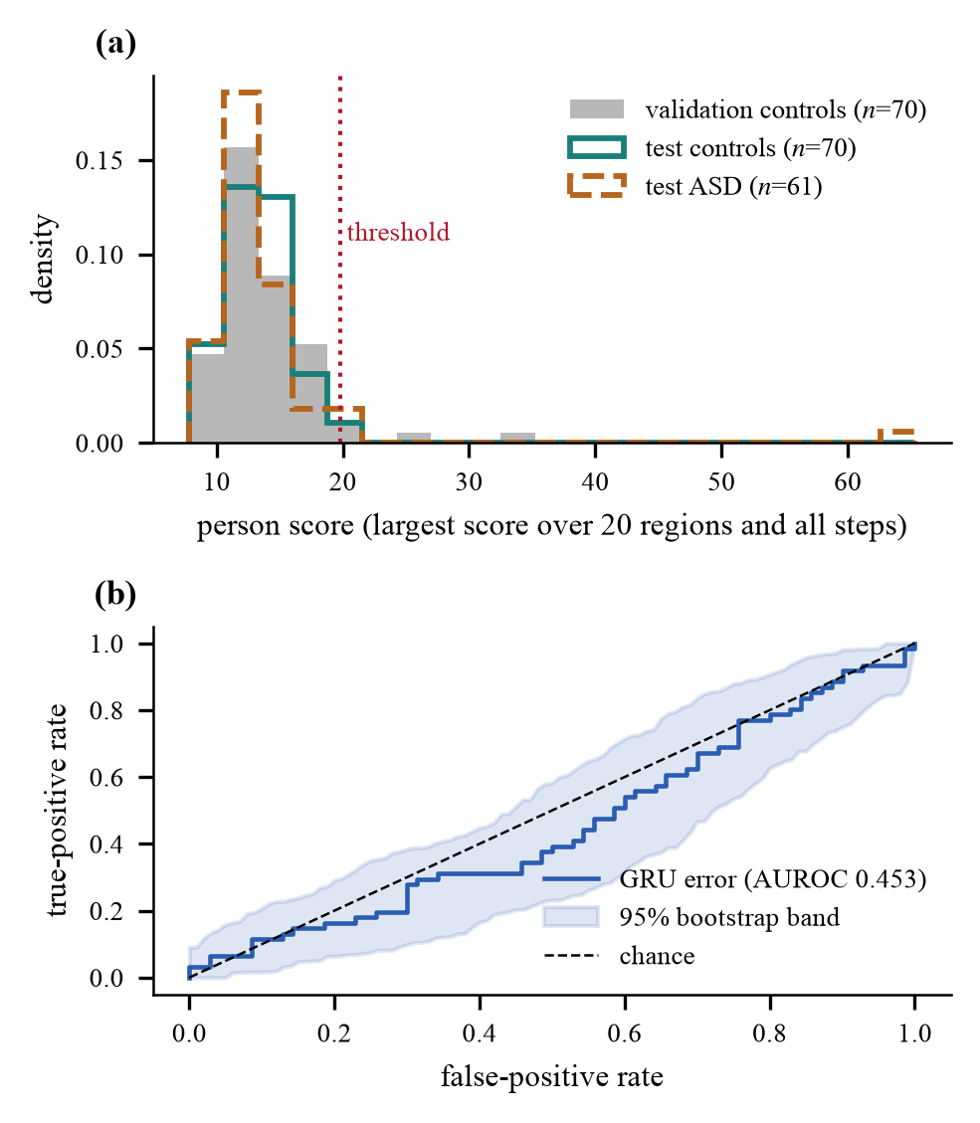
Fig. 2. Detector score distribution and ROC curve.
Panel (a) shows the patient scores of validation controls, test controls and test ASD patients against the detection threshold of 19.81; the three distributions overlap almost completely. Panel (b) shows the ROC curve with a 95% bootstrap band, which stays close to the chance line (AUROC 0.453).
B. Does modelling time help? (RQ1)
Table I presents a comparison of three evaluation scores calculated by the same frozen encoder: the distance from the control mean (static), the difference from the prior window (persistence) and the GRU error. The presented values show that all have AUROC scores in the range of 0.45 - 0.49 with overlapping intervals. This means that temporal modeling has not brought any significant effect. The encoder was trained with the GRU, so the baselines cannot count as completely independent.
TABLE I. Scoring methods on the test set.
Score | AUROC [95% CI] | p | F1 | Flagged
Static | 0.452 [0.356, 0.553] | 0.34 | 0.143 | 9
Persistence | 0.485 [0.380, 0.582] | 0.78 | 0.062 | 4
GRU (proposed) | 0.453 [0.353, 0.552] | 0.35 | 0.062 | 4
C. Synthetic anomalies (RQ2)
A total of 7,200 synthetic records (60 control subjects × 20 locations × 3 intensities × 2 types of processing) were produced without breaking any rules. The average score increased from 4.0 to 7.6 through the edited version while the average score when edits were made randomly was around 2.9. At the highest severity, 45.8% of the guided records passed the step threshold, while only 4.8% of random edits did (Fig. 3); in contrast, actual control subjects and actual ASD ones crossed the step line in 5.0% and 4.9% of cases, respectively. The same model performed both types of processing, so this shows that the generator does not produce random noise, not that the anomalies resemble autism.
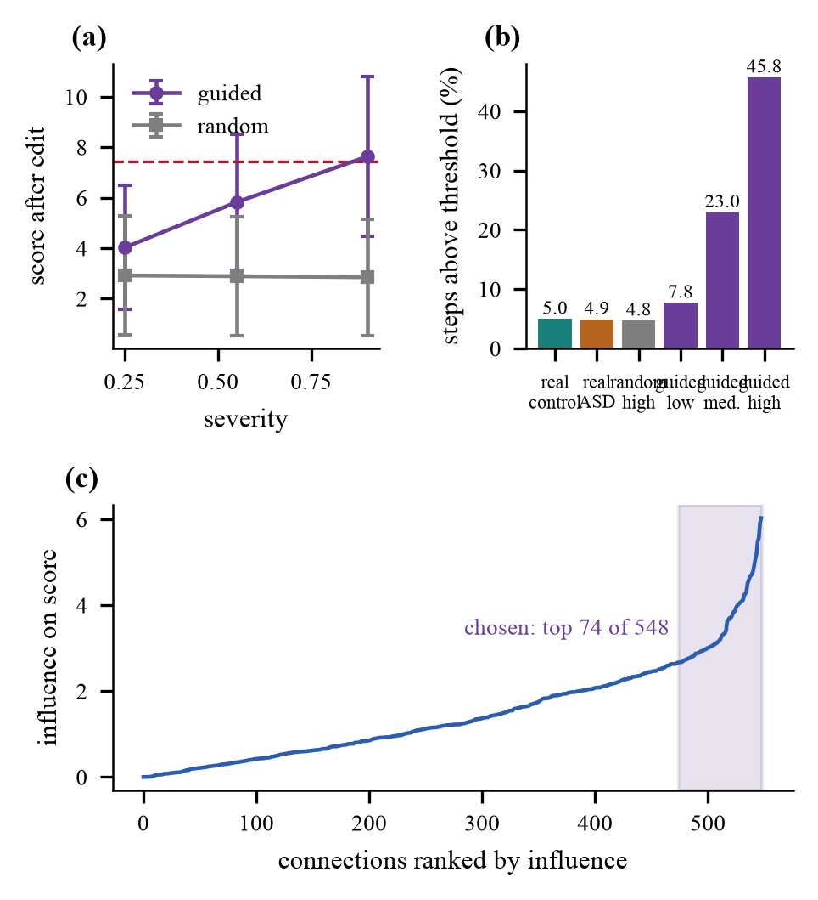
Fig. 3. Effect of guided edits on anomaly scores.
Panel (a) shows the score rising with edit severity for guided edits and staying flat for random edits. Panel (b) gives the share of steps above the threshold: 45.8% for guided high-severity edits, 4.8% for random edits and about 5% for real scans. Panel (c) ranks the connections by influence.
D. Few-shot adaptation (RQ2)
Table II summarizes the few-shot experiments. With one real ASD scan the classifier flags almost nobody and reaches an F1 of only 0.006. Adding 30 generated anomalies lifts the one-shot F1 to 0.39-0.40, and for 5 and 10 shots the F1 rises from 0.15 and 0.31 to about 0.40 and 0.43. Generated anomalies therefore make few-shot adaptation usable from a single real scan, where real scans alone fail. The AUROC stays near 0.50 in every setup, and the F1 values match the chance F1 for the same flag rate (35-39% of patients), so the gain comes from higher recall and not from a better ranking. Guided and random anomalies give similar results here, which shows that the benefit comes from the generated positives and not from their structure.
TABLE II. Few-shot results. SA: guided, R: random.
Shots | Training set | F1 | AUROC | Flag | Chance F1
1 | ASD only | 0.006±0.01 | 0.516±0.06 | – | –
 | + SA | 0.387±0.04 | 0.497±0.03 | 0.36 | 0.41
 | + R | 0.403±0.07 | 0.506±0.04 | 0.35 | 0.40
5 | ASD only | 0.149±0.07 | 0.485±0.02 | 0.10 | 0.16
 | + SA | 0.390±0.03 | 0.486±0.03 | 0.36 | 0.41
 | + R | 0.399±0.05 | 0.502±0.02 | 0.37 | 0.41
10 | ASD only | 0.311±0.09 | 0.524±0.05 | 0.26 | 0.33
 | + SA | 0.402±0.05 | 0.501±0.05 | 0.38 | 0.42
 | + R | 0.431±0.04 | 0.515±0.05 | 0.39 | 0.42
E. Severity estimation (RQ3)
In the case of the 60 ASD individuals who did not participate in the training process, the accuracy of predicting severity was found to be 43.3%, as opposed to merely saying “high,” which could yield a better score of 55.0%. Cross-validation proved that for the whole group of 193 individuals the accuracy dropped to 39.1% against 43.0%. The relationship between the estimated severity scores and true severity measurement was very weak (Spearman 0.13, p=0.32) indicating that the score may not provide any essential information.
F. Guided sub-structure versus random edits
Guided sub-structure edits get detected far better than random edits of the same size on every metric (Table III): accuracy 70.2% versus 50.0%, precision 0.902 versus 0.500, recall 0.454 versus 0.049, F1 0.604 versus 0.090 and AUROC 0.906 versus 0.491. Random edits stay at chance level, while guided editing raised the mean transition score from 2.94 to 7.62. Because the model that decides the edits also scores them, this test shows the visibility of the generated anomalies and not an ASD diagnosis.
TABLE III. Detection of generated anomalies.
Approach | Accuracy | Precision | Recall | F1 | AUROC
Random | 50.0% | 0.500 | 0.049 | 0.090 | 0.491
Sub-structure | 70.2% | 0.902 | 0.454 | 0.604 | 0.906
G. Model-wise comparison
To compare models, the graph encoder and the temporal predictor were exchanged while the data, the split, the loss in Eq. (12), the optimizer and the five training epochs stayed identical. The graph encoders were GIN [20], GCN [5] (signed weights summed without normalization) and GraphConv [25], and the temporal predictors were GRU [21] and LSTM [26]. Table IV compares the models. The proposed GIN + GRU reaches 70.2% accuracy and 0.906 AUROC on guided edits, against 59.1% and 0.718 for GCN + GRU, 64.1% and 0.855 for GraphConv + GRU, and 69.5% and 0.901 for GIN + LSTM. GIN + GRU gives the highest guided-edit AUROC, followed closely by GIN + LSTM, which supports the choice of GIN as the graph encoder. All models give ASD detection AUROC values near the chance level of 0.5, and random edits stay near 0.5 for every model.
TABLE IV. Model-wise comparison.
Model | ASD AUROC | ASD Acc. | Guided Acc. | Guided AUROC | Random AUROC
GIN + GRU | 0.453 | 53.4% | 70.2% | 0.906 | 0.491
GCN + GRU | 0.494 | 55.0% | 59.1% | 0.718 | 0.494
GraphConv + GRU | 0.479 | 52.7% | 64.1% | 0.855 | 0.499
GIN + LSTM | 0.442 | 56.5% | 69.5% | 0.901 | 0.503

V. DISCUSSION AND LIMITATIONS
The pipeline trains stably, the generator produces anomalies that the model detects far better than random edits (AUROC 0.906 against 0.491), and GIN + GRU is the strongest of the four encoder and predictor pairs tested. Direct ASD detection on ABIDE I stays at chance level (AUROC 0.453). Some possible reasons include: 1) low signal; 2) huge variability of ASD; 3) site effects [27]; 4) noise and other effects [7]; and 5) the use of 20 features out of the total 360. The limitations include: training was run only once; two design decisions (the patient threshold and the selection of 20 features) followed the results and not prior planning; no cross-site experiments were done; baseline comparisons were not done for the whole graph, and sliding window tests were not performed; severity linking presumes a specific order. The guided-edit result comes from a scorer and a generator sharing one model, so it shows that generated anomalies stay visible to the model and does not guarantee effectiveness in ASD detection.
VI. CONCLUSION
The pipeline traces the behavior of small brain subgraphs over time, captures significant changes, produces structure-aware anomalies and adapts itself using ASD scans. Guided sub-structure modifications get detected far better than random changes of the same size (AUROC 0.906 against 0.491 on held-out control scans), GIN + GRU gives the best detection among the four models compared, and generated anomalies lift one-shot F1 from 0.006 to about 0.40. Direct ASD detection on ABIDE I stays at chance level (AUROC 0.453), which marks the main limit of the present study.
Future work will address this limit through leave-one-site-out evaluation with site harmonization [27], scoring of generated anomalies with a second model that did not guide the edits, full-graph baselines and parameter sweeps over multiple training runs, data-driven selection of the monitored regions, ordinal regression on continuous ADOS-2 scores, and validation on independent cohorts together with clinicians.
REFERENCES
[1] E. Bullmore and O. Sporns, “Complex brain networks: Graph theoretical analysis of structural and functional systems,” Nat. Rev. Neurosci., vol. 10, no. 3, pp. 186–198, Mar. 2009, doi: 10.1038/nrn2575.
[2] S. M. Smith et al., “Network modelling methods for FMRI,” NeuroImage, vol. 54, no. 2, pp. 875–891, Jan. 2011, doi: 10.1016/j.neuroimage.2010.08.063.
[3] A. S. Heinsfeld, A. R. Franco, R. C. Craddock, A. Buchweitz, and F. Meneguzzi, “Identification of autism spectrum disorder using deep learning and the ABIDE dataset,” NeuroImage Clin., vol. 17, pp. 16–23, 2018, doi: 10.1016/j.nicl.2017.08.017.
[4] S. I. Ktena et al., “Distance metric learning using graph convolutional networks: Application to functional brain networks,” in Med. Image Comput. Comput.-Assist. Intervent. (MICCAI), 2017, pp. 469–477, doi: 10.1007/978-3-319-66182-7_54.
[5] T. N. Kipf and M. Welling, “Semi-supervised classification with graph convolutional networks,” in Proc. Int. Conf. Learn. Represent. (ICLR), 2017, arXiv:1609.02907.
[6] E. A. Allen, E. Damaraju, S. M. Plis, E. B. Erhardt, T. Eichele, and V. D. Calhoun, “Tracking whole-brain connectivity dynamics in the resting state,” Cereb. Cortex, vol. 24, no. 3, pp. 663–676, Mar. 2014, doi: 10.1093/cercor/bhs352.
[7] R. M. Hutchison et al., “Dynamic functional connectivity: Promise, issues, and interpretations,” NeuroImage, vol. 80, pp. 360–378, Oct. 2013, doi: 10.1016/j.neuroimage.2013.05.079.
[8] P. Aggarwal and A. Gupta, “Multivariate graph learning for detecting aberrant connectivity of dynamic brain networks in autism,” Med. Image Anal., vol. 56, pp. 11–25, Aug. 2019, doi: 10.1016/j.media.2019.05.007.
[9] G. Pang, C. Shen, L. Cao, and A. van den Hengel, “Deep learning for anomaly detection: A review,” ACM Comput. Surv., vol. 54, no. 2, 2022, doi: 10.1145/3439950.
[10] W. Yu, W. Cheng, C. C. Aggarwal, K. Zhang, H. Chen, and W. Wang, “NetWalk: A flexible deep embedding approach for anomaly detection in dynamic networks,” in Proc. ACM SIGKDD Int. Conf. Knowl. Discovery Data Mining (KDD), 2018, pp. 2672–2681, doi: 10.1145/3219819.3220024.
[11] L. Zheng, Z. Li, J. Li, Z. Li, and J. Gao, “AddGraph: Anomaly detection in dynamic graph using attention-based temporal GCN,” in Proc. Int. Joint Conf. Artif. Intell. (IJCAI), 2019, pp. 4419–4425, doi: 10.24963/ijcai.2019/614.
[12] A. Behrouz and M. Seltzer, “Anomaly detection in human brain via inductive learning on temporal multiplex networks,” in Proc. Mach. Learn. Healthcare Conf., PMLR vol. 219, 2023, pp. 50–75.
[13] S. Sadeghian, X. Li, and M. Seltzer, “HyperBrain: Anomaly detection for temporal hypergraph brain networks,” arXiv:2410.02087, Oct. 2024.
[14] K. Ding, Q. Zhou, H. Tong, and H. Liu, “Few-shot network anomaly detection via cross-network meta-learning,” in Proc. Web Conf. (WWW), 2021, pp. 2448–2456, doi: 10.1145/3442381.3449922.
[15] N. J. Dhinagar, V. Santhalingam, K. E. Lawrence, E. Laltoo, and P. M. Thompson, “Few-shot classification of autism spectrum disorder using site-agnostic meta-learning and brain MRI,” in Proc. Annu. Int. Conf. IEEE Eng. Med. Biol. Soc. (EMBC), 2023, doi: 10.1109/EMBC40787.2023.10340852.
[16] K. Xu et al., “Topology attack and defense for graph neural networks: An optimization perspective,” in Proc. Int. Joint Conf. Artif. Intell. (IJCAI), 2019, pp. 3961–3967, doi: 10.24963/ijcai.2019/550.
[17] A. Madry, A. Makelov, L. Schmidt, D. Tsipras, and A. Vladu, “Towards deep learning models resistant to adversarial attacks,” in Proc. Int. Conf. Learn. Represent. (ICLR), 2018, arXiv:1706.06083.
[18] A. Di Martino et al., “The autism brain imaging data exchange: Towards a large-scale evaluation of the intrinsic brain architecture in autism,” Mol. Psychiatry, vol. 19, no. 6, pp. 659–667, Jun. 2014, doi: 10.1038/mp.2013.78.
[19] M. F. Glasser et al., “A multi-modal parcellation of human cerebral cortex,” Nature, vol. 536, no. 7615, pp. 171–178, Aug. 2016, doi: 10.1038/nature18933.
[20] K. Xu, W. Hu, J. Leskovec, and S. Jegelka, “How powerful are graph neural networks?” in Proc. Int. Conf. Learn. Represent. (ICLR), 2019, arXiv:1810.00826.
[21] K. Cho et al., “Learning phrase representations using RNN encoder-decoder for statistical machine translation,” in Proc. Conf. Empirical Methods Natural Lang. Process. (EMNLP), Doha, Qatar, Oct. 2014, pp. 1724–1734, doi: 10.3115/v1/D14-1179.
[22] A. Bardes, J. Ponce, and Y. LeCun, “VICReg: Variance-invariance-covariance regularization for self-supervised learning,” in Proc. Int. Conf. Learn. Represent. (ICLR), 2022, arXiv:2105.04906.
[23] K. Gotham, A. Pickles, and C. Lord, “Standardizing ADOS scores for a measure of severity in autism spectrum disorders,” J. Autism Dev. Disord., vol. 39, no. 5, pp. 693–705, May 2009, doi: 10.1007/s10803-008-0674-3.
[24] D. P. Kingma and J. Ba, “Adam: A method for stochastic optimization,” in Proc. Int. Conf. Learn. Represent. (ICLR), 2015, arXiv:1412.6980.
[25] C. Morris et al., “Weisfeiler and Leman go neural: Higher-order graph neural networks,” in Proc. AAAI Conf. Artif. Intell., vol. 33, no. 1, 2019, pp. 4602–4609, doi: 10.1609/aaai.v33i01.33014602.
[26] S. Hochreiter and J. Schmidhuber, “Long short-term memory,” Neural Comput., vol. 9, no. 8, pp. 1735–1780, 1997, doi: 10.1162/neco.1997.9.8.1735.
[27] M. Yu et al., “Statistical harmonization corrects site effects in functional connectivity measurements from multi-site fMRI data,” Hum. Brain Mapp., vol. 39, no. 11, pp. 4213–4227, Nov. 2018, doi: 10.1002/hbm.24241.

