Few-Shot Temporal Subgraph Anomaly Detection and Structure-Aware Anomaly Generation in Functional Brain Networks
Dr. Prof. Premanand Ghadekar  Vishwakarma Institute of Technology,  Pune, India  premanand.ghadekar@vit.edu |  | Harsh Patel  Vishwakarma Institute of Technology,  Pune, India  patel.harsh24@vit.edu |  | Tanaya Hartalekar  Vishwakarma Institute of Technology,  Pune, India  tanaya.hartalekar24@vit.edu
 | Hanil Shah  Vishwakarma Institute of Technology,  Pune, India  hanil.shah24@vit.edu |  | Shravani Dixit  Vishwakarma Institute of Technology,  Pune, India  shravani.dixit24@vit.edu

Abstract: The technology of brain imaging (resting-state fMRI) is most frequently converted into a network for each person. This technology may cover the activation of a brain region that may work only for a short time, and there is available a limited number of scans with a label. The current paper proposes a model that tracks the functions of microregions in the brain network. The model learns what is abnormal behavior based on control scans alone. The region behaving abnormally receives a significantly high anomaly score. The paper demonstrates how artificial anomalies are obtained on the basis of actual control scans and analyzes whether these modifications along with some original scans help improve the classification process. The fictitious anomalies are correctly identified (45.8% vs. 4.8% for random changes) since the very model is responsible for generating them. Minor modification has improved the F1 score without affecting the AUROC measure, as the changes were reported frequently. The obtained severity measure did not show better results than guessing. The results of the study are presented openly and the established pipeline is available.
Keywords: brain networks, anomaly detection, temporal graphs, few-shot learning, autism spectrum disorder, resting-state fMRI
I. INTRODUCTION
Resting-state fMRI (functional MRI) is a technique used for examining brain function in a motionless state. The acquired data is processed in order to construct the brain network where each of its nodes represents a specific area of the brain and the links between the nodes demonstrate the correlation between the movement of the two brain regions together. Most studies in the field of deep learning process every scan image in such a way that the final brain network model developed accommodates whether autism spectrum disorder is present or not. Reports on the public ABIDE dataset reveal that results show slight differences in research as they depend on where the examination is carried out.
It should be taken into consideration that a brain network is not a stable construct. The network can change within a second. Therefore, the networks available in the scans may hide the brain areas with abnormal activity for a few seconds. What is more, the small number of and the HR (high resolution) scans done in patients does not allow some of the neuro/verbal tests to indicate serious brain disorders.
The current study is about following these principles. Our analysis includes three main study questions. The first question (RQ1) is: does modeling a timeline help with just a single scanning (random) network? The second question (RQ2) is: do synthetic and real unusual things help each other? The third question (RQ3) is: can the scores reflect the severity of autism?
Our contribution consists of four parts: (1) a model which is possible to follow small brain graphs in order to find how they change; (2) a generator that uses the genuine anomalies to create synthetic anomalies from real connections and makes the benchmarks for random networks; (3) experiments that do not reveal the answers as they are honest; (4) demo application with 20 sample scans. There are no clinical claims in this research.
II. LITERATURE REVIEW
The brain activity measures taken using fMRI can be transformed into a network form, and some techniques related to graphs can summarize brain activity in a straightforward way [1],[2]. The first works devoted to deep learning used feed connection values into traditional networks and achieved moderate precision on ABIDE [30]. Some graph-oriented models estimate the distance between brain networks thanks to graph convolution [31] that is based on the graph convolutional neural networks [32] principles. BrainNetCNN employs special filters for analysis of connectivity matrices [33]. Population graph models use each person as a node in the graph [3]. BrainGNN [4], BrainGB [5] and Brain Network Transformer [6] analyze the networks of the subjects separately.
Research in the area of sliding-window use has demonstrated that changes in connectivity occur over time [9], [10]. Literature reviews indicate there are many approaches to researching the dynamic connectome [35]. STAGIN utilizes a graph network to each window, hence categorizing the entire scan study [11]; that is similar to what was done in [12]. Other researchers in the dynamic network domain have focused on specific parts of the connectome considered as abnormal [36] or utilized graph curvature to determine the value of edges in the temporal networks and compare it to its normal level [37]. The aforementioned methods provide information about the groups or only one final decision per study, but do not specify which area of the brain was behaving abnormally.
In graph anomaly detection, we are supposed to search for strange nodes, edges, subgraphs, or graphs altogether, which is reviewed in [38]. Classical scoring aims at seeing how well the model reconstructs a node [14]. The one-class methods deal with building a compact description of normal data from which the instances that deviate should be flagged [39]. There are graph-level implementations of the above-stated methods as well [40]. For dynamic graphs, static approaches include NetWalk and AddGraph that flag unordinary edges during the evolution of the network [41],[42]. There are some models for brain data that trained solely on the scans of the controls and then flagged different edges and hyperedges using synthetic anomalies for testing [15],[16]. The method we use here is based on this idea of using only controls because it measures the error of forecasting the subsequent condition of the traced subgraph. Normative modeling provides a similar idea in clinical studies: the distance of each individual from the healthy control source [43].
The concept of few-shot learning was discussed in [44]. Various methods in the field of meta-learning, such as MAML [45] and prototype-based techniques [46], show great degree of adaptability toward new tasks based on a few training instances. For analysing graphs, any recent presence of labelling of at least several anomalies can lead to improved identification of anomalies using cross network-based meta-learning [17]. In terms of brain studies, few-shot opportunities are mostly used for supervised learning, e.g. meta-learning based on several brain connectomes [47], graph foundation models adjusted by uses of prompts [48] or few-shot categorization of individuals suffering from autism based on structural MRI [49]. This study builds on utilization of a small number of original brain scans obtained from individuals diagnosed with ASD together with instances of synthetic anomalies inside the anomaly scoring pipeline.
Additional instances for graphs have been generated by interpolation in the embedding space of rare classes [50]. The concept of changing graph edges using gradients is already familiar from the area of adversarial attacks [18], [19]. We apply this concept in order to create anomalies, instead of using it for the model attack: the modifications are confined by the existing connection weights and validated using some random baseline.
We do not know about any earlier publications introducing the combination of (a) tracking small brain subgraphs over time with the prediction of future steps, (b) gradient-based alteration of the connection weights in order to generate anomalies, and (c) usage of few-shot adaptation for ASD. Authors of previous works either classify all the scans, consider dynamic processes at group level, find anomalies at edges or adapt few-shot classifiers. Each of these parts exist separately.
III. METHOD
A. Data acquisition and patient separation
We applied ABIDE I [20]: 871 checked scans (403 ASD, 468 controls) collected from 20 locations. Each scan gives the mean activity measurement from 360 brain regions according to the Glasser atlas [21], collected using Nilearn [22] after being preprocessed [23]. We perform the separation based on individuals: 609 people go to training (328 controls and 281 ASD), 131 – to validation, and 131 – to testing, maintaining the ASD/control ratio. Each individual is unique for every split.
B. Brain graphs creation using the sliding-window method
We divide each scan into 30-time-point windows with sliding of 10 points each time. In each window we calculate correlations between each pair of regions and keep the strongest 20% of connections and their sign. The result is a brain network extracted from each of the windows (from 5 to 29 windows for each scan).
C. Tracking of Brain-region Subgraph
Employing all 360 brain regions is cumbersome and does not delineate the location where an alteration occurs. We select 20 regions correctly distributed across the brain. For each of them, we take the region and its immediate neighbours in the initial window and keep following this constant set of regions in all subsequent windows. Only connection and weights of the connections are altered. On average a subgraph consists of around 71 regions.
Figure 1 shows the pipeline. It has nine steps.
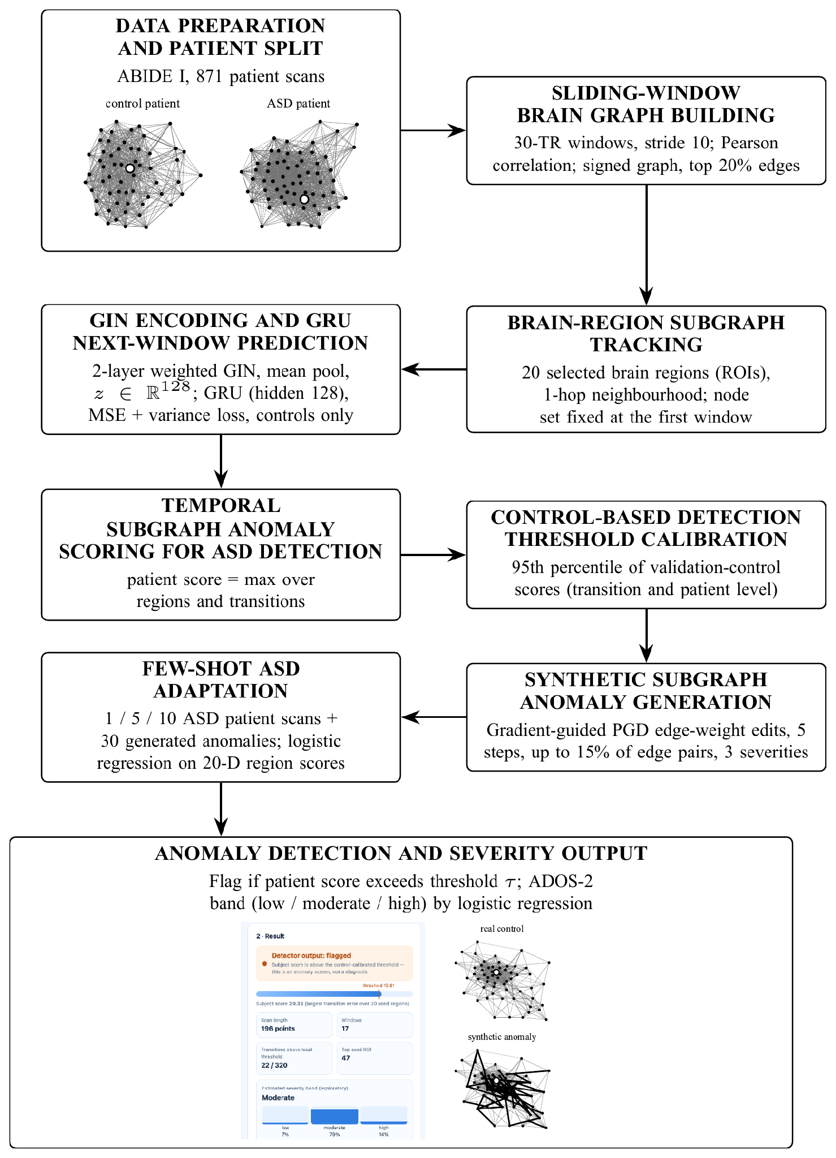
Fig. 1. Pipeline description in nine steps. Illustration: subgraphs of brain regions from a control subject and an ASD subject are used as input images, and output image is obtained from the real brain subgraph and its modified synthetic anomaly, edges highlighted in bold.
D. GIN Encoding and GRU Prediction
A two-layer graph isomorphism network (GIN) [24] transforms each subgraph into a vector of 128 numbers. A GRU [25] examines the vectors until window t and predicts the vector at window t + 1. Both of them are trained simultaneously only on control scans. The loss is the prediction error along with the small penalty that prevents all the vectors from becoming identical [26]. We use the PyTorch [27] and the PyTorch Geometric [28].
E. Temporal Subgraph Anomaly Scoring
The anomaly score of a subgraph at step t is the difference between the predicted vector and the actual vector, which is given by the following equation At = ||zt+1 − ẑt+1||. A larger value indicates that the subgraph changed in an unpredictable manner compared to the normal control scans. The anomaly score of a person corresponds to the highest value At among all the 20 regions and time steps.
F. Calibration of the threshold based on control
The threshold is set at the 95% percentile of the control scan results provided from the validation samples. We must utilize one threshold value for the steps likewise one for the individual. The individual threshold with the step alone was enough to identify all the test subjects. The reason being that an individual performs around 280 steps and 5% of the test subjects are able to go beyond the step threshold even by mistake. It was only after we conducted all the tests that we realised this so the analysis of precision, recall and F1 cannot be said to be completely blind; AUROC remains unaffected.
G. Generation of synthetic anomalies
In case of the actual control subgraph we make adjustments to the existing weights. We assess how significant change each weight would bring which allows us to keep those weights that seem most important (up to 15% of the weights). Afterwards we change the weights in 5 small steps in the direction of increasing the error [18], [19]. The weights remain at the range of −1 to 1, no new connections are established or no connections removed. Severity (0.25, 0.55, 0.9) shows how many connections and how much change is introduced.
H. Few-shot Adaptation
The model remains unchanged. Every individual is assessed through 20 different digits. As such, we proceed with training logistic regression with either 1, 5 or 10 of the actual ASD scans counted as positive examples, 30 synthetic anomalies counted as additional positives, and the 328 zeros as negatives. This procedure is done for at least five different samples of ASD scans, while comparing the results of three setups; only real ASD scans, plus synthetic anomalies guided by our real scans, and including random synthetic anomalies.
I. Detection and Severity Assessment
Individuals are considered marked if their score exceeds our threshold. For all marked individuals, we provide severity estimates based on the ADOS-2 severity score (1-10); low (≤5), moderate (6-7) or high (≥8). This categorization is done by us and is not done according to DSM-5. The scores are available for 193 out of 403 individuals diagnosed with ASD. The scans corresponding to each of these people were linked by reapplying the quality filter mentioned in the data release; the numbers matched in all 20 sites, though the numbers themselves remain the same.
IV. EXPERIMENTAL SETUP
The first table shows the settings. No particular tuning was done: all the settings were pre-defined, and the check point yielding the best validation loss (epoch 4 out of 5) was employed in the experiments. Testing data were only used for the final evaluation. AUROC and AUPRC which are independent from any threshold are reported, along with precision, recall and F1 for the selected threshold. The uncertainty is defined as a 95 percent bootstrap interval based on 2000 resamples and permutation test based on 5000 shuffles. Results in few-shot settings are the mean and standard deviation of results from five experiments that share a single test set. Finally, the F1 of a random classifier is calculated for sharing the same proportion of flagged individuals: F1chance = 2πq/(π + q), where π = 0.466 is the proportion of ASD individuals in the testing set.
TABLE I. Main settings.
Item | Setting
Windows | 30 time points, step 10; top 20% edges
Tracked regions | 20, one-hop neighbours, fixed set
GIN / GRU | 2 layers, hidden 64, output 128 / hidden 128
Training | Adam, rate 0.001, batch 16, 5 epochs, controls only
Threshold | 95th percentile, validation controls
Generator | 5 steps, ≤15% edges, 3 severities
Few-shot | Logistic regression, 1/5/10 scans + 30 synthetic
Hardware | Apple-silicon laptop (training 300 s)
V. RESULTS
A. Detector
A total of 131 test subjects were used, of which only 4 were flagged by the detector but only 2 were correct. The calculated performance measures of the detector were as follow: precision 0.500, recall 0.033, F1 0.062 and accuracy 53.4%. The AUROC value was found to be 0.453 (95% CI 0.353-0.552, permutation p = 0.35). The AUPRC value was found to be 0.467, which is equal to the chance level of detection of 0.466.
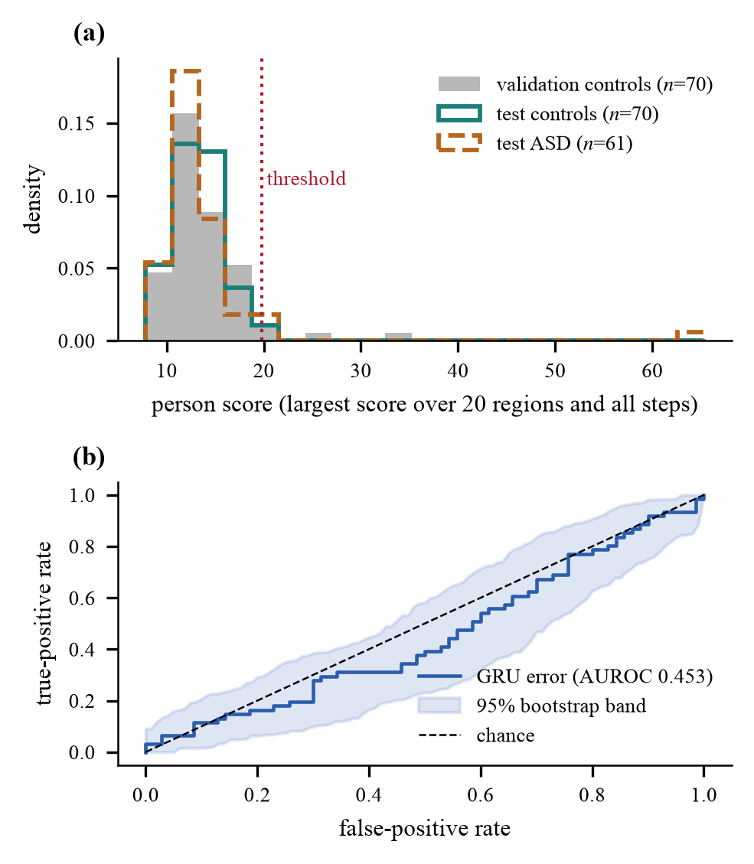
Fig. 2. presents the detector outcomes regarding the 131 subjects tested. (a) shows the results of validations, tests of controls, and tests performed on people suffering from ASD (Autism Spectrum Disorder) with the threshold fixed at 19.81. (b) presents ROC curves which were achieved with 95% bootstrap samples, showing a chance line showing the chances of being correct.
B. Does modelling time help? (RQ1)
Table II presents a comparison of three evaluation scores calculated by the same frozen encoder: the distance from the control mean (static), the difference from the prior window (persistence) and our GRU error. The presented values show that all have AUROC scores in the range of 0.45 - 0.49 with overlapping intervals. This means that temporal modeling has not brought any significant effect. The encoder was trained with the GRU, so the baselines are not completely independent.
TABLE II. Scoring methods on the test set.
Score | AUROC [95% CI] | p | F1 | Flagged
Static | 0.452 [0.356, 0.553] | 0.34 | 0.143 | 9
Persistence | 0.485 [0.380, 0.582] | 0.78 | 0.062 | 4
GRU (ours) | 0.453 [0.353, 0.552] | 0.35 | 0.062 | 4
C. Synthetic anomalies (RQ2)
A total of 7,200 synthetic records (60 control subjects × 20 locations × 3 intensities × 2 types of processing) were produced without breaking any rules. The average score increased from 4.0 to 7.6 through the edited version while the average score when edits were made randomly was around 2.9. At the highest severity, 45.8% of the guided records passed the step threshold, while only 4.8% of random edits did (Fig 3); in contrast, actual control subjects and actual ASD ones crossed the step line in 5.0% and 4.9% of cases, respectively. This is to be expected, as exactly the same model performed both types of processing. Thus it is established that the generator does not produce random noise, nor that the anomalies appear to display autism.
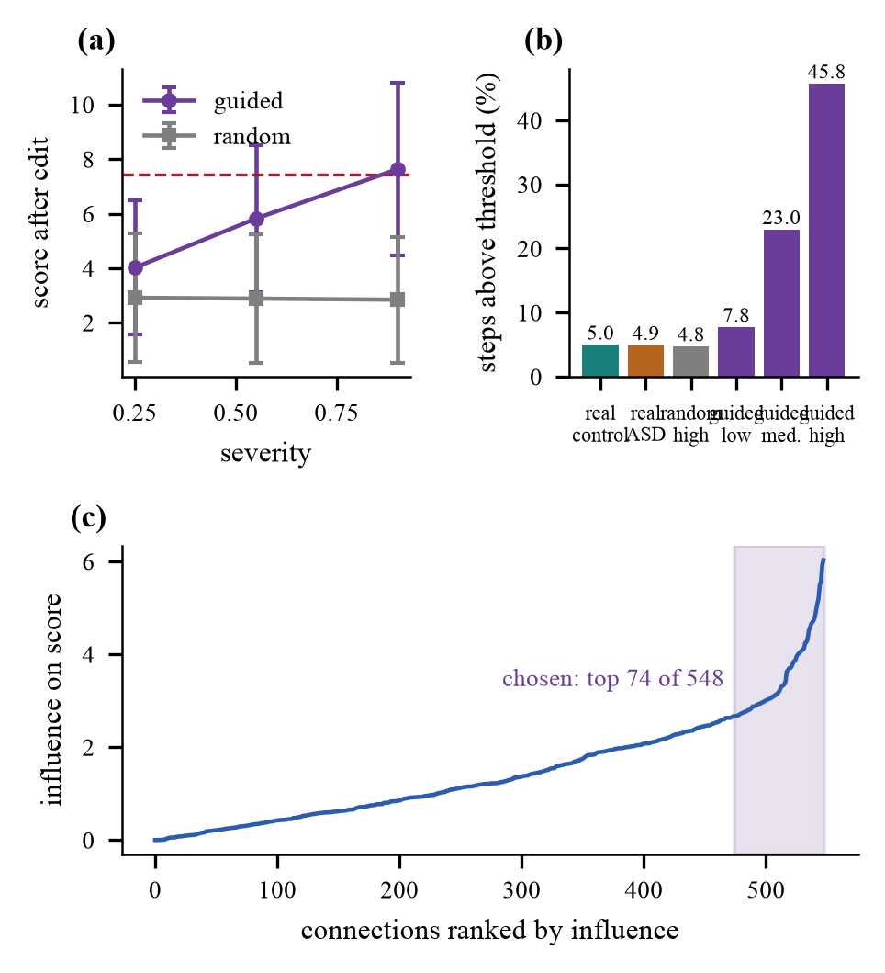
Fig. 3. Synthetic anomalies. (a) Score after modification against severity level. (b) Number of steps over the step threshold. (c) Effect of the connections in the case, i.e., 74 selected out of the total 548.
D. Few-shot adaptation (RQ2)
The results of the few-shot experiments are summarized in Table III and illustrated in Fig. 4. The few-shot classification with one ASD scan gives a very low F1 score of 0.006, as almost no one is flagged. However, when 30 synthetic anomalies are added, the one-shot F1 score increases considerably to about 0.39–0.40. Nevertheless, the AUROC scores remain close to 0.50 in each case. These classifiers flag approximately 35–39% of people and have a corresponding F1 score of 0.40–0.42. In this case it should be noted that the increased F1 score is due to a larger number of people being flagged rather than the classifier performing better in rank ordering the anomalies. Random and guided synthetic anomalies yield a similar performance.
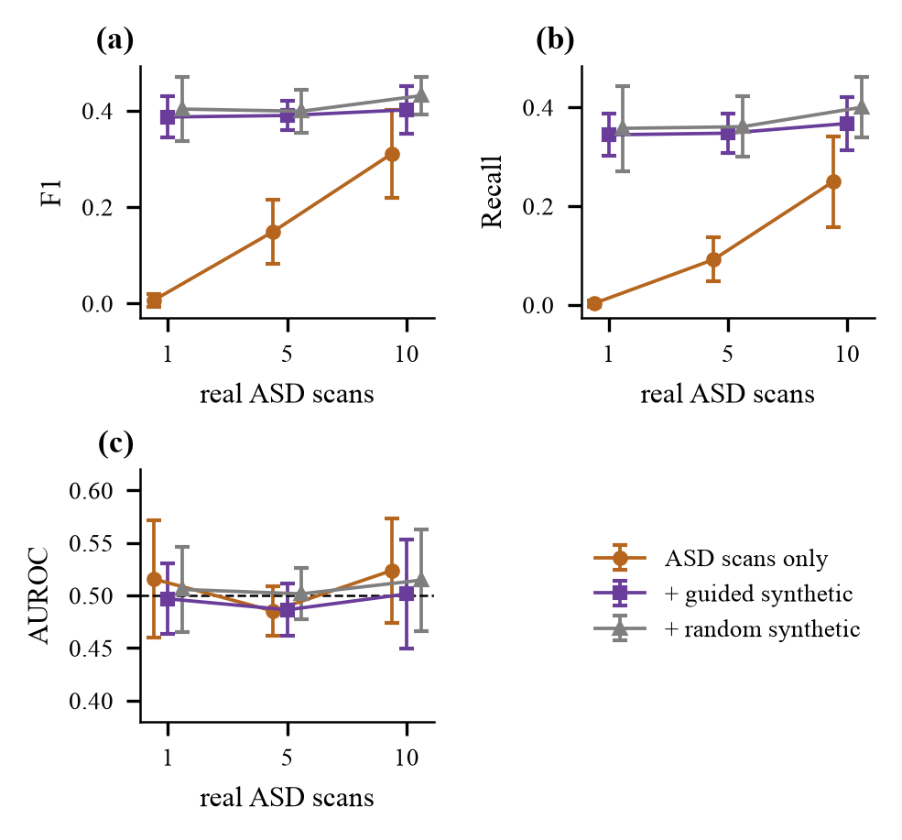
Fig. 4. Few-shot results (mean ± SD, five draws): (a) F1, (b) recall, (c) AUROC. F1 and recall rise with synthetic anomalies, but AUROC stays near chance (0.5).
TABLE III. Few-shot results (mean ± SD, five draws). SA = guided synthetic anomalies, R = random.
Shots | Training set | F1 | AUROC | Flag | Chance F1
1 | ASD only | 0.006±0.01 | 0.516±0.06 | – | –
 | + SA | 0.387±0.04 | 0.497±0.03 | 0.36 | 0.41
 | + R | 0.403±0.07 | 0.506±0.04 | 0.35 | 0.40
5 | ASD only | 0.149±0.07 | 0.485±0.02 | 0.10 | 0.16
 | + SA | 0.390±0.03 | 0.486±0.03 | 0.36 | 0.41
 | + R | 0.399±0.05 | 0.502±0.02 | 0.37 | 0.41
10 | ASD only | 0.311±0.09 | 0.524±0.05 | 0.26 | 0.33
 | + SA | 0.402±0.05 | 0.501±0.05 | 0.38 | 0.42
 | + R | 0.431±0.04 | 0.515±0.05 | 0.39 | 0.42
E. Severity estimation (RQ3)
In the case of the 60 ASD individuals who did not participate in the training process, the accuracy of predicting severity was found to be 43.3%, as opposed to merely saying “high,” which could yield a better score of 55.0% (See Table IV). Cross-validation proved that for the whole group of 193 individuals the accuracy dropped to 39.1% against 43.0%. The relationship between the estimated severity scores and true severity measurement was very weak (Spearman 0.13, p=0.32) indicating that the score may not provide any essential information.
TABLE IV. Severity band estimation (three classes).
Evaluation | n | Accuracy | Macro-F1 | Majority
Held-out ASD | 60 | 0.433 | 0.395 | 0.550
5-fold CV ×10 | 193 | 0.391 | 0.372 | 0.430
F. Demo application
We developed a web app that operates on the user's computer. The user uploads a time series dataset of 360 independent regions and receives the detector's output and the severity band, if there is one. In the case of twenty randomized test files (ten files with normal data and ten with abnormal data, none of which were selected based on the output of the model), the detector's performance was correct for eleven test files while one file was flagged.
VI. DISCUSSION AND LIMITATIONS
Although the training of the pipeline is successful and the generator functions correctly, the system fails to find ASD. Various hypotheses can explain that: 1) low signal; 2) great variation of ASD; 3) site effects [8]; 4) multitude of noise and effects [10]; and 5) 20 out of 360 features used. The following limitations can be highlighted: one training run; two prespecified design decisions (individual cutting threshold and set of 20 features) are obtained after observations of their performance; there was no testing next to other sites; there is no baseline analysis through the whole graph, nor another encoders and sliding windows tests; linking severity presumes a certain order; synthetic anomalies were tested against the same model only.
VII. CONCLUSION
We constructed and evaluated a pipeline that tracks small brain subgraphs through time, identifies unexpected shifts, generates artificial anomalies, and adjusts itself through some ASD scans. The generator functions well, but the detector performs at random on ABIDE I (AUROC 0.453); benefits from little data in terms of F1 score stem from flagging more people and cannot assess severity based on scores. The following steps will include full-graph and other-encoder baseline performances, cross-site tests, sweep over window and threshold values, multiple training runs, and verification of anomalies generated with an independent model.
REFERENCES
[1]E. Bullmore and O. Sporns, “Complex brain networks: Graph theoretical analysis of structural and functional systems,” Nat. Rev. Neurosci., vol. 10, no. 3, pp. 186–198, Mar. 2009, doi: 10.1038/nrn2575.
[2]S. M. Smith et al., “Network modelling methods for FMRI,” NeuroImage, vol. 54, no. 2, pp. 875–891, Jan. 2011, doi: 10.1016/j.neuroimage.2010.08.063.
[3]S. Parisot et al., “Disease prediction using graph convolutional networks: Application to autism spectrum disorder and Alzheimer's disease,” Med. Image Anal., vol. 48, pp. 117–130, Aug. 2018, doi: 10.1016/j.media.2018.06.001.
[4]X. Li et al., “BrainGNN: Interpretable brain graph neural network for fMRI analysis,” Med. Image Anal., vol. 74, Art. no. 102233, Dec. 2021, doi: 10.1016/j.media.2021.102233.
[5]H. Cui et al., “BrainGB: A benchmark for brain network analysis with graph neural networks,” IEEE Trans. Med. Imag., vol. 42, no. 2, pp. 493–506, Feb. 2023, doi: 10.1109/TMI.2022.3218745.
[6]X. Kan, W. Dai, H. Cui, Z. Zhang, Y. Guo, and C. Yang, “Brain network transformer,” in Adv. Neural Inf. Process. Syst. (NeurIPS), vol. 35, 2022.
[7]A. Abraham et al., “Deriving reproducible biomarkers from multi-site resting-state data: An autism-based example,” NeuroImage, vol. 147, pp. 736–745, Feb. 2017, doi: 10.1016/j.neuroimage.2016.10.045.
[8]M. Yu et al., “Statistical harmonization corrects site effects in functional connectivity measurements from multi-site fMRI data,” Hum. Brain Mapp., vol. 39, no. 11, pp. 4213–4227, Nov. 2018, doi: 10.1002/hbm.24241.
[9]E. A. Allen, E. Damaraju, S. M. Plis, E. B. Erhardt, T. Eichele, and V. D. Calhoun, “Tracking whole-brain connectivity dynamics in the resting state,” Cereb. Cortex, vol. 24, no. 3, pp. 663–676, Mar. 2014, doi: 10.1093/cercor/bhs352.
[10]R. M. Hutchison et al., “Dynamic functional connectivity: Promise, issues, and interpretations,” NeuroImage, vol. 80, pp. 360–378, Oct. 2013, doi: 10.1016/j.neuroimage.2013.05.079.
[11]B.-H. Kim, J. C. Ye, and J.-J. Kim, “Learning dynamic graph representation of brain connectome with spatio-temporal attention,” in Adv. Neural Inf. Process. Syst. (NeurIPS), vol. 34, 2021, arXiv:2105.13495.
[12]S. Gadgil, Q. Zhao, A. Pfefferbaum, E. V. Sullivan, E. Adeli, and K. M. Pohl, “Spatio-temporal graph convolution for resting-state fMRI analysis,” in Med. Image Comput. Comput.-Assist. Intervent. (MICCAI), 2020, pp. 528–538, doi: 10.1007/978-3-030-59728-3_52.
[13]X. Ma et al., “A comprehensive survey on graph anomaly detection with deep learning,” IEEE Trans. Knowl. Data Eng., vol. 35, no. 12, pp. 12012–12038, Dec. 2023, doi: 10.1109/TKDE.2021.3118815.
[14]K. Ding, J. Li, R. Bhanushali, and H. Liu, “Deep anomaly detection on attributed networks,” in Proc. SIAM Int. Conf. Data Mining (SDM), 2019, pp. 594–602, doi: 10.1137/1.9781611975673.67.
[15]A. Behrouz and M. Seltzer, “Anomaly detection in human brain via inductive learning on temporal multiplex networks,” in Proc. Mach. Learn. Healthcare Conf., PMLR vol. 219, 2023, pp. 50–75.
[16]S. Sadeghian, X. Li, and M. Seltzer, “HyperBrain: Anomaly detection for temporal hypergraph brain networks,” arXiv:2410.02087, Oct. 2024.
[17]K. Ding, Q. Zhou, H. Tong, and H. Liu, “Few-shot network anomaly detection via cross-network meta-learning,” in Proc. Web Conf. (WWW), 2021, pp. 2448–2456, doi: 10.1145/3442381.3449922.
[18]K. Xu et al., “Topology attack and defense for graph neural networks: An optimization perspective,” in Proc. Int. Joint Conf. Artif. Intell. (IJCAI), 2019, pp. 3961–3967, doi: 10.24963/ijcai.2019/550.
[19]A. Madry, A. Makelov, L. Schmidt, D. Tsipras, and A. Vladu, “Towards deep learning models resistant to adversarial attacks,” in Proc. Int. Conf. Learn. Represent. (ICLR), 2018, arXiv:1706.06083.
[20]A. Di Martino et al., “The autism brain imaging data exchange: Towards a large-scale evaluation of the intrinsic brain architecture in autism,” Mol. Psychiatry, vol. 19, no. 6, pp. 659–667, Jun. 2014, doi: 10.1038/mp.2013.78.
[21]M. F. Glasser et al., “A multi-modal parcellation of human cerebral cortex,” Nature, vol. 536, no. 7615, pp. 171–178, Aug. 2016, doi: 10.1038/nature18933.
[22]A. Abraham et al., “Machine learning for neuroimaging with scikit-learn,” Front. Neuroinform., vol. 8, Art. no. 14, 2014, doi: 10.3389/fninf.2014.00014.
[23]A. Brahim and N. Farrugia, “Graph Fourier transform of fMRI temporal signals based on an averaged structural connectome for the classification of neuroimaging,” Artif. Intell. Med., vol. 106, Art. no. 101870, 2020, doi: 10.1016/j.artmed.2020.101870.
[24]K. Xu, W. Hu, J. Leskovec, and S. Jegelka, “How powerful are graph neural networks?” in Proc. Int. Conf. Learn. Represent. (ICLR), 2019, arXiv:1810.00826.
[25]K. Cho et al., “Learning phrase representations using RNN encoder-decoder for statistical machine translation,” in Proc. Conf. Empirical Methods Natural Lang. Process. (EMNLP), Doha, Qatar, Oct. 2014, pp. 1724–1734, doi: 10.3115/v1/D14-1179.
[26]A. Bardes, J. Ponce, and Y. LeCun, “VICReg: Variance-invariance-covariance regularization for self-supervised learning,” in Proc. Int. Conf. Learn. Represent. (ICLR), 2022, arXiv:2105.04906.
[27]A. Paszke et al., “PyTorch: An imperative style, high-performance deep learning library,” in Adv. Neural Inf. Process. Syst. (NeurIPS), vol. 32, 2019, arXiv:1912.01703.
[28]M. Fey and J. E. Lenssen, “Fast graph representation learning with PyTorch Geometric,” in ICLR Workshop Representation Learn. Graphs Manifolds, 2019, arXiv:1903.02428.
[29]K. Gotham, A. Pickles, and C. Lord, “Standardizing ADOS scores for a measure of severity in autism spectrum disorders,” J. Autism Dev. Disord., vol. 39, no. 5, pp. 693–705, May 2009, doi: 10.1007/s10803-008-0674-3.
[30] A. S. Heinsfeld, A. R. Franco, R. C. Craddock, A. Buchweitz, and F. Meneguzzi, “Identification of autism spectrum disorder using deep learning and the ABIDE dataset,” NeuroImage Clin., vol. 17, pp. 16–23, 2018, doi: 10.1016/j.nicl.2017.08.017.
[31] S. I. Ktena et al., “Distance metric learning using graph convolutional networks: Application to functional brain networks,” in Med. Image Comput. Comput.-Assist. Intervent. (MICCAI), 2017, pp. 469–477, doi: 10.1007/978-3-319-66182-7_54.
[32] T. N. Kipf and M. Welling, “Semi-supervised classification with graph convolutional networks,” in Proc. Int. Conf. Learn. Represent. (ICLR), 2017, arXiv:1609.02907.
[33] J. Kawahara et al., “BrainNetCNN: Convolutional neural networks for brain networks; towards predicting neurodevelopment,” NeuroImage, vol. 146, pp. 1038–1049, Feb. 2017, doi: 10.1016/j.neuroimage.2016.09.046.
[34] T. Lanciano, F. Bonchi, and A. Gionis, “Explainable classification of brain networks via contrast subgraphs,” in Proc. ACM SIGKDD Int. Conf. Knowl. Discovery Data Mining (KDD), 2020, pp. 3308–3318, doi: 10.1145/3394486.3403383.
[35] M. G. Preti, T. A. Bolton, and D. Van De Ville, “The dynamic functional connectome: State-of-the-art and perspectives,” NeuroImage, vol. 160, pp. 41–54, Oct. 2017, doi: 10.1016/j.neuroimage.2016.12.061.
[36] P. Aggarwal and A. Gupta, “Multivariate graph learning for detecting aberrant connectivity of dynamic brain networks in autism,” Med. Image Anal., vol. 56, pp. 11–25, Aug. 2019, doi: 10.1016/j.media.2019.05.007.
[37] T. Chatterjee, R. Albert, S. Thapliyal, N. Azarhooshang, and B. DasGupta, “Detecting network anomalies using Forman-Ricci curvature and a case study for human brain networks,” Sci. Rep., vol. 11, no. 1, Art. no. 8121, Apr. 2021, doi: 10.1038/s41598-021-87587-z.
[38] G. Pang, C. Shen, L. Cao, and A. van den Hengel, “Deep learning for anomaly detection: A review,” ACM Comput. Surv., vol. 54, no. 2, 2022, doi: 10.1145/3439950.
[39] L. Ruff et al., “Deep one-class classification,” in Proc. Int. Conf. Mach. Learn. (ICML), PMLR vol. 80, 2018, pp. 4393–4402.
[40] R. Ma, G. Pang, L. Chen, and A. van den Hengel, “Deep graph-level anomaly detection by glocal knowledge distillation,” in Proc. ACM Int. Conf. Web Search Data Mining (WSDM), 2022, pp. 704–714, doi: 10.1145/3488560.3498473.
[41] W. Yu, W. Cheng, C. C. Aggarwal, K. Zhang, H. Chen, and W. Wang, “NetWalk: A flexible deep embedding approach for anomaly detection in dynamic networks,” in Proc. ACM SIGKDD Int. Conf. Knowl. Discovery Data Mining (KDD), 2018, pp. 2672–2681, doi: 10.1145/3219819.3220024.
[42] L. Zheng, Z. Li, J. Li, Z. Li, and J. Gao, “AddGraph: Anomaly detection in dynamic graph using attention-based temporal GCN,” in Proc. Int. Joint Conf. Artif. Intell. (IJCAI), 2019, pp. 4419–4425, doi: 10.24963/ijcai.2019/614.
[43] A. F. Marquand, I. Rezek, J. Buitelaar, and C. F. Beckmann, “Understanding heterogeneity in clinical cohorts using normative models: Beyond case-control studies,” Biol. Psychiatry, vol. 80, no. 7, pp. 552–561, Oct. 2016, doi: 10.1016/j.biopsych.2015.12.023.
[44] Y. Wang, Q. Yao, J. T. Kwok, and L. M. Ni, “Generalizing from a few examples: A survey on few-shot learning,” ACM Comput. Surv., vol. 53, no. 3, Art. no. 63, 2020, doi: 10.1145/3386252.
[45] C. Finn, P. Abbeel, and S. Levine, “Model-agnostic meta-learning for fast adaptation of deep networks,” in Proc. Int. Conf. Mach. Learn. (ICML), PMLR vol. 70, 2017, pp. 1126–1135.
[46] J. Snell, K. Swersky, and R. Zemel, “Prototypical networks for few-shot learning,” in Adv. Neural Inf. Process. Syst. (NIPS), vol. 30, 2017, arXiv:1703.05175.
[47] Y. Yang et al., “Data-efficient brain connectome analysis via multi-task meta-learning,” in Proc. ACM SIGKDD Int. Conf. Knowl. Discovery Data Mining (KDD), 2022, pp. 4743–4751, doi: 10.1145/3534678.3542680.
[48] X. Wei, K. Zhao, Y. Jiao, L. He, and Y. Zhang, “A brain graph foundation model: Pre-training and prompt-tuning across broad atlases and disorders,” arXiv:2506.02044, 2025.
[49] N. J. Dhinagar, V. Santhalingam, K. E. Lawrence, E. Laltoo, and P. M. Thompson, “Few-shot classification of autism spectrum disorder using site-agnostic meta-learning and brain MRI,” in Proc. Annu. Int. Conf. IEEE Eng. Med. Biol. Soc. (EMBC), 2023, doi: 10.1109/EMBC40787.2023.10340852.
[50] T. Zhao, X. Zhang, and S. Wang, “GraphSMOTE: Imbalanced node classification on graphs with graph neural networks,” in Proc. ACM Int. Conf. Web Search Data Mining (WSDM), 2021, pp. 833–841, doi: 10.1145/3437963.3441720.

