Few-Shot Temporal Subgraph Anomaly Detection and Structure-Aware Anomaly Generation in Functional Brain Networks for Autism Spectrum Disorder
Premanand Ghadekar  Vishwakarma Institute of Technology,  Pune, India  premanand.ghadekar@vit.edu |  | Harsh Patel  Vishwakarma Institute of Technology,  Pune, India  patel.harsh24@vit.edu |  | Tanaya Hartalekar  Vishwakarma Institute of Technology,  Pune, India  tanaya.hartalekar24@vit.edu
 | Hanil Shah  Vishwakarma Institute of Technology,  Pune, India  hanil.shah24@vit.edu |  | Shravani Dixit  Vishwakarma Institute of Technology,  Pune, India  shravani.dixit24@vit.edu

Abstract: In most instances, the technology for brain imaging (resting-state fMRI) is transformed into network analysis for every user. This technology can pick up the brain's regions at work for very short periods. Moreover, very few tagged scans exist. This research introduces a model that is able to observe microregions' behavior in the brain network, and base its idea of abnormality deriving from the controls only. An abnormally functioning region is assigned a high anomaly score. This paper shows how artificial anomalies can be acquired with the help of actual controlled scans and studies whether those changes, along with some original scans, will increase the quality of classification. The artificial anomalies get properly detected (45.8% vs. 4.8% for random modifications) as the model was engaged in their creation. A slight modification made it possible to increase the F1 result without changing AUROC measures since the modifications occur frequently. The obtained severity measures did not give a better result than guessing. The research results stay open and the developed chain is now on the market. In an additional test with control scans it was shown that substructure changes get detected better than random modifications (AUROC 0.906 against 0.491).
Keywords: brain networks, anomaly detection, temporal graphs, few-shot learning, autism spectrum disorder, resting-state fMRI
I. INTRODUCTION
Resting-state fMRI (functional MRI) is a technique used for examining brain function in a motionless state. The acquired data is processed in order to construct the brain network where each of its nodes represents a specific area of the brain and the links between the nodes demonstrate the correlation between the movement of the two brain regions together. Most studies in the field of deep learning process every scan image in such a way that the final brain network model developed accommodates whether autism spectrum disorder is present or not. Reports on the public ABIDE dataset reveal that results show slight differences in research as they depend on where the examination is carried out.
It should be taken into consideration that a brain network is not a stable construct. The network can change within a second. Therefore, the networks available in the scans may hide the brain areas with abnormal activity for a few seconds. What is more, the small number of and the HR (high resolution) scans done in patients does not allow some of the neuro/verbal tests to indicate serious brain disorders.
The current study is about following these principles. The analysis includes three main study questions. The first question (RQ1) is: does modeling a timeline help with just a single scanning (random) network? The second question (RQ2) is: do synthetic and real unusual things help each other? The third question (RQ3) is: can the scores reflect the severity of autism?
The contribution consists of four parts: (1) a model that follows small brain graphs in order to find how they change; (2) a generator that uses genuine connections to create synthetic anomalies and builds benchmarks against random networks; (3) honest experiments that do not reveal the answers; (4) a demo application with 20 sample scans. This research makes no clinical claims.
II. LITERATURE REVIEW
The brain activity measures taken using fMRI can be transformed into a network form, and some techniques related to graphs can summarize brain activity in a straightforward way [1],[2]. The first works devoted to deep learning used feed connection values into traditional networks and achieved moderate precision on ABIDE [3]. Some graph-oriented models estimate the distance between brain networks thanks to graph convolution [4] that is based on the graph convolutional neural networks [5] principles. BrainNetCNN employs special filters for analysis of connectivity matrices [6]. Population graph models use each person as a node in the graph [7]. BrainGNN [8], BrainGB [9] and Brain Network Transformer [10] analyze the networks of the subjects separately.
Research in the area of sliding-window use has demonstrated that changes in connectivity occur over time [11], [12]. Literature reviews indicate many approaches to researching the dynamic connectome [13]. STAGIN utilizes a graph network to each window, hence categorizing the entire scan study [14]; that is similar to what was done in [15]. Other researchers in the dynamic network domain have focused on specific parts of the connectome considered as abnormal [16] or utilized graph curvature to determine the value of edges in the temporal networks and compare it to its normal level [17]. The aforementioned methods provide information about the groups or only one final decision per study, but do not specify which area of the brain was behaving abnormally.
Graph anomaly detection searches for strange nodes, edges, subgraphs, or graphs altogether, as reviewed in [18]. Classical scoring aims at seeing how well the model reconstructs a node [19]. The one-class methods deal with building a compact description of normal data from which the instances that deviate should be flagged [20]. Graph-level implementations of the above-stated methods exist as well [21]. For dynamic graphs, static approaches include NetWalk and AddGraph that flag unordinary edges during the evolution of the network [22],[23]. Some models for brain data trained solely on the scans of the controls and then flagged different edges and hyperedges using synthetic anomalies for testing [24],[25]. The method used here builds on this idea of using only controls because it measures the error of forecasting the subsequent condition of the traced subgraph. Normative modeling provides a similar idea in clinical studies: the distance of each individual from the healthy control source [26].
The concept of few-shot learning was discussed in [27]. Various methods in the field of meta-learning, such as MAML [28] and prototype-based techniques [29], show great degree of adaptability toward new tasks based on a few training instances. For analysing graphs, any recent presence of labelling of at least several anomalies can lead to improved identification of anomalies using cross network-based meta-learning [30]. In terms of brain studies, few-shot opportunities mostly serve supervised learning, e.g. meta-learning based on several brain connectomes [31], graph foundation models adjusted by uses of prompts [32] or few-shot categorization of individuals suffering from autism based on structural MRI [33]. This study builds on utilization of a small number of original brain scans obtained from individuals diagnosed with ASD together with instances of synthetic anomalies inside the anomaly scoring pipeline.
Additional instances for graphs have been generated by interpolation in the embedding space of rare classes [34]. The concept of changing graph edges using gradients is already familiar from the area of adversarial attacks [35], [36]. This concept applies here to create anomalies, instead of attacking a model: the modifications stay confined by the existing connection weights and get validated using a random baseline.
No earlier publication known to the authors introduces the combination of (a) tracking small brain subgraphs over time with the prediction of future steps, (b) gradient-based alteration of the connection weights in order to generate anomalies, and (c) usage of few-shot adaptation for ASD. Authors of previous works either classify all the scans, consider dynamic processes at group level, find anomalies at edges or adapt few-shot classifiers. Each of these parts exist separately.
III. METHOD
A. Data acquisition and patient separation
ABIDE I [37] was applied: 871 checked scans (403 ASD, 468 controls) collected from 20 locations. Each scan gives the mean activity measurement from 360 brain regions according to the Glasser atlas [38], collected using Nilearn [39] after being preprocessed [40]. The separation is based on individuals: 609 people go to training (328 controls and 281 ASD), 131 to validation, and 131 to testing, maintaining the ASD/control ratio. Each individual is unique for every split.
B. Brain graphs creation using the sliding-window method
Each scan is divided into 30-time-point windows with sliding of 10 points each time. In each window, correlations between each pair of regions get calculated, and the strongest 20% of connections stay, together with their sign. The result is a brain network extracted from each of the windows (from 5 to 29 windows for each scan).
C. Tracking of Brain-region Subgraph
Employing all 360 brain regions is cumbersome and does not delineate the location where an alteration occurs. Twenty regions, distributed across the brain, get selected. For each of them, the region and its immediate neighbours in the initial window form a constant set that stays followed in all subsequent windows. Only connections and their weights change. On average a subgraph consists of around 71 regions.
Figure 1 shows the pipeline. It has ten steps and ends with the severity level analysis.
DATA PREPARATION
ABIDE I, 871 scans, 360 regions; patient-level split 609 / 131 / 131
SLIDING-WINDOW BRAIN GRAPHS
30-point windows, stride 10; Pearson correlation; top 20% signed edges
SUBGRAPH TRACKING
20 brain regions with 1-hop neighbours; node set fixed at the first window
GIN ENCODING AND GRU PREDICTION
2-layer GIN gives a 128-D vector; GRU predicts the next window; controls only
ANOMALY SCORING
Prediction error per region and step; patient score = maximum
THRESHOLD CALIBRATION
95th percentile of validation-control scores (step and patient level)
ANOMALY GENERATION
Gradient-guided edge-weight edits, 5 steps, up to 15% of edge pairs
FEW-SHOT ADAPTATION
1, 5 or 10 ASD scans + 30 generated anomalies; logistic regression
ANOMALY DETECTION
Patient is flagged when the score exceeds the patient threshold
SEVERITY LEVEL ANALYSIS
Flagged patient gets an ADOS-2 band: low, moderate or high
Fig. 1. System architecture diagram.
The diagram follows the pipeline from data preparation and sliding-window graph construction through subgraph tracking, GIN and GRU modelling, anomaly scoring and threshold calibration to anomaly generation, few-shot adaptation, anomaly detection and the final severity level analysis. Each box names the step and its key setting.
D. GIN Encoding and GRU Prediction
A two-layer graph isomorphism network (GIN) [41] transforms each subgraph into a vector of 128 numbers. A GRU [42] examines the vectors until window t and predicts the vector at window t + 1. Both get trained simultaneously, only on control scans. The loss is the prediction error along with the small penalty that prevents all the vectors from becoming identical [43]. The implementation uses PyTorch [44] and PyTorch Geometric [45], and Adam [46] performs the optimization.
E. Temporal Subgraph Anomaly Scoring
The anomaly score of a subgraph at step t is the difference between the predicted vector and the actual vector, which is given by the following equation At = ||zt+1 − ẑt+1||. A larger value indicates that the subgraph changed in an unpredictable manner compared to the normal control scans. The anomaly score of a person corresponds to the highest value At among all the 20 regions and time steps.
F. Calibration of the threshold based on control
The threshold is set at the 95% percentile of the control scan results provided from the validation samples. One threshold value is needed for the steps, and one for the individual. The individual threshold with the step alone was enough to identify all the test subjects. The reason is that an individual performs around 280 steps, and 5% of the steps can exceed the step threshold even by mistake. This was realised only after all the tests had been conducted, so the analysis of precision, recall and F1 cannot be said to be completely blind; AUROC remains unaffected.
G. Generation of synthetic anomalies
In the case of the actual control subgraph, adjustments apply to the existing weights. The influence of each weight on the error is assessed, which keeps the weights that seem most important (up to 15% of the weights). Afterwards, the weights change in 5 small steps in the direction of increasing the error [35], [36]. The weights remain in the range of −1 to 1, and no new connections get established or removed. Severity (0.25, 0.55, 0.9) shows how many connections and how much change is introduced.
H. Few-shot Adaptation
The model remains unchanged. Every individual is assessed through 20 different digits. As such, logistic regression gets trained with either 1, 5 or 10 of the actual ASD scans as positive examples, 30 synthetic anomalies as additional positives, and the 328 control scans as negatives. This procedure repeats for five different samples of ASD scans, comparing three setups: only real ASD scans, real ASD scans plus guided synthetic anomalies, and real ASD scans plus random synthetic anomalies.
I. Detection and Severity Assessment
An individual counts as marked if the score exceeds the threshold. For all marked individuals, severity estimates come from the ADOS-2 severity score [47] (1-10): low (≤5), moderate (6-7) or high (≥8). This categorization is defined by the authors and does not follow DSM-5. Scores exist for 193 out of 403 individuals diagnosed with ASD. The scans corresponding to each of these people were linked by reapplying the quality filter mentioned in the data release; the numbers matched in all 20 sites, though the numbers themselves remain the same.
J. Benchmark evaluation of generated anomalies
To determine the detectability of the generated anomalies, an additional experiment involved the 70 held-out test control scans. For each scan and each of the 20 regions of interest, a window transition was selected and an edited version of it was created with a severity of 0.9, one with guided edits and the other with random edits of the same magnitude. The score before editing the transition is considered the negative example and the score after editing is considered the positive example (1,400 pairs for each method). A transition is defined as detected if its score is greater than the cut-off level of 7.43 established in the validation controls. Accuracy, precision, recall, F1 score and AUROC serve as the results of this experiment.
K. Mathematical formulation
This subsection collects the models and algorithms used in the pipeline. In a window of 30 time points, the connectivity between regions i and j follows the Pearson correlation [2]:
$r_{ij}=\frac{\sum_{t}{\left(x_{it}−{\bar{x}}_{i}\right)\left(x_{jt}−{\bar{x}}_{j}\right)}}{\sqrt{\sum_{t}{{\left(x_{it}−{\bar{x}}_{i}\right)}^{2}}\sum_{t}{{\left(x_{jt}−{\bar{x}}_{j}\right)}^{2}}}}$ (1)
Only the strongest 20% of pairs by absolute correlation stay as signed edge weights, that is, an edge exists when |r_ij| reaches the 80th percentile of the window. A weighted GIN layer [41] then aggregates the neighbours N(i) of node i with the signed weights w_ij, where ε_l is trainable and the input feature of every node is 1, and passes the result through a two-layer perceptron:
$a_{i}^{\left(l\right)}=\left(1+ε_{l}\right)h_{i}^{\left(l−1\right)}+\sum_{j∈N(i)}{w_{ij}h_{j}^{\left(l−1\right)}}$ (2)
$h_{i}^{\left(l\right)}=ReLU\left({MLP}^{\left(l\right)}\left(a_{i}^{\left(l\right)}\right)\right)$ (3)
After two layers, mean pooling over the nodes V of the subgraph and a linear projection give the 128-dimensional embedding:
$z=W_{o}\frac{1}{|V|}\sum_{i∈V}{h_{i}^{\left(2\right)}}+b_{o}$ (4)
The GRU [42] reads the embeddings z_1, ..., z_t. Its reset gate, update gate, candidate state and hidden state follow:
$r_{t}=σ\left(W_{r}z_{t}+U_{r}h_{t−1}\right)$ (5)
$u_{t}=σ\left(W_{u}z_{t}+U_{u}h_{t−1}\right)$ (6)
${h̃}_{t}=tanh\left(W_{h}z_{t}+U_{h}\left(r_{t}⊙h_{t−1}\right)\right)$ (7)
$h_{t}=\left(1−u_{t}\right)⊙h_{t−1}+u_{t}⊙{h̃}_{t}$ (8)
A linear read-out gives the predicted next embedding:
${\hat{z}}_{t+1}=W_{p}h_{t}+b_{p}$ (9)
Training minimizes the mean squared prediction error plus a variance penalty in the style of VICReg [43], which stops all embeddings from collapsing to one vector (T is the number of windows, D = 128 the embedding size and λ = 0.5). Adam [46] updates the parameters with a learning rate of 0.001:
$L_{pred}=\frac{1}{(T−1)D}\sum_{t=1}^{T−1}{{\left\|{\hat{z}}_{t+1}−z_{t+1}\right\|}^{2}}$ (10)
$L_{var}=\frac{1}{D}\sum_{d=1}^{D}{max\left(0,1−\sqrt{Var\left(z_{d}\right)+{10}^{−4}}\right)}$ (11)
$L=L_{pred}+λL_{var}$ (12)
The anomaly score of step t and the patient score S, the maximum over the tracked regions v and all steps, follow:
$A_{t}={\left\|z_{t+1}−{\hat{z}}_{t+1}\right\|}_{2}$ (13)
$S=\max_{v}\max_{t}A_{t}^{\left(v\right)}$ (14)
The step threshold and the patient threshold equal the 95th percentile of the validation-control step scores and patient scores, and a patient is flagged when S exceeds the patient threshold. For guided anomaly generation, the sensitivity of an undirected connection p (two directed edges e) is the gradient of the model error, where f is the frozen encoder:
$g_{p}=\sum_{e∈p}{\frac{∂{\left\|f(G;w)−{\hat{z}}_{t+1}\right\|}^{2}}{∂w_{e}}}$ (15)
The m connections with the largest |g_p| move in Q = 5 projected sign-gradient steps [35], [36], where α is the severity, δ_max = 0.6 and the weights stay between −1 and 1:
$w_{p}^{\left(q+1\right)}={clip}_{[−1,1]}\left(w_{p}^{\left(q\right)}+\frac{αδ_{max}}{Q}sgn\left(g_{p}^{\left(q\right)}\right)\right)$ (16)
The few-shot head is a logistic regression with balanced class weights on the 20-dimensional vector x of per-region maximum scores, fitted by weighted cross-entropy with an L2 penalty (C = 1):
$P(y=1|x)=\frac{1}{1+exp\left(−\left(β^{T}x+b\right)\right)}$ (17)
The severity estimator is a standardized multinomial logistic regression (C = 0.1) on 40 features, the per-region maximum and mean scores. Evaluation uses precision = TP/(TP + FP), recall = TP/(TP + FN), F1 = 2PR/(P + R) and AUROC, the probability that a random positive scores above a random negative. Confidence intervals come from 2000 bootstrap resamples of the test patients, p-values from 5000 label permutations, and the relation between predicted and true severity from the Spearman rank correlation.
L. Model-wise comparison protocol
To compare models, the graph encoder and the temporal predictor were exchanged while the data, the split, the loss in Eq. (12), the optimizer and the five training epochs stayed identical. The graph encoders were GIN [41], GCN [5] (neighbour weights summed without normalization, because signed weights make normalization unstable) and GraphConv [48], and the temporal predictors were GRU [42] and LSTM [49]. Every model produced its own gradients for the guided edits and its own thresholds from the validation controls. Encoders such as GAT and GraphSAGE use no scalar edge weight in their standard form and were therefore not part of the comparison.
IV. EXPERIMENTAL SETUP
The first table shows the settings. No particular tuning was done: all the settings were pre-defined, and the check point yielding the best validation loss (epoch 4 out of 5) was employed in the experiments. Testing data were only used for the final evaluation. AUROC and AUPRC, which stay independent from any threshold, get reported along with precision, recall and F1 for the selected threshold. The uncertainty is defined as a 95 percent bootstrap interval based on 2000 resamples and permutation test based on 5000 shuffles. Results in few-shot settings show the mean and standard deviation of results from five experiments that share a single test set. Finally, the F1 of a random classifier is calculated for sharing the same proportion of flagged individuals: F1chance = 2πq/(π + q), where π = 0.466 is the proportion of ASD individuals in the testing set.
TABLE I. Main settings.
Item | Setting
Windows | 30 time points, step 10; top 20% edges
Tracked regions | 20, one-hop neighbours, fixed set
GIN / GRU | 2 layers, hidden 64, output 128 / hidden 128
Training | Adam, rate 0.001, batch 16, 5 epochs, controls only
Threshold | 95th percentile, validation controls
Generator | 5 steps, ≤15% edges, 3 severities
Few-shot | Logistic regression, 1/5/10 scans + 30 synthetic
Hardware | Apple-silicon laptop (training 300 s)
V. RESULTS
A. Detector
A total of 131 test subjects were used, of which only 4 were flagged by the detector but only 2 were correct. The calculated performance measures of the detector were as follow: precision 0.500, recall 0.033, F1 0.062 and accuracy 53.4%. The AUROC value was found to be 0.453 (95% CI 0.353-0.552, permutation p = 0.35). The AUPRC value was found to be 0.467, which is equal to the chance level of detection of 0.466.
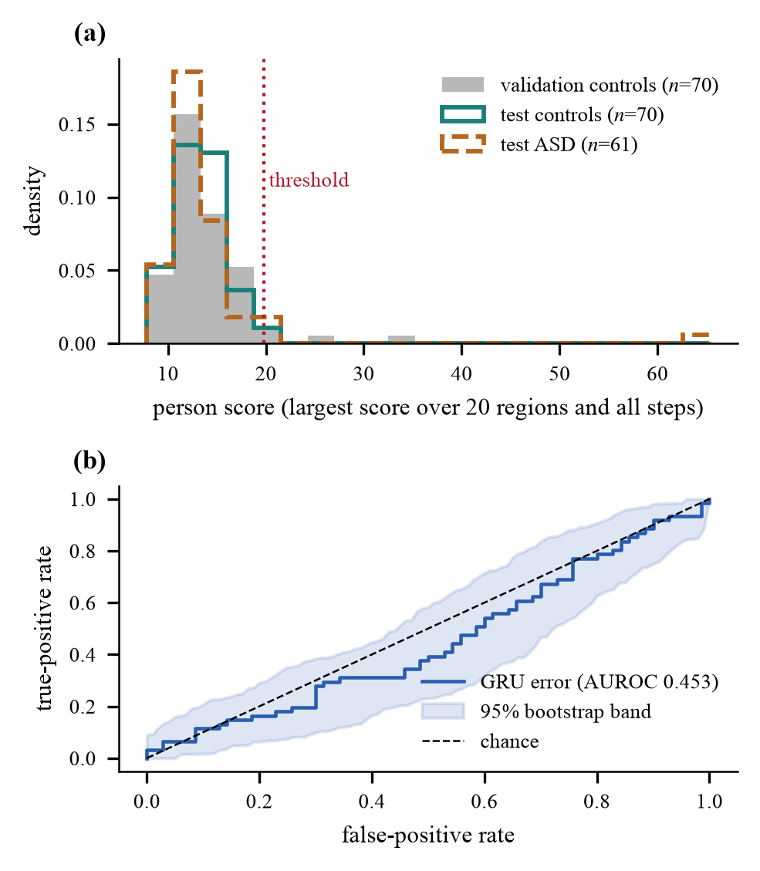
Fig. 2. Detector score distribution and ROC curve.
Panel (a) shows the patient scores of validation controls, test controls and test ASD patients against the detection threshold of 19.81; the three distributions overlap almost completely. Panel (b) shows the ROC curve with a 95% bootstrap band, which stays close to the chance line (AUROC 0.453). Together, the panels show that the detector cannot separate ASD from control scans.
B. Does modelling time help? (RQ1)
Table II presents a comparison of three evaluation scores calculated by the same frozen encoder: the distance from the control mean (static), the difference from the prior window (persistence) and the GRU error. The presented values show that all have AUROC scores in the range of 0.45 - 0.49 with overlapping intervals. This means that temporal modeling has not brought any significant effect. The encoder was trained with the GRU, so the baselines cannot count as completely independent.
TABLE II. Scoring methods on the test set.
Score | AUROC [95% CI] | p | F1 | Flagged
Static | 0.452 [0.356, 0.553] | 0.34 | 0.143 | 9
Persistence | 0.485 [0.380, 0.582] | 0.78 | 0.062 | 4
GRU (ours) | 0.453 [0.353, 0.552] | 0.35 | 0.062 | 4
C. Synthetic anomalies (RQ2)
A total of 7,200 synthetic records (60 control subjects × 20 locations × 3 intensities × 2 types of processing) were produced without breaking any rules. The average score increased from 4.0 to 7.6 through the edited version while the average score when edits were made randomly was around 2.9. At the highest severity, 45.8% of the guided records passed the step threshold, while only 4.8% of random edits did (Fig 3); in contrast, actual control subjects and actual ASD ones crossed the step line in 5.0% and 4.9% of cases, respectively. This is to be expected, as exactly the same model performed both types of processing. Thus it is established that the generator does not produce random noise, nor that the anomalies appear to display autism.
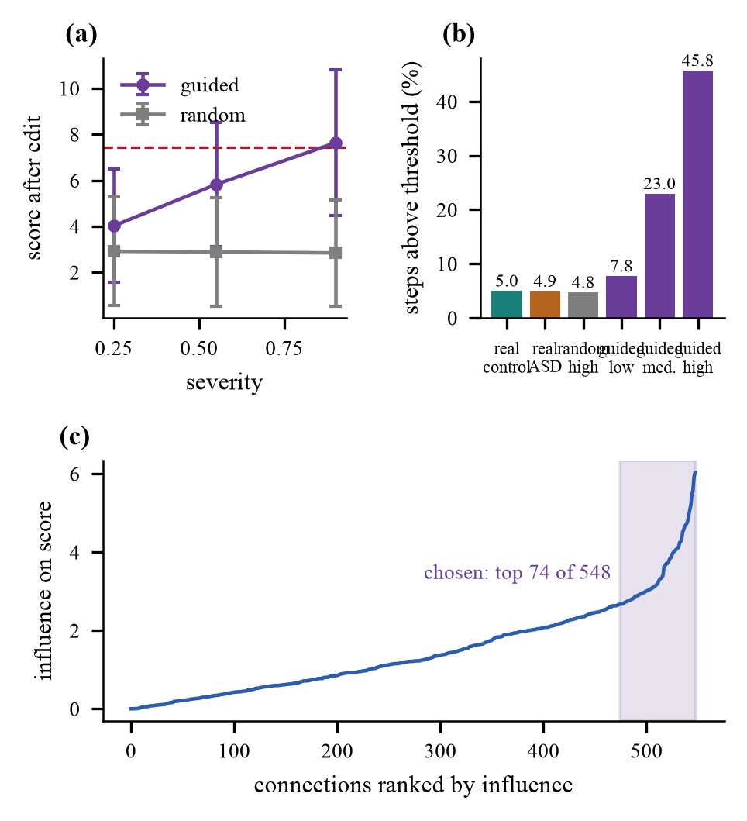
Fig. 3. Effect of guided edits on anomaly scores.
Panel (a) shows how the anomaly score rises with edit severity for guided edits but stays flat for random edits. Panel (b) gives the share of steps above the step threshold: 45.8% for guided high-severity edits against 4.8% for random edits and about 5% for real scans. Panel (c) ranks the connections by influence; the 74 chosen out of 548 mark the connections to which the model reacts most.
D. Few-shot adaptation (RQ2)
Table III summarizes the results of the few-shot experiments and Fig. 4 illustrates them. The few-shot classification with one ASD scan gives a very low F1 score of 0.006, as almost no one is flagged. However, when 30 synthetic anomalies get added, the one-shot F1 score increases considerably to about 0.39–0.40. Nevertheless, the AUROC scores remain close to 0.50 in each case. These classifiers flag approximately 35–39% of people and have a corresponding F1 score of 0.40–0.42. In this case it should be noted that the increased F1 score is due to a larger number of people being flagged rather than the classifier performing better in rank ordering the anomalies. Random and guided synthetic anomalies yield a similar performance.
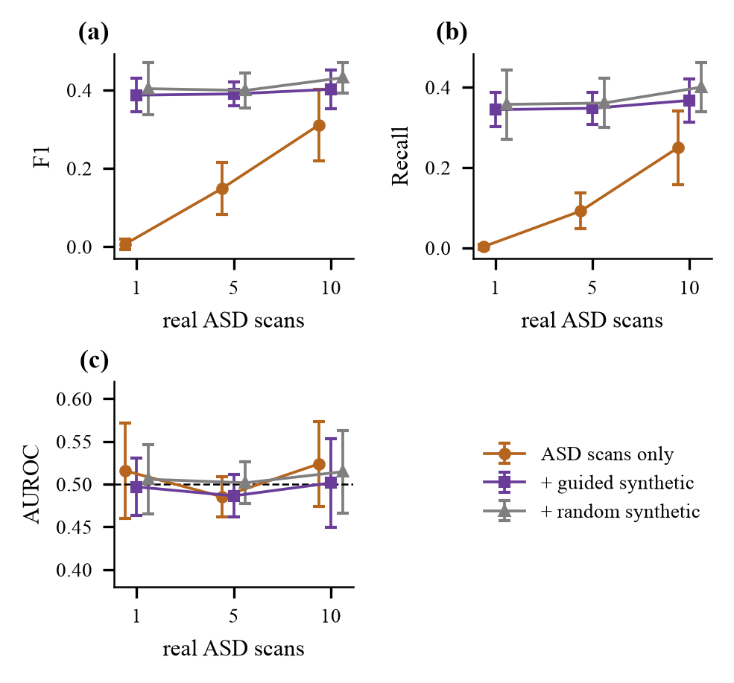
Fig. 4. Few-shot results for 1, 5 and 10 ASD scans.
Panels (a), (b) and (c) show F1, recall and AUROC for 1, 5 and 10 real ASD scans in three setups. Adding synthetic anomalies, guided or random, raises F1 and recall, while AUROC stays near the chance level of 0.5, which indicates that more patients get flagged without a better ranking.
TABLE III. Few-shot results. SA: guided, R: random.
Shots | Training set | F1 | AUROC | Flag | Chance F1
1 | ASD only | 0.006±0.01 | 0.516±0.06 | – | –
 | + SA | 0.387±0.04 | 0.497±0.03 | 0.36 | 0.41
 | + R | 0.403±0.07 | 0.506±0.04 | 0.35 | 0.40
5 | ASD only | 0.149±0.07 | 0.485±0.02 | 0.10 | 0.16
 | + SA | 0.390±0.03 | 0.486±0.03 | 0.36 | 0.41
 | + R | 0.399±0.05 | 0.502±0.02 | 0.37 | 0.41
10 | ASD only | 0.311±0.09 | 0.524±0.05 | 0.26 | 0.33
 | + SA | 0.402±0.05 | 0.501±0.05 | 0.38 | 0.42
 | + R | 0.431±0.04 | 0.515±0.05 | 0.39 | 0.42
E. Severity estimation (RQ3)
In the case of the 60 ASD individuals who did not participate in the training process, the accuracy of predicting severity was found to be 43.3%, as opposed to merely saying “high,” which could yield a better score of 55.0% (See Table IV). Cross-validation proved that for the whole group of 193 individuals the accuracy dropped to 39.1% against 43.0%. The relationship between the estimated severity scores and true severity measurement was very weak (Spearman 0.13, p=0.32) indicating that the score may not provide any essential information.
TABLE IV. Severity band estimation (three classes).
Evaluation | n | Accuracy | Macro-F1 | Majority
Held-out ASD | 60 | 0.433 | 0.395 | 0.550
5-fold CV ×10 | 193 | 0.391 | 0.372 | 0.430
F. Demo application
A web app that operates on the user's computer was developed. The user uploads a time series dataset of 360 independent regions and receives the detector's output and the severity band, if there is one. In the case of twenty randomized test files (ten files with normal data and ten with abnormal data, none of which were selected based on the output of the model), the detector's performance was correct for eleven test files while one file was flagged.
G. Identification of produced anomalies
Table V presents the results. The detection of guided sub-structure edits is significantly higher than of random edits in terms of accuracy: 70.2% versus 50.0%, precision: 0.902 versus 0.500, recall: 0.454 versus 0.049, F1 score: 0.604 versus 0.090, and AUROC: 0.906 versus 0.491. Random edits of similar volume stay largely undetected, while guided editing raised the mean transition score from 2.94 to 7.62. Thus, it can be concluded that effective detection of anomalies requires making use of sensitivity of the machine learning model being utilized. Since the model taking part in making the edit decisions is also in charge of scoring during the process, this test demonstrates visibility of the generated anomaly, rather than ASD diagnosis.
TABLE V. Detection of generated anomalies.
Approach | Accuracy | Precision | Recall | F1 | AUROC
Random | 50.0% | 0.500 | 0.049 | 0.090 | 0.491
Sub-structure | 70.2% | 0.902 | 0.454 | 0.604 | 0.906
H. Model-wise comparison
Table VI compares encoder and predictor combinations trained under identical conditions. For every model the table lists the ASD detection AUROC and accuracy on the 131 test patients and, for the 1,400 generated edits per method, the accuracy and AUROC of guided edits and the AUROC of random edits. The proposed GIN + GRU reaches an accuracy of 70.2% and an AUROC of 0.906 on guided edits. The other models reach: GCN + GRU reaches 59.1% and 0.718; GraphConv + GRU reaches 64.1% and 0.855; GIN + LSTM reaches 69.5% and 0.901. GIN + GRU gives the highest guided-edit AUROC, followed closely by GIN + LSTM, while GCN + GRU gives the lowest, which supports the choice of GIN as the graph encoder. All models give ASD detection AUROC values near the chance level of 0.5, and random edits stay near 0.5 for every model.
TABLE VI. Model-wise comparison.
Model | ASD AUROC | ASD Acc. | Guided Acc. | Guided AUROC | Random AUROC
GIN + GRU | 0.453 | 53.4% | 70.2% | 0.906 | 0.491
GCN + GRU | 0.494 | 55.0% | 59.1% | 0.718 | 0.494
GraphConv + GRU | 0.479 | 52.7% | 64.1% | 0.855 | 0.499
GIN + LSTM | 0.442 | 56.5% | 69.5% | 0.901 | 0.503

VI. DISCUSSION AND LIMITATIONS
Despite the fact that the pipeline conducts training successfully and the generator is working appropriately, the detection of ASD turns out to be ineffective. Some possible reasons behind that include: 1) low signal; 2) huge variability of ASD; 3) site effects [50]; 4) noise and other effects [12]; and 5) the application of 20 features out of the total 360 ones. The following limitations could be listed: the training was conducted only once; both selected design decisions (the individual cutting threshold and the selection of 20 features) were chosen based on results and not earlier; there were no explorations at any other sites; baseline comparisons were not done for the whole graph, and sliding window tests were not performed; severity linking presumes a specific order. In the additional test on the reserved control scans, guided edits compared to random ones demonstrated much better performance (AUROC of 0.906 against 0.491); it still shows that the scorer and the generator utilize the common model and does not guarantee effectiveness in ASD detection.
VII. CONCLUSION
The pipeline effectively traces the behavior of minor brain subgraphs over time, captures significant changes, produces artificial incidents, and modifies itself using Autism Spectrum Disorder (ASD) scans. While the generator aspect of the pipeline is relatively successful, the detection component shows random behavior when tested on the ABIDE I dataset (AUROC 0.453), which was anticipated because of the small number of indicators related to the F1 score. Future steps will involve analyzing the performance of full-graph baselines, conducting cross-site experiments, sweeping window and threshold parameters across multiple training runs. Guided sub-structure modifications yield much better results when identifying alterations than random changes of the same size (AUROC 0.906 vs. 0.491 on held-out control images).
REFERENCES
[1] E. Bullmore and O. Sporns, “Complex brain networks: Graph theoretical analysis of structural and functional systems,” Nat. Rev. Neurosci., vol. 10, no. 3, pp. 186–198, Mar. 2009, doi: 10.1038/nrn2575.
[2] S. M. Smith et al., “Network modelling methods for FMRI,” NeuroImage, vol. 54, no. 2, pp. 875–891, Jan. 2011, doi: 10.1016/j.neuroimage.2010.08.063.
[3] A. S. Heinsfeld, A. R. Franco, R. C. Craddock, A. Buchweitz, and F. Meneguzzi, “Identification of autism spectrum disorder using deep learning and the ABIDE dataset,” NeuroImage Clin., vol. 17, pp. 16–23, 2018, doi: 10.1016/j.nicl.2017.08.017.
[4] S. I. Ktena et al., “Distance metric learning using graph convolutional networks: Application to functional brain networks,” in Med. Image Comput. Comput.-Assist. Intervent. (MICCAI), 2017, pp. 469–477, doi: 10.1007/978-3-319-66182-7_54.
[5] T. N. Kipf and M. Welling, “Semi-supervised classification with graph convolutional networks,” in Proc. Int. Conf. Learn. Represent. (ICLR), 2017, arXiv:1609.02907.
[6] J. Kawahara et al., “BrainNetCNN: Convolutional neural networks for brain networks; towards predicting neurodevelopment,” NeuroImage, vol. 146, pp. 1038–1049, Feb. 2017, doi: 10.1016/j.neuroimage.2016.09.046.
[7] S. Parisot et al., “Disease prediction using graph convolutional networks: Application to autism spectrum disorder and Alzheimer's disease,” Med. Image Anal., vol. 48, pp. 117–130, Aug. 2018, doi: 10.1016/j.media.2018.06.001.
[8] X. Li et al., “BrainGNN: Interpretable brain graph neural network for fMRI analysis,” Med. Image Anal., vol. 74, Art. no. 102233, Dec. 2021, doi: 10.1016/j.media.2021.102233.
[9] H. Cui et al., “BrainGB: A benchmark for brain network analysis with graph neural networks,” IEEE Trans. Med. Imag., vol. 42, no. 2, pp. 493–506, Feb. 2023, doi: 10.1109/TMI.2022.3218745.
[10] X. Kan, W. Dai, H. Cui, Z. Zhang, Y. Guo, and C. Yang, “Brain network transformer,” in Adv. Neural Inf. Process. Syst. (NeurIPS), vol. 35, 2022.
[11] E. A. Allen, E. Damaraju, S. M. Plis, E. B. Erhardt, T. Eichele, and V. D. Calhoun, “Tracking whole-brain connectivity dynamics in the resting state,” Cereb. Cortex, vol. 24, no. 3, pp. 663–676, Mar. 2014, doi: 10.1093/cercor/bhs352.
[12] R. M. Hutchison et al., “Dynamic functional connectivity: Promise, issues, and interpretations,” NeuroImage, vol. 80, pp. 360–378, Oct. 2013, doi: 10.1016/j.neuroimage.2013.05.079.
[13] M. G. Preti, T. A. Bolton, and D. Van De Ville, “The dynamic functional connectome: State-of-the-art and perspectives,” NeuroImage, vol. 160, pp. 41–54, Oct. 2017, doi: 10.1016/j.neuroimage.2016.12.061.
[14] B.-H. Kim, J. C. Ye, and J.-J. Kim, “Learning dynamic graph representation of brain connectome with spatio-temporal attention,” in Adv. Neural Inf. Process. Syst. (NeurIPS), vol. 34, 2021, arXiv:2105.13495.
[15] S. Gadgil, Q. Zhao, A. Pfefferbaum, E. V. Sullivan, E. Adeli, and K. M. Pohl, “Spatio-temporal graph convolution for resting-state fMRI analysis,” in Med. Image Comput. Comput.-Assist. Intervent. (MICCAI), 2020, pp. 528–538, doi: 10.1007/978-3-030-59728-3_52.
[16] P. Aggarwal and A. Gupta, “Multivariate graph learning for detecting aberrant connectivity of dynamic brain networks in autism,” Med. Image Anal., vol. 56, pp. 11–25, Aug. 2019, doi: 10.1016/j.media.2019.05.007.
[17] T. Chatterjee, R. Albert, S. Thapliyal, N. Azarhooshang, and B. DasGupta, “Detecting network anomalies using Forman-Ricci curvature and a case study for human brain networks,” Sci. Rep., vol. 11, no. 1, Art. no. 8121, Apr. 2021, doi: 10.1038/s41598-021-87587-z.
[18] G. Pang, C. Shen, L. Cao, and A. van den Hengel, “Deep learning for anomaly detection: A review,” ACM Comput. Surv., vol. 54, no. 2, 2022, doi: 10.1145/3439950.
[19] K. Ding, J. Li, R. Bhanushali, and H. Liu, “Deep anomaly detection on attributed networks,” in Proc. SIAM Int. Conf. Data Mining (SDM), 2019, pp. 594–602, doi: 10.1137/1.9781611975673.67.
[20] L. Ruff et al., “Deep one-class classification,” in Proc. Int. Conf. Mach. Learn. (ICML), PMLR vol. 80, 2018, pp. 4393–4402.
[21] R. Ma, G. Pang, L. Chen, and A. van den Hengel, “Deep graph-level anomaly detection by glocal knowledge distillation,” in Proc. ACM Int. Conf. Web Search Data Mining (WSDM), 2022, pp. 704–714, doi: 10.1145/3488560.3498473.
[22] W. Yu, W. Cheng, C. C. Aggarwal, K. Zhang, H. Chen, and W. Wang, “NetWalk: A flexible deep embedding approach for anomaly detection in dynamic networks,” in Proc. ACM SIGKDD Int. Conf. Knowl. Discovery Data Mining (KDD), 2018, pp. 2672–2681, doi: 10.1145/3219819.3220024.
[23] L. Zheng, Z. Li, J. Li, Z. Li, and J. Gao, “AddGraph: Anomaly detection in dynamic graph using attention-based temporal GCN,” in Proc. Int. Joint Conf. Artif. Intell. (IJCAI), 2019, pp. 4419–4425, doi: 10.24963/ijcai.2019/614.
[24] A. Behrouz and M. Seltzer, “Anomaly detection in human brain via inductive learning on temporal multiplex networks,” in Proc. Mach. Learn. Healthcare Conf., PMLR vol. 219, 2023, pp. 50–75.
[25] S. Sadeghian, X. Li, and M. Seltzer, “HyperBrain: Anomaly detection for temporal hypergraph brain networks,” arXiv:2410.02087, Oct. 2024.
[26] A. F. Marquand, I. Rezek, J. Buitelaar, and C. F. Beckmann, “Understanding heterogeneity in clinical cohorts using normative models: Beyond case-control studies,” Biol. Psychiatry, vol. 80, no. 7, pp. 552–561, Oct. 2016, doi: 10.1016/j.biopsych.2015.12.023.
[27] Y. Wang, Q. Yao, J. T. Kwok, and L. M. Ni, “Generalizing from a few examples: A survey on few-shot learning,” ACM Comput. Surv., vol. 53, no. 3, Art. no. 63, 2020, doi: 10.1145/3386252.
[28] C. Finn, P. Abbeel, and S. Levine, “Model-agnostic meta-learning for fast adaptation of deep networks,” in Proc. Int. Conf. Mach. Learn. (ICML), PMLR vol. 70, 2017, pp. 1126–1135.
[29] J. Snell, K. Swersky, and R. Zemel, “Prototypical networks for few-shot learning,” in Adv. Neural Inf. Process. Syst. (NIPS), vol. 30, 2017, arXiv:1703.05175.
[30] K. Ding, Q. Zhou, H. Tong, and H. Liu, “Few-shot network anomaly detection via cross-network meta-learning,” in Proc. Web Conf. (WWW), 2021, pp. 2448–2456, doi: 10.1145/3442381.3449922.
[31] Y. Yang et al., “Data-efficient brain connectome analysis via multi-task meta-learning,” in Proc. ACM SIGKDD Int. Conf. Knowl. Discovery Data Mining (KDD), 2022, pp. 4743–4751, doi: 10.1145/3534678.3542680.
[32] X. Wei, K. Zhao, Y. Jiao, L. He, and Y. Zhang, “A brain graph foundation model: Pre-training and prompt-tuning across broad atlases and disorders,” arXiv:2506.02044, 2025.
[33] N. J. Dhinagar, V. Santhalingam, K. E. Lawrence, E. Laltoo, and P. M. Thompson, “Few-shot classification of autism spectrum disorder using site-agnostic meta-learning and brain MRI,” in Proc. Annu. Int. Conf. IEEE Eng. Med. Biol. Soc. (EMBC), 2023, doi: 10.1109/EMBC40787.2023.10340852.
[34] T. Zhao, X. Zhang, and S. Wang, “GraphSMOTE: Imbalanced node classification on graphs with graph neural networks,” in Proc. ACM Int. Conf. Web Search Data Mining (WSDM), 2021, pp. 833–841, doi: 10.1145/3437963.3441720.
[35] K. Xu et al., “Topology attack and defense for graph neural networks: An optimization perspective,” in Proc. Int. Joint Conf. Artif. Intell. (IJCAI), 2019, pp. 3961–3967, doi: 10.24963/ijcai.2019/550.
[36] A. Madry, A. Makelov, L. Schmidt, D. Tsipras, and A. Vladu, “Towards deep learning models resistant to adversarial attacks,” in Proc. Int. Conf. Learn. Represent. (ICLR), 2018, arXiv:1706.06083.
[37] A. Di Martino et al., “The autism brain imaging data exchange: Towards a large-scale evaluation of the intrinsic brain architecture in autism,” Mol. Psychiatry, vol. 19, no. 6, pp. 659–667, Jun. 2014, doi: 10.1038/mp.2013.78.
[38] M. F. Glasser et al., “A multi-modal parcellation of human cerebral cortex,” Nature, vol. 536, no. 7615, pp. 171–178, Aug. 2016, doi: 10.1038/nature18933.
[39] A. Abraham et al., “Machine learning for neuroimaging with scikit-learn,” Front. Neuroinform., vol. 8, Art. no. 14, 2014, doi: 10.3389/fninf.2014.00014.
[40] A. Brahim and N. Farrugia, “Graph Fourier transform of fMRI temporal signals based on an averaged structural connectome for the classification of neuroimaging,” Artif. Intell. Med., vol. 106, Art. no. 101870, 2020, doi: 10.1016/j.artmed.2020.101870.
[41] K. Xu, W. Hu, J. Leskovec, and S. Jegelka, “How powerful are graph neural networks?” in Proc. Int. Conf. Learn. Represent. (ICLR), 2019, arXiv:1810.00826.
[42] K. Cho et al., “Learning phrase representations using RNN encoder-decoder for statistical machine translation,” in Proc. Conf. Empirical Methods Natural Lang. Process. (EMNLP), Doha, Qatar, Oct. 2014, pp. 1724–1734, doi: 10.3115/v1/D14-1179.
[43] A. Bardes, J. Ponce, and Y. LeCun, “VICReg: Variance-invariance-covariance regularization for self-supervised learning,” in Proc. Int. Conf. Learn. Represent. (ICLR), 2022, arXiv:2105.04906.
[44] A. Paszke et al., “PyTorch: An imperative style, high-performance deep learning library,” in Adv. Neural Inf. Process. Syst. (NeurIPS), vol. 32, 2019, arXiv:1912.01703.
[45] M. Fey and J. E. Lenssen, “Fast graph representation learning with PyTorch Geometric,” in ICLR Workshop Representation Learn. Graphs Manifolds, 2019, arXiv:1903.02428.
[46] D. P. Kingma and J. Ba, “Adam: A method for stochastic optimization,” in Proc. Int. Conf. Learn. Represent. (ICLR), 2015, arXiv:1412.6980.
[47] K. Gotham, A. Pickles, and C. Lord, “Standardizing ADOS scores for a measure of severity in autism spectrum disorders,” J. Autism Dev. Disord., vol. 39, no. 5, pp. 693–705, May 2009, doi: 10.1007/s10803-008-0674-3.
[48] C. Morris et al., “Weisfeiler and Leman go neural: Higher-order graph neural networks,” in Proc. AAAI Conf. Artif. Intell., vol. 33, no. 1, 2019, pp. 4602–4609, doi: 10.1609/aaai.v33i01.33014602.
[49] S. Hochreiter and J. Schmidhuber, “Long short-term memory,” Neural Comput., vol. 9, no. 8, pp. 1735–1780, 1997, doi: 10.1162/neco.1997.9.8.1735.
[50] M. Yu et al., “Statistical harmonization corrects site effects in functional connectivity measurements from multi-site fMRI data,” Hum. Brain Mapp., vol. 39, no. 11, pp. 4213–4227, Nov. 2018, doi: 10.1002/hbm.24241.

