Few-Shot Temporal Subgraph Anomaly Detection and Structure-Aware Anomaly Generation in Functional Brain Networks for Autism Spectrum Disorder
Premanand Ghadekar  Vishwakarma Institute of Technology,  Pune, India  premanand.ghadekar@vit.edu |  | Harsh Patel  Vishwakarma Institute of Technology,  Pune, India  patel.harsh24@vit.edu |  | Tanaya Hartalekar  Vishwakarma Institute of Technology,  Pune, India  tanaya.hartalekar24@vit.edu
 | Hanil Shah  Vishwakarma Institute of Technology,  Pune, India  hanil.shah24@vit.edu |  | Shravani Dixit  Vishwakarma Institute of Technology,  Pune, India  shravani.dixit24@vit.edu

Abstract: Resting state fMRI converts each scan into a functioning brain network; however, very few labelled scans exist. This paper suggests a method of detecting small brain subgraphs over time that learns the normal functioning from controls only; anomalous regions receive a high anomaly score. Thus, suitable controls serve for the formation of structure-guided anomalies. These guided edits get detected with much better accuracy than random edits: the AUROC on the 70 tests was 0.906 and 0.491 respectively, and GIN+GRU had the best effectiveness among 4 encoder-predictor pairs. The few-shot learning method generates anomalies that improve the one-shot F1 from 0.006 to about 0.40, although AUROC is close to 0.5 because many more patients get classified without the improved ranking. The attempt to detect ASD via ABIDE I data remained at the chance level with AUROC results of 0.453; the severity bands cannot outperform the majority class of patients in the same dataset too and represent the limits for the future features/dataset combination.
Keywords: brain networks, anomaly detection, temporal graphs, few-shot learning, autism spectrum disorder, resting-state fMRI
I. INTRODUCTION
Resting-state fMRI is a technique that takes static images for investigating brain function. The obtained data get processed in such a way that it provides a brain network with a node for every brain area and the links between nodes represent correlation between movements of two regions of the brain. Most studies in the field use such preprocessing on every scan image to produce a final brain network model which accommodates the presence or absence of autism spectrum disorder. Reports on the public ABIDE dataset indicate some differences in results showing that findings depend on the location of the experiment.
It is important to recognize that brain networks do not stay fixed. These networks can change from one moment to the next. Thus, the network observed in a scan can miss brain areas with abnormal activity for a few seconds.
The analysis will answer three primary questions. The first question (RQ1) is: does the construction of a timeline have an impact on one single (random) network? The second question (RQ2) is: do unusual real and synthetic events assist each other? Lastly, the third question (RQ3) is: can the ratings show the degree of autism?
This article contains five components: (1) the time model which considers small sub-networks and only learns normal behavior from controls; (2) the structure-aware generator that manipulates real connections noting fewer anomalies than random alterations (AUROC 0.906 vs. 0.491); (3) model comparison which shows that GIN + GRU is the winning pair of encoders and predictors; (4) few-shot modeling which leads to the success of one-shot models and makes it feasible to increase F1 from 0.006 to some 0.40 using generated anomalies; and (5) complete mathematical models of all the mentioned models used in the study.
II. LITERATURE REVIEW
The fMRI brain activity information can be turned into the format of a network and used for the simplification of displaying the brain activity via various graph methods [1],[2]. The first studies in the sphere of deep learning sent feed connection data to the classical networks and received rather moderate results on ABIDE [3]. The graph-based models allow estimating the distance between what is happening in brain networks using the graph convolution [4] which is based on the principles of the graph convolutional neural networks [5].
The studies related to sliding-window usage have shown [6],[7] that the connectivity changes with the time passing. The research in the sphere of dynamic network studies has been focused on some separate parts of the connectome which were thought to be abnormal [8]. These methods give the information about groups or a single final decision per research but do not make clear which part of the brain was behaving abnormally.
Graph anomaly detection looks for graphs, subgraphs, nodes, and edges with unusual properties. In the case of dynamic graphs, static methods like NetWalk and AddGraph can detect different edges in the network over time. Using artificial anomalies, some methods trained on data from healthy individuals detected anomalies from the brain. The technique used in this research is based on the concept of using only data from healthy individuals to forecast the future state of the subgraph being studied.
When investigating anomalies in graphs, it is important to label recent anomalies, which will make it easier to detect anomalies using cross-network-based meta-learning. In brain research, few-shot techniques have so far been mostly related to supervised learning (an example of this is a few-shot classification of people with autism based on structural MRI scans). In this study, a limited number of original brain images from individuals with ASD will be used alongside artificial anomalies in the anomaly detection process.
The application of graph edge alteration through the use of gradients is well-established in the literature on adversarial attacks [9], [10]. In this application, however, anomalies get created instead of model attacks; changes get determined solely by the existing weights of connections and get assessed using a random baseline.
To the knowledge of the authors, there has been no earlier study that combines (a) monitoring small brain subgraphs through time with somatic forecasting, (b) the use of gradient-based change in weights for anomaly creation, and (c) the use of few-shot adaptation for ASD. Papers prior to this one either deal with classification of all scans, investigate dynamic processes at a group level, identify anomalies in edges, or perform few-shot adaptation.
III. METHODOLOGY
A. Data acquisition and patient separation
The dataset used in ABIDE I [11] consisted of 871 images (403 ASD scans, 468 control scans) acquired from 20 different locations. In each scan, the average activity in 360 different areas of the brain has been established based on the Glasser atlas [12]. Individuals in the dataset fall into three groups: 609 individuals in training group (281 ASD individuals and 328 control individuals), 131 in a validation group, and 131 in a testing group. It is important to note, however, that the same individual is not used in any of the groups.
B. Brain graphs creation using the sliding-window method
Every scan is split into thirty-time-point windows, with each one sliding by ten points. In these windows, the correlations between all areas get computed; only the strongest twenty percent of connections acquired will remain including their signs. The outcome is the formation of a brain network based on the information obtained from every window (five to twenty-nine windows per scan).
C. Tracking of Brain-region Subgraph
Using all available 360 brain regions is a difficult task and it doesn’t point out the specific place of change. A total of twenty regions located in the brain get selected in this regard. For these twenty regions, the area of each region plus adjacent regions in the first window makes a constant set and remains unchanged in further windows. Only connections and their weights change. On the average, the subgraph has approximately 71 regions.
Fig. 1 shows the ten-step pipeline.
DATA PREPARATION
ABIDE I, 871 scans, 360 regions; patient-level split 609 / 131 / 131
SLIDING-WINDOW BRAIN GRAPHS
30-point windows, stride 10; Pearson correlation; top 20% signed edges
SUBGRAPH TRACKING
20 brain regions with 1-hop neighbours; node set fixed at the first window
GIN ENCODING AND GRU PREDICTION
2-layer GIN gives a 128-D vector; GRU predicts the next window; controls only
ANOMALY SCORING
Prediction error per region and step; patient score = maximum
THRESHOLD CALIBRATION
95th percentile of validation-control scores (step and patient level)
ANOMALY GENERATION
Gradient-guided edge-weight edits, 5 steps, up to 15% of edge pairs
FEW-SHOT ADAPTATION
1, 5 or 10 ASD scans + 30 generated anomalies; logistic regression
ANOMALY DETECTION
Patient is flagged when the score exceeds the patient threshold
SEVERITY LEVEL ANALYSIS
Flagged patient gets an ADOS-2 band: low, moderate or high
Fig. 1. System architecture diagram.
The diagram follows the pipeline from data preparation to the final severity level analysis. Each box names a step and its key setting.
D. GIN Encoding and GRU Prediction
A two-layer graph isomorphism network (GIN) [13] converts every subgraph into a vector comprising 128 numbers. A Gated Recurrent Unit (GRU) [14] processes the vectors up to time window t and forecasts the vector at time window t + 1. Both systems get trained concurrently, but only on the reference scans. The loss function comprises the prediction error and a minor penalty, which prevents the vectors from being the same [15]. The anomaly score at each step is defined as distance between the predicted and actual vector (Eq. (13)). The patient score is defined as the maximum value among the 20 regions and all the steps (Eq. (14)).
E. Calibration of the threshold based on control
The cutoff exceeds the 95th percentile of the validation-control values, both in terms of steps and patients. The step mark itself would capture nearly every patient in the process, due to the fact that a patient takes around 280 steps, and 5% of them can randomly exceed the threshold. However, this was discovered after all tests, which makes it difficult to consider the precision, recall, and F1 performance. Nonetheless, AUROC is not affected in any way.
F. Generation of synthetic anomalies
For the current control subgraph, the weights already in place get modified. The contribution of each weight to the error is calculated. The most important weights retained have a contribution that does not exceed 15%. Then weight variations occur in five small steps toward increasing the error. The range of weights during this process is kept constant, from -1 to 1, without establishing new or removing any existing links. The severity parameter (severe, mild, cold) shows how many links change.
G. Few-shot Adaptation
The model remains the same. The same 20 digits get evaluated for all individuals. Thus, logistic regression is trained with 1, 5, or 10 of the positive ASD scans, 30 synthetic anomalies that act as positives, and 328 negatives taken from control scans. The same process is carried out through five different sets of ASD scans comparing three configurations: real ASD scans only, real ASD scans with synthetic anomalies created through the guidance of real scans, and real scans with randomly created synthetic anomalies.
H. Detection and Severity Assessment
When someone's score reaches a certain limit, they count as being in the marked category. For each individual marked as such, the severity level is established with the use of the ADOS-2 severity score [16] (scale from 1 to 10), which includes three severity levels: low (≤5), moderate (6-7) and high (≥8). The levels correspond to individual definitions developed by the authors and do not correspond to DSM-5 criteria. In total, 193 scores come from 403 patients with ASD.
I. Benchmark evaluation of generated anomalies
In order to evaluate the detectability of the anomalies, 70 test scans were employed. Each of the scans was tested in two transitions, with one of them being edited using the Guided edit method and the second transition using the Random edit method. The unaided transition serves as the negative example and the edited transition serves as the positive example (1,400 pairs per methodology), where the positive transition is detected if the score of the transition was higher than 7.43. Other parameters were set in advance and the checkpoint with the least validation loss was chosen, with test scans being used only for final assessment. The bootstrap parameter is calculated at the 95% confidence level (2,000 resamples), with permutation tests being applied (5,000 shuffles).
J. Mathematical formulation
In a window of 30 time points, the connectivity between regions i and j follows the Pearson correlation [2]:
$r_{ij}=\frac{\sum_{t}{\left(x_{it}−{\bar{x}}_{i}\right)\left(x_{jt}−{\bar{x}}_{j}\right)}}{\sqrt{\sum_{t}{{\left(x_{it}−{\bar{x}}_{i}\right)}^{2}}\sum_{t}{{\left(x_{jt}−{\bar{x}}_{j}\right)}^{2}}}}$ (1)
Only the strongest 20% of pairs by absolute correlation stay as signed edge weights, that is, an edge exists when |r_ij| reaches the 80th percentile of the window. A weighted GIN layer [13] then aggregates the neighbours N(i) of node i with the signed weights w_ij, where ε_l is trainable and the input feature of every node is 1, and passes the result through a two-layer perceptron:
$a_{i}^{\left(l\right)}=\left(1+ε_{l}\right)h_{i}^{\left(l−1\right)}+\sum_{j∈N(i)}{w_{ij}h_{j}^{\left(l−1\right)}}$ (2)
$h_{i}^{\left(l\right)}=ReLU\left({MLP}^{\left(l\right)}\left(a_{i}^{\left(l\right)}\right)\right)$ (3)
After two layers, mean pooling over the nodes V of the subgraph and a linear projection give the 128-dimensional embedding:
$z=W_{o}\frac{1}{|V|}\sum_{i∈V}{h_{i}^{\left(2\right)}}+b_{o}$ (4)
The GRU [14] reads the embeddings z_1, ..., z_t. Its reset gate, update gate, candidate state and hidden state follow:
$r_{t}=σ\left(W_{r}z_{t}+U_{r}h_{t−1}\right)$ (5)
$u_{t}=σ\left(W_{u}z_{t}+U_{u}h_{t−1}\right)$ (6)
${h̃}_{t}=tanh\left(W_{h}z_{t}+U_{h}\left(r_{t}⊙h_{t−1}\right)\right)$ (7)
$h_{t}=\left(1−u_{t}\right)⊙h_{t−1}+u_{t}⊙{h̃}_{t}$ (8)
A linear read-out gives the predicted next embedding:
${\hat{z}}_{t+1}=W_{p}h_{t}+b_{p}$ (9)
The training phase is responsible for minimizing the mean squared prediction error, and the penalty due to variance as proposed by VICReg [15], thus preventing all embeddings from converging to a single vector (where T refers to the number of windows, D = 128 is the size of the embedding and λ = 0.5). The method of Adam [17] is used for updating the parameters with a learning rate value of 0.001:
$L_{pred}=\frac{1}{(T−1)D}\sum_{t=1}^{T−1}{{\left\|{\hat{z}}_{t+1}−z_{t+1}\right\|}^{2}}$ (10)
$L_{var}=\frac{1}{D}\sum_{d=1}^{D}{max\left(0,1−\sqrt{Var\left(z_{d}\right)+{10}^{−4}}\right)}$ (11)
$L=L_{pred}+λL_{var}$ (12)
The anomaly score of step t and the patient score S, the maximum over the tracked regions v and all steps, follow:
$A_{t}={\left\|z_{t+1}−{\hat{z}}_{t+1}\right\|}_{2}$ (13)
$S=\max_{v}\max_{t}A_{t}^{\left(v\right)}$ (14)
The step threshold and the patient threshold each equal the 95th percentile of the validation-control step scores and patient scores, respectively. A patient is flagged if S surpasses patient threshold. In the case of guided anomaly generation, the sensitivity of the undirected link p (two directed edges e) is regarded as the gradient associated with model error when f is frozen encoder:
$g_{p}=\sum_{e∈p}{\frac{∂{\left\|f(G;w)−{\hat{z}}_{t+1}\right\|}^{2}}{∂w_{e}}}$ (15)
The m connections with the largest |g_p| move in Q = 5 projected sign-gradient steps [9], [10], where α is the severity, δ_max = 0.6 and the weights stay between −1 and 1:
$w_{p}^{\left(q+1\right)}={clip}_{[−1,1]}\left(w_{p}^{\left(q\right)}+\frac{αδ_{max}}{Q}sgn\left(g_{p}^{\left(q\right)}\right)\right)$ (16)
The few-shot head is a logistic regression with balanced class weights on the 20-dimensional vector x of per-region maximum scores, fitted by weighted cross-entropy with an L2 penalty (C = 1):
$P(y=1|x)=\frac{1}{1+exp\left(−\left(β^{T}x+b\right)\right)}$ (17)
A generic multinomial logistic regression, with a cutoff of 0.1, is performed on a total of 40 features from per-region max and mean scores. The evaluation is done using precision = TP/(TP + FP), recall = TP/(TP + FN), F1 = 2PR/(P + R), and AUROC, the probability that a random positive scores higher than a random negative. The correlation in ranks between predicted and actual severity is measured by Spearman rank correlation. Algorithm 1 summarizes the entire procedure and equations detailed above.
Algorithm 1. Training, anomaly generation and few-shot detection.
Input: scans of ABIDE I; 20 seed regions R; window 30, stride 10; edit budget m, steps Q = 5, severity δ; shots k.
Output: patient flag and severity band.
1: for each scan, build the window graphs G_t by Eq. (1)–(2).
2: for each seed r in R, fix the 1-hop subgraph V_r from G_1 and keep it for all windows.
3: train on control scans only: embed z_t by Eq. (3)–(4), predict the next embedding by Eq. (5)–(9), minimize L by Eq. (10)–(12).
4: score each step A_t by Eq. (13), the patient S by Eq. (14); set thresholds from validation controls by Eq. (15).
5: for each control scan, region and severity: repeat Q times, take the gradient of A_t with respect to the edge weights, update the m most influential edges by Eq. (16) and clip the weights to [−1, 1].
6: build x, the 20 per-region maximum scores, for k real ASD scans, 30 generated anomalies and the control scans.
7: fit the logistic regression head by Eq. (17).
8: for a new patient, compute S; flag the patient when S exceeds the patient threshold or the head predicts ASD; assign a low, moderate or high severity band to flagged patients.
IV. RESULTS
A. Detector
The research study depended on the performance of 131 subjects of which only 4 were positively identified by the detector with only 2 being accurate. The derived performance values of the detector give precision as 0.500, recall as 0.033, F1 as 0.062, and accuracy and 53.4%. Additionally, the value of AUROC was determined to be 0.453 (95% CI = 0.353 – 0.552, permutation p = 0.35, and AUPRC equal to 0.466 that is. The score distributions and ROC curve appear in Fig. 2, respectively.
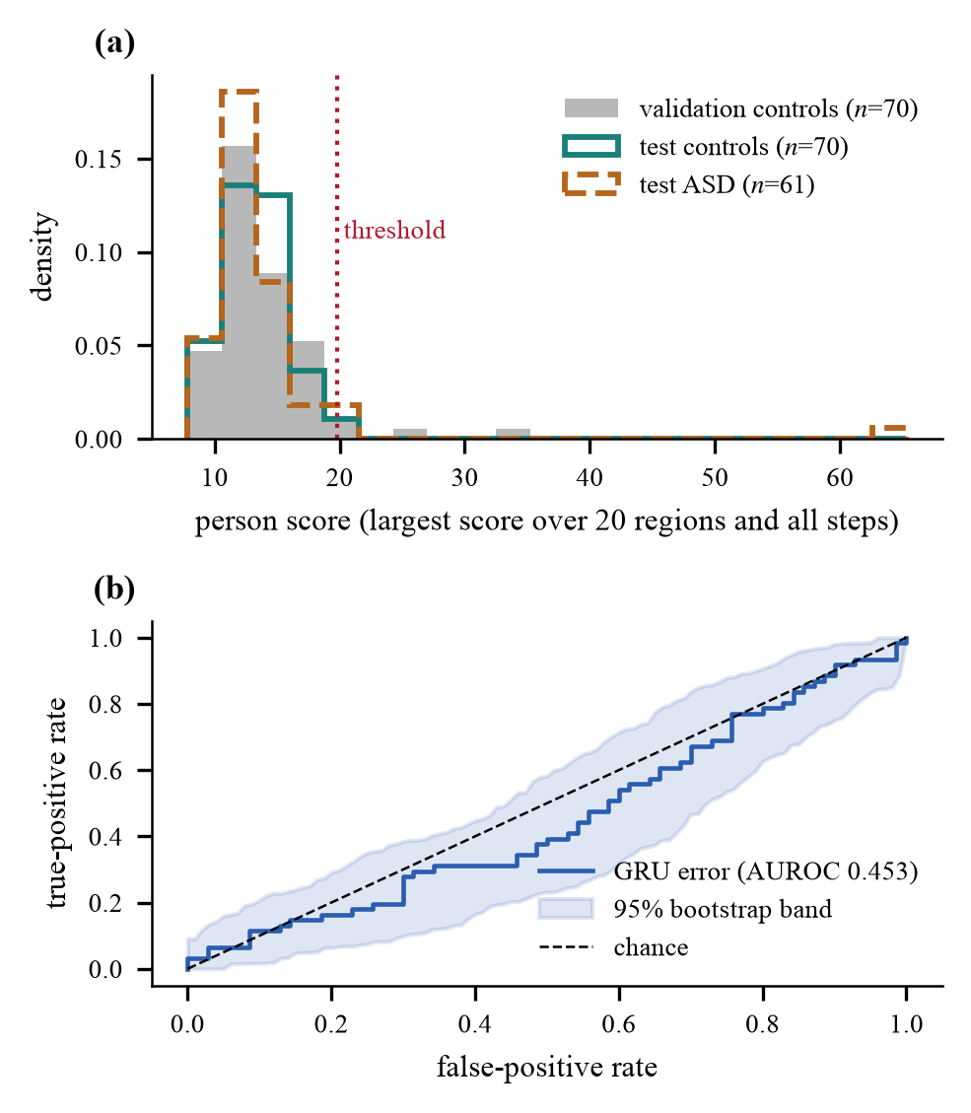
Fig. 2. Detector score distribution and ROC curve.
In panel (a), the scoring of the patients in the validation and test controls along with the test ASD patients is plotted against the threshold of detection of 19.81. The three distributions practically entirely overlap with one another. Furthermore, in panel (b), there exists the ROC curve with 95% bootstrap band remaining highly close to that of the chance line (AUROC of 0.453).
B. Does modelling time help? (RQ1)
Table I shows a comparison of three evaluation scores computed from the same frozen encoder: the distance from the control mean (static), the difference from the previous window (persistence), and GRU error. The results demonstrate all scores have AUROC values within the range of 0.45 - 0.49, with overlapping intervals. Therefore, it can be concluded that temporal modeling does not bear considerable impact. The encoder is trained with GRU; hence the baselines should not be considered fully independent.
TABLE I. Scoring methods on the test set.
Score | AUROC [95% CI] | p | F1 | Flagged
Static | 0.452 [0.356, 0.553] | 0.34 | 0.143 | 9
Persistence | 0.485 [0.380, 0.582] | 0.78 | 0.062 | 4
GRU (proposed) | 0.453 [0.353, 0.552] | 0.35 | 0.062 | 4
C. Synthetic anomalies (RQ2)
A total of 7,200 synthetic records were generated (60 control subjects × 20 locations × 3 intensities × 2 types of processing) without violating any regulations. When it comes to average scores, the edited version saw an increase in average scores from 4.0 to 7.6, whilst randomly edited versions had only an average score of about 2.9. With maximum severity, about 45.8% of the records that were created through guidance managed to pass the step threshold, and only 4.8% of those produced through random editing did (Fig. 3). In comparison to controlled and actual subjects, the ones categorized as ASD only managed to cross the step line in 5.0% and 4.9% of cases respectively. The same model was used to process both types of records, therefore this implies that the generator is not producing random noise, not that the anomalies in the produced records resemble autism.
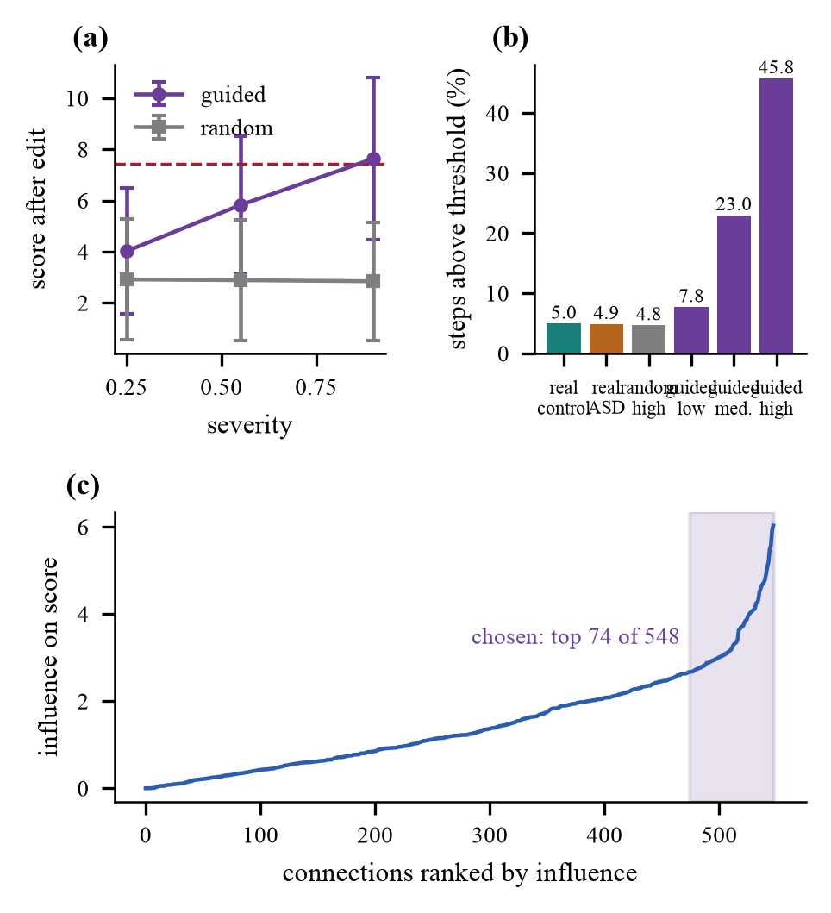
Fig. 3. Effect of guided edits on anomaly scores.
In the first panel, the score rises with the severity of the edits for the case of guided edits, while the score does not change for the case of random edits. In panel (b), the percentage of the steps that crossed the threshold is presented; these percentages read as follows: 45.8% for guided edits with high severity, 4.8% for random edits, and approximately 5% for the actual scans. In the last panel, the connections get ranked based on their influence.
D. Few-shot adaptation (RQ2)
Table II outlines the results from the few-shot experiments. With only one genuine ASD scan, the classifier labels only a select few individuals with the F1 of 0.006. With the addition of 30 constructed anomalies, the F1 ratio rises to between 0.39 and 0.40. The F1 score is more substantial for five and ten-shot use cases, where the score increases from 0.15 and 0.31, respectively, to 0.40 and 0.43. The construction of anomalies has made it possible to take advantage of few-shot learning from one authentic scan, whereas in cases where only genuine scans were used, it was not successful. There is no significant change in AUROC metrics, whereas the F1 metrics stay practically the same as the chance F1 for the similar flag ratio (35-39% of patients). It can be noticed that both guided and randomly generated anomalies yield practically identical results, which indicates that the positive aspect comes from the use of constructed anomalies rather than the content of the signal.
TABLE II. Few-shot results. SA: guided, R: random.
Shots | Training set | F1 | AUROC | Flag | Chance F1
1 | ASD only | 0.006±0.01 | 0.516±0.06 | – | –
 | + SA | 0.387±0.04 | 0.497±0.03 | 0.36 | 0.41
 | + R | 0.403±0.07 | 0.506±0.04 | 0.35 | 0.40
5 | ASD only | 0.149±0.07 | 0.485±0.02 | 0.10 | 0.16
 | + SA | 0.390±0.03 | 0.486±0.03 | 0.36 | 0.41
 | + R | 0.399±0.05 | 0.502±0.02 | 0.37 | 0.41
10 | ASD only | 0.311±0.09 | 0.524±0.05 | 0.26 | 0.33
 | + SA | 0.402±0.05 | 0.501±0.05 | 0.38 | 0.42
 | + R | 0.431±0.04 | 0.515±0.05 | 0.39 | 0.42
E. Severity estimation (RQ3)
For the 60 ASD people who failed to enter the training scheme, the ability to forecast the severity level was demonstrated to be 43.3%, compared with only 55.0% that can be obtained by marking “high.” The cross-validation indicated that for the whole sample of 193, the accuracy went down to 39.1% in comparison with 43%. The correlation of the estimated severity value with the real one turned out to be very minimal (Spearman 0.13, p=0.32), which proves that the result does not carry any essential meaning.
F. Guided sub-structure versus random edits
On all counts (Table III), guided sub-structure changes get recognized far better than random changes of the same magnitude: 70.2% versus 50.0% accuracy, 0.902 versus 0.500 precision, 0.454 versus 0.049 recall, 0.604 versus 0.090 F1, and 0.906 versus 0.491 AUROC scores. Random changes remain at chance, while guided edits increase average transition score from 2.94 to 7.62. It is worth noting that the model that is in charge of making the changes also performs scoring, which evidences the visibility of the generated anomalies, not an ASD diagnosis.
TABLE III. Detection of generated anomalies.
Approach | Accuracy | Precision | Recall | F1 | AUROC
Random | 50.0% | 0.500 | 0.049 | 0.090 | 0.491
Sub-structure | 70.2% | 0.902 | 0.454 | 0.604 | 0.906
G. Model-wise comparison
To evaluate the models, the graph encoders were substituted with temporal predictors while keeping the data, split, loss function in Equation (12), optimizer, and number of epochs same. The graph encoders considered were GIN [13], GCN [5] (the signed weights were used in a non-normalized format) and GraphConv [18], while the temporal predictors were GRU [14] and LSTM [19]. The dataset used is shown in Table IV. GIN + GRU obtained an accuracy of 70.2% and an AUROC of 0.906 for guided edits while GCN + GRU got 59.1% and 0.718; GraphConv + GRU has 64.1% and 0.855 AUROC; GIN + LSTM achieved 69.5% and 0.901 AUROC. GIN + GRU has the best AUROC for guided edits closely followed by GIN + LSTM, indicating that GIN should be chosen as the graph encoder. All models perform similarly on ASD detection AUROC of about 0.5, while also for random edits the models give around 0.5 AUROC for every method.
TABLE IV. Model-wise comparison.
Model | ASD AUROC | ASD Acc. | Guided Acc. | Guided AUROC | Random AUROC
GIN + GRU | 0.453 | 53.4% | 70.2% | 0.906 | 0.491
GCN + GRU | 0.494 | 55.0% | 59.1% | 0.718 | 0.494
GraphConv + GRU | 0.479 | 52.7% | 64.1% | 0.855 | 0.499
GIN + LSTM | 0.442 | 56.5% | 69.5% | 0.901 | 0.503
V. DISCUSSION AND LIMITATIONS
The quality and performances of the delivery pipeline and the generator prove good and, respectively, the model managed to effectively detect anomalies that were generated by the generator with higher accuracy compared to chance (AUROC 0.906 vs. 0.491), while the combination of GIN and GRU appeared to be the best among the four tested combinations of encoder and prediction procedures, however, the direct ASD detection in ABIDE I showed chance-level results (AUROC 0.453). Some potential reasons for that include: 1) low signal; 2) high variability of the maladaptive behavior associated with ASD; 3) the role of location effects; 4) noise and other interfering effects; and 5) the use of 20 features out of 360. Some limitations include that training was conducted only once, and out of the two methodological choices regarding both patient threshold score and choice to limit features to only twenty were made based on the results and not prior assumptions and that while site experimentation was not performed, tests evaluating the whole graph were not done.
VI. CONCLUSION
The tracking system reveals how the activity of small areas of the brain changes over time while allowing for the identification of important fluctuations as well as the generation of anomalies depending on the structure of the brain, adapting after each ASD scan. The detection of the anatomically modified substructures is much better than random modifications of the same dimensions (AUROC 0.906 compared to 0.491 on the control scans), and the GIN + GRU model is the most accurate of the four models compared, with the generated anomalies increasing one-shot F1 score from 0.006 to around 0.40.
When it comes to direct ASD detection, the ABIDE I database only reaches 0.453 AUROC score, which serves as a significant limitation of this paper. Future studies will seek ways of dealing with this limitation through leave-out comparisons of various sites and their harmonization, evaluation of produced anomalies using another model that has not been involved in creating the modification, evaluation of baseline models of the entire brain, parameter sweeps during the training process, identification of structures to be observed with the help of data-driven approach, ordinal regression approach using continuous ADOS-2 measurements, and independent evaluation involving medical practices.
REFERENCES
[1] E. Bullmore and O. Sporns, “Complex brain networks: Graph theoretical analysis of structural and functional systems,” Nat. Rev. Neurosci., vol. 10, no. 3, pp. 186–198, Mar. 2009, doi: 10.1038/nrn2575.
[2] S. M. Smith et al., “Network modelling methods for FMRI,” NeuroImage, vol. 54, no. 2, pp. 875–891, Jan. 2011, doi: 10.1016/j.neuroimage.2010.08.063.
[3] A. S. Heinsfeld, A. R. Franco, R. C. Craddock, A. Buchweitz, and F. Meneguzzi, “Identification of autism spectrum disorder using deep learning and the ABIDE dataset,” NeuroImage Clin., vol. 17, pp. 16–23, 2018, doi: 10.1016/j.nicl.2017.08.017.
[4] S. I. Ktena et al., “Distance metric learning using graph convolutional networks: Application to functional brain networks,” in Med. Image Comput. Comput.-Assist. Intervent. (MICCAI), 2017, pp. 469–477, doi: 10.1007/978-3-319-66182-7_54.
[5] T. N. Kipf and M. Welling, “Semi-supervised classification with graph convolutional networks,” in Proc. Int. Conf. Learn. Represent. (ICLR), 2017, arXiv:1609.02907.
[6] E. A. Allen, E. Damaraju, S. M. Plis, E. B. Erhardt, T. Eichele, and V. D. Calhoun, “Tracking whole-brain connectivity dynamics in the resting state,” Cereb. Cortex, vol. 24, no. 3, pp. 663–676, Mar. 2014, doi: 10.1093/cercor/bhs352.
[7] R. M. Hutchison et al., “Dynamic functional connectivity: Promise, issues, and interpretations,” NeuroImage, vol. 80, pp. 360–378, Oct. 2013, doi: 10.1016/j.neuroimage.2013.05.079.
[8] P. Aggarwal and A. Gupta, “Multivariate graph learning for detecting aberrant connectivity of dynamic brain networks in autism,” Med. Image Anal., vol. 56, pp. 11–25, Aug. 2019, doi: 10.1016/j.media.2019.05.007.
[9] K. Xu et al., “Topology attack and defense for graph neural networks: An optimization perspective,” in Proc. Int. Joint Conf. Artif. Intell. (IJCAI), 2019, pp. 3961–3967, doi: 10.24963/ijcai.2019/550.
[10] A. Madry, A. Makelov, L. Schmidt, D. Tsipras, and A. Vladu, “Towards deep learning models resistant to adversarial attacks,” in Proc. Int. Conf. Learn. Represent. (ICLR), 2018, arXiv:1706.06083.
[11] A. Di Martino et al., “The autism brain imaging data exchange: Towards a large-scale evaluation of the intrinsic brain architecture in autism,” Mol. Psychiatry, vol. 19, no. 6, pp. 659–667, Jun. 2014, doi: 10.1038/mp.2013.78.
[12] M. F. Glasser et al., “A multi-modal parcellation of human cerebral cortex,” Nature, vol. 536, no. 7615, pp. 171–178, Aug. 2016, doi: 10.1038/nature18933.
[13] K. Xu, W. Hu, J. Leskovec, and S. Jegelka, “How powerful are graph neural networks?” in Proc. Int. Conf. Learn. Represent. (ICLR), 2019, arXiv:1810.00826.
[14] K. Cho et al., “Learning phrase representations using RNN encoder-decoder for statistical machine translation,” in Proc. Conf. Empirical Methods Natural Lang. Process. (EMNLP), Doha, Qatar, Oct. 2014, pp. 1724–1734, doi: 10.3115/v1/D14-1179.
[15] A. Bardes, J. Ponce, and Y. LeCun, “VICReg: Variance-invariance-covariance regularization for self-supervised learning,” in Proc. Int. Conf. Learn. Represent. (ICLR), 2022, arXiv:2105.04906.
[16] K. Gotham, A. Pickles, and C. Lord, “Standardizing ADOS scores for a measure of severity in autism spectrum disorders,” J. Autism Dev. Disord., vol. 39, no. 5, pp. 693–705, May 2009, doi: 10.1007/s10803-008-0674-3.
[17] D. P. Kingma and J. Ba, “Adam: A method for stochastic optimization,” in Proc. Int. Conf. Learn. Represent. (ICLR), 2015, arXiv:1412.6980.
[18] C. Morris et al., “Weisfeiler and Leman go neural: Higher-order graph neural networks,” in Proc. AAAI Conf. Artif. Intell., vol. 33, no. 1, 2019, pp. 4602–4609, doi: 10.1609/aaai.v33i01.33014602.
[19] S. Hochreiter and J. Schmidhuber, “Long short-term memory,” Neural Comput., vol. 9, no. 8, pp. 1735–1780, 1997, doi: 10.1162/neco.1997.9.8.1735.

