Bank Customer Churn

Create database and tables:


Q.1. What is the distribution of customers by Geography and how does churn vary across them?
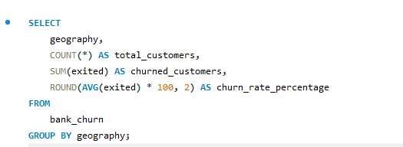
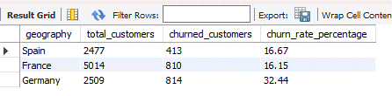

Q.2. Does gender have any significant impact on churn?
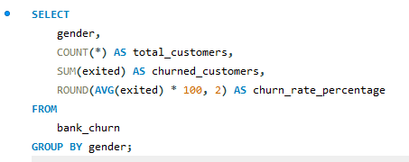
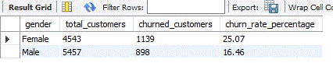
Q.3. What is the average age of customers who churned vs. those who stayed?
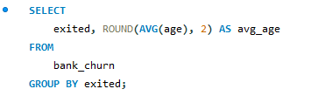
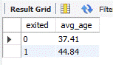
Q.4. Is there a difference in salary levels between churned and non-churned customers?
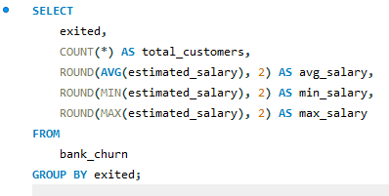
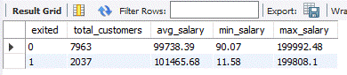

Q.5. Do customers with more products have lower churn rates?
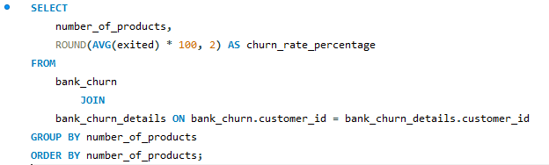
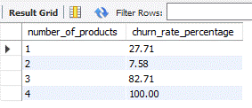
Q.6. What is the churn rate for customers who own a credit card vs. those who don’t?
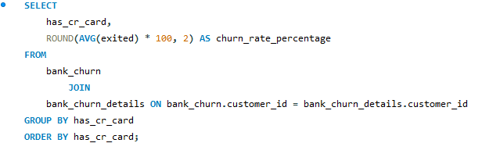

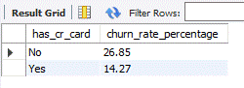

Q.7. Does having an active membership reduce churn?
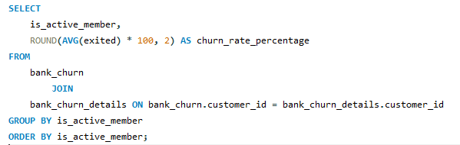
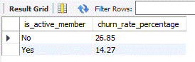
Q.8. How does account balance influence churn probability?

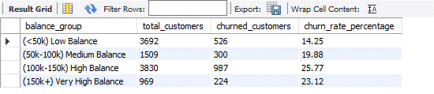

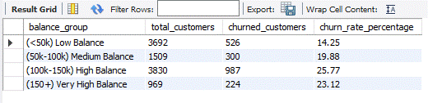

Q.9. What is the churn rate by tenure group?
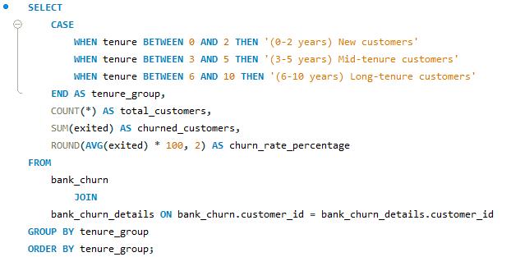
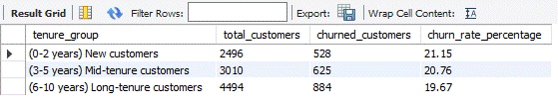
Q.10. Do customers with longer tenure show higher loyalty, or is churn evenly spread? (similar as previous query)
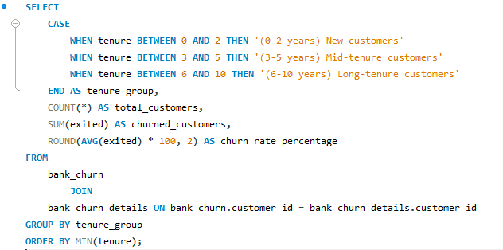
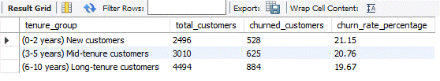
Q.11. What is the average CreditScore of churned vs. retained customers?
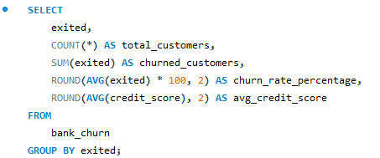
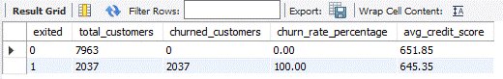
Q.12. Which group contributes more to lost revenue:
-- High-salary churners
-- Low-salary churners
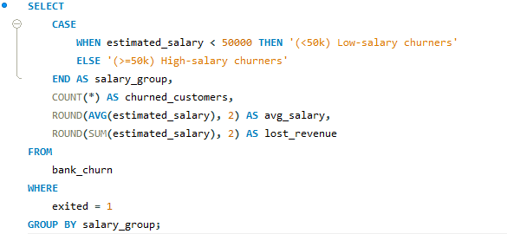
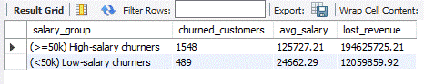

Q.13. If we assume churned customers = lost revenue, what is the total estimated salary lost due to churn?
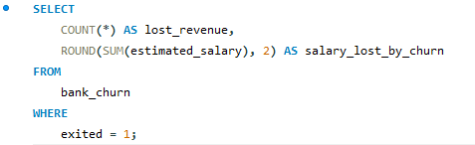
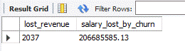
Q.14. -- Total Customers
-- Churn Rate %
-- Avg. Credit Score
-- Avg. Balance
