Linux Networking Commands – Documentation
1. Introduction
This document contains commonly used Linux commands for installing, checking, and troubleshooting network-related tools.
Each command is explained in simple language along with its purpose, syntax, example, and screenshot of the command/output.
2. Installing Networking Tools
Command
sudo apt update && sudo apt install -y traceroute dnsutils curl openssl net-tools nmap
Purpose
This command is used to update the Ubuntu package information and install several useful networking tools.
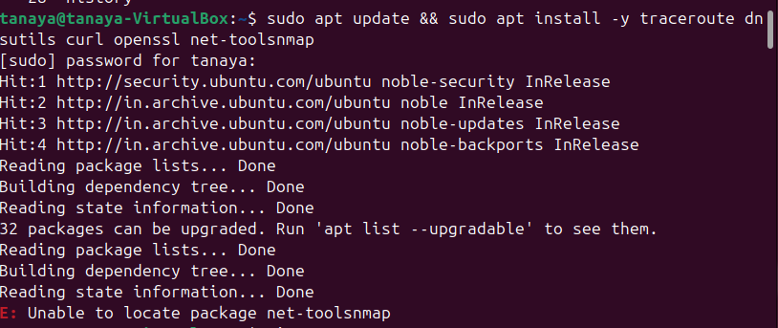
3.Ping a Specific IP Address
You can also ping an IP address directly.
Command
ping 8.8.8.8 This tests connectivity to the IP address 8.8.8.8. 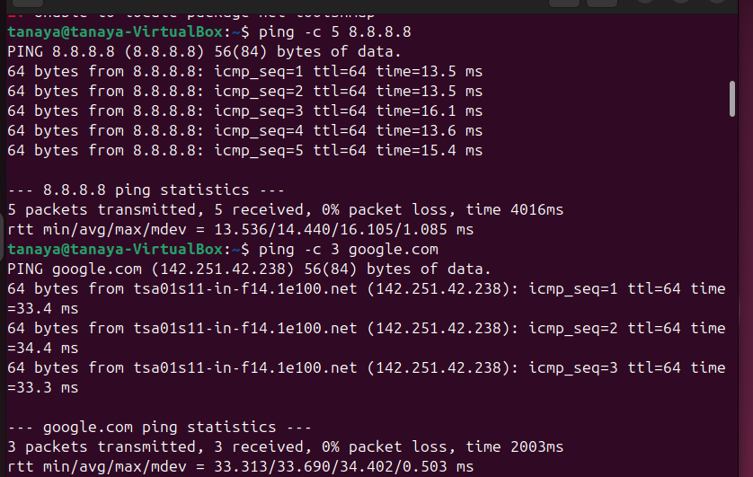
4.traceroute
Command
traceroute google.com
Purpose
traceroute shows the network path taken by packets from your computer to a destination.
It can help identify where a network connection is experiencing delays or failures.
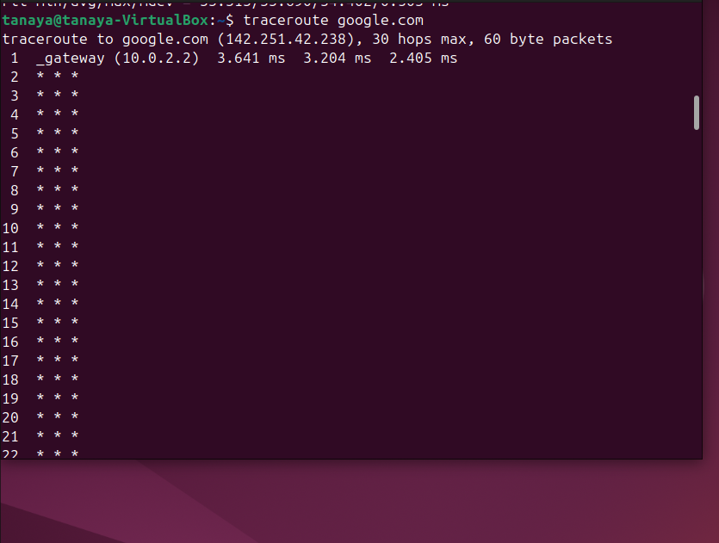
5.nslookup
Command
nslookup google.com
Purpose
nslookup is another command used to query DNS information.
It can be used to check whether a domain name is resolving correctly.
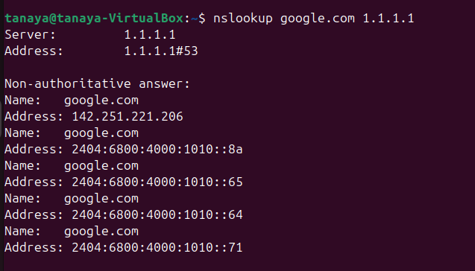
6.DNS Utilities – dig
Command
dig google.com
Purpose
dig is a DNS troubleshooting tool.
DNS converts domain names such as:
google.com
into IP addresses.
dig allows us to check DNS information for a domain.
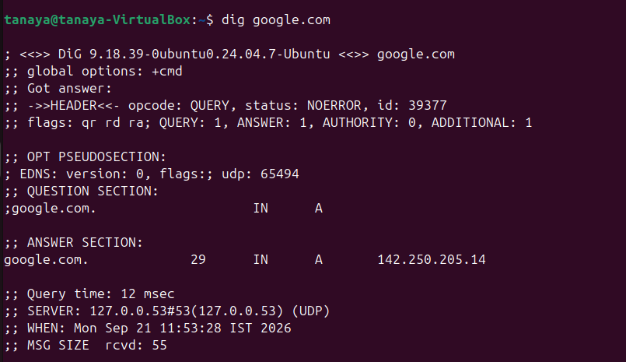
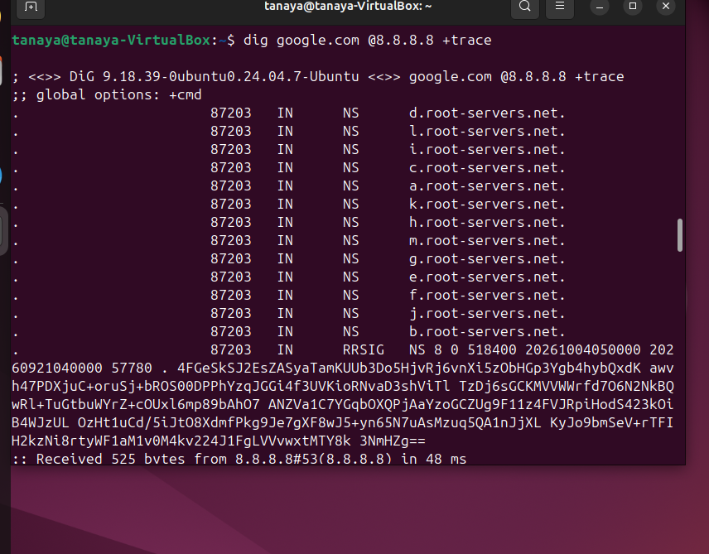
7.Nmap
Command
Nmap-sV localhost
Purpose
nmap is a network discovery and port-scanning tool.
It can be used to identify:
- Available hosts
- Open ports
- Network services
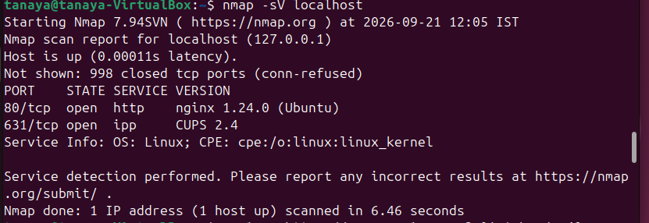
8.curl
Command
curl https://example.com
Purpose
curl is a command-line tool used to communicate with websites and servers.
It is commonly used for:
- Testing HTTP/HTTPS connections
- Calling APIs
- Downloading data
- Checking server responses
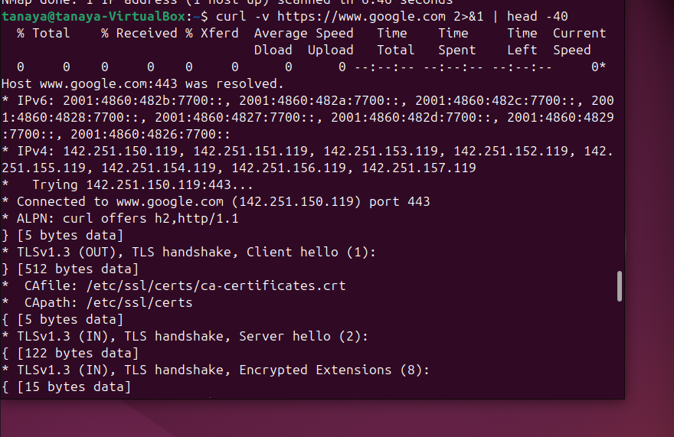
9.Extract Certificate Information
You can combine OpenSSL with another Linux command to display certificate information.
Command
echo | openssl s_client -connect google.com:443 -servername google.com 2>/dev/null | openssl x509 -noout -subject -issuer -dates
Purpose
This command connects to the HTTPS server and displays important certificate information.
It can show:
- Certificate subject
- Certificate issuer
- Certificate start date
- Certificate expiry date
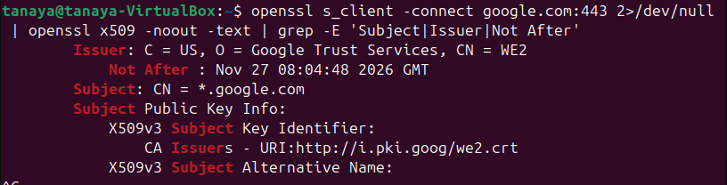
10.Installing Nginx and UFW
You ran:
sudo apt install -y nginx ufw
2. Starting and enabling Nginx
You ran:
sudo systemctl start nginx && sudo systemctl enable nginx
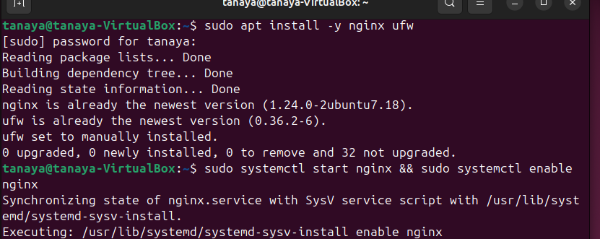
Creating a custom HTML page
You ran:
echo '<h1>COGS Lab - TLS Demo</h1><p>Hello from Local VM Lab!</p>' | sudo tee /var/www/html/index.html
This created/replaced the Nginx default webpage with your own HTML content.
11.Allowing SSH through UFW
You ran:
sudo ufw allow 22/tcp
Output:
Rules updated
Rules updated (v6)
Meaning: TCP port 22 was allowed through the firewall, which is commonly used for SSH.
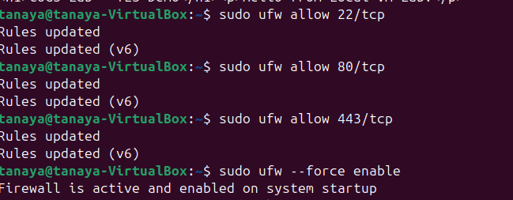
12.Nginx HTTPS/TLS Configuration
1. Create SSL Directory
Command:
sudo mkdir -p /etc/nginx/ssl
Create Nginx TLS Configuration
An Nginx configuration file named lab-tls was created. The configuration enables HTTPS on port 443, specifies a self-signed certificate and private key, allows TLS 1.2 and TLS 1.3, and serves the website from /var/www/html. A second server block listens on HTTP port 80 and redirects HTTP requests to HTTPS.
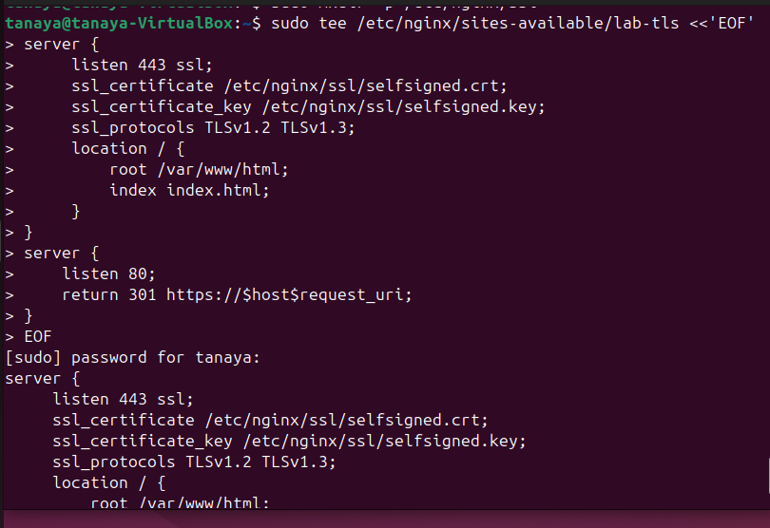
TOTP MFA — Generate and Verify Time-Based OTPs
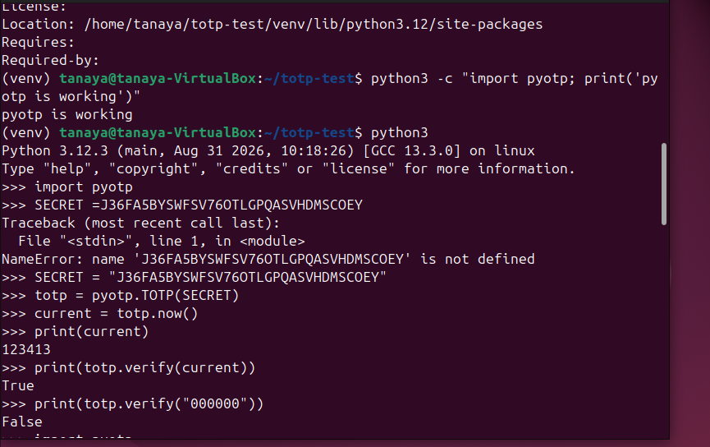
Lab 3.2 — Prometheus + Grafana — Build Your Own APM Dashboard
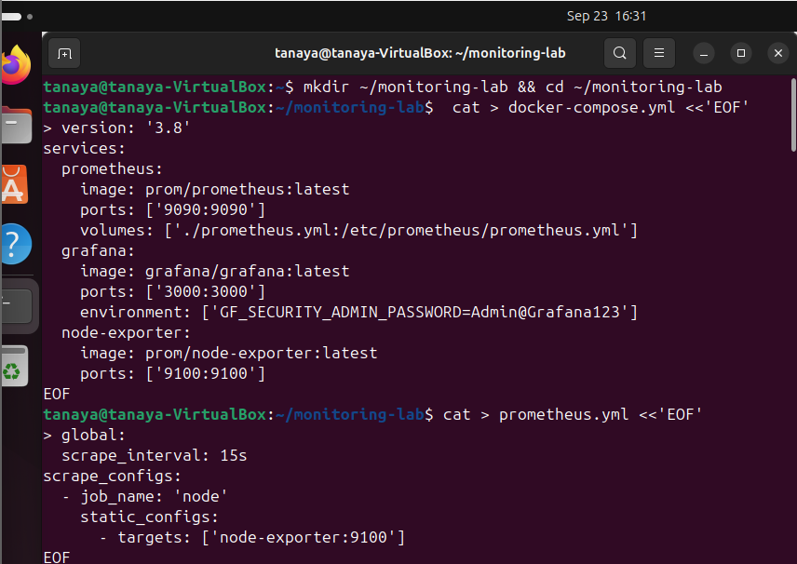
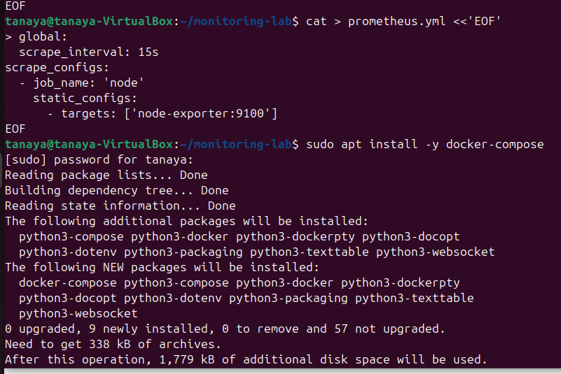
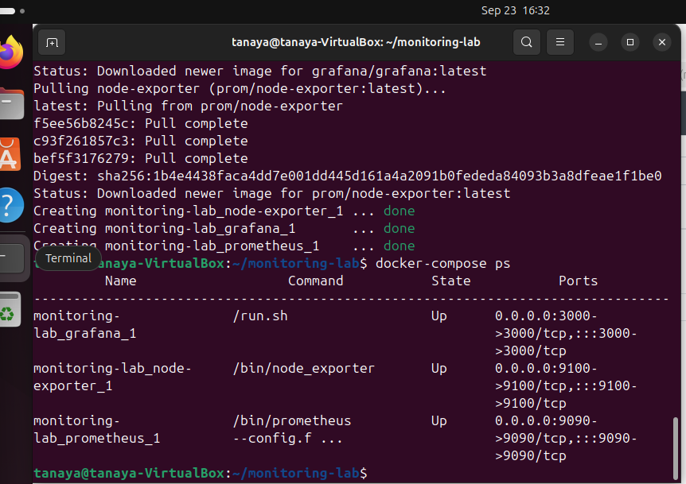
CPU usage (like Site24x7 CPU alert):
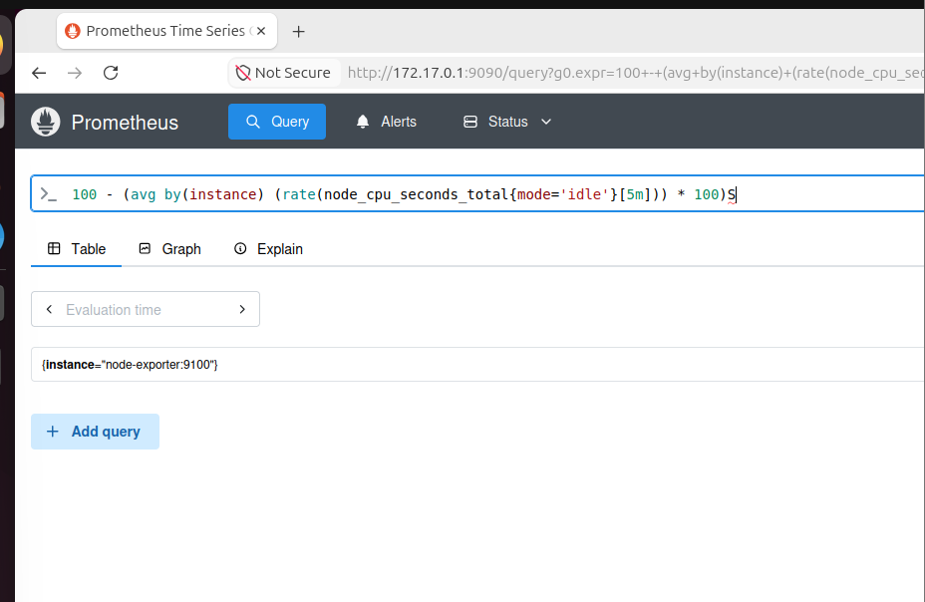
# Memory usage:
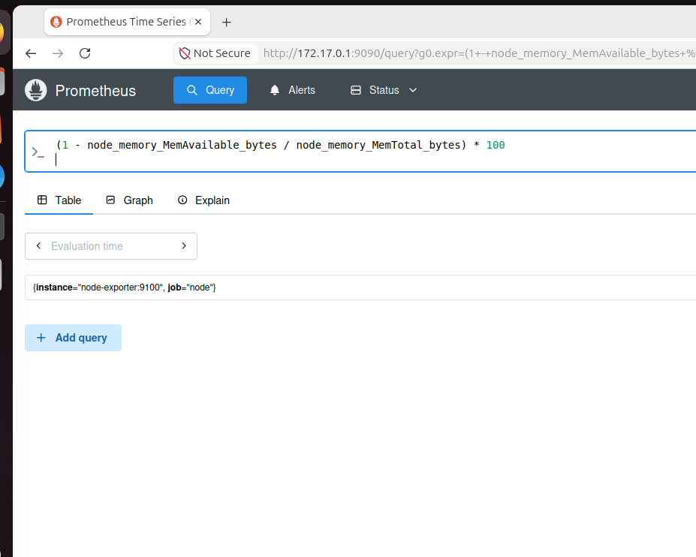
# Disk usage:
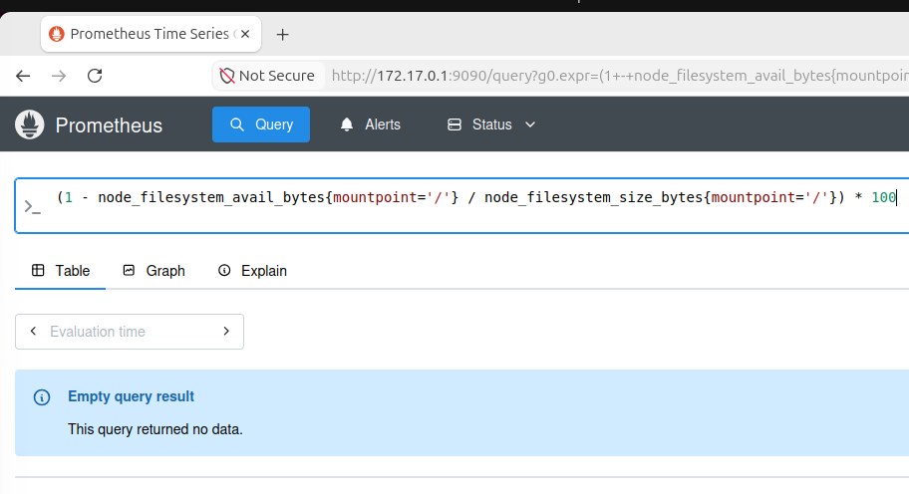
Network bytes in (like bandwidth monitoring):
GRG
GRA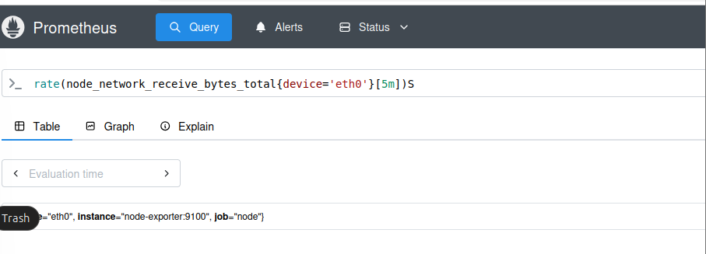
GRAPH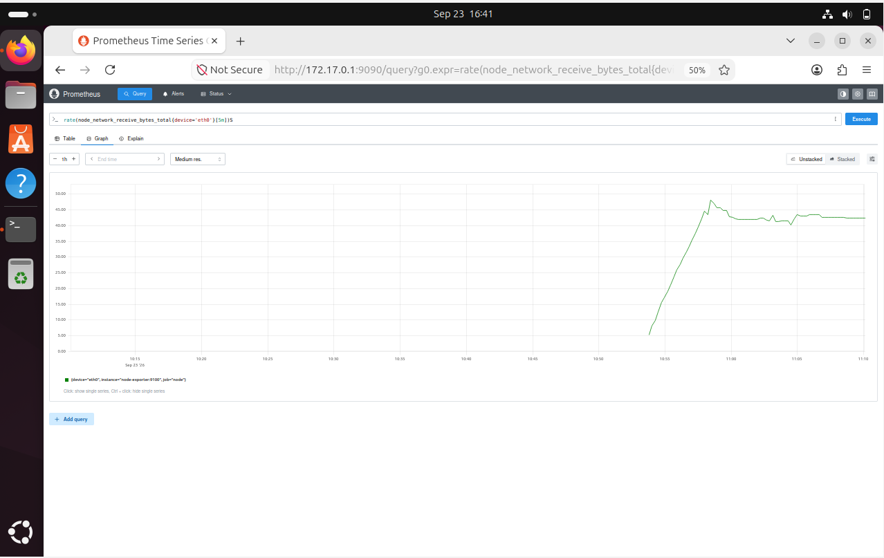

GRAPHANA
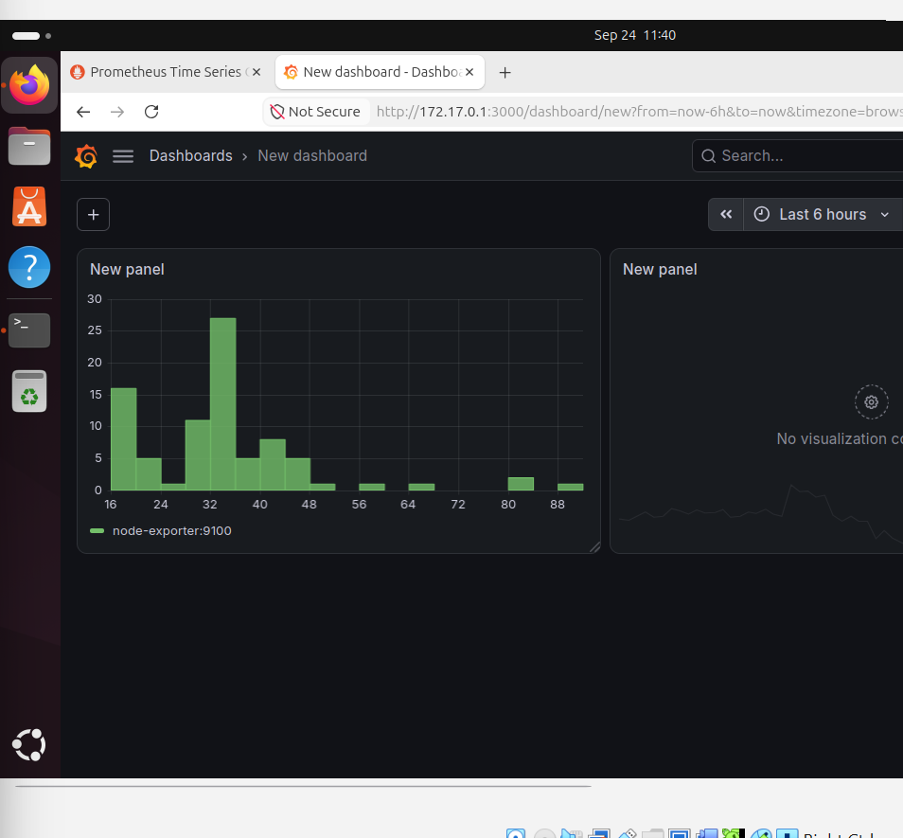

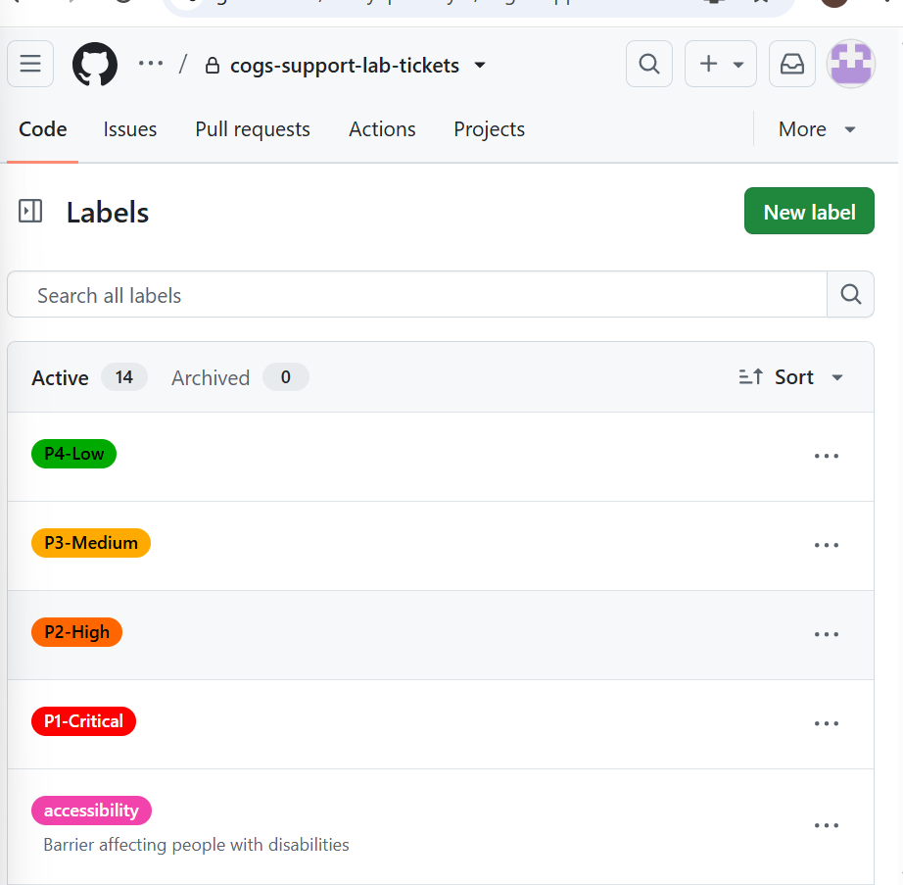
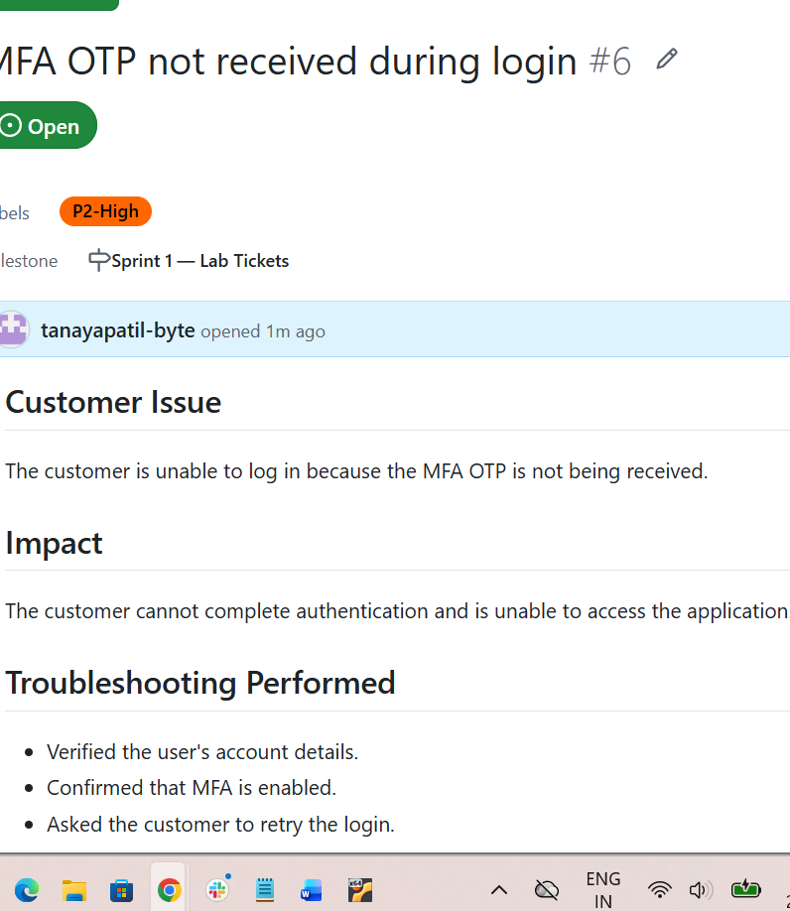
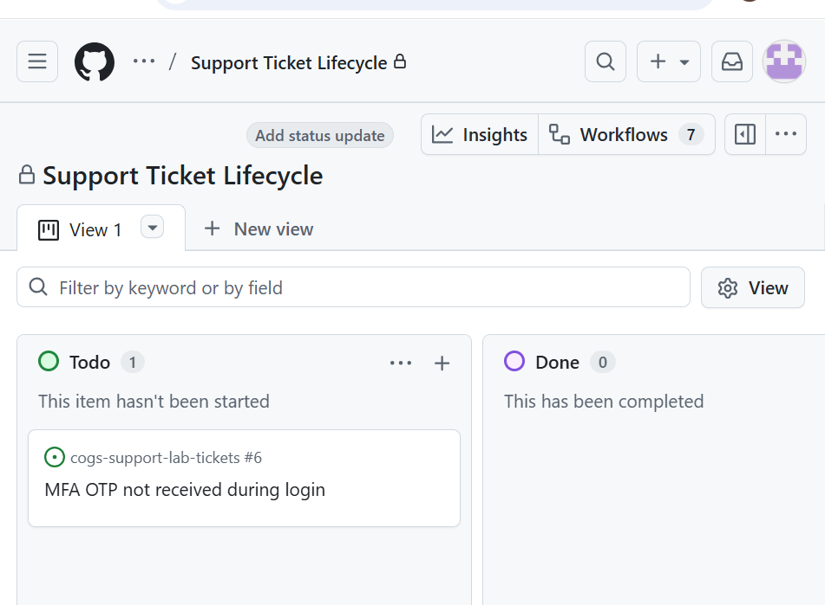
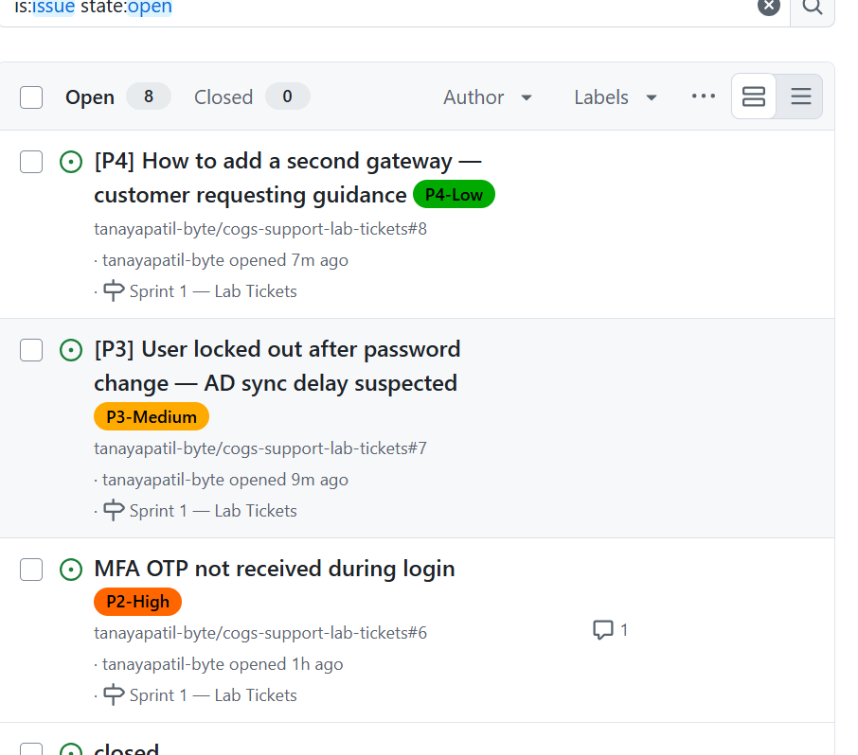
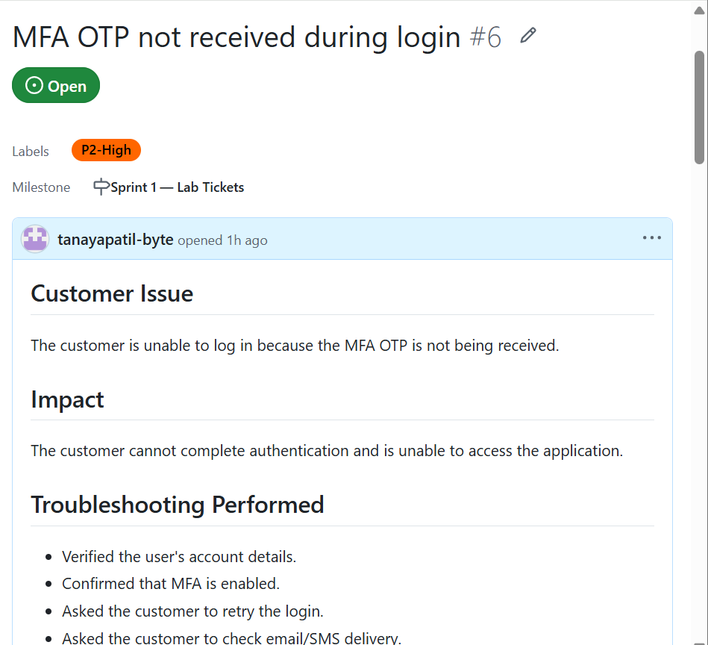
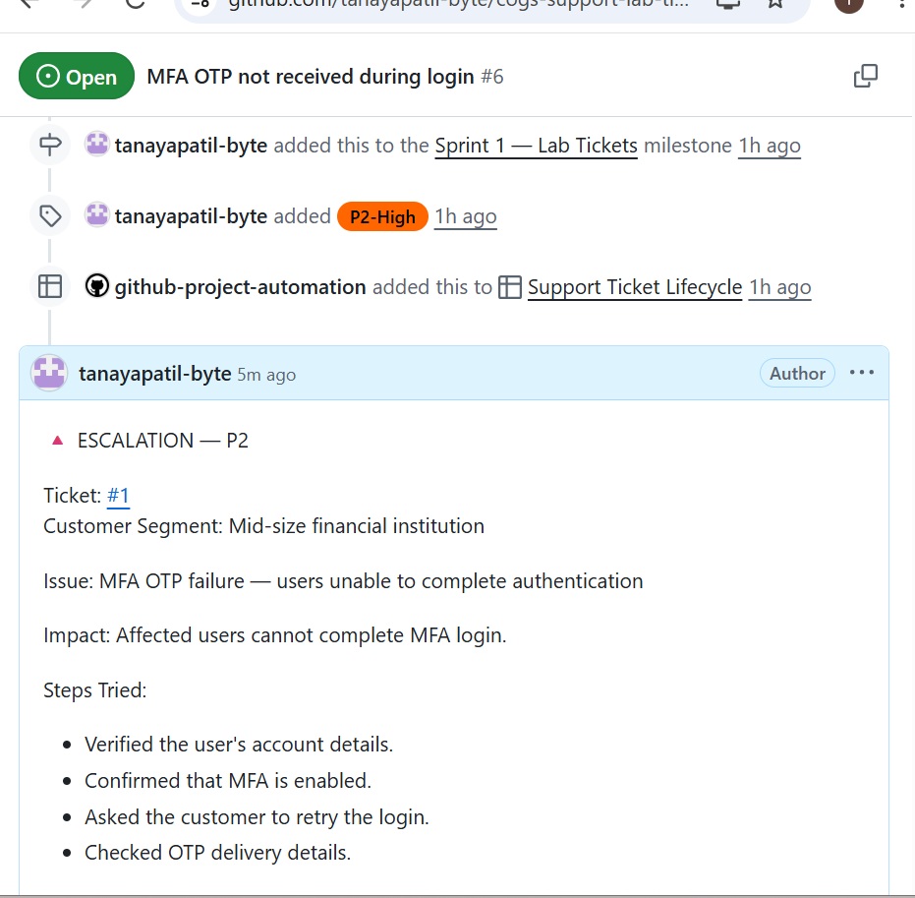
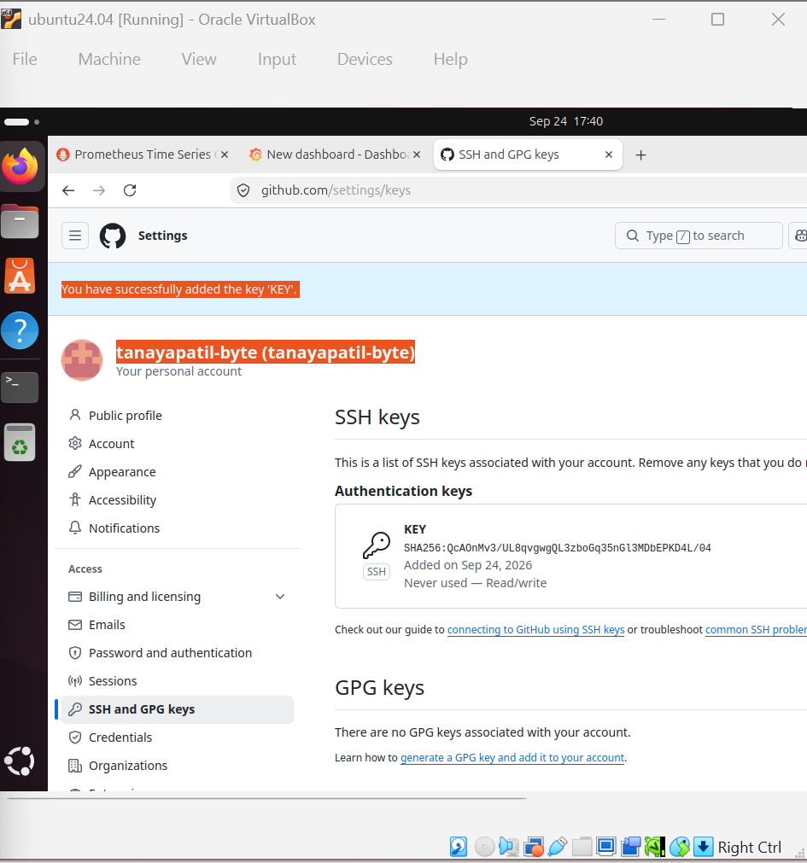
UP-TIME KUMA
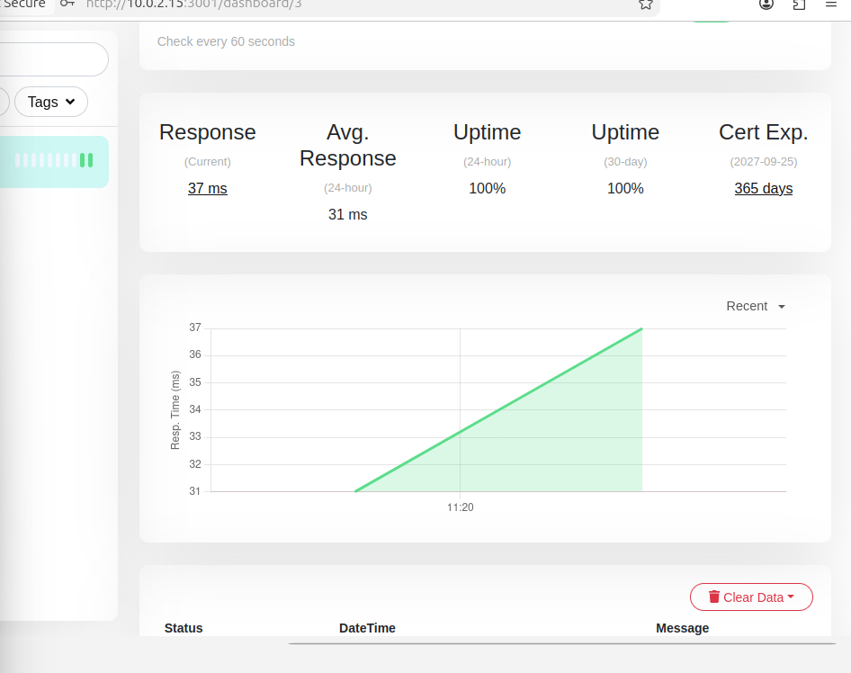
INACTIVE DOWNTIME
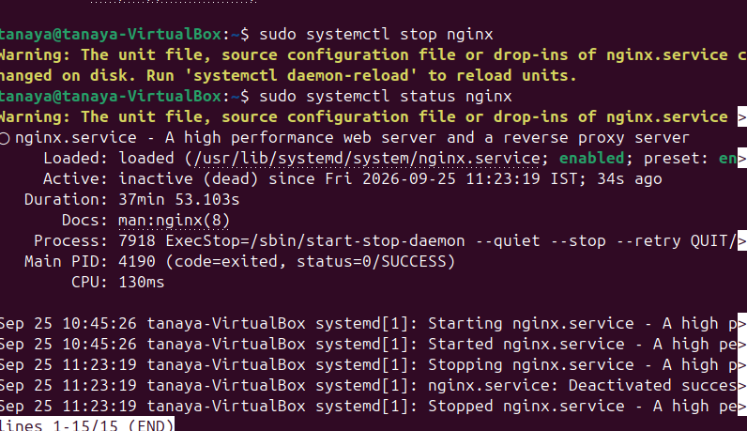
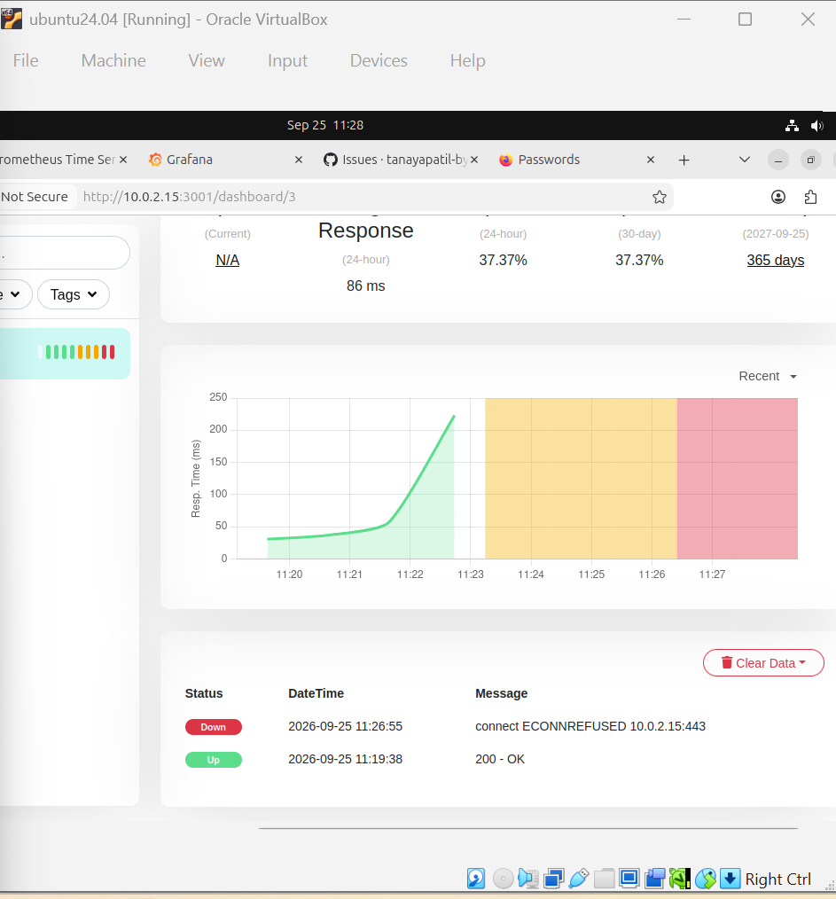
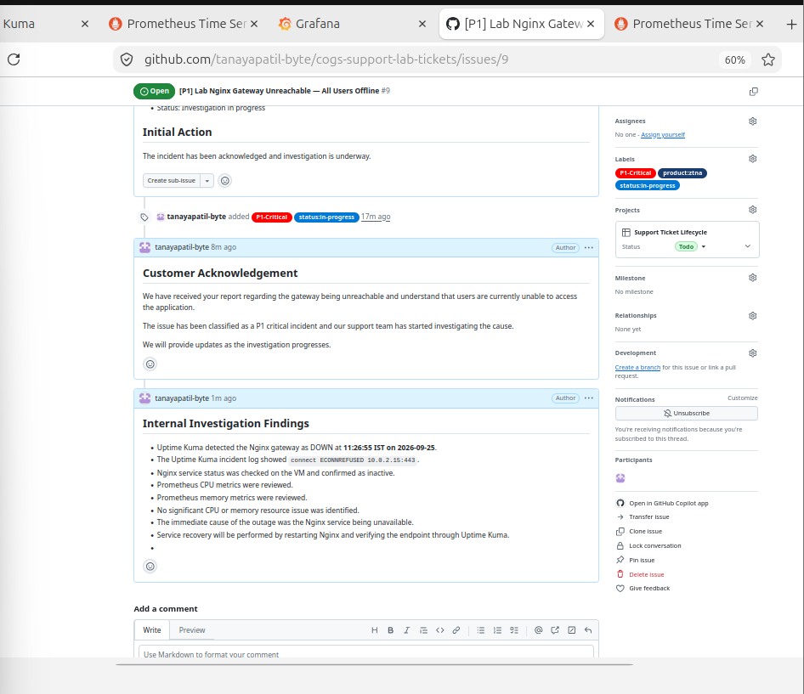
Lab 5.2 — Change Management Simulation — Safe Change on a Live System
