

Foundations of Programming

Lab Assignment No. : 03
Name: Tanay Sushil Dhoot
Div: 2
Batch:1
Prn no:1262252662

PROBLEM STATEMENT:
Write a program in C to generate multiplication tables for a given number.
OBJECTIVES:
- To understand the use of looping statements in C.
- To generate multiplication tables using loops.
- To improve program logic and execution flow understanding.

THEORY:
Syntax for for loop example program
Syntax for while loop example program
Syntax for do while loop example program
ALGORITHM: Step 1: Start

Step 2: Declare variables i, num, prdt as integer.

Step 3: Display the message
“Enter a number”.

Step 4: Read the number num.

Step 5: Use a for loop

Initialize prdt = 1

Condition i ≤ 12

Increment i

Step 6: Inside the loop, compute
prdt = prdt × i

Step 7: Repeat until the condition becomes false.

Step 8: Stop.

Step 9: End.

Type Program (Multiplication table)

PLATFORM:
Linux

INPUT: #include <stdio.h>

void main() {

// taking the number to have the multiplication table
int i = 5;

// an incrementing counter variable
int prdt = 1;

for (prdt = 0; prdt <= 12; prdt++) {

// having the statement to print multiplication table
printf("%d x %d = %d\n", i, prdt, i * prdt);

}
}

OUTPUT:
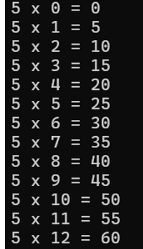

SAMPLE INPUT:
5

SAMPLE OUTPUT:
Multiplication table

CONCLUSION:
Thus, the menu driven program in C successfully performs basic arithmetic operations using switch–case statements.

FAQs:
- Which loop is best suited for generating multiplication tables?
- What is the role of loop initialization?
- Difference between for loop, while loop and do while loop?
- Can a do–while loop be used to generate multiplication tables? Explain.
- Why is the do–while loop called an exit-controlled loop?

