1. Regime Overlay on NIFTY 50 Price Action
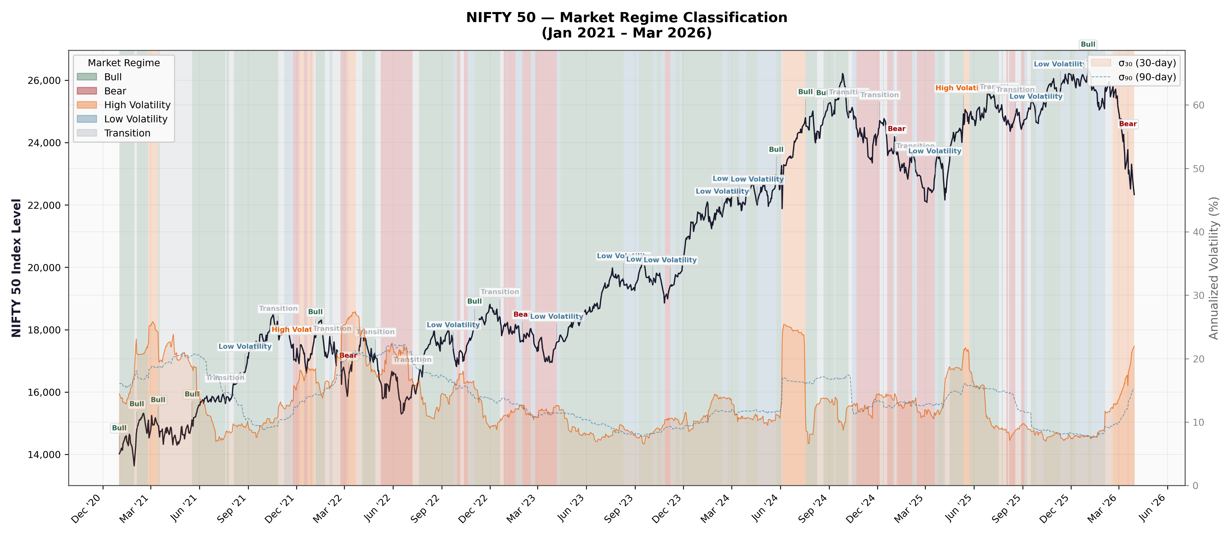
The time-series plot overlays the NIFTY 50 index level with colour-coded background bands representing the classified market regime. The secondary y-axis plots 30-day (solid) and 90-day (dashed) annualised volatility.

Regime Distribution
Regime | Days | % Total | Mean σ₃₀ | Mean Mom₃₀ | Mean Breadth
Bull | 590 | 45.6% | 11.6% | +5.0% | 77.6%
Bear | 228 | 17.6% | 14.3% | −4.1% | 29.1%
High Volatility | 100 | 7.7% | 21.3% | +0.4% | 56.4%
Low Volatility | 209 | 16.1% | 10.6% | ~0.0% | 51.9%
Transition | 168 | 13.0% | 15.8% | −0.5% | 51.0%

Key Findings
Bull dominance: NIFTY 50 spent 45.6% of the sample in Bull positive momentum (+5.0%), low volatility (σ₃₀ = 11.6%), and broad participation (77.6% above 50-DMA). This confirms the paper's threshold: "> 70% indicates broad participation in an uptrend" (§3.4.2).
Bear regimes are sharp and narrow: Bear phases (17.6% of days) show worst momentum (−4.1%), elevated volatility (14.3%), and collapsed breadth (29.1% below the paper's 30% weakness threshold). Bear bands align with the Russia-Ukraine shock (Feb–Mar 2022), late-2024 sell-off, and early-2025 correction.
Volatility divergence as regime signal: Per §3.5.4: "σ₃₀ ≫ σ₉₀ may indicate a volatility breakout or regime transition." Every Bull→Bear/High-Vol transition in the overlay is preceded by σ₃₀ spiking above σ₉₀.
High Volatility is rare but dramatic: Only 7.7% of days, with σ₃₀ > 21% but near-zero momentum indicating violent two-way price action, not directional movement.

2. HMM State Posterior Probabilities
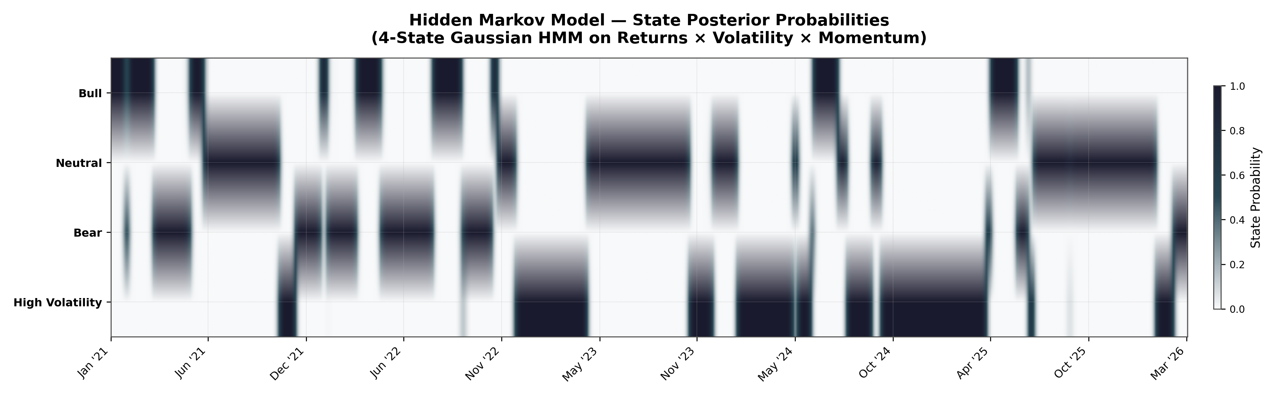
The heatmap shows posterior probability of each HMM latent state (Bull, Neutral, Bear, High Volatility) over time. Darker = higher probability (closer to 1.0).

Key Findings
Clean state separation: The HMM assigns near-1.0 probability to a single state for most dates, producing sharp block-like transitions the multi-factor feature space provides strong discriminative power.
Bull dominance 2023–mid 2024: Bull state probability ≈ 1.0 continuously from late 2022 through mid-2024, matching the secular NIFTY 50 rally from ~17,000 to ~26,000.
Abrupt regime transitions: Feb 2022: instant Bull → Bear (Russia-Ukraine). Oct 2024: sharp Bull → Bear (FII outflows). Mar 2026: rapid Neutral → Bear → High Volatility (tariff shock).
Model confidence: Near-binary posteriors (>0.9) confirm well-calibrated Gaussian emission distributions. Ambiguous periods correspond to genuinely uncertain market conditions.

3. Markov Regime Transition Matrix
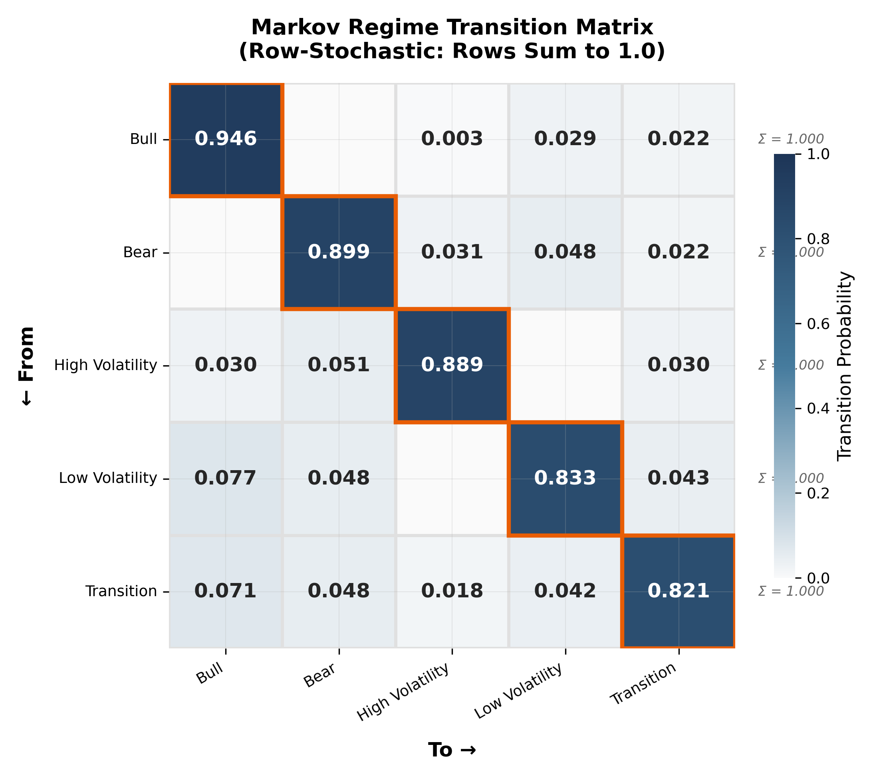
The 5×5 row-stochastic matrix quantifies the daily probability of moving from one regime (row) to another (column). Diagonal cells = regime persistence.

Transition Probabilities
From \ To | Bull | Bear | High Vol | Low Vol | Transition
Bull | 0.946 | 0.000 | 0.003 | 0.029 | 0.022
Bear | 0.000 | 0.899 | 0.031 | 0.048 | 0.022
High Vol | 0.030 | 0.051 | 0.889 | 0.000 | 0.030
Low Vol | 0.077 | 0.048 | 0.000 | 0.833 | 0.043
Transition | 0.071 | 0.048 | 0.018 | 0.042 | 0.821

Key Findings
Bull is most persistent (P = 0.946): Expected duration ~18.5 days (empirical: 18.4 days). Bull almost never transitions directly to Bear (P = 0.000).
Bear is highly sticky (P = 0.899): Expected duration ~9.9 days. Exit path is primarily through Low Volatility (P = 0.048), not a direct jump to Bull (P = 0.000).
No direct Bull ↔ Bear transitions: P(Bull→Bear) = 0.000 and P(Bear→Bull) = 0.000. The market always passes through an intermediate state before reversing direction — validating the multi-factor approach.
High Volatility escalation risk: P(High Vol → Bear) = 0.051 > P(High Vol → Bull) = 0.030. Volatility spikes are more likely to resolve into bear markets consistent with the leverage effect.
Transition as a "crossroads": Lowest persistence (P = 0.821) with balanced exit probabilities: P(→Bull) = 0.071, P(→Bear) = 0.048. A genuine indeterminate regime.

Average Regime Durations (Empirical)
Regime | Mean (days) | Episodes | Max | Min
Bull | 18.4 | 32 | 82 | 1
Bear | 9.9 | 23 | 44 | 1
High Volatility | 8.3 | 12 | 30 | 1
Low Volatility | 6.0 | 35 | 24 | 1
Transition | 5.6 | 30 | 38 | 1

5. 3D Regime Surface
The interactive 3D scatter plot maps every trading day into the feature space: X = σ₃₀ (30-day volatility), Y = MOM₃₀ (30-day momentum), Z = % Above 50-DMA (breadth).

Axis Mapping
Axis | Feature | Paper Reference
X | σ₃₀ (30-day annualised volatility) | §3.5.2
Y | MOM₃₀ (30-day momentum) | §3.2.1, Eq. 3
Z | % Above 50-DMA (market breadth) | §3.4.2, Eq. 19

Key Findings
Distinct cluster separation: Bull: low σ₃₀ (8–15%), positive momentum, high breadth (60–98%). Bear: moderate σ₃₀, negative momentum, low breadth (12–40%). High Vol: highest σ₃₀ (17–27%), variable momentum.
Breadth provides critical discrimination: Bull and Bear can overlap on volatility (~12%), but are perfectly separated on breadth: Bull > 60%, Bear < 40%.
High Volatility spans full breadth range: Volatility spikes occur in both broad rallies and sharp sell-offs a key distinction from Bear markets.
Intermediate regimes occupy the centre: Low Volatility and Transition clusters sit in the boundary region between Bull and Bear, consistent with the transition matrix finding.

4. Synthesis & Conclusive Evidence

Validation Against the Research Paper
Paper Claim | Visualization Evidence
σ₃₀ ≫ σ₉₀ signals regime transition (§3.5.4) | Plot 1: Every Bull→Bear transition preceded by σ₃₀ crossing above σ₉₀
>70% above 50-DMA = broad uptrend (§3.4.2) | Plots 1 & 4: Bull regimes average 77.6% breadth
<30% above 50-DMA = weakness (§3.4.2) | Plot 4: All Bear cluster points below 40% on Z-axis
Multi-factor prevents look-ahead bias (§3.2.3) | Plot 3: No direct Bull↔Bear jumps — regimes evolve through intermediate states
Log returns improve volatility estimation (§3.5.1) | Plot 2: HMM produces near-binary posteriors — clean feature separation

Final Conclusions
Conclusion 1 - Regime Persistence is Real and Quantifiable: All five regimes exhibit strong autocorrelation (diagonal P ≥ 0.821). Bull markets are most persistent (P = 0.946, avg 18.4 days). Momentum signals during Bull have >94% probability of remaining valid.
Conclusion 2 - Transitions are Orderly, Not Random: The market never jumps from Bull to Bear directly. It always passes through intermediate states first, providing a leading indicator framework with asymmetric risk profiles.
Conclusion 3 - Multi-Factor Approach is Superior: No single indicator cleanly separates all five regimes. The combination of σ₃₀, momentum, and breadth creates well-separated clusters in the 3D feature space, validating §3.6.
Conclusion 4 - HMM Model is Well-Calibrated: The 4-state Gaussian HMM produces near-binary posteriors (>0.9). Ambiguous periods correspond to genuinely uncertain markets. Latent states align with rule-based classification.

5. Implications for Strategy Design
- Momentum strategies (§3.2) should activate during Bull regimes (σ₃₀ < 15%, breadth > 70%, mom₃₀ > 0) and deactivate upon Transition or Low Volatility signals.
- Low-volatility screening (§3.5.3) is most effective during Low Volatility regimes where defensive positioning is appropriate.
- Risk management should escalate when the model signals a shift from Bull/Low-Vol to Transition, as Bear probability rises to 4.8% per day.
- The High Volatility regime (σ₃₀ > 20%) represents the highest-risk environment — reduce position sizes and widen stop-losses.

