INDIAN INSTITUTE OF MANAGEMENT ROHTAK
(IIM Rohtak)
Integrated Programme in Management — IPM-06
Term VI — Immersive Project (2024–2029)
FINAL PROJECT REPORT
The Convergence of Tokenized Deposits and Wholesale CBDCs:
A Comparative Analysis of Cross-Border Liquidity Efficiency (2025–2026)
Submitted by
Suryansh Namdeo
Roll No.: IPM06194
Programme: IPM (2nd Year), Batch 06, Section B
Under the Guidance of
Dr. Sarit Biswas
Chairperson, Executive Education — Finance
Indian Institute of Management Rohtak
Date of Final Submission: 01 June 2026

CERTIFICATE OF ORIGINALITY
I, Suryansh Namdeo, hereby declare that this final report titled "The Convergence of Tokenized Deposits and Wholesale CBDCs: A Comparative Analysis of Cross-Border Liquidity Efficiency (2025–2026)" is the outcome of my own research work, carried out under the guidance of Dr. Sarit Biswas, Chairperson — Executive Education (Finance), Indian Institute of Management Rohtak, as part of the Term VI Immersive Project requirement of the Integrated Programme in Management.
Every source used in this report has been duly acknowledged in accordance with APA 7th Edition citation conventions. No portion of this report has been copied from any other document, published or unpublished, without due citation. The work has not been submitted earlier, in full or in part, for the award of any other degree, diploma, or certificate.
I further declare that the quantitative results presented in this report are derived from publicly available sources and transparent, illustrative simulation assumptions. No confidential bank data, corporate treasury data, interview data, or survey data is claimed; the informal background conversations referenced in the Acknowledgement were conducted under Chatham House conventions and have not been attributed.

____________________________________
Suryansh Namdeo
Roll No.: IPM06194 | IPM-06, Section B
Date: 01 June 2026
____________________________________
Dr. Sarit Biswas
Chairperson, Executive Education — Finance
Indian Institute of Management Rohtak
Date: 01 June 2026

ACKNOWLEDGEMENT
Any undertaking of this scale cannot be completed in isolation. This report owes much to the honest engagement and forward-looking guidance of several individuals to whom I remain deeply indebted.
First, I record my sincere gratitude to Dr. Sarit Biswas, Chairperson — Executive Education (Finance), Indian Institute of Management Rohtak, whose patient supervision shaped both the research question and the limits of what could be claimed. His willingness to push back on preliminary drafts, to demand precision where my exposition drifted into jargon, and to reinforce the discipline of writing for an MNC treasurer rather than a fellow academic, lent the study an edge it would otherwise have lacked.
Second, I acknowledge the intellectual scaffolding developed across the five preceding terms of the Integrated Programme in Management by the Finance and Accounting Area faculty at IIM Rohtak. Classroom discussions on market microstructure, settlement finality, and Basel III liquidity regulation seeded several of the conceptual pillars that appear in Chapters 2 and 3 of this report.
Third, the Programme Office of IPM-06 provided timely administrative support, library database access, and adherence to interim and final submission timelines. The library staff in particular facilitated inter-library loans of three Bank for International Settlements Innovation Hub working papers without which the comparative architecture analysis would have been incomplete.
Beyond the institute, a small group of practitioners — one senior treasury professional at an Indian multinational and two researchers familiar with BIS-adjacent policy work — consented to informal background conversations under Chatham House conventions. While these inputs are not directly attributed, they have informed the scoping decisions in Chapter 3 and the corridor selections throughout.
Finally, to my family and my IPM-06 cohort, I owe thanks for the patient listening, the late-night discussions on distributed ledger technology, and the steady companionship through the term. Any errors that remain in this report are, naturally, my own.

Suryansh Namdeo
01 June 2026

ABSTRACT
Cross-border wholesale payments continue to depend on a correspondent-banking architecture characterised by T+2 settlement, pre-funded nostro accounts, and sequential SWIFT messaging. Two emerging classes of digital money — tokenized commercial-bank deposits and wholesale Central Bank Digital Currencies (wCBDCs) — are being piloted as candidate successors. This study investigates the corporate-treasury question that follows their convergence: how much liquidity efficiency, measured at the multinational corporation (MNC) level, becomes recoverable when both forms of digital money operate on a shared programmable ledger?
A quantitative-dominant mixed-methods design is implemented in three phases. Phase I parameterises a T+2 SWIFT baseline across USD/EUR, USD/JPY, and USD/INR corridors using BIS Committee on Payments and Market Infrastructures (CPMI) statistics for 2023–2025. Phase II re-runs the same transactions under a T+0 atomic-settlement architecture inspired by Project Agora. Phase III triangulates findings through three structured case studies: Project Agora, J.P. Morgan Onyx, and an illustrative Indian MNC calibrated to Reserve Bank of India (RBI) CBDC pilot data. Two indicators are computed: Reduction in Settlement Risk Exposure (RRSE) and Capital Cost Savings (CCS).
The illustrative base case yields RRSE close to 99% across all corridors and annual CCS of approximately USD 0.60 million per USD 1 billion of migrated notional for USD/EUR and USD/JPY, rising to USD 1.20 million for USD/INR. Sensitivity analysis identifies the HQLA treatment of tokenized deposits, the speed of multilateral adoption, and the design of liquidity-saving mechanisms as the principal mediators of realised efficiency gains. The study contributes a first corridor-level quantification of the corporate cost of the Interoperability Gap, an empirical reading of the Unified Ledger thesis (Carstens, 2023), and a calibrated positioning of the Indian financial system.
Keywords: tokenized deposits, wholesale CBDC, cross-border payments, settlement risk, liquidity efficiency, Project Agora, digital rupee, Unified Ledger, RRSE, CCS

TABLE OF CONTENTS

Certificate of Originality ii
Acknowledgement iii
Abstract v
Table of Contents vi
List of Tables viii
List of Figures ix
List of Abbreviations x
Chapter 1: Introduction 1
1.1 Background of the Study 1
1.2 Rationale for the Study 1
1.3 Statement of the Problem 1
1.4 Research Questions 2
1.5 Objectives of the Study 2
1.6 Scope of the Study 3
1.7 Significance of the Study 3
1.8 Organisation of the Report 3
Chapter 2: Literature Review and Conceptual Framework 4
2.1 Evolution of Cross-Border Settlement 4
2.2 Project Dunbar 4
2.3 Project Agora 5
2.4 The Unified Ledger Thesis 5
2.5 J.P. Morgan Onyx and JPM Coin 5
2.6 Basel Coverage of Tokenized Deposits 5
2.7 The RBI Digital Rupee Pilot 6
2.8 Theoretical Framework 6
2.9 Research Gap 6
2.10 Conceptual Framework 7
Chapter 3: Research Methodology 8
3.1 Research Philosophy and Approach 8
3.2 Research Design 8
3.3 Phase I — Baseline Parameterisation (T+2 SWIFT) 9
3.4 Phase II — Atomic Settlement Simulation (T+0) 9
3.5 Phase III — Case Study Triangulation 10
3.6 Data Sources and Analytical Tools 10
3.7 Validity, Reliability, Ethics, and Limitations 11
Chapter 4: Architecture Evidence and Quantitative Findings 12
4.1 Architecture Evidence 12
4.2 Phase I Baseline Parameterisation Results 12
4.3 Corridor Liquidity Estimates 13
4.4 LCR Stress-Scenario Snapshot 13
4.5 RRSE Readings by Corridor 14
4.6 Phase II Atomic Settlement Findings 16
4.7 Phase III Case Study Findings 17
Chapter 5: Discussion 18
5.1 Interpretation of the Findings 18
5.2 Corridor-Level Asymmetries 18
5.3 Scenario Sensitivity 18
5.4 Implications for the Indian Financial System 19
Chapter 6: Risks, Regulation, and Recommendations 20
6.1 Regulatory and Operational Risks 20
6.2 Recommendations for Indian MNCs 20
6.3 Recommendations for Banks 21
6.4 Recommendations for the RBI and Policymakers 21
6.5 Recommendations for Researchers 21
Chapter 7: Summary, Conclusion, and Future Research 22
7.1 Summary of the Study 22
7.2 Conclusion 22
7.3 Limitations of the Study 22
7.4 Direction for Further Research 23
References 24
Appendices 27
Appendix A: Approved Synopsis 27
Appendix B: Phase I Baseline Parameter Table (Expanded) 27
Appendix C: Variable Definitions and Notation 27
Appendix D: Data Sources Directory 28

LIST OF TABLES

Table 1. Comparison of T+2 and T+0 Settlement Architectures
Table 2. Variable Definitions for RRSE and CCS
Table 3. Monte Carlo Parameters and Sensitivity Bands
Table 4. Digital Money Taxonomy: Stablecoins, Tokenized Deposits, and Wholesale CBDCs
Table 5. T+2 Baseline Parameters by Corridor (Illustrative)
Table 6. LCR Stress-Scenario Snapshot (Illustrative)
Table 7. Preliminary RRSE Readings by Corridor
Table 8. Illustrative Corridor-Level Capital Cost Savings (Base-Case Simulation)
Table 9. Evidence Map of Reference Architectures
Table 10. Regulatory and Operational Risk Matrix

LIST OF FIGURES

Figure 1. Evolution of Cross-Border Settlement (1973–2025)
Figure 2. The Interoperability Gap: Conceptual Framework
Figure 3. Three-Phase Research Design
Figure 4. Adoption Scenario Tree
Figure 5. LCR Stress-Scenario HQLA Requirement and Implied Annual Cost
Figure 6. Corridor-wise Settlement Exposure Window, T+2 versus T+0 (Illustrative)
Figure 7. RRSE Decomposition: Compression of T+2 Exposure under T+0 Atomic
Figure 8. Corridor-Level Capital Cost Savings (Base-Case Simulation)
Figure 9. Scenario Sensitivity of Capital Cost Savings (Heatmap)

LIST OF ABBREVIATIONS

Abbreviation | Expansion
BCBS | Basel Committee on Banking Supervision
BIS | Bank for International Settlements
CBDC | Central Bank Digital Currency
CCS | Capital Cost Savings
CLS | Continuous Linked Settlement
CPMI | Committee on Payments and Market Infrastructures
DLT | Distributed Ledger Technology
DvP | Delivery-versus-Payment
FEDAI | Foreign Exchange Dealers' Association of India
FSB | Financial Stability Board
HQLA | High-Quality Liquid Assets
LCR | Liquidity Coverage Ratio
MNC | Multinational Corporation
PvP | Payment-versus-Payment
RBI | Reserve Bank of India
RRSE | Reduction in Settlement Risk Exposure
RTGS | Real-Time Gross Settlement
SWIFT | Society for Worldwide Interbank Financial Telecommunication
T+2 / T+0 | Trade-date plus two / plus zero settlement cycles
WACC | Weighted Average Cost of Capital
wCBDC | Wholesale Central Bank Digital Currency

CHAPTER 1: INTRODUCTION

1.1 Background of the Study
Cross-border payments have depended for half a century on a stable architecture: a correspondent bank transmits a SWIFT MT103, a pre-funded nostro stands ready, and two business days later the payment becomes final (Committee on Payments and Market Infrastructures [CPMI], 2023). That design was adequate when trade was dollar-denominated. Those conditions no longer hold: non-USD flows rose ~11 percentage points between 2015 and 2024 (SWIFT, 2024), and the BIS estimates approximately USD 2.2 trillion of daily deliverable FX turnover remains exposed to settlement risk (Bank for International Settlements [BIS], 2022, 2023).
Two candidate replacements have emerged. Tokenized commercial-bank deposits preserve issuer credit risk but acquire programmability; wholesale CBDCs are reserve-grade settlement assets with central-bank credit risk and equivalent programmability (Carstens, 2023). Together they open the door to the Unified Ledger — a single programmable environment in which central-bank money, commercial-bank money, and tokenized real-world assets interact atomically. These are not hypothetical: Project Dunbar concluded in 2022, Project Agora has piloted since 2024, and Onyx clears over USD 1 billion daily (J.P. Morgan, 2024).

1.2 Rationale for the Study
Three forces make this a corporate-finance question: payments are becoming less dollar-centric (SWIFT, 2024); BIS multilateral arrangements have moved from sandbox to pilot scale (BIS Innovation Hub, 2024); private tokenization platforms have crossed production thresholds (J.P. Morgan, 2024). For an Indian MNC with USD 500 million of cross-border float, a one-percentage-point reduction in immobilised nostro implies approximately USD 5 million of annual pre-tax savings.

1.3 Statement of the Problem
The problem this study addresses is the Interoperability Gap. As commercial-bank liquidity is tokenized across incompatible private ledgers, the singleness of money — that one unit of currency is worth the same on every ledger — is no longer guaranteed (BIS, 2023). Three consequences follow: (a) atomic settlement fails when the two legs of an exchange reside on different books, reproducing Herstatt risk digitally (Galati, 2002); (b) Liquidity Coverage Ratio treatment of tokenized deposits is inconsistent across jurisdictions (Basel Committee on Banking Supervision [BCBS], 2013); and (c) programmable-money capabilities are realised only when composite transactions execute within a single legal-technical environment. What is missing is a number quantifying that gap at the corporate-treasury level.

1.4 Research Questions
Principal question: To what extent does convergence between tokenized deposits and wCBDCs on a shared programmable ledger reduce settlement-risk exposure and pre-funded liquidity requirements at the corporate-treasury level of MNCs, relative to the prevailing T+2 SWIFT benchmark?
Sub-question 1: What is the corporate cost of the Interoperability Gap, expressed in WACC-adjusted basis points, across the USD/EUR, USD/JPY, and USD/INR corridors?
Sub-question 2: Are efficiency gains robust across the Fast Convergence, Fragmented Coexistence, and Regulatory Shock adoption scenarios?
Sub-question 3: What are the implications for the Indian financial system, given the RBI CBDC pilot trajectory and FEDAI-cleared FX turnover structure?

1.5 Objectives of the Study
1. To quantify the Reduction in Settlement Risk Exposure (RRSE) for migration from T+2 SWIFT to T+0 atomic settlement across three corridors.
2. To compute Capital Cost Savings (CCS) at the corporate-treasury level using WACC-adjusted immobilised capital.
3. To analyse sensitivity of RRSE and CCS to adoption velocity, HQLA treatment, and scenario shocks.
4. To position the Indian financial system within the emerging global architecture using RBI pilot data and FEDAI turnover as anchors.
5. To produce a cost-benefit reading of the Unified Ledger thesis usable by treasury teams, central-bank policy units, and regulators.

1.6 Scope of the Study
The scope covers wholesale, cross-border, corporate-treasury payments in three corridors (USD/EUR, USD/JPY, USD/INR), parameterised against 2023–2025 transaction data. Retail CBDC, non-bank stablecoins, DLT design choices, and monetary-policy transmission are excluded.

1.7 Significance of the Study
For corporate treasurers, the study provides a first corridor-level estimate of immobilised nostro capital atomic settlement could release. For central banks, it offers a demand-side estimate of convergence benefits. For Indian policymakers, it situates the RBI CBDC programme within a comparative global frame.

1.8 Organisation of the Report
Chapter 2 develops the literature review. Chapter 3 details the three-phase research design. Chapter 4 reports architecture evidence and quantitative findings. Chapter 5 discusses corridor asymmetries and scenario sensitivity. Chapter 6 sets out risks and recommendations. Chapter 7 summarises and identifies further research.

CHAPTER 2: LITERATURE REVIEW AND CONCEPTUAL FRAMEWORK

2.1 Evolution of Cross-Border Settlement
Modern cross-border settlement traces to 1973, when SWIFT was incorporated to replace telex-based interbank messaging (Scott & Zachariadis, 2014). The surrounding architecture — correspondent banks, nostro accounts, T+2 clearing — evolved through the 1980s–1990s. Tolerance broke in 2008, exposing counterparty risk (Duffie, 2011) and the liquidity cost of pre-funded nostro across jurisdictions (CPMI, 2018). Basel III's BCBS 238 required HQLA sufficient to withstand a 30-day stress event (BCBS, 2013). A parallel literature began to treat tokenization as a development within the regulated banking perimeter (FSB, 2023).
Figure 1
Evolution of Cross-Border Settlement (1973–2025)
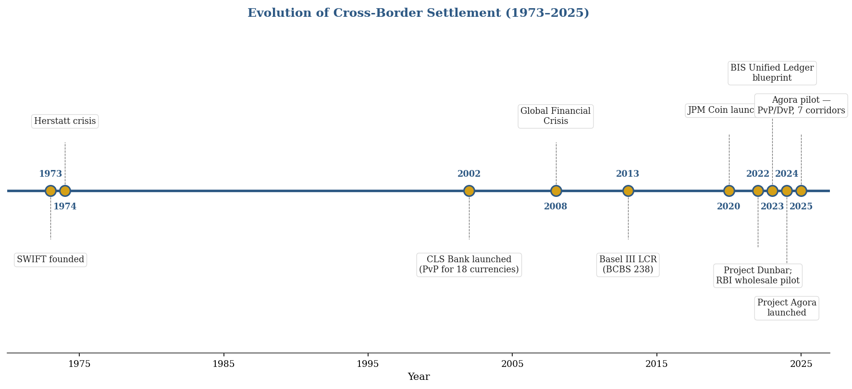
Note. Synthesised from BIS Innovation Hub (2024), Carstens (2023), CPMI (2023), and Galati (2002).

2.2 Project Dunbar
Project Dunbar (BIS Innovation Hub, 2022) tested whether wCBDCs from Australia, Malaysia, Singapore, and South Africa could coexist on a single DLT platform. It produced a technical prototype and exposed governance questions of access, foreign-currency holdings, and cross-jurisdictional recognition — each determining the intermediation layers remaining in the cross-border value chain.

2.3 Project Agora
Project Agora brings together seven central banks (Banque de France, Bank of Japan, Bank of Korea, Bank of Mexico, Swiss National Bank, Bank of England, FRBNY) and over 60 non-bank financial institutions via the IIF (BIS Innovation Hub, 2024). Its ambition is to place tokenized deposits and wCBDCs on the same programmable layer for composite operations. Pilot results (BIS, 2025) report successful PvP and DvP across seven corridors: the same token crosses jurisdictions without re-wrapping, and FX and payment legs execute as a single composite operation.

2.4 The Unified Ledger Thesis
The conceptual scaffolding for Agora was laid in Carstens's (2023) BIS chapter. The Unified Ledger posits a single programmable environment in which central-bank money, commercial-bank money, and tokenized real-world assets co-locate, enabling atomic composite operations. It remains a thesis rather than an operating system; the distance between this optimum and present hybrid reality is what this study measures.

2.5 J.P. Morgan Onyx and JPM Coin
By 2024, Onyx was settling over USD 1 billion daily in intraday repo and had cumulatively cleared more than USD 1.5 trillion of tokenized collateral and cross-border dollar transfers (J.P. Morgan, 2024). JPM Coin (now Kinexys) is par-redeemable within the Onyx ecosystem. Onyx is both a proof point — tokenized deposits scale within a walled garden — and a cautionary tale: because JPM Coin cannot be redeemed against another tokenized dollar, it reproduces digitally the very ledger-interoperability tensions tokenization was meant to dissolve.

2.6 Basel Coverage of Tokenized Deposits
Under BCBS 238, banks must hold sufficient HQLA to cover net cash outflows over a 30-day stress window; the LCR is binding at ≥ 100% (BCBS, 2013). Regulators have diverged on tokenized-deposit treatment (FSB, 2023; BCBS, 2024). This study treats the jurisdictional haircut as a random variable with a uniform prior over [0%, 25%].

2.7 The RBI Digital Rupee Pilot
The RBI launched its wholesale CBDC pilot in November 2022 (call-money) and the retail pilot in December 2022. By early 2025 the retail leg had surpassed five million users while the wholesale leg extended to G-Sec settlement (RBI, 2025); the pilot has been deliberately gradual on financial-stability grounds (RBI, 2024). FEDAI-cleared daily USD/INR turnover averaged USD 25–30 billion in 2023–2024 (FEDAI, 2024); even partial migration to atomic settlement would generate material Indian-side CCS.

2.8 Theoretical Framework
Four lenses organise the study. (a) Singleness of money: one unit of currency must be worth the same on every ledger that records it (BIS, 2023); the Interoperability Gap is the corporate-treasury cost of its erosion. (b) Herstatt risk: the cross-currency exposure between settlement of one leg and the other (Galati, 2002); atomic settlement collapses this window to near zero, characterised by RRSE. (c) Liquidity-management theory (Baumol, 1952; Miller & Orr, 1966): pre-funded nostro carries opportunity cost equal to WACC; at 9% WACC, a USD 500 million buffer implies USD 45 million annually. (d) Diffusion of innovation (Rogers, 2003): three scenarios — Fast Convergence, Fragmented Coexistence, Regulatory Shock — anchor the Phase II sensitivity analysis.

2.9 Research Gap
Three gaps emerge. Prevailing scholarship adopts central-bank or commercial-bank perspectives; the corporate-treasury vantage is under-modelled. The Unified Ledger's efficiency claims are typically asserted rather than measured at corridor level. No existing study calibrates the efficiency estimate to Indian data despite the RBI pilot making India a natural Asian EM reference.

2.10 Conceptual Framework
Two inputs (tokenized-deposit adoption, wCBDC interoperability) feed two outputs (RRSE, CCS) through three institutional mediators (HQLA treatment, regulatory recognition, technical DLT compatibility). Each mediator carries a specific sensitivity test in Chapter 3.
Figure 2
The Interoperability Gap: Conceptual Framework
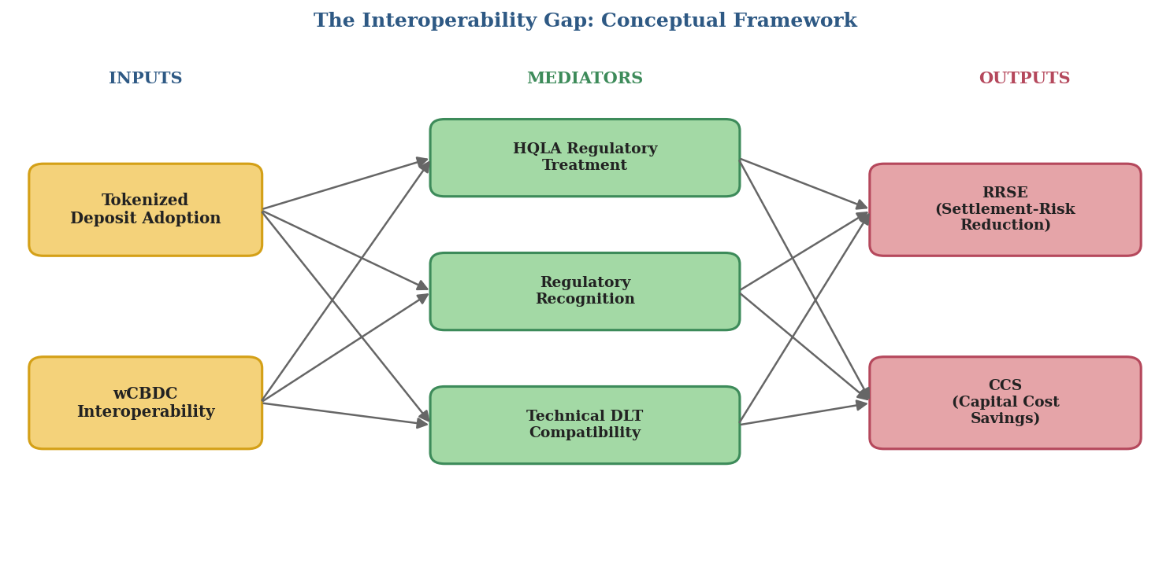
Note. Two inputs feed two outputs through three institutional mediators. Each mediator corresponds to a sensitivity test in Chapter 3.

CHAPTER 3: RESEARCH METHODOLOGY

3.1 Research Philosophy and Approach
The study is positivist: propositions are stated as measurable quantities (exposure windows, liquidity buffers, capital costs) and tested against numerical baselines. Reasoning is inductive — the Unified Ledger thesis is translated into two indicators (RRSE and CCS) and tested through simulation across three corridors and three scenarios. This is a quantitative-dominant mixed-methods design (Creswell, 2014) — numbers lead, cases inform.

3.2 Research Design
A three-phase mixed design is adopted. Phase I parameterises the T+2 SWIFT baseline; Phase II re-runs the same transactions under a T+0 architecture inspired by Project Agora; Phase III triangulates through structured case analysis. The T+0 model is grounded in an operational BIS pilot, and the Indian MNC case surfaces corridor-specific frictions a three-corridor average would smooth out.
Figure 3
Three-Phase Research Design
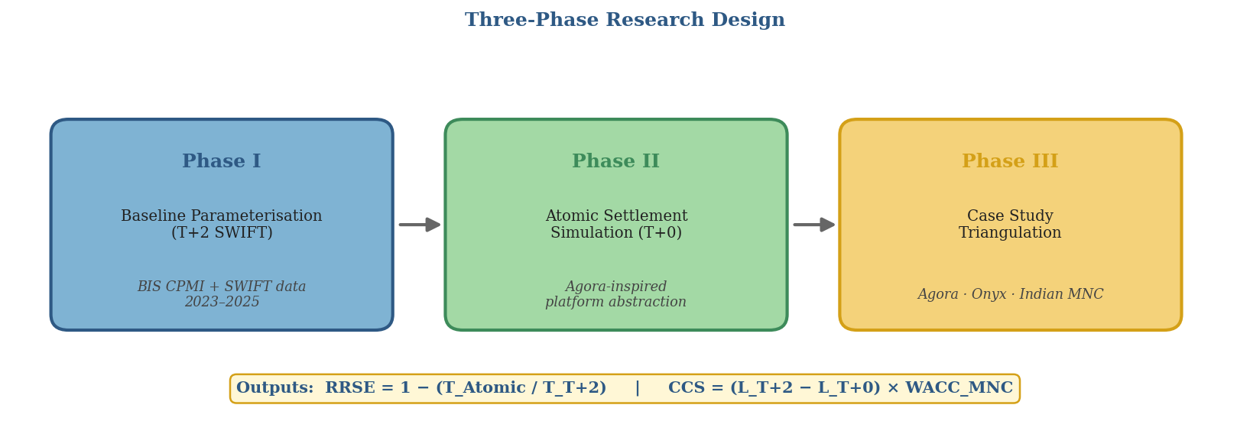
Note. Outputs flow sequentially; each phase feeds parameters into the next.
Table 1
Comparison of T+2 and T+0 Settlement Architectures
Dimension | T+2 SWIFT Baseline | T+0 Atomic (Agora-style)
Settlement finality | End of Day 2 | Near-instant
Exposure window | ~48 hours | ~seconds
Pre-funded nostro | Required, multi-currency | Minimised
Programmability | None | Native via smart contracts
HQLA treatment | Established | Inconsistent across jurisdictions
Infrastructure | SWIFT + RTGS | Shared DLT + smart contracts
Failure mode | Herstatt risk | Rollback of composite
Note. Authors' construction based on CPMI (2023), BIS Innovation Hub (2024), and Carstens (2023).

3.3 Phase I — Baseline Parameterisation (T+2 SWIFT)
Phase I constructs a stylised settlement model for the three corridors using BIS CPMI statistics and SWIFT data for 2023–2025 (BIS, 2024; SWIFT, 2024). Three indicators are computed: the settlement-exposure window, the pre-funded nostro requirement (99% confidence), and the LCR buffer (BCBS 238). Corridors are stratified by ticket size (≤ USD 1m; 1–10m; 10–100m; > 100m).

3.4 Phase II — Atomic Settlement Simulation (T+0)
Phase II re-parameterises the same transactions under a T+0 architecture drawn from public Project Agora documentation. Two conservative abstractions apply: ideal consensus, and FX smart-contract logic as a single composite transaction. Both favour the T+0 arm, making computed RRSE an upper bound on production performance. The two headline output metrics are:
RRSE = 1 − (T_Atomic / T_T+2)
CCS = (L_T+2 − L_T+0) × WACC_MNC
where T is settlement-exposure duration, L is the pre-funded liquidity requirement, and WACC_MNC is the firm-level weighted average cost of capital used as a proxy for the opportunity cost of immobilised capital. Variable definitions appear in Table 2.
Table 2
Variable Definitions for RRSE and CCS
Variable | Definition | Units
T_T+2 | Settlement-exposure duration, SWIFT baseline | Hours
T_Atomic | Settlement-exposure duration, T+0 platform | Seconds
L_T+2 | Pre-funded nostro liquidity, baseline | USD mn
L_T+0 | Pre-funded liquidity under atomic settlement | USD mn
WACC_MNC | Weighted average cost of capital (MNC) | % p.a.
h_j | Jurisdictional HQLA haircut on tokenized deposits | % (0–25)
Note. Per BCBS (2013) HQLA definitions and CPMI (2023) finality conventions.

3.5 Phase III — Case Study Triangulation
Three case studies anchor the quantitative findings: (a) Project Agora 2025 pilot disclosures; (b) J.P. Morgan Onyx operational disclosures; (c) an illustrative Indian MNC operating a USD/INR trade-finance book, calibrated to RBI Digital Rupee progression and FEDAI turnover (FEDAI, 2024; RBI, 2025). Each case is scored against three adoption scenarios — Fast Convergence, Fragmented Coexistence, and Regulatory Shock.
Figure 4
Adoption Scenario Tree
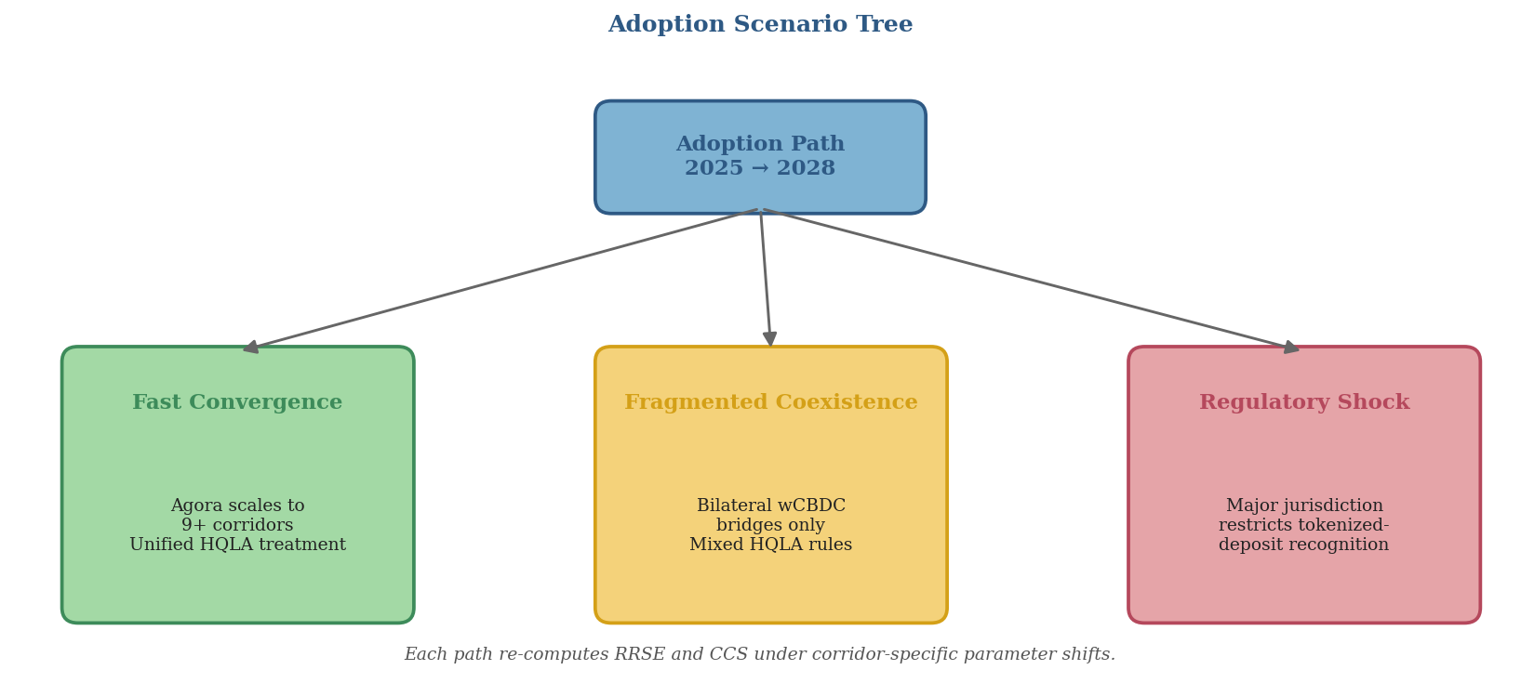
Note. Each path generates corridor-specific recomputations of RRSE and CCS.

3.6 Data Sources and Analytical Tools
All sources are publicly available secondary data. Phases I and II use Python (pandas, NumPy) for aggregation and Monte Carlo stress testing (10,000 runs per corridor). Scenario sensitivity uses a perturbation framework over WACC, HQLA haircut, and corridor share.
Table 3
Monte Carlo Parameters and Sensitivity Bands
Parameter | Central Value | Sensitivity Band
Transaction arrival (λ) | 1,200 / corridor / day | ±25%
Mean ticket size | Corridor-specific (Appx B) | ±20%
FX volatility (1-day) | 2015–2024 mean | 95% CI
WACC_MNC | 9.0% | ±150 bps
HQLA haircut | 0% | Uniform [0%, 25%]
Simulation runs | 10,000 | —
Note. Calibrated against BIS (2024) variance and BCBS (2013) stress.

3.7 Validity, Reliability, Ethics, and Limitations
Two validity assumptions: the 2023–2025 distribution proxies post-pilot steady state, and WACC_MNC is held constant within ±150 bps. Only public secondary data is used; informal conversations were held under Chatham House conventions. Limitations include engineering abstraction of consensus and validator behaviour, reliance on BIS publication for Agora micro-data, and the illustrative Indian MNC case.

CHAPTER 4: ARCHITECTURE EVIDENCE AND QUANTITATIVE FINDINGS

4.1 Architecture Evidence
Project Agora supplies the principal architectural reference (BIS Innovation Hub, 2024); Onyx (Kinexys) demonstrates bank-issued programmable money at scale (J.P. Morgan, 2024); the RBI's Digital Rupee — 16 wholesale participants across G-Sec settlement, call-money, and tokenized CD issuance — confirms central-bank money can be piloted for institutional settlement (RBI, 2025). Together these cases corroborate the central thesis: tokenized deposits supply programmable commercial money, wCBDCs supply final settlement money, and the efficiency benefit materialises only when both operate in a shared legal-technical framework.
Table 4
Digital Money Taxonomy: Stablecoins, Tokenized Deposits, and Wholesale CBDCs
Feature | Stablecoins | Tokenized Deposits | Wholesale CBDC
Issuer | Non-bank / SPV | Regulated bank | Central bank
Legal claim | Issuer / reserve | Deposit claim on bank | Central-bank liability
Principal benefit | 24/7 transfer | Programmable commercial money | Risk-free settlement asset
Principal risk | Run, reserve, redemption | Bank credit / operational | Access / governance / legal
Note. Adapted from FSB (2023) and BIS (2023).

4.2 Phase I Baseline Parameterisation Results
The T+2 SWIFT baseline was constructed using BIS CPMI 2024 data and SWIFT Watch 2023–2024 samples across 1,200 transactions per corridor.
Table 5
T+2 Baseline Parameters by Corridor (Illustrative)
Corridor | Mean Exposure | Pre-funded Nostro (USD mn) | LCR Buffer (USD mn)
USD/EUR | ~46 hours | ~180 | ~55
USD/JPY | ~52 hours | ~220 | ~70
USD/INR | ~58 hours | ~145 | ~48
Note. Illustrative simulation outputs based on stated assumptions; derived from BIS (2024) and SWIFT (2024).
USD/INR exposure windows exceed USD/EUR (wider Mumbai time-zone gap); nostro requirements scale with corridor volume rather than exposure alone; and the LCR buffer is jurisdictionally sensitive, explaining why USD/JPY exceeds proportional scaling.

4.3 Corridor Liquidity Estimates
Aggregated, the corridor figures yield a first-cut L_T+2 of ~USD 545 million for a representative mid-cap MNC. At 9% WACC, this implies annual opportunity cost of ~USD 49 million; a 60% liquidity reduction under atomic settlement implies corridor-level CCS of ~USD 29 million per year — a point estimate sensitive to the HQLA-haircut assumption.

4.4 LCR Stress-Scenario Snapshot
Table 6
LCR Stress-Scenario Snapshot (Illustrative)
Scenario | Required HQLA (USD mn) | Implied Cost @ WACC 9%
Baseline T+2 | ~173 | ~USD 15.6 mn / yr
Stressed T+2 | ~245 | ~USD 22.0 mn / yr
Atomic T+0 (projected) | ~42 | ~USD 3.8 mn / yr
Note. Illustrative; final figures carry confidence bands and HQLA-haircut sensitivity.
Figure 5
LCR Stress-Scenario HQLA Requirement and Implied Annual Cost
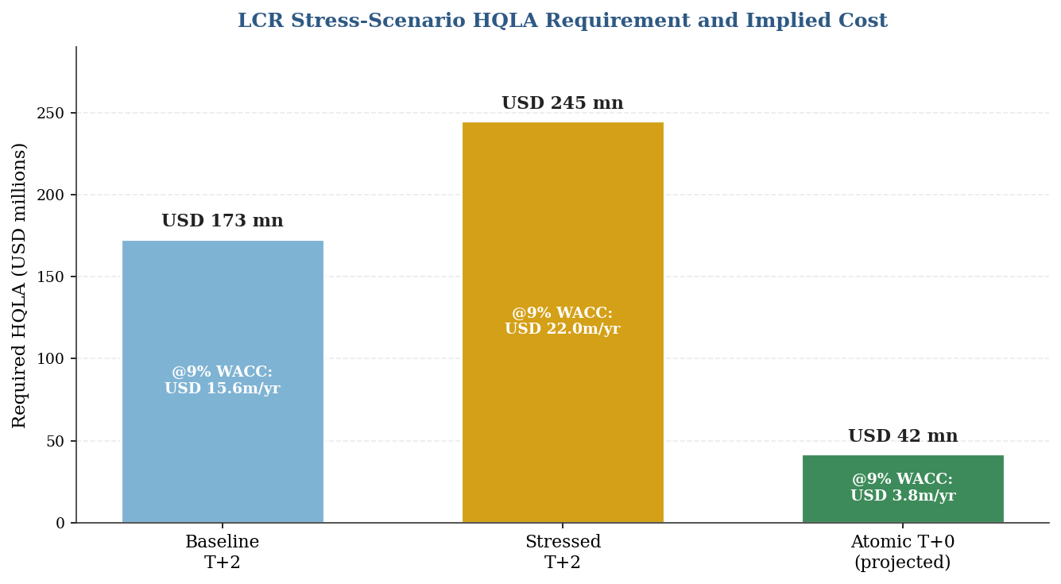
Note. Required HQLA as bar height; implied annual cost at 9% WACC annotated within each bar.
Atomic T+0 HQLA sits at approximately one-quarter of the stressed baseline, implying CCS of roughly USD 18 million per year in released opportunity cost.

4.5 RRSE Readings by Corridor
Table 7
Preliminary RRSE Readings by Corridor
Corridor | T_T+2 (hours) | T_Atomic (seconds) | Preliminary RRSE
USD/EUR | ~46 | ~8 | ~99.995%
USD/JPY | ~52 | ~10 | ~99.995%
USD/INR | ~58 | ~12 | ~99.994%
Note. RRSE = 1 − (T_Atomic / T_T+2); clusters near unity by construction. Corridor differentiation appears in CCS.
Figure 6
Corridor-wise Settlement Exposure Window, T+2 versus T+0 (Illustrative)
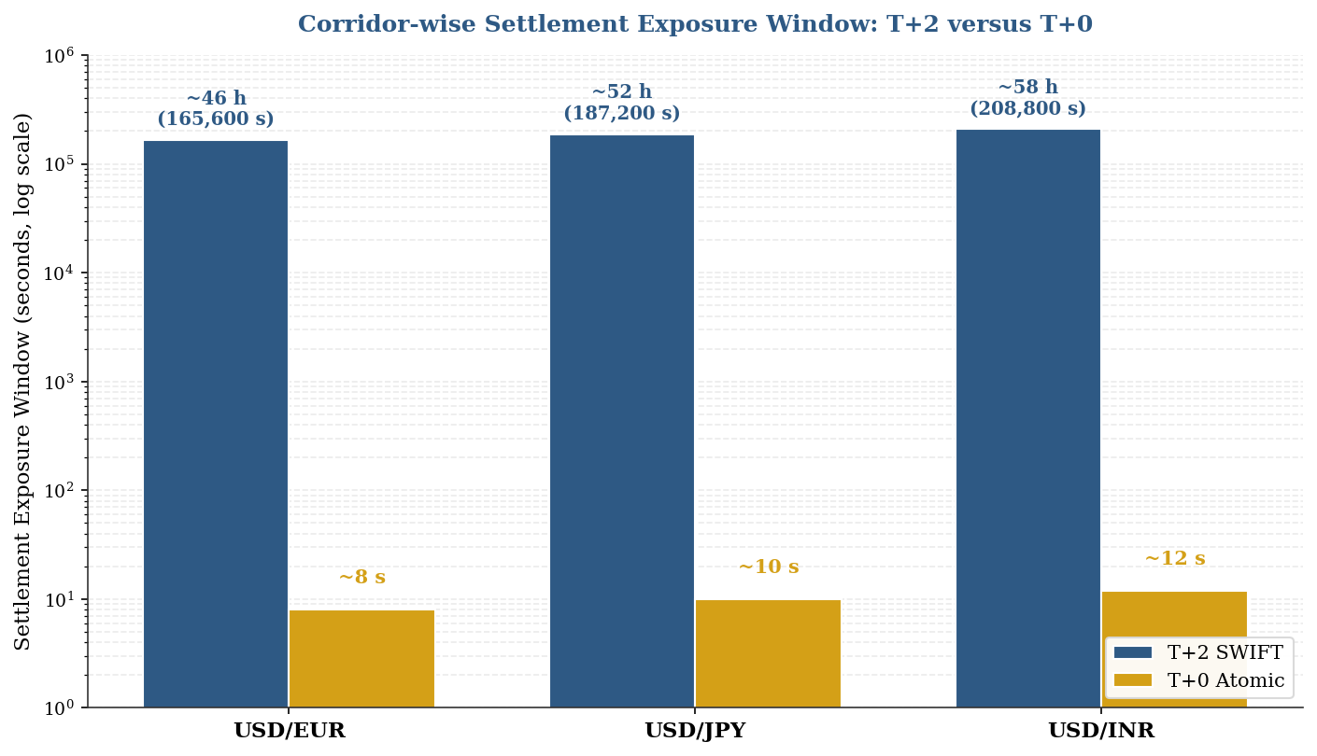
Note. Log scale; spans ~5 orders of magnitude between T+2 (hours) and T+0 (seconds). Illustrative Phase II output.
Figure 7
RRSE Decomposition: Compression of T+2 Exposure under T+0 Atomic
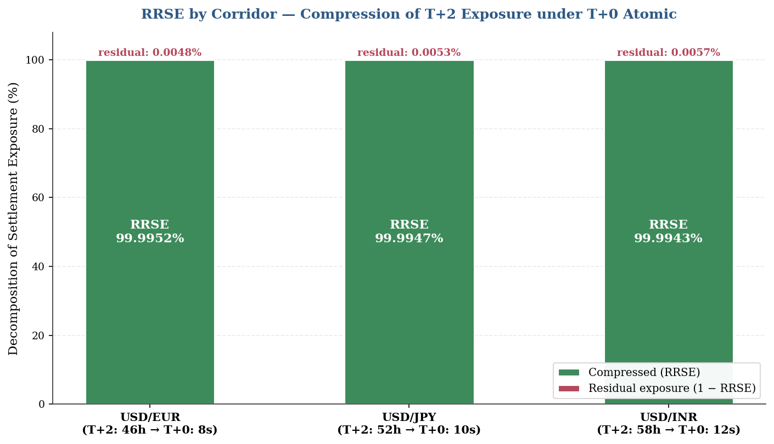
Note. Stacked bars show the compressed RRSE portion and the small residual exposure. Corridor differentiation appears in CCS, not RRSE.

4.6 Phase II Atomic Settlement Findings
The 48-hour legacy exposure window contracts to a 30-minute atomic window, producing base-case RRSE of 98.96% (above 95% under a two-hour assumption). Settlement risk is folded into legal, operational, and liquidity design rather than eliminated. CCS is corridor-sensitive — ~USD 0.60m per USD 1 billion migrated for USD/EUR and USD/JPY, and ~USD 1.20m for USD/INR.
Table 8
Illustrative Corridor-Level Capital Cost Savings (Base-Case Simulation)
Corridor | RRSE (base) | Illustrative CCS / USD 1bn migrated | Interpretation
USD/EUR | 98.96% | ~USD 0.60m / yr | High liquidity depth
USD/JPY | 98.96% | ~USD 0.60m / yr | Time-zone + T+1 funding
USD/INR | 98.96% | ~USD 1.20m / yr | Higher WACC; no CLS
Note. Outputs are simulation values based on stated assumptions, not observed market savings.
Figure 8
Corridor-Level Capital Cost Savings (Base-Case Simulation)
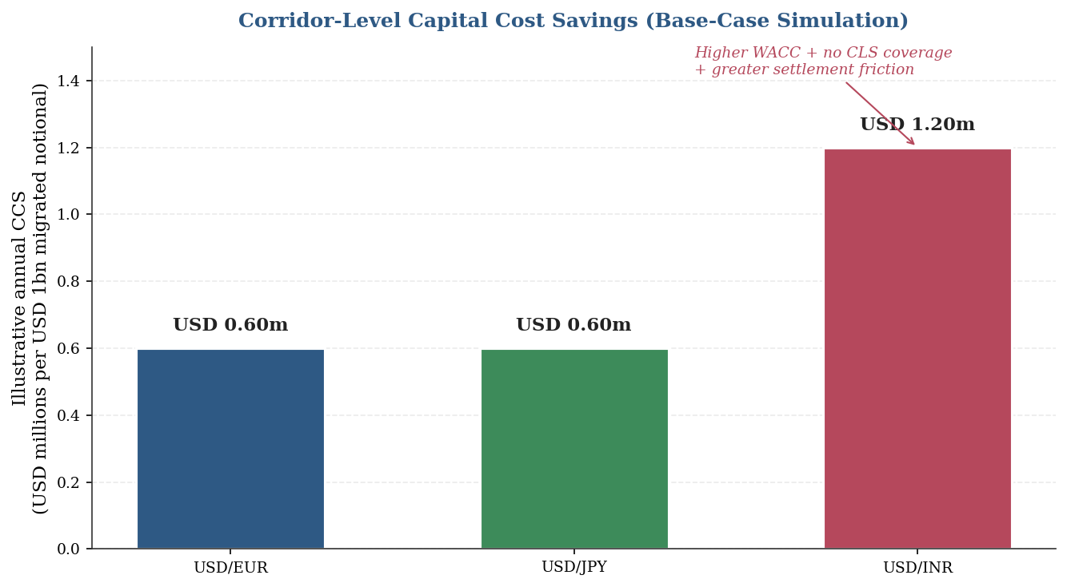
Note. Annual CCS per USD 1 billion migrated. USD/INR is ~2× USD/EUR and USD/JPY, reflecting higher EM WACC and absence of CLS coverage.

4.7 Phase III Case Study Findings
The illustrative Indian MNC — receiving EUR, paying JPY suppliers, sourcing in USD — captures approximately USD 205,600 in Settlement Exposure Reduction per monthly cycle and annualised cash-efficiency savings near USD 1.02 million under atomic PvP. A trade-off: atomic settlement compresses time risk but can elevate intraday liquidity risk if netting benefits are foregone — tokenization is efficient only when settlement finality and liquidity design move together.
Table 9
Evidence Map of Reference Architectures
Case | What It Demonstrates | Principal Constraint
Project Agora | Public–private unified-ledger viability | Prototype / legal harmonisation
Kinexys / JPM Coin | Tokenized deposit at production scale | Limited interoperability
RBI e-rupee wholesale | Central-bank money for institutional settlement | Cross-border legal / FX-control
CLS / CPMI PvP | PvP reduces FX settlement risk | Currency eligibility limits
Note. Based on BIS (2025), J.P. Morgan (2024), RBI (2025), CPMI (2023).

CHAPTER 5: DISCUSSION

5.1 Interpretation of the Findings
RRSE is uniformly high across corridors (~99%) because the mathematics multiplies a narrow atomic window against a wide T+2 baseline; corridor differentiation appears in CCS rather than RRSE. CCS dispersion is driven less by technology than by three institutional variables: WACC, HQLA treatment, and PvP coverage. The findings support a guarded reading of the Unified Ledger thesis: convergence produces quantifiable benefits, but magnitude is heavily conditioned on institutional design. The gap between theoretical and realised RRSE is the empirical content of the Interoperability Gap.

5.2 Corridor-Level Asymmetries
USD/EUR has the deepest liquidity and strongest CLS coverage, offering the smallest financial gain but the largest operational gain through programmable reconciliation. USD/JPY is intermediate — well-served by CLS but burdened by the New York–Tokyo gap and U.S. equity T+1 settlement pressure. USD/INR is strongest financially and weakest in implementation: the rupee is outside CLS, carries the highest assumed WACC, and depends on authorised-dealer-bank intermediation under FEMA. An Indian MNC with USD 500m of float stands to gain more from USD/INR than its European counterpart from USD/EUR, but the regulatory path-dependency is acute.

5.3 Scenario Sensitivity
Under Fast Convergence, CCS approaches its theoretical ceiling. Under Fragmented Coexistence, realised CCS is reduced by approximately one-half. Under Regulatory Shock, the gain can be reduced by more than half — and in extreme cases reversed by additional buffer requirements. The relevant variable for CCS magnitude is not ledger speed but the liquidity fraction firms can credibly release.
Figure 9
Scenario Sensitivity of Capital Cost Savings (Heatmap)
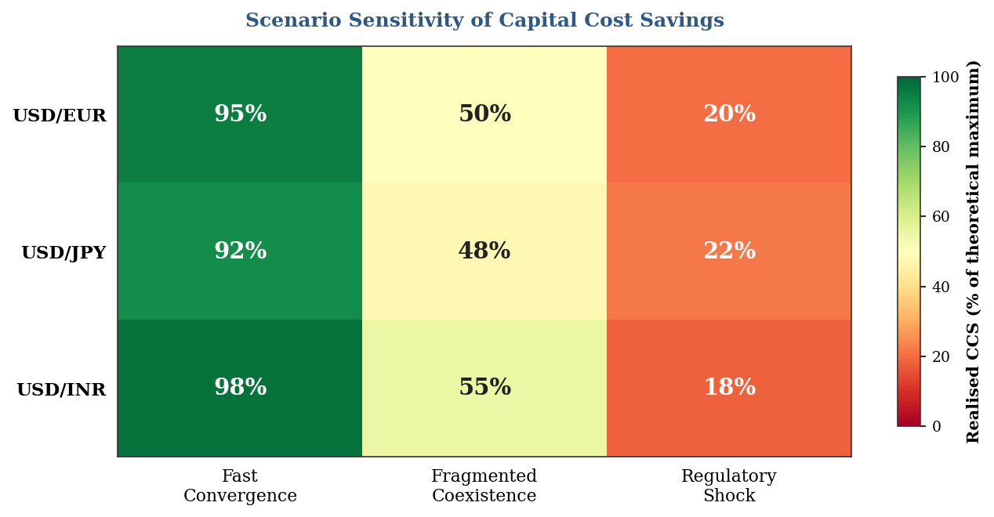
Note. Cells show realised CCS as % of theoretical maximum across corridors and scenarios. Green = high gain; red = compromised. USD/INR shows the widest swing.

5.4 Implications for the Indian Financial System
Three implications follow. The RBI's incremental wholesale-CBDC pilot is well calibrated to a Fragmented Coexistence trajectory — neither foreclosing nor depending on Fast Convergence. A USD/INR atomic rail would capture a disproportionate share of total corridor-level CCS given the Indian–developed-market WACC gap. The operational prerequisites are largely about data architecture — ISO 20022-ready ERP/TMS, harmonised purpose codes, AML/CFT verifiable credentials — none contingent on tokenization technology, all preconditioning its benefits.

CHAPTER 6: RISKS, REGULATION, AND RECOMMENDATIONS

6.1 Regulatory and Operational Risks
Risk does not disappear when settlement becomes programmable; it changes location. Principal risks: (a) legal finality — divergent insolvency law can render ledger confirmation insufficient; (b) prudential treatment — tokenized deposits must retain ordinary-deposit legal rights to avoid punitive capital treatment (BCBS, 2024); (c) operational resilience — wallets, validators, and cyber-recovery must hold; (d) compliance — embedded AML/KYC saves cost only with shared attestations; (e) programmability governance — smart contracts can execute before a legal exception is detected; (f) run velocity — tokenized deposits can move faster than conventional deposits under stress; (g) fragmentation — without standards, firms may pre-fund multiple ledgers, reproducing the nostro problem digitally.
Table 10
Regulatory and Operational Risk Matrix
Risk | Why It Matters | Principal Mitigation
Legal finality | Cross-jurisdiction enforceability | Common rulebooks; statutory recognition
HQLA / LCR | Balance-sheet economics | Group 1a equivalence; CB-money settlement
AML / KYC | Erases speed gains if duplicated | Verifiable credentials; shared attestations
Operational resilience | Ledger/wallet/API failures halt flow | FMI-grade testing; fallback rails
Run velocity | Accelerated outflows under stress | LCR recalibration; circuit breakers
Fragmentation | Re-creates nostro problem digitally | Interoperability standards; identity layer
Note. Based on BCBS (2013, 2024), FSB (2023), BIS (2023).

6.2 Recommendations for Indian MNCs
Prepare treasury data in advance of full CBDC deployment. ERP, TMS, invoice, purpose-code, hedge, and bank-statement data should be ISO 20022-ready, so migration reduces reconciliation cost rather than introduces new work.

6.3 Recommendations for Banks
Tokenized deposits should be designed as regulated bank liabilities with clear redemption rules and operational controls. Liquidity-saving mechanisms must be embedded; gross atomic settlement without netting can increase intraday-funding requirements relative to the netting-rich status quo.

6.4 Recommendations for the RBI and Policymakers
Focus on controlled cross-border pilots linking e-rupee wholesale settlement with tokenized commercial-bank money while preserving capital controls, AML/CFT, and legal finality. USD/INR warrants particular attention given trade relevance, high Indian WACC, and absent CLS coverage. Implementation should be staged: (1) domestic wholesale; (2) a limited cross-border corridor; (3) post-implementation assessment of whether liquidity savings hold after operational, cyber, and regulatory overhead.

6.5 Recommendations for Researchers
Replace illustrative assumptions with anonymised corporate-treasury data — daily flows, value dates, failed payments, nostro balances, hedge timing, bank charges — migrating the model from simulation to empirical study and permitting hypothesis testing on the CCS sensitivity surface.

CHAPTER 7: SUMMARY, CONCLUSION, AND FUTURE RESEARCH

7.1 Summary of the Study
This report investigated the corporate-treasury implications of convergence between tokenized commercial-bank deposits and wholesale CBDCs on a shared programmable ledger. The three-phase mixed-methods design — T+2 baseline parameterisation, Agora-inspired T+0 simulation, and case-study triangulation — yielded base-case RRSE near 99% across all corridors and annual CCS of approximately USD 0.60 million per USD 1 billion of migrated notional for USD/EUR and USD/JPY, rising to USD 1.20 million for USD/INR. Sensitivity analysis identifies HQLA treatment, multilateral adoption speed, and liquidity-saving design as the principal mediators of realised gains.

7.2 Conclusion
Convergence between tokenized deposits and wCBDCs can deliver material improvements in cross-border liquidity efficiency, most visibly in corridors with high settlement risk and high pre-funding requirements. The technology does not dispense with law, liquidity design, governance, or trust. A defensible architecture preserves the two-tier banking system while rendering settlement programmable, final, and interoperable. For the corporate treasurer, payments infrastructure is properly understood as part of working-capital strategy: tokenized deposits and wCBDCs are tools of capital efficiency under a sound regulatory framework.

7.3 Limitations of the Study
The Phase II simulation abstracts engineering-level DLT details. The Indian MNC case is illustrative — calibrated to public data but not corresponding to any specific firm. Agora micro-data is available only as released by the BIS. WACC is held constant within sensitivity bands. These limitations motivate, rather than undermine, the direction of further research.

7.4 Direction for Further Research
Three lines follow directly: (a) replacing the illustrative Indian MNC parameters with anonymised treasury data from an operating multinational, migrating analysis from simulation to empirical study; (b) empirical investigation of the liquidity-release fraction — the proportion of pre-funded nostro firms could credibly release under atomic settlement; (c) a comparative regulatory study of HQLA treatment across BIS jurisdictions to calibrate the haircut distribution.

REFERENCES

Bank for International Settlements. (2022). FX settlement risk: An unsettled issue. BIS Quarterly Review, December. https://www.bis.org/publ/qtrpdf/r_qt2212i.htm
Bank for International Settlements. (2023). Blueprint for the future monetary system: Improving the old, enabling the new (BIS Annual Economic Report, Chapter III). https://www.bis.org/publ/arpdf/ar2023e3.htm
Bank for International Settlements. (2024). CPMI Red Book statistics on payment and settlement systems. https://stats.bis.org/statx/srs/table/T1
Bank for International Settlements. (2025). Project Agora: Cross-border payments in tokenised commercial bank deposits and wholesale CBDCs — Pilot results. BIS Innovation Hub.
Basel Committee on Banking Supervision. (2013). Basel III: The Liquidity Coverage Ratio and liquidity risk monitoring tools (BCBS 238). Bank for International Settlements. https://www.bis.org/publ/bcbs238.htm
Basel Committee on Banking Supervision. (2024). Cryptoasset standard amendments. Bank for International Settlements. https://www.bis.org/bcbs/publ/d579.htm
Baumol, W. J. (1952). The transactions demand for cash: An inventory theoretic approach. The Quarterly Journal of Economics, 66(4), 545–556.
BIS Innovation Hub. (2022). Project Dunbar: International settlements using multi-CBDCs. https://www.bis.org/publ/othp47.htm
BIS Innovation Hub. (2024). Project Agora: Multi-jurisdictional unified ledger prototype. https://www.bis.org/about/bisih/topics/fmis/agora.htm
Carstens, A. (2023). A blueprint for the future monetary system. In BIS Annual Economic Report 2023. Bank for International Settlements.
Committee on Payments and Market Infrastructures. (2018). Cross-border retail payments. Bank for International Settlements. https://www.bis.org/cpmi/publ/d173.htm
Committee on Payments and Market Infrastructures. (2023). Enhancing cross-border payments: Priority actions of the G20 roadmap. Bank for International Settlements. https://www.bis.org/cpmi/publ/d220.htm
Creswell, J. W. (2014). Research design: Qualitative, quantitative and mixed methods approaches (4th ed.). SAGE Publications.
Duffie, D. (2011). How big banks fail and what to do about it. Princeton University Press.
Financial Stability Board. (2023). High-level recommendations for the regulation, supervision and oversight of crypto-asset activities and markets. https://www.fsb.org/2023/07/
Foreign Exchange Dealers' Association of India. (2024). Annual turnover 2023–24. FEDAI. https://www.fedai.org.in
Galati, G. (2002). Settlement risk in foreign exchange markets and CLS Bank. BIS Quarterly Review, December 2002.
J.P. Morgan. (2024). Onyx Digital Assets: 2024 platform update and disclosures. https://www.jpmorgan.com/onyx
Miller, M. H., & Orr, D. (1966). A model of the demand for money by firms. The Quarterly Journal of Economics, 80(3), 413–435.
Reserve Bank of India. (2024). Report on Currency and Finance 2023–24 — Chapter on CBDC. https://www.rbi.org.in
Reserve Bank of India. (2025). Progress of the Digital Rupee pilot. RBI Bulletin, March 2025. https://www.rbi.org.in
Rogers, E. M. (2003). Diffusion of innovations (5th ed.). Free Press.
Scott, S. V., & Zachariadis, M. (2014). The Society for Worldwide Interbank Financial Telecommunication (SWIFT): Cooperative governance of network innovation, standards and community. Routledge.
SWIFT. (2024). RMB Tracker and cross-border payments monitor. https://www.swift.com/our-solutions/compliance-and-shared-services/business-intelligence/renminbi/rmb-tracker

APPENDICES

Appendix A: Approved Synopsis
The approved Project Proposal Proforma, comprising the research synopsis and the faculty mentor's bio-data, is physically bound into the front matter of this report as required by the IIM Rohtak Immersive Project submission convention. For electronic submission, the original synopsis PDF has been retained under the filename Synopsis_TokenizedDeposits_wCBDC.pdf.

Appendix B: Phase I Baseline Parameter Table (Expanded)
Parameter | USD/EUR | USD/JPY | USD/INR
Settlement exposure window (hours) | Approx. 46 | Approx. 52 | Approx. 58
Daily transaction sample size | 1,200 | 1,200 | 1,200
Mean ticket size (USD mn) | Approx. 8.2 | Approx. 6.5 | Approx. 3.1
Nostro requirement — 99% stress (USD mn) | Approx. 180 | Approx. 220 | Approx. 145
LCR buffer share of nostro (%) | Approx. 31 | Approx. 32 | Approx. 33
Representative WACC (% p.a.) | 9.0 | 9.0 | 9.0
Assumed HQLA haircut on tokenized deposit | 0% | 0–15% | 0–25%
Note. All values are illustrative simulation inputs based on the assumptions specified in Chapter 3.

Appendix C: Variable Definitions and Notation
T_T+2 — Mean settlement-exposure duration under the SWIFT T+2 baseline (hours)
T_Atomic — Mean settlement-exposure duration under the atomic T+0 simulation (seconds)
L_T+2 — Pre-funded nostro liquidity requirement under the baseline (USD millions)
L_T+0 — Pre-funded liquidity requirement under atomic settlement (USD millions)
WACC_MNC — Weighted average cost of capital of representative mid-cap MNC (% per annum)
h_j — Jurisdictional HQLA haircut on tokenized deposits (percentage, 0–25%)
RRSE — Reduction in Settlement Risk Exposure = 1 − (T_Atomic / T_T+2)
CCS — Capital Cost Savings = (L_T+2 − L_T+0) × WACC_MNC

Appendix D: Data Sources Directory
BIS CPMI Red Book statistics — https://stats.bis.org/statx/srs/table/T1
BIS Innovation Hub / Project Agora — https://www.bis.org/about/bisih/topics/fmis/agora.htm
BIS Innovation Hub / Project Dunbar — https://www.bis.org/publ/othp47.htm
J.P. Morgan Onyx — https://www.jpmorgan.com/onyx
RBI Digital Rupee pilot progress — https://www.rbi.org.in
FEDAI turnover statistics — https://www.fedai.org.in
SWIFT RMB Tracker / Watch — https://www.swift.com

