

IIM ROHTAK
INDIAN INSTITUTE OF MANAGEMENT ROHTAK

Integrated Programme in Management, IPM-06
Term VI, Immersive Project (2024–2029)

The Convergence of Tokenized Deposits and Wholesale CBDCs:
A Comparative Analysis of Cross-Border Liquidity Efficiency (2025–2026)

Submitted by
Suryansh Namdeo
Roll No.: IPM06194
Programme: IPM (2nd Year), Batch 06

Under the Guidance of
Dr. Sarit Biswas
CERTIFICATE OF ORIGINALITY
I, Suryansh Namdeo, hereby declare that this final report titled "The Convergence of Tokenized Deposits and Wholesale CBDCs: A Comparative Analysis of Cross-Border Liquidity Efficiency (2025–2026)" is the outcome of my own research work, carried out under the guidance of Dr. Sarit Biswas, Chairperson — Executive Education (Finance), Indian Institute of Management Rohtak, as part of the Term VI Immersive Project requirement of the Integrated Programme in Management.
Every source used in this report has been duly acknowledged in accordance with APA 7th Edition citation conventions. No portion of this report has been copied from any other document, published or unpublished, without due citation. The work has not been submitted earlier, in full or in part, for the award of any other degree, diploma, or certificate.
I further declare that the quantitative results presented in this report are derived from publicly available sources and transparent, illustrative simulation assumptions. No confidential bank data, corporate treasury data, interview data, or survey data is claimed; the informal background conversations referenced in the Acknowledgement were conducted under Chatham House conventions and have not been attributed.

Suryansh Namdeo Dr. Sarit Biswas
Roll No.: IPM06194 Chairperson, Executive Education
Date: 01 June 2026 Indian Institute of Management Rohtak
Date: 01 June 2026

ACKNOWLEDGEMENT
Any undertaking of this scale cannot be completed in isolation. This report owes much to the honest engagement and forward-looking guidance of several individuals to whom I remain deeply indebted.
First, I record my sincere gratitude to Dr. Sarit Biswas, Chairperson (Executive Education), Indian Institute of Management Rohtak, whose patient supervision shaped both the research question and the limits of what could be claimed. His willingness to push back on preliminary drafts, to demand precision where my exposition drifted into jargon, and to reinforce the discipline of writing for an MNC treasurer rather than a fellow academic, lent the study an edge it would otherwise have lacked.
Second, I acknowledge the intellectual scaffolding developed across the five preceding terms of the Integrated Programme in Management by the Finance and Accounting Area faculty at IIM Rohtak. Classroom discussions on market microstructure, settlement finality, and Basel III liquidity regulation seeded several of the conceptual pillars that appear in Chapters 2 and 3 of this report.
Third, the Programme Office of IPM-06 provided timely administrative support, library database access, and adherence to interim and final submission timelines. The library staff in particular facilitated inter-library loans of three Bank for International Settlements Innovation Hub working papers without which the comparative architecture analysis would have been incomplete.
Beyond the institute, a small group of practitioners — one senior treasury professional at an Indian multinational and two researchers familiar with BIS-adjacent policy work — consented to informal background conversations under Chatham House conventions. While these inputs are not directly attributed, they have informed the scoping decisions in Chapter 3 and the corridor selections throughout.
Finally, to my family and my IPM-06 cohort, I owe thanks for the patient listening, the late-night discussions on distributed ledger technology, and the steady companionship through the term. Any errors that remain in this report are, naturally, my own.

Suryansh Namdeo
01 June 2026

ABSTRACT
The cross-border wholesale payments system remains reliant on a correspondent banking system with T+2 settlement, pre-funded nostro accounts and sequential SWIFT messaging. Two new types of digital currency – tokenized commercial-bank deposits and wholesale Central Bank Digital Currencies (wCBDC) – are being trialed as potential successors. This study aims to address the business-treasury question that arises once these two money types are combined into a single programmable ledger: what liquidity efficiency, at the multinational corporation (MNC) level, can be recovered from the convergence of these two types of digital money?
The three stages of the quantitative-dominant mixed-methods design are followed. Phase I includes BIS Committee on Payments and Market Infrastructures (CPMI) statistics for 2023–2025 to model a T+2 SWIFT baseline for three corridors – USD/EUR, USD/JPY and USD/INR. Phase II re-executes the same transactions with a T+0 atomic-settlement model design concept, similar to that of Project Agora. The findings of Phase III are triangulated through three carefully structured case studies: Project Agora, J.P. Morgan Onyx and an illustrative Indian MNC that is mapped to Reserve Bank of India (RBI) pilot data. Two indicators are computed: Reduction in Settlement Risk Exposure (RRSE) and Capital Cost Savings (CCS).
The illustrative base case provides RRSE around 99% for all corridors and around USD 0.60 million per USD 1 billion of migrated notional for USD/EUR and USD/JPY and USD 1.20 million for USD/INR. The main mediators of realised efficiency gains are: Sensitivity analysis; Multilateral adoption speed; Design of liquidity-saving mechanisms; Treatment of tokenized deposits by HQLA. The study provides a first-of-its-kind calculation of the cost of the Interoperability Gap to the corporate sector, an empirical analysis of the Unified Ledger thesis (Carstens, 2023), and a calibrated placement of the Indian financial system.
Consequently, the following are the key considerations to take into account:Therefore, the following points should be considered:

TABLE OF CONTENTS

Certificate of Originality ii
Acknowledgement iii
Abstract v
Table of Contents vii
List of Tables x
List of Figures xi
List of Abbreviations xii
Chapter 1: Introduction 1
1.1 Background of the Study 1
1.2 Rationale for the Study 1
1.3 Statement of the Problem 2
1.4 Research Questions 2
1.5 Objectives of the Study 3
1.6 Scope of the Study 3
1.7 Significance of the Study 4
1.8 Organisation of the Report 4
Chapter 2: Literature Review and Conceptual Framework 5
2.1 Evolution of Cross-Border Settlement 5
2.2 Project Dunbar 6
2.3 Project Agora 6
2.4 The Unified Ledger Thesis 6
2.5 J.P. Morgan Onyx and JPM Coin 7
2.6 Basel Coverage of Tokenized Deposits 7
2.7 The RBI Digital Rupee Pilot 7
2.8 Theoretical Framework 8
2.9 Research Gap 8
2.10 Conceptual Framework 8
Chapter 3: Research Methodology 10
3.1 Research Philosophy and Approach 10
3.2 Research Design 10
3.3 Phase I — Baseline Parameterisation (T+2 SWIFT) 11
3.4 Phase II — Atomic Settlement Simulation (T+0) 12
3.5 Phase III — Case Study Triangulation 13
3.6 Data Sources and Analytical Tools 13
3.7 Validity, Reliability, Ethics, and Limitations 14
Chapter 4: Architecture Evidence and Quantitative Findings 15
4.1 Architecture Evidence 15
4.2 Phase I Baseline Parameterisation Results 16
4.3 Corridor Liquidity Estimates 16
4.4 LCR Stress-Scenario Snapshot 17
4.5 RRSE Readings by Corridor 18
4.6 Phase II Atomic Settlement Findings 19
4.7 Phase III Case Study Findings 21
Chapter 5: Discussion 22
5.1 Interpretation of the Findings 22
5.2 Corridor-Level Asymmetries 22
5.3 Scenario Sensitivity 23
5.4 Implications for the Indian Financial System 23
Chapter 6: Risks, Regulation, and Recommendations 25
6.1 Regulatory and Operational Risks 25
6.2 Recommendations for Indian MNCs 26
6.3 Recommendations for Banks 26
6.4 Recommendations for the RBI and Policymakers 26
6.5 Recommendations for Researchers 27
Chapter 7: Summary, Conclusion, and Future Research 28
7.1 Summary of the Study 28
7.2 Conclusion 28
7.3 Limitations of the Study 29
7.4 Direction for Further Research 29
References 30
Appendices 33
Appendix A: Approved Synopsis 33
Appendix B: Phase I Baseline Parameter Table (Expanded) 33
Appendix C: Variable Definitions and Notation 33
Appendix D: Data Sources Directory 34

LIST OF TABLES
Table 1. Comparison of T+2 and T+0 Settlement Architectures
Table 2. Variable Definitions for RRSE and CCS
Table 3. Monte Carlo Parameters and Sensitivity Bands
Table 4. Digital Money Taxonomy: Stablecoins, Tokenized Deposits, and Wholesale CBDCs
Table 5. T+2 Baseline Parameters by Corridor (Illustrative)
Table 6. LCR Stress-Scenario Snapshot (Illustrative)
Table 7. Preliminary RRSE Readings by Corridor
Table 8. Illustrative Corridor-Level Capital Cost Savings (Base-Case Simulation)
Table 9. Evidence Map of Reference Architectures
Table 10. Regulatory and Operational Risk Matrix

LIST OF FIGURES
Figure 1. Evolution of Cross-Border Settlement (1973–2025)
Figure 2. The Interoperability Gap: Conceptual Framework
Figure 3. Three-Phase Research Design
Figure 4. Adoption Scenario Tree
Figure 5. LCR Stress-Scenario HQLA Requirement and Implied Annual Cost
Figure 6. Corridor-wise Settlement Exposure Window, T+2 versus T+0 (Illustrative)
Figure 7. RRSE Decomposition: Compression of T+2 Exposure under T+0 Atomic
Figure 8. Corridor-Level Capital Cost Savings (Base-Case Simulation)
Figure 9. Scenario Sensitivity of Capital Cost Savings (Heatmap)

LIST OF ABBREVIATIONS
Abbreviation | Expansion
BCBS | Basel Committee on Banking Supervision
BIS | Bank for International Settlements
CBDC | Central Bank Digital Currency
CCS | Capital Cost Savings
CLS | Continuous Linked Settlement
CPMI | Committee on Payments and Market Infrastructures
DLT | Distributed Ledger Technology
DvP | Delivery-versus-Payment
FEDAI | Foreign Exchange Dealers' Association of India
FSB | Financial Stability Board
HQLA | High-Quality Liquid Assets
LCR | Liquidity Coverage Ratio
MNC | Multinational Corporation
PvP | Payment-versus-Payment
RBI | Reserve Bank of India
RRSE | Reduction in Settlement Risk Exposure
RTGS | Real-Time Gross Settlement
SWIFT | Society for Worldwide Interbank Financial Telecommunication
T+2 / T+0 | Trade-date plus two / plus zero settlement cycles
WACC | Weighted Average Cost of Capital
wCBDC | Wholesale Central Bank Digital Currency

CHAPTER 1: INTRODUCTION

1.1 Background of the Study
Cross-border payments have depended for half a century on a stable architecture: a correspondent bank transmits a SWIFT MT103, a pre-funded nostro stands ready, and two business days later the payment becomes final (Committee on Payments and Market Infrastructures [CPMI], 2023). That design was adequate when trade was dollar-denominated. Those conditions no longer hold: non-USD flows rose ~11 percentage points between 2015 and 2024 (SWIFT, 2024), and the BIS estimates approximately USD 2.2 trillion of daily deliverable FX turnover remains exposed to settlement risk (Bank for International Settlements [BIS], 2022, 2023).
Two candidate replacements have emerged. Tokenized commercial-bank deposits preserve issuer credit risk but acquire programmability; wholesale CBDCs are reserve-grade settlement assets with central-bank credit risk and equivalent programmability (Carstens, 2023). Together they open the door to the Unified Ledger — a single programmable environment in which central-bank money, commercial-bank money, and tokenized real-world assets interact atomically. These are not hypothetical: Project Dunbar concluded in 2022, Project Agora has piloted since 2024, and Onyx clears over USD 1 billion daily (J.P. Morgan, 2024).

1.2 Rationale for the Study
Three forces make this a corporate-finance question: payments are becoming less dollar-centric (SWIFT, 2024); BIS multilateral arrangements have moved from sandbox to pilot scale (BIS Innovation Hub, 2024); private tokenization platforms have crossed production thresholds (J.P. Morgan, 2024). For an Indian MNC with USD 500 million of cross-border float, a one-percentage-point reduction in immobilised nostro implies approximately USD 5 million of annual pre-tax savings.

1.3 Statement of the Problem

The Interoperability Gap is the problem which this study is tackling. With commercial-bank liquidity now being tokenized on incompatible private ledgers, the consistency of money — in that a single unit of money is worth the same on each of the ledgers — is no longer guaranteed (BIS, 2023). There are three consequences: (a) atomic settlement is only possible if the two legs of an exchange, that is, the money supply and the transaction, are settled in the same jurisdiction; since the money supply leg is settled ahead of the transaction leg, it is a simulation of Herstatt risk in a digital world (Galati, 2002); (b) approaches to liquidity coverage ratio (LCR) treatment of tokenized deposits vary by jurisdiction (Basel Committee on Banking Supervision [BCBS] 2013); and (c) programmable-money capabilities can only be realised if the composite transaction is executed in the same legal-technical environment as the money supply leg. That is, what is missing is a number that represents that gap at the corporate-treasury level.

1.4 Research Questions
Principal question: How much lower can the settlement-risk exposure and pre-funded liquidity needs of the corporate-treasury level of MNCs be reduced by convergence between tokenized deposits and wCBDCs, compared to the current benchmark of T+2 SWIFT?
Sub-question 1: What is the USD/EUR, USD/JPY, USD/INR (corporate) cost of the Interoperability Gap in WACC-adjusted basis points?
Sub-question 2: Are the efficiency gains consistent in all of the adoption scenarios (Fast Convergence, Fragmented Coexistence and Regulatory Shock)?
Sub-question 3: RBI CBDC pilot roadmap and FX turnover approved by FEDAI has what implications for the Indian financial system?

1.5 Objectives of the Study
1. To measure the Reduction in Settlement Risk Exposure (RRSE) in three corridors for migration from T+2 SWIFT to T+0 atomic settlement.
2. To calculate the Capital Cost Savings (CCS) at the corporate-treasury level by employing WACC-adapted immobilised capital.
3. The sensitivity of RRSE and CCS to adoption velocity, HQLA treatment, and shocks to the scenarios.
4. To realign the Indian financial system to the new global architecture as per pilot data from RBI and turnover from FEDAI.
5. To create a cost-benefit reading of the Unified Ledger thesis that can be understood by the treasury team, central bank policy units and regulators.
1.6 Scope of the Study
It is the scope which includes wholesale, cross-border payments in the three corridors (USD/EUR, USD/JPY, USD/INR), parameterised with payments data for the period 2023-2025. The following is not included: Retail CBDC, non-bank stablecoins, DLT design considerations, or monetary-policy transmission.
1.7 Significance of the Study

The study offers the first corridor-level estimate of immobilised nostro capital atomic settlement that can be freed up for corporate treasurers. It provides a demand-side estimate of convergence benefits for central banks. It places the RBI CBDC programme in the context of the various global initiatives.

1.8 Organisation of the Report
The literature review is further developed in Chapter 2. The three-phase research design is described in Chapter 3. The architecture evidence and quantitative results are reported in Chapter 4. The issue of asymmetries in corridors and scenario sensitivity is covered in Chapter 5. Chapter 6 presents risks and recommendations. Chapter 7 summarizes and defines areas for further research.

CHAPTER 2: LITERATURE REVIEW AND CONCEPTUAL FRAMEWORK

2.1 Evolution of Cross-Border Settlement
Modern cross-border settlement traces to 1973, when SWIFT was incorporated to replace telex-based interbank messaging (Scott & Zachariadis, 2014). The surrounding architecture — correspondent banks, nostro accounts, T+2 clearing — evolved through the 1980s–1990s. Tolerance broke in 2008, exposing counterparty risk (Duffie, 2011) and the liquidity cost of pre-funded nostro across jurisdictions (CPMI, 2018). Basel III's BCBS 238 required HQLA sufficient to withstand a 30-day stress event (BCBS, 2013). A parallel literature began to treat tokenization as a development within the regulated banking perimeter (FSB, 2023).
Figure 1
Evolution of Cross-Border Settlement (1973–2025)
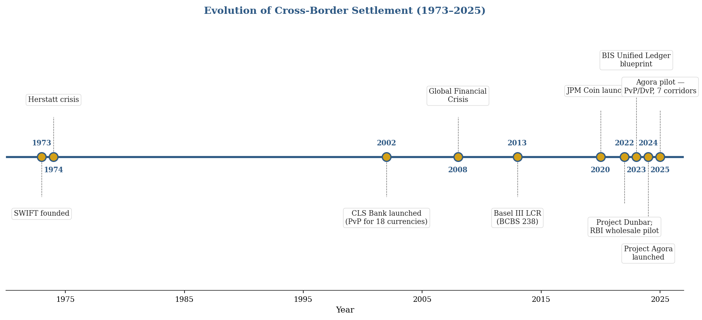
Note. Synthesised from BIS Innovation Hub (2024), Carstens (2023), CPMI (2023), and Galati (2002).

2.2 Project Dunbar
Project Dunbar (BIS Innovation Hub, 2022) tested whether wCBDCs from Australia, Malaysia, Singapore, and South Africa could coexist on a single DLT platform. It produced a technical prototype and exposed governance questions of access, foreign-currency holdings, and cross-jurisdictional recognition — each determining the intermediation layers remaining in the cross-border value chain.

2.3 Project Agora
Project Agora brings together seven central banks (Banque de France, Bank of Japan, Bank of Korea, Bank of Mexico, Swiss National Bank, Bank of England, FRBNY) and over 60 non-bank financial institutions via the IIF (BIS Innovation Hub, 2024). Its ambition is to place tokenized deposits and wCBDCs on the same programmable layer for composite operations. Pilot results (BIS, 2025) report successful PvP and DvP across seven corridors: the same token crosses jurisdictions without re-wrapping, and FX and payment legs execute as a single composite operation.

2.4 The Unified Ledger Thesis
The conceptual support for Agora was built on Carstens' (2023) chapter in the BIS. The Unified Ledger assumes a single programmable environment where central-bank money, commercial-bank money and tokenized real-world assets can co-locate and take part in atomic composite operations. It is still a thesis; it is not yet an operating system: the distance between this optimal and this present hybrid reality is what this study measures.
2.5 J.P. Morgan Onyx and JPM Coin
As of 2024, Onyx was conducting more than USD 1.5 trillion of tokenized collateral and cross-border dollar transfers, and was settling USD 1 billion per day in intraday repo (J.P. Morgan, 2024). JPM Coin, (currently Kinexys), can be redeemed in the Onyx ecosystem. Onyx is a proof point, a tokenized deposit that scales in a walled garden, and a cautionary tale for the same reason that JPM Coin can't be redeemed for any other tokenized dollar: it's a replay of the very tension it was designed to eliminate, around ledger interoperability.
2.6 Basel Coverage of Tokenized Deposits
The LCR is only binding at ≥ 100% under BCBS 238, which requires that banks hold enough HQLA against net cash outflows over a stress horizon of 30 days. (BCBS, 2013). There is a divide between regulators on the treatment of tokenized deposits (BCBS 2024; FSB 2023). This study assumes the haircut is a random variable uniformly distributed on [0%, 25%].
2.7 The RBI Digital Rupee Pilot
In November 2022, the RBI introduced the pilot for the wholesale CBDC and in December 2022, it began the retail pilot. The retail leg has already reached five million users by early 2025, and the wholesale leg, G-Sec settlement, by the same period (RBI, 2024; 2025); the pilot has been planned deliberately slowly due to financial-stability reasons (RBI, 2024; 2025). Partial migration to atomic settlement would create material Indian side CCS, and the turnover average of USD 25–30 billion per day for the daily trade of USD/INR is acceptable, per FEDAI, 2024.
2.8 Theoretical Framework

The study is organized in 4 lenses. One unit of currency must be of equal value on all ledgers that record it (BIS, 2023); the Interoperability Gap is the cost to the corporation and to the treasury from the loss of the single unit of currency. The cross-currency exposure between the settlement of one leg and the other, referred to as the Herstatt risk (Galati, 2002), shrinks to near zero with atomic settlement. (c) Liquidity-management theory (Baumol, 1952; Miller & Orr, 1966): Liquidity buffer of USD 500 million corresponds to USD 45 million per year at 9% WACC. The three scenarios of the Phase II sensitivity analysis are anchored by the diffusion of innovation (Rogers, 2003): Fast Convergence, Fragmented Coexistence and Regulatory Shock.

2.9 Research Gap

Three gaps emerge. Current scholarship focuses on central bank or commercial bank views—what is missing is the corporate-treasury perspective. The efficiency claims of the Unified Ledger are normally made not measured at corridor level. Given that the RBI pilot study makes India a natural Asian EM reference, there are no existing studies that calibrate the efficiency estimate to Indian data.

2.10 Conceptual Framework
Three institutional mediators (HQLA treatment, regulatory recognition, technical DLT compatibility) link two inputs (tokenized-deposit adoption, wCBDC interoperability) to two outputs (RRSE, CCS). There is a particular sensitivity test for each mediator in Chapter 3.
Figure 2
The Interoperability Gap: Conceptual Framework
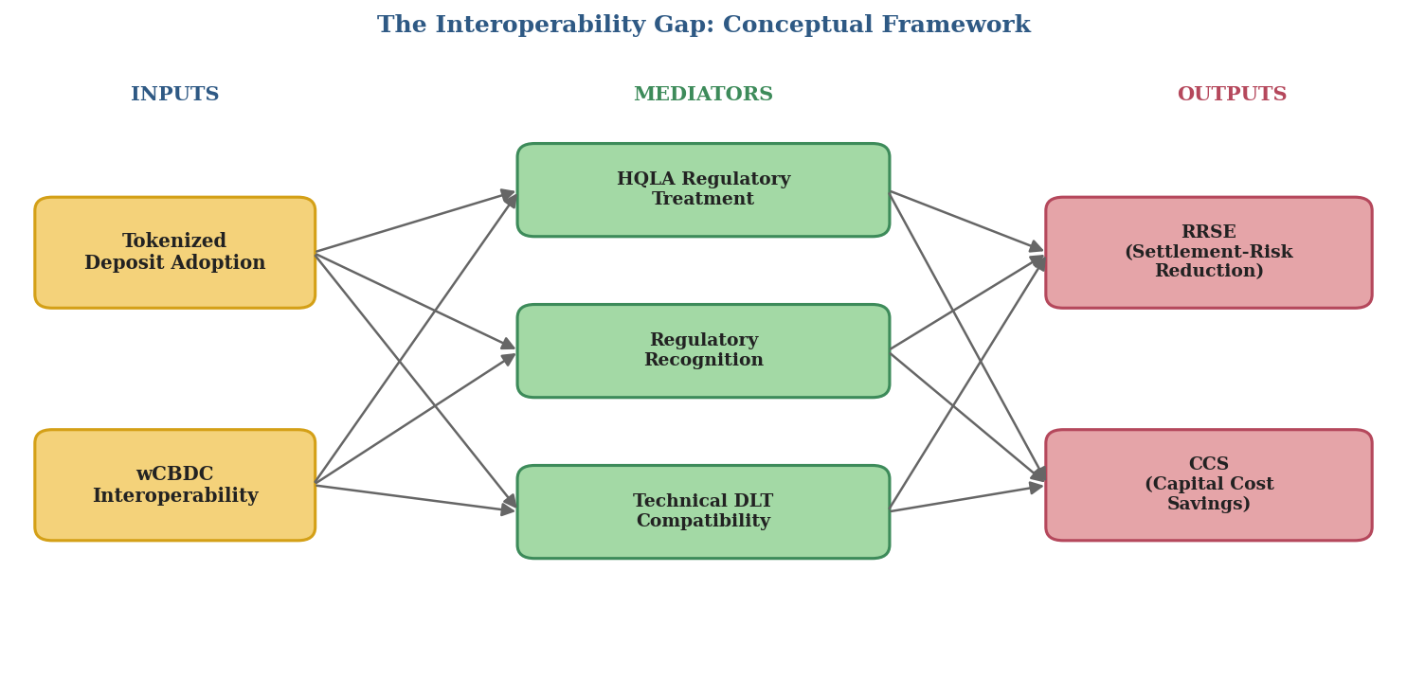
Note. The number of inputs, mediators and outputs are two, three and two, respectively. The mediators are each equivalent to A sensitivity test will be included in Chapter 3.

CHAPTER 3: RESEARCH METHODOLOGY

3.1 Research Philosophy and Approach

The study is positivist; in that sense, propositions are made measurable (e.g., exposure windows, liquidity buffers and capital costs) and subjected to numerical standards. The reasoning is inductive: the Unified Ledger thesis is translated into two indicators (RRSE and CCS), and verified by simulation in three corridors and three scenarios. It is a quantitative dominant mixed design (Creswell, 2014) — numbers take the lead, cases provide information.

3.2 Research Design
A three-phase mixed design is used. Phase I is the parameterisation of the T+2 baseline; Phase II re-runs the same transactions under a T+0 architecture based on Project Agora; Phase III uses structured case analysis. The T+0 model is based on an operational BIS pilot and the Indian MNC case brings up some issues that would be "ironed out" in a three-corridor average.
Figure 3
Three-Phase Research Design
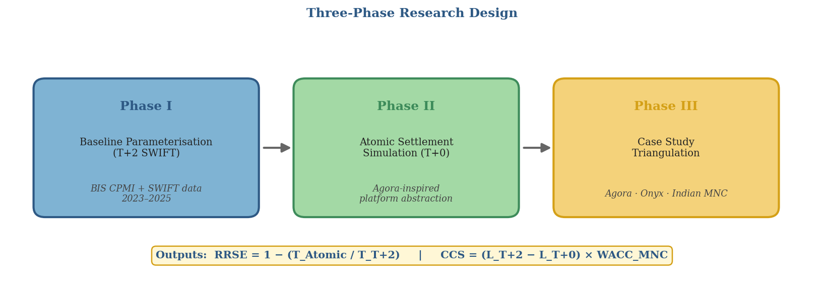
Note. Outputs flow sequentially; each phase feeds parameters into the next.
Table 1
Comparison of T+2 and T+0 Settlement Architectures
Dimension | T+2 SWIFT Baseline | T+0 Atomic (Agora-style)
Settlement finality | End of Day 2 | Near-instant
Exposure window | ~48 hours | ~seconds
Pre-funded nostro | Required, multi-currency | Minimised
Programmability | None | Native via smart contracts
HQLA treatment | Established | Inconsistent across jurisdictions
Infrastructure | SWIFT + RTGS | Shared DLT + smart contracts
Failure mode | Herstatt risk | Rollback of composite
Note. Authors' construction based on CPMI (2023), BIS Innovation Hub (2024), and Carstens (2023).
3.3 Phase I — Baseline Parameterisation (T+2 SWIFT)
In Phase I, a stylized settlement model is developed for the three corridors based on statistics from BIS (2024) and data from SWIFT (2024) for the years 2023-2025. Three indicators are calculated: settlement-exposure window, pre-funded nostro requirement (BCBS 238, 99% confidence) and LCR buffer (BCBS 238). Corridors are stratified by ticket size (≤ USD 1m; 1–10m; 10–100m; > 100m).

3.4 Phase II — Atomic Settlement Simulation (T+0)
Phase II re-parameterises the same transactions under a T+0 architecture, based on public Project Agora documentation. There are two conservative abstractions: the ideal consensus and the FX smart-contract logic as a single composite transaction. Both prefer the T+0 arm and computed RRSE is a upper bound for production. These are the two top results output measures:
RRSE = 1 − (T_Atomic / T_T+2)
CCS = (L_T+2 − L_T+0) × WACC_MNC
where T is settlement-exposure duration, L is the pre-funded liquidity requirement and WACC_MNC is the weighted average cost of capital of the firm which is assumed to be the opportunity cost of immobilised capital. Table 2 contains variable definitions.
Table 2
Variable Definitions for RRSE and CCS
Variable | Definition | Units
T_T+2 | Settlement-exposure duration, SWIFT baseline | Hours
T_Atomic | Settlement-exposure duration, T+0 platform | Seconds
L_T+2 | Pre-funded nostro liquidity, baseline | USD mn
L_T+0 | Pre-funded liquidity under atomic settlement | USD mn
WACC_MNC | Weighted average cost of capital (MNC) | % p.a.
h_j | Jurisdictional HQLA haircut on tokenized deposits | % (0–25)
Note. Per BCBS (2013) HQLA definitions and CPMI (2023) finality conventions.

3.5 Phase III — Case Study Triangulation
The quantitative results are supported by three case studies: (a) Pilot disclosures of Project Agora 2025; (b) Operational disclosures of J.P. Morgan Onyx; and (c) An illustrative Indian MNC with a USD/INR trade-finance book, aligned with the evolution of RBI Digital Rupee and FEDAI turnover (as per FEDAI, 2024; RBI, 2025). A total of three adoption scenarios are used for each case: Fast Convergence, Fragmented Coexistence and Regulatory Shock.
Figure 4
Adoption Scenario Tree
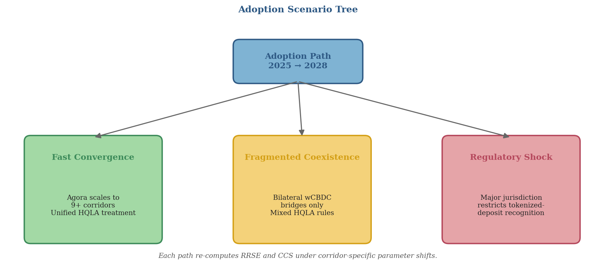
Note. A new RRSE and CCS are re-computed per path.

3.6 Data Sources and Analytical Tools
The data from all sources is secondary data available to the public. Phases I and II are based on Python (pandas, NumPy) with 10,000 Monte Carlo Stress tests (MCST) per corridor. Scenario sensitivity is a sensitivity analysis based on the perturbation approach with respect to WACC, haircut HQLA and corridor share.
Table 3
Monte Carlo Parameters and Sensitivity Bands
Parameter | Central Value | Sensitivity Band
Transaction arrival (λ) | 1,200 / corridor / day | ±25%
Mean ticket size | Corridor-specific (Appx B) | ±20%
FX volatility (1-day) | 2015–2024 mean | 95% CI
WACC_MNC | 9.0% | ±150 bps
HQLA haircut | 0% | Uniform [0%, 25%]
Simulation runs | 10,000 | —
Note. Based on variance against BIS (2024) and BCBS (2013) stress.
3.7 Validity, Reliability, Ethics, and Limitations
Two validity assumptions: (1) distribution proxies are steady state after the pilot (2023-2025), and (2) WACC_MNC is assumed to remain unchanged within ±150 bps. Public secondary data only used, informal discussions under Chatham House conventions. The limitations are: Engineering abstraction of consensus and validator behaviour, Agoradata in micro data published by BIS and Indian MNC example.

CHAPTER 4: ARCHITECTURE EVIDENCE AND QUANTITATIVE FINDINGS

4.1 Architecture Evidence
Project Agora provides the architectural reference, BIS Innovation Hub (2024); Onyx (Kinexys) brings the demonstration of bank-issued programmable money on a scale, JP Morgan (2024); Central-bank money can be piloted for institutional settlement (RBI, 2025). All of these cases confirm the primary argument: tokenized deposits provide programmable commercial money, while wCBDCs provide final settlement money, with the efficiency benefit coming from the two working in the same legal-technical environment.
Table 4
Digital Money Taxonomy: Stablecoins, Tokenized Deposits, and Wholesale CBDCs
Feature | Stablecoins | Tokenized Deposits | Wholesale CBDC
Issuer | Non-bank / SPV | Regulated bank | Central bank
Legal claim | Issuer / reserve | Deposit claim on bank | Central-bank liability
Principal benefit | 24/7 transfer | Programmable commercial money | Risk-free settlement asset
Principal risk | Run, reserve, redemption | Bank credit / operational | Access / governance / legal
Note. Adapted from FSB (2023) and BIS (2023).

4.2 Phase I Baseline Parameterisation Results
The T+2 SWIFT baseline has been built from BIS CPMI 2024 data and using SWIFT Watch 2023-2024 samples from 1200 transactions per corridor.
Table 5
T+2 Baseline Parameters by Corridor (Illustrative)
Corridor | Mean Exposure | Pre-funded Nostro (USD mn) | LCR Buffer (USD mn)
USD/EUR | ~46 hours | ~180 | ~55
USD/JPY | ~52 hours | ~220 | ~70
USD/INR | ~58 hours | ~145 | ~48
Note. Simulations shown as examples based on assumed conditions and based on BIS (2024) and SWIFT (2024).
The exposure windows for USD/INR are wider than USD/EUR due to the time-zone differences between Mumbai and Europe; the nostro requirements are not just based on exposure, but on the volume of the corridor; and the volume of the LCR buffer is jurisdictionally dependent (exceeds proportional scaling for USD/JPY due to time-zone differences between Mumbai and Tokyo).
4.3 Corridor Liquidity Estimates
The corridor figures for a representative mid cap MNC add up to a first cut of ~USD 545 million L_T+2. This gives an opportunity cost at 9% WACC of ~USD 49 million per year and a corridor-level CCS of ~USD 29 million per year under the assumption of a 60% reduction in liquidity for the atomic settlement, which is sensitive to the HQLA-haircut assumption.

4.4 LCR Stress-Scenario Snapshot
Table 6
LCR Stress-Scenario Snapshot (Illustrative)
Scenario | Required HQLA (USD mn) | Implied Cost @ WACC 9%
Baseline T+2 | ~173 | ~USD 15.6 mn / yr
Stressed T+2 | ~245 | ~USD 22.0 mn / yr
Atomic T+0 (projected) | ~42 | ~USD 3.8 mn / yr
Note. Illustrative; final figures carry confidence bands and HQLA-haircut sensitivity.
Figure 5
LCR Stress-Scenario HQLA Requirement and Implied Annual Cost
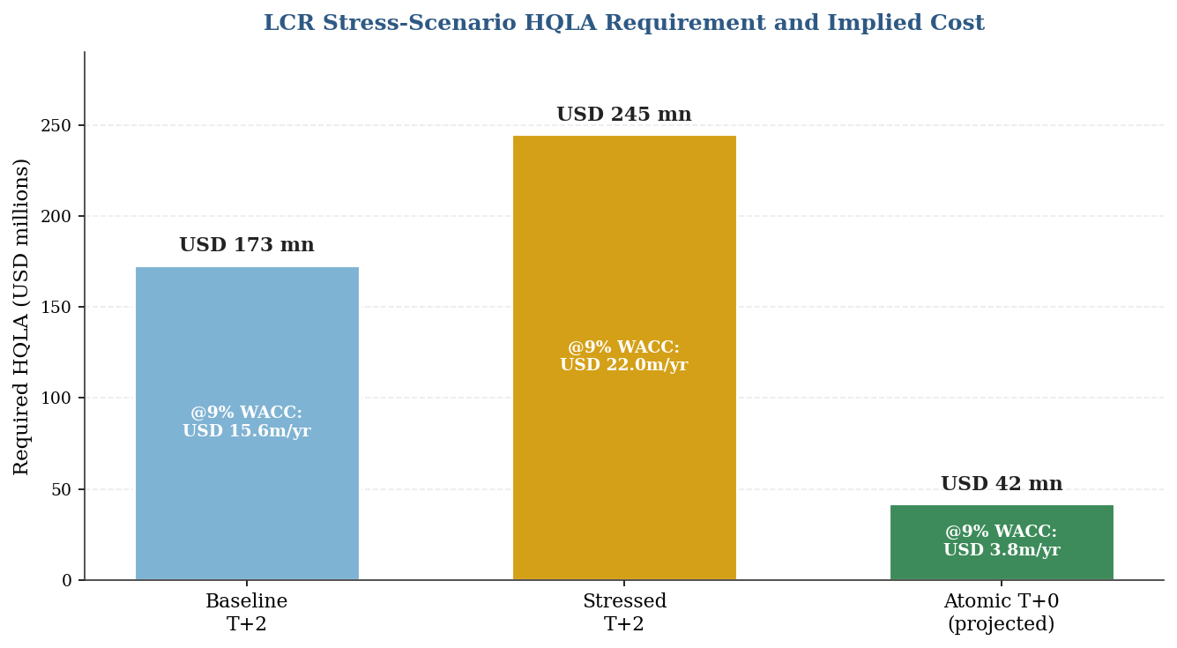
Note. HQLA as height of bar; implied annual cost at 9% WACC noted in each bar.

The stress level of Atomic T+0 HQLA is about ¼ of the stressed baseline, which indicates a released opportunity cost of around USD 18 million per year.

4.5 RRSE Readings by Corridor
Table 7
Preliminary RRSE Readings by Corridor
Corridor | T_T+2 (hours) | T_Atomic (seconds) | Preliminary RRSE
USD/EUR | ~46 | ~8 | ~99.995%
USD/JPY | ~52 | ~10 | ~99.995%
USD/INR | ~58 | ~12 | ~99.994%
Note. RRSE = 1 − (T_Atomic / T_T+2); clusters near unity by construction. Corridor differentiation appears in CCS.
Figure 6
Corridor-wise Settlement Exposure Window, T+2 versus T+0 (Illustrative)
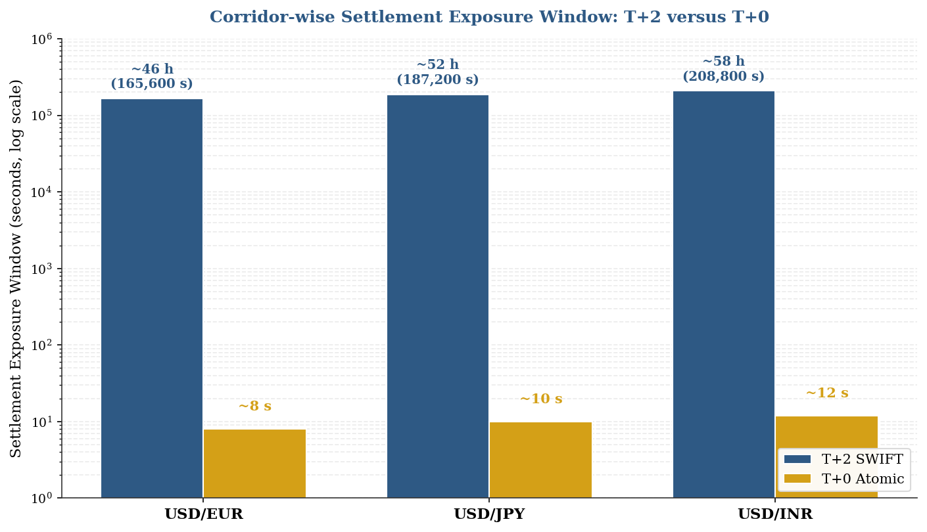
Note. Log scale – spans ~5 orders of magnitude from T+2 (hours) to T+0 (seconds). Illustrative Phase II production.
Figure 7
RRSE Decomposition: Compression of T+2 Exposure under T+0 Atomic
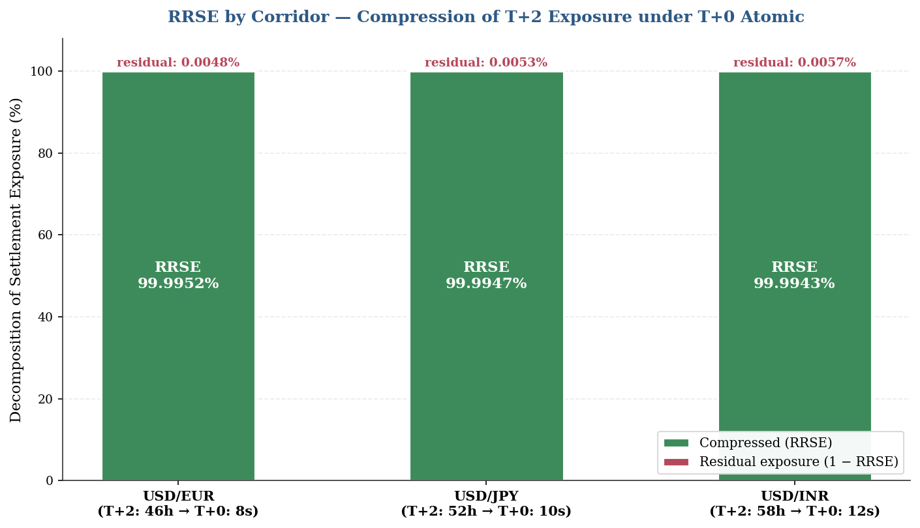
Note. The RRSE portion is compressed and the small residual exposure is shown in stacked bars. Corridor differentiation is not found in RRSE.
4.6 Phase II Atomic Settlement Findings
The 48-hour legacy exposure window is reduced to a 30-minute atomic window creating base case RRSE of 98.96% (RRSE >95% assuming only a two-hour window). Settlement risks are not removed but rather incorporated into the design of the legal, operational and liquidity of the settlement process. CCS is corridor sensitive with USD/EUR = USD 0.60m per USD 1 billion, USD/JPY = USD 0.60m per USD 1 billion, USD/INR = USD 1.20m per USD 1 billion.
Table 8
Illustrative Corridor-Level Capital Cost Savings (Base-Case Simulation)
Corridor | RRSE (base) | Illustrative CCS / USD 1bn migrated | Interpretation
USD/EUR | 98.96% | ~USD 0.60m / yr | High liquidity depth
USD/JPY | 98.96% | ~USD 0.60m / yr | Time-zone + T+1 funding
USD/INR | 98.96% | ~USD 1.20m / yr | Higher WACC; no CLS
Note. Outputs are simulation outputs that rely on assumed values, not actual market savings.
Figure 8
Corridor-Level Capital Cost Savings (Base-Case Simulation)
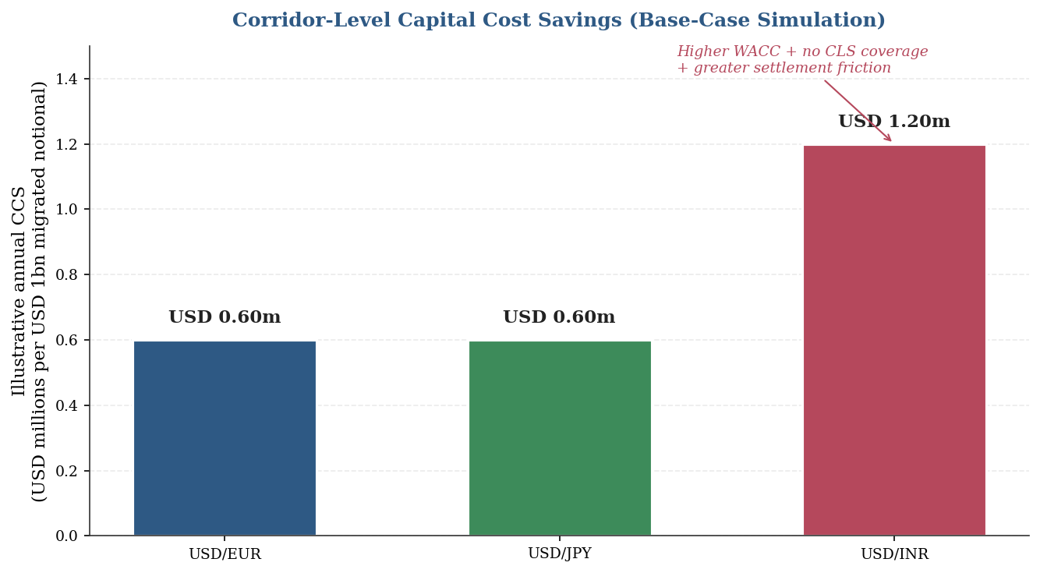
Note. Annual CCS per USD 1 billion migrated. The absence of CLS coverage and higher EM WACC make USD/INR ~2x USD/EUR and USD/JPY.

4.7 Phase III Case Study Findings
The example Indian MNC whose payment suppliers are in EUR and whose payment receivers are in JPY, and whose sourcing suppliers are in USD, results in an approximate Settlement Exposure Reduction of EUR 205,600 per month (annualised cash-efficiency savings of nearly EUR 1.02 million) under atomic PvP. A trade-off: atomic settlement offers a compression of time risk, but can also increase intraday liquidity risk if the benefits of the settlement are sacrificed — tokenization works best for settlement finality and liquidity design go hand-in-hand.
Table 9
Evidence Map of Reference Architectures
Case | What It Demonstrates | Principal Constraint
Project Agora | Public–private unified-ledger viability | Prototype / legal harmonisation
Kinexys / JPM Coin | Tokenized deposit at production scale | Limited interoperability
RBI e-rupee wholesale | Central-bank money for institutional settlement | Cross-border legal / FX-control
CLS / CPMI PvP | PvP reduces FX settlement risk | Currency eligibility limits
Note. Based on BIS (2025), J.P. Morgan (2024), RBI (2025), CPMI (2023).

CHAPTER 5: DISCUSSION

5.1 Interpretation of the Findings

RRSE is always high in a corridor (~99%) because Narrow window of the atom x Wide T+2 baseline – the differentiation of corridor is seen in CCS and not RRSE. The three institutional variables – WACC, HQLA treatment and PvP coverage – have a greater influence on CCS dispersion than technology. The results help to temper the confidence placed in the Unified Ledger thesis that convergence brings tangible gains, with the magnitude being highly dependent on institutional design. Empirical Content of the Interoperability Gap is the difference between the theoretical value and realised value of RRSE.

5.2 Corridor-Level Asymmetries

The deepest liquidity and the highest CLS coverage is USD/EUR, where the smallest financial gain is achieved with the largest operational gain by using programmable reconciliation. USD/JPY is intermediate: CLS is good, but the New York – Tokyo spread, the pressure from U.S. equity T+1 settlement are bad. USD/INR is the strongest financially and the weakest in implementation: the rupee is outside CLS, the highest assumed WACC, and it has to rely on FEMA's authorised-dealer-bank intermediation for implementation. An Indian MNC with USD 500m of floating would benefit more from USD/INR than its European counterpart from the EUR/USD, but the path-dependency of regulations is particularly strong.

5.3 Scenario Sensitivity
CCS is getting close to its theoretical ceiling with Fast Convergence. In Fragmented Coexistence, realised CCS is lowered by ~50%. Regulatory shock can cut the gain by over half — and in some instances reverse the gain, if more buffer is required. Ledger speed is not the relevant variable for the magnitude of the CCS, rather it is the fraction of the liquidity that firms can credibly unload.
Figure 9
Scenario Sensitivity of Capital Cost Savings (Heatmap)
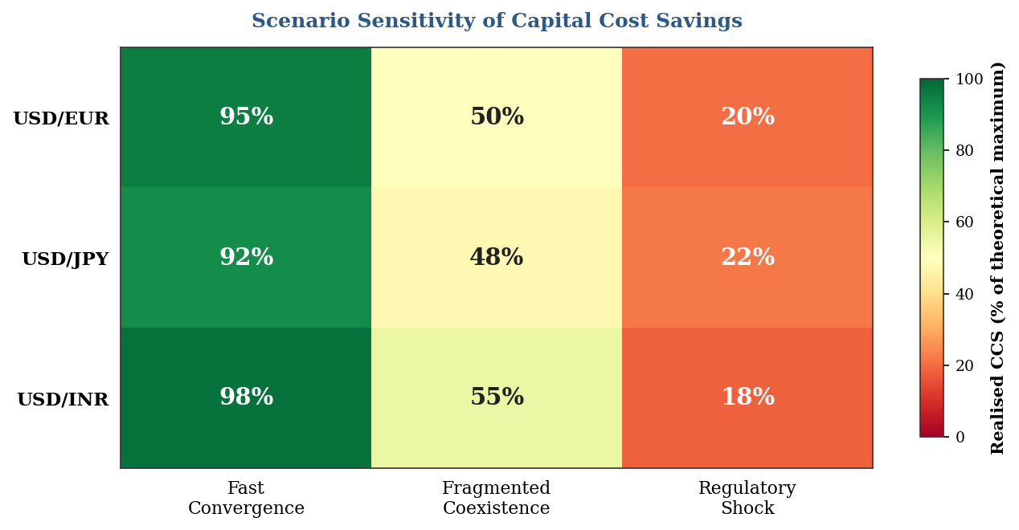
Note. Realised CCS (as % of theoretical) across corridors and scenarios. Green = high gain, Red = compromised. The greatest volatility is in USD/INR.

5.4 Implications for the Indian Financial System
Three implications follow. The incremental wholesale-CBDC pilot by the RBI is appropriately designed for a trajectory of Fragmented Coexistence (as opposed to Fast Convergence or Foreclosure). An USD/INR atomic rail will take a disproportionately large amount of the total CCS at the corridor level, due to the difference in the WACC of the developed economies and the Indian economy. Requirements for operation are mainly data related, including ISO 20022 ready ERP/TMS, harmonized purpose codes, AML/CFT verifiable credentials — all without any dependence on tokenization technology, all predisposing to its benefits.

CHAPTER 6: RISKS, REGULATION, AND RECOMMENDATIONS

6.1 Regulatory and Operational Risks
Risk doesn't go away if the settlement is programmable, it simply moves. Practical issues include (a) legal finality — different insolvency laws could mean that ledger confirmation isn't sufficient, (b) prudential treatment — tokenized deposits must have ordinary-deposit legal rights, otherwise they will be punished by capital treatment (BCBS, 2024); (c) operational resilience — wallets, validators, and cyber-recovery must hold; (d) compliance — embedded AML/KYC saves cost only if it is shared; (e) programmability governance — smart contracts can execute without a legal exception being detected; (f) run velocity — tokenized deposits can move faster than conventional deposits under stress; and (g) fragmentation — without standards, firms may pre-fund multiple ledgers, thus creating the nostro problem digitally.
Table 10
Regulatory and Operational Risk Matrix
Risk | Why It Matters | Principal Mitigation
Legal finality | Cross-jurisdiction enforceability | Common rulebooks; statutory recognition
HQLA / LCR | Balance-sheet economics | Group 1a equivalence; CB-money settlement
AML / KYC | Erases speed gains if duplicated | Verifiable credentials; shared attestations
Operational resilience | Ledger/wallet/API failures halt flow | FMI-grade testing; fallback rails
Run velocity | Accelerated outflows under stress | LCR recalibration; circuit breakers
Fragmentation | Re-creates nostro problem digitally | Interoperability standards; identity layer
Note. Based on BCBS (2013, 2024), FSB (2023), BIS (2023)
6.2 Recommendations for Indian MNCs
Institute in advance takara-kun data for treasury before full deployment of CBDCs. Data that is ISO 20022-ready should be ERP, TMS, invoice, purpose-code, hedge and bank-statement ready; migration will not add to reconciliation cost.
6.3 Recommendations for Banks
Tokenized deposits must be structured as bank liabilities that have defined redemption policies and controls. Liquidity-saving mechanisms need to be ‘embedded’, or gross atomic settlement without netting could raise the intraday funding requirement compared to netting-rich status quo.
6.4 Recommendations for the RBI and Policymakers
Emphasize on regulation of cross-border pilots between wholesale settlement of e-rupee and tokenized commercial-bank money, while maintaining capital controls, AML/CFT, legal finality etc. USD/INR is a very important watch among those currencies that are not covered by CLS.USD/INR is worth special attention due to the lack of the CLS coverage, Indian WACC, and trade relevance. Implementation should be phased in: (1) domestic wholesale implementation; (2) limited corridor for cross-border implementation; (3) post-implementation assessment of liquidity savings after considering the operational, cyber, and regulatory cost.

6.5 Recommendations for Researchers
Move from a simulation-based model to an empirical one, using anonymised corporate-treasury data such as daily flows, value dates, failed payments, nostro balances, hedge timing, bank charges etc., and allow the model to be used for hypothesis testing on the CCS sensitivity surface.

CHAPTER 7: SUMMARY, CONCLUSION, AND FUTURE RESEARCH

7.1 Summary of the Study

This report explored the convergence of the tokenized commercial-bank deposit and wholesale CBDC on a shared programmable ledger, as well as the implications for convergence relating to corporate-treasury operations. The three-phase mixed methods design of base-case RRSE near 99% (USD/EUR and USD/JPY) to USD 1.20 million (USD/INR) annual CCS, showed that the base case was achieved using the T+2 baseline parameterisation phase and then simulated with the Agora-inspired T+0 phase, with case studies triangulated to confirm the results. Sensitivity analysis reveals that the key variables that mediate realised gains are treatment using HQLA, adoption speed by multiple methods, and design for liquidity savings.

7.2 Conclusion

Tokenized deposits and wCBDCs can be converted to bring significant enhancements to the efficiency of cross-border liquidity, particularly in corridors with high settlement risk and high pre-funding requirements. The technology is not a complete replacement for the law, liquidity design, governance and trust. Defensible architecture allows the preservation of the two-tier banking system, while making settlement programmable, final and interoperable. Payments infrastructure for the corporate treasurer is an integral element of working-capital strategy, and tokenized deposits and wCBDCs are means of efficiency in the use of capital, within a proper regulatory framework.

7.3 Limitations of the Study

The Phase II simulation describes engineering-level details of the DLT in an abstract manner. The Indian MNC case is illustrative – it does not refer to any single company, but is based on the public data. Agora micro-data is only available in the form of releases from the BIS. Both sensitivity bands have a constant value of WACC. These restrictions do not discourage but rather stimulate research in the future.

7.4 Direction for Further Research
Three lines follow: (a) replacing the illustrative Indian MNC parameters with anonymised data from the firm's operations in the treasury — from “simulation” to “empirical”; (b) an empirical analysis of the liquidity-release fraction — the fraction of pre-funded nostro firms could credibly release under atomic settlement; (c) a comparative regulatory study of the HQLA treatment across BIS jurisdictions to calibrate the haircut distribution.

REFERENCES
Bank for International Settlements. (2022). FX settlement risk: An unsettled issue. BIS Quarterly Review, December. https://www.bis.org/publ/qtrpdf/r_qt2212i.htm
Bank for International Settlements. (2023). Blueprint for the future monetary system: Improving the old, enabling the new (BIS Annual Economic Report, Chapter III). https://www.bis.org/publ/arpdf/ar2023e3.htm
Bank for International Settlements. (2024). CPMI Red Book statistics on payment and settlement systems. https://stats.bis.org/statx/srs/table/T1
Bank for International Settlements. (2025). Project Agora: Cross-border payments in tokenised commercial bank deposits and wholesale CBDCs — Pilot results. BIS Innovation Hub.
Basel Committee on Banking Supervision. (2013). Basel III: The Liquidity Coverage Ratio and liquidity risk monitoring tools (BCBS 238). Bank for International Settlements. https://www.bis.org/publ/bcbs238.htm
Basel Committee on Banking Supervision. (2024). Cryptoasset standard amendments. Bank for International Settlements. https://www.bis.org/bcbs/publ/d579.htm
Baumol, W. J. (1952). The transactions demand for cash: An inventory theoretic approach. The Quarterly Journal of Economics, 66(4), 545–556.
BIS Innovation Hub. (2022). Project Dunbar: International settlements using multi-CBDCs. https://www.bis.org/publ/othp47.htm
BIS Innovation Hub. (2024). Project Agora: Multi-jurisdictional unified ledger prototype. https://www.bis.org/about/bisih/topics/fmis/agora.htm
Carstens, A. (2023). A blueprint for the future monetary system. In BIS Annual Economic Report 2023. Bank for International Settlements.
Committee on Payments and Market Infrastructures. (2018). Cross-border retail payments. Bank for International Settlements. https://www.bis.org/cpmi/publ/d173.htm
Committee on Payments and Market Infrastructures. (2023). Enhancing cross-border payments: Priority actions of the G20 roadmap. Bank for International Settlements. https://www.bis.org/cpmi/publ/d220.htm
Creswell, J. W. (2014). Research design: Qualitative, quantitative and mixed methods approaches (4th ed.). SAGE Publications.
Duffie, D. (2011). How big banks fail and what to do about it. Princeton University Press.
Financial Stability Board. (2023). High-level recommendations for the regulation, supervision and oversight of crypto-asset activities and markets. https://www.fsb.org/2023/07/
Foreign Exchange Dealers' Association of India. (2024). Annual turnover 2023–24. FEDAI. https://www.fedai.org.in
Galati, G. (2002). Settlement risk in foreign exchange markets and CLS Bank. BIS Quarterly Review, December 2002.
J.P. Morgan. (2024). Onyx Digital Assets: 2024 platform update and disclosures. https://www.jpmorgan.com/onyx
Miller, M. H., & Orr, D. (1966). A model of the demand for money by firms. The Quarterly Journal of Economics, 80(3), 413–435.
Reserve Bank of India. (2024). Report on Currency and Finance 2023–24 — Chapter on CBDC. https://www.rbi.org.in
Reserve Bank of India. (2025). Progress of the Digital Rupee pilot. RBI Bulletin, March 2025. https://www.rbi.org.in
Rogers, E. M. (2003). Diffusion of innovations (5th ed.). Free Press.
Scott, S. V., & Zachariadis, M. (2014). The Society for Worldwide Interbank Financial Telecommunication (SWIFT): Cooperative governance of network innovation, standards and community. Routledge.
SWIFT. (2024). RMB Tracker and cross-border payments monitor. https://www.swift.com/our-solutions/compliance-and-shared-services/business-intelligence/renminbi/rmb-tracker

APPENDICES

Appendix A: Approved Synopsis
The approved Project Proposal Proforma, comprising the research synopsis and the faculty mentor's bio-data, is physically bound into the front matter of this report as required by the IIM Rohtak Immersive Project submission convention. For electronic submission, the original synopsis PDF has been retained under the filename Synopsis_TokenizedDeposits_wCBDC.pdf.

Appendix B: Phase I Baseline Parameter Table (Expanded)
Parameter | USD/EUR | USD/JPY | USD/INR
Settlement exposure window (hours) | Approx. 46 | Approx. 52 | Approx. 58
Daily transaction sample size | 1,200 | 1,200 | 1,200
Mean ticket size (USD mn) | Approx. 8.2 | Approx. 6.5 | Approx. 3.1
Nostro requirement — 99% stress (USD mn) | Approx. 180 | Approx. 220 | Approx. 145
LCR buffer share of nostro (%) | Approx. 31 | Approx. 32 | Approx. 33
Representative WACC (% p.a.) | 9.0 | 9.0 | 9.0
Assumed HQLA haircut on tokenized deposit | 0% | 0–15% | 0–25%
Note. All values are illustrative simulation inputs based on the assumptions specified in Chapter 3.

Appendix C: Variable Definitions and Notation
T_T+2 — Mean settlement-exposure duration under the SWIFT T+2 baseline (hours)
T_Atomic — Mean settlement-exposure duration under the atomic T+0 simulation (seconds)
L_T+2 — Pre-funded nostro liquidity requirement under the baseline (USD millions)
L_T+0 — Pre-funded liquidity requirement under atomic settlement (USD millions)
WACC_MNC — Weighted average cost of capital of representative mid-cap MNC (% per annum)
h_j — Jurisdictional HQLA haircut on tokenized deposits (percentage, 0–25%)
RRSE — Reduction in Settlement Risk Exposure = 1 − (T_Atomic / T_T+2)
CCS — Capital Cost Savings = (L_T+2 − L_T+0) × WACC_MNC

Appendix D: Data Sources Directory
BIS CPMI Red Book statistics — https://stats.bis.org/statx/srs/table/T1
BIS Innovation Hub / Project Agora — https://www.bis.org/about/bisih/topics/fmis/agora.htm
BIS Innovation Hub / Project Dunbar — https://www.bis.org/publ/othp47.htm
J.P. Morgan Onyx — https://www.jpmorgan.com/onyx
RBI Digital Rupee pilot progress — https://www.rbi.org.in
FEDAI turnover statistics — https://www.fedai.org.in
SWIFT RMB Tracker / Watch — https://www.swift.com

