**3.1P**

**UML Diagram**

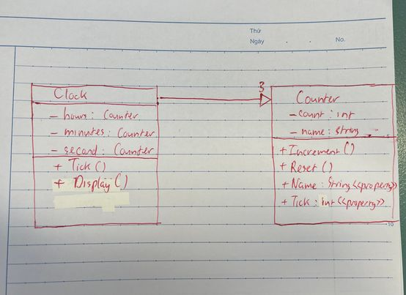

**Program file**

namespace _3._1

{

internal class Program

{

static void Main(string[] args)

{

Clock clock = new Clock();

for (int i = 0; i < 86400; i++)

{

clock.Tick();

clock.Display();

}

}

}

}

**Counter class**

using System;

using System.Collections.Generic;

using System.Linq;

using System.Text;

using System.Threading.Tasks;

namespace _3._1

{

public class Counter

{

private int _count;

private string _name;

public Counter(string name)

{

_name = name;

_count = 0;

}

public void Increment()

{

_count++;

}

public void Reset()

{

_count = 0;

}

public string Name

{

get { return _name; }

set { _name = value; }

}

public int Ticks

{

get { return _count; }

}

}

}

**Clock class**

using System;

using System.Collections.Generic;

using System.Linq;

using System.Text;

using System.Threading.Tasks;

namespace _3._1

{

public class Clock

{

private Counter _hours;

private Counter _minutes;

private Counter _seconds;

public Clock()

{

_hours = new Counter("Hours");

_minutes = new Counter("Minutes");

_seconds = new Counter("Seconds");

}

public void Tick()

{

_seconds.Increment();

if (_seconds.Ticks == 60)

{

_seconds.Reset();

_minutes.Increment();

if (_minutes.Ticks == 60)

{

_minutes.Reset();

_hours.Increment();

if (_hours.Ticks == 24)

{

_hours.Reset();

}

}

}

}

public void Reset()

{

_hours.Reset();

_minutes.Reset();

_seconds.Reset();

}

public void Display()

{

Console.WriteLine($"{ _hours.Ticks:D2}: {_minutes.Ticks:D2}: {_seconds.Ticks:D2}");

}

}

}

**Output**

**The clock runs till it hits 0:0:0 then stops**

**Test File**

using _3._1;

namespace TestProject2

{

public class Tests

{

[SetUp]

public void Setup()

{

}

Clock clock = new Clock();

[Test]

public void Test1()

{

clock.Reset();

Assert.That(clock.Display, Is.EqualTo("00: 00: 00"));

}

[Test]

public void Test2()

{

clock.Reset();

clock.Tick();

Assert.That(clock.Display, Is.EqualTo("00: 00: 01"));

}

[Test]

public void Test3()

{

clock.Reset();

for (int i = 0; i < 60; i++)

{

clock.Tick();

}

Assert.That(clock.Display, Is.EqualTo("00: 01: 00"));

}

[Test]

public void Test4()

{

clock.Reset();

for (int i = 0; i < 3600; i++)

{

clock.Tick();

}

Assert.That(clock.Display, Is.EqualTo("01: 00: 00"));

}

[Test]

public void Test5()

{

clock.Reset();

for (int i = 0; i < 86400; i++)

{

clock.Tick();

}

Assert.That(clock.Display, Is.EqualTo("00: 00: 00"));

}

}

}

**Test Result**

