**9.2 Path Implementation**

**Class Diagram**

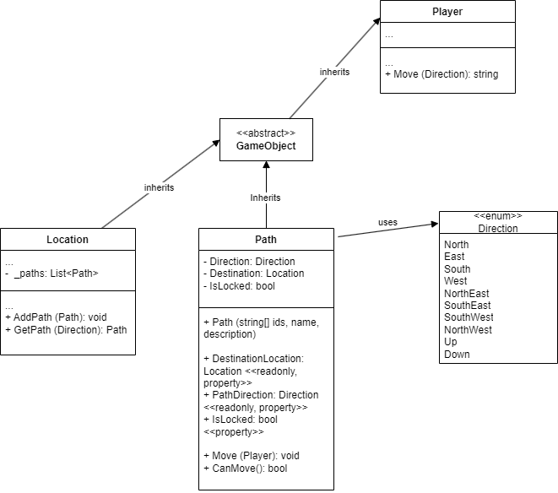

**Move Command Sequence Diagram**

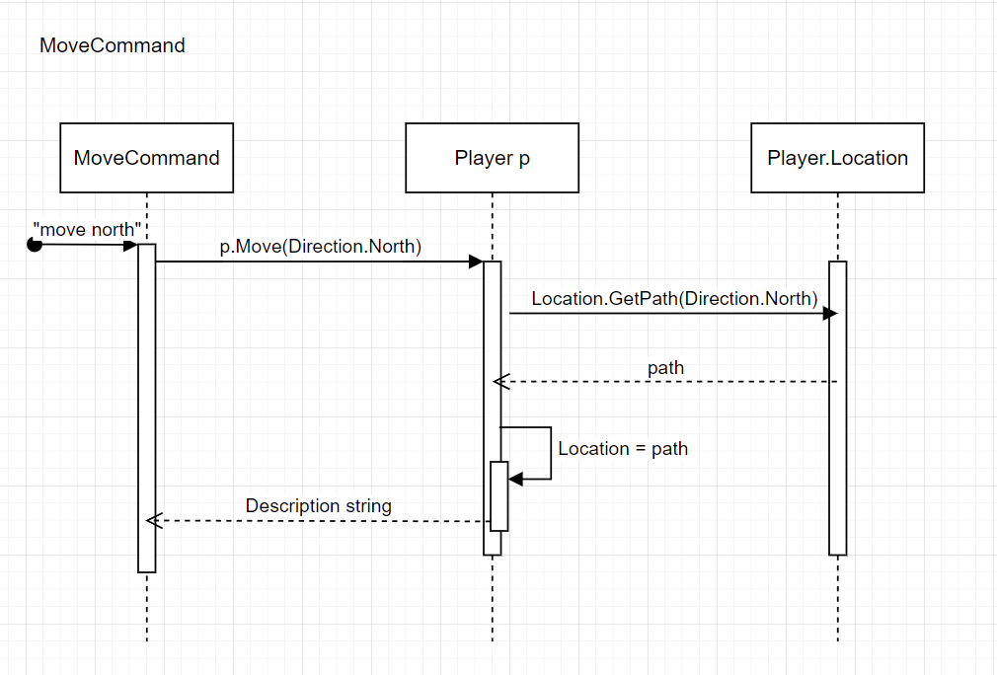

**Path**

using System;

using System.Collections.Generic;

using System.Linq;

using System.Text;

using System.Threading.Tasks;

namespace SwinAdventure

{

public enum Direction

{

North, NorthEast, East, SouthEast, South, SouthWest, West, NorthWest, Up, Down

}

public class Path : GameObject

{

private Direction Direction;

private Location Destination;

public bool IsLocked { get; set; } = false;

public Path(Direction direction, string name, string description, Location destination) : base(new string[] { direction.ToString()}, name, description)

{

Direction = direction;

Destination = destination;

}

public Location DestinationLocation

{

get

{

return Destination;

}

}

public Direction PathDirection

{

get

{

return Direction;

}

}

public bool CanMove()

{

return !IsLocked;

}

public void Move(Player p)

{

p.Location = DestinationLocation;

}

}

}

**UnitTest**

using SwinAdventure;

using Path = SwinAdventure.Path;

namespace TestQueue

{

public class Tests

{

Item item1 = new Item(new string[] { "sword" }, "sword", "a sword");

Item item2 = new Item(new string[] { "shield" }, "shield", "a shield");

Item item3 = new Item(new string[] { "shiba" }, "shiba", "a shiba");

Item item4 = new Item(new string[] { "gem" }, "gem", "a gem");

[SetUp]

public void Setup()

{

}

// Test the Item class

[Test]

public void ItemIdentifiable()

{

Assert.IsTrue(item1.AreYou("sword"));

}

[Test]

public void ShortDescription()

{

Assert.That(item1.ShortDescription, Is.EqualTo("a sword (sword)"));

}

[Test]

public void FullDescription()

{

Assert.That(item1.FullDescription, Is.EqualTo("a sword"));

}

// Test the Inventory class

[Test]

public void FindItem()

{

Inventory inventory = new Inventory();

inventory.Put(item1);

Assert.IsTrue(inventory.HasItem("sword"));

}

[Test]

public void NoItem()

{

Inventory inventory = new Inventory();

Assert.IsFalse(inventory.HasItem("sword"));

}

[Test]

public void FetchItem()

{

Inventory inventory = new Inventory();

inventory.Put(item1);

Assert.That(item1, Is.EqualTo(inventory.Fetch("sword")));

Assert.IsTrue(inventory.HasItem("sword"));

}

[Test]

public void TakeItem()

{

Inventory inventory = new Inventory();

inventory.Put(item1);

Assert.That(item1, Is.EqualTo(inventory.Take("sword")));

Assert.IsFalse(inventory.HasItem("sword"));

}

[Test]

public void ItemList()

{

Inventory inventory = new Inventory();

inventory.Put(item1);

inventory.Put(item2);

//the list string below is the expected output, consisting of every item in the following format: name ( first id)

Assert.That(inventory.ItemList, Is.EqualTo("\t a sword (sword)\n\t a shield (shield)\n"));

}

// Test the Player class

[Test]

public void PlayerIdentifiable()

{

Player player = new Player("Tan", "A player");

Assert.IsTrue(player.AreYou("me"));

Assert.IsTrue(player.AreYou("inventory"));

}

[Test]

public void PlayerLocate()

{

Player player = new Player("Tan", "A player");

player.Inventory.Put(item1);

Assert.That(item1, Is.EqualTo(player.Locate("sword")));

}

[Test]

public void PlayerLocateItself()

{

Player player = new Player("Tan", "A player");

Assert.That(player, Is.EqualTo(player.Locate("me")));

Assert.That(player, Is.EqualTo(player.Locate("inventory")));

}

[Test]

public void PlayerLocateNothing()

{

Player player = new Player("Tan", "A player");

Assert.That(player.Locate("sword"), Is.Null);

}

[Test]

public void PlayerFullDescription()

{

Player player = new Player("Tan", "A player");

player.Inventory.Put(item1);

player.Inventory.Put(item2);

//the list string below is the expected output, consisting of every item in the following format: name ( first id)

Assert.That(player.FullDescription, Is.EqualTo("You are Tan A player\nYou are carrying:\n\t a sword (sword)\n\t a shield (shield)\n"));

}

//Test the Bag class

[Test]

public void BagLocate()

{

Bag backpack = new Bag(new string[] { "backpack" }, "backpack", "a backpack");

backpack.Inventory.Put(item1);

backpack.Inventory.Put(item2);

backpack.Inventory.Put(item3);

//ask to return item and item stays in backpack

Assert.That(item3, Is.EqualTo(backpack.Locate("shiba")));

Assert.IsTrue(backpack.Inventory.HasItem("shiba"));

}

[Test]

public void BagLocatesItself()

{

Bag backpack = new Bag(new string[] { "backpack" }, "backpack", "a backpack");

Assert.That(backpack, Is.EqualTo(backpack.Locate("backpack")));

}

[Test]

public void BagLocateNothing()

{

Bag backpack = new Bag(new string[] { "backpack" }, "backpack", "a backpack");

Assert.That(backpack.Locate("sword"), Is.Null);

}

[Test]

public void BagFullDescription()

{

Bag backpack = new Bag(new string[] { "backpack" }, "backpack", "A backpack");

backpack.Inventory.Put(item1);

backpack.Inventory.Put(item2);

backpack.Inventory.Put(item3);

//the list string below is the expected output, consisting of every item in the following format: name ( first id)

Assert.That(backpack.FullDescription, Is.EqualTo("A backpack\nYou look in the backpack and see:\n\t a sword (sword)\n\t a shield (shield)\n\t a shiba (shiba)\n"));

}

[Test]

public void BagInBag()

{

Bag backpack = new Bag(new string[] { "backpack" }, "backpack", "a backpack");

Bag satchel = new Bag(new string[] { "satchel" }, "satchel", "a satchel");

backpack.Inventory.Put(satchel);

Assert.That(satchel, Is.EqualTo(backpack.Locate("satchel")));

}

//Test for the LookCommand class

[Test]

public void LookAtMe()

{

Player player = new Player("Tan", "A player");

player.Inventory.Put(item1);

player.Inventory.Put(item2);

LookCommand LookCommand = new LookCommand();

string expectedDescription = "You are Tan A player\nYou are carrying:\n\t a sword (sword)\n\t a shield (shield)\n";

string testDescription = LookCommand.Execute(player, new string[] { "look", "at", "me" });

Assert.That(testDescription, Is.EqualTo(expectedDescription));

}

[Test]

public void LookAtGem()

{

Player player = new Player("Tan", "A player");

player.Inventory.Put(item4);

LookCommand LookCommand = new LookCommand();

string expectedDescription = "a gem";

string testDescription = LookCommand.Execute(player, new string[] { "look", "at", "gem" });

Assert.That(testDescription, Is.EqualTo(expectedDescription));

}

[Test]

public void LookAtUnk()

{

Player player = new Player("Tan", "A player");

LookCommand LookCommand = new LookCommand();

string expectedDescription = "I can't find the gem in the Tan";

string testDescription = LookCommand.Execute(player, new string[] { "look", "at", "gem" });

Assert.That(testDescription, Is.EqualTo(expectedDescription));

}

[Test]

public void LookAtGemInBag()

{

Player player = new Player("Tan", "A player");

Bag backpack = new Bag(new string[] { "backpack" }, "backpack", "a backpack");

player.Inventory.Put(backpack);

backpack.Inventory.Put(item4);

LookCommand LookCommand = new LookCommand();

string expectedDescription = "a gem";

string testDescription = LookCommand.Execute(player, new string[] { "look", "at", "gem", "in", "backpack" });

Assert.That(testDescription, Is.EqualTo(expectedDescription));

}

[Test]

public void LookAtBag()

{

Player player = new Player("Tan", "A player");

Bag backpack = new Bag(new string[] { "backpack" }, "backpack", "A backpack");

backpack.Inventory.Put(item1);

backpack.Inventory.Put(item2);

player.Inventory.Put(backpack);

LookCommand LookCommand = new LookCommand();

string expectedDescription = "A backpack\nYou look in the backpack and see:\n\t a sword (sword)\n\t a shield (shield)\n";

string testDescription = LookCommand.Execute(player, new string[] { "look", "at", "backpack" });

Assert.That(testDescription, Is.EqualTo(expectedDescription));

}

[Test]

public void LookAtGemInNoBag()

{

Player player = new Player("Tan", "A player");

LookCommand LookCommand = new LookCommand();

string expectedDescription = "I can't find the backpack";

string testDescription = LookCommand.Execute(player, new string[] { "look", "at", "gem", "in", "backpack" });

Assert.That(testDescription, Is.EqualTo(expectedDescription));

}

[Test]

public void LookAtNoGemInBag()

{

Player player = new Player("Tan", "A player");

Bag backpack = new Bag(new string[] { "backpack" }, "backpack", "a backpack");

player.Inventory.Put(backpack);

LookCommand LookCommand = new LookCommand();

string expectedDescription = "I can't find the gem in the backpack";

string testDescription = LookCommand.Execute(player, new string[] { "look", "at", "gem", "in", "backpack" });

Assert.That(testDescription, Is.EqualTo(expectedDescription));

}

[Test]

public void InvalidLookCommand()

{

Player player = new Player("Tan", "A player");

LookCommand LookCommand = new LookCommand();

string expectedDescription = "I don't know how to look like that";

//only 2 arguments

string testDescription = LookCommand.Execute(player, new string[] { "look", "at" });

Assert.That(testDescription, Is.EqualTo(expectedDescription));

//4 arguments

string testDescription2 = LookCommand.Execute(player, new string[] { "look", "at", "gem", "in" });

Assert.That(testDescription2, Is.EqualTo(expectedDescription));

//5 arguments but the 4th argument is not "in"

string testDescription3 = LookCommand.Execute(player, new string[] { "look", "at", "a", "at", "b" });

string expectedDescription2 = "What do you want to look in?";

Assert.That(testDescription3, Is.EqualTo(expectedDescription2));

//5 arguments but the 2nd argument is not "at"

string testDescription4 = LookCommand.Execute(player, new string[] { "look", "in", "a", "in", "b" });

string expectedDescription3 = "What do you want to look at?";

Assert.That(testDescription4, Is.EqualTo(expectedDescription3));

}

//Test for Location

[Test]

public void LookInPlayerLocationForItem()

{

Player player = new Player("Tan", "A player");

player.Location = new Location(new string[] { "Garden" }, "Garden", "A garden filled with butterflies");

player.Location.Inventory.Put(item1);

LookCommand LookCommand = new LookCommand();

string textDescription = LookCommand.Execute(player, new string[] { "look", "at", "sword" });

string expectedDescription = "a sword";

Assert.That(textDescription, Is.EqualTo(expectedDescription));

}

[Test]

public void LookInPlayerLocationForBag()

{

Player player = new Player("Tan", "A player");

player.Location = new Location(new string[] { "Garden" }, "Garden", "A garden filled with butterflies");

Bag backpack = new Bag(new string[] { "backpack" }, "backpack", "a backpack");

backpack.Inventory.Put(item1);

player.Location.Inventory.Put(backpack);

LookCommand LookCommand = new LookCommand();

string textDescription = LookCommand.Execute(player, new string[] { "look", "at", "sword", "in", "backpack" });

string expectedDescription = "a sword";

Assert.That(textDescription, Is.EqualTo(expectedDescription));

}

[Test]

public void LookInPlayerLocationForPlayerLocationWhichHasItem()

{

Player player = new Player("Tan", "A player");

player.Location = new Location(new string[] { "Garden" }, "Garden", "A garden filled with butterflies");

player.Location.Inventory.Put(item1);

LookCommand LookCommand = new LookCommand();

string textDescription = LookCommand.Execute(player, new string[] { "look", "at", "sword", "in", "Garden" });

string expectedDescription = "a sword";

Assert.That(textDescription, Is.EqualTo(expectedDescription));

}

[Test]

public void LocationIdentifyItself()

{

Location location = new Location(new string[] { "Garden" }, "Garden", "A garden filled with butterflies");

Assert.IsTrue(location.AreYou("Garden"));

}

[Test]

public void LocateItemInPlayerLocation()

{

Player player = new Player("Tan", "A player");

player.Location = new Location(new string[] { "Garden" }, "Garden", "A garden filled with butterflies");

player.Location.Inventory.Put(item1);

Assert.That(item1, Is.EqualTo(player.Location.Locate("sword")));

}

//Test for MoveCommand

[Test]

public void MoveToLocation()

{

Player player = new Player("Tan", "A player");

Location Garden = new Location(new string[] { "Garden" }, "Garden", "A garden filled with butterflies");

Location Forest = new Location(new string[] { "Forest" }, "Forest", "A forest filled with trees");

player.Location = Garden;

Path path = new Path(Direction.North, "north", "You go through a door", Forest);

player.Location.AddPath(path);

MoveCommand moveCommand = new MoveCommand();

string textDescription = moveCommand.Execute(player, new string[] { "move", "north" });

string expectedDescription = "You head North\nYou go through a door\nYou have arrived in a small Forest";

Assert.That(textDescription, Is.EqualTo(expectedDescription));

}

[Test]

public void GetPathFromLocation()

{

Location Garden = new Location(new string[] { "Garden" }, "Garden", "A garden filled with butterflies");

Location Forest = new Location(new string[] { "Forest" }, "Forest", "A forest filled with trees");

Path path = new Path(Direction.NorthEast, "northeast", "You go through a door", Forest);

Garden.AddPath(path);

Assert.That(path, Is.EqualTo(Garden.GetPath(Direction.NorthEast)));

}

[Test]

public void PathMovePlayer()

{

Player player = new Player("Tan", "A player");

Location Garden = new Location(new string[] { "Garden" }, "Garden", "A garden filled with butterflies");

Location Forest = new Location(new string[] { "Forest" }, "Forest", "A forest filled with trees");

player.Location = Garden;

Path path = new Path(Direction.West, "west", "You go through a door", Forest);

path.Move(player);

Assert.That(player.Location, Is.EqualTo(Forest));

}

[Test]

public void PlayerLocationDontChange()

{

Player player = new Player("Tan", "A player");

Location Garden = new Location(new string[] { "Garden" }, "Garden", "A garden filled with butterflies");

Location Forest = new Location(new string[] { "Forest" }, "Forest", "A forest filled with trees");

player.Location = Garden;

Path path = new Path(Direction.North, "north", "You go through a door", Forest);

player.Location.AddPath(path);

MoveCommand moveCommand = new MoveCommand();

string textDescription = moveCommand.Execute(player, new string[] { "move", "south" });

Assert.That(player.Location, Is.EqualTo(Garden));

}

}

}

**Location**

using System;

using System.Collections.Generic;

using System.Linq;

using System.Text;

using System.Threading.Tasks;

using System.Xml.Linq;

using static SwinAdventure.LookCommand;

namespace SwinAdventure

{

public class Location : GameObject, IHaveInventory

{

private Inventory _inventory = new Inventory();

private List<Path> _paths = new List<Path>();

public Location(string[] ids, string name, string description) : base(ids, name, description)

{

}

public List<Path> Paths

{

get

{

return _paths;

}

}

public void AddPath(Path path)

{

_paths.Add(path);

}

public Path? GetPath (Direction Direction)

{

foreach (Path path in Paths)

{

if (path.AreYou(Direction.ToString()))

{

return path;

}

}

return null;

}

public Inventory Inventory

{

get

{

return _inventory;

}

}

public GameObject? Locate(string id)

{

if (AreYou(id))

{

return this;

}

return _inventory.Fetch(id);

}

public string GetExits()

{

string exits = "";

foreach (Path path in _paths)

{

exits += path.PathDirection.ToString() + ", ";

}

return exits;

}

public override string FullDescription

{

get

{

return "You are in a small" + Name + "\n" + Description + "\n" + "There are exits to the " + GetExits() + ".\n\n" + "In this room you can see:\n" + Inventory.ItemList;

}

}

GameObject? IHaveInventory.Locate(string id)

{

return Locate(id);

}

string IHaveInventory.Name

{

get

{

return Name;

}

}

}

}

**MoveCommand**

using System;

using System.Collections.Generic;

using System.Linq;

using System.Text;

using System.Threading.Tasks;

namespace SwinAdventure

{

public class MoveCommand : Command

{

public MoveCommand() : base(new string[] { "move, go, head, leave" })

{

}

public override string Execute(Player p, string[] text)

{

if (text.Length != 2)

{

return "I don't know how to move like that";

}

else if (text[0].ToLower() != "move" && text[0].ToLower() != "go" && text[0].ToLower() != "head" && text[0].ToLower() != "leave")

{

return "Error in move input";

}

else if (text[1].ToLower() != "north" && text[1].ToLower() != "south" && text[1].ToLower() != "east" && text[1].ToLower() != "west")

{

return "I don't know how to move like that";

}

else

{

if (text[1].ToLower() == "north" || text[1].ToLower() == "n")

{

return p.Move(Direction.North);

}

else if (text[1].ToLower() == "south" || text[1].ToLower() == "s")

{

return p.Move(Direction.South);

}

else if (text[1].ToLower() == "east" || text[1].ToLower() == "e")

{

return p.Move(Direction.East);

}

else if (text[1].ToLower() == "west" || text[1].ToLower() == "w")

{

return p.Move(Direction.West);

} else if (text[1].ToLower() == "northeast" || text[1].ToLower() == "ne")

{

return p.Move(Direction.NorthEast);

} else if (text[1].ToLower() == "northwest" || text[1].ToLower() == "nw")

{

return p.Move(Direction.NorthWest);

} else if (text[1].ToLower() == "southeast" || text[1].ToLower() == "se")

{

return p.Move(Direction.SouthEast);

} else if (text[1].ToLower() == "southwest" || text[1].ToLower() == "sw")

{

return p.Move(Direction.SouthWest);

} else if (text[1].ToLower() == "up")

{

return p.Move(Direction.Up);

} else if (text[1].ToLower() == "down")

{

return p.Move(Direction.Down);

} else

{

return "I don't know how to move like that";

}

}

}

}

}

**Look Command**

using System;

using System.Collections.Generic;

using System.Linq;

using System.Text;

using System.Threading.Tasks;

namespace SwinAdventure

{

public class LookCommand : Command

{

public LookCommand() : base(new string[] { "look" })

{

}

public override string Execute(Player p, string[] text)

{

if (text.Length != 3 && text.Length != 5)

{

return "I don't know how to look like that";

}

else if (text[0].ToLower() != "look")

{

return "Error in look input";

}

else if (text[1].ToLower() != "at")

{

return "What do you want to look at?";

}

else if (text.Length == 3)

{

return LookAtIn(text[2], p);

}

else if (text.Length == 5)

{

if (text[3].ToLower() != "in")

{

return "What do you want to look in?";

}

else

{

IHaveInventory container = FetchContainer(p, text[4]) as IHaveInventory;

// Check if container is null after the cast

if (container == null)

{

return "I can't find the " + text[4];

}

else

{

// Look at the thing in the container

return LookAtIn(text[2], container);

}

}

}

//default return

return "I don't know how to look like that";

}

public IHaveInventory? FetchContainer(Player p, string containerId)

{

if (p.Locate(containerId) != null)

{

return p.Locate(containerId) as IHaveInventory;

}

else

{

return null;

}

}

public string LookAtIn(string thingId, IHaveInventory containerId)

{

GameObject? thing = containerId.Locate(thingId);

if (thing == null)

{

return "I can't find the " + thingId + " in the " + containerId.Name;

}

else

{

return thing.FullDescription;

}

}

public interface IHaveInventory

{

GameObject? Locate(string id);

string Name { get; }

}

}

}

**Command**

using System;

using System.Collections.Generic;

using System.Linq;

using System.Text;

using System.Threading.Tasks;

namespace SwinAdventure

{

public abstract class Command : IdentifiableObject

{

public Command(string[] ids) : base(ids)

{

}

public abstract string Execute(Player p, string[] text);

}

}

**Player**

using System;

using System.Collections.Generic;

using System.Linq;

using System.Text;

using System.Threading.Tasks;

using static SwinAdventure.LookCommand;

namespace SwinAdventure

{

public class Player : GameObject, IHaveInventory

{

private Inventory _inventory = new Inventory();

private Location _location;

public Player(string name, string desc) : base(new string[] { "me", "inventory" }, name, desc)

{

}

public string Move (Direction direction)

{

Path? path = Location.GetPath(direction);

if (path == null)

{

return "There is no path in that direction";

}

else

{

Location = path.DestinationLocation;

return "You head " + path.PathDirection.ToString() + "\n" + path.FullDescription + "\nYou have arrived in a small " + path.DestinationLocation.Name;

}

}

public Location Location

{

get

{

return _location;

}

set

{

_location = value;

}

}

public Inventory Inventory

{

get

{

return _inventory;

}

}

public GameObject? Locate(string id)

{

if (AreYou(id))

{

return this;

}

else if (Inventory.HasItem(id))

{

return Inventory.Fetch(id);

}

else if (Location != null)

{

return Location.Locate(id);

}

else

{

return null;

}

}

public override string FullDescription

{

get

{

return "You are " + Name + " " + Description + "\nYou are carrying:\n" + _inventory.ItemList;

}

}

GameObject? IHaveInventory.Locate(string id)

{

return Locate(id);

}

string IHaveInventory.Name

{

get

{

return Name;

}

}

}

}

**Program**

namespace SwinAdventure

{

internal class Program

{

static void Main(string[] args)

{

Console.WriteLine("Enter the player's name:");

string? playerName = Console.ReadLine();

Console.WriteLine("Enter the player's description:");

string? playerDescription = Console.ReadLine();

Player player = new Player(playerName, playerDescription);

Item shiba = new Item(new string[] { "shiba", "dog" }, "Shiba", "A cute shiba inu");

Item nitendo = new Item(new string[] { "switch", "nitendo" }, "Nitendo Switch", "A gaming console");

player.Inventory.Put(shiba);

player.Inventory.Put(nitendo);

Bag container = new Bag(new string[] { "bag", "container" }, "Bag", "A metal container");

player.Inventory.Put(container);

Item staff = new Item(new string[] { "staff", "stick" }, "Staff", "A wooden (magical?) staff");

Item glasses = new Item(new string[] { "glasses", "spectacles" }, "Glasses", "A pair of glasses");

container.Inventory.Put(staff);

container.Inventory.Put(glasses);

while (true)

{

Console.WriteLine("Enter a command:");

string? command = Console.ReadLine();

// Split the command into an array of words contained within the command

string[] convertedCommand = command.Split(' ');

LookCommand lookCommand = new LookCommand();

Console.WriteLine(lookCommand.Execute(player, convertedCommand));

}

}

}

}

**Bag**

using System;

using System.Collections.Generic;

using System.Linq;

using System.Text;

using System.Threading.Tasks;

using static SwinAdventure.LookCommand;

namespace SwinAdventure

{

public class Bag : Item, IHaveInventory

{

private Inventory _inventory = new Inventory();

public Bag(string[] idents, string name, string desc) : base(idents, name, desc)

{

}

public Item? Locate(string id)

{

if (AreYou(id))

{

return this;

}

else

return _inventory.Fetch(id);

}

public override string FullDescription

{

get

{

if (Inventory.ItemList == "")

{

return Description + "The " + Name + " is empty.";

}

else

return Description + "\nYou look in the " + Name + " and see:\n" + _inventory.ItemList;

}

}

public Inventory Inventory

{

get

{

return _inventory;

}

}

GameObject? IHaveInventory.Locate(string id)

{

return Locate(id);

}

string IHaveInventory.Name

{

get

{

return Name;

}

}

}

}

**Inventory**

using System;

using System.Collections.Generic;

using System.Linq;

using System.Text;

using System.Threading.Tasks;

namespace SwinAdventure

{

public class Inventory

{

private List<Item> _items = new List<Item>();

public Inventory()

{

}

public string ItemList

{

get

{

string list = "";

foreach (Item item in _items)

{

list += "\t " + item.ShortDescription + "\n";

}

return list;

}

}

public bool HasItem(string id)

{

foreach (Item item in _items)

{

if (item.AreYou(id))

{

return true;

}

}

return false;

}

public void Put(Item itm)

{

_items.Add(itm);

}

public Item? Take(string id)

{

foreach (Item item in _items)

{

if (item.AreYou(id))

{

_items.Remove(item);

return item;

}

}

return null;

}

public Item? Fetch(string id)

{

foreach (Item item in _items)

{

if (item.AreYou(id))

{

return item;

}

}

return null;

}

}

}

**GameObject**

using System;

using System.Collections.Generic;

using System.Linq;

using System.Text;

using System.Threading.Tasks;

namespace SwinAdventure

{

public class GameObject : IdentifiableObject

{

private string _name;

private string _description;

public GameObject(string[] idents, string name, string desc) : base(idents)

{

_name = name;

_description = desc;

}

public string Name

{

get

{

return _name;

}

}

public string Description

{

get

{

return _description;

}

}

public string ShortDescription

{

get

{

return Description + " (" + FirstId + ")";

}

}

public virtual string FullDescription

{

get

{

return Description;

}

}

}

}

**Identifiable Object**

using System;

using System.Collections.Generic;

using System.Linq;

using System.Text;

using System.Threading.Tasks;

namespace SwinAdventure

{

public abstract class IdentifiableObject

{

private List<string> _identifiers = new List<string>();

public IdentifiableObject(string[] idents)

{

foreach (string id in idents)

{

AddIdentifier(id.ToLower());

}

}

public bool AreYou(string id)

{

return _identifiers.Contains(id.ToLower());

}

public string FirstId

{

get

{

if (_identifiers.Count > 0)

{

return _identifiers[0];

}

else

{

return "";

}

}

}

public void AddIdentifier(string id)

{

_identifiers.Add(id.ToLower());

}

}

}

**Item**

using System;

using System.Collections.Generic;

using System.Linq;

using System.Text;

using System.Threading.Tasks;

namespace SwinAdventure;

public class Item : GameObject

{

public Item(string[] idents, string name, string desc) : base(idents, name, desc)

{

}

}