### API下载地址：

**下载php的第三方类库<https://github.com/elastic/elasticsearch-php>**

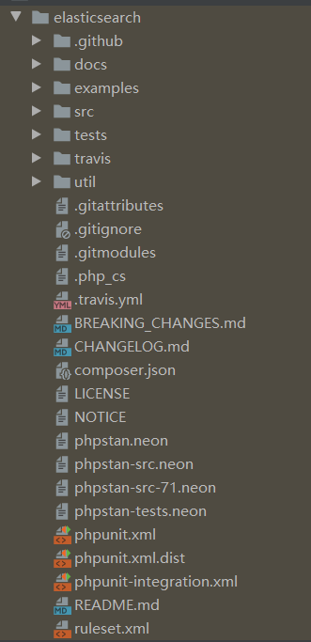

### API文档手册：

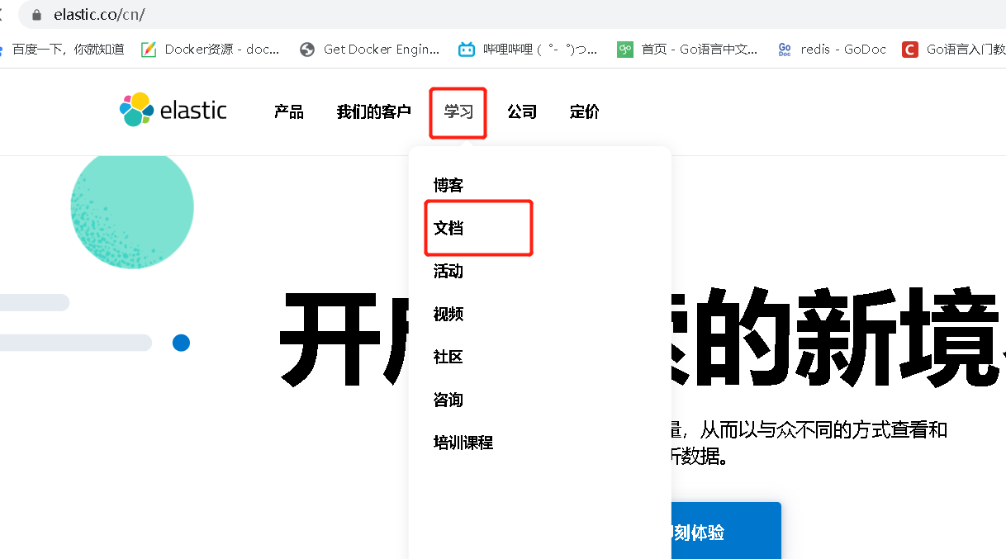

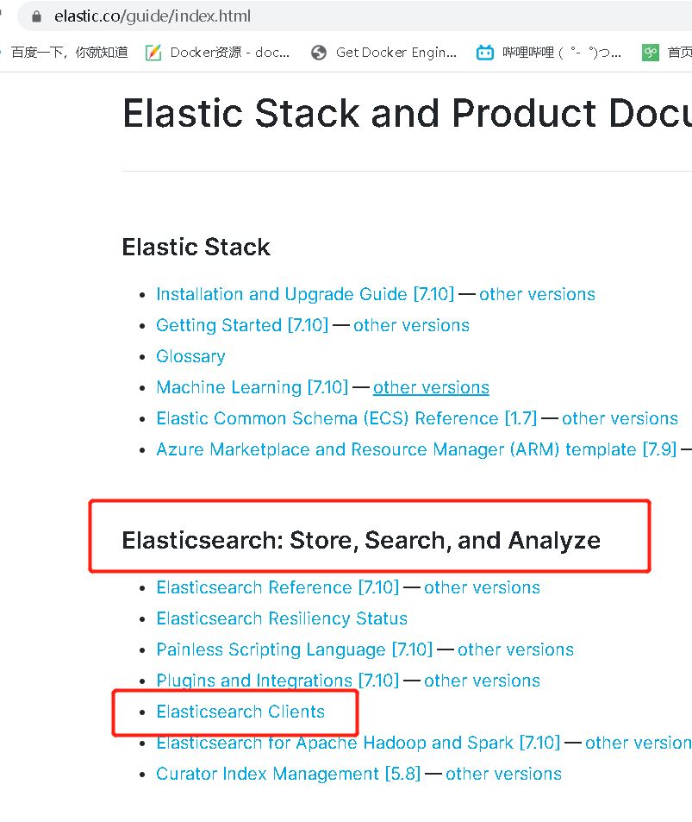

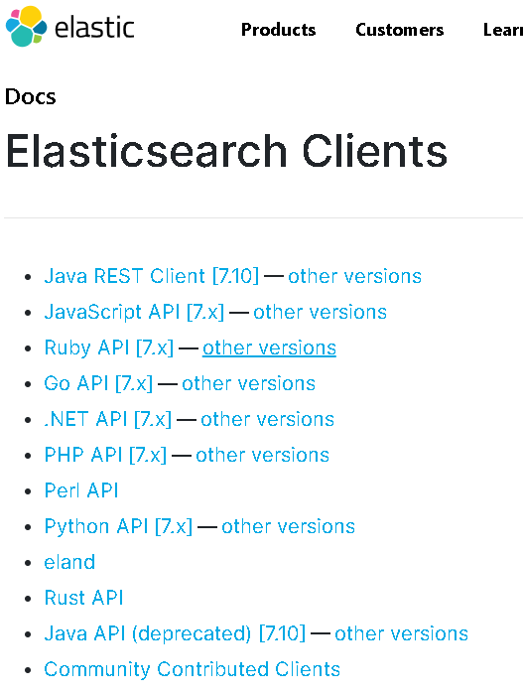

### php示例：

<?php  
  
require 'vendor/autoload.php';  
  
use Elasticsearch\ClientBuilder;  
  
require_once("functions.php");  
  
$config['es_jz_cluster'] = [  
 "10.0.101.96:9200", // es01  
 "10.0.101.94:9200", // es02  
 "10.0.101.103:9200", // es03  
 "10.0.101.98:9200", // es04  
 "10.0.101.95:9200", // es05  
];  
$config['es_jz_user'] = "elastic";  
$config['es_jz_password'] = "elkstack2020#";  
  
$esClient = ClientBuilder::*create*()  
 ->setHosts($config['es_jz_cluster'])  
 ->setBasicAuthentication($config['es_jz_user'], $config['es_jz_password'])  
 ->build();  
$es_index = "scan_2020";  
$tableName = "`scrm-data-scan`.tmp_20201130";  
$sql = "select unique_logic from {$tableName} where len = 29";  
$rows = pdo_fetchall($pdo_scan, $sql);  
$affected_rows = 0;  
foreach($rows as $row) {  
 $id = $row["unique_logic"];  
 $params = [  
 'index' => $es_index,  
 'id' => $id,  
 'body' => [  
 'doc' => [  
 "verification" => "0",  
 "is_first" => 0,  
 ],  
 ]  
 ];  
 dlog(var_export($params,1), "scan");  
  
 // Update doc at /my_index/_doc/my_id  
 $response = $esClient->update($params);  
 dlog(var_export($response,1),"scan");  
  
 $affected_rows++;  
  
 if ($affected_rows/1000==0) {  
 dlog("====affected_rows:".$affected_rows,"scan");  
 }  
}  
dlog("affected_rows:".$affected_rows,"scan");  
echo "ok";