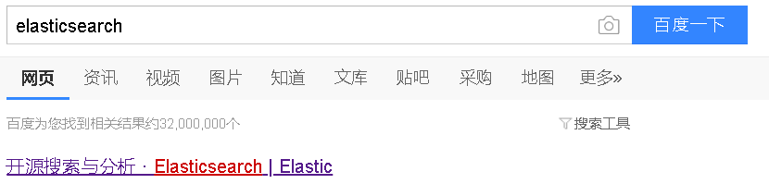

<https://www.elastic.co/cn/>

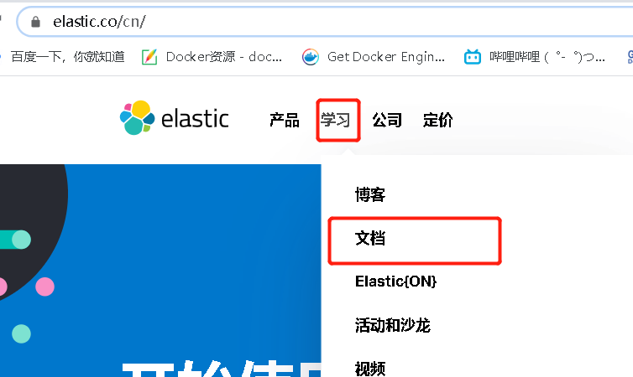

<https://www.elastic.co/guide/index.html>

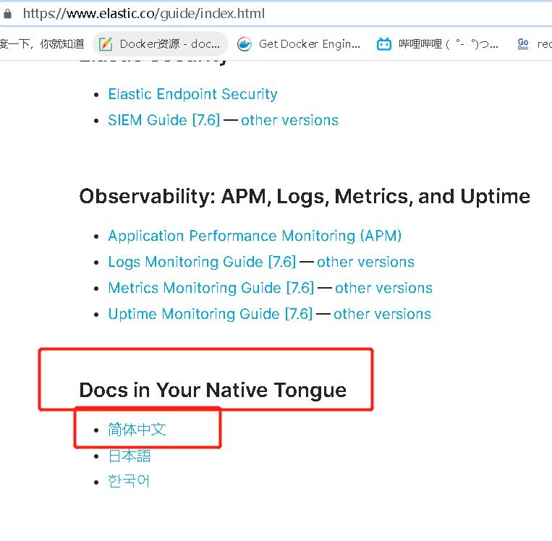

<https://www.elastic.co/guide/index.html>

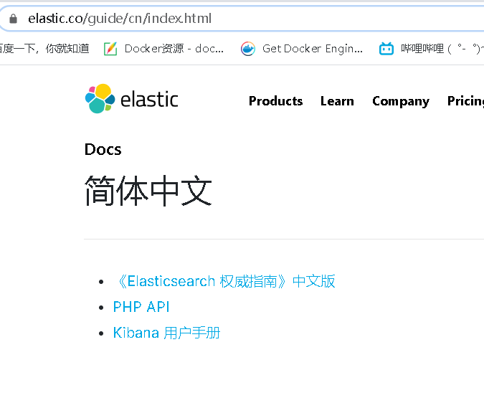

<https://www.elastic.co/guide/cn/index.html>