**第一种方式：**

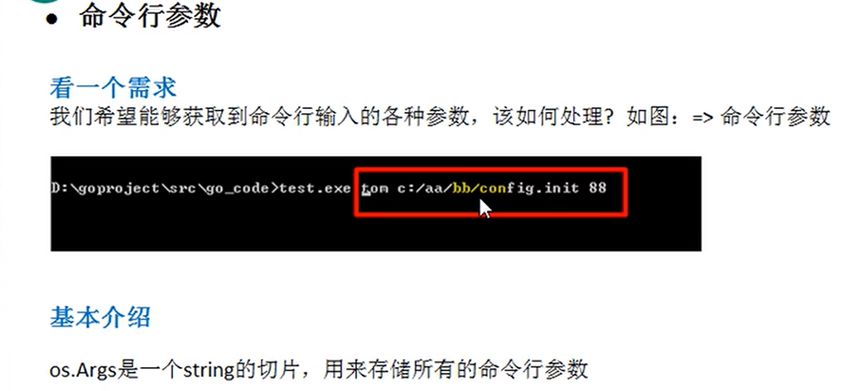

Func main(){

fmt.Println(len(os.Args))

for I,v:= range os.Args{

fmt.Printf(“args[%v]=%v\n”,I,v)

}

}

**第二种方式：**

**使用flag包进行参数的操作**

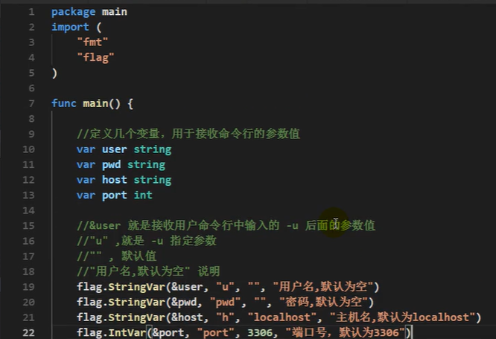

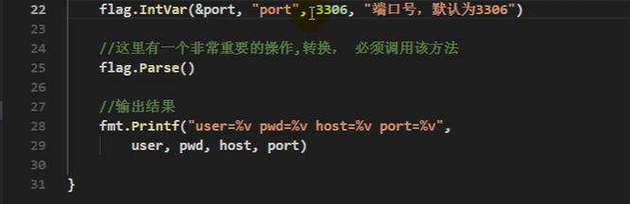

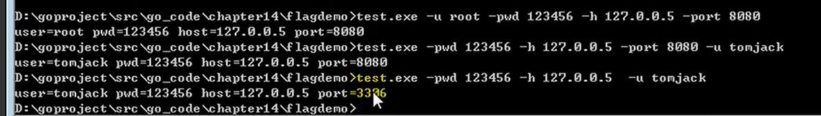

func main() {  
 var user string  
 var pwd string  
 var host string  
 var port int  
 flag.StringVar(&user,"u","","用户名默认为空！")  
 flag.StringVar(&pwd,"pwd","","用户密码默认为空！")  
 flag.StringVar(&host,"host","127.0.0.1","用户主机默认为127.0.0.1！")  
 flag.IntVar(&port,"port",3306,"端口号默认为3306！")  
 flag.Parse()  
 if user != "user"{  
 fmt.Println("用户名不存在")  
 return  
 }  
 fmt.Printf("user=%+v pwd=%+v host=%+v port=%+v",user,pwd,host,port)  
}