<https://github.com/marioizquierdo/jquery.serializeJSON>



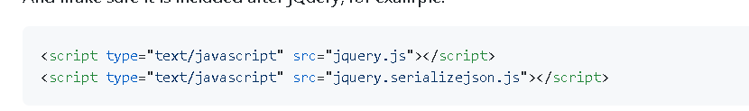

HTML form:

<form id="my-profile">

<!-- simple attribute -->

<input type="text" name="name" value="Mario" />

<!-- nested attributes -->

<input type="text" name="address[city]" value="San Francisco" />

<input type="text" name="address[state][name]" value="California" />

<input type="text" name="address[state][abbr]" value="CA" />

<!-- array -->

<input type="text" name="jobbies[]" value="code" />

<input type="text" name="jobbies[]" value="climbing" />

<!-- nested arrays, textareas, checkboxes ... -->

<textarea name="projects[0][name]">serializeJSON</textarea>

<textarea name="projects[0][language]">javascript</textarea>

<input type="hidden" name="projects[0][popular]" value="0" />

<input type="checkbox" name="projects[0][popular]" value="1" checked />

<textarea name="projects[1][name]">tinytest.js</textarea>

<textarea name="projects[1][language]">javascript</textarea>

<input type="hidden" name="projects[1][popular]" value="0" />

<input type="checkbox" name="projects[1][popular]" value="1"/>

<!-- select -->

<select name="selectOne">

<option value="paper">Paper</option>

<option value="rock" selected>Rock</option>

<option value="scissors">Scissors</option>

</select>

<!-- select multiple options, just name it as an array[] -->

<select multiple name="selectMultiple[]">

<option value="red" selected>Red</option>

<option value="blue" selected>Blue</option>

<option value="yellow">Yellow</option>

</select>

</form>

JavaScript:

$('#my-profile').serializeJSON();

// returns =>

{

fullName: "Mario",

address: {

city: "San Francisco",

state: {

name: "California",

abbr: "CA"

}

},

jobbies: ["code", "climbing"],

projects: {

'0': { name: "serializeJSON", language: "javascript", popular: "1" },

'1': { name: "tinytest.js", language: "javascript", popular: "0" }

},

selectOne: "rock",

selectMultiple: ["red", "blue"]

}