官网：<https://clipboardjs.com/>

npm install clipboard –save

<script src="dist/clipboard.min.js"></script>

<a href="javascript:void(0)" class="copy_access" title="复制"><i class="el-icon-document-copy"></i></a>

<script>  
 $(function () {  
 //剪切版操作  
 ***window***.clipboard=new ClipboardJS('.copy_access', {  
 text: function(trigger) {  
 // return trigger.getAttribute('aria-label');  
 // console.log(trigger);  
 return $($(trigger).closest("tr").find("td")[1]).text();  
 }  
 });  
  
 clipboard.on('success', function(e) {  
 // console.info('Action:', e.action);  
 ***console***.info('Text:', e.text);  
 // console.info('Trigger:', e.trigger);  
 e.clearSelection();  
 layer.msg('复制成功！');  
 });  
  
 clipboard.on('error', function(e) {  
 ***console***.error('Action:', e.action);  
 ***console***.error('Trigger:', e.trigger);  
 layer.msg('复制失败！', {time: 1000});  
 });  
 });  
</script>

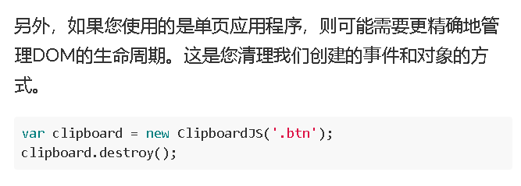

//jquery load()进来的页面需要在load之前销毁剪切板  
if(typeof clipboard !== "undefined"){  
 clipboard.destroy();  
 ***window***.clipboard=null;  
}

$("#mainConfiguration").load(this.url+"/"+this.activeName+"/"+***app_uuid***+"/"+btoa(encodeURIComponent(***app_name***)));