**插件介绍**

先上一个图：

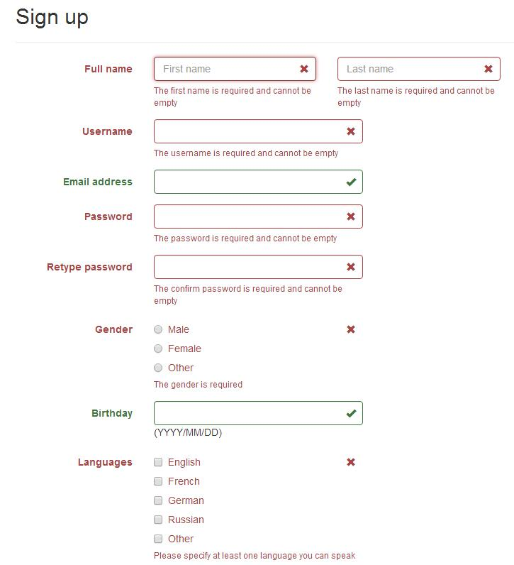  
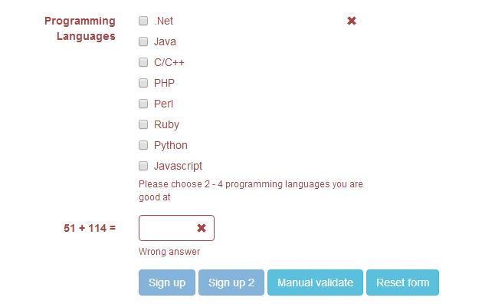

下载地址：https://github.com/nghuuphuoc/bootstrapvalidator

使用方法：http://www.cnblogs.com/huangcong/p/5335376.html

**使用提示**

**中文化：**  
下载插件后，将\js\bootstrapValidator\language\zh_CN.js 引入文件，即实现中文化

**提交前验证表单：**  
更丰富一点的表单验证例子：http://www.jq22.com/yanshi522，直接上代码：

1 <!DOCTYPE html>

2 <html>

3 <head>

4 <title>BootstrapValidator demo</title>

5

6 <link rel="stylesheet" href="vendor/bootstrap/css/bootstrap.css"/>

7 <link rel="stylesheet" href="dist/css/bootstrapValidator.css"/>

8

9 <!-- Include the FontAwesome CSS if you want to use feedback icons provided by FontAwesome -->

10 <!--<link rel="stylesheet" href="http://netdna.bootstrapcdn.com/font-awesome/4.0.3/css/font-awesome.css" />-->

11

12 <script type="text/javascript" src="vendor/jquery/jquery-1.10.2.min.js"></script>

13 <script type="text/javascript" src="vendor/bootstrap/js/bootstrap.min.js"></script>

14 <script type="text/javascript" src="dist/js/bootstrapValidator.js"></script>

15 </head>

16 <body>

17 <div class="container">

18 <div class="row">

19 <!-- form: -->

20 <section>

21 <div class="col-lg-8 col-lg-offset-2">

22 <div class="page-header">

23 <h2>Sign up</h2>

24 </div>

25

26 <form id="defaultForm" method="post" class="form-horizontal" action="target.php">

27 <div class="form-group">

28 <label class="col-lg-3 control-label">Full name</label>

29 <div class="col-lg-4">

30 <input type="text" class="form-control" name="firstName" placeholder="First name" />

31 </div>

32 <div class="col-lg-4">

33 <input type="text" class="form-control" name="lastName" placeholder="Last name" />

34 </div>

35 </div>

36

37 <div class="form-group">

38 <label class="col-lg-3 control-label">Username</label>

39 <div class="col-lg-5">

40 <input type="text" class="form-control" name="username" />

41 </div>

42 </div>

43

44 <div class="form-group">

45 <label class="col-lg-3 control-label">Email address</label>

46 <div class="col-lg-5">

47 <input type="text" class="form-control" name="email" />

48 </div>

49 </div>

50

51 <div class="form-group">

52 <label class="col-lg-3 control-label">Password</label>

53 <div class="col-lg-5">

54 <input type="password" class="form-control" name="password" />

55 </div>

56 </div>

57

58 <div class="form-group">

59 <label class="col-lg-3 control-label">Retype password</label>

60 <div class="col-lg-5">

61 <input type="password" class="form-control" name="confirmPassword" />

62 </div>

63 </div>

64

65 <div class="form-group">

66 <label class="col-lg-3 control-label">Gender</label>

67 <div class="col-lg-5">

68 <div class="radio">

69 <label>

70 <input type="radio" name="gender" value="male" /> Male

71 </label>

72 </div>

73 <div class="radio">

74 <label>

75 <input type="radio" name="gender" value="female" /> Female

76 </label>

77 </div>

78 <div class="radio">

79 <label>

80 <input type="radio" name="gender" value="other" /> Other

81 </label>

82 </div>

83 </div>

84 </div>

85

86 <div class="form-group">

87 <label class="col-lg-3 control-label">Birthday</label>

88 <div class="col-lg-5">

89 <input type="text" class="form-control" name="birthday" /> (YYYY/MM/DD)

90 </div>

91 </div>

92

93 <div class="form-group">

94 <label class="col-lg-3 control-label">Languages</label>

95 <div class="col-lg-5">

96 <div class="checkbox">

97 <label>

98 <input type="checkbox" name="languages[]" value="english" /> English

99 </label>

100 </div>

101 <div class="checkbox">

102 <label>

103 <input type="checkbox" name="languages[]" value="french" /> French

104 </label>

105 </div>

106 <div class="checkbox">

107 <label>

108 <input type="checkbox" name="languages[]" value="german" /> German

109 </label>

110 </div>

111 <div class="checkbox">

112 <label>

113 <input type="checkbox" name="languages[]" value="russian" /> Russian

114 </label>

115 </div>

116 <div class="checkbox">

117 <label>

118 <input type="checkbox" name="languages[]" value="other" /> Other

119 </label>

120 </div>

121 </div>

122 </div>

123

124 <div class="form-group">

125 <label class="col-lg-3 control-label">Programming Languages</label>

126 <div class="col-lg-5">

127 <div class="checkbox">

128 <label>

129 <input type="checkbox" name="programs[]" value="net" /> .Net

130 </label>

131 </div>

132 <div class="checkbox">

133 <label>

134 <input type="checkbox" name="programs[]" value="java" /> Java

135 </label>

136 </div>

137 <div class="checkbox">

138 <label>

139 <input type="checkbox" name="programs[]" value="c" /> C/C++

140 </label>

141 </div>

142 <div class="checkbox">

143 <label>

144 <input type="checkbox" name="programs[]" value="php" /> PHP

145 </label>

146 </div>

147 <div class="checkbox">

148 <label>

149 <input type="checkbox" name="programs[]" value="perl" /> Perl

150 </label>

151 </div>

152 <div class="checkbox">

153 <label>

154 <input type="checkbox" name="programs[]" value="ruby" /> Ruby

155 </label>

156 </div>

157 <div class="checkbox">

158 <label>

159 <input type="checkbox" name="programs[]" value="python" /> Python

160 </label>

161 </div>

162 <div class="checkbox">

163 <label>

164 <input type="checkbox" name="programs[]" value="javascript" /> Javascript

165 </label>

166 </div>

167 </div>

168 </div>

169

170 <div class="form-group">

171 <label class="col-lg-3 control-label" id="captchaOperation"></label>

172 <div class="col-lg-2">

173 <input type="text" class="form-control" name="captcha" />

174 </div>

175 </div>

176

177 <div class="form-group">

178 <div class="col-lg-9 col-lg-offset-3">

179 <button type="submit" class="btn btn-primary" name="signup" value="Sign up">Sign up</button>

180 <button type="submit" class="btn btn-primary" name="signup2" value="Sign up 2">Sign up 2</button>

181 <button type="button" class="btn btn-info" id="validateBtn">Manual validate</button>

182 <button type="button" class="btn btn-info" id="resetBtn">Reset form</button>

183 </div>

184 </div>

185 </form>

186 </div>

187 </section>

188 <!-- :form -->

189 </div>

190 </div>

191

192 <script type="text/javascript">

193 $(document).ready(function() {

194 // Generate a simple captcha

195 function randomNumber(min, max) {

196 return Math.floor(Math.random() * (max - min + 1) + min);

197 };

198 $('#captchaOperation').html([randomNumber(1, 100), '+', randomNumber(1, 200), '='].join(' '));

199

200 $('#defaultForm').bootstrapValidator({

201 // live: 'disabled',

202 message: 'This value is not valid',

203 feedbackIcons: {

204 valid: 'glyphicon glyphicon-ok',

205 invalid: 'glyphicon glyphicon-remove',

206 validating: 'glyphicon glyphicon-refresh'

207 },

208 fields: {

209 firstName: {

210 validators: {

211 notEmpty: {

212 message: 'The first name is required and cannot be empty'

213 }

214 }

215 },

216 lastName: {

217 validators: {

218 notEmpty: {

219 message: 'The last name is required and cannot be empty'

220 }

221 }

222 },

223 username: {

224 message: 'The username is not valid',

225 validators: {

226 notEmpty: {

227 message: 'The username is required and cannot be empty'

228 },

229 stringLength: {

230 min: 6,

231 max: 30,

232 message: 'The username must be more than 6 and less than 30 characters long'

233 },

234 regexp: {

235 regexp: /^[a-zA-Z0-9_\.]+$/,

236 message: 'The username can only consist of alphabetical, number, dot and underscore'

237 },

238 remote: {

239 url: 'remote.php',

240 message: 'The username is not available'

241 },

242 different: {

243 field: 'password',

244 message: 'The username and password cannot be the same as each other'

245 }

246 }

247 },

248 email: {

249 validators: {

250 emailAddress: {

251 message: 'The input is not a valid email address'

252 }

253 }

254 },

255 password: {

256 validators: {

257 notEmpty: {

258 message: 'The password is required and cannot be empty'

259 },

260 identical: {

261 field: 'confirmPassword',

262 message: 'The password and its confirm are not the same'

263 },

264 different: {

265 field: 'username',

266 message: 'The password cannot be the same as username'

267 }

268 }

269 },

270 confirmPassword: {

271 validators: {

272 notEmpty: {

273 message: 'The confirm password is required and cannot be empty'

274 },

275 identical: {

276 field: 'password',

277 message: 'The password and its confirm are not the same'

278 },

279 different: {

280 field: 'username',

281 message: 'The password cannot be the same as username'

282 }

283 }

284 },

285 birthday: {

286 validators: {

287 date: {

288 format: 'YYYY/MM/DD',

289 message: 'The birthday is not valid'

290 }

291 }

292 },

293 gender: {

294 validators: {

295 notEmpty: {

296 message: 'The gender is required'

297 }

298 }

299 },

300 'languages[]': {

301 validators: {

302 notEmpty: {

303 message: 'Please specify at least one language you can speak'

304 }

305 }

306 },

307 'programs[]': {

308 validators: {

309 choice: {

310 min: 2,

311 max: 4,

312 message: 'Please choose 2 - 4 programming languages you are good at'

313 }

314 }

315 },

316 captcha: {

317 validators: {

318 callback: {

319 message: 'Wrong answer',

320 callback: function(value, validator) {

321 var items = $('#captchaOperation').html().split(' '), sum = parseInt(items[0]) + parseInt(items[2]);

322 return value == sum;

323 }

324 }

325 }

326 }

327 }

328 });

329

330 // Validate the form manually

331 $('#validateBtn').click(function() {

332 $('#defaultForm').bootstrapValidator('validate');

333 });

334

335 $('#resetBtn').click(function() {

336 $('#defaultForm').data('bootstrapValidator').resetForm(true);

337 });

338 });

339 </script>

340 </body>

341 </html>

看331行，点击提交时，用

$('#defaultForm').bootstrapValidator('validate');

触发表单验证

下面是碰到的一个坑：

bootstrapValidator默认逻辑是当表单验证失败时，把按钮给变灰色。  
但是项目中，button并不在form内部，是通过事件绑定来ajax提交的。那么问题来了：

项目需要当form验证失败时，不执行所绑定的后续事件。百度半天找不到相关资料，最后还是要靠google：

$("#yourform").submit(function(ev){ev.preventDefault();});

$("#submit").on("click", function(){

var bootstrapValidator = $("#yourform").data('bootstrapValidator');

bootstrapValidator.validate();

if(bootstrapValidator.isValid())

$("#yourform").submit();

else return;

});