# [TP5异常处理](https://www.cnblogs.com/yanweifeng/p/10950424.html)

## **自定义异常处理**

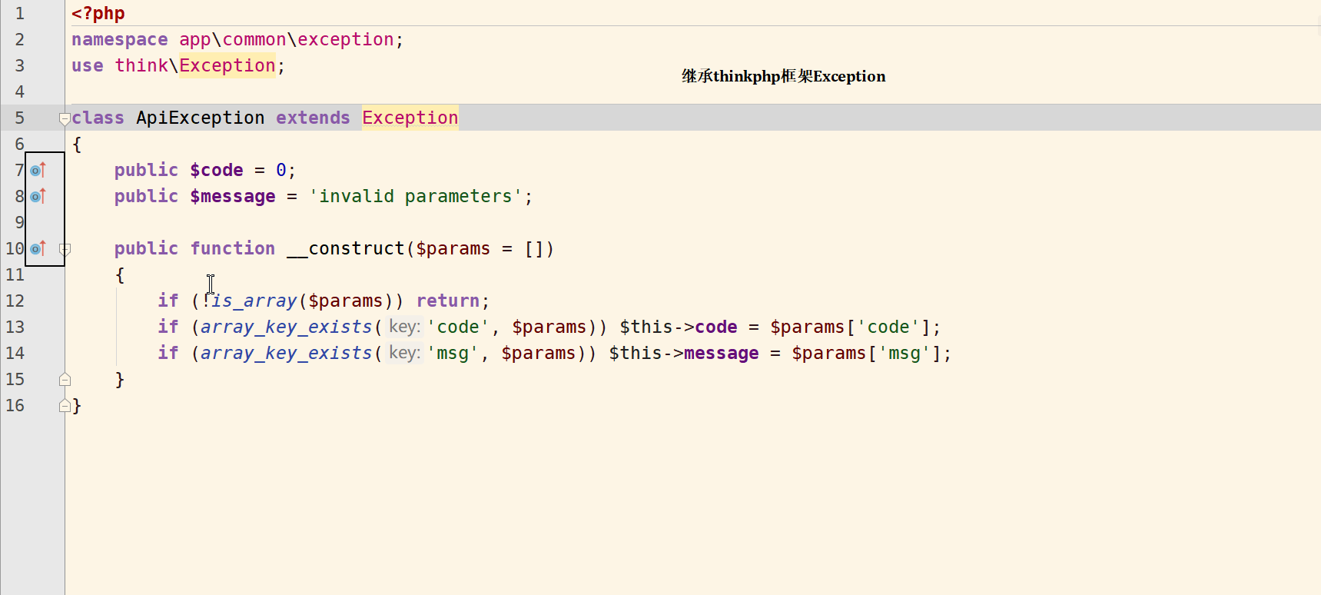

namespace app\common\exception;use think\Exception;

class ApiException extends Exception{

public $code = 0;

public $message = 'invalid parameters';

public function __construct($params = [])

{

if (!is_array($params)) return;

if (array_key_exists('code', $params)) $this->code = $params['code'];

if (array_key_exists('msg', $params)) $this->message = $params['msg'];

}

}

## **异常处理接管[重写]**

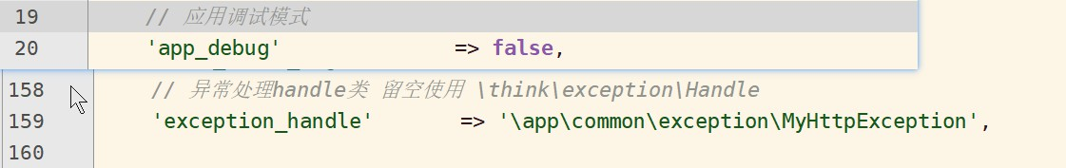

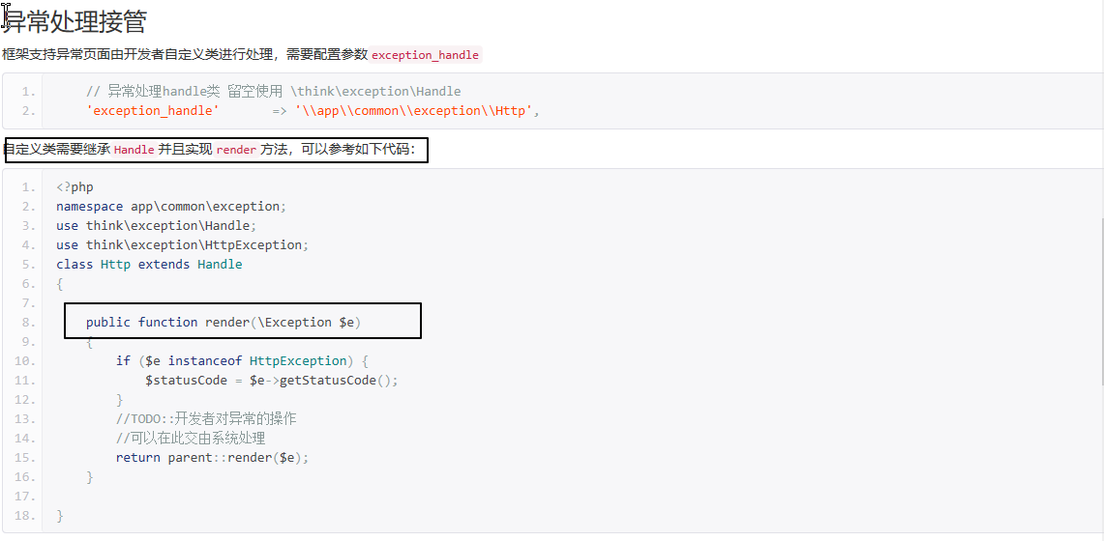

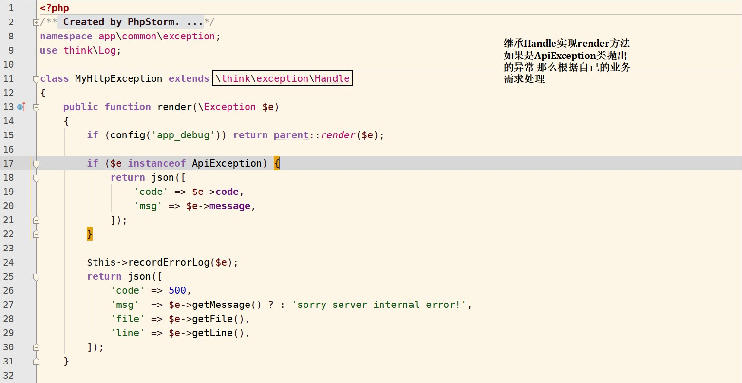

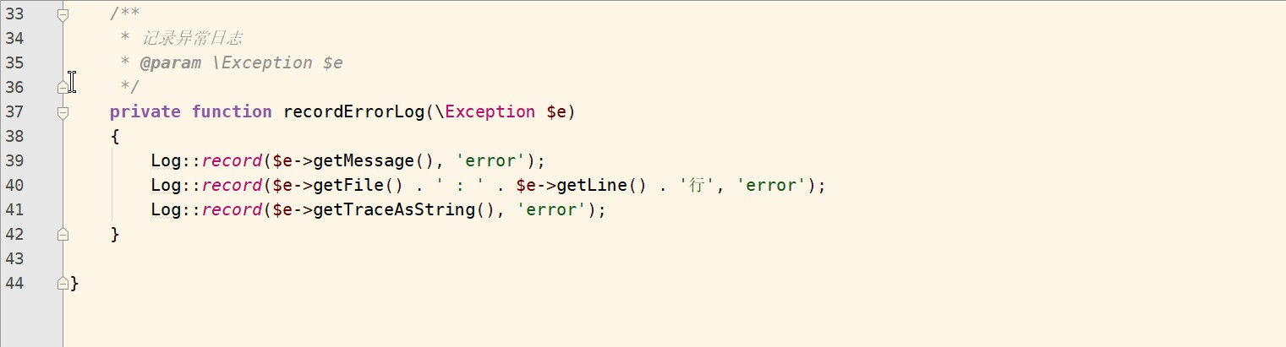

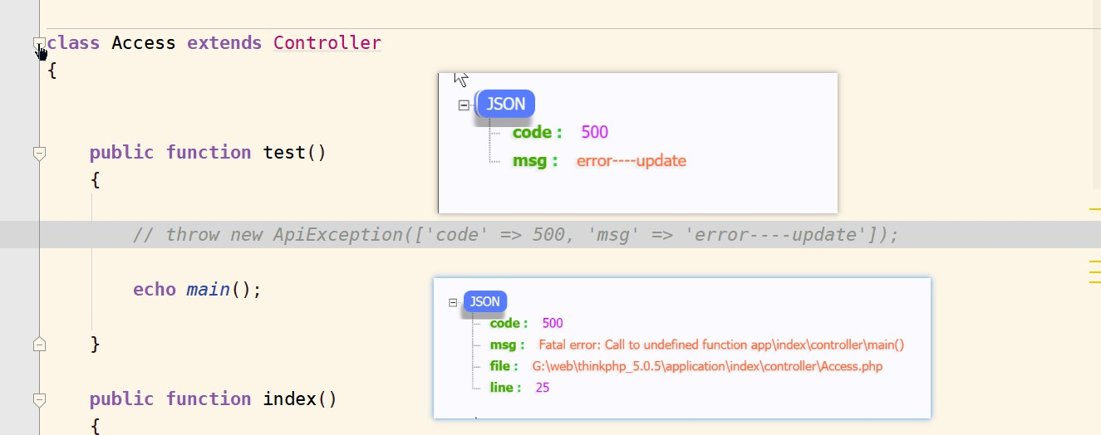

<?php/**

* Created by PhpStorm.

* User: ywf

* Date: 2019/5/16

* Time: 11:13

*/namespace app\common\exception;use think\Log;

class MyHttpException extends \think\exception\Handle{

public function render(\Exception $e)

{

if (config('app_debug')) return parent::render($e);

if ($e instanceof ApiException) {

return json([

'code' => $e->code,

'msg' => $e->message,

]);

}

$this->recordErrorLog($e);

return json([

'code' => 500,

'msg' => $e->getMessage() ? : 'sorry server internal error!',

'file' => $e->getFile(),

'line' => $e->getLine(),

]);

}

/**

* 记录异常日志

* @param \Exception $e

*/

private function recordErrorLog(\Exception $e)

{

Log::record($e->getMessage(), 'error');

Log::record($e->getFile() . ' : ' . $e->getLine() . '行', 'error');

Log::record($e->getTraceAsString(), 'error');

}

}