**Task 1**

1.

We have to simulate Geometric Brownian Motion (GBM) in the first part of the task 1. The equation of the brownian motion is dS(t) = 0.1dt + 0.26dB(t) and S(0) = 39. We have simulated 1000 runs to get the results. The following figure is the plot of the five realizations of GBM.

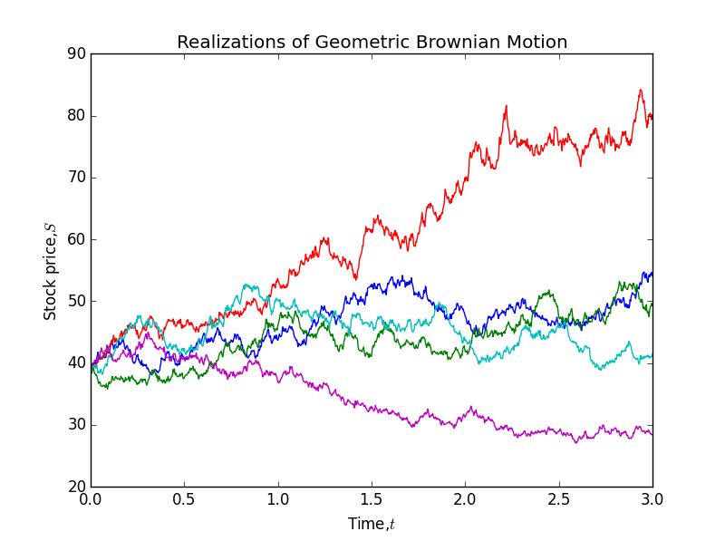

E(S3) = 49.2613347026

Var(S3) = 166.257749618

P[S(3)>39] = 0.772

E[S(3)|S(3)>39] = 53.8540030889

Apart from that, we also have to calculate expectation value and the variance of S(3). Numpy function, np.mean is used to find the expectation value of S(3) and np.var is used to obtain the variance of S(3).

Next, in order to calculate the probability of S(3) greater than 39, P[S(3) > 39], we form a new matrix consists of true false element (1 and 0) and sum up the total number of path that exceeds 39, then divided by the length of values that are greater than 39.

Then, the new matrix formed above is multiplying with the original matrix, get the sum and divided by the sum of S(3) greater than 39 (the new matrix formed above).

2.

The second part of task 1 is to simulate mean reversal process based on the equation   
dR(t) = [0.064 - R(t)] dt + 0.27 R(t) dB(t) and R(0) = 3. The following figure is the plot of five realizations of mean reversal process.

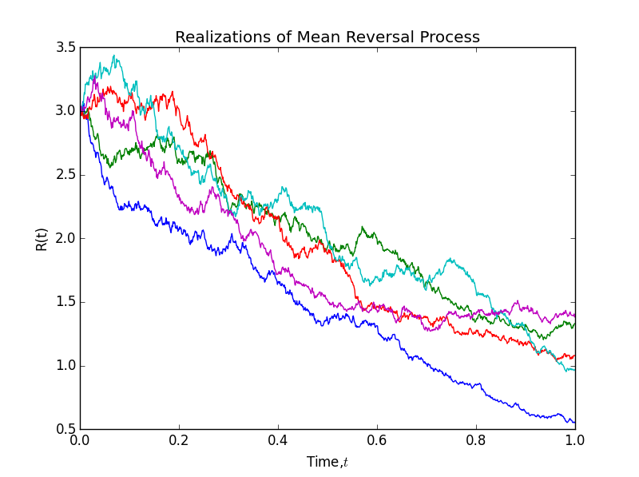

E(R1) = 1.13698602573

P[R(1)>2] = 0.012

We use a numpy function, np.mean to find the value of the expectation value of R(1). Similarly to the first part of task 1, in order to obtain the probability of R(1) greater than 2, we form a new matrix consists of true false element (1 and 0) and sum up the total number of path that exceeds 2, then divided by the number_path which is 1000.

**Task 2**

There are 30 components in FTSE Bursa Malaysia KLCI Index. By referring to the sources in Bloombeg, we create a table list the following information for all the component stocks: Stock Name, Stock Code, Stock Sector, Weightage in FTSEKLCI, PE ratio and Net Market Capital. The information is last updated at 24/7/2015.

|  |  |  |  |  |  |
| --- | --- | --- | --- | --- | --- |
| Stock Name | Stock Code | Stock Sector | Weightage in FTSEKLCI | PE Ratio | Net Market Capital (B,as billion) |
| Public Bank Bhd | 1295 | Banks | 11.6 | 15.21 | 73.368 |
| Malayan Banking | 1155 | Banks | 9.32 | 12.4 | 88.041 |
| Tenaga Nasional | 5347 | Alternative Electricity | 9.28 | 9.15 | 69.304 |
| CIMB Group Holdings | 1023 | Banks | 5.76 | 17.52 | 46.694 |
| Axiata Group Bhd | 6888 | Mobile Telecommunications | 5.62 | 24.3 | 55.349 |
| Sime Darby Bhd | 4197 | Diversified Industrials | 5.51 | 21.89 | 52.671 |
| Digi.com | 6947 | Mobile Telecommunications | 4.16 | 21.02 | 41.830 |
| Genting | 3182 | Hotels | 3.68 | 19.30 | 30.748 |
| PETRONAS Chemicals Group Bhd | 5183 | Commodity Chemicals | 3.55 | 21.83 | 50.640 |
| Maxis Bhd | 6012 | Mobile Telecommunications | 3.45 | 30.05 | 49.409 |
| Petronas Gas | 6033 | Exploration & Production | 3.4 | 22.79 | 42.741 |
| IHH Healthcare | 5225 | Health Care Providers | 3.28 | 63.15 | 48.758 |
| IOI | 1961 | Farming & Fishing | 2.99 | 73.65 | 26.731 |
| Telekom Malaysia | 4863 | Fixed Line Telecommunications | 2.96 | 32.34 | 24.195 |
| Genting Malaysia Bhd | 4715 | Hotels | 2.5 | 20.21 | 24.097 |
| MISC | 3816 | Marine Transportation | 2.45 | 15.99 | 35.264 |
| AMMB Holdings | 1015 | Banks | 2.38 | 8.82 | 16.970 |
| Kuala Lumpur Kepong | 2445 | Farming & Fishing | 2.28 | 29.21 | 23.983 |
| SapuraKencana Petroleum | 5218 | Oil Equipment & Services | 1.98 | 12.08 | 14.321 |
| PBB Group | 4065 | Food Products | 1.8 | 18.13 | 18.233 |
| British American Tobacco (Malaysia) | 4162 | Tobacco | 1.7 | 20.06 | 18.445 |
| Hong Leong Bank | 5819 | Banks | 1.67 | 11.19 | 24.572 |
| YTL Corp | 4677 | Multiutilities | 1.63 | 14.95 | 16.670 |
| UMW Holdings | 4588 | Automobiles | 1.37 | 20.41 | 11.987 |
| Astro Malaysia Holdings | 6399 | Broadcasting & Entertainment | 1.22 | 28.06 | 15.761 |
| Petronas Dagangan Bhd | 5681 | Intrgrated Oil & Gas | 1.21 | 37.05 | 20.445 |
| RHB Capital | 1066 | Banks | 1.06 | 9.18 | 19.129 |
| Westports Holdings | 5246 | Transportation Services | 0.93 | 26.84 | 14.356 |
| Hong Leong Financial | 1082 | Banks | 0.64 | 9.92 | 16.255 |
| KLCC Prop & Reits - Stapled Sec | 5235SS | Real Estate Holding & Development | 0.63 | 13.63 | 12.637 |

2.

We have chosen Malayan Banking with the code 1155 and downloaded its daily data start from   
Jan 1 2010 to July 24 2015. The following is the plotting for the 5-days moving average of Malayan Banking.

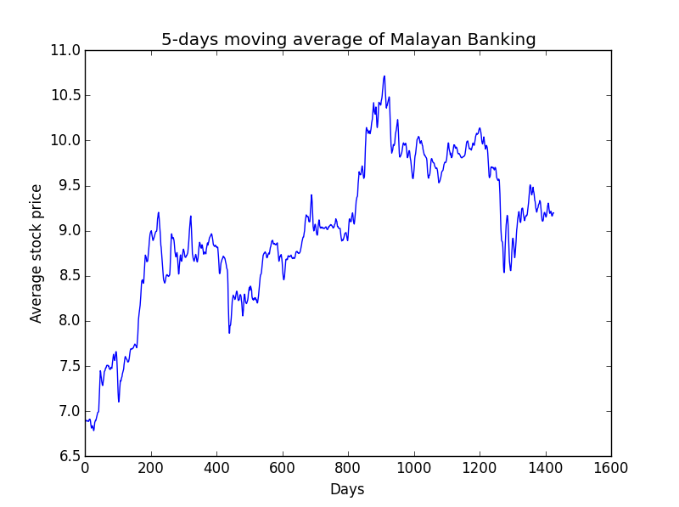

In order to obtain the 5 days moving average, the closing price of Malayan Banking is added for 5 days, then the total is divided by 5. Next, the correlation between the FTSEKLCI and Malayan Banking for same duration is calculated and the results is as below:

Correlation = 1155.KL ^KLSE

1155.KL 1.000000 0.975116

^KLSE 0.975116 1.000000