

**CZ 4042**

**Neural Networks and Deep Learning**

**Assignment 2 Report**

**Tan Chuan Xin**

**U1821755B**

Table of Contents

Prologue 3

Part A: Classification Problem 4

Introduction 4

Methods 4

Normalization 4

Mini-Batch Gradient Descent 5

Loss Function – SparseCategoricalCrossentropy (ce) 5

k-fold Cross-Validation 5

Three-Way Data Split 6

Regularization 7

Custom Callbacks 7

Saving Data 8

Incremental analysis 8

Question 0 – Normalization method 9

Question 1 – Convergence 11

Question 2 – Batch size 12

Question 3 – Number of neurons 14

Question 4 – Weight decay parameter 16

Question 5 – Comparison against 4-layer network 18

Summary 19

Part B: Regression Problem 20

Introduction 20

Methods 20

Loss Function – MeanSquareError (mse) 20

Recursive Feature Elimination 20

Dropout Layers 21

Question 0 – Normalization method 22

Question 1 – Convergence 24

Question 2 – Recursive Feature Elimination 26

Question 3 – Number of Layers, Dropout 28

Summary 30

Prologue

This assignment was done through Google Colaboratory Notebooks. The repository has been hosted on Github, and cloning it will be the best way to get a copy of the code to run. It can be found at the following link: [https://github.com/tanchuanxin/cz4042_assignment_](https://github.com/tanchuanxin/cz4042_assignment_1)2

Each individual question has a notebook dedicated to it. Please refer to the relevant notebooks alongside this project report for a better understanding.

This report will be written as a companion to the notebook. Code blocks will be omitted as much as possible, as this report shall center on the rationale of various decisions made that led to the code, rather than the actual code itself.

**Source code**

The source codes can be found under the folders titled 1a and 1b

The relevant .ipynb files are as such

|  |  |
| --- | --- |
| For 1a | For 1b |

Part A: Object Recognition

# Introduction

Part A is an object recognition problem on the CIFAR-10 dataset, which contains images in 10 classes. This is also a classification problem. The end goal is to perform a multi-class classification and output a class label corresponding to the input image.

There are four tasks given, namely

1. Implement a Convolutional Neural Network (CNN) based on parameters that were provided
2. Perform a grid search to find optimal channels for the CNN
3. Experiment with various optimization techniques to improve performance
4. Compare every model created and discuss their performance

The primary goal of this problem is to discover a set of hyperparameters that are optimal to classify the images in the CIFAR-10 dataset when using CNNs.

# Methods

There are several primary techniques that are common throughout the notebooks used for Part A. We shall address why these methods were necessary, and hence chosen. We will also explain the methods used by the starter code, when deemed important.

## Data Preparation

Some changes were made to the load_data(file) function in the starter code. When trying to plot out the source image for inspection, random noise was plotted out instead. It was discovered that there was a problem with the reshaping of the source data into proper images. Therefore, this line was added to ensure proper reshaping into a 32x32x3 dimension image.

  data = data.reshape(len(data), 3, 32, 32).transpose(0, 2, 3, 1)

Before, the numpy array representations of the images were incorrectly prepared. Feeding these into our model provided incoherent predictions and very random intermediate layer activations. Therefore, it was important that the data was prepared correctly. Now, we are able to output the images as they were meant to be.

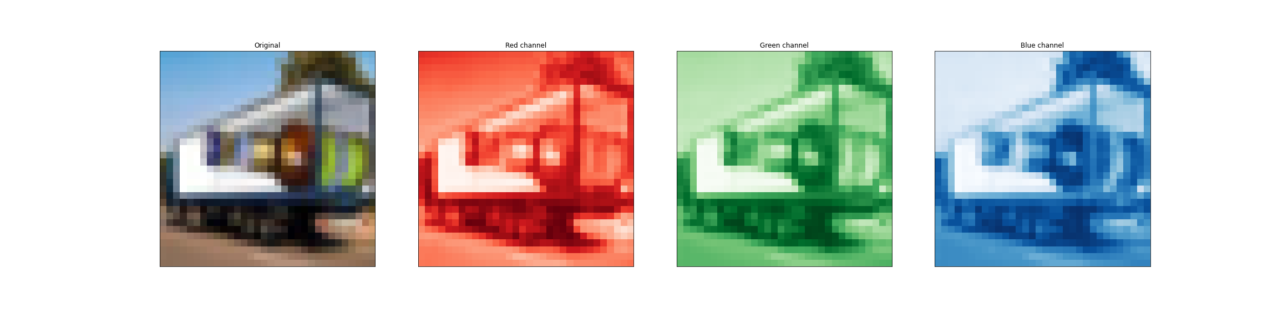

## Convolutional Neural Networks (CNN)

CNNs are a powerful form of feedforward neural networks, especially when it comes to tasks related to computer vision. CNNs are defined in a large part with convolutional layers and pooling layers.

Convolutional layers perform convolutional operations that involve taking a kernel (essentially a set of weights) and passing it across the entire input matrix to produce a feature map. Multiple kernels of varying sizes can be passed through the input matrix to produce various feature maps, that may correspond to certain characteristics of the input matrix. Feature maps are then passed through pooling layers, which perform local interpolation on feature maps to select just a few values from them, such as maxpooling, which takes the maximum value from a window of values.

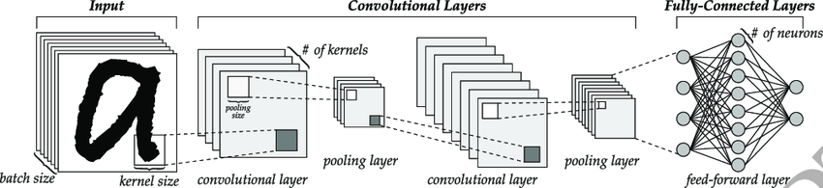

The number of channels in a convolutional layer represent the number of kernels that are applied on the input matrix, which produces an equal number of feature maps for the image. Given that ‘feature maps’ are nothing but characteristics of a given input matrix (commonly images) represented as a matrix/vector, we expect that earlier convolutional layers should have more channels to capture various simple characteristics of the input, and later convolutional layers will have fewer channels that capture overarching themes of the earlier feature maps produced by earlier layers.

We can capture the feature maps at each convolutional layer and pooling layer by simply getting the outputs of each layer in a fully trained model, instead of just the terminal output at the softmax layer. This allows us to visualize what the convolutional and pooling layers are doing.

## Optimization

To enhance the performance of our model, various optimization techniques were used. The following were utilized in this question.

1. Stochastic Gradient Descent (SGD) / Mini-Batch Gradient Descent

SGD is one of the simplest learning algorithms that we can use. In essence, we compute the gradient of the cost function with respect to the parameter that we are optimizing (usually the weights of the model) to discover the optimal set of values for the weights that minimizes our cost function. Stochastic Gradient Descent (formally) will update the weights with every training input. In our case, we implemented mini-batch gradient descent.

Mini-Batch Gradient Descent updates the weights after a specified number of inputs have been processed, termed as the batch size. This speeds up the model, as SGD is very slow due to weights updating for every single training input.

1. Mini-Batch Gradient Descent with momentum term

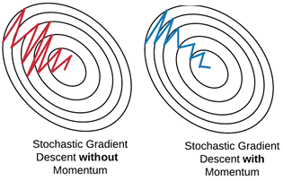Gradient Descent aims to find an optimal set of weights that allows us to achieve the global/local minima for the cost function. However, these minimum points are often associated with steep gradient drops. Vanilla SGD tends to oscillate across the slopes of these ‘ravines’ and take much longer to reach the minima. Therefore, the model will take a longer time to approach convergence at minima.

Momentum terms nudge the gradient towards the ravine. Essentially, the momentum term accelerates the gradient in the direction that previous gradients also imply. If the history of the pastgradients has vectors that point in a certain direction, then there is momentum in that direction, and the momentum terms accounts for this direction, adding the momentum to the current gradient. Thus, if the direction of past gradients points toward the minima, the gradient will be accelerated towards the minima instead of taking small steps and bouncing across the ravine.

More formally,

|  |  |  |  |
| --- | --- | --- | --- |
| γ momentum term | θ optimization parameter | η learning rate | vt update vector at time t |
| vt=γvt−1+η∇θJ(θ) the momentum from update vector at previous time (t-1) carries into the update vector at time t, and joins with actual gradient of loss function with respect to optimization parameter to form new update vector | | | |

We expect that momentum terms will help navigate gradients better and converge faster and more accurately.

1. RMSProp algorithm

Complex neural networks like that pass gradients through multiple layers in back propagation might face vanishing gradients if the gradients are small and undergo repeated matrix multiplications with other small gradients, effectively causing them to go to zero. The inverse is true for gradient explosions, where large gradients keep getting bigger.

RMSProp normalizes gradients by using a running average of the magnitudes of recent gradients. Therefore, it places restrictions on how big and how small the gradients can end up being, which helps avoid exploding gradients and vanishing gradients. This keeps the model weights under control, and training at a reasonable pace.

1. Adam optimizer

The Adam optimizer differs from SGD where learning rates are concerned. In SGD, a single learning rate is applied to the model. Adam uses adaptive moments to calculate a suitable learning rate for individual parameters, thus learning rates do not remain the same throughout training, and it is adapted by calculating exponential moving average of the gradient and squared gradients (controlled by two parameters β1 and β2). Adam optimizer shows good performance in many tasks.

1. Dropout

Neural networks function using layers of neurons. Dropout is a regularization technique that will randomly turn off some of the neurons in a neural network. Turning off a neuron simply renders its synaptic output invalid, and therefore the weights that are learned by neurons that have been turned off do not propagate through the model. Dropout is usually used to prevent overfitting by randomly turning off certain weights, which might include very large weights learned in overfitting. It is expected that dropout will help models generalize better in cases of overfitting.

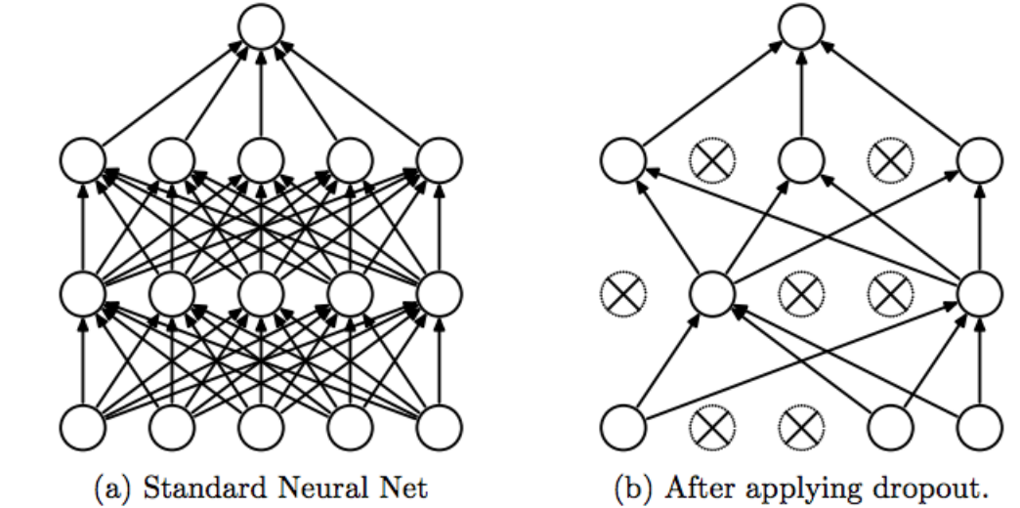

## Saving Data

The history of each model generated by the model.fit( ) method will be saved. Logging these outputs is necessary, to analyze them afterwards without having to keep the notebook instance running constantly. It will allow us to easily plot any graph that we want without having to run the model and go through the model training every time.

We save the history of the model, which includes loss and accuracy information, as a .json file, which we can easily retrieve through helper functions that have been defined.

# Question 1 – Create a specified CNN, visualize feature maps

### Experiments

We were given specifications for a CNN, and tasked to build this CNN, train it, and visualize the feature maps at each convolution and pooling layer. Also, the loss and accuracy should be plotted.

Notebook title: 2a/2a1.ipynb

### Results

**Q1a – cost and accuracy plots**

|  |  |
| --- | --- |
|  |  |

We can see that the model has achieved convergence for the test set.

**Q1b – feature maps**

1. Convolutional layer C1, Maxpool layer S1 – 50 channels
2. Convolutional layer C2, Maxpool layer S2 – 60 channels

Therefore, we expect 50 feature maps for the first pair of layers, and 60 feature maps for the second pair of layers. We will plot the original image, and the feature maps for the first two test images. C1, S1 will be a grid of 5x10 images, each grid square representing a feature map, and C2, S2 will be a grid of 6x10 images, each grid square representing a feature map as well.

We can observe some edge detection from the C1 and S1, but nothing too significant or obvious. C2 and S2 simply look like noise, or rather the features are not discernable to us.

|  |  |  |
| --- | --- | --- |
| Original | Conv1 | Pool1 |

**x_test image 0**

|  |  |
| --- | --- |
|  | |
|  |  |
|  |  |

**x_test image 1**

|  |  |
| --- | --- |
|  | |
|  |  |
|  |  |

# Question 2 – Hyperparameter sweep

### Experiments

Question 1 involved us using 50 channels for C1, S1 and 60 channels for C2, S2. Now, we will do a hyperparameter sweep over the following: C1, S1 – 10, 30, 50, 70, 90 and C2, S2 – 20, 40, 60, 80 ,100. We will use test accuracy to determine the optimal combination.

Notebook title: 2a/2a2.ipynb

### Results

**Test accuracy (all 25 combinations)**

|  |  |
| --- | --- |
| Test accuracy against epochs | Test accuracy against epochs (last 200 epochs) |

Given the noise in the test accuracy graphs, we cannot visually inspect and determine the best model. We shall take the average test accuracy over the last 200 epochs (after model convergence) and the model with the highest average test accuracy over the last 200 epochs will be the best model.

Format: ‘q2_model_{channel 1}_{channel 2}’: average test accuracy over last 200 epochs

{'q2_model_10_100': 0.5092549993097782,

'q2_model_10_20': 0.5072299998998642,

'q2_model_10_40': 0.5165350003540516,

'q2_model_10_60': 0.5079275012016297,

'q2_model_10_80': 0.5130325011909008,

'q2_model_30_100': 0.5356725010275841,

'q2_model_30_20': 0.5303774985671044,

'q2_model_30_40': 0.5441125003993511,

'q2_model_30_60': 0.5437750002741814,

'q2_model_30_80': 0.5301324997842312,

'q2_model_50_100': 0.5432974998652935,

'q2_model_50_20': 0.5372199986875057,

'q2_model_50_40': 0.5496200008690357,

'q2_model_50_60': 0.5447699983417987,

'q2_model_50_80': 0.5449249994754791,

'q2_model_70_100': 0.5574675002694129,

'q2_model_70_20': 0.5477649991214275,

'q2_model_70_40': 0.548912497907877,

'q2_model_70_60': 0.5547874991595745,

'q2_model_70_80': 0.5480099998414516,

'q2_model_90_100': 0.5468275010585785,

'q2_model_90_20': 0.5526650014519692,

**'q2_model_90_40': 0.5589424978196621, 🡪 best**

'q2_model_90_60': 0.5553849995136261,

'q2_model_90_80': 0.5434250001609325}

**Test accuracy (pruned models where max(accuracy) – min(accuracy) < 0.15)**

We further notice from the graphs of the last 200 epochs that certain models have very wild fluctuations. We can also attempt to prune off the models with the largest variances in performance and pick the top model from those that are more stable.

histories_json_pruned = {}

for model_name in histories_json.keys():

  test_acc = histories_json[model_name]['val_accuracy'][800:]

  if np.max(test_acc) - np.min(test_acc) < 0.15:

histories_json_pruned[model_name] = histories_json[model_name]

|  |  |
| --- | --- |
| Test accuracy against epochs (pruned) | Test accuracy against epochs (pruned) (last 200 epochs) |

Format: ‘q2_model_{channel 1}_{channel 2}’: average test accuracy over last 200 epochs (for pruned models)

{'q2_model_10_20': 0.5072299998998642,

'q2_model_10_40': 0.5165350003540516,

'q2_model_10_60': 0.5079275012016297,

'q2_model_30_40': 0.5441125003993511,

'q2_model_50_20': 0.5372199986875057,

'q2_model_50_60': 0.5447699983417987,

**'q2_model_90_40': 0.5589424978196621} 🡪 best**

**Best model**

We see that the model with 90 channels in C1, S1 and 40 channels in C2, S2 performed the best in both analyses. This fits right in with our hypothesis that the first convolutional layer should have more channels so that it can create more feature maps and pick up various characteristics of the image, while the second convolutional layer should aggregate the feature maps and pick up salient points that are relevant for the classification output.

# Question 3 – Optimization

### Experiments

With the optimal parameter set of channels {90, 40} found in question 2, we will now experiment with various optimizers. Optimizers will affect how our model learns – choosing a bad optimizer will cause our model to either learn slowly, poorly, or never converge. A good optimizer can allow us to converge quickly and accurately.

The optimization choices in question are:

1. Mini-Batch Gradient Descent with momentum γ = 0.1
2. RMSProp algorithm
3. Adam optimizer
4. Mini-Batch Gradient Descent with dropout, probability = 0.5 to the fully connected layers

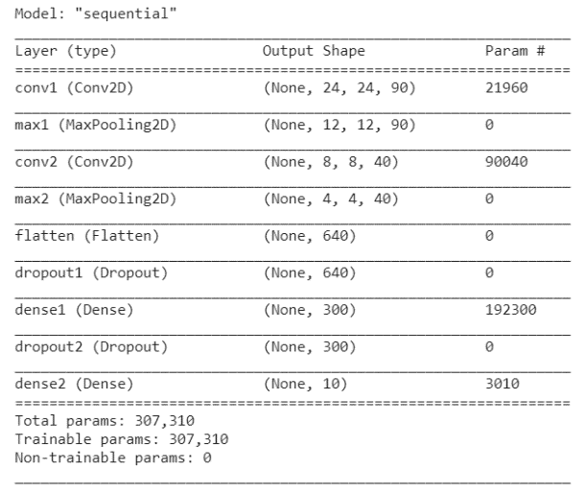For dropout, an amendment was made. In our model, there are only two fully connected (dense) layers. However, the second fully connected layer is the output nodes for classification and applying dropouts on this layer does not make any sense – we end up removing the prediction classes. Therefore, dropouts will be applied after the ‘flatten’ layer, and the first ‘dense’ layer. Therefore, we will end up with the model as shown on the right if we were to use dropout.

Although the ‘flatten’ layer is not technically a dense layer in keras, it can be treated as such since it is the one-dimensional vector representation of every synaptic output from the previous convolutional/maxpool operations.

Notebook title: 2a/2a3.ipynb

### Results

**Mini-Batch Gradient Descent with momentum γ = 0.1**

|  |  |
| --- | --- |
|  |  |

We have achieved convergence for this model with momentum. For accuracy, it was obtained around 600 epochs, while loss was stable around 500 epochs.

If we compare to the equivalent model without momentum (accuracy converged at 800 epochs, loss at 600), we can see that the convergence of the model was achieved much faster. This is likely due to the momentum term aiding the model in moving towards the minimum points.

|  |  |
| --- | --- |
|  |  |

**RMSProp algorithm**

|  |  |
| --- | --- |
|  |  |

We have achieved convergence on the test set for accuracy, but not loss with RMSProp. The reason for this appears to be due to overfitting – the training loss for RMSProp is close to zero while accuracy is close to 1, which suggests that RMSProp is perfectly predicting the training set. This is a clear sign of overfitting and is reinforced by the fact that the test loss is climbing, since the model is unable to generalize to new data as it continues to overfit. While the test accuracy has not fallen, it will fall eventually as the probability of correct prediction falls as the loss climbs. Once it hits a tipping point (more epochs), the model will then fail to predict on test data.

**Adam optimizer**

|  |  |
| --- | --- |
|  |  |

Adam optimizer performs cyclically. It is very interesting to note that the Adam optimizer is able to reach convergence extremely quickly for the test set with rather good accuracy and loss numbers, but once a few epochs passes the optimal point, the model will spike in loss till a peak value (around 16) and the accuracy will fall all the way down, only to recover shortly thereafter.

As discussed earlier under **Methods**, the Adam optimizer utilizes an exponential moving average of the gradient and squared gradients to adjust the learning rate dynamically. A possible reason for this sudden fall in performance, but very quick recovery thereafter is that the dynamically adjusted learning rate remained very high even though an average was taken, simply because the gradients were too steep. Therefore, divergent behavior occurs.

**Mini-Batch Gradient Descent with dropout, probability = 0.5 to the fully connected layers**

|  |  |
| --- | --- |
|  |  |

We observe quite clearly that the model is basically equally good at predicting both the test and the train data, although there is a significant variation in the performance of the model on the test data. This is directly attributable to the model having dropout layers included in its architecture. By randomly killing some neurons, we cause the model to lose some information and weights, and if these weights happen to be overfitted weights, the entire model benefits as a whole as we remove overfitting and the rest of the model needs to learn to generalize.

# Question 4 – Comparison

### Experiments

We are to compare the models from Question 1 to Question 3. Note that the model in Question is subsumed under the hyperparameter sweep in Question 2, so we only need to compare Question 2 to Question 3.

There will be several categories of comparison.

1. Optimal number of channels in the first convolutional / maxpool layer
   1. The options were [10, 30, 50, 70, 90]
2. Optimal number of channels in the second convolutional / maxpool layer
   1. The options were [20, 40, 60, 80, 100]
3. The optimal model in Question 2
4. Optimal model from Question 2, versus the four models in Question 3
   1. The difference is in the optimization

Notebook title: 2a/2a4.ipynb

### Results

**Optimal number of channels in the first and second convolutional / maxpool layer + optimal model in question 2**

Below is a plot of the test accuracies for the five models that have num_ch_c1 = 10. We can see that there is a lot of variation in the test accuracies, therefore we shall take an average of the test accuracies over the last 200 epochs and tabulate them instead.

|  |  |
| --- | --- |
| Test accuracies | Test accuracies (last 200 epochs) |

|  |  |  |  |  |  |  |  |
| --- | --- | --- | --- | --- | --- | --- | --- |
| Ave Test Acc.  (last 200 epochs) | | num_ch_1 | | | | |  |
| 10 | 30 | 50 | 70 | 90 | Row Ave |
| Num_ch _2 | 20 | 0.5072299998 | 0.5303774985 | 0.5372199986 | 0.5477649991 | 0.5526650014 | 0.5350514995 |
| 40 | 0.5165350003 | 0.5441125003 | 0.5496200008 | 0.5489124979 | 0.5589424978 | **0.5436244994** |
| 60 | 0.5079275012 | 0.5437750002 | 0.5447699983 | 0.5547874991 | 0.5553849995 | 0.5413289996 |
| 80 | 0.5130325011 | 0.5301324997 | 0.5449249994 | 0.5480099998 | 0.5434250001 | 0.5359050000 |
| 100 | 0.5092549993 | 0.5356725010 | 0.5432974998 | 0.5574675002 | 0.5468275010 | 0.5385040003 |
|  | Col Ave | 0.510796000 | 0.5368140000 | 0.5439664994 | 0.5513884992 | **0.5514490000** |  |

90 channels for the first layer appears to be optimal for the first set of layers, while 40 channels for the second layer is optimal. Unsurprisingly, our best model is the model with the 90-40 configuration.

The reason is likely because more first-layer features will capture more basic details and characteristics of the image. Too few and we capture too little detail to differentiate features of different image classes effectively. Conversely, fewer second-layer features will capture the salient features of each image class. Given that we have 10 image classes to predict, we should not have too many salient features, otherwise we run into problems of different classes having many of the salient features.

**Optimal model from Question 2, versus the four models in Question 3**

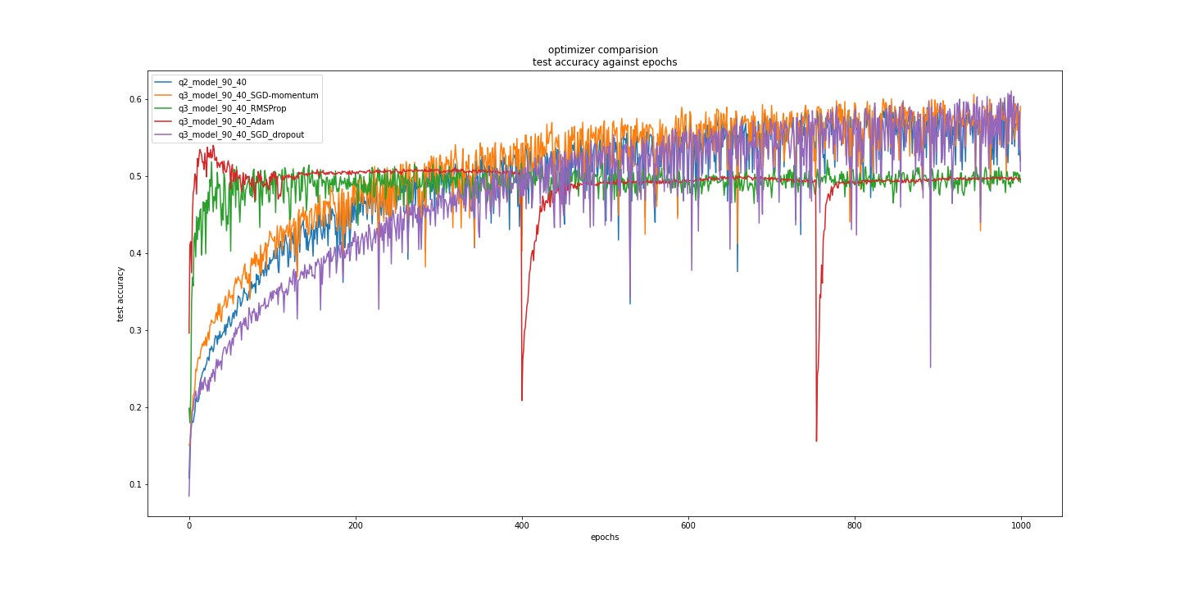

From the figure above, we observe the following:

1. RMSProp and Adam optimizer do not perform that well in the long run
2. RMSProp and Adam optimizer perform significantly better than all other models in small number of epochs

As explained in Question 3, the gradient and learning rate manipulation works against RMSProp and Adam optimizer in the long run. However, in the short term, they clearly work wonders as both models required less than 50 epochs to reach their peak test accuracy.

This is surprisingly short and significantly faster than the other three “top models”, which leads us to conclude that if training time/cost is of concern, RMSProp and Adam optimizer are amazing options as they allow for rapid model training and strong performance in a short period of time

1. Dropout has a lot of fluctuations among the models that perform well

This is to be expected. As some high-weightage nodes are randomly turned off, we can expect the model performance to deteriorate significantly before recovering

1. The best models perform very similarly, but the best on average (last 200 epochs) is Dropout

{'q2_model_90_40': 0.5589424978196621,

'q3_model_90_40_SGD-momentum': 0.5681024992465973,

'q3_model_90_40_RMSProp': 0.4952874992787838,

'q3_model_90_40_Adam': 0.4952874985337257,

**'q3_model_90_40_SGD_dropout': 0.559667500257492,**

'ave': 0.5354574990272523}

We can see that dropout, while simple, has allowed us to obtain impressive results. This may be due to the small training set which makes overfitting a problem. However, we can imagine that if we combine these optimization methods, we will obtain a much better test accuracy than what we have now, where we applied optimization methods independently.

# Summary

The process of finetuning the hyperparameters of a model will eventually lead to us having a more robust model that can generalize to new and unseen test cases. We have discussed the reason why 90 and 40 channels might be the optimal channels to select for the two convolutional/maxpool layers and saw the benefits that different optimization methods might bring for our models.

**<<< END >>>**