Heart Disease Risk Prediction
End-to-End ML Model Development, CI/CD and Production Deployment
Author: Viswa Sai Vardhan T (2025AE05284)
Repository: <https://github.com/tancred27/mlops-assignment>
Date: 20 October 2026

1. Introduction and solution overview
The objective is to build a classifier that predicts the risk of heart disease from routine patient health data, and to ship it the way a production service is shipped: reproducible, tested, tracked, containerised, deployed and monitored. The model is a scikit-learn pipeline trained on the UCI Heart Disease dataset and served by a FastAPI /predict endpoint that returns a prediction together with a confidence score.
The complete source code, Dockerfile, Kubernetes manifests, CI workflow and tests are in the repository: <https://github.com/tancred27/mlops-assignment>
Table 1: Technology stack
Area | Tools
Data and modelling | Python 3.11, ucimlrepo, pandas, scikit-learn (Logistic Regression, Random Forest)
Experiment tracking | MLflow (SQLite backend)
Testing and CI/CD | pytest, ruff, GitHub Actions
Serving and packaging | FastAPI, Uvicorn, Pydantic, Docker
Deployment | Kubernetes (Docker Desktop), LoadBalancer Service
Monitoring | Prometheus, Grafana, structured request logs

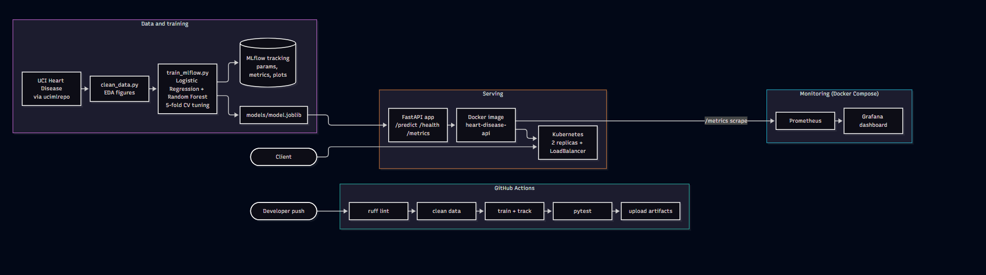
Figure 1: Solution architecture: data and training, CI pipeline, serving and monitoring

2. Setup and installation
Everything runs from a clean clone on Windows PowerShell with Python 3.11.
git clone https://github.com/tancred27/mlops-assignment
cd heart-disease-mlops
py -3.11 -m venv .venv
.venv\Scripts\Activate.ps1
pip install -r requirements.txt -r requirements-dev.txt

python -m src.data.download_data # fetch the dataset
python -m src.data.clean_data # clean and binarise the target
python -m src.data.eda # EDA figures
python -m src.models.train_mlflow # train, tune, track, save models/model.joblib
ruff check .
pytest -v

- Pinned dependencies. requirements.txt holds the direct dependencies, requirements-serve.txt the minimal set installed in the Docker image, and requirements-lock.txt a frozen snapshot of the complete environment.
- Verified from scratch. The repository was cloned into an empty folder, a fresh virtual environment was created, dependencies were installed from requirements.txt, and data download, training and the test suite were run. The CI workflow repeats cleaning, training and testing on a fresh Linux runner on every push.

3. Data acquisition and exploratory data analysis

3.1 Dataset
The UCI Heart Disease dataset (repository id 45) is fetched programmatically with the ucimlrepo package by src/data/download_data.py, which writes data/raw/heart.csv. The package exposes the Cleveland subset: 303 patients, 13 predictors and a diagnosis label num. Column names come from the dataset metadata rather than being hardcoded.
Table 2: Predictors in the dataset
Feature | Type | Description
age | Numeric | Age in years
sex | Categorical | 1 = male, 0 = female
cp | Categorical | Chest pain type: 1 typical angina, 2 atypical angina, 3 non-anginal, 4 asymptomatic
trestbps | Numeric | Resting blood pressure on admission (mm Hg)
chol | Numeric | Serum cholesterol (mg/dl)
fbs | Categorical | Fasting blood sugar > 120 mg/dl (1 = true)
restecg | Categorical | Resting ECG: 0 normal, 1 ST-T abnormality, 2 left ventricular hypertrophy
thalach | Numeric | Maximum heart rate achieved
exang | Categorical | Exercise-induced angina (1 = yes)
oldpeak | Numeric | ST depression induced by exercise relative to rest
slope | Categorical | Slope of the peak exercise ST segment: 1 up, 2 flat, 3 down
ca | Categorical | Number of major vessels (0-3) coloured by fluoroscopy
thal | Categorical | Thal test result: 3 normal, 6 fixed defect, 7 reversible defect

The original label grades angiographic disease from 0 to 4 (counts: 0: 164, 1: 55, 2: 36, 3: 35, 4: 13). Following the usual framing for this dataset, the task is binary: num > 0 means disease present.

3.2 Cleaning and preprocessing decisions
- Duplicates: 0 duplicate rows found.
- Missing values: 6 in total, in ca (4) and thal (2). They are deliberately left in the cleaned CSV and imputed inside the modelling pipeline, so imputation statistics are learned from training data only and nothing leaks from validation folds or the test set. The API applies the same imputation when ca or thal are omitted.
- Validation: every categorical column is checked against its documented set of values, and unexpected values stop the pipeline with a clear error.
- Outliers: cholesterol reaches 564 and resting blood pressure 200. Both are medically plausible, so the rows are kept, and scaling limits their influence.
- Target: num is converted to a binary target (0 = no disease, 1 = disease).

3.3 Exploratory analysis
The classes are close to balanced: 164 patients (54.1%) without disease and 139 (45.9%) with disease. No resampling is needed, and accuracy is meaningful alongside precision, recall and ROC-AUC.
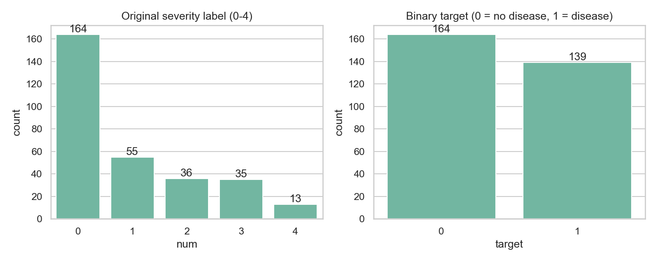
Figure 2: Class balance of the original severity label and the binary target
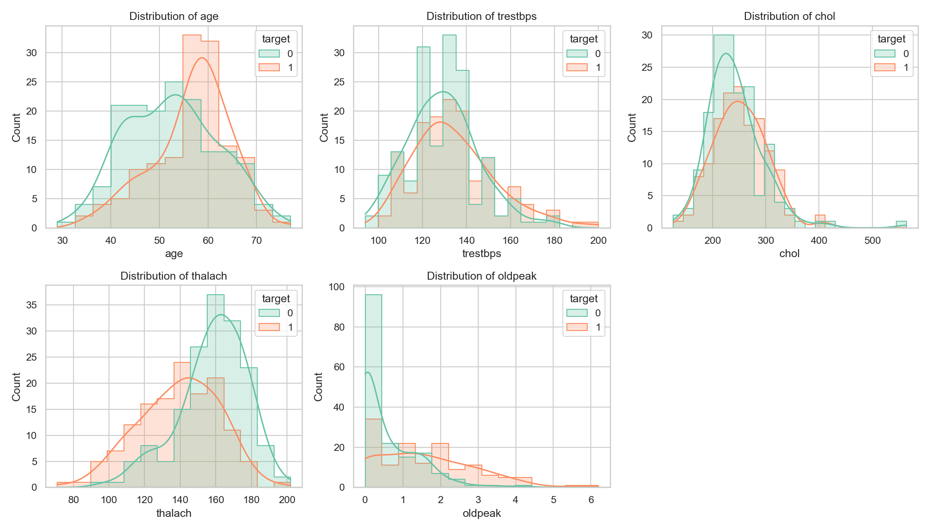
Figure 3: Distributions of the numeric features, split by target
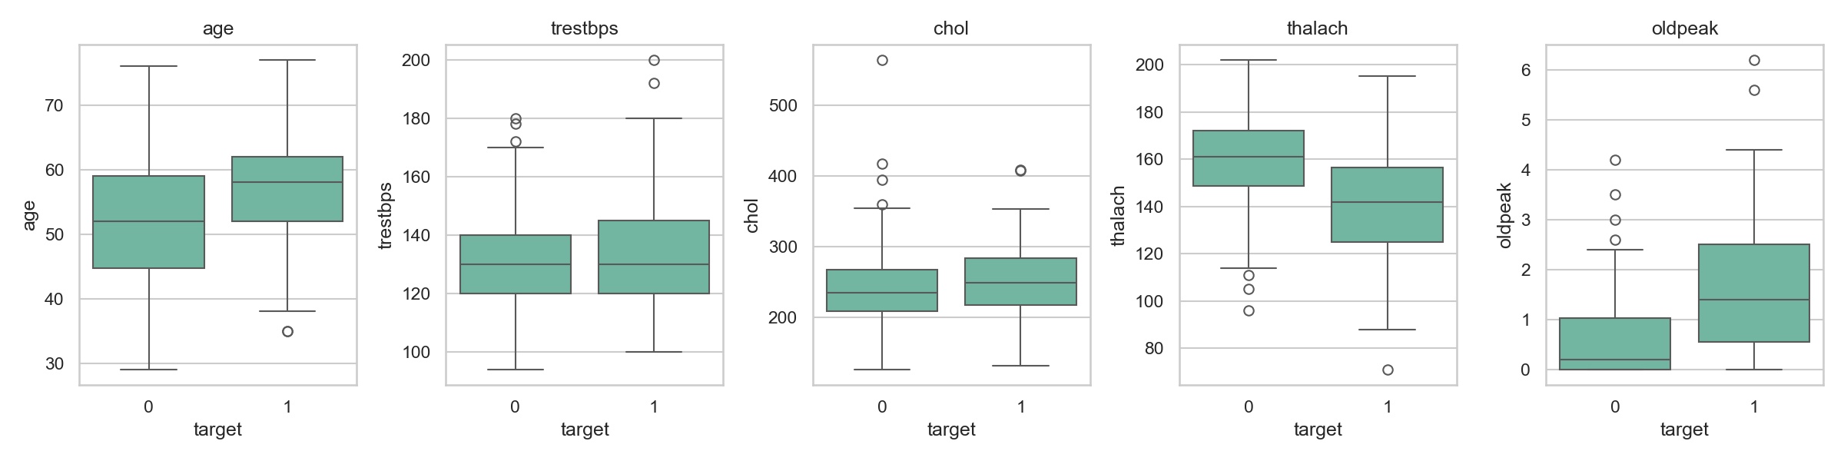
Figure 4: Numeric features by target class
The strongest positive correlations with the target are thal (+0.53), ca (+0.46), exang (+0.43), oldpeak (+0.42), cp (+0.41); the strongest negative is thalach (-0.42); chol (+0.09), fbs (+0.03) are weakly related. Correlations use the integer codes of the categorical columns, so they indicate direction and rough strength only. Patients with disease have a lower median maximum heart rate (142 vs 161) and a higher median ST depression (1.4 vs 0.2) than patients without.
Table 3: Median of each numeric feature by class
Feature | Median, no disease | Median, disease
age | 52 | 58
trestbps | 130 | 130
chol | 234.5 | 249
thalach | 161 | 142
oldpeak | 0.2 | 1.4

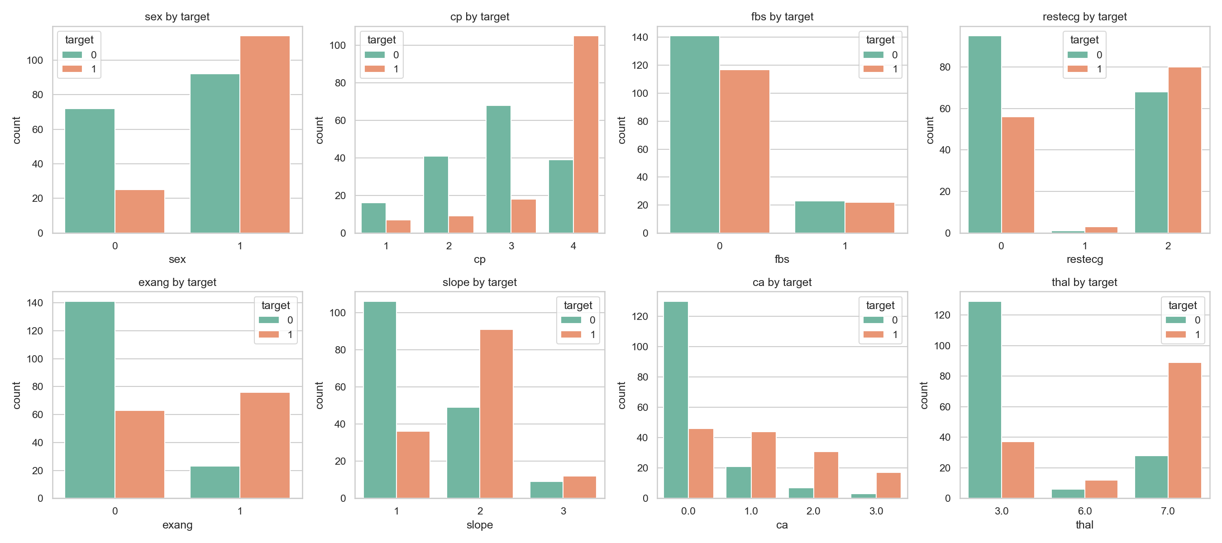
Figure 5: Categorical features by target class
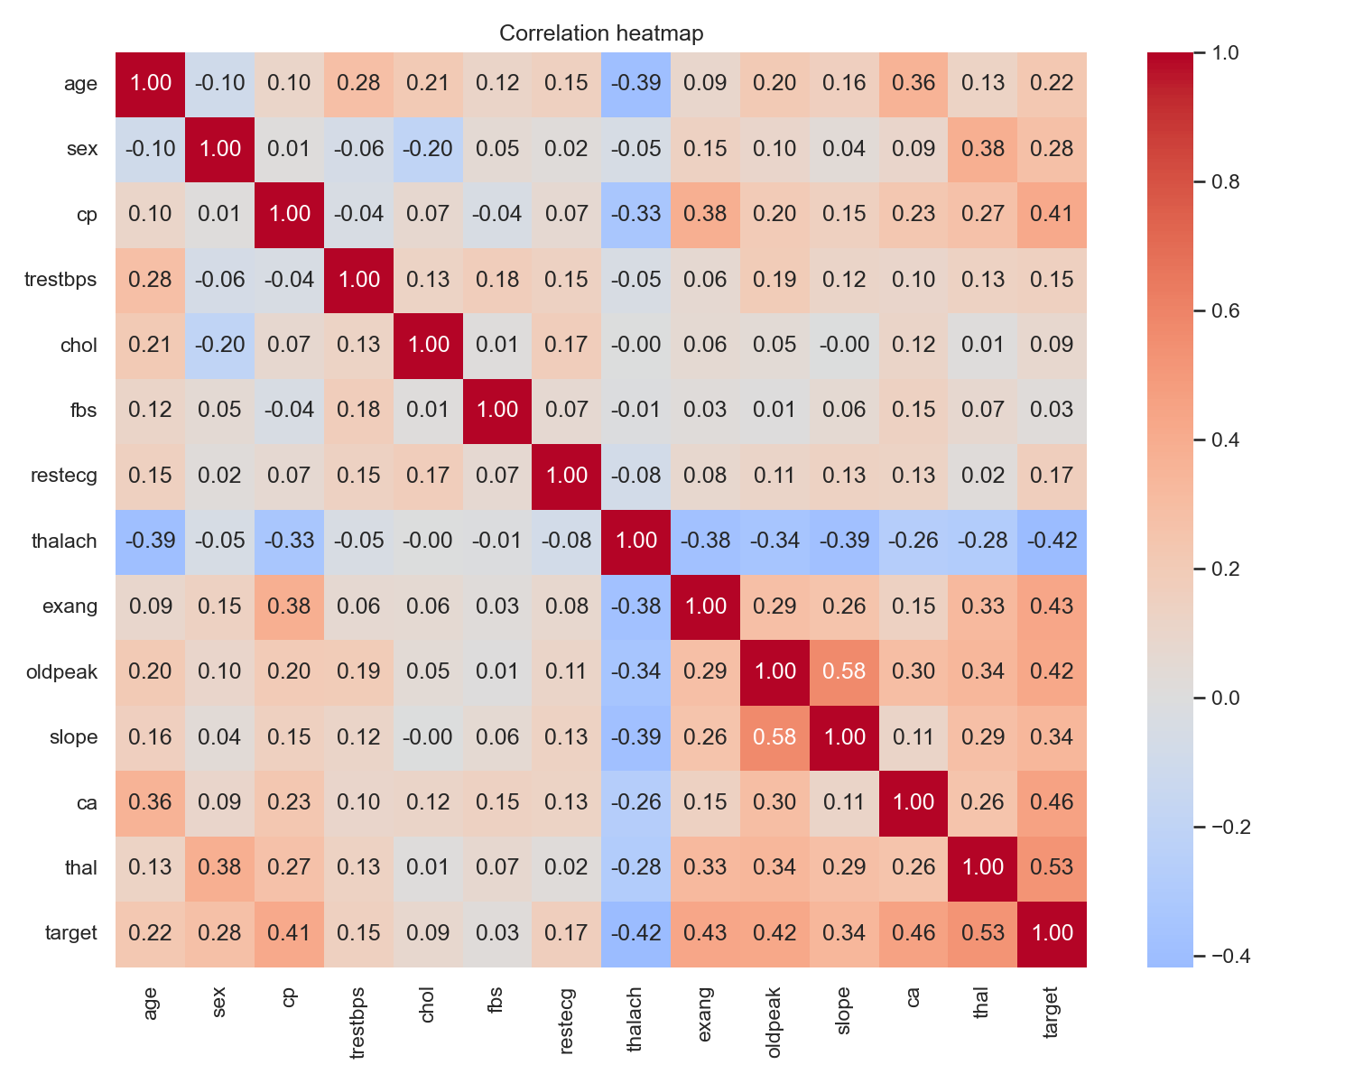
Figure 6: Correlation heatmap

4. Feature engineering and model development

4.1 Preprocessing pipeline
Preprocessing and the classifier form one scikit-learn Pipeline. The same object is cross-validated, saved and loaded by the API, so training and serving cannot diverge.
Table 4: Feature transformations (ca is treated as categorical because it takes only four values)
Columns | Steps
age, trestbps, chol, thalach, oldpeak | Median imputation, then standard scaling
sex, cp, fbs, restecg, exang, slope, ca, thal | Most-frequent imputation, then one-hot encoding (unseen categories ignored at prediction time)

4.2 Training and tuning protocol
- Split: stratified 80/20 train/test split (242 and 61 patients), random_state 42.
- Tuning: GridSearchCV with stratified 5-fold cross-validation on the training portion, recording accuracy, precision, recall and ROC-AUC, and refitting on ROC-AUC.
- Selection: the final model is chosen by cross-validated ROC-AUC, never by test score. The test set is used once, as an independent check.
Table 5: Hyperparameter search
Model | Hyperparameter grid | Best parameters
Logistic Regression | C: [0.01, 0.1, 1, 10] | C = 1
Random Forest | n_estimators: [100, 300]; max_depth: [None, 5, 10]; min_samples_split: [2, 5] | max_depth = None, min_samples_split = 5, n_estimators = 300

4.3 Results
Table 6: 5-fold cross-validation, mean ± standard deviation across folds
Model | Accuracy | Precision | Recall | ROC-AUC
Logistic Regression | 0.847 ± 0.010 | 0.877 ± 0.054 | 0.783 ± 0.046 | 0.902 ± 0.014
Random Forest | 0.814 ± 0.024 | 0.817 ± 0.040 | 0.774 ± 0.096 | 0.899 ± 0.030

Table 7: Held-out test set (61 patients)
Model | Accuracy | Precision | Recall | ROC-AUC
Logistic Regression | 0.885 | 0.839 | 0.929 | 0.966
Random Forest | 0.869 | 0.833 | 0.893 | 0.947

Model selection. Logistic Regression was selected as the final model. Its cross-validated ROC-AUC differs from Random Forest by only 0.003, less than the fold-to-fold standard deviation of either model (0.014 and 0.030), so the two are effectively tied on ROC-AUC and the selection rule decided. Logistic Regression is also ahead on cross-validated Accuracy, Precision, Recall and ROC-AUC. It is also simpler and easier to interpret.
Test-set behaviour. The selected model produced 26 true positives, 28 true negatives, 5 false positives and 2 false negatives (recall 0.929, precision 0.839). A missed case is generally costlier than a false alarm in a screening setting, and the decision threshold was kept at 0.5 rather than tuned. With only 61 test patients, one misclassification moves accuracy by about 1.6 percentage points, so the test scores are a sanity check and the cross-validated figures are the primary estimate.

5. Experiment tracking with MLflow
Every training run is tracked in the MLflow experiment heart-disease-classification (backend sqlite:///mlflow.db). Each model gets its own run, and the fixed random seed makes reruns reproduce the same numbers.
- Parameters: split size, number of folds, random seed, train and test sizes, refit metric, and the best hyperparameters found by the search.
- Tags: model name, git commit hash and dataset path; the selected run is tagged selected = true.
- Metrics: mean and standard deviation of the four cross-validation metrics, plus the four test metrics.
- Artifacts: the full tuning table (tuning/cv_results.csv), ROC curve and confusion matrix plots, and the complete pipeline with an input/output signature and an input example.
Table 8: Tracked runs
Model | Run ID | CV ROC-AUC | Test ROC-AUC | Selected
Logistic Regression | 0b281a07 | 0.902 | 0.966 | Yes
Random Forest | c2eeba58 | 0.899 | 0.947

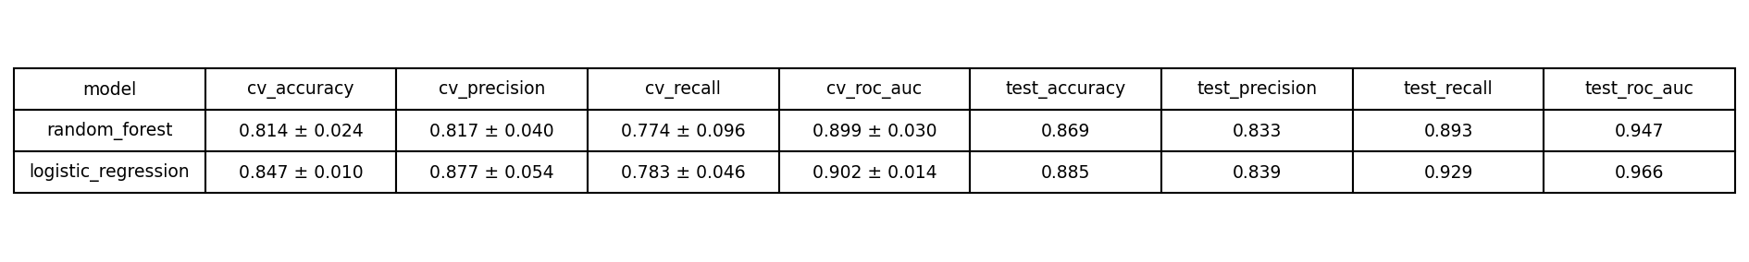
Figure 7: Summary of tracked runs generated from MLflow (cross-validation metrics as mean ± std)
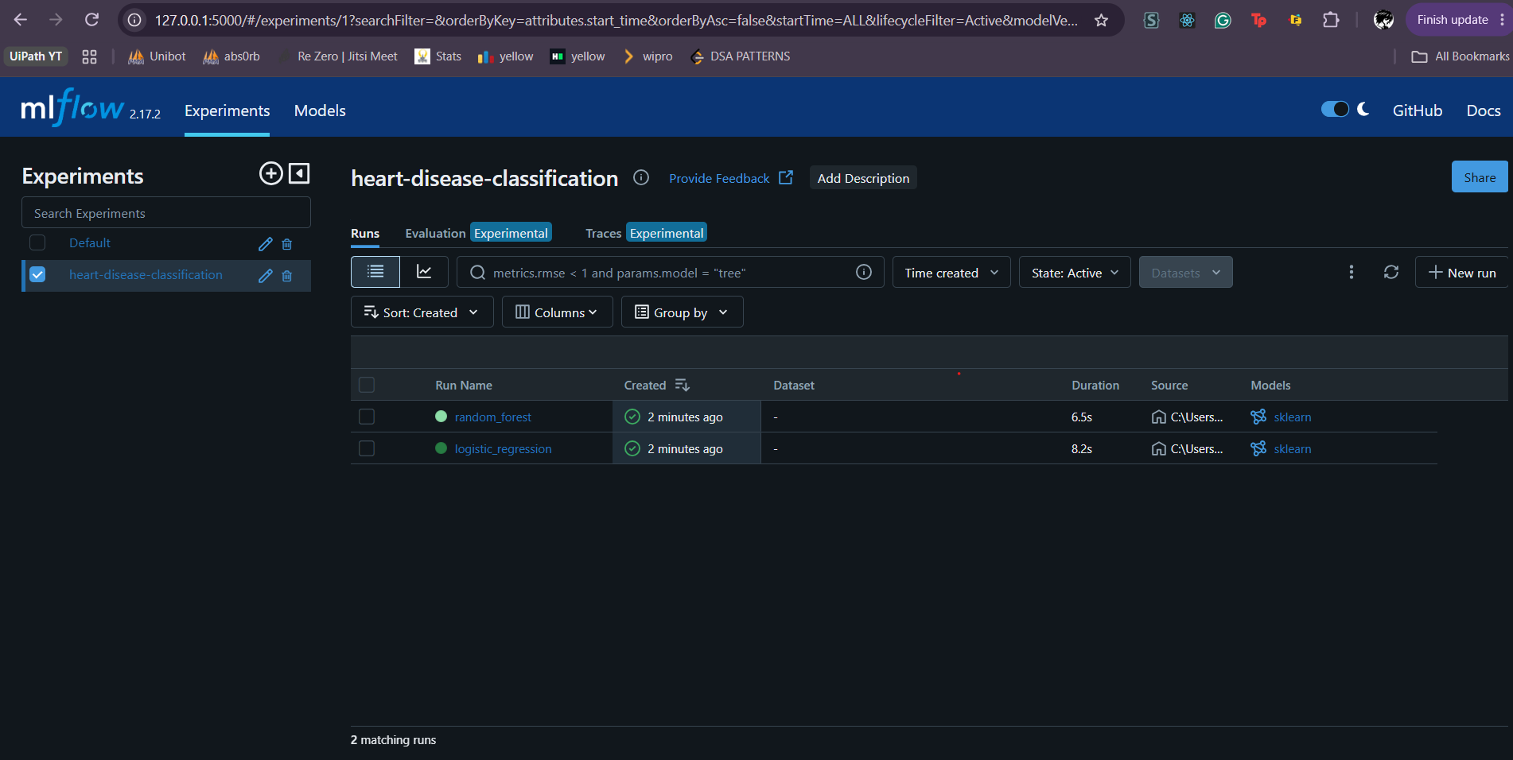
Figure 8: MLflow experiment page listing both runs
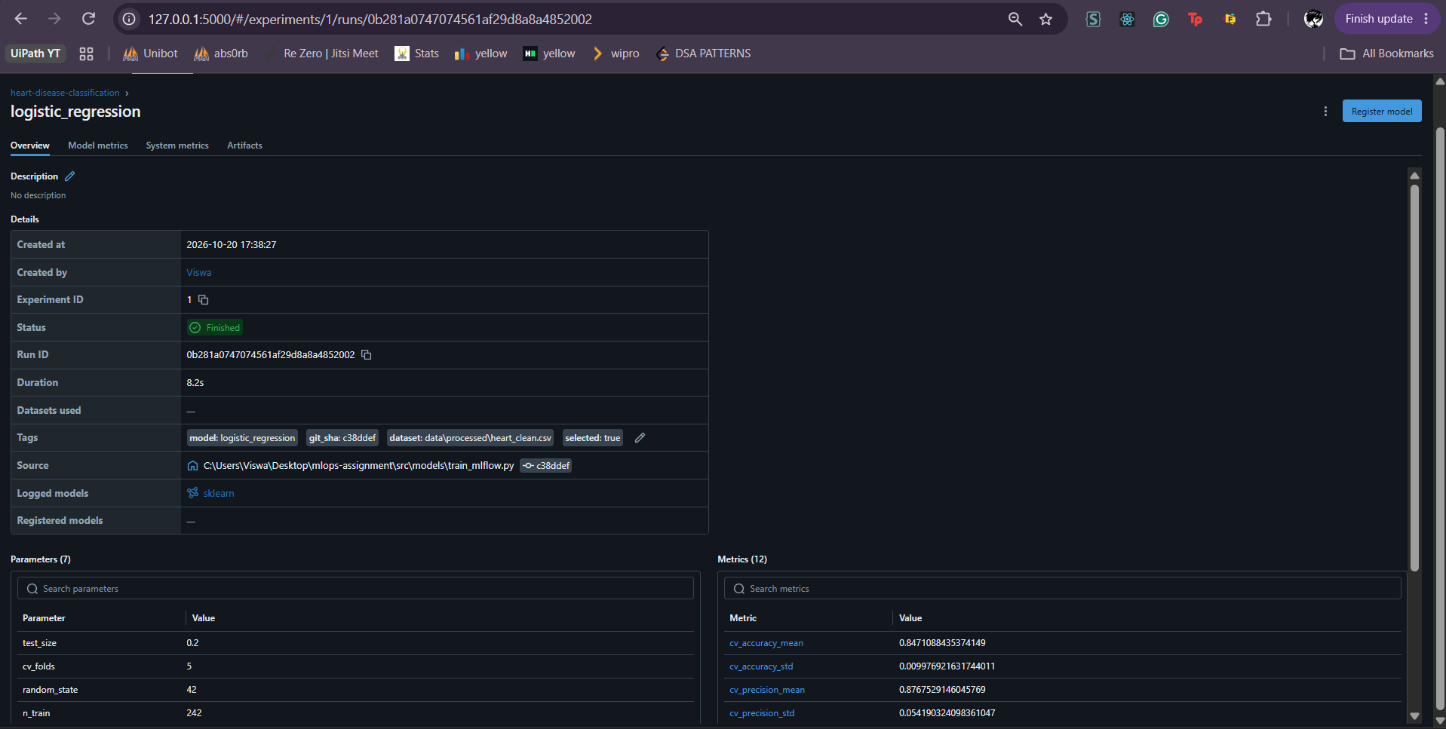
Figure 9: MLflow run page: parameters, metrics and artifacts
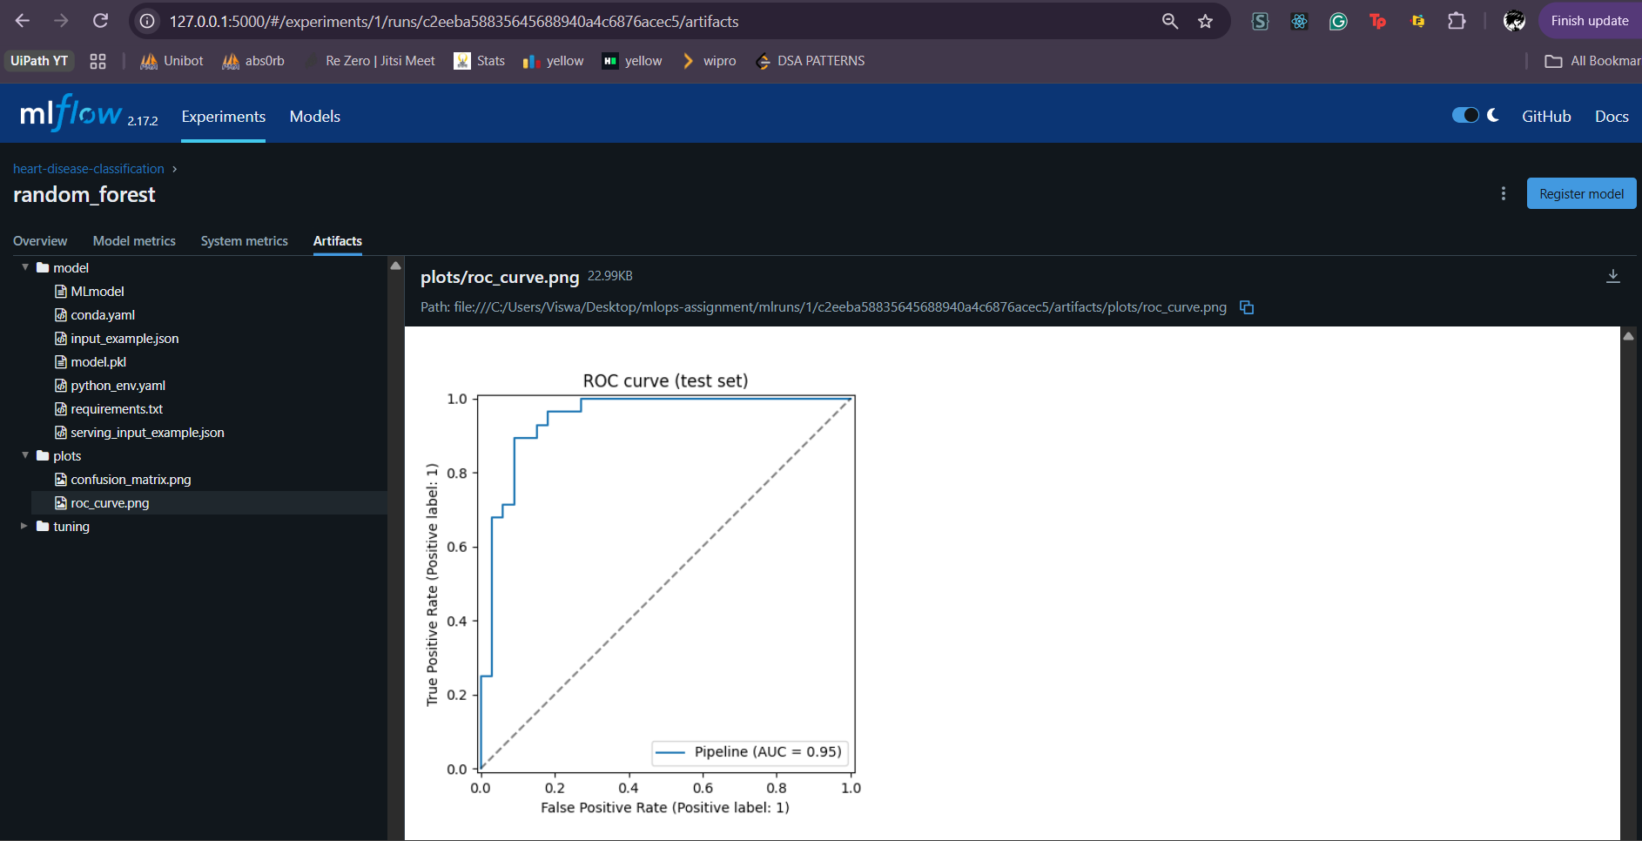
Figure 10: ROC curve logged as an MLflow artifact

6. Model packaging and reproducibility
- Reusable format. The selected model is the whole scikit-learn pipeline (imputation, scaling, encoding and classifier) saved with joblib as models/model.joblib. Both pipelines are also logged to MLflow with an input/output signature and an input example.
- Preprocessing travels with the model. Because the transformers are inside the pipeline, the API applies exactly the transformations learned in training, including imputation of missing values.
- Pinned environments. requirements.txt pins every direct dependency, requirements-serve.txt holds the minimal set for the container, and requirements-lock.txt freezes the full environment. Pins resolved two real incompatibilities during development (SQLAlchemy with MLflow, scipy with scikit-learn).
- Deterministic runs. Fixed random seeds for the split, cross-validation and models make reruns reproduce the same metrics.
- Input validation. src/serving/predictor.py checks that required features are present and numeric and that categorical codes are in their documented ranges. Only ca and thal may be missing, matching the training data.

7. Automated testing and CI/CD
Table 9: Unit test suite (pytest)
Test file | Tests | What it covers
test_api.py | 5 | /health, /predict success and error handling (HTTP 422)
test_data.py | 5 | Cleaning: target binarisation, duplicates, missing values kept, invalid categories rejected
test_metrics.py | 2 | Prometheus counters and request statuses
test_model.py | 3 | Stratified split, candidate models, ROC-AUC quality gate
test_predictor.py | 6 | Input validation and prediction output format
test_preprocessing.py | 2 | Imputation, scaling, one-hot encoding, unseen categories
Total | 23

The GitHub Actions workflow (.github/workflows/ci.yml) runs on every push on a clean Ubuntu runner with Python 3.11. Steps run in order and the first failing step stops the job.
Table 10: CI pipeline steps
# | Step | Purpose
1 | Check out code | Fetch the repository on a fresh runner
2 | Set up Python | Python 3.11 with pip caching
3 | Install dependencies | Install requirements.txt and requirements-dev.txt
4 | Lint | ruff check; any violation fails the run
5 | Clean data | Regenerate the cleaned dataset from the raw CSV
6 | Train and track models | Tune both models and log runs to MLflow
7 | Run unit tests | pytest against the freshly trained model; writes junit.xml
8 | Upload artifacts | Models, metrics, MLflow runs and test report; runs even on failure

Failure behaviour. To prove the pipeline fails on errors, the model quality gate was deliberately raised above what the model achieves on a throwaway branch. The run stopped red at the test step with the assertion error in its log, while earlier steps stayed green and the artifacts were still uploaded.
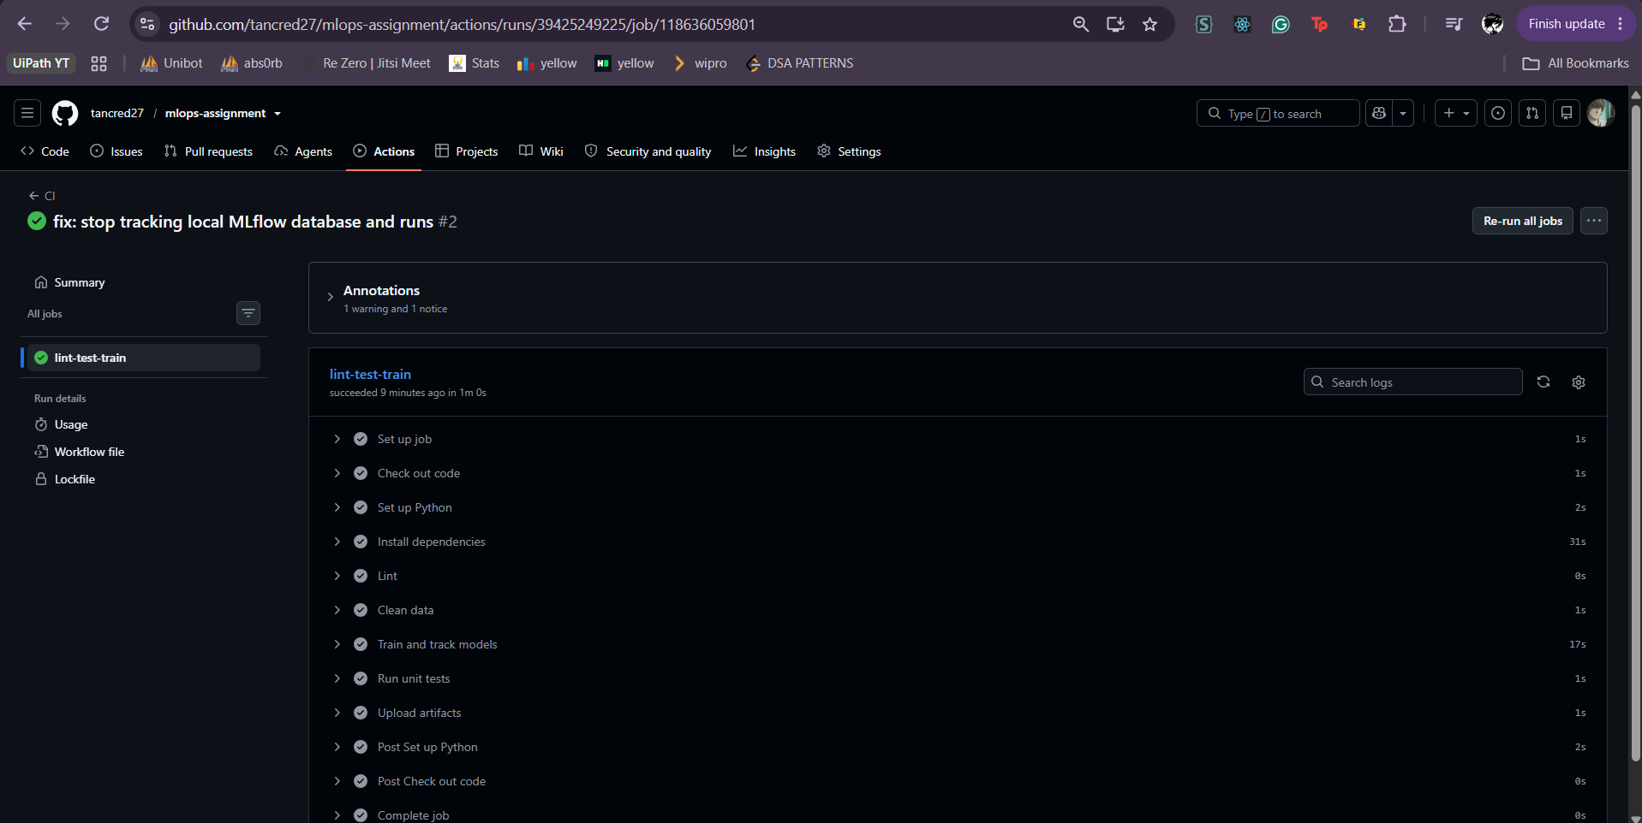  Figure 11: Successful run, all steps green | 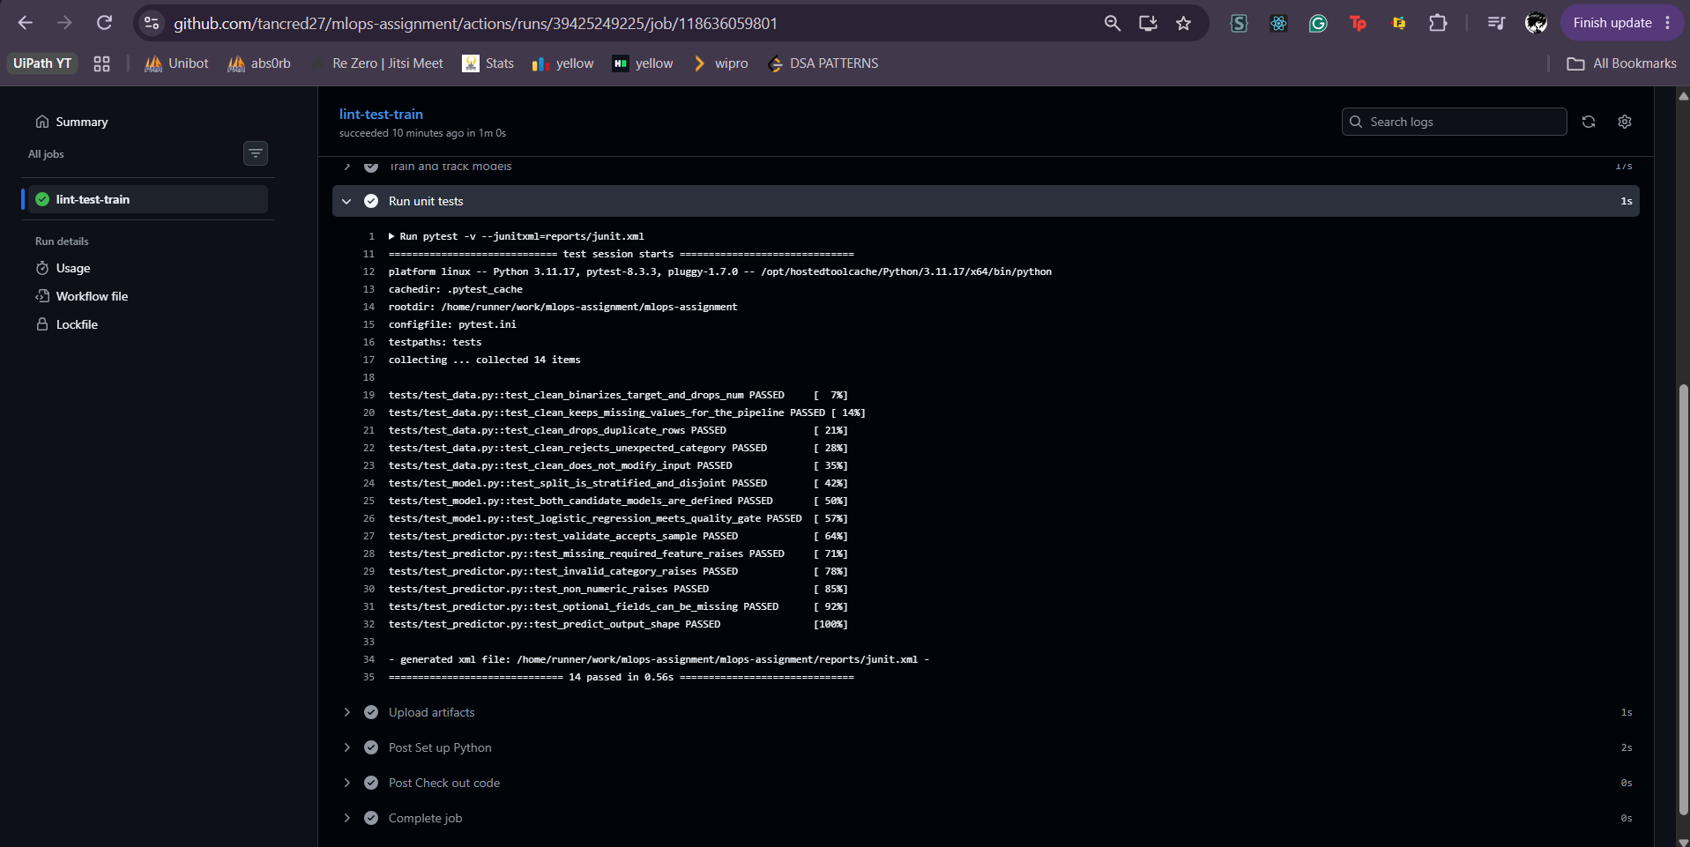  Figure 12: Unit test step log
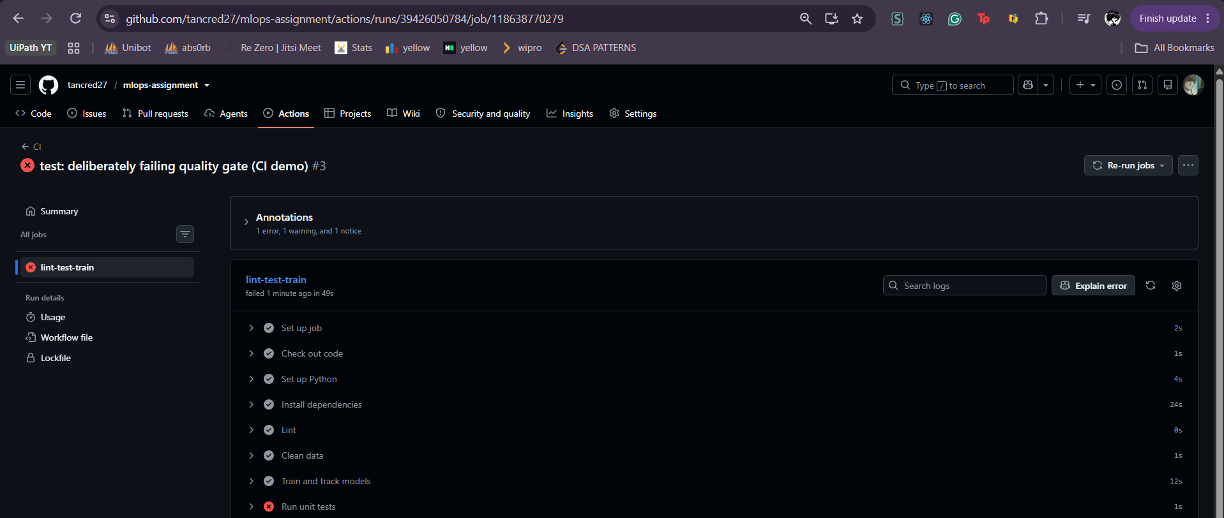  Figure 13: Deliberately failing run | 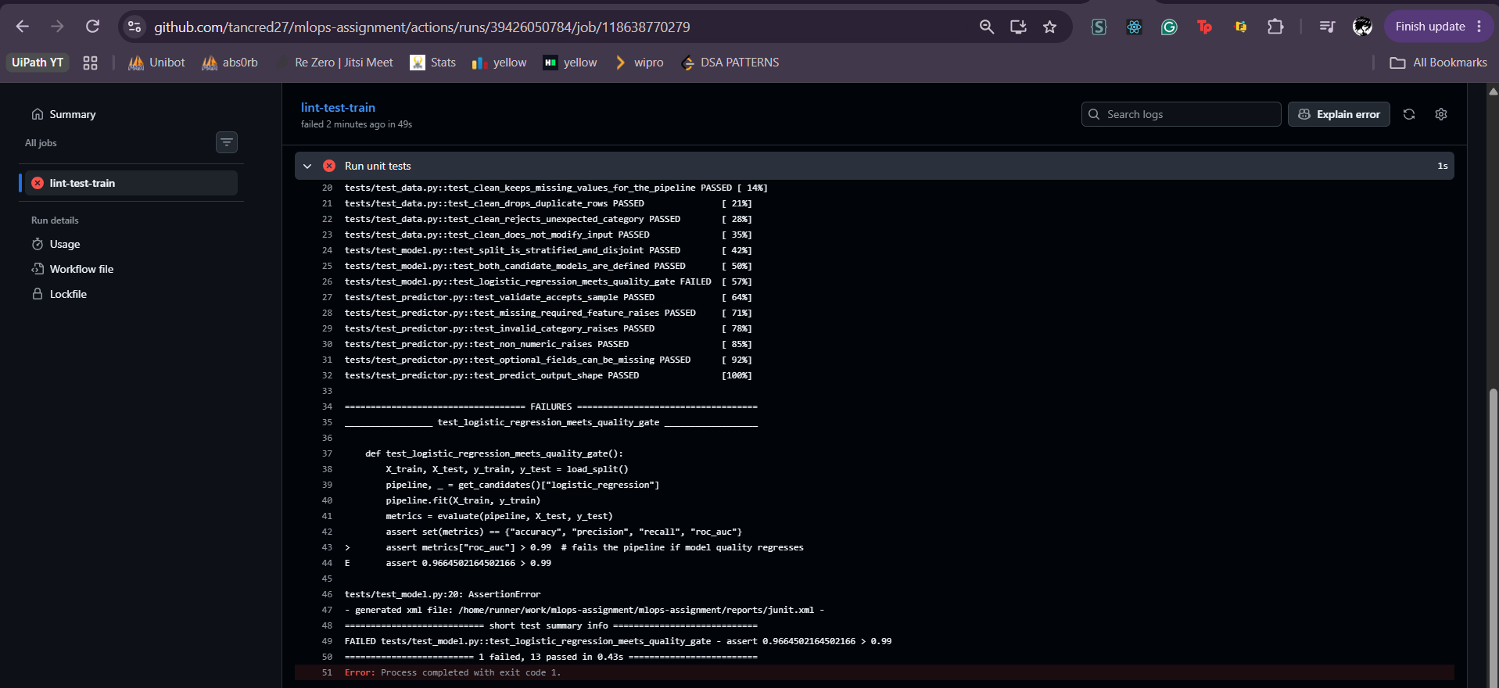  Figure 14: Failing test with a clear error

8. Containerization and deployment

8.1 Serving API
Table 11: API endpoints
Endpoint | Purpose
POST /predict | JSON patient features in; prediction (0/1), confidence and disease probability out
GET /health | Liveness and readiness probe
GET /metrics | Prometheus metrics
GET /docs | Interactive Swagger documentation

Example request body and response:
{"age": 63, "sex": 1, "cp": 1, "trestbps": 145, "chol": 233, "fbs": 1, "restecg": 2, "thalach":
150, "exang": 0, "oldpeak": 2.3, "slope": 3, "ca": 0, "thal": 6}

{"prediction": 0, "confidence": 0.8345, "probability_disease": 0.1655}

Invalid input (for example a chest-pain code outside 1 to 4) is rejected with HTTP 422 and a message naming the offending feature.

8.2 Docker image
- Based on python:3.11-slim; installs only requirements-serve.txt, so MLflow, plotting and test libraries stay out of the image.
- Copies only src/ and models/model.joblib; a .dockerignore excludes data, notebooks, runs and tests.
- Runs as a non-root user and defines a HEALTHCHECK on /health.
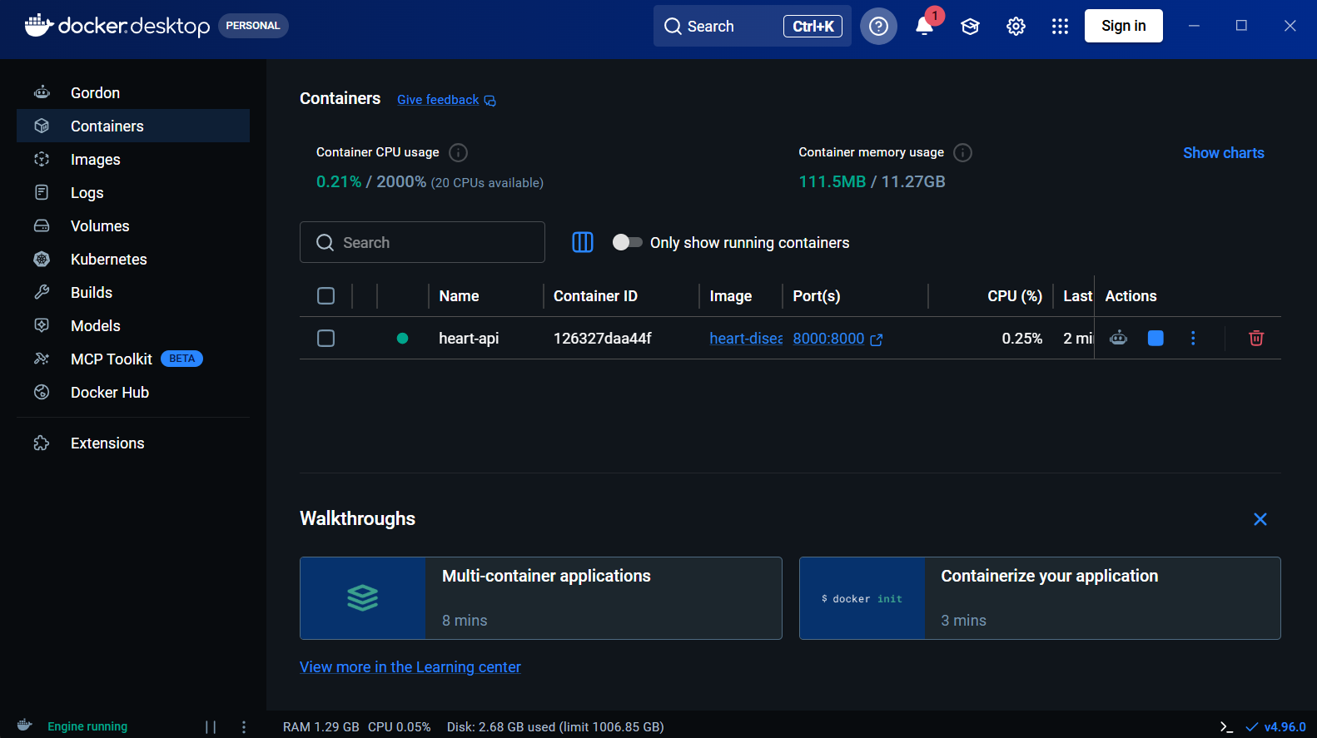  Figure 15: Healthy container | 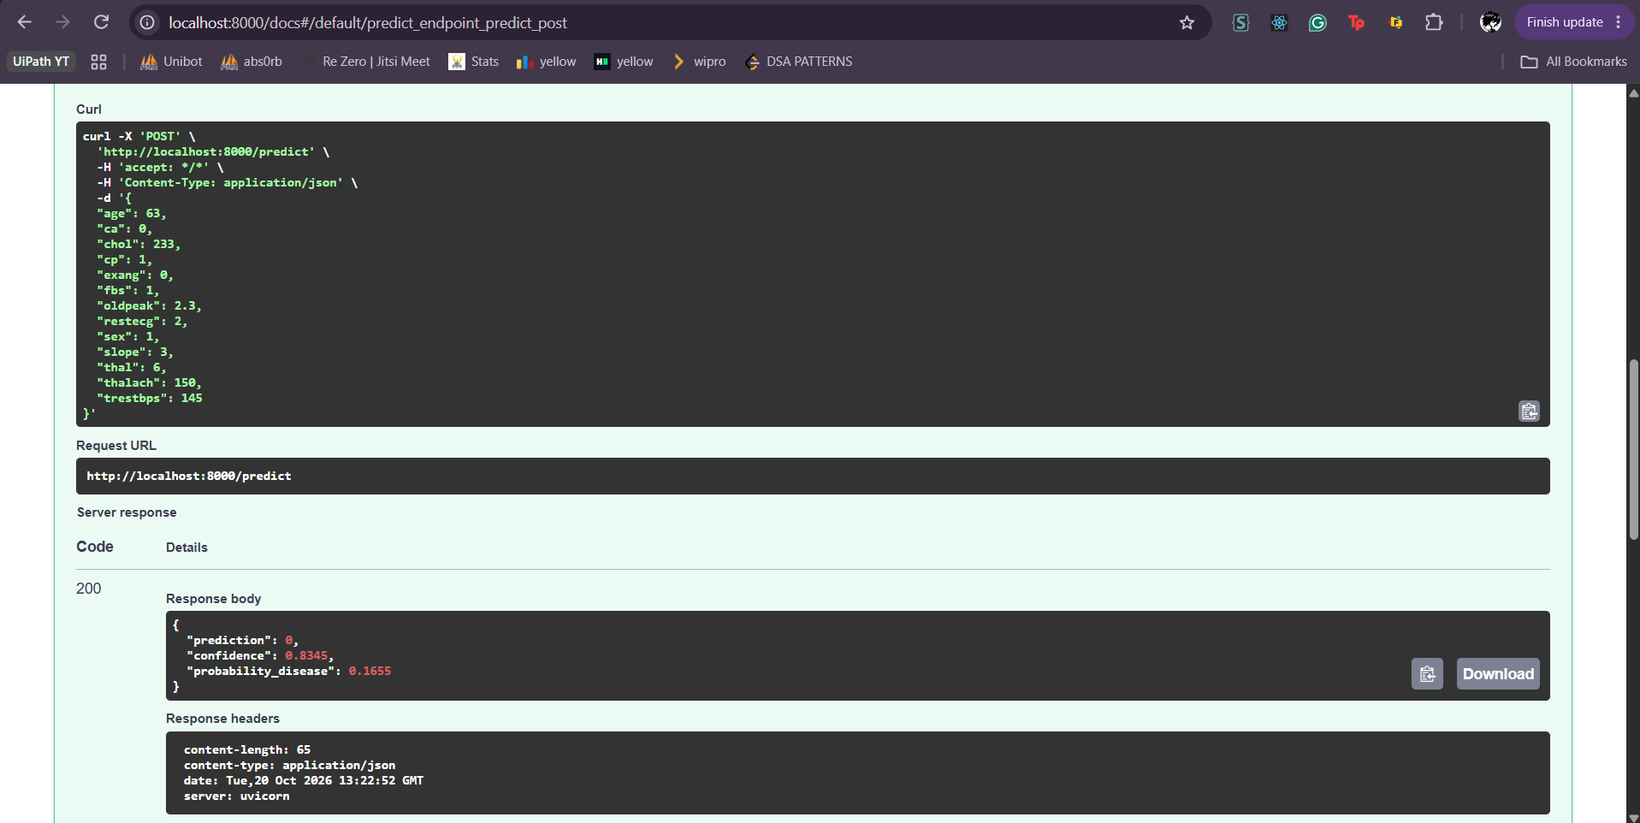  Figure 16: /predict response from the container
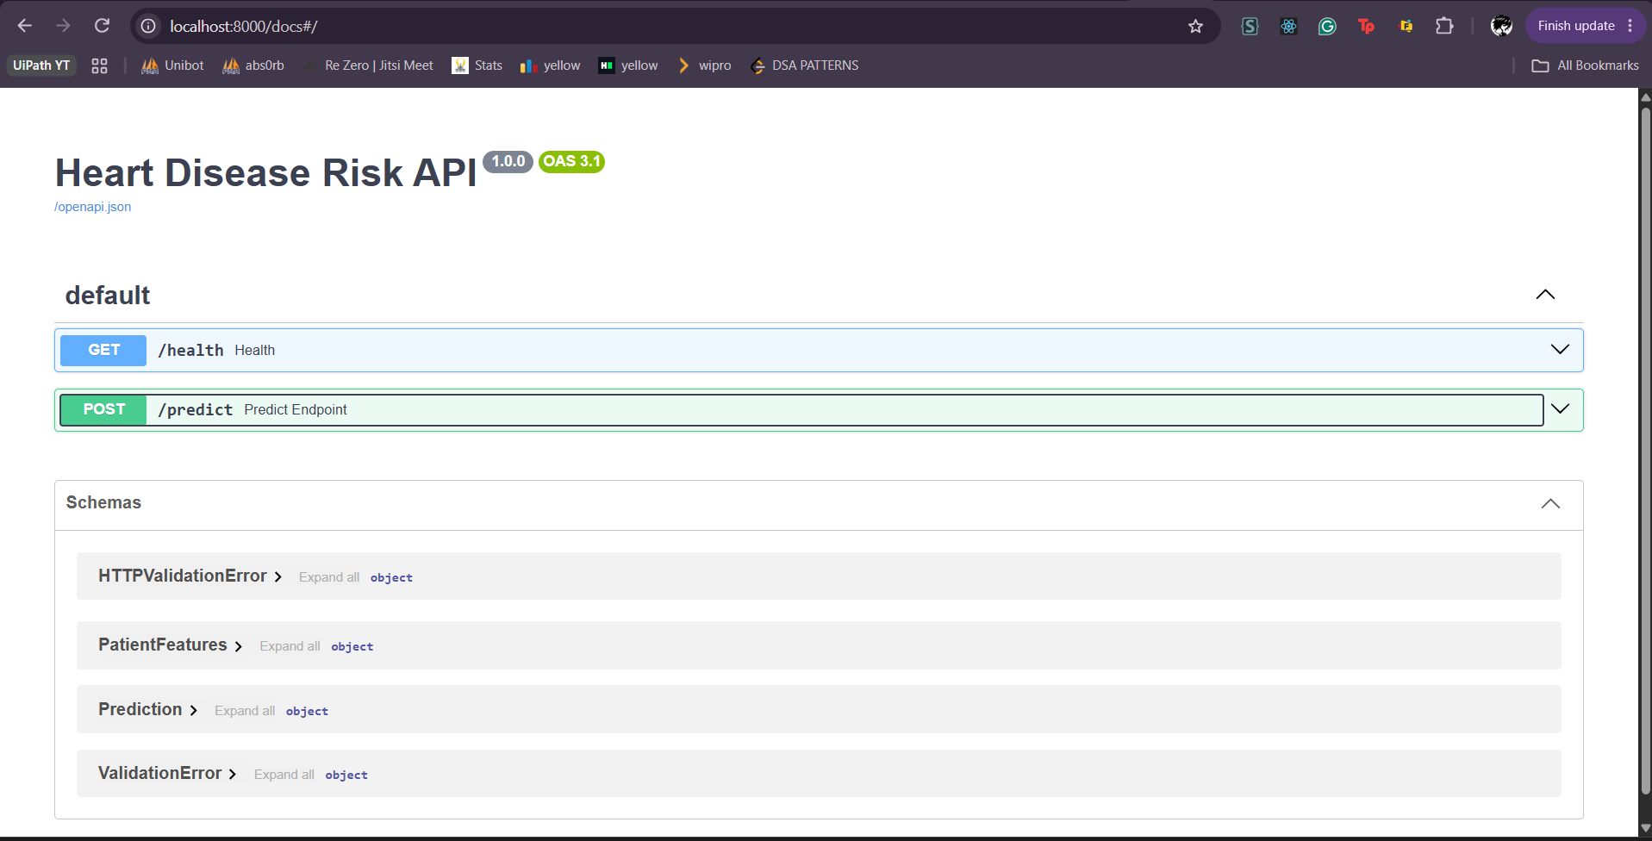
Figure 17: Swagger UI served by the container

8.3 Kubernetes deployment
Table 12: Kubernetes manifests (k8s/deployment.yaml and k8s/service.yaml)
Setting | Value
Image | heart-disease-api:1.1
Replicas | 2
Update strategy | RollingUpdate (maxUnavailable 0, maxSurge 1)
Probes | readiness and liveness on /health
Resources | requests 100m CPU / 256Mi; limits 500m CPU / 512Mi
Service | LoadBalancer, port 8080 to container port 8000

The manifests were deployed to the Kubernetes cluster built into Docker Desktop. The LoadBalancer Service is published on http://localhost:8080, which is the access point for testing (/health, /predict, /docs). The zero-unavailable rolling update was used to move from image 1.0 to 1.1 (adding metrics) without downtime.
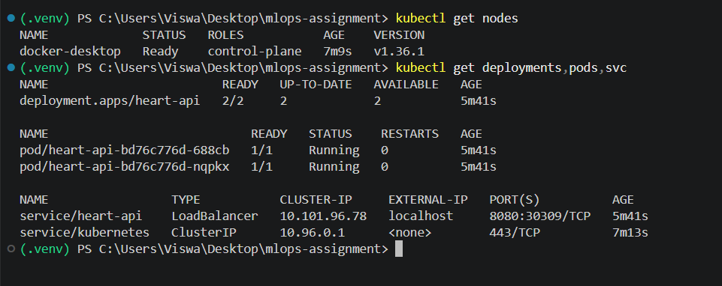  Figure 18: Node, deployment, pods and service | 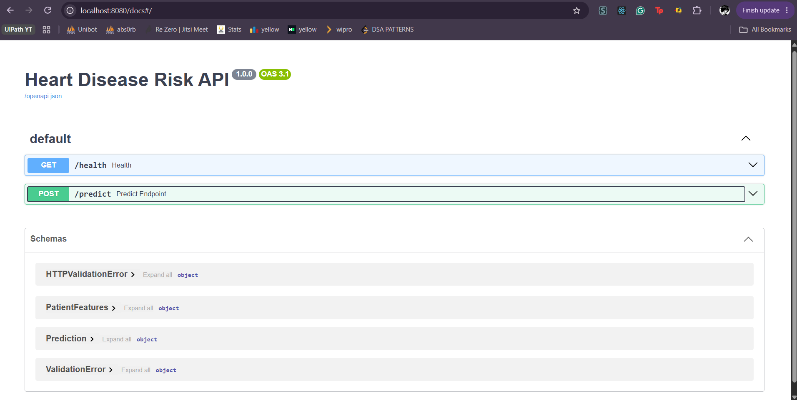  Figure 19: Swagger UI through the LoadBalancer
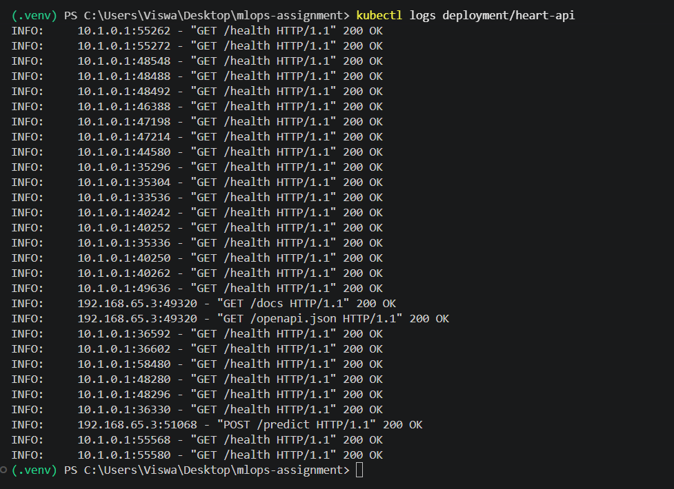
Figure 20: Pod logs

9. Monitoring and logging
- Request logging. Middleware logs method, path, status and duration for every request. Prediction outcomes are logged as class and confidence only; patient feature values are never written to logs. Health probes are excluded to keep the log readable.
- Metrics. The API exposes Prometheus metrics at /metrics.
- Stack. Docker Compose runs the API, Prometheus (scraping every 5 seconds) and Grafana with a provisioned data source and dashboard, so the setup is reproducible with one command.
Table 13: Application metrics
Metric | Type | Use
http_requests_total | Counter (method, path, status) | Request rate and error rate
http_request_duration_seconds | Histogram (path) | p50 and p95 latency
predictions_total | Counter (prediction class) | Mix of predicted classes over time

A traffic script (scripts/generate_traffic.py) sends valid and invalid requests so the dashboard shows request rate, latency percentiles, class mix and error responses.
[MISSING IMAGE: monitoring_api_logs.png]  Figure 21: Structured request logs | [MISSING IMAGE: monitoring_prometheus_targets.png]  Figure 22: Prometheus target is UP

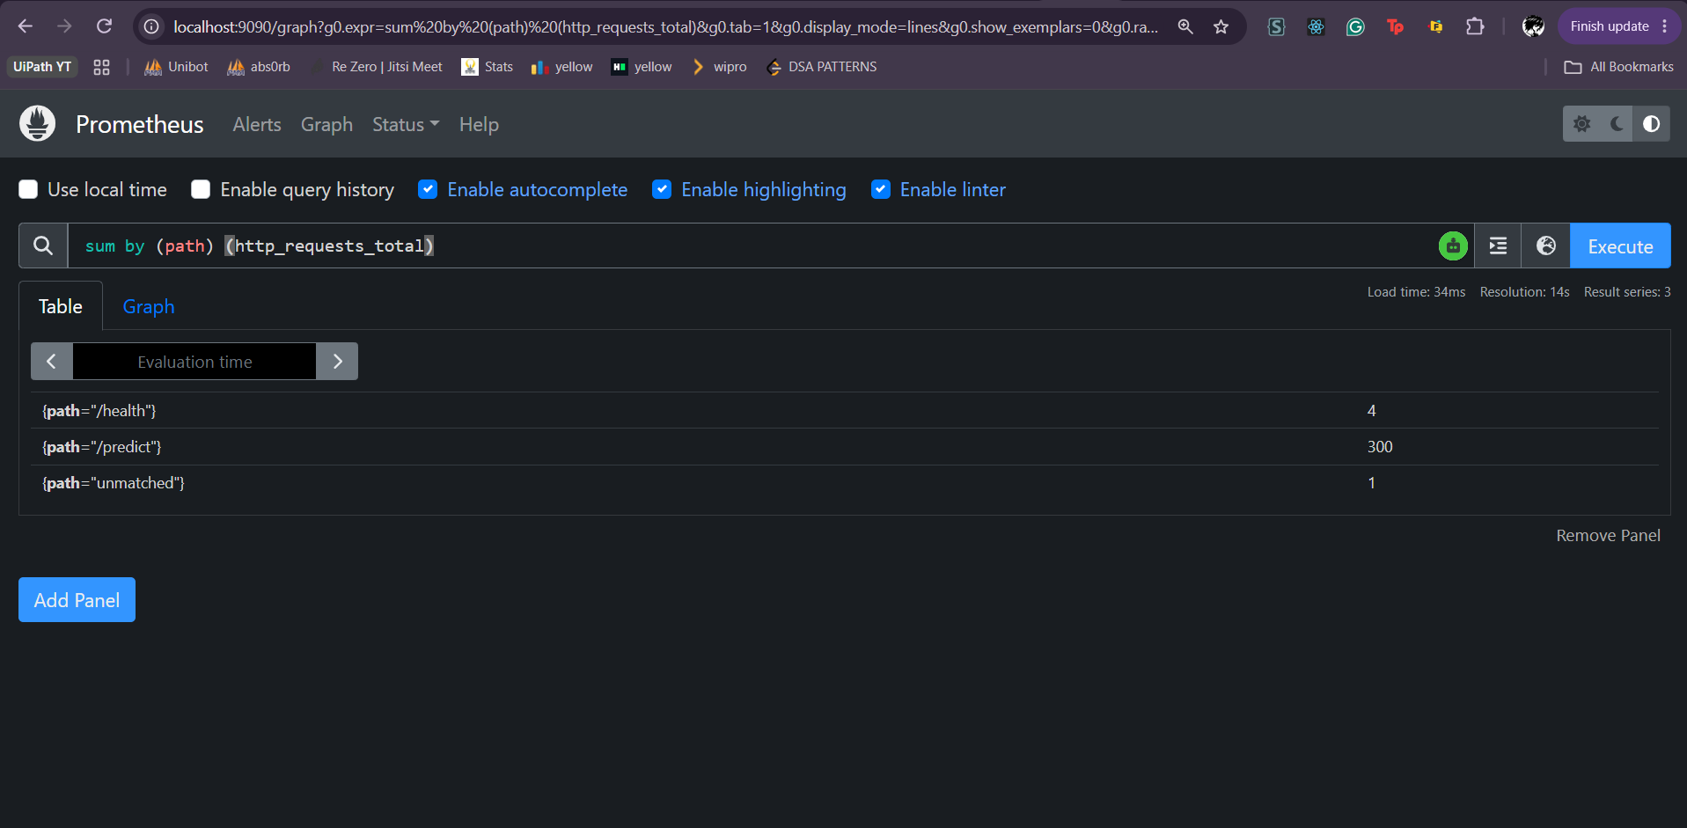
Figure 23: A PromQL query in Prometheus
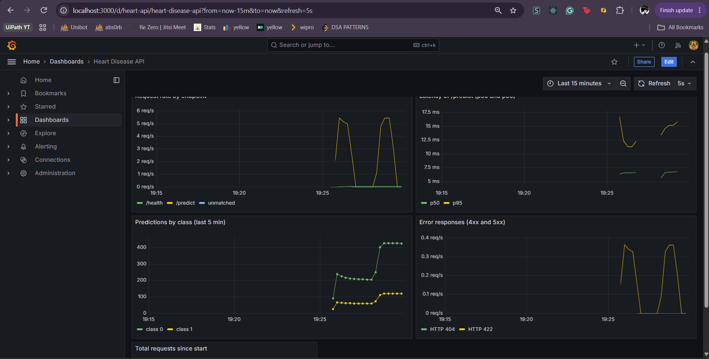
Figure 24: Grafana dashboard under generated traffic

10. Deliverables, limitations and conclusion
Table 14: Deliverables checklist
Deliverable | Location | Included
Source code (data, features, models, serving) | src/ | Yes
Dockerfile and .dockerignore | Dockerfile, .dockerignore | Yes
Dependency files | requirements*.txt | Yes
Cleaned dataset | data/processed/heart_clean.csv | Yes
Download script | src/data/download_data.py | Yes
EDA, training and inference scripts | src/data/eda.py, src/models/train_mlflow.py, src/serving/predictor.py | Yes
Unit tests | tests/ | Yes
GitHub Actions workflow | .github/workflows/ci.yml | Yes
Deployment manifests | k8s/ | Yes
Monitoring stack | docker-compose.yml, monitoring/ | Yes
Screenshots | screenshots/ | Yes
Written report | This document | Yes
Deployed API access | http://localhost:8080 after kubectl apply -f k8s/ | Yes
Pipeline demo video | Submitted with this report | Yes

Limitations and future work
- Small, single-source data. 303 patients from one clinic and 61 test patients mean wide uncertainty; the model is a demonstration, not a validated or clinically approved tool.
- Fixed decision threshold. The threshold is 0.5; a screening deployment would tune it for recall using clinical cost estimates.
- Local deployment. The cluster and image are local. A cloud deployment would push the image to a registry and add an Ingress with TLS.
- No API authentication or rate limiting.
- Monitoring scope. Current metrics cover service health and prediction mix, not input drift or live model accuracy, which would need ground-truth feedback.
- Model storage. The model file is committed for simplicity; a model registry or object store would suit larger models.
Conclusion. The project delivers a reproducible path from raw data to a monitored, containerised prediction service, with tracked experiments, automated tests and a CI pipeline that fails visibly on lint, test or quality-gate errors.

