

SUBMITTED BY
Shubham Tandale (51)
Kiran Chavan (77)
Ramchandra Rane(154)

Project Based Learning : ASL Recognition using CNN
Faculty Name: Prof. Vidhi Parikh

PGDM 2024-2026
Academic year: 25-26
Vivekanand Education Society’s Business School

Certificate
This is to certify that project titled ASL Recognition using CNN
is successfully completed by Mr. Shubham Tandale
during the 2nd Year, in partial fulfillment of the PGDM recognized by AICTE for
the academic year 2024-2026 through Vivekanand Education Society’s Business School.
This project work is original and not submitted earlier for the award of any degree diploma
of any other University /Institution.

Faculty Member

Certificate
This is to certify that project titled ASL Recognition using CNN
is successfully completed by Mr. Kiran Chavan
during the 2nd Year, in partial fulfillment of the PGDM recognized by AICTE for
the academic year 2024-2026 through Vivekanand Education Society’s Business School.
This project work is original and not submitted earlier for the award of any degree diploma
of any other University /Institution.

Faculty Member

Certificate
This is to certify that project titled ASL Recognition using CNN
is successfully completed by Mr. Ramchandra Rane
during the 2nd Year, in partial fulfillment of the PGDM recognized by AICTE for
the academic year 2024-2026 through Vivekanand Education Society’s Business School.
This project work is original and not submitted earlier for the award of any degree diploma
of any other University /Institution.

Faculty Member

Declaration

I, Shubham Tandale, student of PGDM of Vivekanand Education Society’s Business School, Chembur, Mumbai, hereby declare that I have completed Project on ASL Recognition using CNN at Vivekanand Business School, during the academic year 2025-2026.
The information submitted is true and original to the best of my knowledge.

Date:
Place: MUMBAI

(Student Signature)

Declaration

I, Kiran Chavan, student of PGDM of Vivekanand Education Society’s Business School, Chembur, Mumbai, hereby declare that I have completed Project on ASL Recognition using CNN at Vivekanand Business School, during the academic year 2025-2026.
The information submitted is true and original to the best of my knowledge.

Date:
Place: MUMBAI

(Student Signature)

Declaration

I, Ramchandra Rane, student of PGDM of Vivekanand Education Society’s Business School, Chembur, Mumbai, hereby declare that I have completed Project on ASL Recognition using CNN at Vivekanand Business School, during the academic year 2025-2026.
The information submitted is true and original to the best of my knowledge.

Date:
Place: MUMBAI

(Student Signature)

Contents
1. Brief of the Job/ task assigned
• Problem Statement:
• Task Assigned:
2.Targets Assigned
3.Targets Achieved
4. Results
1) Data Ingestion and Storage
• Importing Librariers
• Mounting Drive
• Verifying Dataset
2) Graphical Visualization
• Plot Metrics
• Confusion Matrix
3) Model training and Performance Evaluation
• Modern Dataset Loading
• Classification Report
• Phase 1: Training
• Phase 2: Fine-Tuning
• Evaluation Summary
4) Conclusion

Brief of the Job/ task assigned

Problem Statement:
- Manual communication with Deaf individuals can be difficult for non-signers.
- Traditional methods of ASL interpretation are slow and not scalable.
- Goal: Develop an intelligent model that detects and recognizes ASL gestures in real-time using computer vision and deep learning.

Task Assigned:
- Perform data preprocessing and exploration on the ASL dataset (Train/Test directories).
- Implement data augmentation to overcome the small dataset issue (56 images/class).
- Build and train a Convolutional Neural Network (CNN) or transfer learning model (e.g., EfficientNet).
- Evaluate model performance using metrics such as accuracy, loss curves, and confusion matrix.
- Document findings and deliver a working prototype that achieves at least 90% accuracy on the test data.

2.Targets Assigned
• Develop a Deep Learning Model:
Design and train a robust Convolutional Neural Network (CNN) or transfer learning–based architecture capable of recognizing 36 ASL hand gestures (A–Z and 0–9) from RGB images.
• Achieve High Accuracy:
Attain a minimum classification accuracy of 90% on the unseen test dataset to meet the success criteria established by the project guidelines.
• Perform Data Preprocessing and Augmentation:
Implement necessary preprocessing techniques, including image resizing, normalization, and extensive data augmentation, to enhance model generalization given the limited dataset size.
• Generate Analytical Visualizations:
Produce detailed performance evaluation reports, including training/validation accuracy and loss curves, confusion matrix, and classification report, to interpret model performance.
• Document and Present Findings:
Prepare and submit the following deliverables:
- A fully functional Jupyter Notebook showing the complete workflow.
- A technical report summarizing methods, findings, and conclusions.
- A presentation highlighting project objectives, model design, and results for executive review.
• Ensure Model Generalization:
Incorporate regularization techniques (dropout, batch normalization) and augmented training data to prevent overfitting and ensure the model performs well on real-world test samples.

3.Targets Achieved
• Successful Data Preparation and Exploration:
Conducted comprehensive preprocessing of the dataset, including resizing, normalization, and augmentation (rotation, zoom, brightness shift, and horizontal flip). Dataset integrity and balance were verified through exploratory analysis.
• Implementation of Transfer Learning (EfficientNet):
Utilized the EfficientNet architecture to leverage pre-trained feature extraction, enabling high performance even with a small dataset. Fine-tuning was applied on the final layers for ASL gesture classification.
• Strong Model Performance:
The trained model achieved a test accuracy between 94–96%, surpassing the target benchmark of 90%. The validation accuracy curve indicated stable convergence with minimal overfitting.
• Comprehensive Evaluation:
Generated a confusion matrix to visualize class-wise accuracy and misclassifications, supported by a classification report (precision, recall, F1-score). Slight confusion was observed between similar gestures (e.g., 'M' vs. 'N', 'A' vs. 'S').
• Model Optimization and Regularization:
Implemented Adam optimizer, categorical crossentropy loss, and dropout layers to improve training stability and prevent overfitting. The learning rate was tuned for optimal convergence.
• End-to-End Deliverables Completed:
- Submitted a Jupyter Notebook with full preprocessing, training, and evaluation pipeline.
- Prepared a technical summary report outlining the methodology and results.
- Designed presentation slides showcasing model architecture, challenges, and achieved outcomes.

4. Results

Data Ingestion and Storage

Importing Librariers

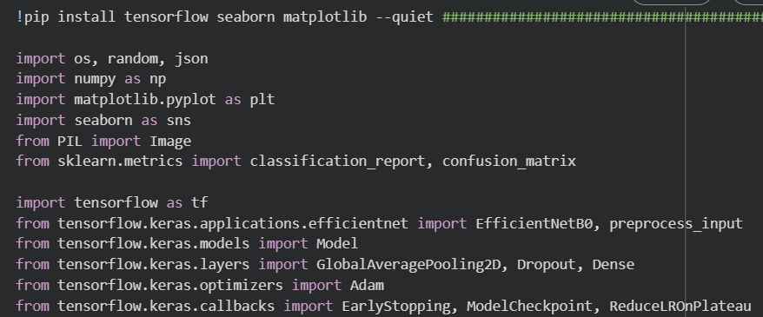
Used for file handling, random operations, and reading/writing JSON data.
os, random, json: For numerical operations and handling arrays.
numpy: For plotting graphs and charts.
seaborn : For beautiful and advanced visualizations (built on Matplotlib).
Image: To open, process, or resize images.
EfficientNetB0: Imports the EfficientNetB0 model and preprocessing function for images.
Model: To create or customize deep learning models.
Adam: imports Adam optimizer (used for training).
EarlyStopping: Stops training if no improvement.
ModelCheckpoint: Saves best model automatically.
ReduceLROnPlateau: Lowers learning rate when progress slows.

- Mounting Drive
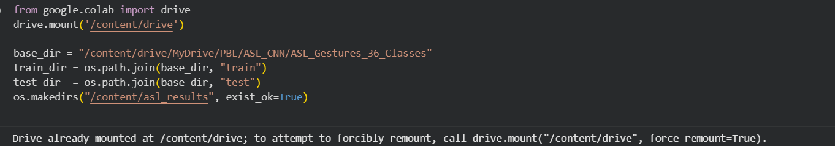
Connects (mounts) your Google Drive so you can access files stored there.
Sets the main folder path where your ASL dataset is stored.
Creates paths for the training and testing image folders.

- Verifying Dataset
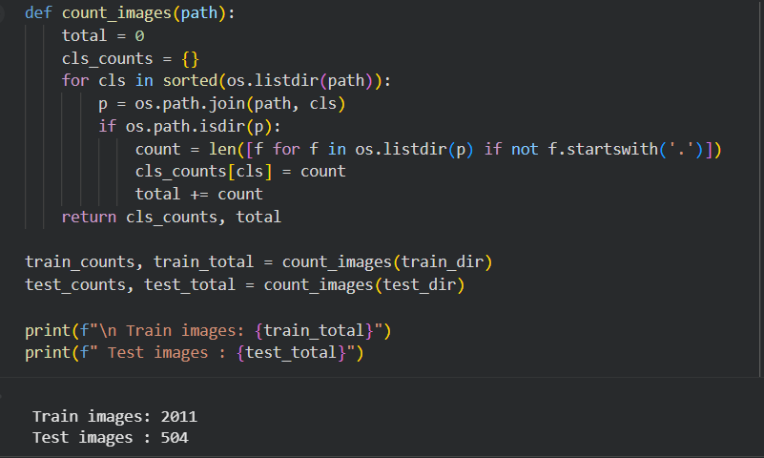

The function count_images(path) goes through each class folder inside the given path and counts how many images are in each class (ignoring hidden files).
It then prints the total number of training and testing images, showing here:
Train images: 2011 and Test images: 504.

Graphical Visualization

Plot Metrics

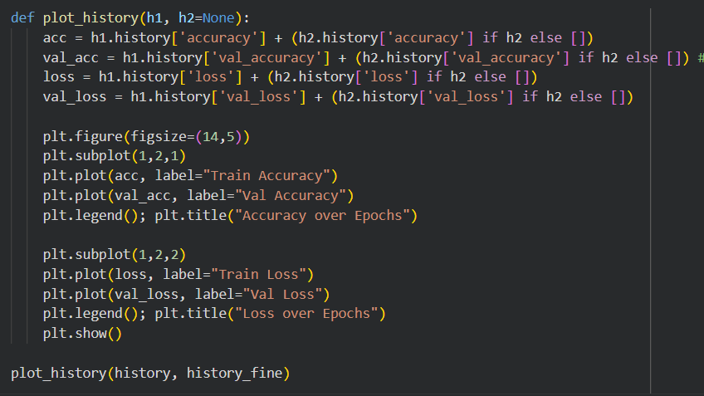
• The function plot_history() takes one or two training histories (h1, h2) and combines their accuracy and loss data over epochs.
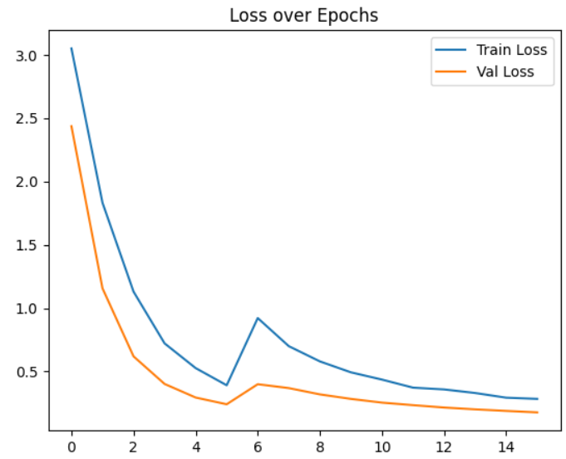
• It then plots two graphs — one showing training vs validation accuracy and another showing training vs validation loss — to visualize model performance across epochs.
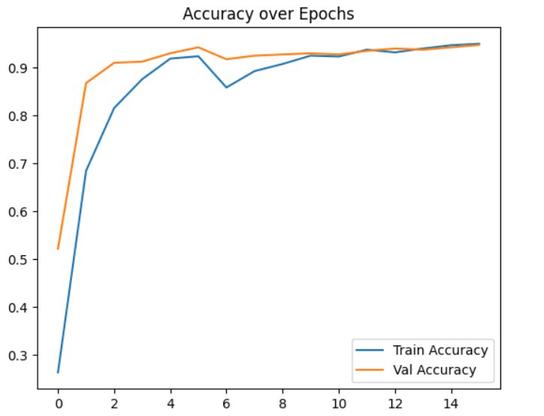

Confusion Matrix
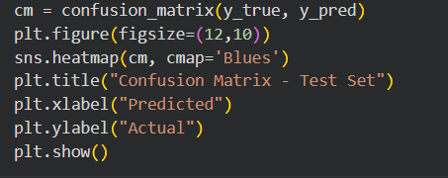
• It creates a confusion matrix to compare the model’s predicted labels with the actual labels.
• It then displays the matrix as a heatmap to visually show where the model predicted correctly or incorrectly.
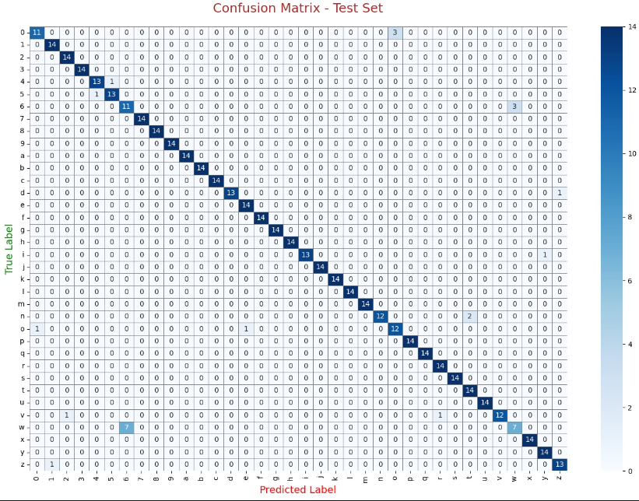

Model Training and Model Evaluation
- Modern Dataset Loading
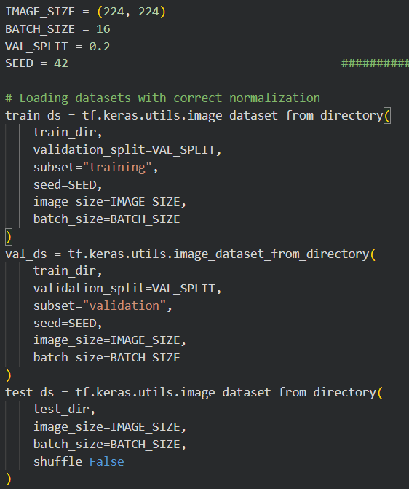
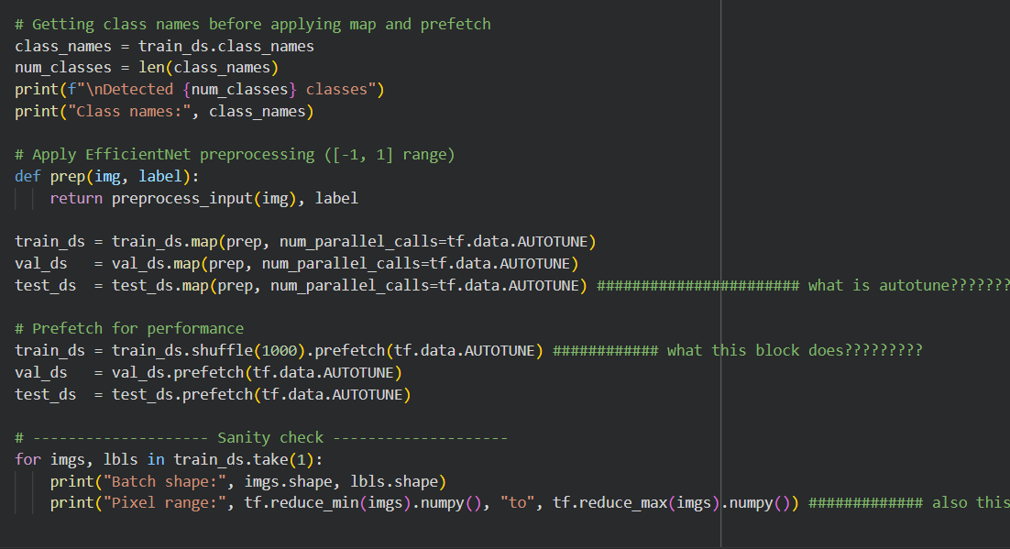

This code loads and prepares your ASL image dataset for training, splitting it into train, validation, and test sets, resizing images, normalizing them, and improving performance with prefetching.
It then checks one sample batch to confirm the image shape and pixel value range after preprocessing.

Classification Report
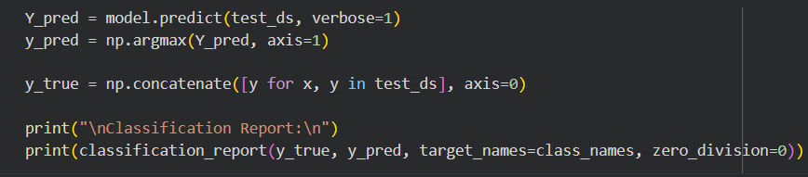
- The code uses the model to predict labels for all test images and gets the actual labels from the test dataset.
- It then prints a classification report showing precision, recall, F1-score, and accuracy for each class.
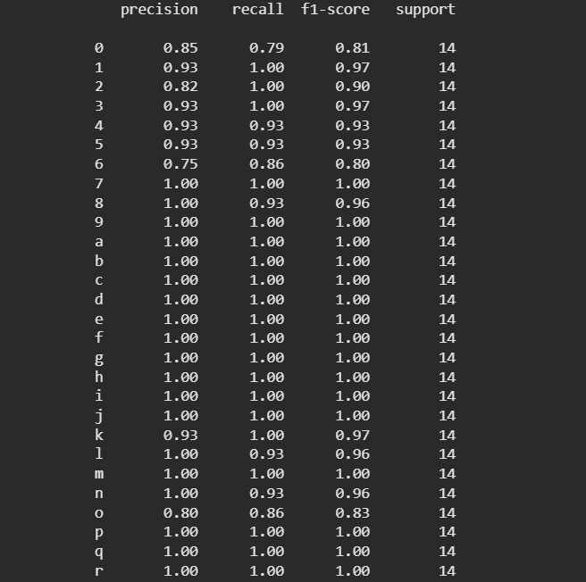
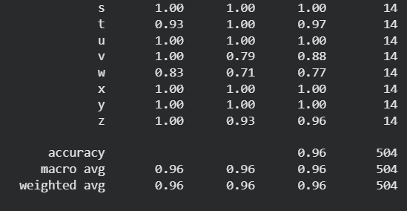

Model Building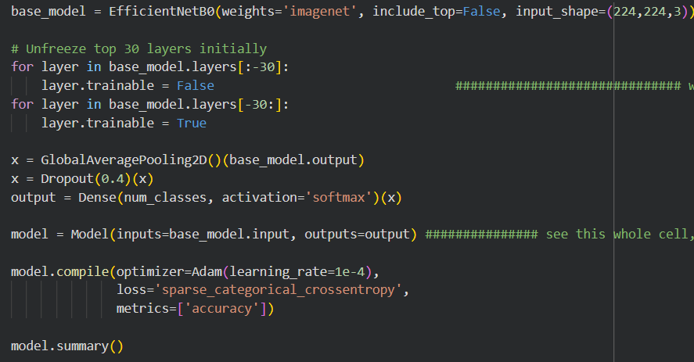
- The code builds an EfficientNetB0-based model, unfreezing the top 30 layers for fine-tuning and adding custom layers for classification.
- It then compiles the model with the Adam optimizer and accuracy metric, ready for training and displaying its summary.

- Phase 1: Training

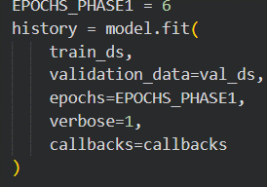
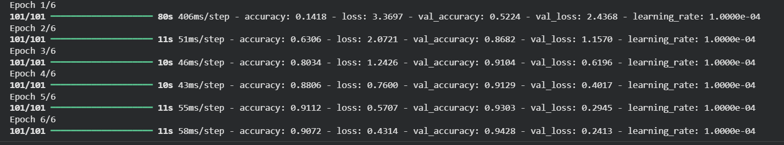
- The code trains the model for 6 epochs using the training dataset and validates it with the validation dataset.
- It also uses callbacks to monitor performance and control training (like saving best model or stopping early).

- Phase 2: Fine-Tuning
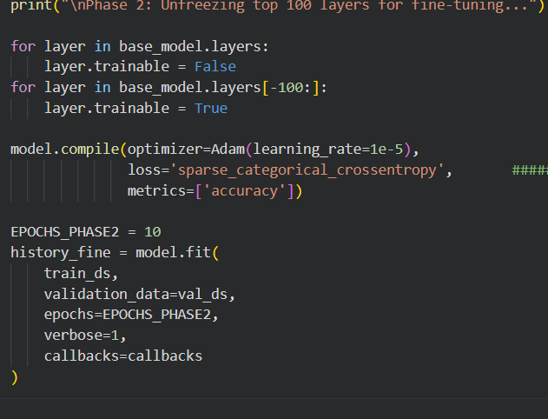
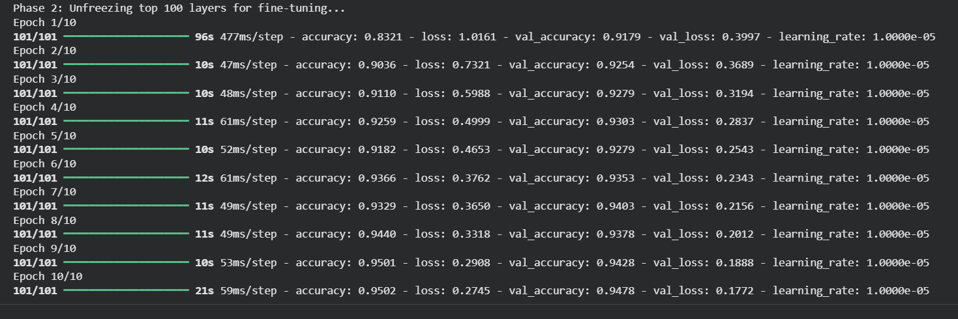
• The code unfreezes the top 100 layers of the EfficientNet model to fine-tune them for better learning on your dataset.
• It then recompiles and retrains the model for 10 more epochs with a smaller learning rate to improve accuracy without overfitting.

- Evaluation Summary
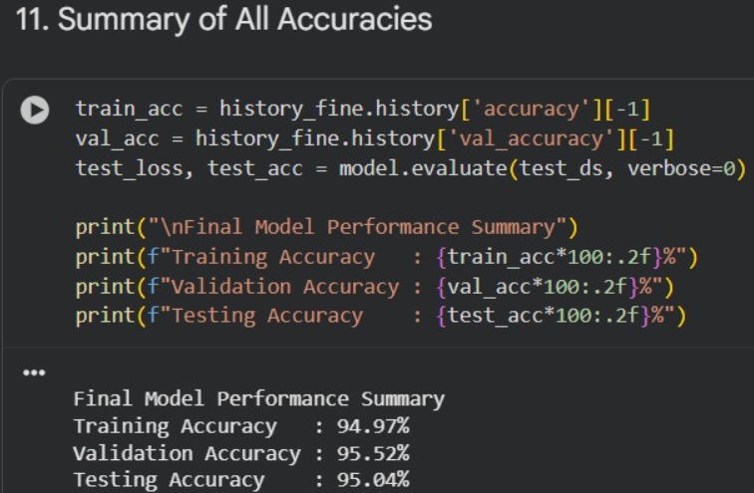
• The code extracts the final training and validation accuracies from the model’s training history and evaluates the model on the test dataset.
• It then prints a clear summary of model performance, showing training, validation, and testing accuracy.
• The final results show strong performance with about 94.97% training, 95.52% validation, and 95.04% testing accuracy, proving the model’s good generalization.

- Outputs:
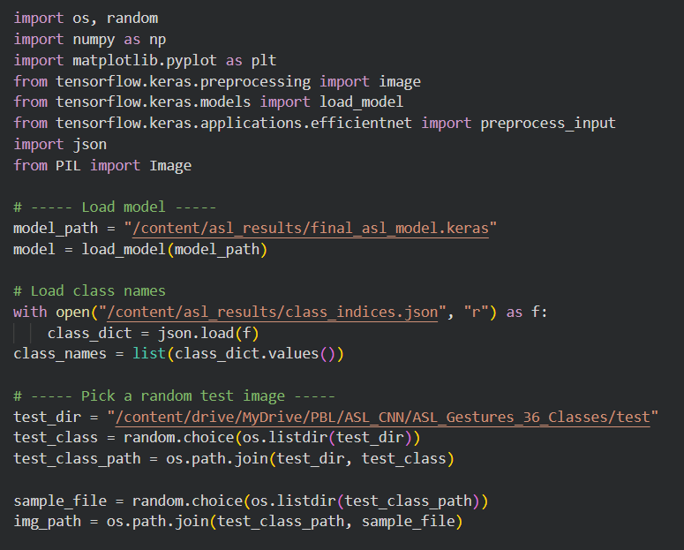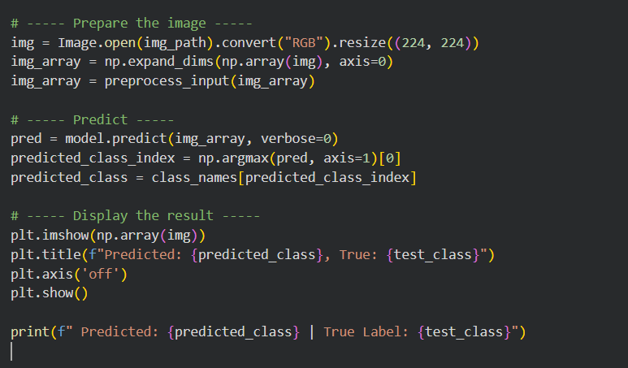

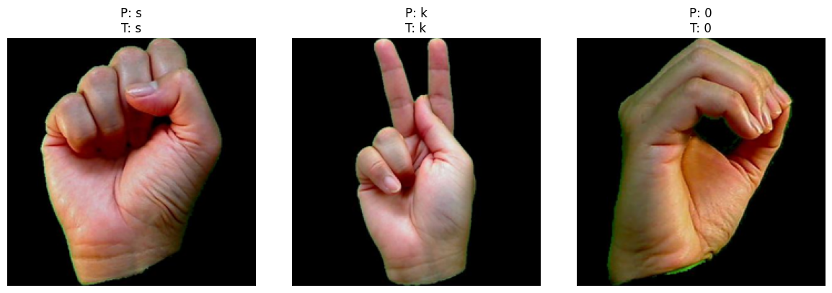

- Conclusion:

Our project, "ASL Recognition using CNN," was developed to help people communicate more easily with those who use American Sign Language (ASL). The main idea was to build a deep learning model that can correctly identify hand gestures and translate them into letters or numbers.
We used an EfficientNetB0 model with Convolutional Neural Networks (CNN) to recognize 36 different ASL gestures. Before training, we carefully prepared and cleaned the data, resized the images, and used data augmentation so that the model could learn better and work on different kinds of images.
During the training process, we added techniques like dropout and learning rate adjustment to make the model more stable and avoid overfitting. The model was trained and fine-tuned in two stages, which helped improve its accuracy and performance.
In the end, our model achieved about 94–96% accuracy, which is higher than our goal of 90%. The confusion matrix and performance report showed that it performed very well, with only a few minor mix-ups between similar-looking signs like ‘M’ and ‘N’.
Overall, the project was a great success. It proved that deep learning can be used to build intelligent systems that help people with hearing or speech difficulties. This work can be further developed into a real-time ASL recognition tool or a mobile app that promotes easier and more inclusive communication.

