About

About Me
Hi, I’m Tom, and I am currently working as Cyber Security Engineer in the Finance Technology sector. I am passionate about technology and am dedicated to crafting innovative solutions that make a difference. In security, being told “anything can be hacked” had peaked my curiosity when it comes to hack types, tools, systems, as well as how the risks can be mitigated, I hope to make a difference in this space.

Since a young age I have been fascinated by computers. I worked at a paper-round which helped me to be able to afford my first computer, in which contained an AMD Athlon X4 and XFX 7770. This allowed me to explore hardware and software, to which mostly led to playing around with things, breaking things and fixing things.

This interest directed my career into the technology, studying foundation diploma in IT at college, networking apprenticeship, to IT and security engineering roles. Technology always developes quickly, so there is a continuous state of learning in the space, I hope to share and build knowledge platform with other.

About This Site
This platform is used to share knowledge and documents of security developments, home lab solutions, scripting, and more. If you have any interests in my posts or want to share your own experiences, you can write a comment using your GitHub account. It will be a place to collaborate on projects that can be used and developed on by anyone. You are always welcome to explore my site, if you have any feedback or suggestions, you can leave a comment under a post or contact via my email.

Current Home Lab
Setup is a hosted environment on Proxmox Virtual Environment (Unix-based). Used to experiment with applications, services, virtual firewalls, and emerging threats. Additionally, a Cloud-hosted environment on Oracle Cloud Platform used for testing cloud threats, applications, and website building. I am using this lab to learn, develop and share tools. Shared below is my current network diagram:
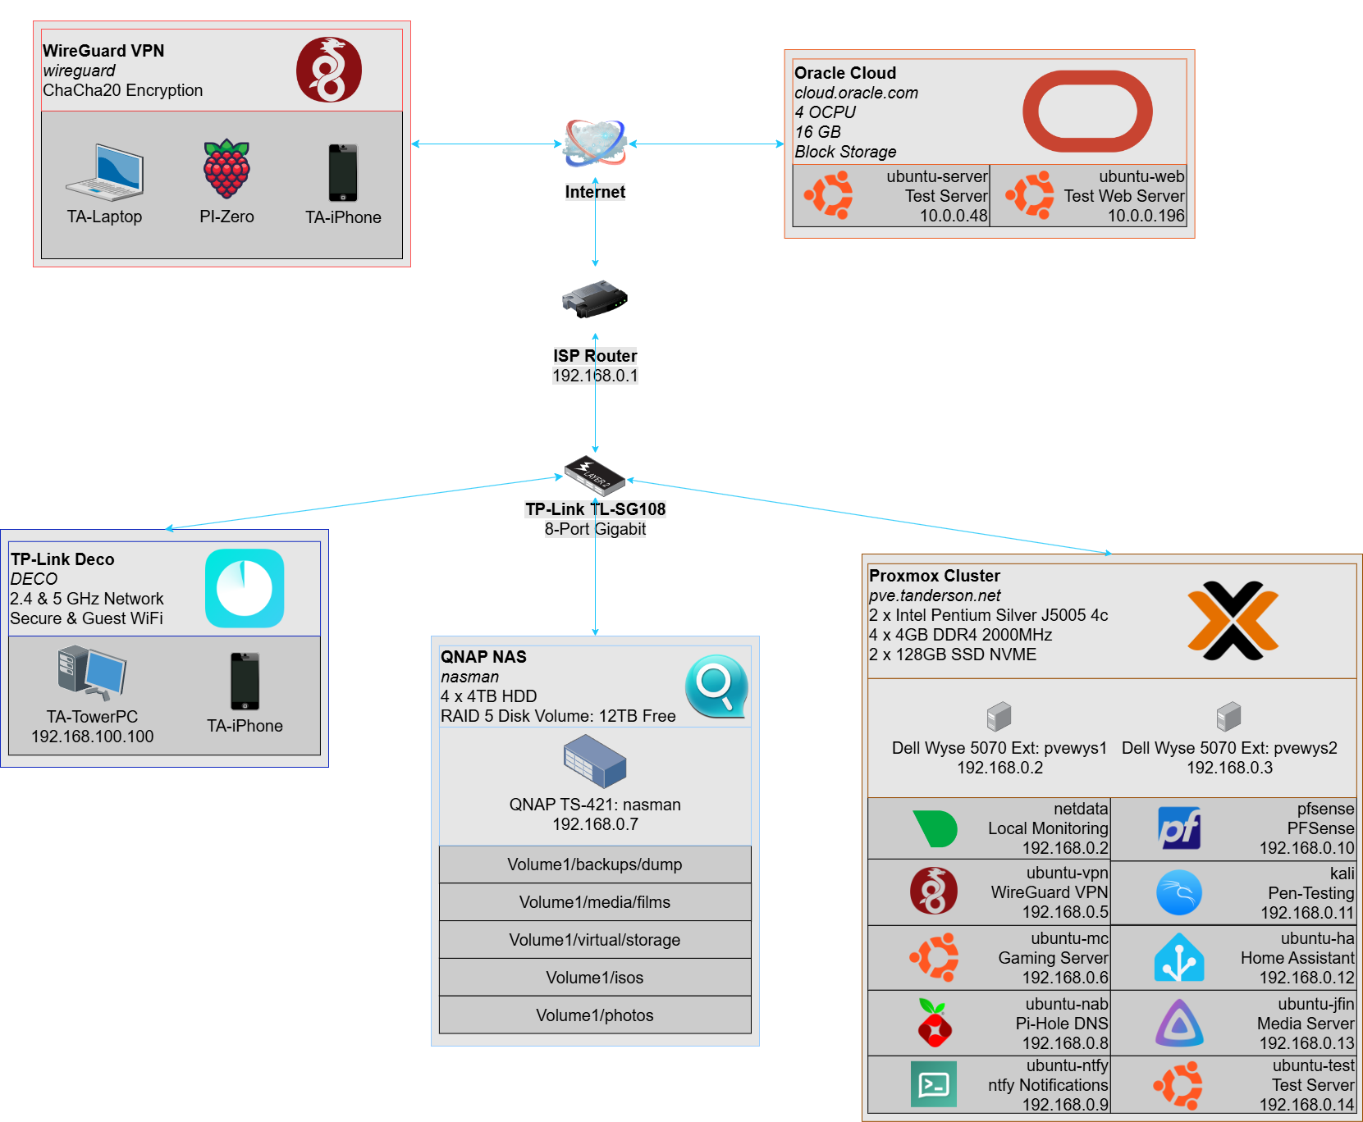

Current Project
I was diagnosed with type-1 diabetes at the age of 3, this means that I have to always keep on top of my glucose level. Technology has improved throughout the years with the latest Abott FreeSytle Libre, allowing accurate, continuous and fast readings. It uses API to share information with other applications such as LibreLinkUp and LibreView. I will be using the API to build upon my own application, that will allow me to view my glucose level from an alternative device, that is not my phone, using LibreLinkUp API Client documented by DiaKEM. More information can be found here.

Previous Project
I love playing older games especially the Mario Kart series. However, the consoles which were used to play them are not very reliable and expensive to replace. This solution will only require a single console and should be more reliable than the tradition consoles. RetroFlag produce a range of different controllers and shell game consoles that allow for Raspberry Pi computers to be added to create an emulator console using an operating system like RetroPie. More information can be found here.

