CSE575-Section4: GPA Calculator activity

1. Layout: we will use Spinner to make a dropdown list of items, such as; grade points and grades.
   1. Create some value strings

Click values > strings.xml > add some strings for the activity as the picture below

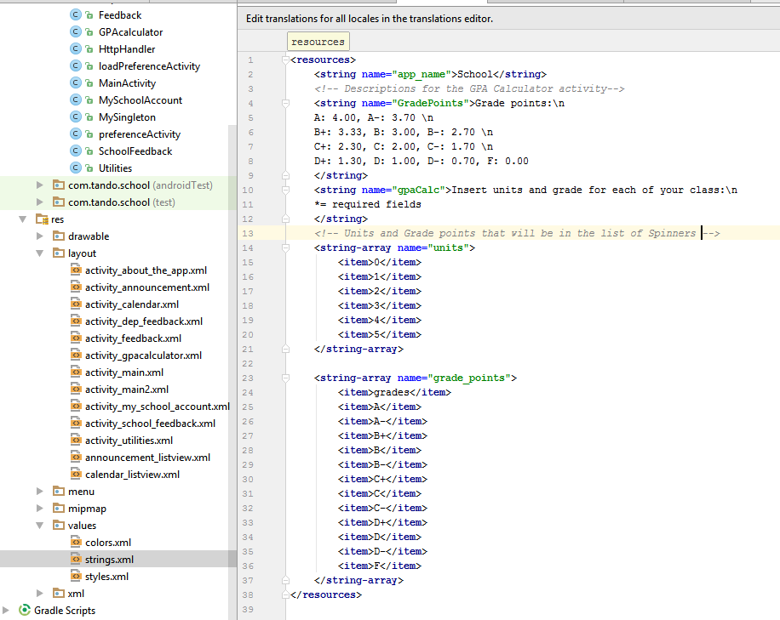

* 1. Activity_gpacalculator.xml

*<?***xml version="1.0" encoding="utf-8"***?>*<**LinearLayout xmlns:android="http://schemas.android.com/apk/res/android"  
 xmlns:app="http://schemas.android.com/apk/res-auto"  
 xmlns:tools="http://schemas.android.com/tools"  
 android:layout_width="match_parent"  
 android:layout_height="match_parent"  
 tools:context="com.tando.school.GPAcalculator"  
 android:orientation="vertical"**>  
 <**ScrollView  
 android:layout_width="match_parent"  
 android:layout_height="match_parent"**>  
 <**LinearLayout  
 android:layout_width="match_parent"  
 android:layout_height="match_parent"  
 android:orientation="vertical"**>  
 *<!--Logo -->* <**ImageView  
 android:id="@+id/logo"  
 android:layout_width="150dp"  
 android:layout_height="100dp"  
 android:background="@drawable/school_logo"  
 android:layout_gravity="center"**/>  
 <**TextView  
 android:layout_marginLeft="10dp"  
 android:layout_width="match_parent"  
 android:layout_height="wrap_content"  
 android:textStyle="bold"  
 android:textColor="#000"  
 android:paddingTop="5dp"  
 android:text="@string/GradePoints"  
 android:textSize="18dp"** />  
 <**TextView  
 android:layout_marginLeft="10dp"  
 android:layout_width="match_parent"  
 android:layout_height="wrap_content"  
 android:textStyle="bold"  
 android:textColor="#000"  
 android:layout_marginTop="10dp"  
 android:layout_marginBottom="7dp"  
 android:text="@string/gpaCalc"**/>  
 <**GridLayout  
 android:layout_width="wrap_content"  
 android:layout_height="wrap_content"  
 android:layout_marginTop="5dp"  
 android:layout_marginBottom="5dp"  
 android:layout_marginLeft="10dp"**>  
 <**TextView  
 android:layout_width="wrap_content"  
 android:layout_height="wrap_content"  
 android:text="Units*:"  
 android:layout_column="0"  
 android:layout_row="0"  
 android:textColor="#000"  
 android:textStyle="bold"** />  
 <**android.support.v7.widget.AppCompatSpinner  
 android:layout_width="wrap_content"  
 android:layout_height="wrap_content"  
 android:id="@+id/spinner1"  
 android:layout_column="1"  
 android:layout_row="0"**>  
 </**android.support.v7.widget.AppCompatSpinner**>  
 <**TextView  
 android:layout_width="wrap_content"  
 android:layout_height="wrap_content"  
 android:text="Grade*:"  
 android:layout_column="2"  
 android:layout_row="0"  
 android:textColor="#000"  
 android:textStyle="bold"** />  
 <**android.support.v7.widget.AppCompatSpinner  
 android:layout_width="wrap_content"  
 android:layout_height="wrap_content"  
 android:id="@+id/spinner2"  
 android:layout_column="3"  
 android:layout_row="0"**>  
 </**android.support.v7.widget.AppCompatSpinner**>  
 <**Button  
 android:id="@+id/bntInsert"  
 android:layout_width="wrap_content"  
 android:layout_height="45dp"  
 android:text="INSERT"  
 android:layout_row="0"  
 android:layout_column="4"  
 android:layout_marginRight="15dp"**/>  
 </**GridLayout**>  
 <**Button  
 android:id="@+id/calcGPA"  
 android:layout_width="wrap_content"  
 android:layout_height="wrap_content"  
 android:layout_gravity="center"  
 android:layout_marginTop="5dp"  
 android:text="Compute"** />  
 <**Button  
 android:id="@+id/bntClear"  
 android:layout_width="wrap_content"  
 android:layout_height="45dp"  
 android:text="Reset"  
 android:layout_gravity="center"** />  
  
  
 <**TextView  
 android:id="@+id/resultTotalUnits"  
 android:layout_width="wrap_content"  
 android:layout_height="wrap_content"  
 android:text="Total units:"  
 android:textColor="#000"  
 android:layout_marginTop="5dp"  
 android:layout_marginBottom="5dp"  
 android:textStyle="bold"  
 android:layout_marginLeft="10dp"**/>  
  
 <**TextView  
 android:id="@+id/resultTotalGrades"  
 android:layout_width="wrap_content"  
 android:layout_height="wrap_content"  
 android:text="Total grade points:"  
 android:textColor="#000"  
 android:layout_marginTop="5dp"  
 android:layout_marginBottom="5dp"  
 android:textStyle="bold"  
 android:layout_marginLeft="10dp"**/>  
  
 <**TextView  
 android:id="@+id/gpa"  
 android:layout_width="wrap_content"  
 android:layout_height="wrap_content"  
 android:text="Your GPA:"  
 android:textColor="#000"  
 android:layout_marginTop="5dp"  
 android:layout_marginBottom="10dp"  
 android:textStyle="bold"  
 android:layout_marginLeft="10dp"**/>  
 </**LinearLayout**>  
 </**ScrollView**>  
</**LinearLayout**>

1. GPAcalculator.java (explanations are in the comments)

**package** com.tando.school;  
  
**import** android.support.v7.app.AppCompatActivity;  
**import** android.os.Bundle;  
**import** android.view.View;  
**import** android.widget.ArrayAdapter;  
**import** android.widget.Button;  
**import** android.widget.Spinner;  
**import** android.widget.TextView;  
**import** android.widget.Toast;  
  
**import** java.text.DecimalFormat;  
**import** java.util.ArrayList;  
  
**public class** GPAcalculator **extends** AppCompatActivity {  
 *//Declare an array to store units type is double* **public static** ArrayList<Double> *unitsAdd* = **new** ArrayList<Double>();  
 *//Declare an array to store grade points* **public static** ArrayList<Double> *gradeAdd* = **new** ArrayList<Double>();  
 *//Declare an array to store the result of units * gradepoints* **public static** ArrayList<Double> *gradePoints* = **new** ArrayList<Double>();  
 *//Declare the spinners* Spinner **spinner1**, **spinner2**;  
 *//Declare adapter to connect array in string value* ArrayAdapter<CharSequence> **adapter1**;  
 *//Adapter 2* ArrayAdapter<CharSequence> **adapter2**;  
 *//Declare some double variables* Double **numOfUnits**, **numOfGrades**, **gradepoints**, **totalGPA**, **totalGrades** = 0.00, **totalUnits** = 0.00;  
 @Override  
 **protected void** onCreate(Bundle savedInstanceState) {  
 **super**.onCreate(savedInstanceState);  
 setContentView(R.layout.***activity_gpacalculator***);  
  
 *//Link spinners to their IDs* **spinner1** = (Spinner) findViewById(R.id.***spinner1***);  
 **spinner2** = (Spinner) findViewById(R.id.***spinner2***);  
 *//link adaters to their strings and style the drop-down menu* **adapter1** = ArrayAdapter.*createFromResource*(GPAcalculator.**this**, R.array.***units***,  
 android.R.layout.***simple_spinner_item***);  
 *//Set Drop-down style* **adapter1**.setDropDownViewResource(android.R.layout.***simple_spinner_dropdown_item***);  
 **adapter2** = ArrayAdapter.*createFromResource*(GPAcalculator.**this**, R.array.***grade_points***,  
 android.R.layout.***simple_spinner_item***);  
 *//Set Drop-down style* **adapter2**.setDropDownViewResource(android.R.layout.***simple_spinner_dropdown_item***);  
 *//display the adapter contain the lists* **spinner1**.setAdapter(**adapter1**);  
 **spinner2**.setAdapter(**adapter2**);  
  
 *//declare buttons* Button bntInsert = (Button) findViewById(R.id.***bntInsert***);  
 Button bntCountGPA = (Button) findViewById(R.id.***calcGPA***);  
 Button bntClear = (Button) findViewById(R.id.***bntClear***);  
  
 *//textView for total units* **final** TextView resultTotalUnits = (TextView) findViewById(R.id.***resultTotalUnits***);  
 *//textView for total grade points* **final** TextView resultTotalGrades = (TextView) findViewById(R.id.***resultTotalGrades***);  
 *//textView for GPA* **final** TextView resultGPA = (TextView) findViewById(R.id.***gpa***);  
  
 *//Insert button function* bntInsert.setOnClickListener(**new** View.OnClickListener() {  
 @Override  
 **public void** onClick(View v) {  
 *//Declare a string for selected Unit_items* String unitSelected = **spinner1**.getSelectedItem().toString();  
 *//Covert string to double* **numOfUnits** = Double.*parseDouble*(unitSelected);  
 *//add double value into array  
 unitsAdd*.add(**numOfUnits**);  
 *//Declare a string for selected Grades_items* String gradeSelected = **spinner2**.getSelectedItem().toString();  
 *//Convert the letters into Doubles. For example A = 4.00* **if** (gradeSelected.equals(**"A"**)){  
 **numOfGrades** = 4.00;  
 *gradeAdd*.add(**numOfGrades**);  
 }  
 **else if** (gradeSelected.equals(**"A-"**)) {  
 **numOfGrades** = 3.70;  
 *gradeAdd*.add(**numOfGrades**);  
 }  
 **else if** (gradeSelected.equals(**"B+"**)) {  
 **numOfGrades** = 3.33;  
 *gradeAdd*.add(**numOfGrades**);  
 }  
 **else if** (gradeSelected.equals(**"B"**)) {  
 **numOfGrades** = 3.00;  
 *gradeAdd*.add(**numOfGrades**);  
 }  
 **else if** (gradeSelected.equals(**"B-"**)) {  
 **numOfGrades** = 2.70;  
 *gradeAdd*.add(**numOfGrades**);  
 }  
 **else if** (gradeSelected.equals(**"C+"**)) {  
 **numOfGrades** = 2.30;  
 *gradeAdd*.add(**numOfGrades**);  
 }  
 **else if** (gradeSelected.equals(**"C"**)) {  
 **numOfGrades** = 2.00;  
 *gradeAdd*.add(**numOfGrades**);  
 }  
 **else if** (gradeSelected.equals(**"C-"**)) {  
 **numOfGrades** = 1.70;  
 *gradeAdd*.add(**numOfGrades**);  
 }  
 **else if** (gradeSelected.equals(**"D+"**)) {  
 **numOfGrades** = 1.30;  
 *gradeAdd*.add(**numOfGrades**);  
 }  
 **else if** (gradeSelected.equals(**"D"**)) {  
 **numOfGrades** = 1.00;  
 *gradeAdd*.add(**numOfGrades**);  
 }  
 **else if** (gradeSelected.equals(**"D-"**)) {  
 **numOfGrades** = 0.70;  
 *gradeAdd*.add(**numOfGrades**);  
 }  
 **else if** (gradeSelected.equals(**"F"**)) {  
 **numOfGrades** = 0.00;  
 *gradeAdd*.add(**numOfGrades**);  
 }  
 **else** {  
 *//Nothing is selected* Toast.*makeText*(getApplicationContext(), **"Error!!!"**, Toast.***LENGTH_LONG***).show();  
 }  
 *//Display the Toast to let users know what they have inserted* Toast.*makeText*(getApplicationContext(),  
 **"You have inserted: "** + **numOfUnits** + **" units and "** + **numOfGrades** + **" Grade Points"**,  
 Toast.***LENGTH_SHORT***).show();  
 *//Function of GradePoints* **gradepoints** = **numOfUnits** * **numOfGrades**;  
 *//add gradepoints into gradepoints array* **if** (**gradepoints** >= 0) {  
 *gradePoints*.add(**gradepoints**);  
 } **else** {  
 Toast.*makeText*(getApplicationContext(), **"Error!!!"**, Toast.***LENGTH_LONG***).show();  
 }  
 *//Clear the spinner after pick strings from them* **spinner1**.setSelection(0);  
 **spinner2**.setSelection(0);  
 }  
 });  
 *//Count GPA button function* bntCountGPA.setOnClickListener(**new** View.OnClickListener() {  
 @Override  
 **public void** onClick(View v) {  
 DecimalFormat format = **new** DecimalFormat(**"#.#"**);  
 *//Have to declare totalUnits = 0.00 from the beginning* **for**(**int** i=0;i<*unitsAdd*.size();i++){  
 *//sum of all elements(units) in the array called units* **totalUnits** += (*unitsAdd*.get(i));  
 }  
 *//sum of all elements(gradePoint = numOfUnits * numOfGrades) in the array gradePoints* **for**(**int** j=0;j<*gradePoints*.size();j++){  
 **totalGrades** += (*gradePoints*.get(j));  
 }  
 *//Count GPA* **totalGPA** = **totalGrades** / **totalUnits**;  
 *//Display the results in the TextView sections* resultTotalUnits.setText(**"Total units: "**+Double.*toString*(**totalUnits**));  
 *//Display total gradePoints* resultTotalGrades.setText(**"Total grade points: "**+format.format(**totalGrades**));  
 *//Display GPA* resultGPA.setText(**"GPA: "**+format.format(**totalGPA**));  
 *//Clear the array after button clicked* **totalGPA** = 0.00;  
 **totalUnits** = 0.00;  
 **totalGrades** = 0.00;  
 *unitsAdd*.clear();  
 *gradeAdd*.clear();  
 *gradePoints*.clear();  
  
 }  
 });  
 *//Clear function* bntClear.setOnClickListener(**new** View.OnClickListener() {  
 @Override  
 **public void** onClick(View v) {  
 **spinner1**.setSelection(0);  
 **spinner2**.setSelection(0);  
 resultTotalUnits.setText(**"Total units: clear"**);  
 resultTotalGrades.setText(**"Total grade points: clear"**);  
 resultGPA.setText(**"Your GPA: clear"**);  
 *gradePoints*.clear();  
 *unitsAdd*.clear();  
 *gradeAdd*.clear();  
 *gradePoints*.clear();  
 Toast.*makeText*(GPAcalculator.**this**, **"Clear!"**, Toast.***LENGTH_LONG***).show();  
 }  
 });  
 }  
}

Here is the GPA Calculator activity

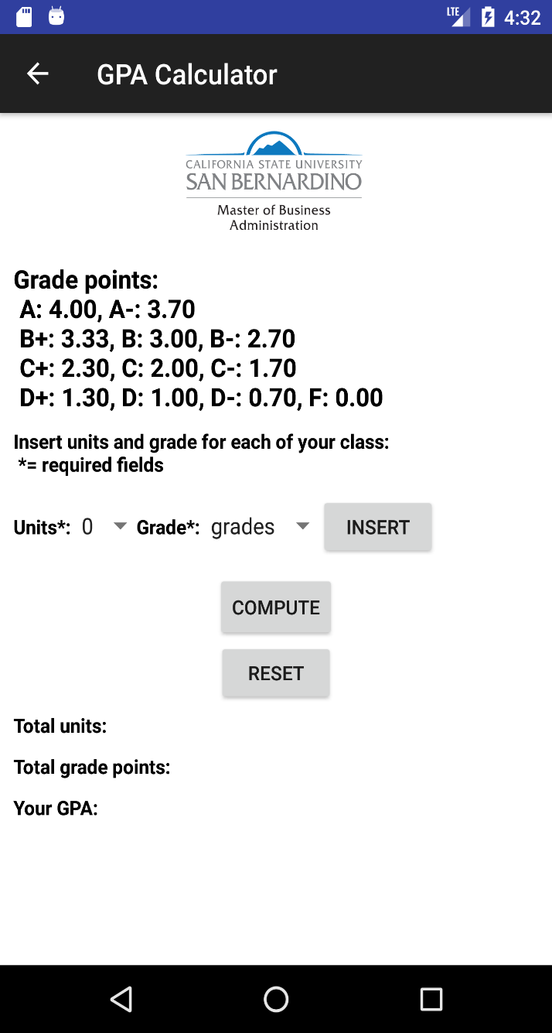

When we finished selecting from Spinners list and hit Insert button

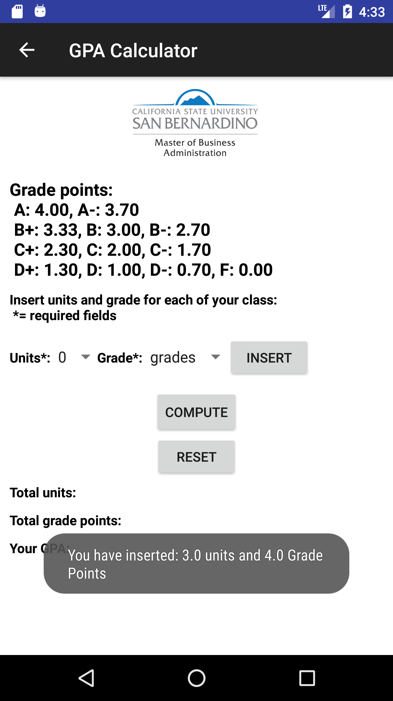

When we click the compute button

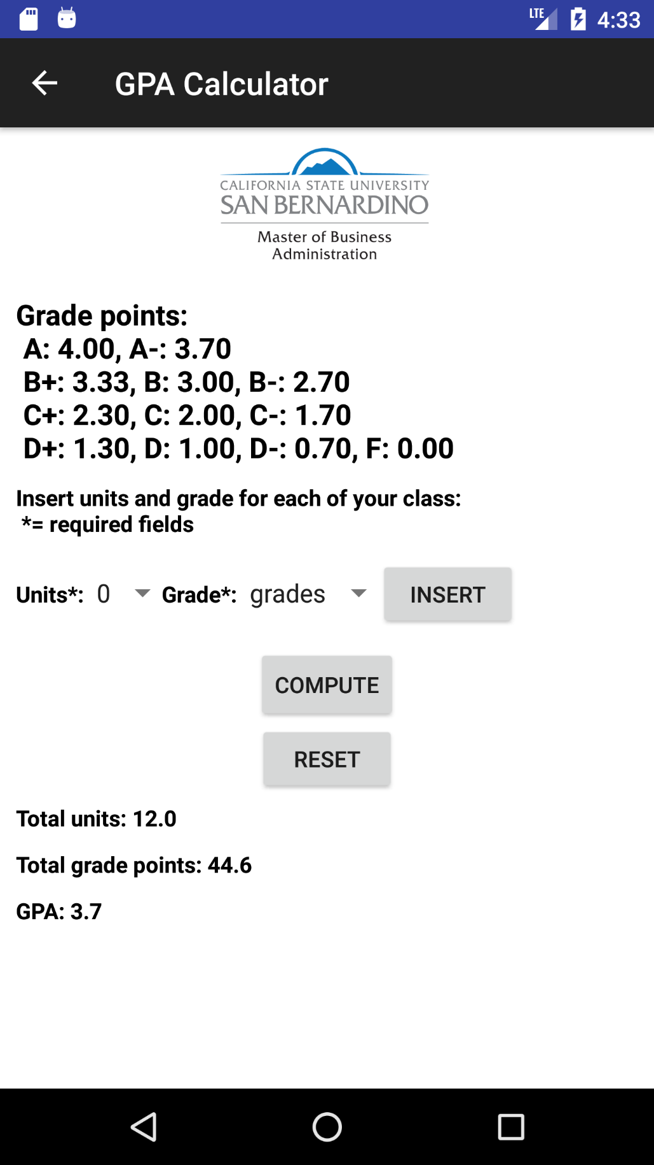

When we click the Reset button

