CSE575-Section4: MyLocation activity

1. Giving access to the location service (GPS) of Android device by adding this line of code in to the AndroidManifest.xml

<**uses-permission android:name="android.permission.ACCESS_FINE_LOCATION"** />

It should look like this AndroidManifest.xml

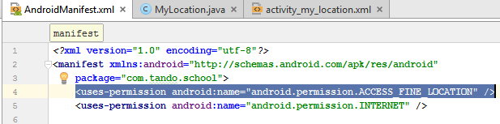

1. Layout activity_my_location.xml

*<?***xml version="1.0" encoding="utf-8"***?>*<**LinearLayout xmlns:android="http://schemas.android.com/apk/res/android"  
 xmlns:app="http://schemas.android.com/apk/res-auto"  
 xmlns:tools="http://schemas.android.com/tools"  
 android:layout_width="match_parent"  
 android:layout_height="match_parent"  
 tools:context="com.tando.school.MyLocation"  
 android:orientation="vertical"**>  
 <**ScrollView  
 android:layout_width="match_parent"  
 android:layout_height="match_parent"**>  
 <**LinearLayout  
 android:layout_width="match_parent"  
 android:layout_height="match_parent"  
 android:orientation="vertical"**>  
 <**TextView  
 android:layout_width="match_parent"  
 android:layout_height="wrap_content"  
 android:layout_marginTop="15dp"  
 android:layout_marginBottom="20dp"  
 android:gravity="center"  
 android:text="Current Location"  
 android:textColor="#000"  
 android:textSize="20dp"** />  
  
 <**TextView  
 android:id="@+id/txtLat"  
 android:layout_width="wrap_content"  
 android:layout_height="wrap_content"  
 android:layout_marginLeft="15dp"  
 android:layout_marginTop="10dp"  
 android:text="Latitude: "  
 android:textColor="#000"  
 android:textSize="15dp"** />  
  
 <**TextView  
 android:id="@+id/txtLong"  
 android:layout_width="wrap_content"  
 android:layout_height="wrap_content"  
 android:layout_marginLeft="15dp"  
 android:layout_marginTop="10dp"  
 android:text="Longitude: "  
 android:textColor="#000"  
 android:textSize="15dp"** />  
  
 <**TextView  
 android:id="@+id/txtAccuracy"  
 android:layout_width="wrap_content"  
 android:layout_height="wrap_content"  
 android:layout_marginLeft="15dp"  
 android:layout_marginTop="10dp"  
 android:text="Accuracy: "  
 android:textColor="#000"  
 android:textSize="15dp"** />  
  
 <**TextView  
 android:id="@+id/txtAltitude"  
 android:layout_width="wrap_content"  
 android:layout_height="wrap_content"  
 android:layout_marginLeft="15dp"  
 android:layout_marginTop="10dp"  
 android:text="Altitude: "  
 android:textColor="#000"  
 android:textSize="15dp"** />  
  
 <**TextView  
 android:id="@+id/txtAddress"  
 android:layout_width="wrap_content"  
 android:layout_height="wrap_content"  
 android:layout_marginLeft="15dp"  
 android:layout_marginTop="10dp"  
 android:text="Address: "  
 android:textColor="#000"  
 android:textSize="15dp"** />  
 </**LinearLayout**>  
 </**ScrollView**>  
</**LinearLayout**>

1. MyLocation.java (Explanations are in comments)

**package** com.tando.school;  
  
**import** android.Manifest;  
**import** android.content.Context;  
**import** android.content.pm.PackageManager;  
**import** android.location.Address;  
**import** android.location.Geocoder;  
**import** android.location.Location;  
**import** android.location.LocationListener;  
**import** android.location.LocationManager;  
**import** android.os.Build;  
**import** android.support.annotation.NonNull;  
**import** android.support.v4.app.ActivityCompat;  
**import** android.support.v4.content.ContextCompat;  
**import** android.support.v7.app.AppCompatActivity;  
**import** android.os.Bundle;  
**import** android.util.Log;  
**import** android.widget.TextView;  
  
**import** java.io.IOException;  
**import** java.util.List;  
**import** java.util.Locale;  
*//Must give permission ACCESS_FINE_LOCATION in the manifest***public class** MyLocation **extends** AppCompatActivity {  
 *// provides access to the system location services* LocationManager **locationManager**;  
 *//Used for receiving notifications from the LocationManager when the location has changed* LocationListener **locationListener**;  
 *//Process when users give the permission* @Override  
 **public void** onRequestPermissionsResult(**int** requestCode, @NonNull String[] permissions, @NonNull **int**[] grantResults) {  
 **super**.onRequestPermissionsResult(requestCode, permissions, grantResults);  
 *//Start the location service when users allow for the location service* **if** (grantResults.**length** > 0 && grantResults[0] == PackageManager.***PERMISSION_GRANTED***) {  
 startListening();  
 }  
  
 }  
 *//checking method for granted permission* **public void** startListening() {  
 **if** (ContextCompat.*checkSelfPermission*(**this**, Manifest.permission.***ACCESS_FINE_LOCATION***) == PackageManager.***PERMISSION_GRANTED***) {  
 **locationManager** = (LocationManager) **this**.getSystemService(Context.***LOCATION_SERVICE***);  
 }  
 }  
 *//Update location method. When the user moves to another location* **public void** updatedLocationInfo(Location location) {  
 *//testing on log* Log.*i* (**"Location"**, location.toString());  
 *//Cast into their IDs textviews to parse information from location service* TextView latTextView = (TextView) findViewById(R.id.***txtLat***);  
 TextView lonTextView = (TextView) findViewById(R.id.***txtLong***);  
 TextView altTextView = (TextView) findViewById(R.id.***txtAltitude***);  
 TextView accTextView = (TextView) findViewById(R.id.***txtAccuracy***);  
 *//Retrieve latitude, longtitude, altitude, accuracy from the location service* latTextView.setText(**"Latitude: "** + location.getLatitude());  
 lonTextView.setText(**"Longitude: "** + location.getLongitude());  
 altTextView.setText(**"Altitude: "** + location.getAltitude());  
 accTextView.setText(**"Accuracy: "** + location.getAccuracy());  
  
 */**  
 * Create Geocoder object to Get the address  
 * A class for handling geocoding and reverse geocoding. Geocoding is the process of  
 * transforming a street address or other description of a location  
 * into a (latitude, longitude) coordinate.  
 * reference: https://developer.android.com/reference/android/location/Geocoder.html  
 */* Geocoder geocoder = **new** Geocoder(getApplicationContext(), Locale.*getDefault*());  
 *//Using try/catch to prevent the app from crashing when failing to get Addresses from Geocoder* **try** {  
 *//Declare the error string* String address = **"Unable to get the address!"**;  
 *//Returns an array of Addresses that are known to describe the area immediately surrounding the given latitude and longitude, return only 1 address* List<Address> listAddresses = geocoder.getFromLocation(location.getLatitude(), location.getLongitude(), 1);  
 **if** (listAddresses != **null** && listAddresses.size() > 0) {  
 *//Set address to empty string again when we know it is working* address = **"Address: \n"**;  
 *//check for every item in the list Addresses is valid* **if** (listAddresses.get(0).getSubThoroughfare() != **null**) {  
 address += listAddresses.get(0).getSubThoroughfare() + **" "**;  
 }  
 *//Street name* **if** (listAddresses.get(0).getThoroughfare() != **null**) {  
 address += listAddresses.get(0).getThoroughfare() + **"\n"**;  
 }  
 *//City name* **if** (listAddresses.get(0).getLocality() != **null**) {  
 address += listAddresses.get(0).getLocality() + **"\n"**;  
 }  
 *//Zip code* **if** (listAddresses.get(0).getPostalCode() != **null**) {  
 address += listAddresses.get(0).getPostalCode() + **"\n"**;  
 }  
 *//Country name* **if** (listAddresses.get(0).getCountryName() != **null**) {  
 address += listAddresses.get(0).getCountryName() + **"\n"**;  
 }  
  
 }  
  
 TextView addressTextView = (TextView) findViewById(R.id.***txtAddress***);  
 *//set the array of address into the text View declared above* addressTextView.setText(address);  
  
 } **catch** (IOException e) {  
 e.printStackTrace();  
 }  
 }  
 @Override  
 **protected void** onCreate(Bundle savedInstanceState) {  
 **super**.onCreate(savedInstanceState);  
 setContentView(R.layout.***activity_my_location***);  
 **locationManager** = (LocationManager) **this**.getSystemService(Context.***LOCATION_SERVICE***);  
 *//Retrieve the new address list from locationManager when the users change their location* **locationListener** = **new** LocationListener() {  
 @Override  
 **public void** onLocationChanged(Location location) {  
 *//Call the updatedLocationInfo method.* updatedLocationInfo(location);  
 }  
 *//These method will not be used* @Override  
 **public void** onStatusChanged(String provider, **int** status, Bundle extras) {  
  
 }  
  
 @Override  
 **public void** onProviderEnabled(String provider) {  
  
 }  
  
 @Override  
 **public void** onProviderDisabled(String provider) {  
  
 }  
 };  
 *//Check for the version of SDK* **if** (Build.VERSION.***SDK_INT*** < 23) {  
  
 startListening();  
 } **else** {  
 *// above 23 we need to check for permission* **if** (ContextCompat.*checkSelfPermission*(**this**, Manifest.permission.***ACCESS_FINE_LOCATION***) != PackageManager.***PERMISSION_GRANTED***) {  
 *//ask for permission. Number 1 is just a request queue.* ActivityCompat.*requestPermissions*(**this**, **new** String[]{Manifest.permission.***ACCESS_FINE_LOCATION***}, 1);  
 }  
 *//we have permission* **else** {  
 **locationManager**.requestLocationUpdates(LocationManager.***GPS_PROVIDER***, 0, 0, **locationListener**);  
 *//Returns a Location indicating the data from the last known location fix obtained from the given provider* Location location = **locationManager**.getLastKnownLocation(LocationManager.***GPS_PROVIDER***);  
 *//In case location does not have lastknownlocation, we call the updatedLocation method above* **if** (location != **null**) {  
 updatedLocationInfo(location);  
 }  
 }  
 }  
 }  
}

Demo:

1. When click on it as the first time, it will ask for a permission

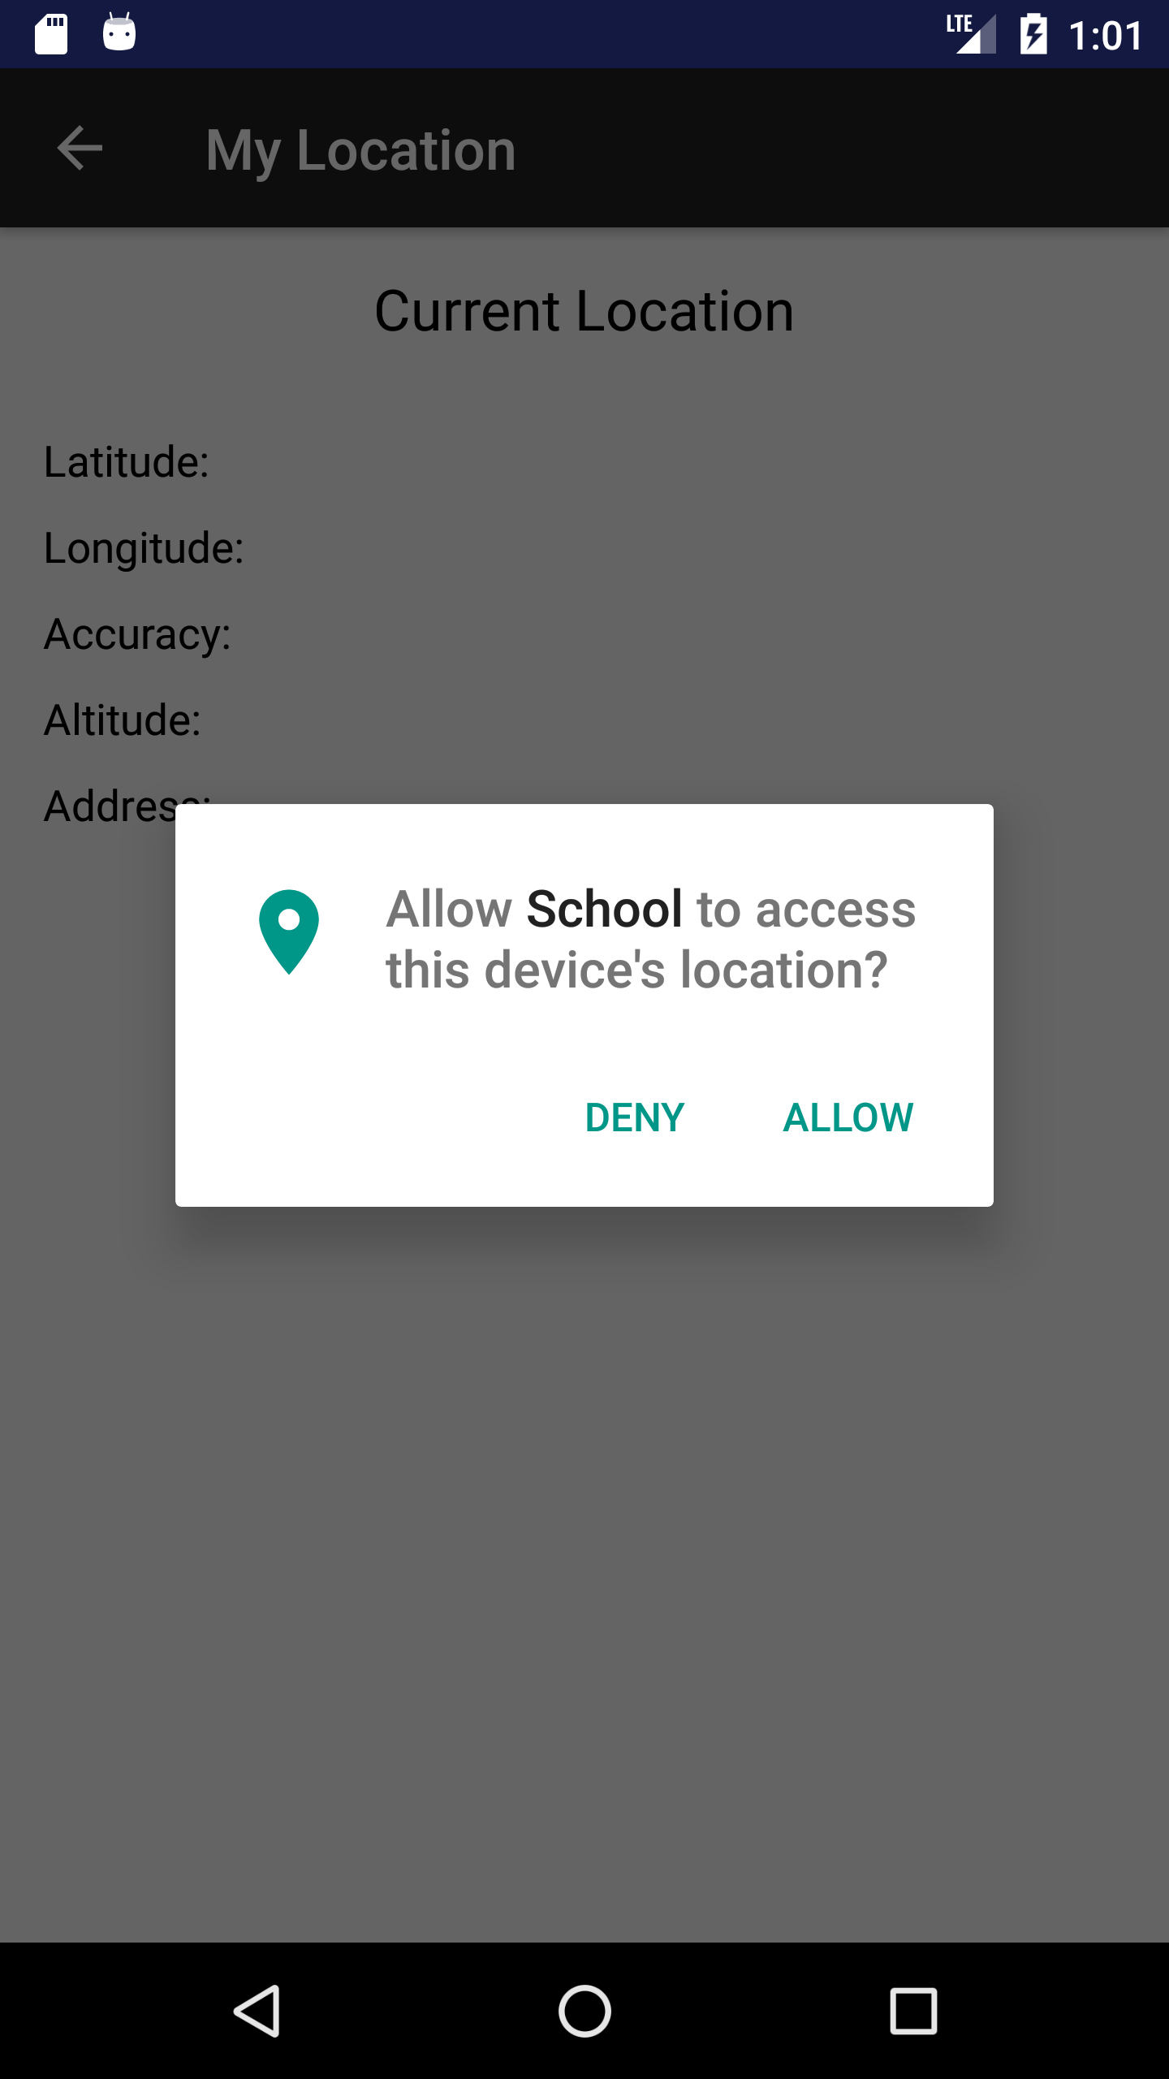

1. Click allow, you will not see anything display, click the back arrow and click on the My Location section again. You will see your current location display

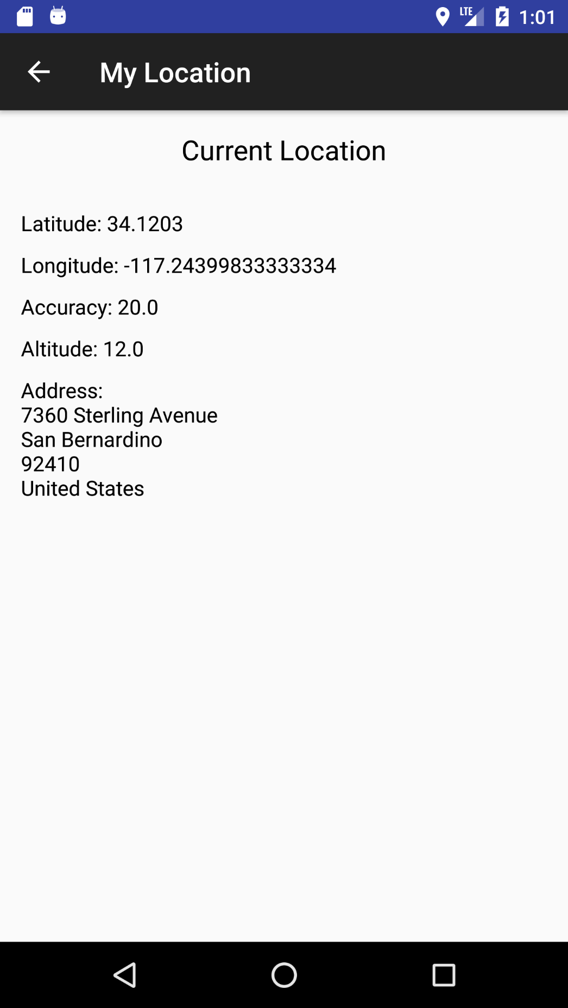

1. Change location to test if the app can update the location

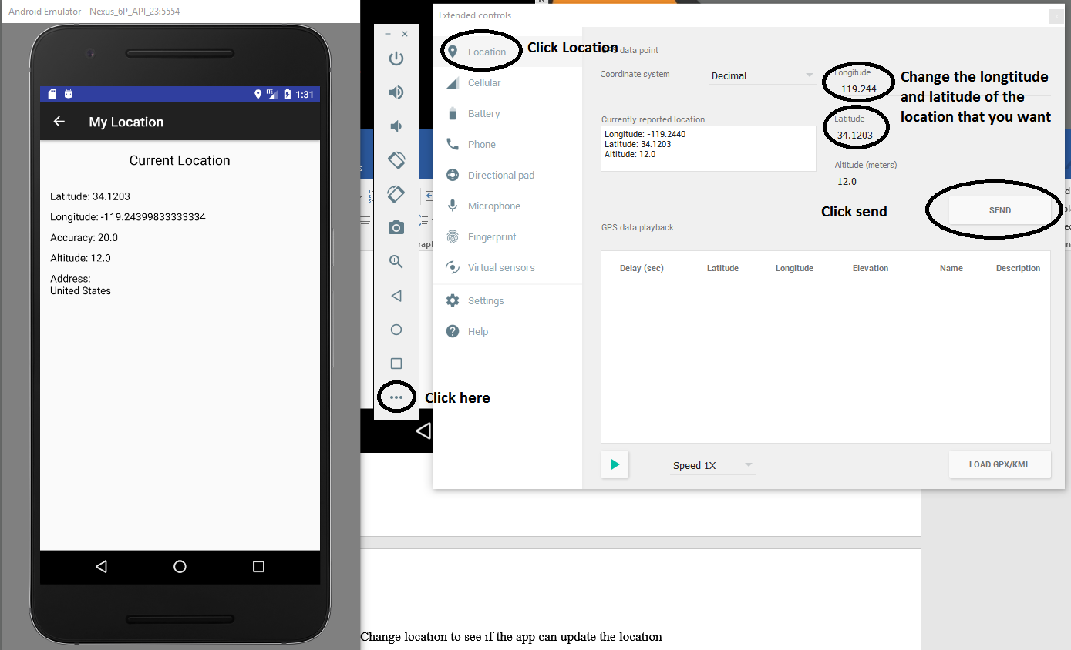

1. The location will change when we click send (In this case I change from my house to CSUSB campus)

