CSE575-Section2: Announcement Activity

1. This activity will require a backend server to update the announcement online without having to update the app.
   1. To create a backend server, I will use <https://c9.io/> to host the server. This one is a free hosting site. We just need create an account.
   2. Follow these steps:

* Sign in after finishing the sign up process

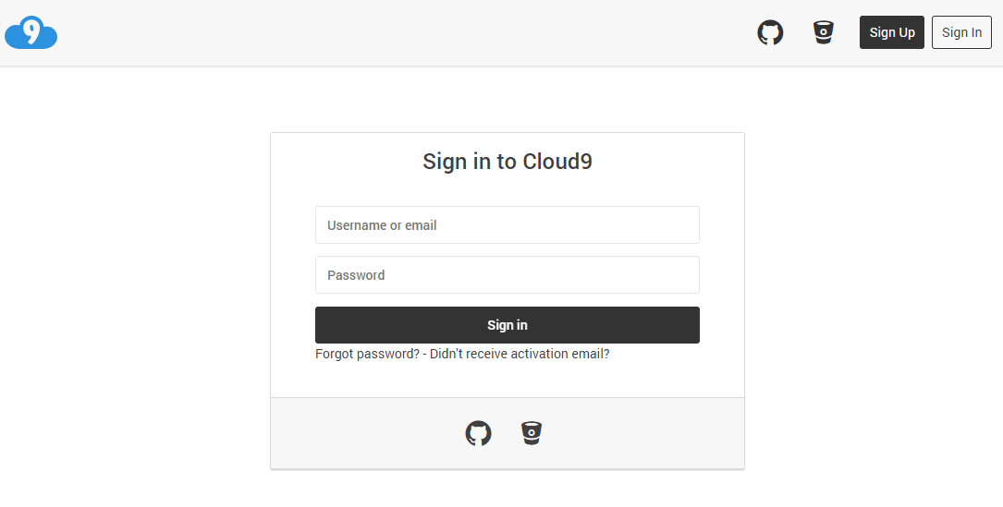

* Click the create new workspace

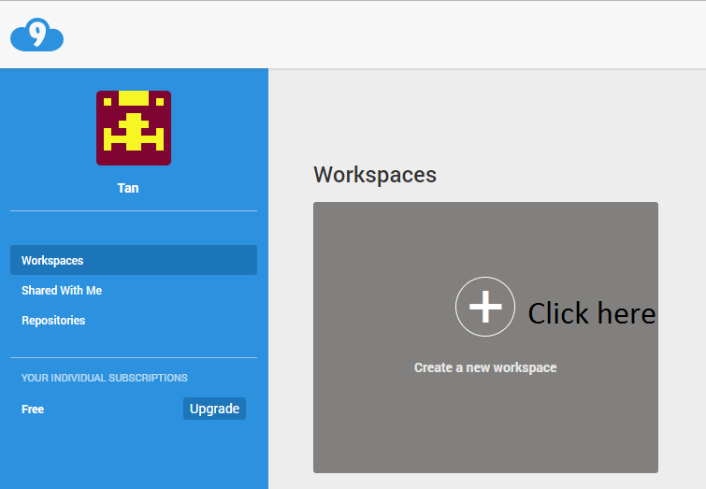

* Name the workspace something that meaningful

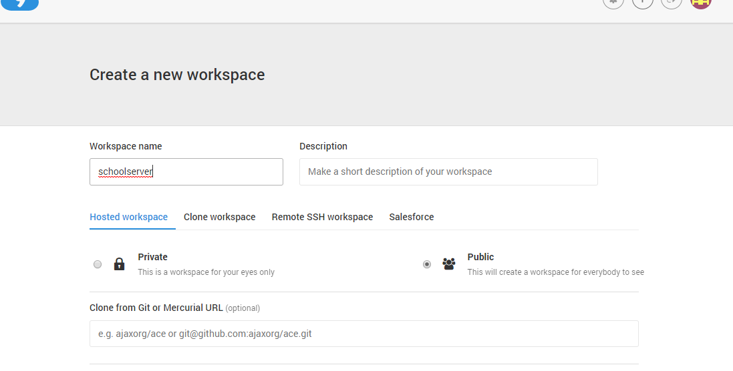

* Leave everything by default > scrolldown to the bottom > click create workspace

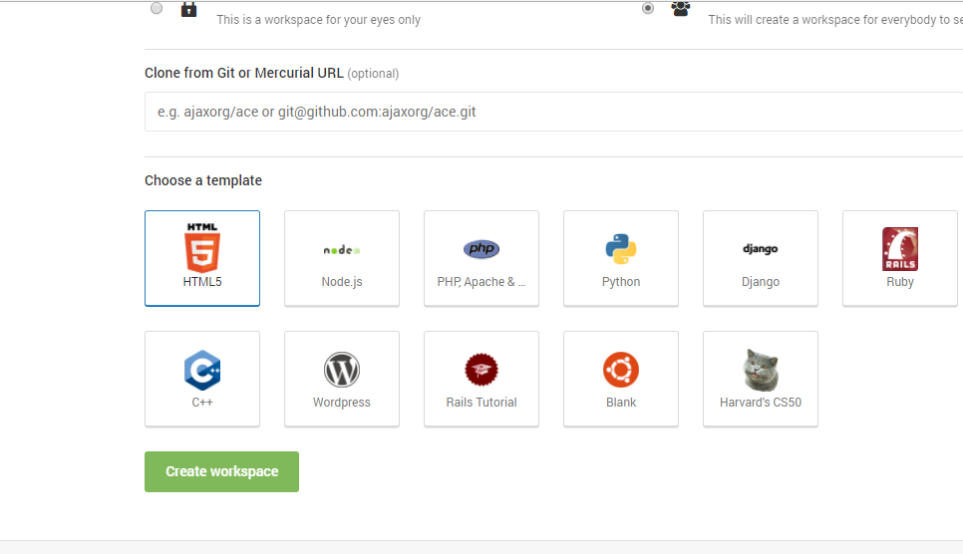

* Your workspace will look like this

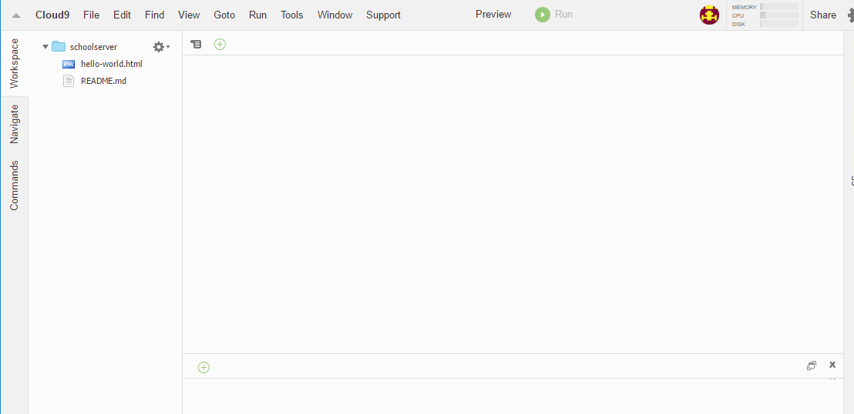

* 1. Now, we will create PHP file to output the JSON strings that we will use for announcement activity

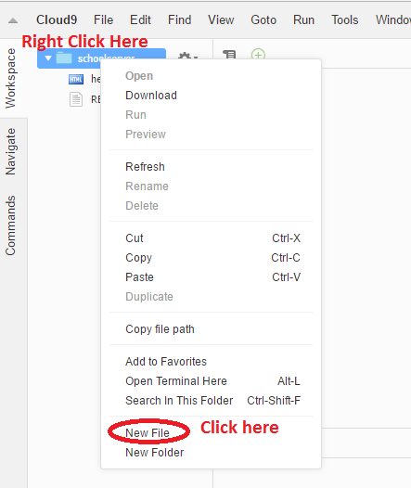

I named the new file as announcement.php

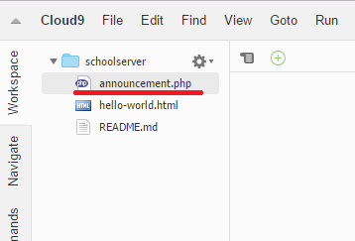

Add following line of codes into the announcement.php file

<?php

//Create a variable that holds an array

$listOfArray = [ "Annoucement" => [

[

"Date" =>"Saturday, May 19, 6:00 p.m.-10:00 p.m",

"Event" =>"Event0",

"Location" => "Location: Somewhere...",

],

[

"Date" =>"Date1",

"Event" =>"Event1",

"Location" => "Location: Somewhere...",

]

]

];

// Convert Array to JSON String

$listOfArray = json_encode($listOfArray);

echo $listOfArray;

?>

Click Run button to see the result

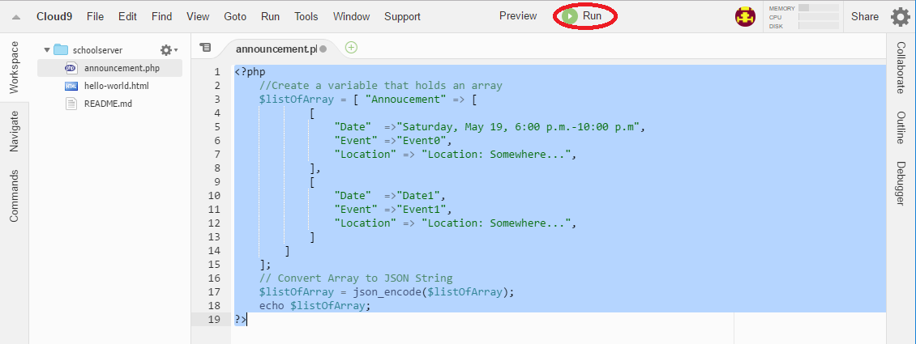

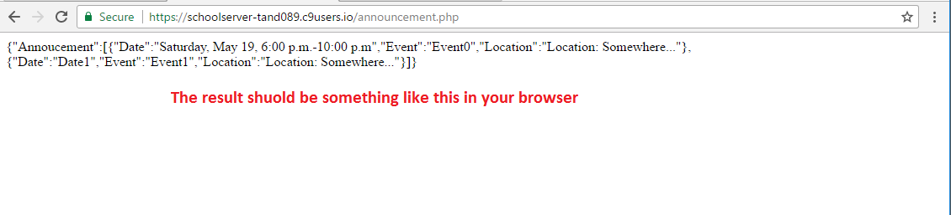

*Note: here is an json structure, that we will use as a reference for future use.

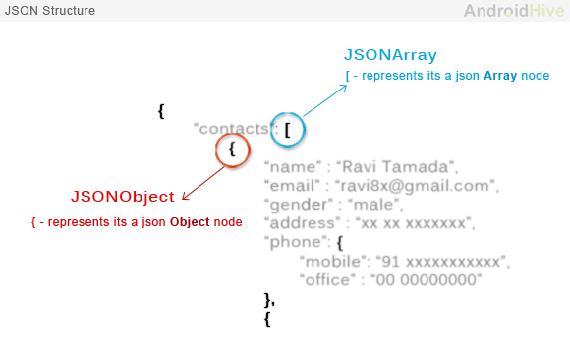

1. After finishing the backend server, we will build the frontend in our app to retrieve the json strings from server. I will use AsyncTask method in this case.
   1. HTTP AsyncTask is a commonly needed function in most Android app. So, it is better to have a class to give us a reusable codes that can take care of the AsyncTask process in when we need it.
      1. Create a class called HttpHandler.java

HttpHandler.java: details explain in the comments

**package** com.tando.school;  
  
**import** android.util.Log;  
  
**import** java.io.BufferedInputStream;  
**import** java.io.BufferedReader;  
**import** java.io.IOException;  
**import** java.io.InputStream;  
**import** java.io.InputStreamReader;  
**import** java.net.HttpURLConnection;  
**import** java.net.MalformedURLException;  
**import** java.net.ProtocolException;  
**import** java.net.URL;  
  
*/**  
 * Created by tan089 on 6/8/2017.  
 */***public class** HttpHandler {  
 *//returns the simple name of the underlying class, easier to track in the Android monitor* **private static final** String ***TAG*** = HttpHandler.**class**.getSimpleName();  
 **public** HttpHandler() {  
 }  
 **public** String makeServiceCall(String reqURL) {  
 String response = **null**;  
 **try** {  
 *//Creates a URL from the given String* URL url = **new** URL(reqURL);  
 *//open the connection to the url object* HttpURLConnection conn = (HttpURLConnection) url.openConnection();  
 *//use GET method to get the JSON from server* conn.setRequestMethod(**"GET"**);  
 *// read the response from server* InputStream in = **new** BufferedInputStream(conn.getInputStream());  
 response = convertStreamToString(in);  
 *//some Exceptions* } **catch** (MalformedURLException e) {  
 Log.*e*(***TAG***, **"MalformedURLException: "** + e.getMessage());  
 } **catch** (ProtocolException e) {  
 Log.*e*(***TAG***, **"ProtocolException: "** + e.getMessage());  
 } **catch** (IOException e) {  
 Log.*e*(***TAG***, **"IOException: "** + e.getMessage());  
 } **catch** (Exception e) {  
 Log.*e*(***TAG***, **"Exception: "** + e.getMessage());  
 }  
 **return** response;  
 }  
 **private** String convertStreamToString(InputStream is) {  
 *//BufferedReader reads text from a character-input stream* BufferedReader reader = **new** BufferedReader(**new** InputStreamReader(is));  
 *//This constructs a string builder with no characters in it* StringBuilder sb = **new** StringBuilder();  
  
 String line;  
 **try** {  
 *//To convert the InputStream to String we use the BufferedReader.readLine()* **while** ((line = reader.readLine()) != **null**) {  
 *//Each line will appended to a StringBuilder and returned as String.* sb.append(line).append(**'\n'**);  
 }  
 } **catch** (IOException e) {  
 e.printStackTrace();  
 } **finally** {  
 *//close when no more input data stream* **try** {  
 is.close();  
 } **catch** (IOException e) {  
 e.printStackTrace();  
 }  
 }  
 *//return string* **return** sb.toString();  
 }  
}

* 1. Create a new empty activity called Announcement. Using the same method as I have discussed on the last section.

Note*: remember to go back to the AndroidManifest.xml to create label, add theme, and make a back button.

* Style the UI for announcement activity.

Activity_annoucement.xml

*<?***xml version="1.0" encoding="utf-8"***?>*<**LinearLayout xmlns:android="http://schemas.android.com/apk/res/android"  
 xmlns:app="http://schemas.android.com/apk/res-auto"  
 xmlns:tools="http://schemas.android.com/tools"  
 android:layout_width="match_parent"  
 android:layout_height="match_parent"  
 tools:context="com.tando.school.Announcement"  
 android:orientation="vertical"  
 android:background="#FFF"**>  
 *<!--Logo -->* <**ImageView  
 android:id="@+id/logo"  
 android:layout_width="150dp"  
 android:layout_height="100dp"  
 android:background="@drawable/school_logo"  
 android:layout_gravity="center"**/>  
 <**TextView  
 android:layout_width="match_parent"  
 android:layout_height="wrap_content"  
 android:text="Announcement"  
 android:textColor="#000"  
 android:textSize="30dp"  
 android:textStyle="bold"  
 android:gravity="center"**/>  
 <**ListView  
 android:layout_width="wrap_content"  
 android:layout_height="match_parent"  
 android:id="@+id/announcList"**>  
 </**ListView**>  
</**LinearLayout**>

* Create new xml layout to style the listview. I named it announcement_listview

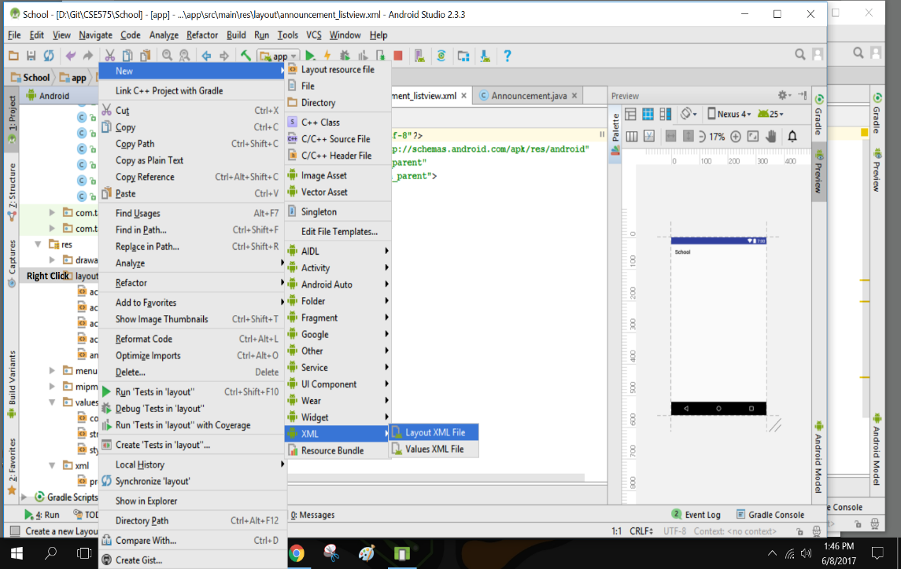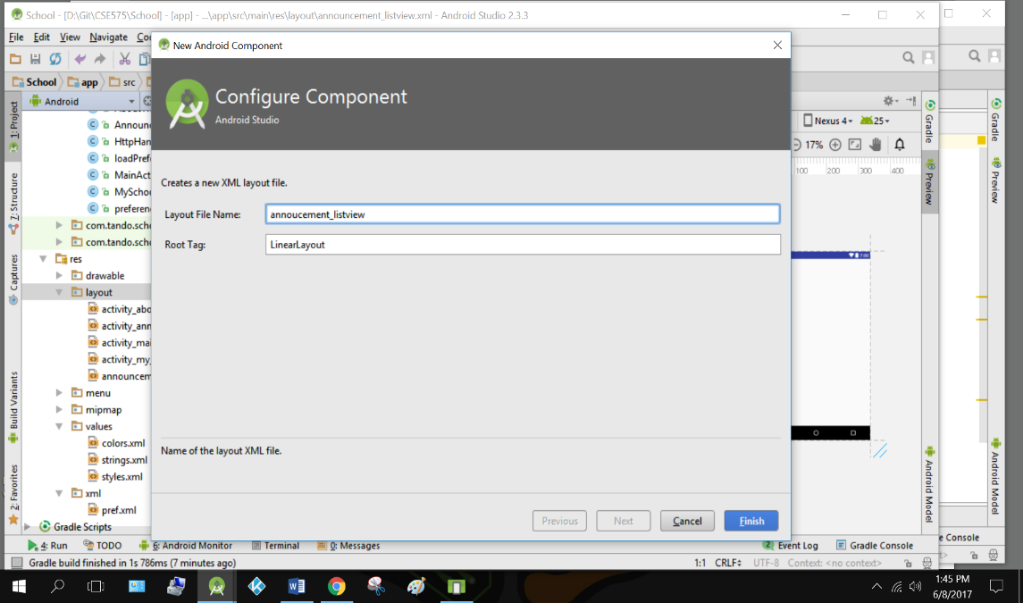

Announcement_listview.xml

*<?***xml version="1.0" encoding="utf-8"***?>*<**LinearLayout xmlns:android="http://schemas.android.com/apk/res/android"  
 android:layout_width="match_parent"  
 android:layout_height="match_parent"  
 android:orientation="vertical"  
 android:padding="10dp"**>  
 <**TextView  
 android:id="@+id/aDate"  
 android:layout_width="fill_parent"  
 android:layout_height="wrap_content"  
 android:paddingBottom="2dp"  
 android:paddingTop="6dp"  
 android:textColor="#ffa31a"  
 android:textSize="20dp"  
 android:textStyle="bold"  
 android:text="Date: "**/>  
 <**TextView  
 android:id="@+id/aEvent"  
 android:layout_width="match_parent"  
 android:layout_height="wrap_content"  
 android:paddingBottom="2dip"  
 android:textColor="#000"  
 android:textSize="15dp"  
 android:text="Note: "  
 android:textStyle="bold"** />  
</**LinearLayout**>

* Next, go to Announcement.java to make the activity functioning. Details of the codes are explained in the comments.

Announcement.java

**package** com.tando.school;  
  
**import** android.app.ProgressDialog;  
**import** android.os.AsyncTask;  
**import** android.support.v7.app.AppCompatActivity;  
**import** android.os.Bundle;  
**import** android.util.Log;  
**import** android.widget.ListAdapter;  
**import** android.widget.ListView;  
**import** android.widget.SimpleAdapter;  
**import** android.widget.Toast;  
  
**import** org.json.JSONArray;  
**import** org.json.JSONException;  
**import** org.json.JSONObject;  
  
**import** java.util.ArrayList;  
**import** java.util.HashMap;  
  
**public class** Announcement **extends** AppCompatActivity {  
 *//returns the simple name of the underlying class, easier to track in the Android monitor* **private** String **TAG** = Announcement.**class**.getSimpleName();  
 *//Prpgress bar while retrieving data* **private** ProgressDialog **pDialog**;  
 *//Declare ListView* **private** ListView **AnnouncementList**;  
 *// URL to get calendar JSON* **private static** String *url* =**"https://schoolserver-tand089.c9users.io/announcement.php"**;  
 *//Declare an array to store the list of items* ArrayList<HashMap<String, String>> **announcList**;  
 @Override  
 **protected void** onCreate(Bundle savedInstanceState) {  
 **super**.onCreate(savedInstanceState);  
 setContentView(R.layout.***activity_announcement***);  
  
 **announcList** = **new** ArrayList<>();  
  
 **AnnouncementList** = (ListView) findViewById(R.id.***announcList***);  
  
 *//execute the GetEvents class* **new** GetEvents().execute();  
 }  
 */**  
 * Async task class to get json by making HTTP call  
 */  
 //Create a GetEvents class to make http calls on background thread* **private class** GetEvents **extends** AsyncTask<Void, Void, Void> {  
 @Override  
 **protected void** onPreExecute() {  
 **super**.onPreExecute();  
 *// Showing progress dialog* **pDialog** = **new** ProgressDialog(Announcement.**this**);  
 **pDialog**.setMessage(**"Loading..."**);  
 **pDialog**.setCancelable(**false**);  
 **pDialog**.show();  
 }  
  
 @Override  
 **protected** Void doInBackground(Void... arg0) {  
 *//call the HttpHandler class* HttpHandler httpHandler = **new** HttpHandler();  
 *// Making a request to url and getting response* String jsonStr = httpHandler.makeServiceCall(*url*);  
 *//make a log to check for response or error* Log.*e*(**TAG**, **"Response from url: "** + jsonStr);  
 *//Get JSON* **if** (jsonStr != **null**) {  
 JSONObject jsonObj = **null**;  
 **try** {  
 jsonObj = **new** JSONObject(jsonStr);  
 */* Getting JSON Array node  
 * Note: the Annoucement is the object node in our JSON. Check the JSON */* JSONArray calendarList = jsonObj.getJSONArray(**"Annoucement"**);  
  
 *// looping through All Events* **for** (**int** i = 0; i < calendarList.length(); i++) {  
 JSONObject c = calendarList.getJSONObject(i);  
 *//get string from the json file* String Date = c.getString(**"Date"**);  
 String Event = c.getString(**"Event"**);  
  
  
 *// tmp hash map for single event* HashMap<String, String> announcements = **new** HashMap<>();  
  
 *// adding each child node to HashMap key => value* announcements.put(**"Date"**, Date);  
 announcements.put(**"Event"**, Event);  
  
  
 *// adding contact to announcList* **announcList**.add(announcements);  
 }  
 } **catch** (**final** JSONException e) {  
 Log.*e*(**TAG**, **"Json parsing error: "** + e.getMessage());  
 runOnUiThread(**new** Runnable() {  
 @Override  
 **public void** run() {  
 Toast.*makeText*(getApplicationContext(),  
 **"Json parsing error: "** + e.getMessage(),  
 Toast.***LENGTH_LONG***)  
 .show();  
 }  
 });  
 }  
 } *//End If* **else** {  
 Log.*e*(**TAG**, **"Couldn't get json objects from server."**);  
 runOnUiThread(**new** Runnable() {  
 @Override  
 **public void** run() {  
 Toast.*makeText*(getApplicationContext(),  
 **"errors!"**,  
 Toast.***LENGTH_LONG***)  
 .show();  
 }  
 });  
  
 }  
 **return null**;  
 } *//End doing background* @Override  
 **protected void** onPostExecute(Void result) {  
 **super**.onPostExecute(result);  
 *// Dismiss the progress dialog* **if** (**pDialog**.isShowing()) {  
 **pDialog**.dismiss();  
 }  
 */**  
 * Updating parsed JSON data into ListView  
 * */* ListAdapter adapter = **new** SimpleAdapter (  
 Announcement.**this**, **announcList**, R.layout.***announcement_listview***, **new** String[]{**"Date"**, **"Event"**}, **new int**[]{R.id.***aDate***,  
 R.id.***aEvent***});  
 **AnnouncementList**.setAdapter(adapter);  
  
 }  
 } *//End AsyncTask*}

* 1. Hit the run app button to see the result

