Final section: Utilities

This section is creating an activity to navigate to other sub-activities such as GPAcalculator, Calendar, and MyLocation.

1. The UI:

*<?***xml version="1.0" encoding="utf-8"***?>*<**LinearLayout xmlns:android="http://schemas.android.com/apk/res/android"  
 xmlns:app="http://schemas.android.com/apk/res-auto"  
 xmlns:tools="http://schemas.android.com/tools"  
 android:layout_width="match_parent"  
 android:layout_height="match_parent"  
 tools:context="com.tando.school.Utilities"  
 android:orientation="vertical"  
 android:background="#FFF"**>  
 <**ScrollView  
 android:layout_width="match_parent"  
 android:layout_height="match_parent"**>  
 <**LinearLayout  
 android:orientation="vertical"  
 android:layout_width="match_parent"  
 android:layout_height="match_parent"  
 android:layout_marginBottom="10dp"**>  
  
 *<!--Logo -->* <**ImageView  
 android:id="@+id/logo"  
 android:layout_width="150dp"  
 android:layout_height="100dp"  
 android:background="@drawable/mainlogo"  
 android:layout_gravity="center"**/>  
 *<!--4 sections of the app -->* <**Button  
 android:layout_width="match_parent"  
 android:layout_height="wrap_content"  
 android:text="Calendar"  
 android:textColor="#FFFFFF"  
 android:layout_marginBottom="30dp"  
 android:layout_marginTop="10dp"  
 android:background="@drawable/utilties"  
 android:onClick="StartCalendar"** />  
 <**Button  
 android:layout_width="match_parent"  
 android:layout_height="wrap_content"  
 android:text="GPA Calculator"  
 android:textColor="#FFFFFF"  
 android:layout_marginBottom="30dp"  
 android:background="@drawable/utilties"  
 android:onClick="StartGPACal"** />  
 <**Button  
 android:layout_width="match_parent"  
 android:layout_height="wrap_content"  
 android:text="My Location"  
 android:textColor="#FFFFFF"  
 android:layout_marginBottom="30dp"  
 android:background="@drawable/utilties"  
 android:onClick="StartLoc"** />  
 *<!--Social Media -->* <**LinearLayout  
 android:layout_width="wrap_content"  
 android:layout_height="wrap_content"  
 android:layout_marginTop="10dp"  
 android:orientation="horizontal"  
 android:layout_gravity="center"**>  
  
 <**ImageView  
 android:id="@+id/faceBook"  
 android:layout_width="wrap_content"  
 android:layout_height="wrap_content"  
 android:layout_weight="1"  
 android:src="@drawable/ic_facebook"  
 android:paddingRight="5dp"  
 android:onClick="fbClick"**/>  
  
 <**ImageView  
 android:id="@+id/googlePlus"  
 android:layout_width="wrap_content"  
 android:layout_height="wrap_content"  
 android:layout_weight="1"  
 android:src="@drawable/ic_google"  
 android:paddingRight="5dp"  
 android:onClick="googleClick"**/>  
  
 <**ImageView  
 android:id="@+id/linkedIn"  
 android:layout_width="wrap_content"  
 android:layout_height="wrap_content"  
 android:layout_weight="1"  
 android:src="@drawable/ic_linkedin"  
 android:paddingRight="5dp"  
 android:onClick="linkedInClick"**/>  
  
 <**ImageView  
 android:id="@+id/youTube"  
 android:layout_width="wrap_content"  
 android:layout_height="wrap_content"  
 android:layout_weight="1"  
 android:src="@drawable/ic_youtube"  
 android:paddingRight="5dp"  
 android:onClick="youTubeClick"**/>  
  
 <**ImageView  
 android:id="@+id/twitterT"  
 android:layout_width="wrap_content"  
 android:layout_height="wrap_content"  
 android:layout_weight="1"  
 android:src="@drawable/ic_twitter"  
 android:paddingRight="5dp"  
 android:onClick="twitterClick"**/>  
 </**LinearLayout**>  
 </**LinearLayout**>  
 </**ScrollView**>  
</**LinearLayout**>

Click the run button this section should be like this:

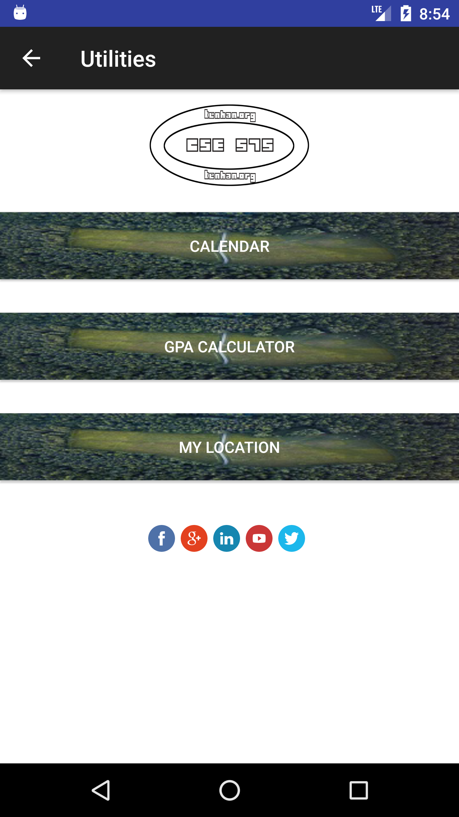

1. Utilities.java: just using intent function to navigate to the sub-pages. Explanations are in the comments

**package** com.tando.school;  
  
**import** android.content.Intent;  
**import** android.net.Uri;  
**import** android.support.v7.app.AppCompatActivity;  
**import** android.os.Bundle;  
**import** android.view.View;  
  
**public class** Utilities **extends** AppCompatActivity {  
  
 @Override  
 **protected void** onCreate(Bundle savedInstanceState) {  
 **super**.onCreate(savedInstanceState);  
 setContentView(R.layout.***activity_utilities***);  
 }  
  
 *//Calendar* **public void** StartCalendar (View view) {  
 startActivity(**new** Intent(**this**, Calendar.**class**));  
 }  
 *//GPA Calculator* **public void** StartGPACal (View view) {  
 startActivity(**new** Intent(**this**, GPAcalculator.**class**));  
 }  
 *//MyLocation* **public void** StartLoc (View view) {  
 startActivity(**new** Intent(**this**, MyLocation.**class**));  
 }  
 *//Location  
  
 //link to FaceBook* **public void** fbClick (View view) {  
 *//use startActivity and Intent methods to parse the link* startActivity(**new** Intent(Intent.***ACTION_VIEW***, Uri.*parse*(**"https://www.facebook.com/flitetest/"**)));  
 }  
 *//google+* **public void** googleClick (View view) {  
 *//use startActivity and Intent methods to parse the link* startActivity(**new** Intent(Intent.***ACTION_VIEW***, Uri.*parse*(**"https://plus.google.com/u/0/+google"**)));  
 }  
 *//LinkedIn* **public void** linkedInClick (View view) {  
 *//use startActivity and Intent methods to parse the link* startActivity(**new** Intent(Intent.***ACTION_VIEW***, Uri.*parse*(**"https://www.linkedin.com/in/mbacsusb/"**)));  
 }  
 *//youtube* **public void** youTubeClick (View view) {  
 *//use startActivity and Intent methods to parse the link* startActivity(**new** Intent(Intent.***ACTION_VIEW***, Uri.*parse*(**"https://www.youtube.com/channel/UCwqJShoifP6032UXYe-sD-A"**)));  
 }  
 *//Twitter* **public void** twitterClick (View view) {  
 *//use startActivity and Intent methods to parse the link* startActivity(**new** Intent(Intent.***ACTION_VIEW***, Uri.*parse*(**"https://twitter.com/Google"**)));  
 }  
}