

**CSUSB Master of Business Administration (MBA) Passport**

**Version 2.0**

**Eungyo Jeong(Project Manager)**

**Cesar Vasquez(Assistant Project Manager)**

**Tan Do(Software Programmer)**

**Francisco Enriquez(Software Programmer)**

**Table of Contents**

**1. Introduction**………………………………………………………....3

1.1 Purpose………………………………………………………..3

1.2 Scope………………………………………………………….3

1.3 Definitions, Acronyms, and Abbreviations…………………...3

1.4 References…………………………………………………….4

1.5 Overview……………………………………………………...4

**2. Overall Description**…………………………………………………4

2.1 Product Perspectives………………………………………….4

2.1.1 System interfaces (deployment diagram)…………….5

2.1.2 User interfaces………………………………………..5

2.1.3 Software interfaces…………………………………...6

2.1.4 Memory………………………………………………6

2.1.5 Operation………………………………………..……6

2.2 Product Functions (use case diagram)………………………..6

2.3 User Characteristics…………………………………………..7

2.4 Constraints…………………………………………………....7

2.5 Assumptions and Dependencies……………………………...7

**3. Specific Requirements**

3.1 External interface requirements………………………………7

3.1.1 User interfaces………………………………………..7

3.1.1.1 Home Page…………………………………...8

3.1.1.2 About Us……………………………………..8

3.1.1.3 Contact Us…………………………………...10

3.2 Communication interfaces…………………………………...11

3.3 Design constraints……………………………………………12

3.4 Software system attributes .………………………………… 13

3.5 Other requirements…………………………………………. 14

**1. Introduction**

1.1 PURPOSE

The purpose of this document is to define the software requirements for the initial release of the **CSUSB Master's of Business Administration (MBA)** mobile application that is being developed by the CSE 455 Software Engineering team at California State University, San Bernardino.The purpose of this APP is to keep students of the program informed and connected. The point of contact is Deborah Grijalva, MBA Graduate Coordinator.

1.2 SCOPE

The goal of the CSUSB MBA app is to provide information and guidance to CSUSB students and the public about the MBA program. **The first prototype of the project will have the pages listed in this document designed and developed for Android mobile devices. The second prototype we plan on adding a feature to make appointments with counselors for students.** The applications should be **functional on Android devices** at the end of the quarter. The limitations that this APP in the 1st and 2nd prototypes will be the Passport feature (This feature is limited just information), the Settings feature, the Student Ambassadors section, the Graduate Assistantship, and any connection to My Coyote.

1.3 DEFINITIONS, ACRONYMS, AND ABBREVIATIONS

Android - Google’s mobile operating system

Android Studio - Google’s IDE for android development

IDE - Integrated Development Environment

3G - Third Generation of wireless data standard

4G - Fourth Generation of wireless data standard

MySql - Database language that interacts with a server to query data

Java - The language used for Android development

HTTPS - Secure transfer protocol for server communication

WiFi - Wireless internet for devices

SRS - Software requirement specifications

MBA Passport - Master Business Administration Passport

PFCs - Peer Financial Coaches

1.4 REFERENCES

● Android Developers http://developer.android.com

● IEEE SRS Template http://www.cse.msu.edu/~cse870/IEEEXplore-SRS-template.pdf

● CSUSB OSMM Assistant SRS Ver 1.0 Example Available upon request

1.5 OVERVIEW

This document covers specifications and interfaces used for the **MBA APP** mobile application, along with requirements as dictated by the design constraints. The next sections will show the user interface and describe where functions will be implemented on the applications.

**2. Overall Description**

2.1 Product Perspectives

The CSUSB MBA Passport app will be a new, self-contained product that will provide information to students and allow easy updating for the employees of the MBA.

As a student, you will open the app to a home screen which will display some basic information about the MBA and a menu for navigating the app to one of the other several pages.

As an employee for the MBA, a system will be set up using a database to store information that will need to be regularly updated.

**2.1.1 System interfaces (deployment diagram)**

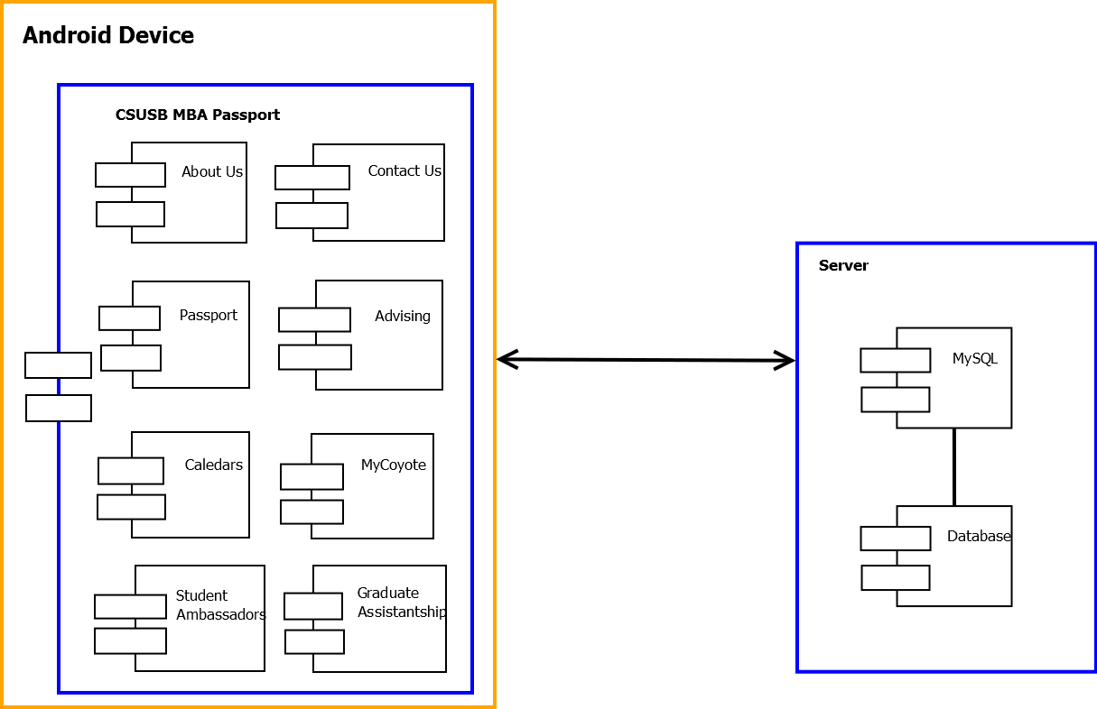

**2.1.2 User interfaces**

-Home Page : Displays a navigation menus and links for social media

-About Us : Displays information about MBA staff, mission, and learning goals

-Contact Us : Displays contact information

-Passport(NFC) : Displays Passport to complete by users and Fall 2016 Events

-Advising : Displays navigation menus for advising

-Calendars : Displays Academic Calendar and updated Events

-MyCoyote : Navigates to MyCoyote Login page

-Student Ambassadors : Displays information about MBA SA

-Graduate Assistantship : Displays application process, hiring documents, and job responsibilities

**2.1.3 Software interfaces**

-Android Studio : Used to develop Android mobile application

-MySQL : Used to query the database

-Photoshop : Used to design the user interface

**2.1.4 Memory**

This application will be dependent on each particular platform’s capability. We are targeting a minimum Android version of 4.1(Jelly Bean).

**2.1.5 Operation**

There will not be any planned downtime in the system. Updates will be done live when changes are made to the server which is hosting the app site.

2.2 Product Functions (use case diagram)

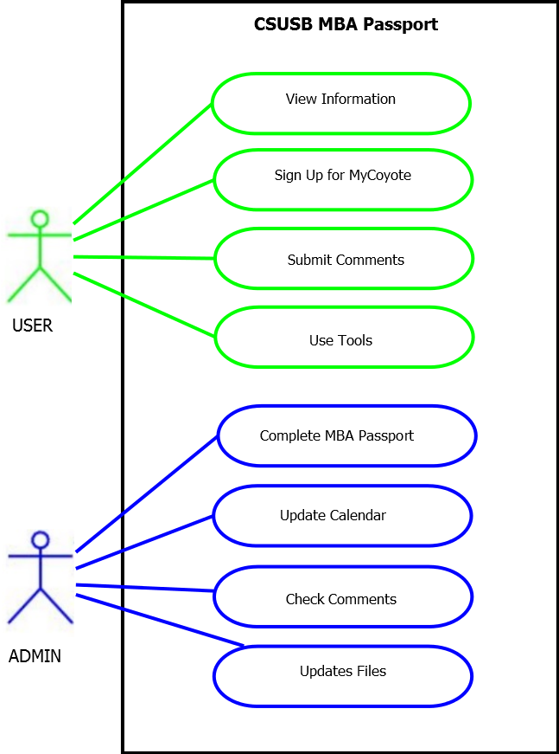

2.3 User Characteristics

A user is MBA students who downloads the app to their mobile device. Admin users will be in charge of updating and managing information on the databases to be loaded into the application.

2.4 Constraints

Operating system constraint - users must have Android 4.1 or higher to download and run this version of the application.

ADA constraint - the application should comply with ADA guidelines for accessibility to all users.

2.5 Assumptions and Dependencies

The user’s device must be connected to the Internet to get updated information, however some information and functions will be accessible without an Internet connection.

A database administrator will need to be assigned to update the database with current information to be loaded into the application.

3. SPECIFIC REQUIREMENTS

3.1 EXTERNAL INTERFACE REQUIREMENTS

**3.1.1 USER INTERFACES**

This section will show how the user interacts with the mobile application. Every page will have the navigation menu at the top right with page title attached to, making the application easier for the user to navigate through the application. Upon opening the application, the CSUSB logo will greet you with all the sections that the MBA program offers. The CSUSB logo can also be pressed and it will return you to the title screen of the app.

**3.1.1.1 HOME PAGE**

The main function of the home page is to welcome users and provide them all the information and material that the MBA program has to offer. Such as advising, calendar information ( i.e. events, workshops, etc.)

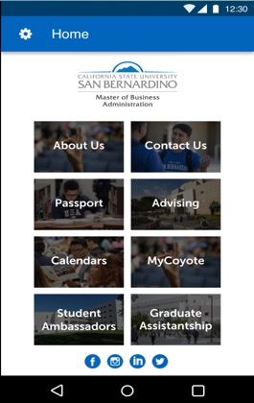

**3.1.1.2 About Us**

The About Us page will provide information for users to know about the MBA staff, the mission that the MBA programs what to achieve, and MBA Learning Goals.

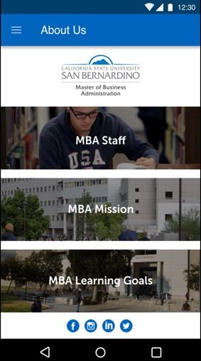

**3.1.1.3 Contact Us**

The contact page will provide information for users to get in contact with the MBA Program via telephone, email, the location of the office on campus, and also the user can ask questions or make comments by using the submit form by adding all the user's’ school information (i.e. School ID number, school e-mail, etc.)

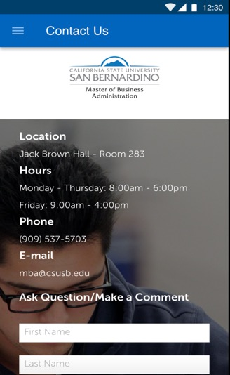

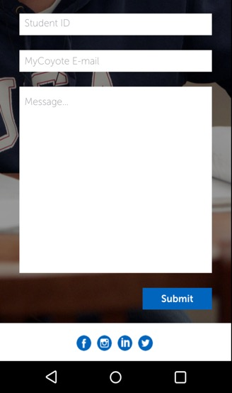

3.2 Communication interfaces

The communication interface that the app will use is the IEEE 802.11™: Wireless LAN standard that the Android based phones are based on.

3.3 Passport

This page of the app has information that encompases leadership, learning goals, and mor than a degree having their corresponding information for each of them.

3.4 Advising

The advising page of this app has the coordinators information, MBA Focus Areas, GPA calculator that the students inputs their classes that they have taken and their corresponding GPA comes out. Request an appointment tab is also in there where you can request an appointment with the adviser that you wish. Also the ask an advisor a question where you can ask the advisor a question and they will get back to you when they can.

3.5 Design Constraints

The design constraints that we will run into in this project will be with MyCoyote and Blackboard integration like the client wanted to be run on the app itself. We might run into errors with integrating the school's website within the app due to possible security holes within the app.

Another constraint that will be run into is the special stamp that the client wants for the passport aspect of the design as if it was a actual passport. The way the client wants the user to receive a stap like object on their account page when they go to an event that they hold.

Advising functionality is going to be another function that is not going to be possible at this current time due to possible timing conflicts and possible security issues due to the users information possible being exposed.

Calendar integration like the client wants with dynamic updates to the calendar when dates become available and to send push notifications when the date approaches.

Graduate assistance this functionality also will not be possible to do due to timing conflicts also since we have to send sensitive information will and could be at risk.

Student ambassadors Functionality of the app will also not be implemented in this iteration of the app due to possible time conflicts.

Within the advising page the two constraints that the app has is that the server functionality for the requesting an appointment and asking an advisor a question will not be possible at this point since the server that was provided is not secure and we do not want to use it since we don't want the students sensitive information to be stolen or sent to the wrong place and their information to be lost.

The passport functionality of this app is the special “stamp” that the physical passport has, the client would like this but given the time it was not possible to implement this feature

**3.5 Software System Attributes**

The requirements in this section specify the required material for this application for it to work correctly

**3.5.1 Reliability**

One of the things that we have to make sure the app does is to be able for the application gives the right result when the user presses on the desired navigation buttons, and back buttons.

**3.5.2 Availability**

The application should be able to connect to the internet to be able to connect with the internet in order for the application to communicate with the database.

**3.6 Other Requirements**

A database is going to be implemented that hold all the information that the MBA Passport holds (i.e. users: ID, Name, phone number, email,)