Exercise 1

a)

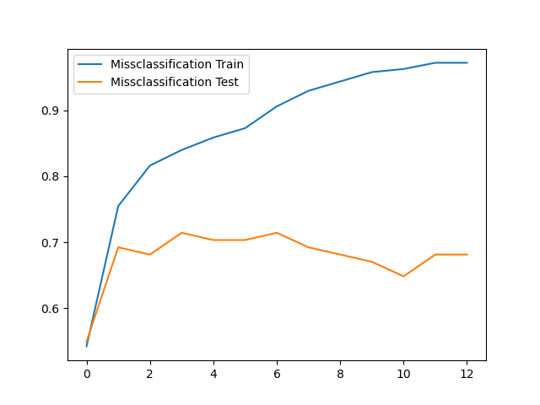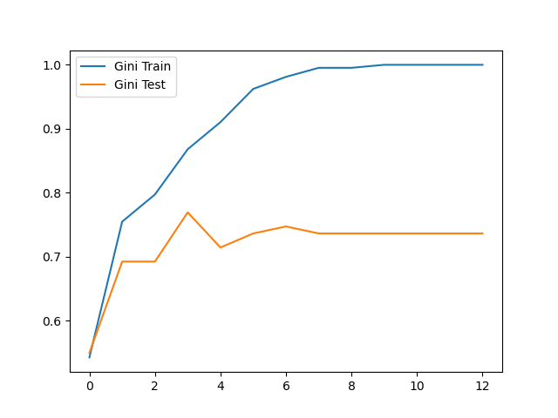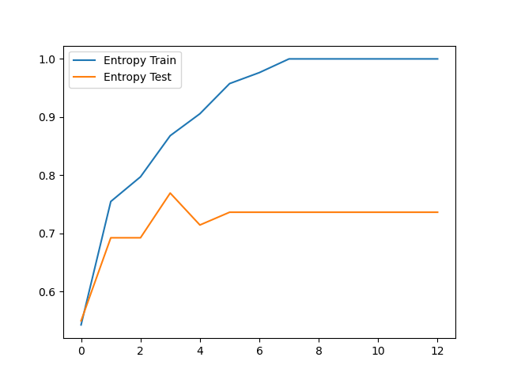x-axis: max depth, y-axis: accuracy

In general, all the loss functions increase in test accuracy as they increase in training accuracy up until a point where further increases in training accuracy is correlated with decreased testing accuracy. As max depth increases, training accuracy increases and test accuracy also increases to a certain point, then decreases. The Gini and Entropy loss functions seem to perform similarly in test and training accuracy.

b)

Without Random Forests

Median: 0.8351648351648352, Minimum: 0.8241758241758241, Maximum: 0.8351648351648352

By using Bagging without Random Forests, the accuracy is greater than that of the non-ensemble methods, even at worst.

With Random Forests

Median: 0.7692307692307693, Minimum: 0.7692307692307693, Maximum: 0.8131868131868132

By using Bagging with Random Forests, the accuracy can potentially be better than that of the non-ensemble methods and on average and at worst perform about as well as the non-ensemble methods.

Comparing the use of random forest, it seems that not using random forests provides a better accuracy across the board.

Exercise 2

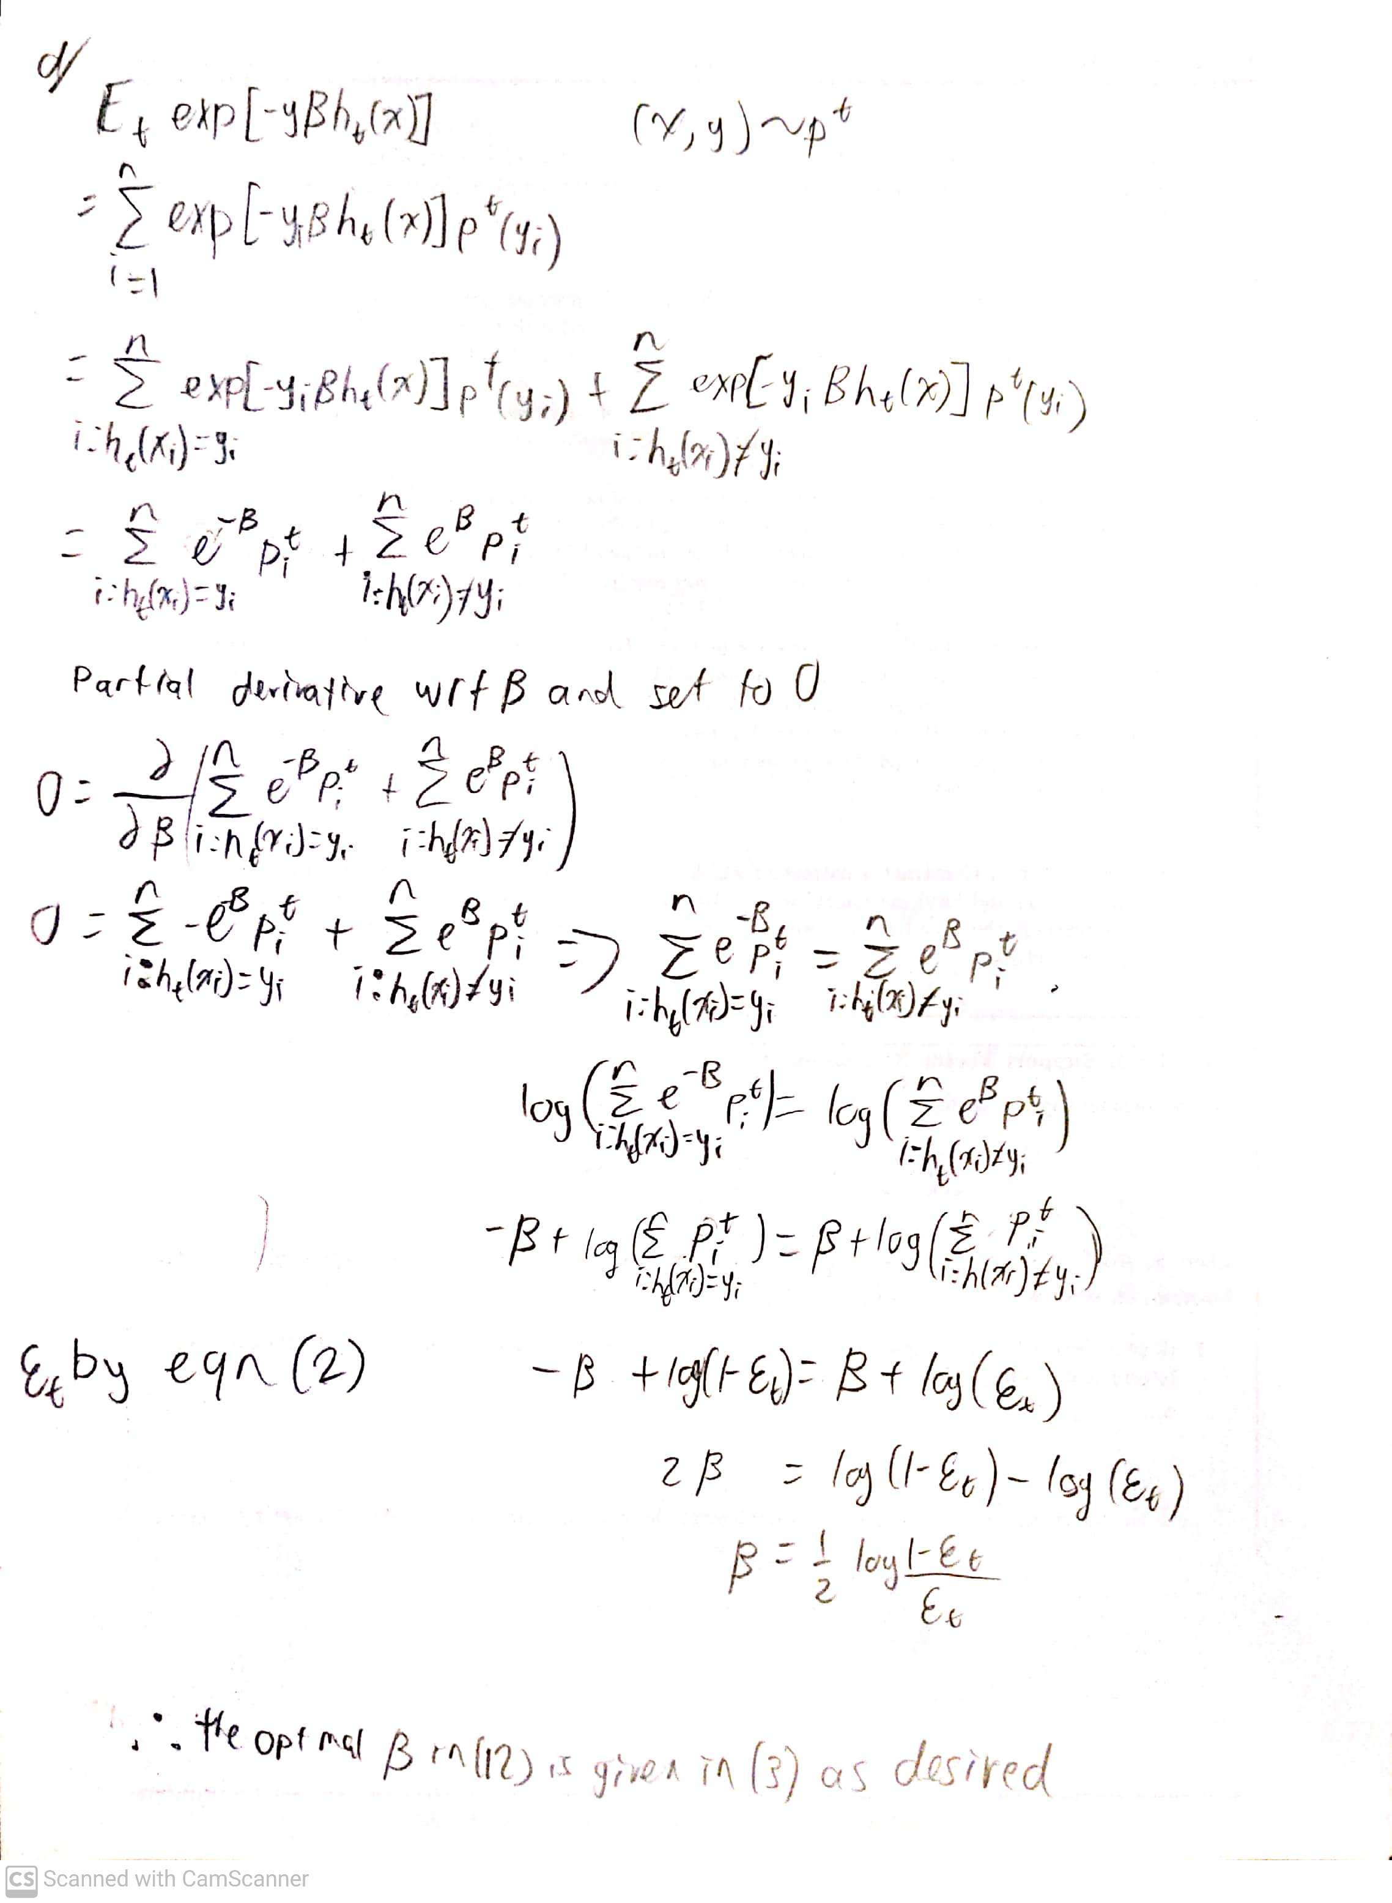

Exercise 3

b) 5 epochs

i.

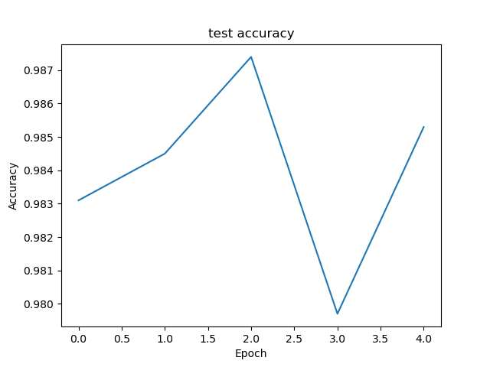

ii.

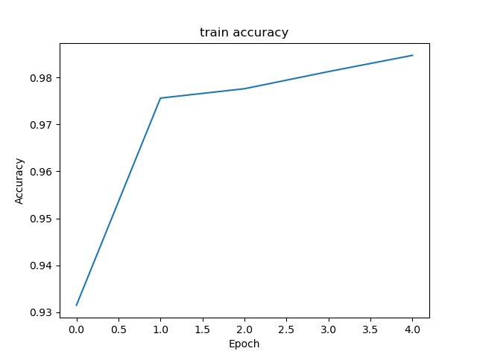

iii.

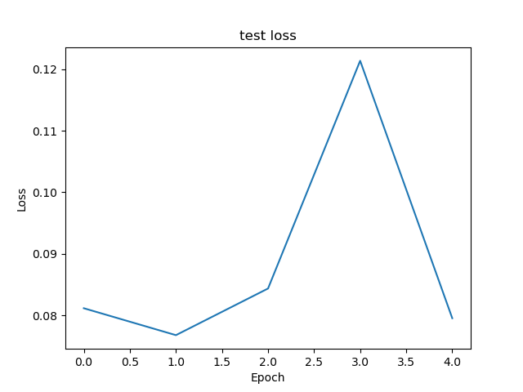

iv.

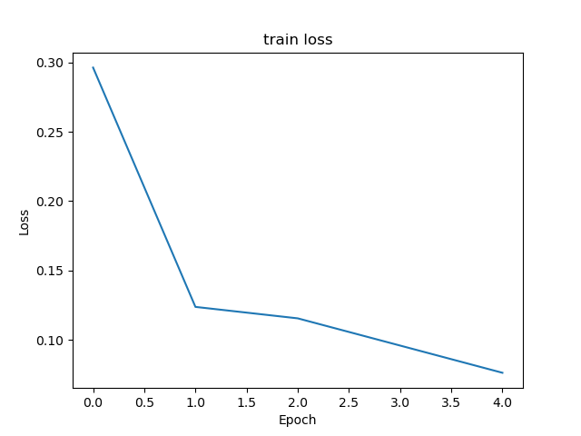

c)

Results after flips:

test_horizontal loss, test_ horizontal acc: [5.478106498718262, 0.392300009727478]

test_vertical loss, test_vertical acc: [4.790810585021973, 0.41999998688697815]

There is a large amount of loss and low accuracy across both horizontal and vertical flips.

d)

Results after Gaussian noise:

test_gn0.01 loss, test_gn0.01 acc: [0.08179637789726257, 0.9830999970436096]

test_gn0.1 loss, test_gn0.1 acc: [0.6923056840896606, 0.8141000270843506]

test_gn1 loss, test_gn1 acc: [2.7780394554138184, 0.2563999891281128]

As more noise is added to the test datasets, the loss increases and accuracy decreases.

e)

test loss, test acc: [0.04784698039293289, 0.988099992275238]

test_h loss, test_h acc: [0.04738935828208923, 0.9873999953269958]

test_v loss, test_v acc: [0.06509146094322205, 0.9815999865531921]

test_gn0.01 loss, test_gn0.01 acc: [0.023918500170111656, 0.993399977684021]

test_gn0.1 loss, test_gn0.1 acc: [0.03706265985965729, 0.9900000095367432]

test_gn1 loss, test_gn1 acc: [0.3881167769432068, 0.879800021648407]

I retrained the model by making training sets with each of the modifications made in part 3 and 4, and added them into a final dataset including the original dataset, ie. a dataset of 6 combined data sets. The resulting test accuracies are as you can see above. The datasets saw a decrease in test loss and increase in test accuracy across all modifications.