1 Wooden Stick Grid Puzzle

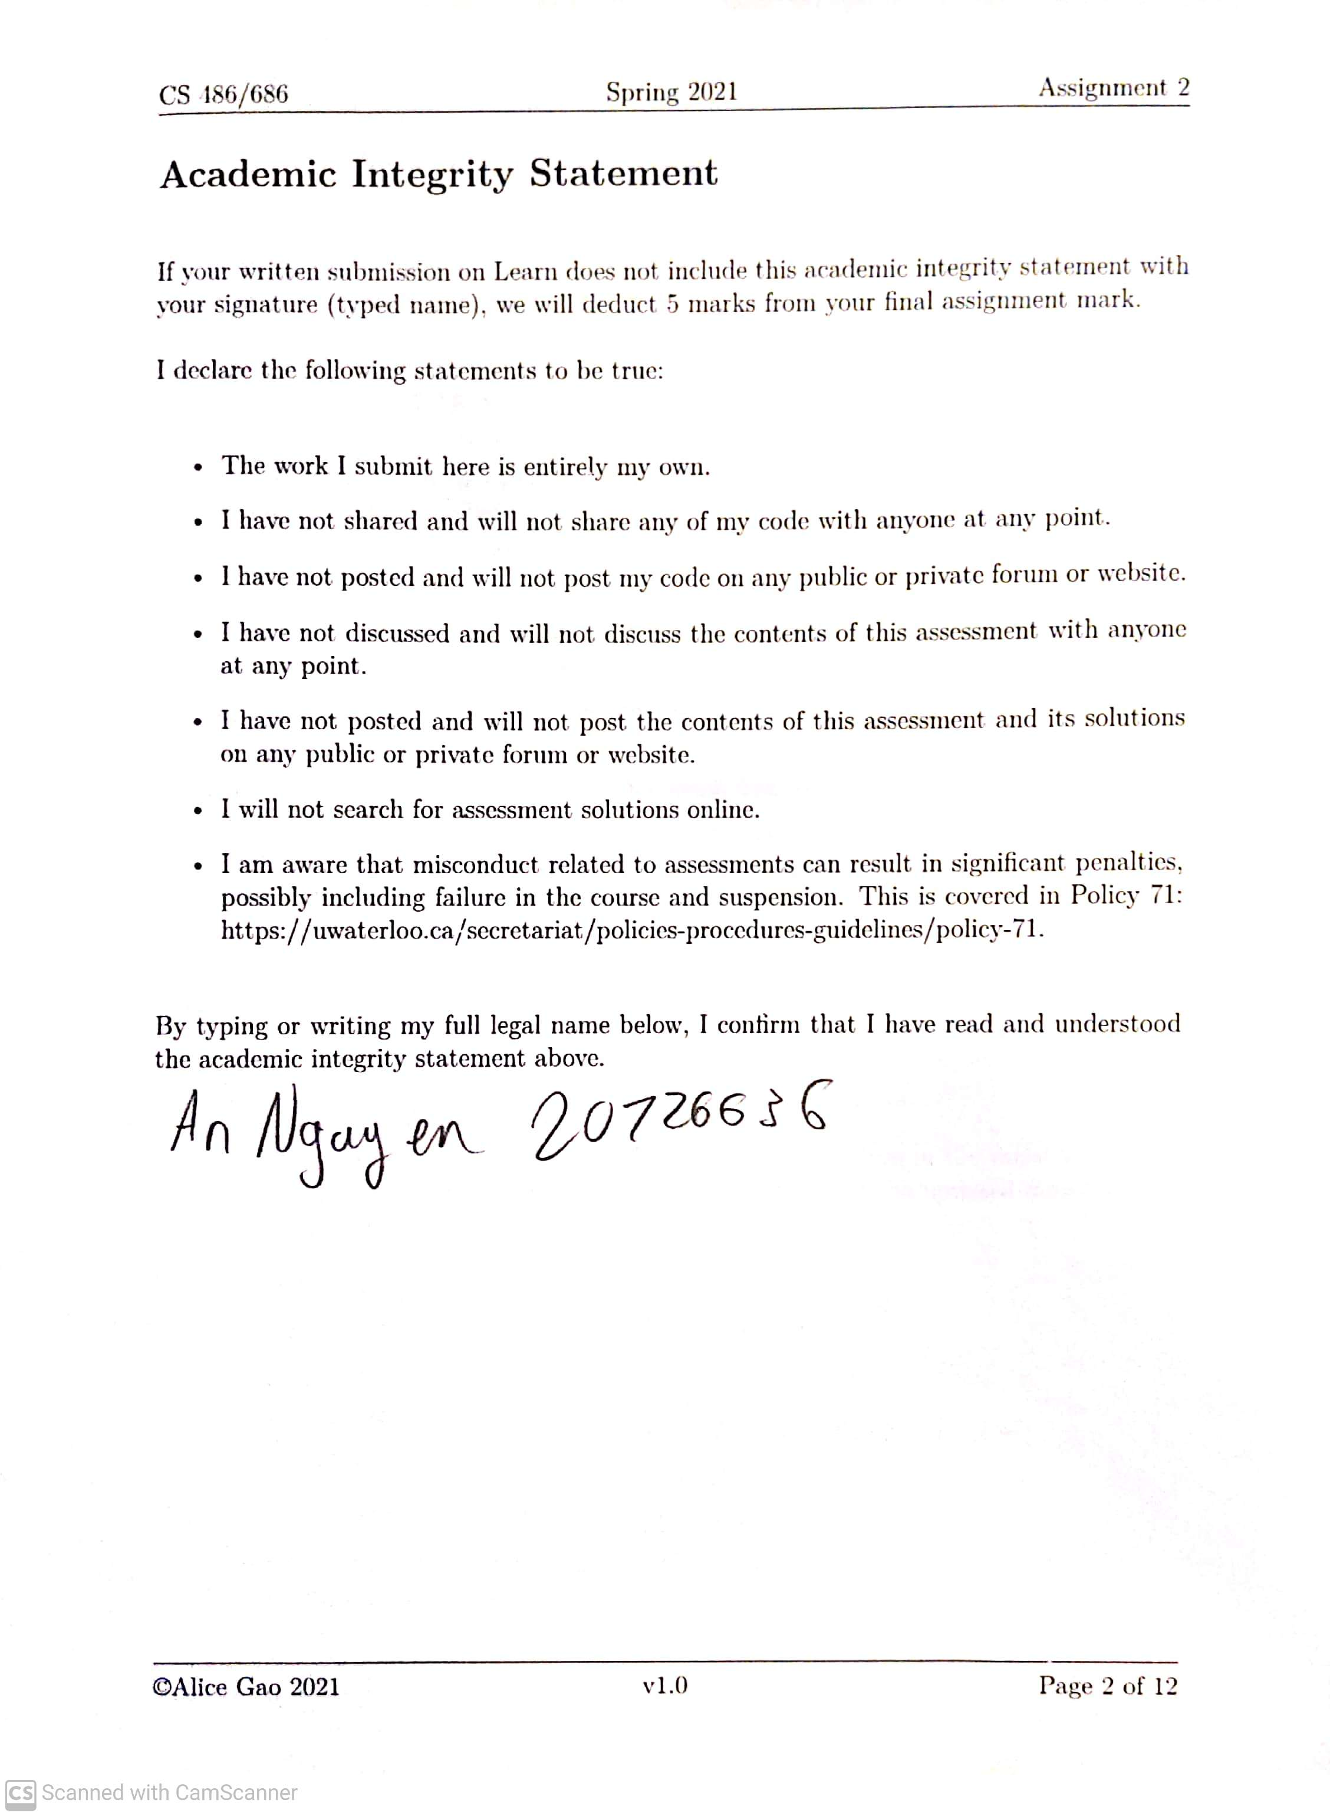

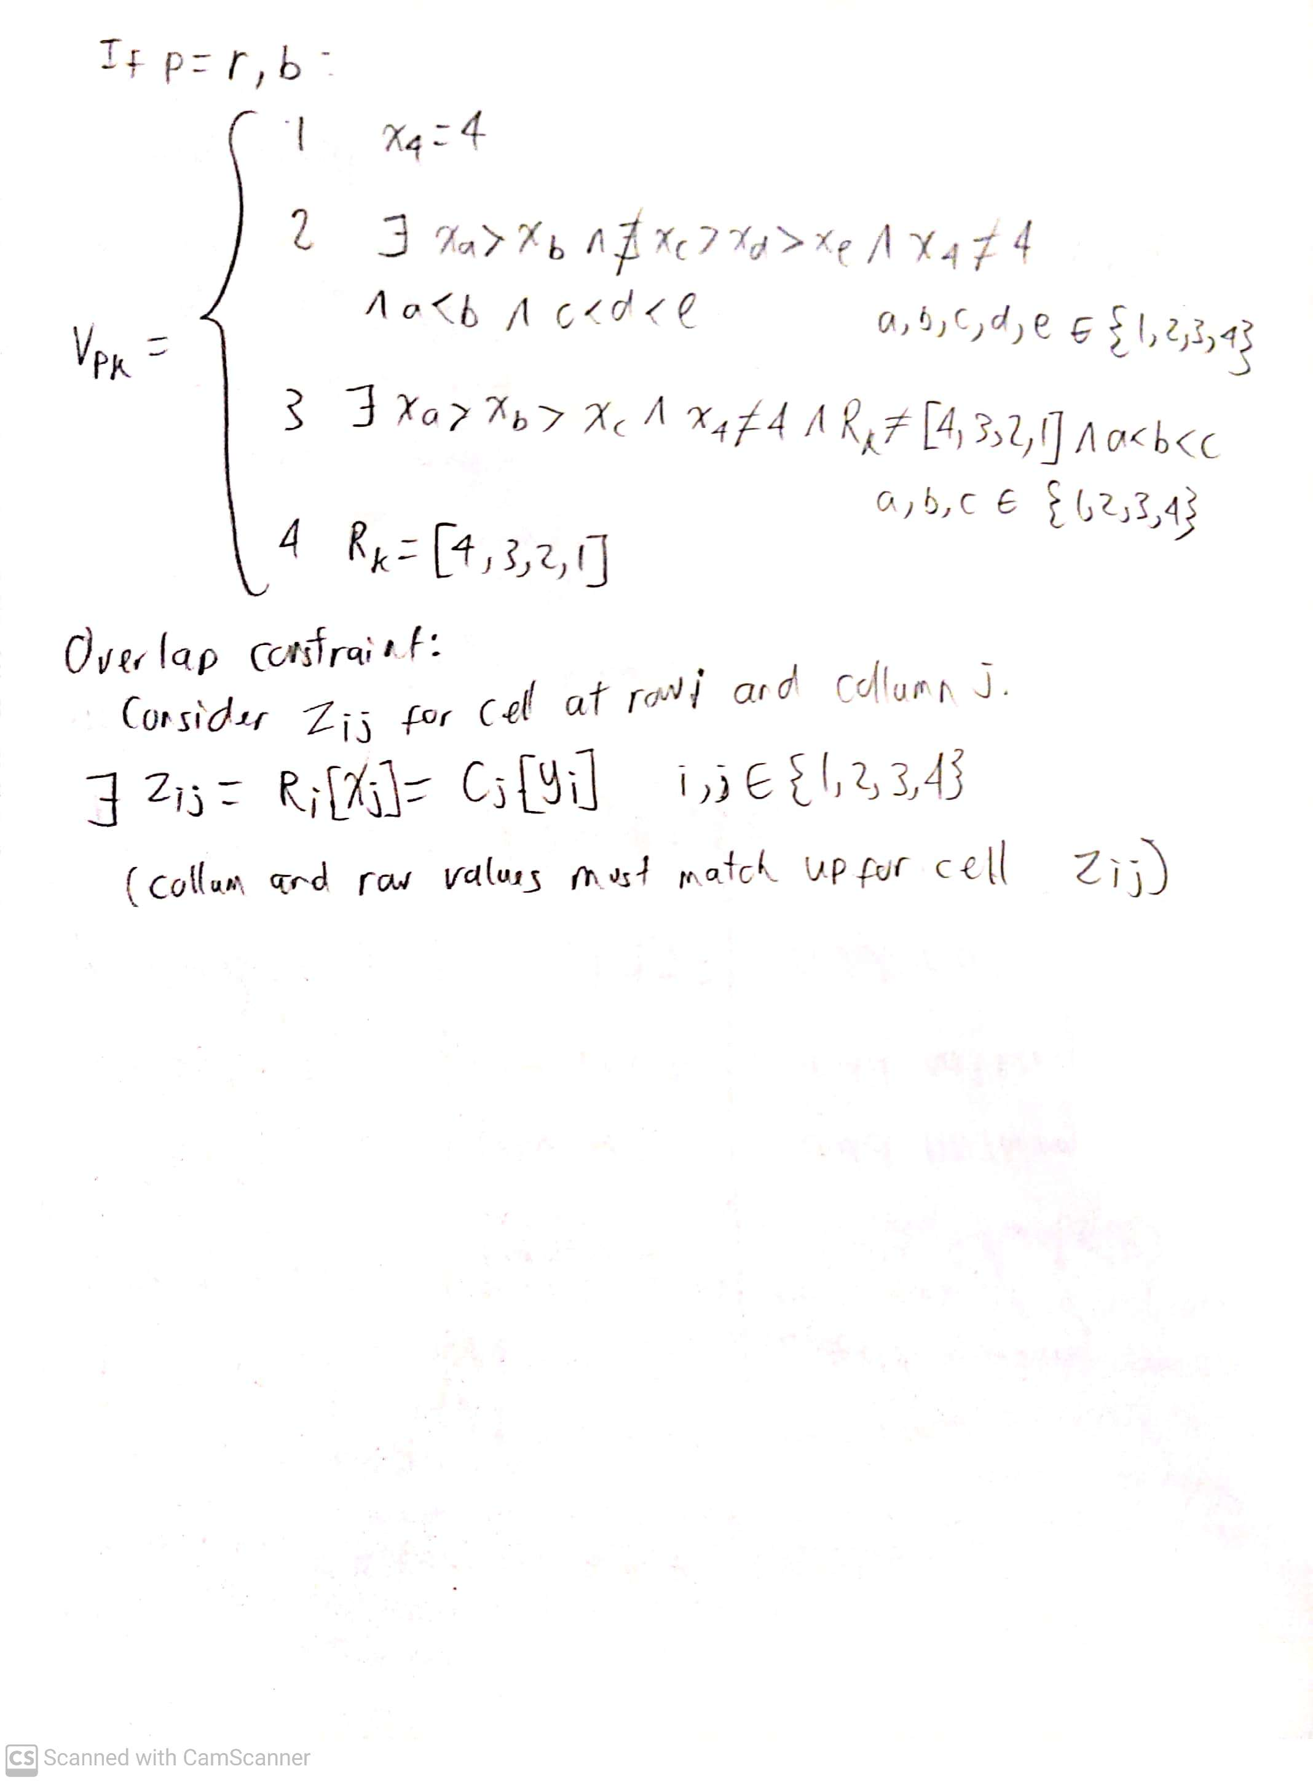

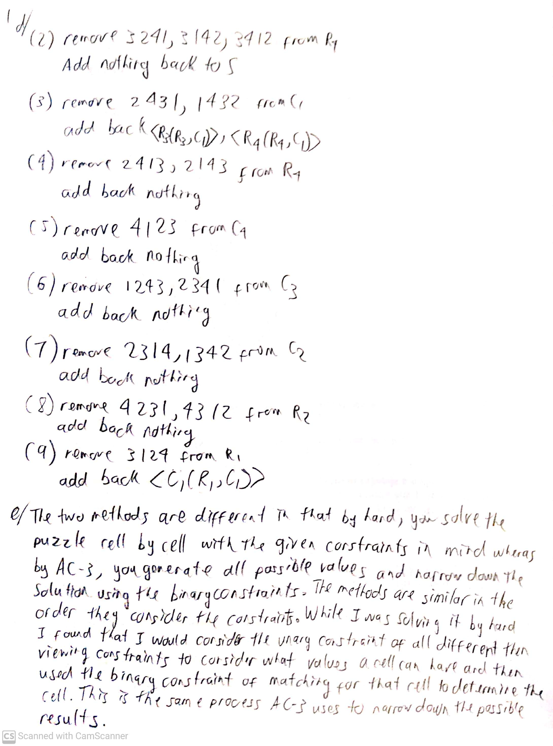

2 Decision Trees

b)

1. The maximum depth of the decision tree is 21 with root being depth 0.

2. The best maximum depth for pre-prunin is 7.

3. The best minimum number of examples for post-pruning is 60.

4. Choosing the full tree would be a bad strategy as it is likely overfitted to the data. That leaves the pruning using max-depth or min-examples. Of these two I would choose to go with max-depth as it would likely be smaller and easier to interpret as well as less expensive to make. By using a minimum number of examples, we must start with a full tree then take out nodes until the minimum number of examples is satisfied. This contrasts with the maximum depth where we would only generate nodes up until the maximum depth which is much faster. For this reason I would choose the maximum depth strategy.