**Security Policy**

1. **Purpose**

The purpose of this policy is to establish guidelines for the protection of the school’s network and data against unauthorised access and cyber threats.

1. **Scope**

This policy applies to all users, systems, and data on the school’s network.

1. **Policy**

* All incoming traffic is blocked by default, with exceptions only for authorised services.
* Management should not be accessible by any team.
* The entire Admin department should not be contactable from any other department.
  + Departments inside the Admin department (such as Teaching) should be able to contact each other.
* Security department should be accessible to only the IT department.
  + The IT department should still have access to everything else.
* Guest department should have no access to anything but the Wi-Fi connection.
* All departments should have access to the Internet and Utility. Certain limitations apply:
  + The Teaching department should have no access to Bandwidth Consuming, Potentially Liable, Security Risk, and Unrated web filter categories.
  + The Students department should have no access to Social Networking.
  + The entire company should have no access to: Adult/Mature Content, Security Risk categories.

Security/Firewall Policies

|  |  |  |  |  |  |  |  |  |
| --- | --- | --- | --- | --- | --- | --- | --- | --- |
| ID | Name | Source | Destination | Schedule | Service | Action | NAT | Comment |
| 1 | Wifi_Accessible | all | Wireless | always | ALL | ACCEPT | Enabled | All departments should have access to the Internet. |
| 2 | Management _Inaccessible | all | Management PC | always | ALL | DENY | Enabled | Management should not be accessible by any department. |
| 3 | Admin_Pingable | Admin PC | Admin PC,  Teaching PC | always | ALL_ICMP  PING | ACCEPT | Enabled | Teams inside the Admin department (such as Teaching) should be able to contact each other. |
| 4 | Admin_Not_Pingable | all | Admin PC | always | ALL_ICMP  PING | DENY | Enabled | The entire Admin department should not be contactable from any other department. |
| 5 | Security_Accessible | Security PC | IT PC | always | ALL | ACCEPT | Enabled | Security department should be accessible to only the IT team. |
| 6 | Security_ Inaccessible | all | Security PC | always | ALL | DENY | Enabled | Any team other than the IT department cannot access Security department. |
| 7 | IT_ Access_All | IT PC | all | always | ALL | ACCEPT | Enabled | The IT department should still have access to everything else. |
| 8 | Guest_Inaccessible | Guest PC | all | always | ALL | DENY | Enabled | Guest department should have no access to anything but the Wi-Fi connection. |
| 9 | Teaching_Restrictions | VR PC | Bandwidth consuming  Potentially liable  Security risk  Unrated web filter | always | ALL | DENY | Enabled | The Teaching department should have no access to Bandwidth Consuming, Potentially Liable, Security Risk, and Unrated web filter categories. |
| 10 | Students_Restriction_Social | Art PC | Social Networking | always | ALL | DENY | Enabled | The Students department should have no access to Social Networking. |
| 11 | All_Departments_Restrictions | all | Adult/Mature content  Security risk | always | ALL | DENY | Enabled | The entire company should have no access to: Adult/Mature Content, Security Risk |
| 12 | Social_Not_Limit_Access | Guest PC | Social Networking | always | ALL | ACCEPT | Enabled | Time is never restricted for the connection from Guest department to Social Networking. |
| 13 | Social_Limit_Access | all | Social Networking | 30_Minutes | ALL | ACCEPT | Enabled | Social networking should be restricted to 30 minutes a day for every department except the Guest department. |
| 14 | Utility_Accessible | all | Utility | always | ALL | ACCEPT | Enabled | All departments should have access to Utility department. |
| 15 | Incoming_Traffic_Block | external | all | always | ALL | DENY | Enabled | All incoming traffic is blocked by default, with exceptions only for authorised services. |

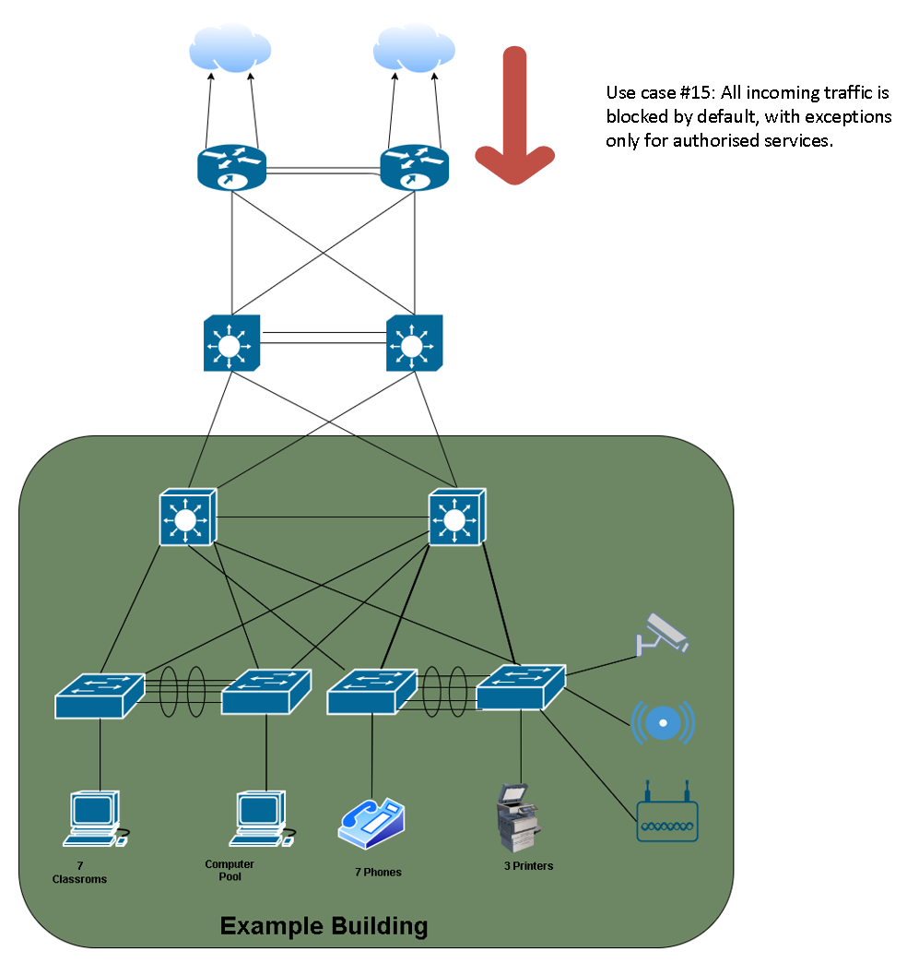Traffic Flow Illustrations

