**REQUIREMENTS**

**1)** Use[**https://superex-reactjs.vercel.app/index-two-dark**](https://superex-reactjs.vercel.app/index-two-dark)as the main homepage

Demo of all index pages:[**https://superex-reactjs.vercel.app/#landing**](https://superex-reactjs.vercel.app/#landing)

**2)** Remove the blog pages

**3)** Remove the login and register functions, users should be able to just connect their wallet and use the marketplace

**4)** Remove this section please of the apps and text

**5)** Make this section in centre instead.

Text to be in centre and the social icons.

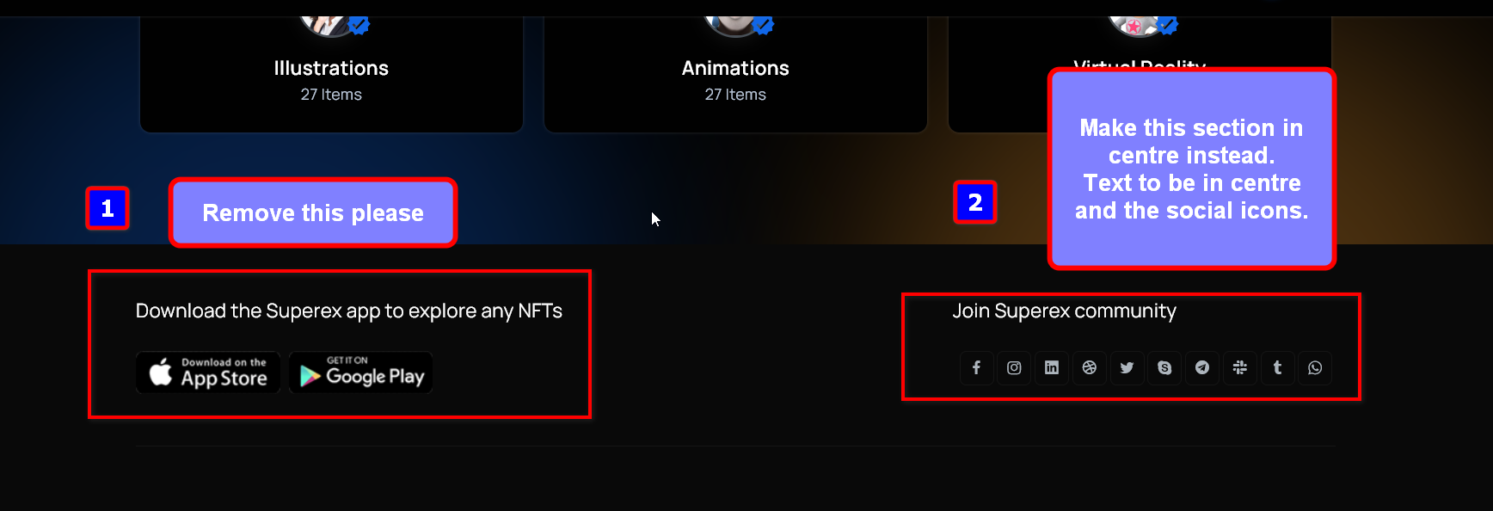

**6)** Remove blog features, example in the middle of this page

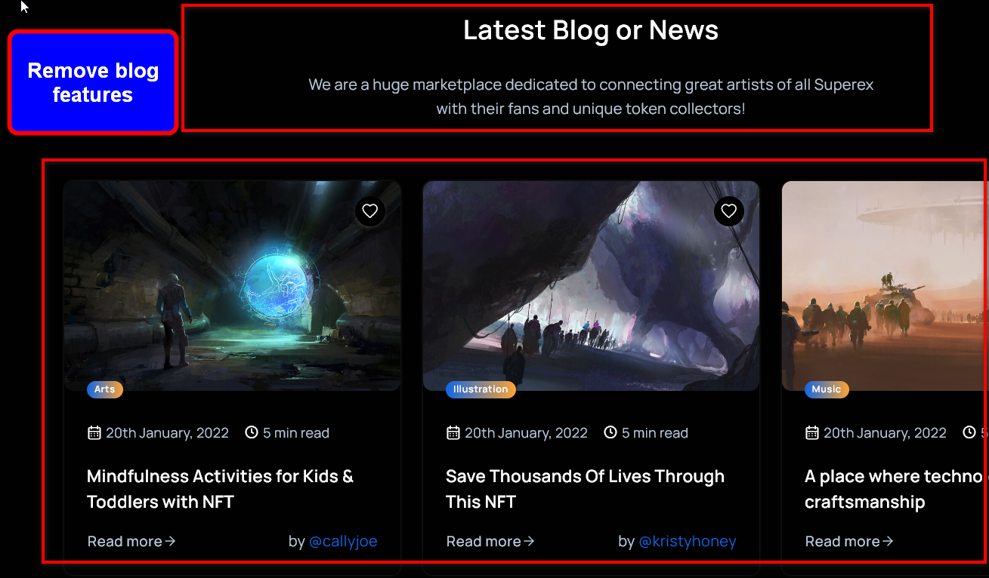

**7)** Remove login and register functions from the site.

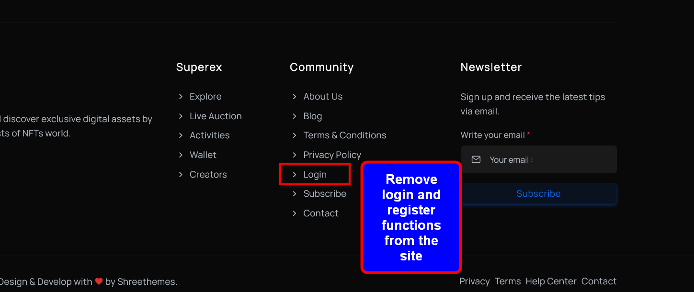

**8)** This is the colour of the theme that should be used

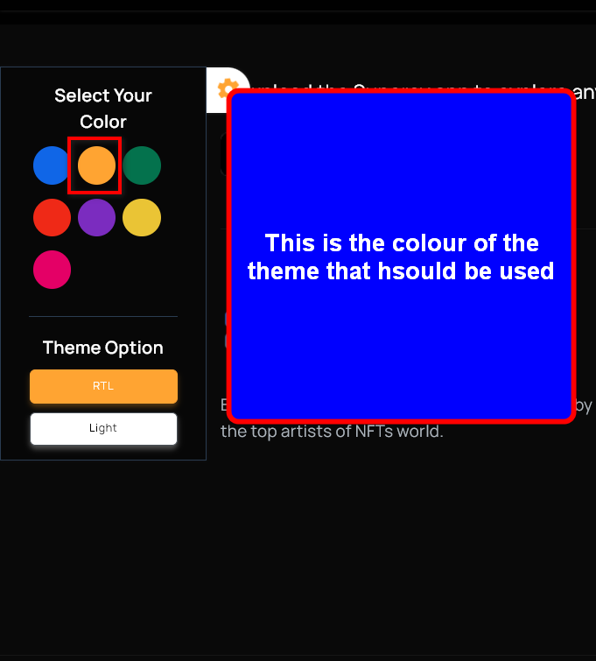



When a page is navigated to, the page should be scrolled to the top, not remain in the position that the previous page the user was on.