ASSIGNMENT 01
CLOUD COMPUTING
Git, Gitea, GitHub, Git LFS, and GitHub Pages
Task 1: Install Gitea and Push a Repository from the Ubuntu Server

1.1 Objective
Install and run a local Gitea server on Ubuntu Server, create a user profile, and initialize the Assignment01 repository.
Gitea Web Interface Running:
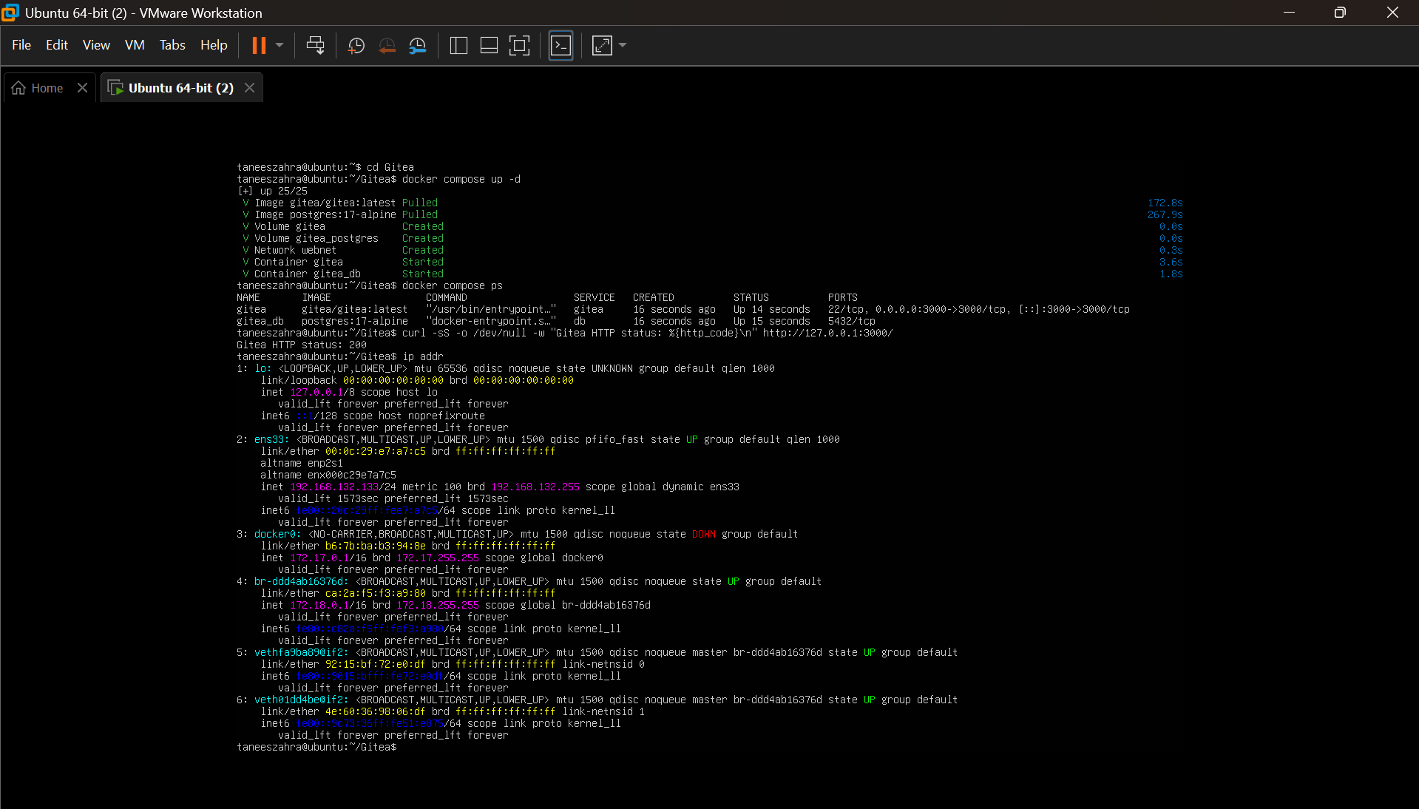
task1_gitea_running.png

Gitea Repository Created:
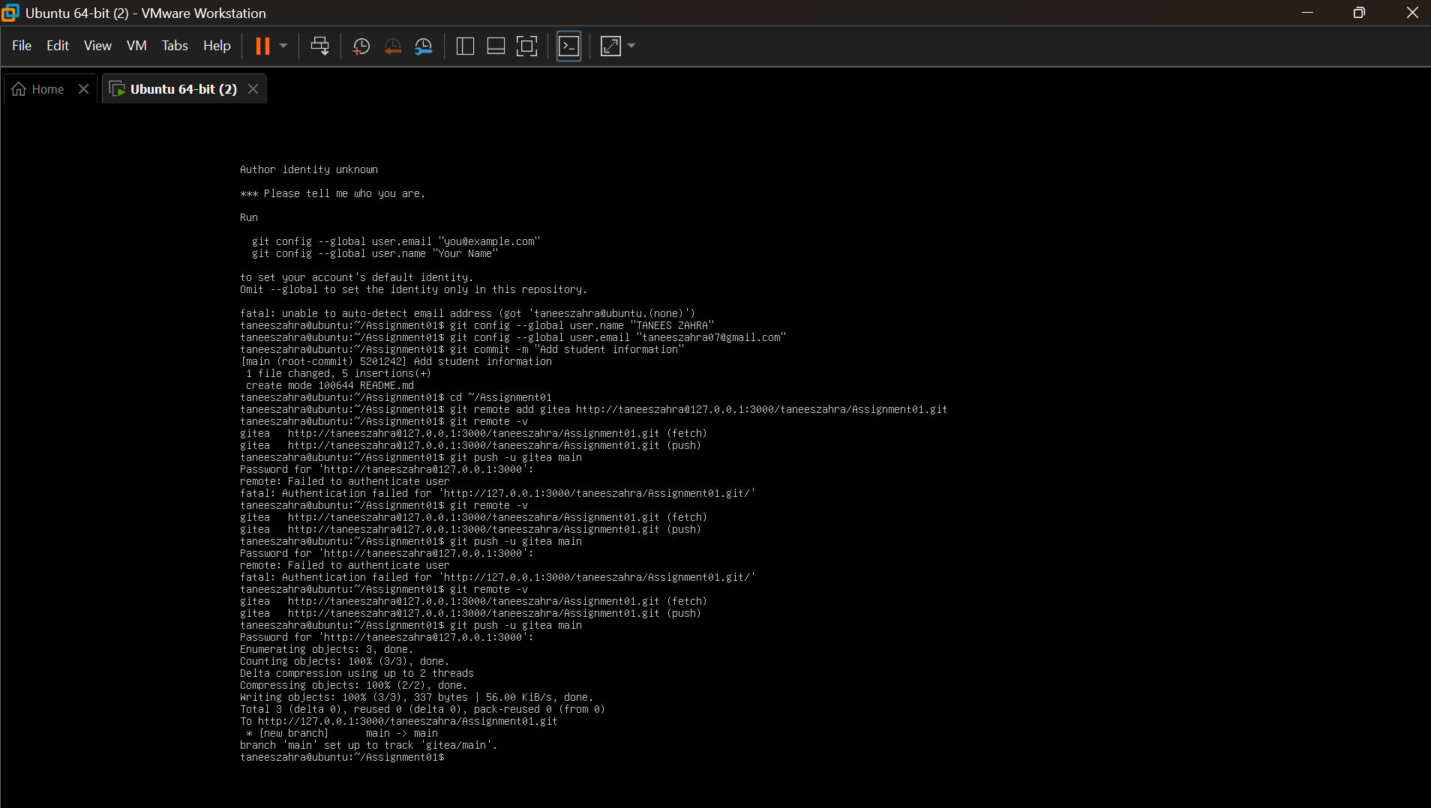
task1_gitea_repository.png
Initial Push to Gitea Remote:
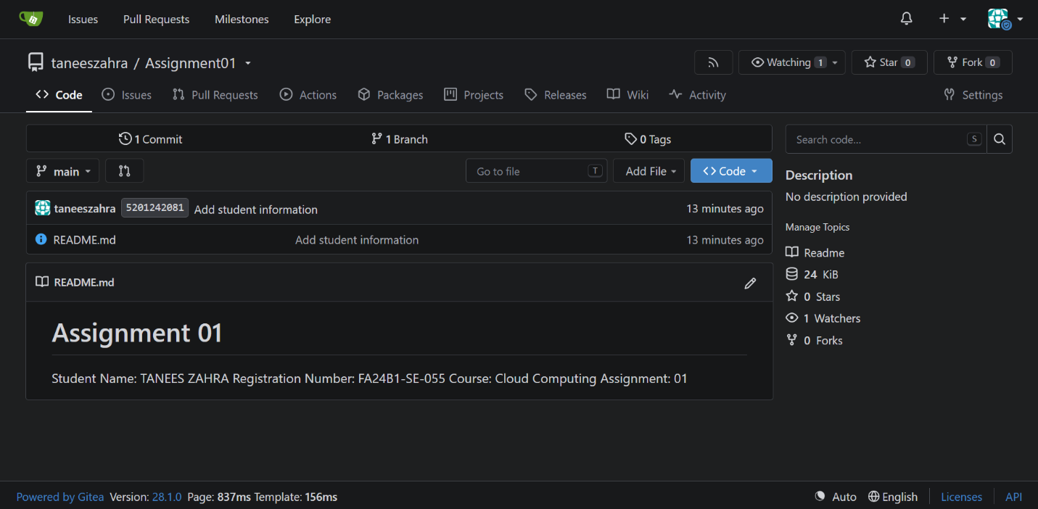
task1_gitea_push.png

Task 2: Multi-Remote Repository Setup (Gitea & GitHub)

2.1 Objective
Configure dual remotes (gitea and github) within the local Git repository and synchronize commits across both platforms using Personal Access Tokens (PAT).
Terminal Verification of Git Remotes:
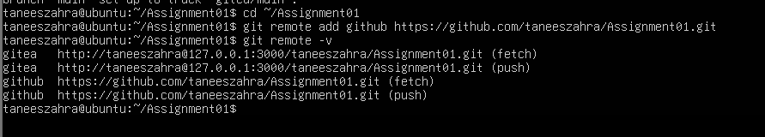
task2_remotes.png
Terminal Push to GitHub Remote:
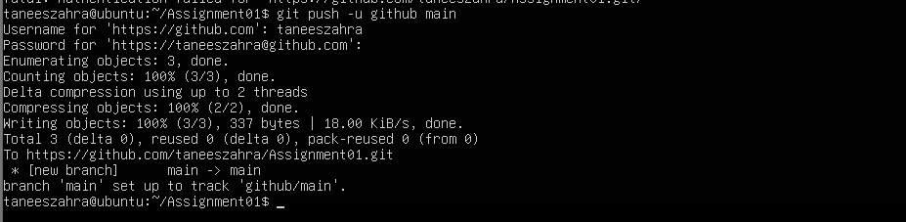
task2_github_push.png
GitHub Web Interface Showing Synchronized Repository:
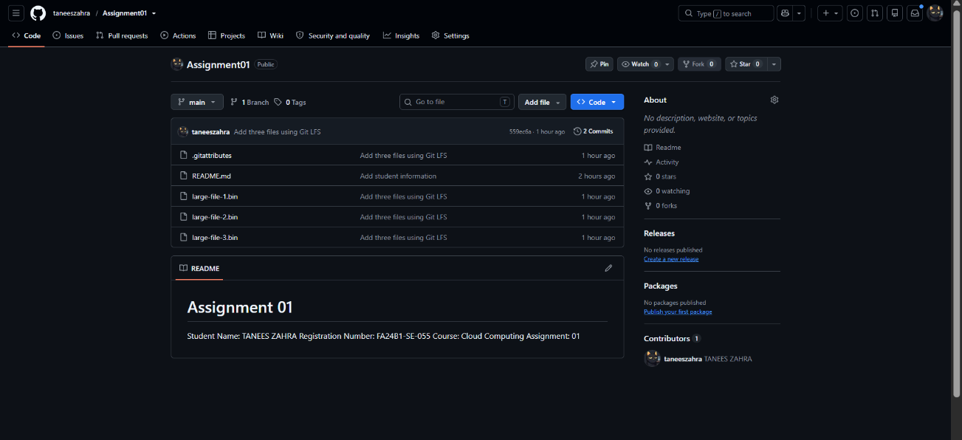
task2_github_repository.png
Task 3: Git Large File Storage (Git LFS) Integration

3.1 Objective
Install Git LFS, configure tracking for .bin binary files, commit large placeholder files, and push to remote repositories.
Git LFS Installation and Tracking Setup:
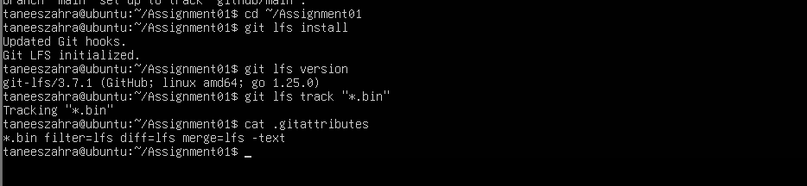
task3_lfs_setup.png
Git LFS File Tracking Status (git lfs ls-files):
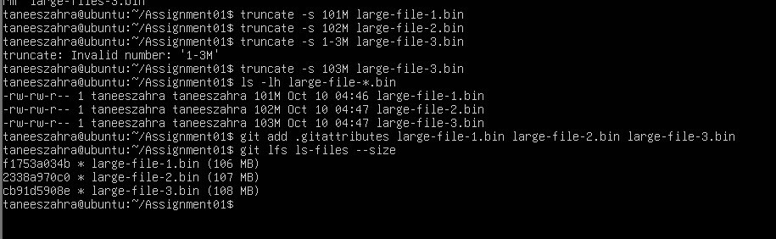
task3_lfs_files.png

Git LFS Object Push Output:
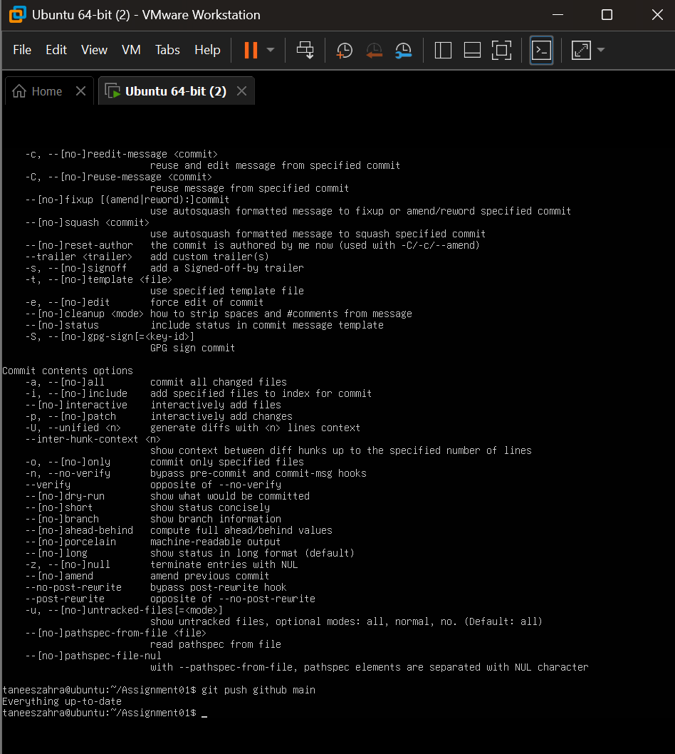
task3_lfs_push.png

Task 4: Responsive Portfolio Deployment via GitHub Pages

4.1 Objective
Design and deploy a modern responsive developer portfolio site tailored for a Software Engineer profile using HTML5, CSS3 Glassmorphism UI styling, and hosting via GitHub Pages.
GitHub Pages Configuration Page:
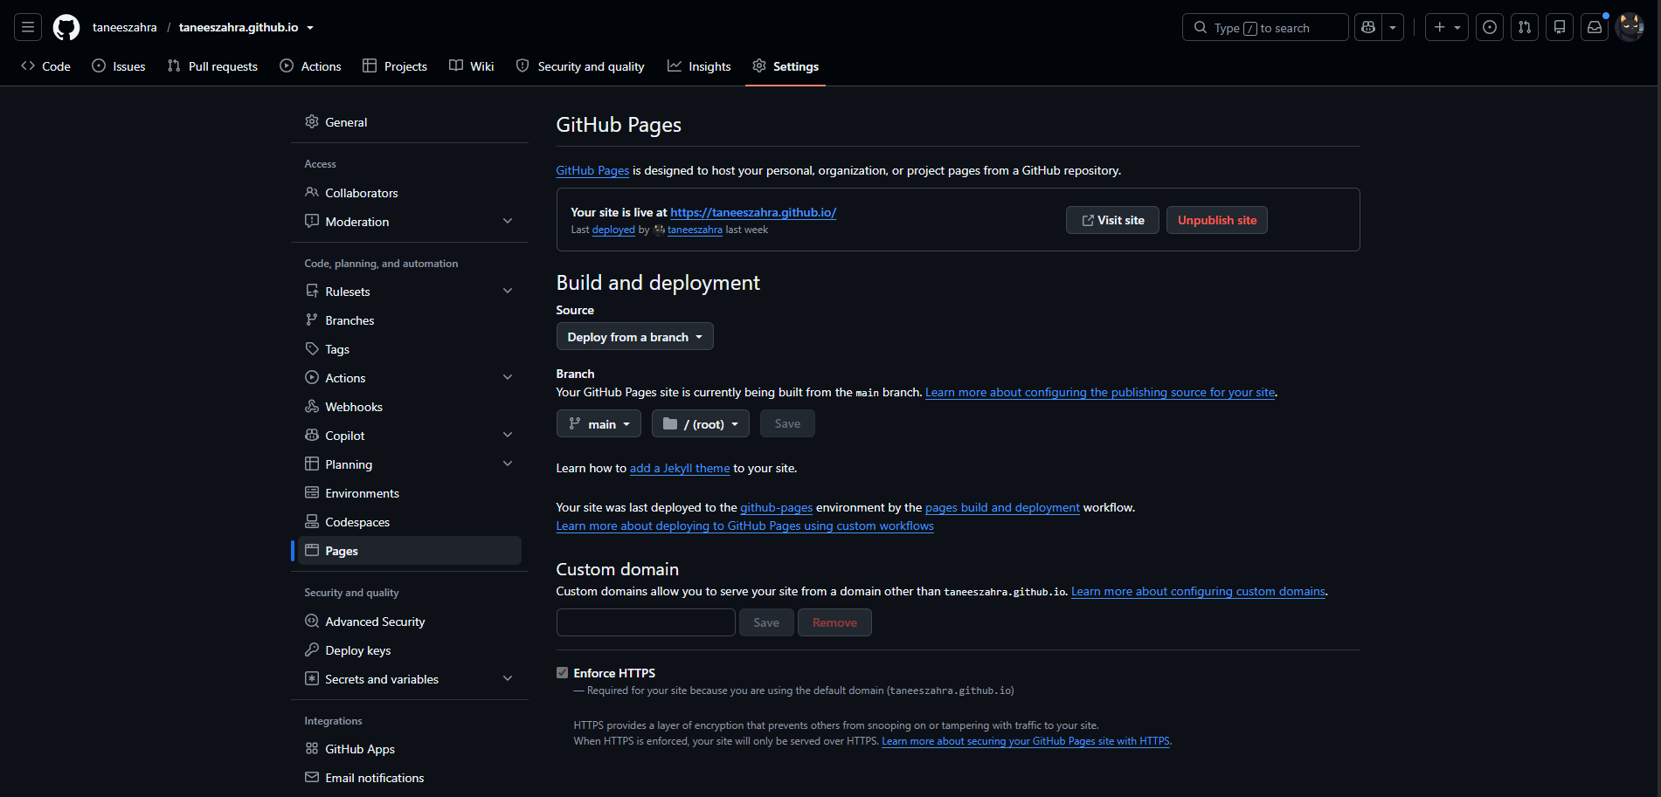
task4_pages_deployment.png
Portfolio Repository Structure on GitHub:
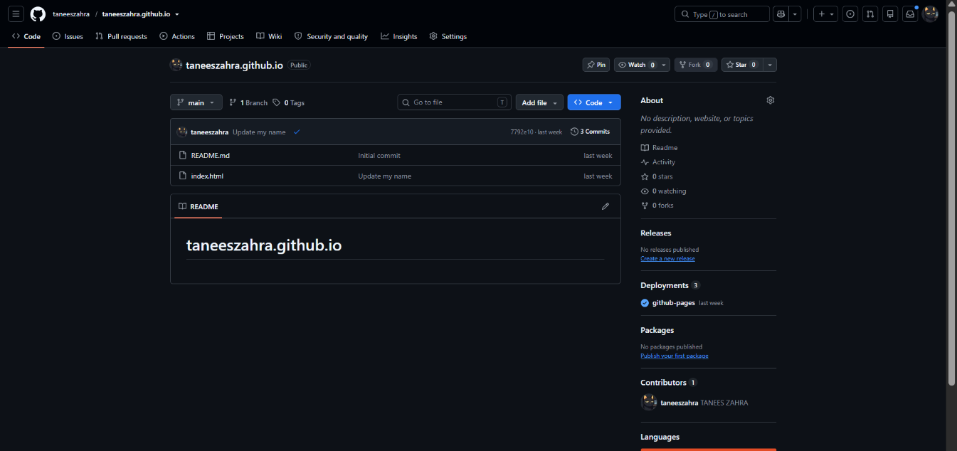
task4_pages_repository.png
Live Deployed Portfolio Web Page View:
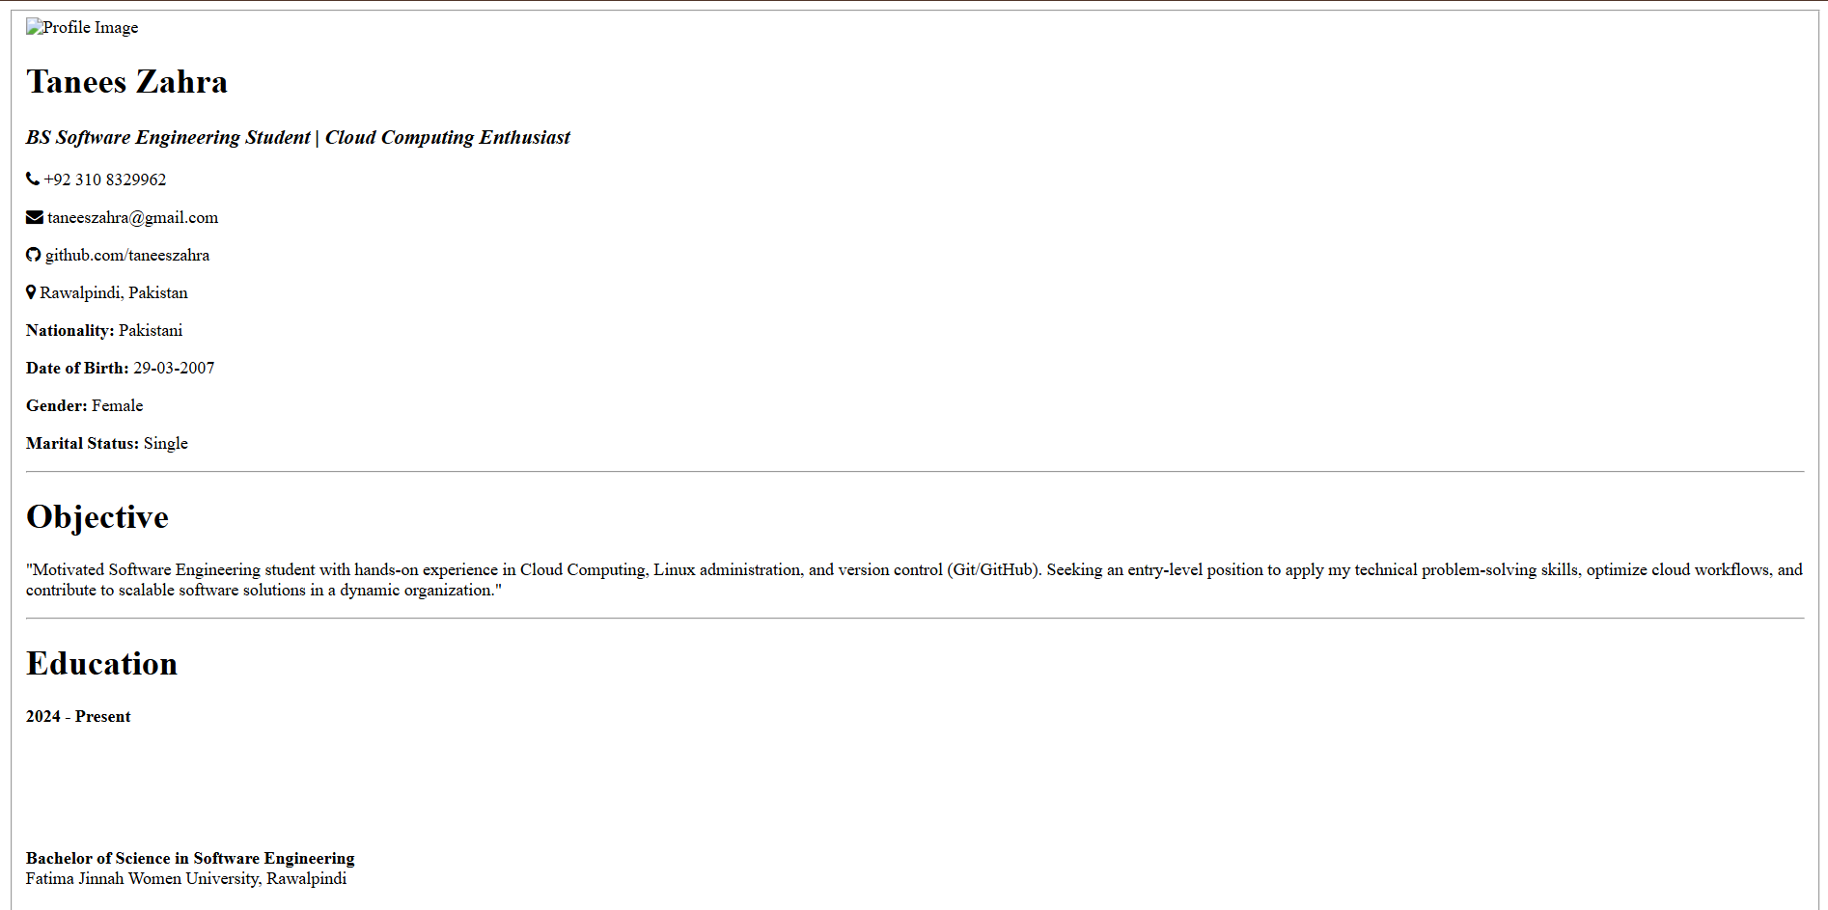
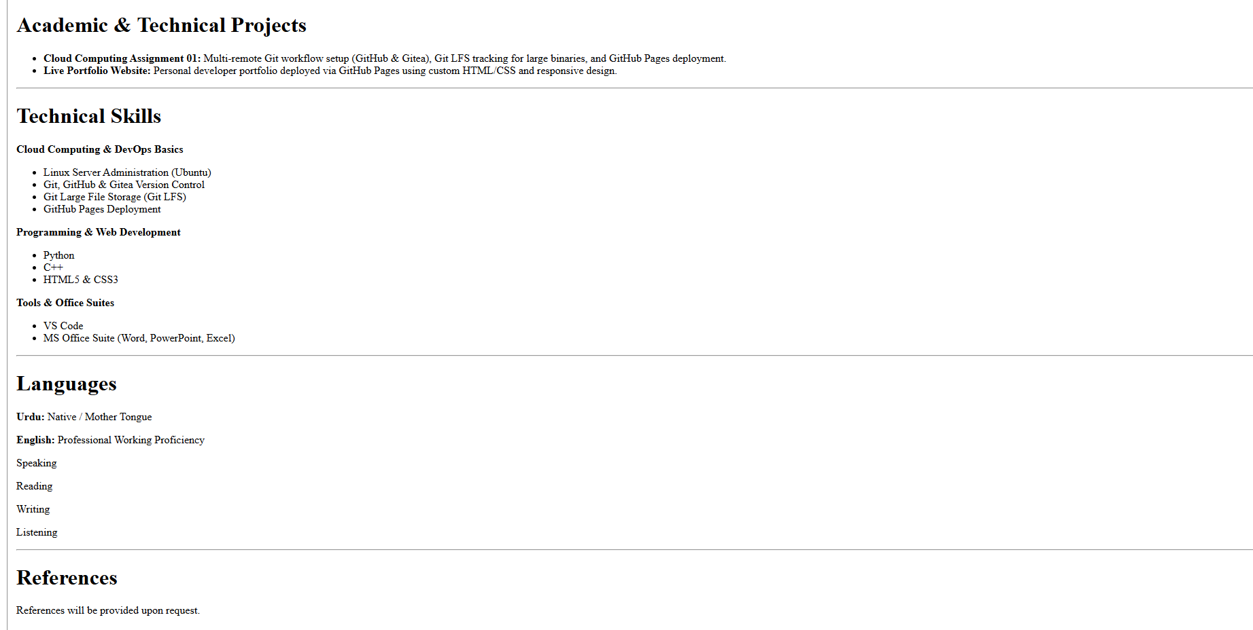
task4_portfolio_live.png

Conclusion
All requirements for Cloud Computing Assignment #1 were completed successfully. The local Gitea instance and GitHub remote synchronizations are functioning, Git LFS correctly handles binary pointers without overloading history, and the personal developer portfolio is live online.

