LAB 01 Solution Report
GitHub Identity, Student Portal Registration, and Ubuntu Server Installation
Name | TANEES ZAHRA
Reg No | 2024-BSE-55
Course Code
Section | A
GitHub Username | taneeszahra

Task 1: Virtual Machine Creation
- GitHub Profile
GitHub profile page displaying the professional username and account details.
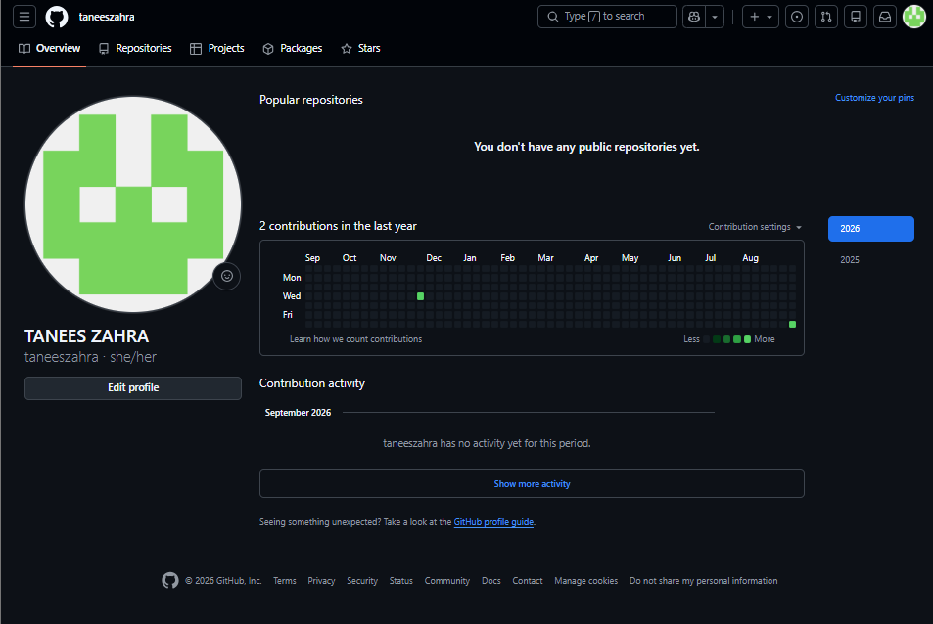

GitHub public profile settings showing the completed actual name field.
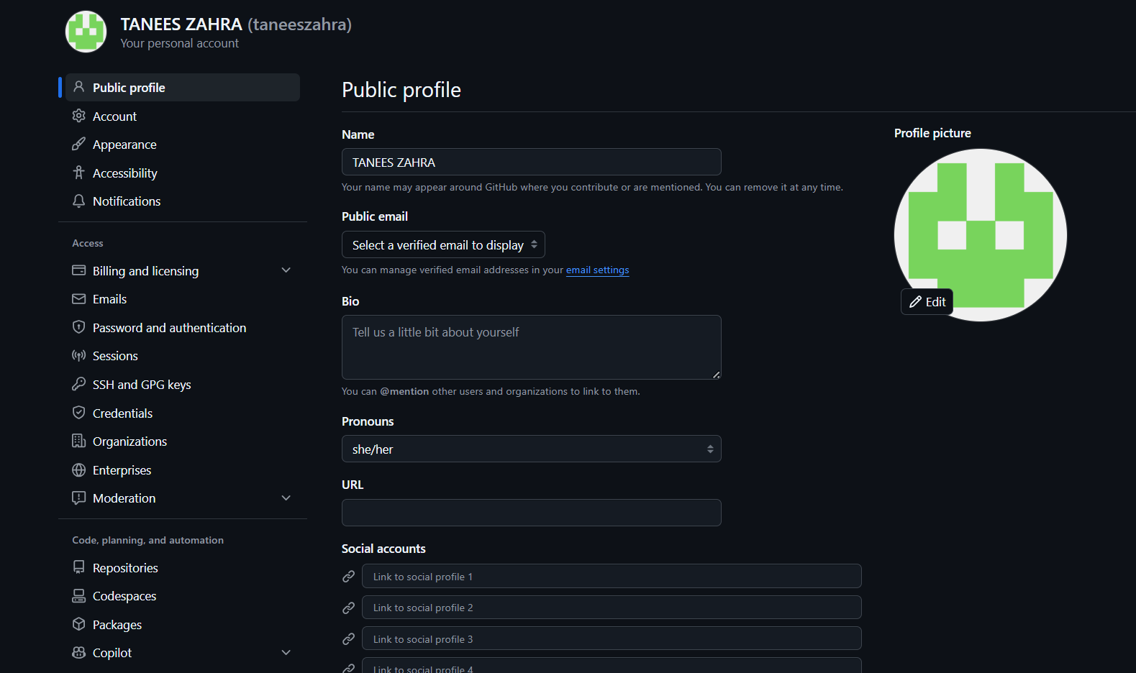
Task 2: Register in the Student Marks Portal
Student marks portal displaying the connected GitHub profile information and account details.
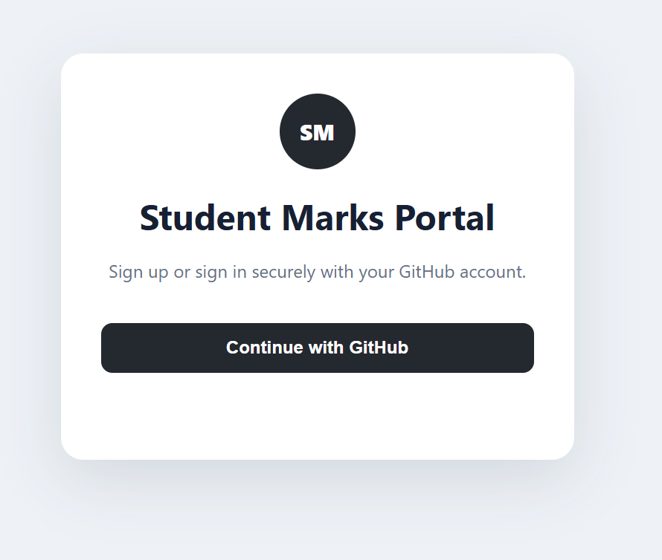
Student portal showing the successfully submitted course enrollment status awaiting approval.
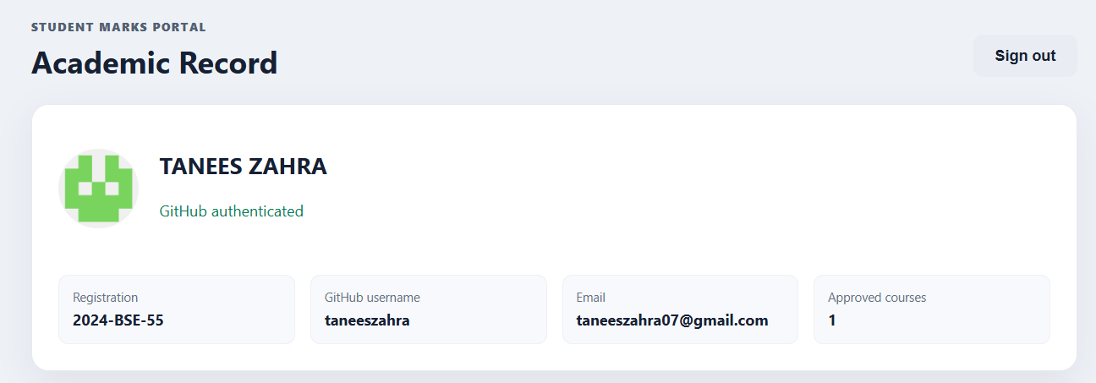
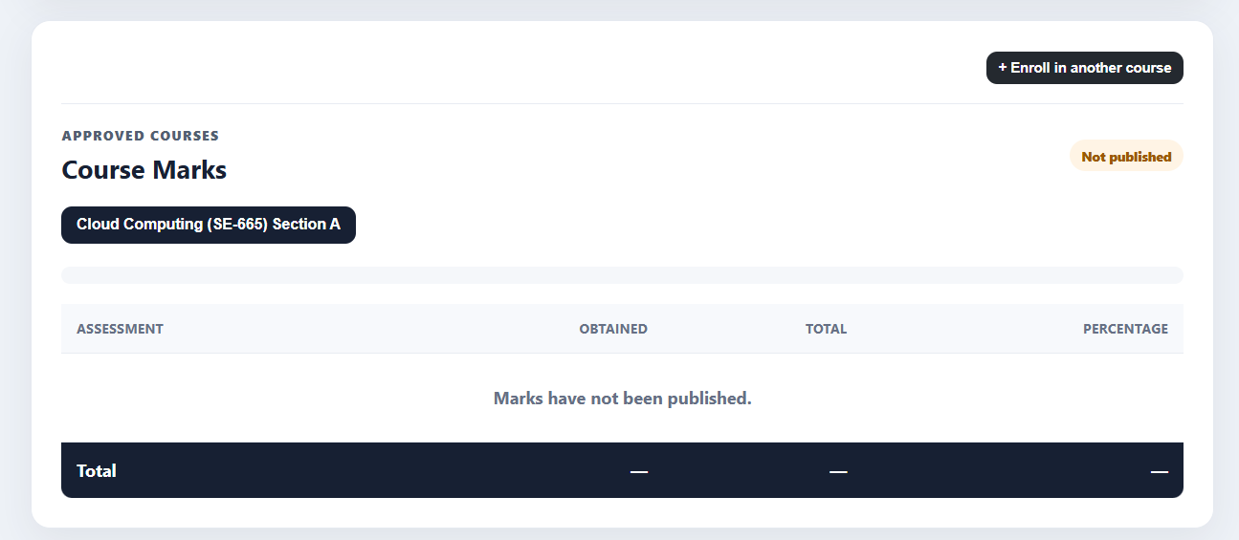

Task 3: Download VMware Workstation Pro and Ubuntu Server
VMware Workstation Pro application running successfully on the Windows host machine.

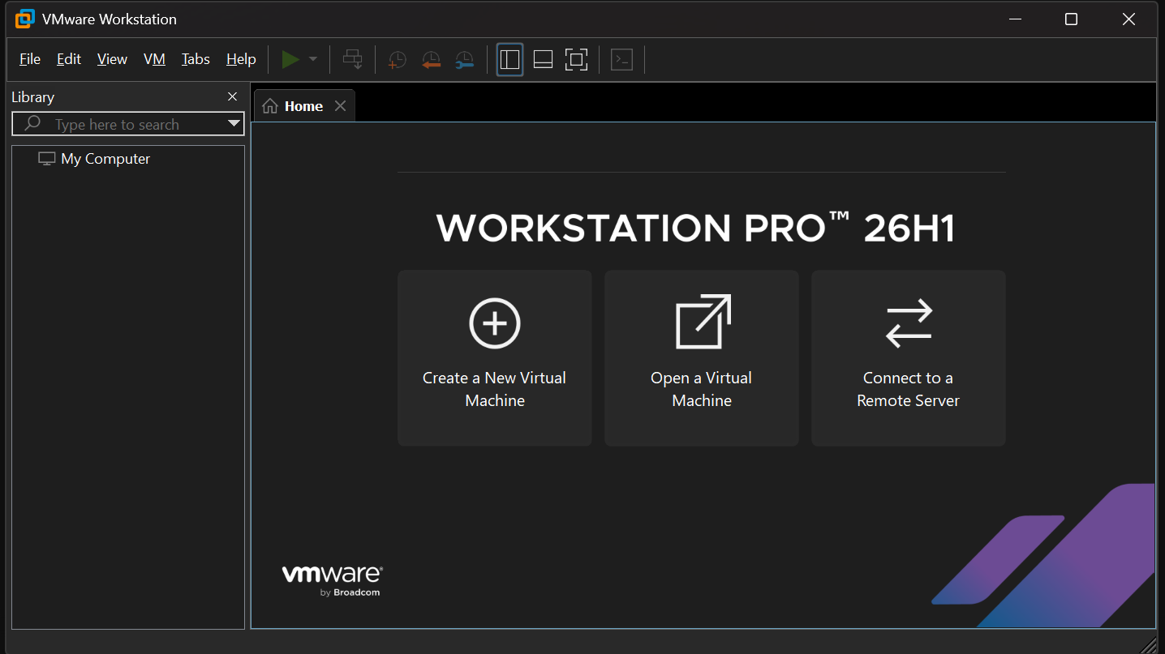
File explorer window showing the successfully downloaded Ubuntu Server LTS ISO file.
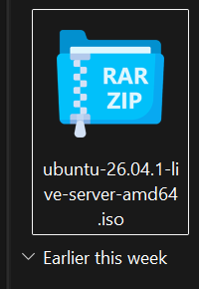
System storage property window verifying more than 20 GB of available disk space for the virtual machine.
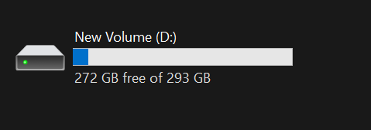
Task 4: Create the Ubuntu Server Virtual Machine
VMware New Virtual Machine Wizard interface open to create a new VM configuration.
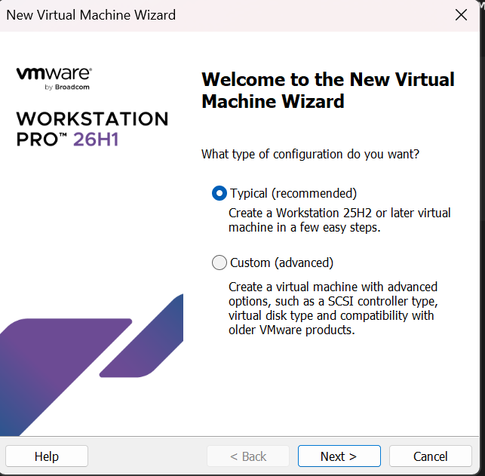
Virtual machine configuration step selecting the recommended Typical setup option.
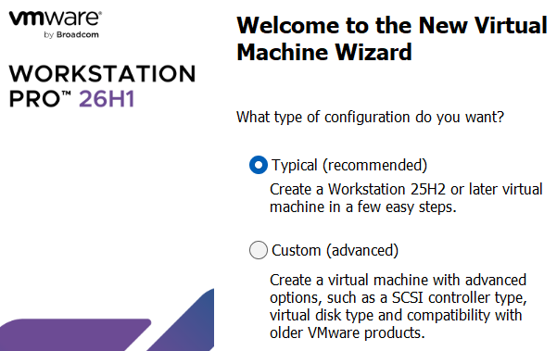

Installer disc image selection step showing the mounted Ubuntu Server ISO path.
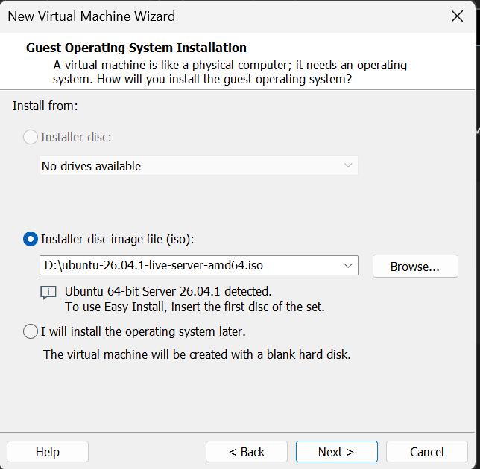
Final virtual machine hardware configuration summary allocating at least 20 GB of virtual disk space.
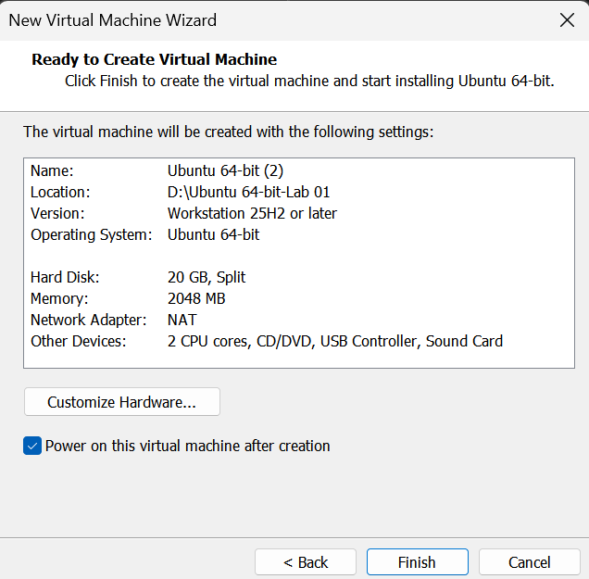
Powered-on virtual machine displaying the Ubuntu Server installer boot screen.
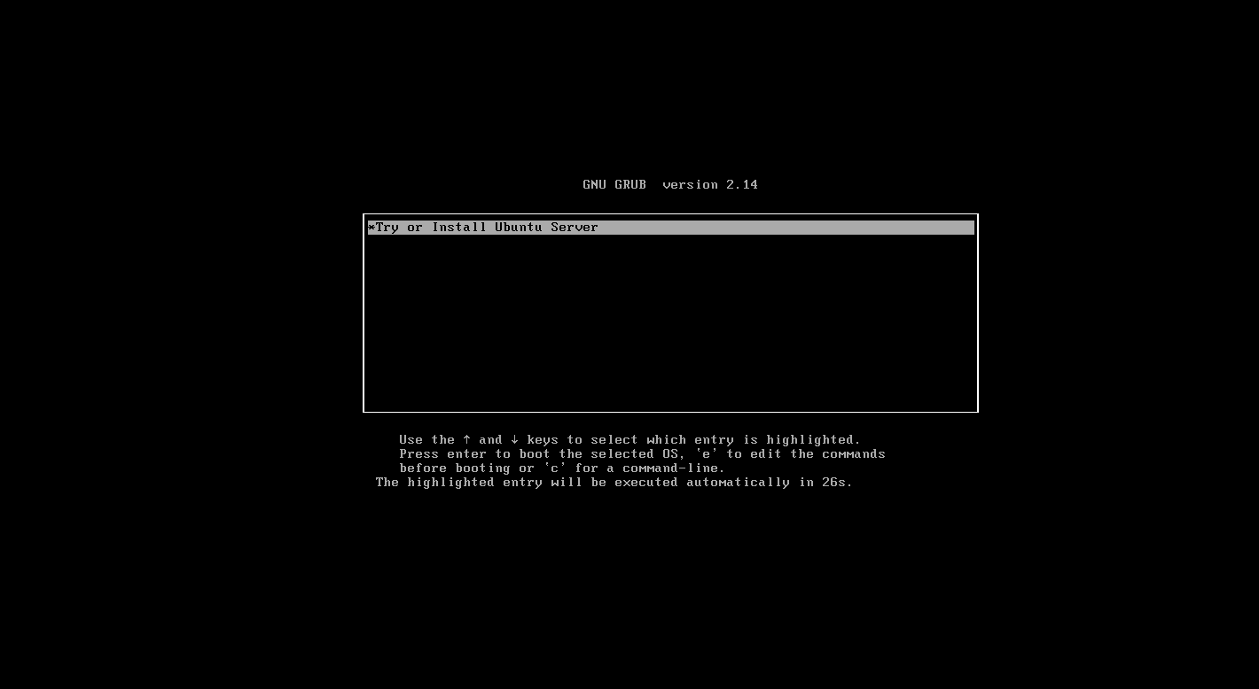
Task 5: Choose the Installation Language
Ubuntu Server installer language selection screen highlighting English as the preferred language.
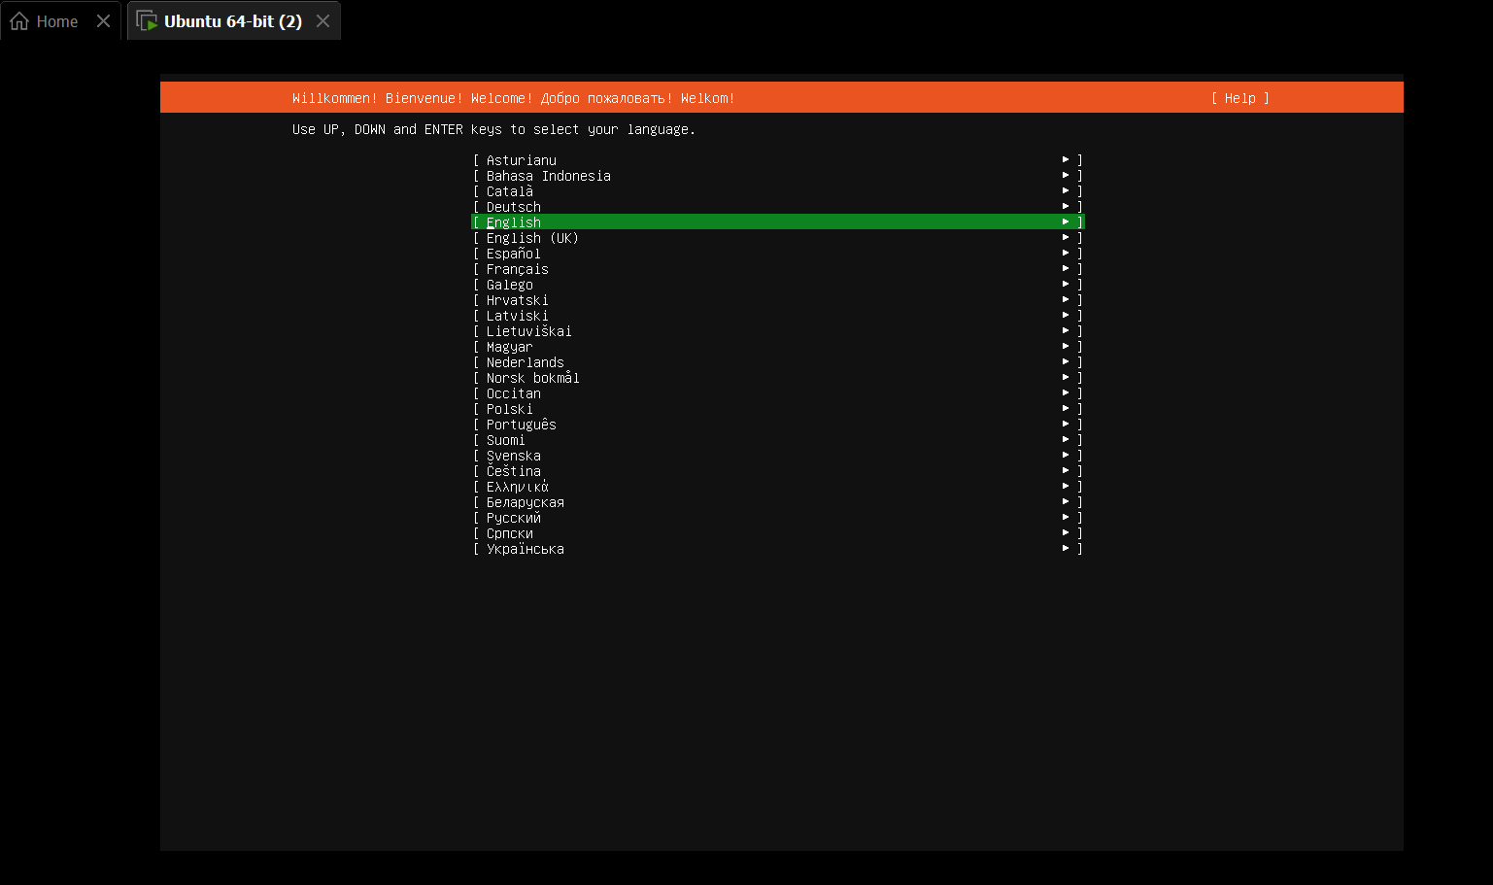

Task 6: Configure the Keyboard Layout
Ubuntu Server keyboard configuration screen showing the selected layout set to English (US).
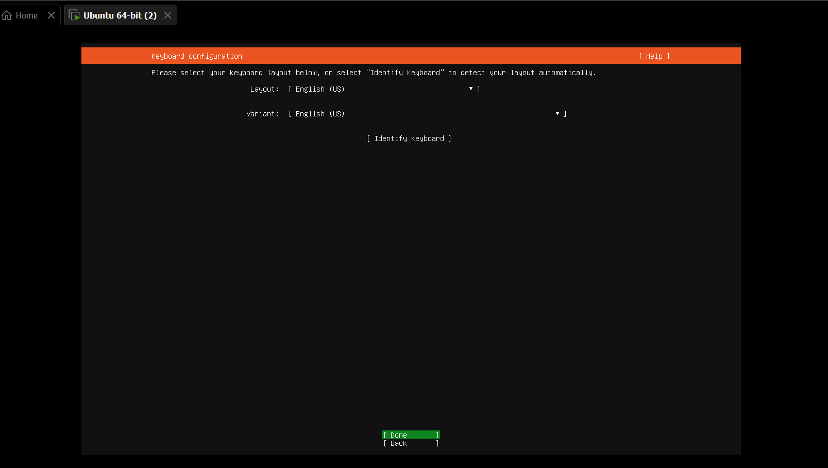
Keyboard configuration options displaying the selected variant configuration.
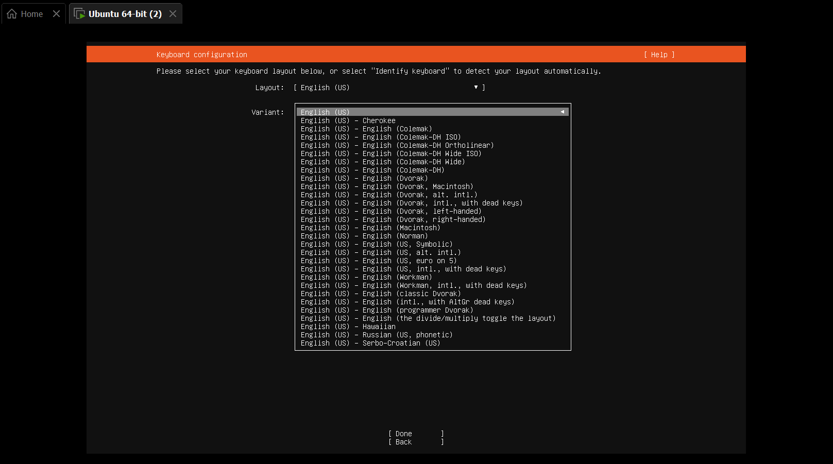

Task 7: Choose the Ubuntu Server Installation Type
Ubuntu Server installation type selection menu highlighting the standard Install Ubuntu option.
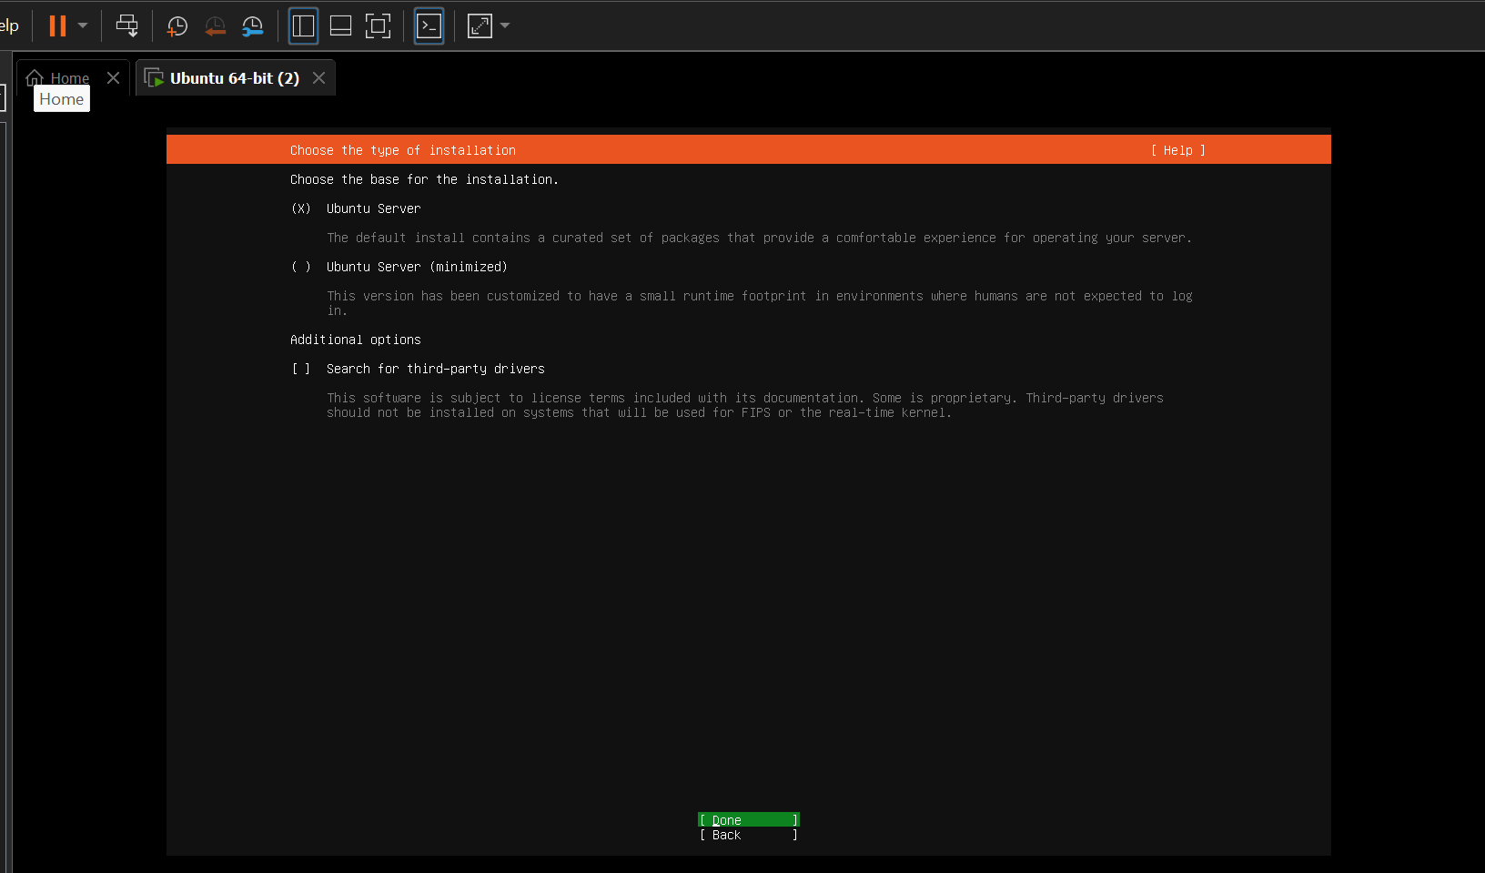
Task 8: Configure the Network
Network connections screen showing the detected ens33 network interface.
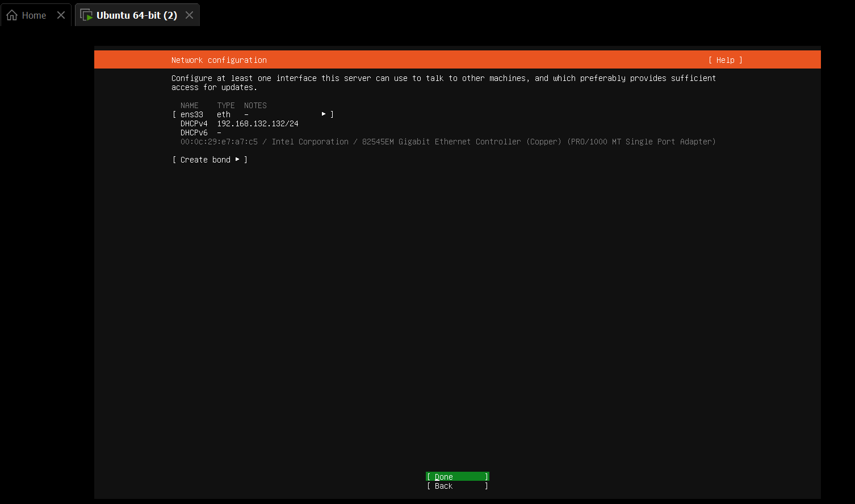
Network configuration details confirming the IPv4 address automatically assigned via DHCP.
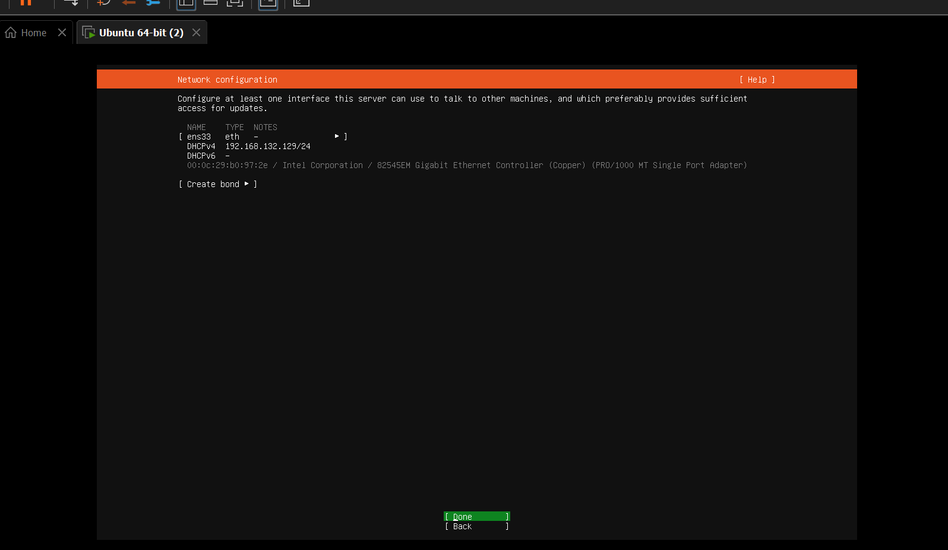
Task 9: Configure Storage
Filesystem setup screen highlighting the guided storage option to use the entire virtual disk.
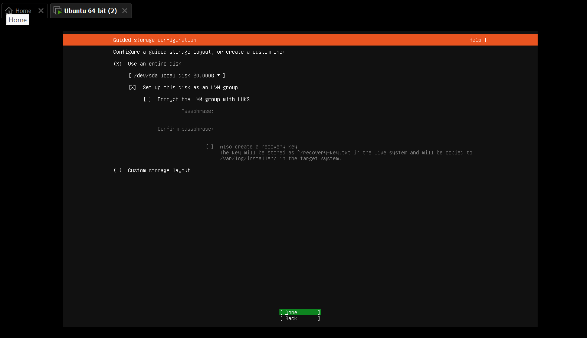
Storage configuration review screen displaying the partition layout before continuing the installation.
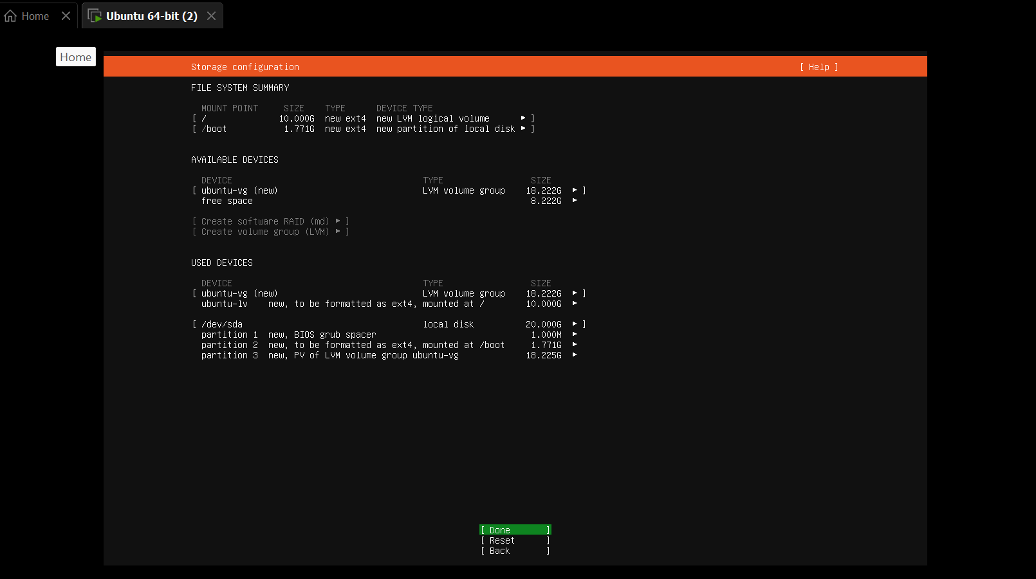
Task 11: Review the Partitions
Filesystem setup summary displaying the proposed virtual disk partitions and mount points.
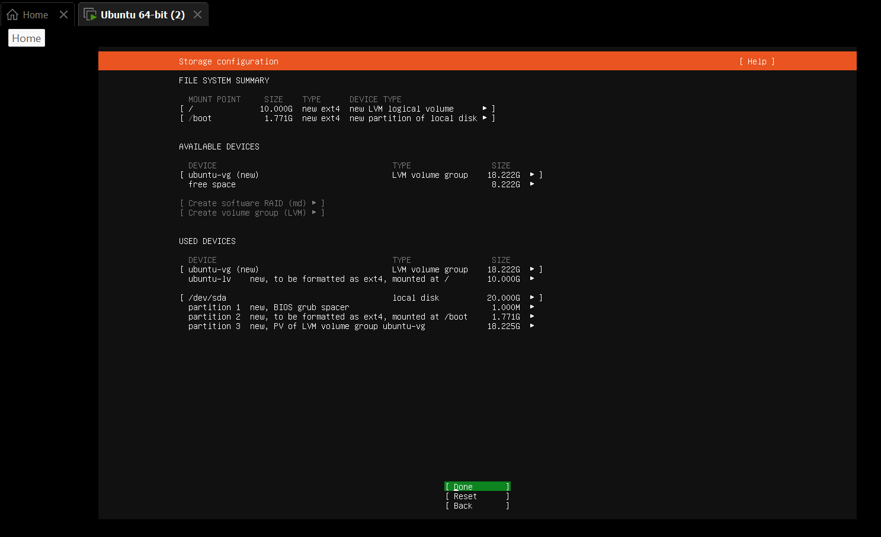
Task 12: Confirm the Storage Changes
Destructive action warning prompt displayed by the installer before formatting the selected disk.
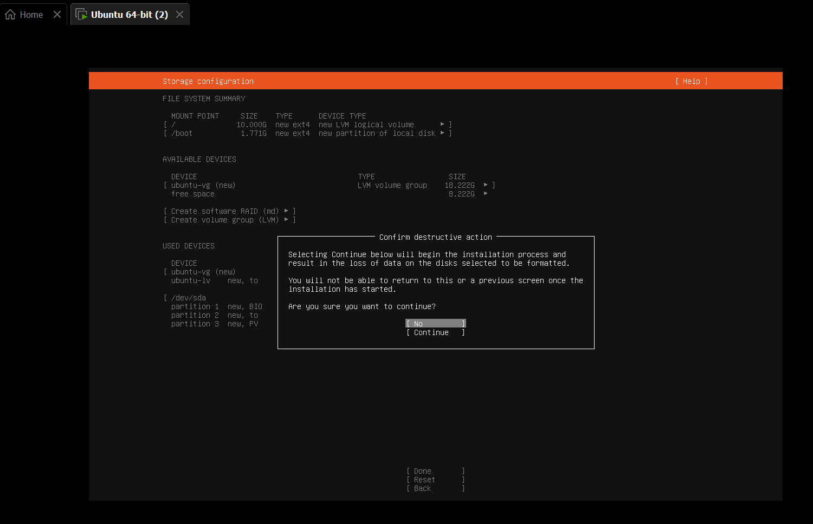
Storage confirmation screen highlighting the selected 'Continue' option to proceed with the installation.
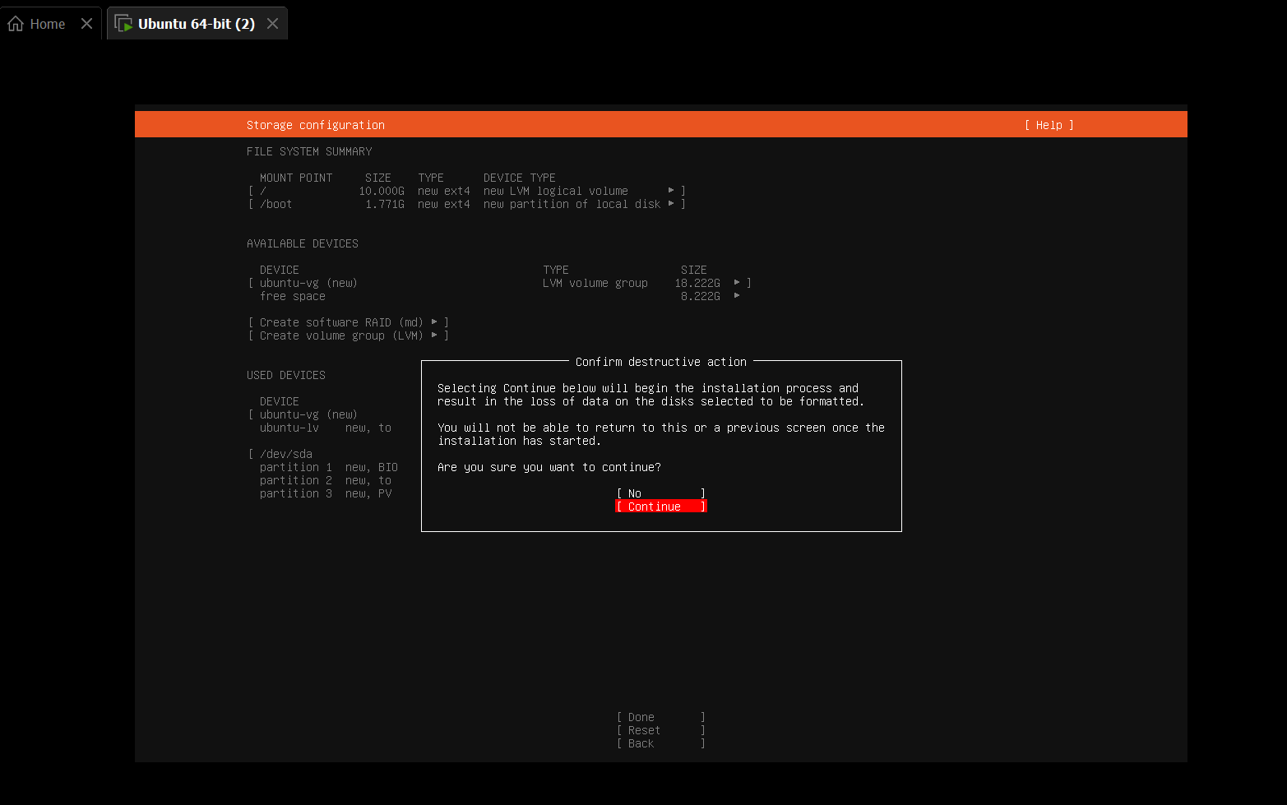
Task 13: Configure the Ubuntu Profile
Ubuntu profile configuration screen showing the user's complete actual name entered in the name field.
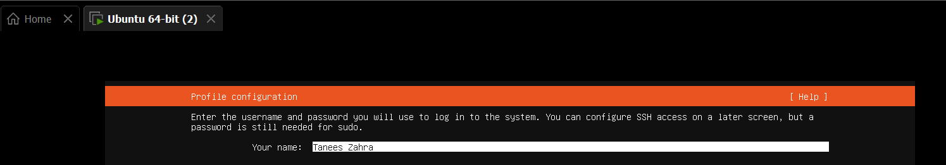
Profile setup screen displaying the server name configured as ubuntu.
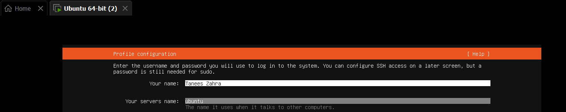
Profile configuration screen showing the exact GitHub username entered in the username field.
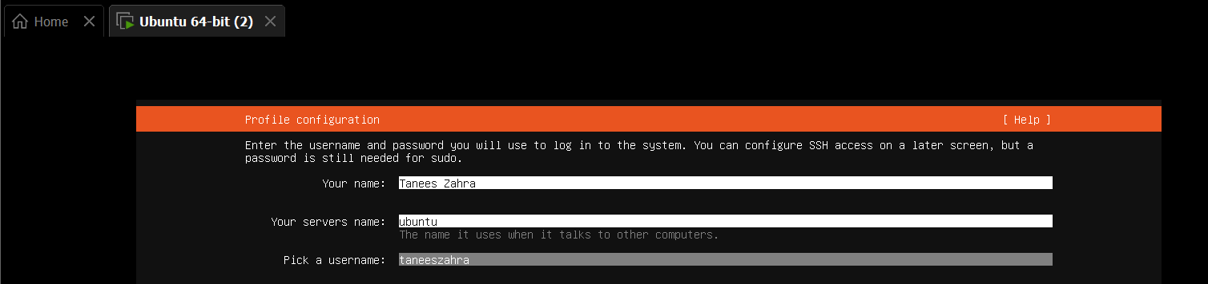

Completed Ubuntu profile setup page showing all configured fields before proceeding to the next step.
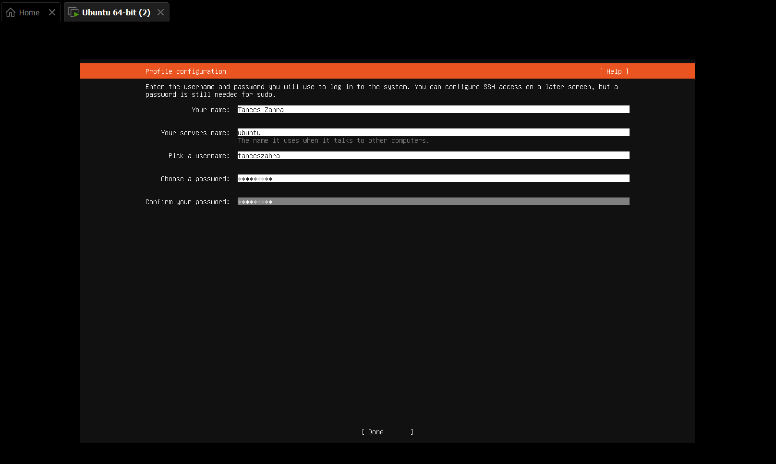
Task 14: Complete the Software Installation
Ubuntu Server system installation progress showing curtin installation commands and disk configuration logs.
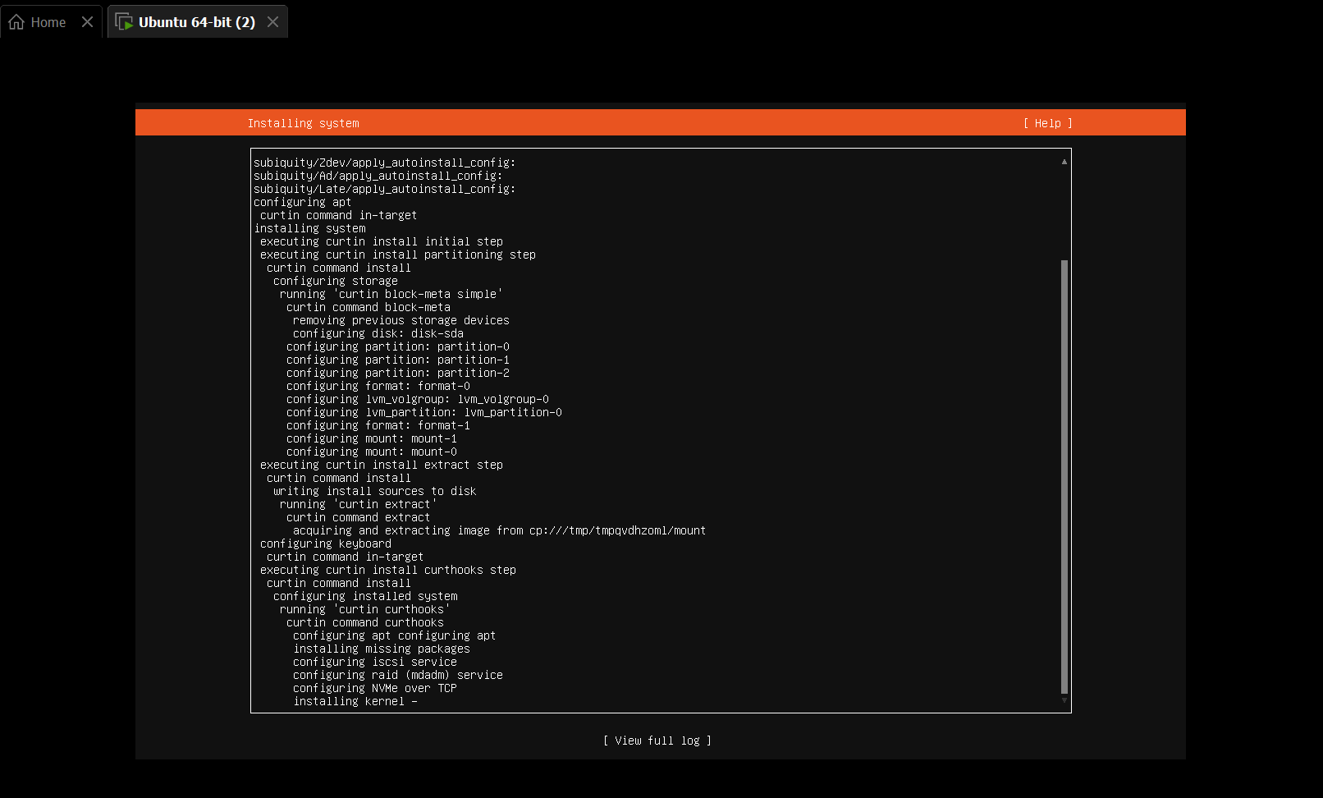
Task 15: Reboot and Verify the Ubuntu Identity
Installation complete screen indicating that the Ubuntu Server setup has successfully finished.
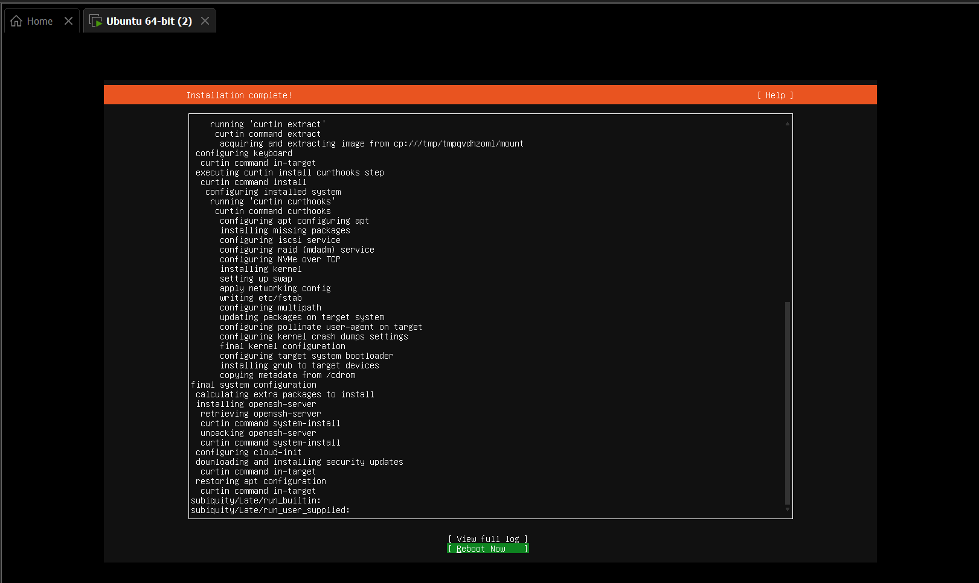
Server login screen displayed after the system restart.
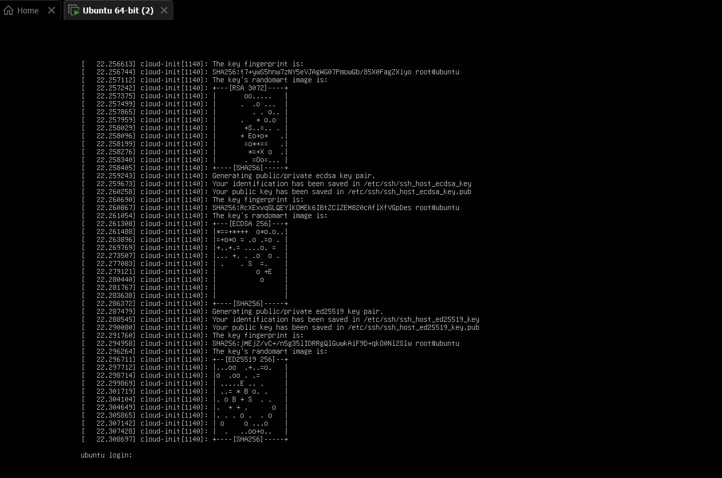

Successful terminal login prompt showing the authenticated user session.
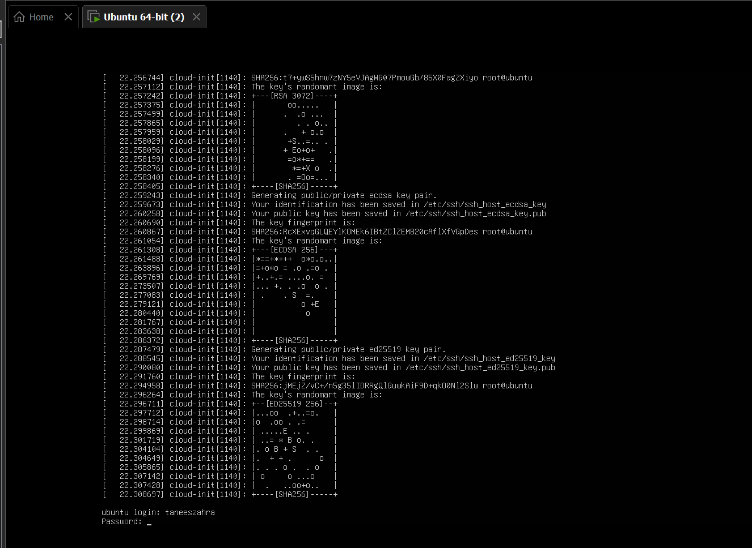

Terminal prompt verifying the correct format displaying the GitHub username and hostname.
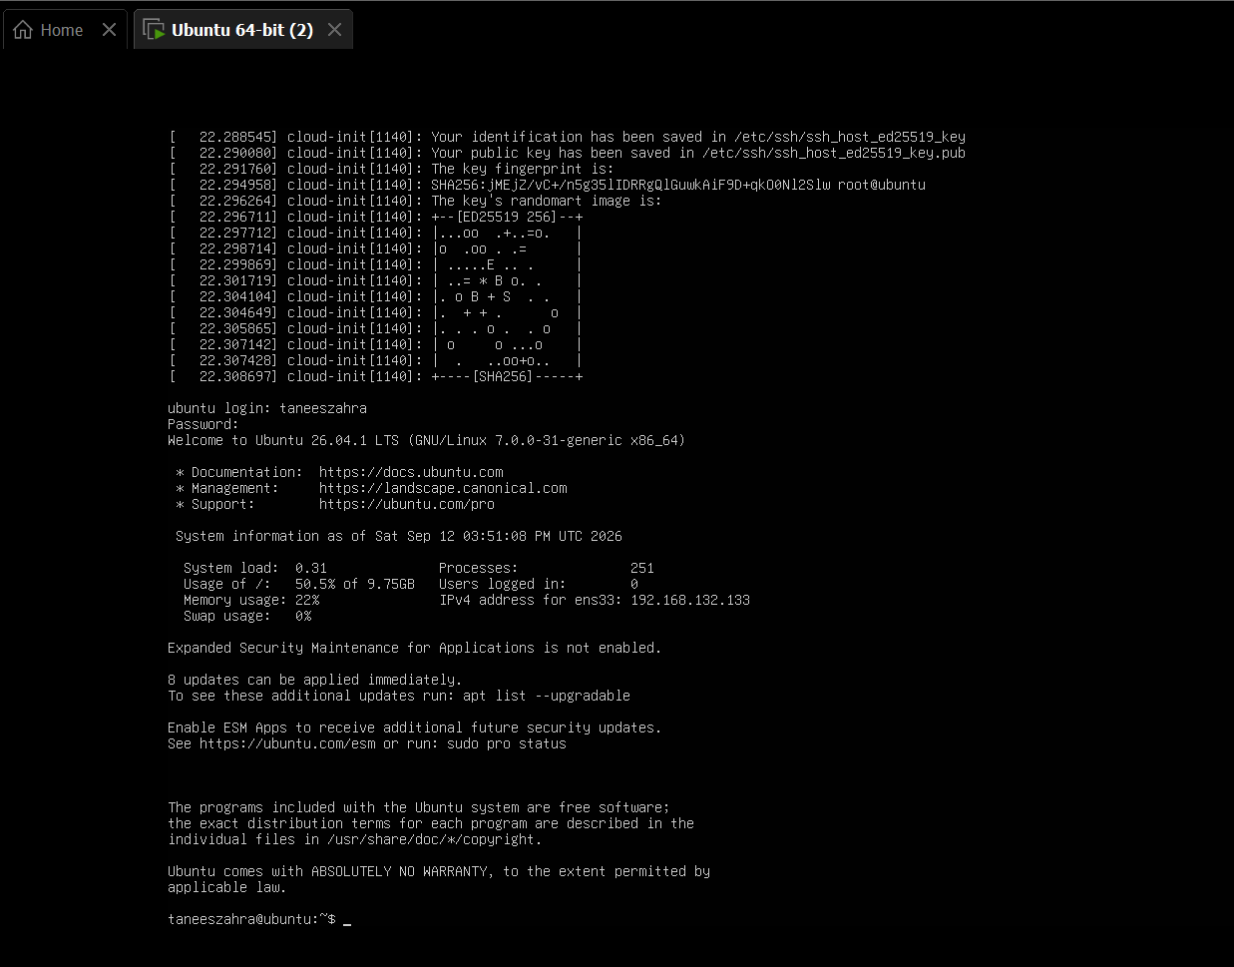
Task 16: Find the Ubuntu Server IP Address
Terminal output displaying the execution of the ip addr command to inspect network interfaces.
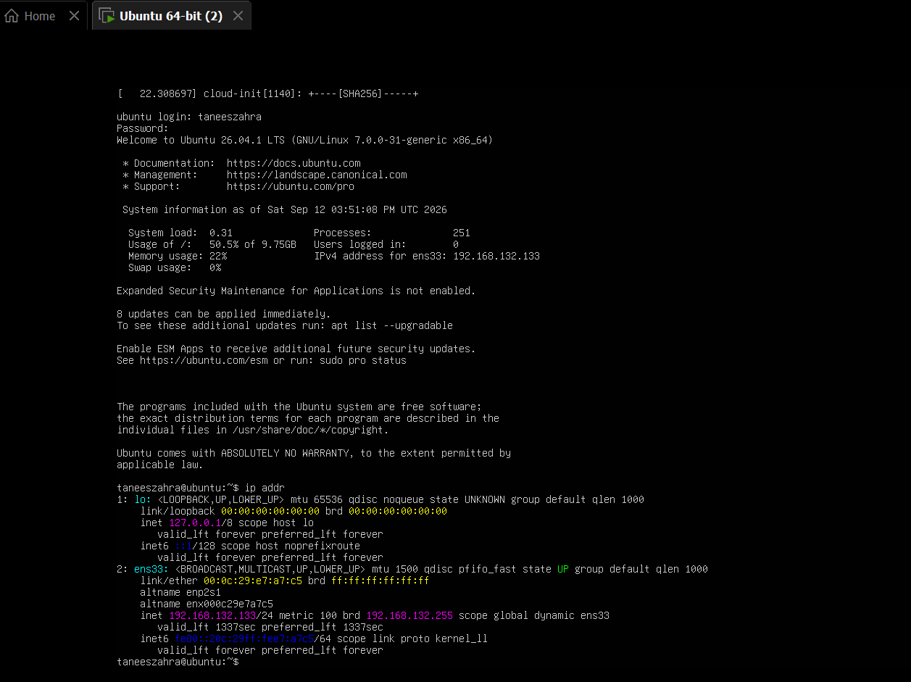
Terminal view highlighting the active IPv4 address assigned to the server's network interface.
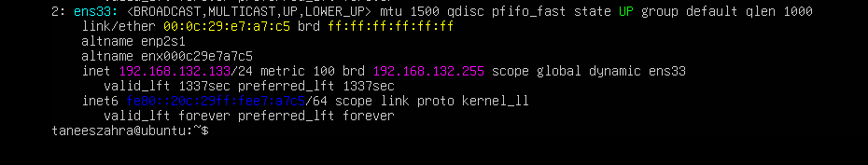
Task 17: Connect to Ubuntu Server from Windows
Windows Command Prompt showing the SSH connection command entered using the remote server's IP address.
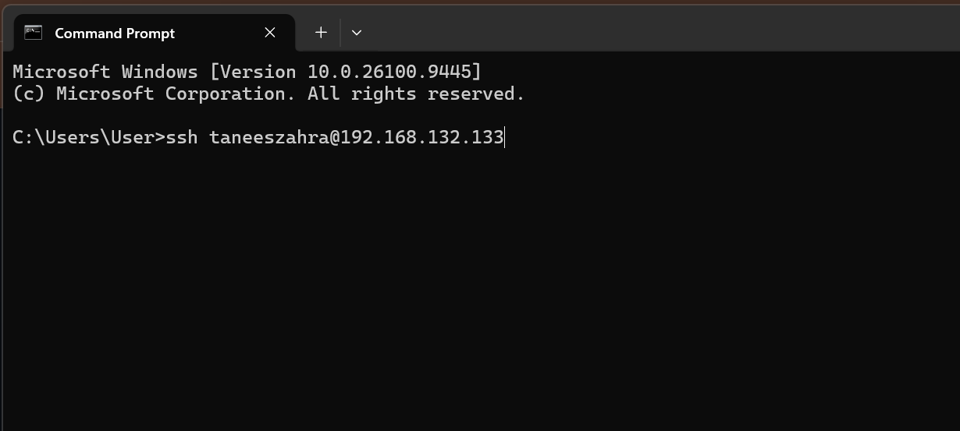
Terminal session displaying the prompt to accept the remote server's authenticity fingerprint.
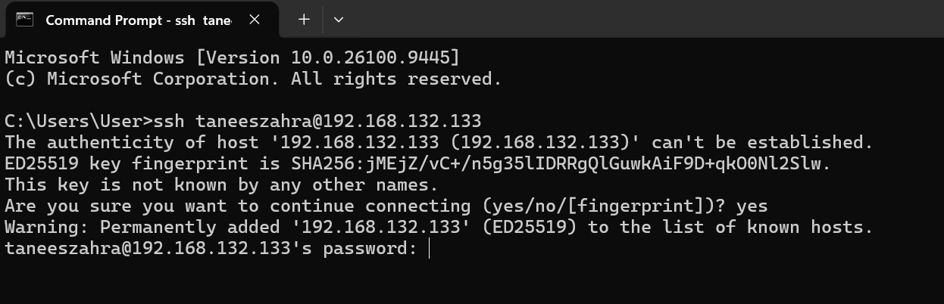
Successful remote SSH session established from the Windows host to the Ubuntu Server.
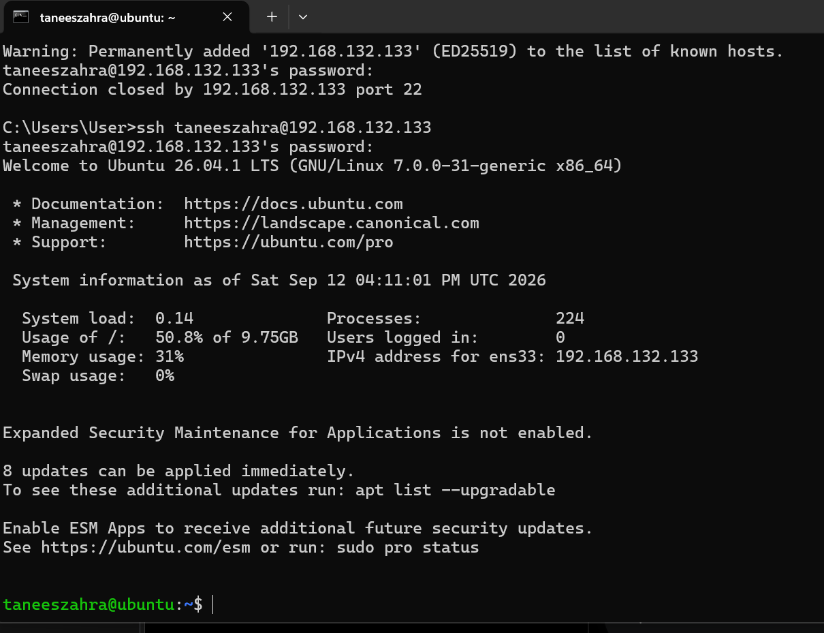
Remote terminal prompt verifying the correct authenticated user identity and server hostname.
