**Steps To Install AWS CLI on local Windows machine**

1. Navigate to - <https://docs.aws.amazon.com/cli/latest/userguide/getting-started-install.html>
2. Expand Windows:-

1. Under the heading – Install or Update the AWS CLI, you will be presented with 2 options
   1. Download and run the AWS CLI MSI installer for Windows (64-bit):
      1. <https://awscli.amazonaws.com/AWSCLIV2.msi>
   2. Run the msiexec command to run the MSI installer.
      1. msiexec.exe /i <https://awscli.amazonaws.com/AWSCLIV2.msi>
2. For my installation, I would go with the first option. I will run the msi file.
3. After downloading AWSCLIV2, double click on the file and click Next : -

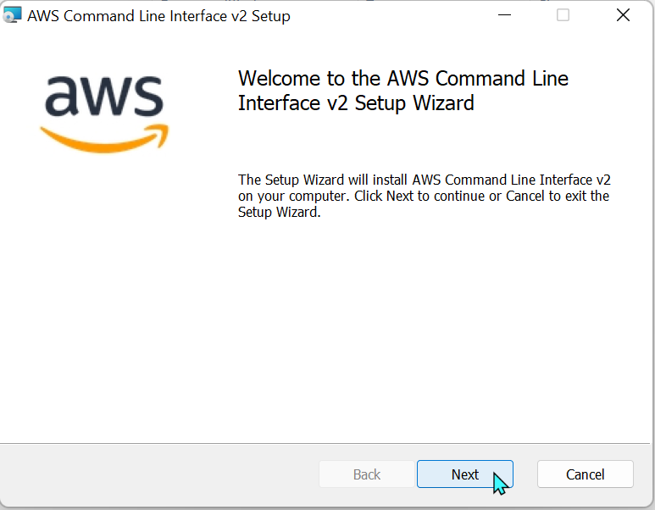

1. Read through the License agreement. Check the “I accept the terms in the License agreement” checkbox and click Next.

1. Choose the location where you want the AWS CLI to be installed.

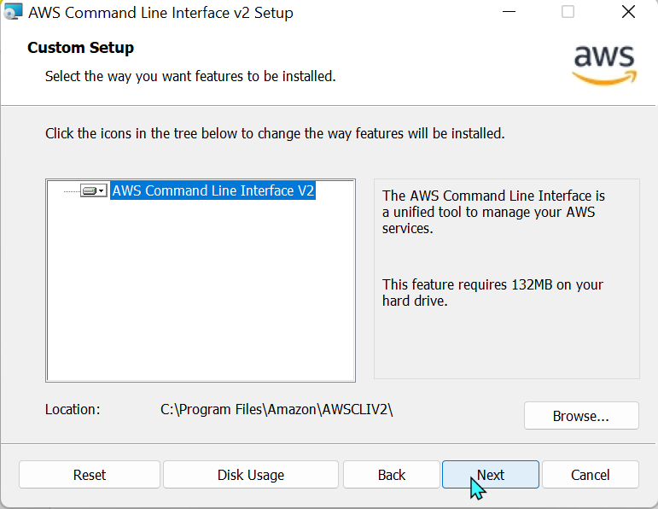

1. Click Install.

1. Wait for the program to be installed

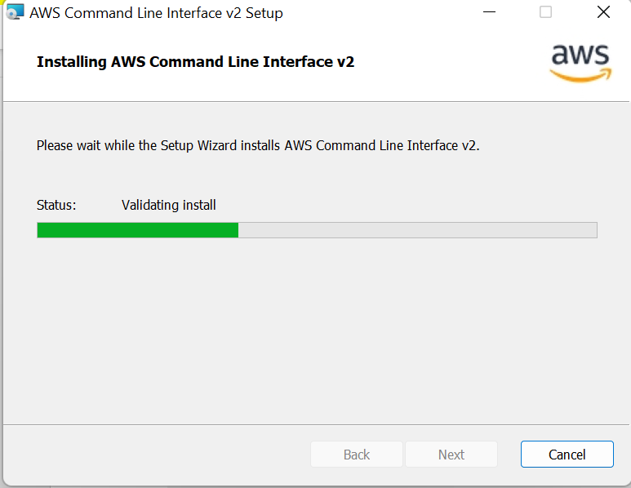

1. Click Finish.

1. To confirm that AWS CLI has been installed successfully, open the Start menu, open up a command window prompt. Type aws –version. You should notice that it returns back the version of the AWS CLI installed.

