|  |  |
| --- | --- |
| **Topic** | ORACLE Analytic SQL |
| **Document Name** | AnalyticSQL01-EX-01-05 |
|  |  |

## Exercise EX -01:

**Definiton :** 1-List employees’ first name and last name in same department in one row.  
 Firstname Lastname; Firstname Lastname ;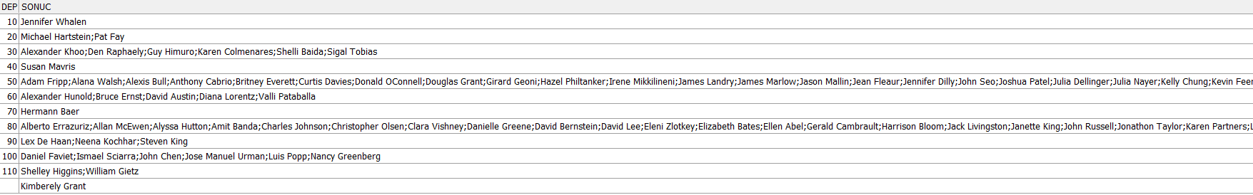

**SQL:**

SELECT DEPARTMENT_ID, LISTAGG(FIRST_NAME || ' ' || LAST_NAME,',')

WITHIN GROUP (ORDER BY DEPARTMENT_ID) AS employees FROM hr.employees GROUP BY

department_id;

**Screenshot:**

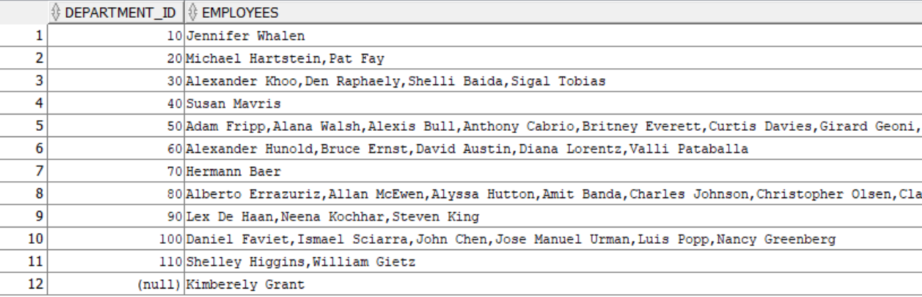

## Exercise EX -02:

**Definiton :** Write a SQL statement that shows employees’ preceeding 1 and following 1 salary totals in same job_id and ordered by hiredate.

**SQL:**

SELECT employee_id, first_name, last_name, job_id, salary,

LAG(salary, 1, 0) OVER (PARTITION BY job_id ORDER BY hire_date) +

LEAD(salary, 1, 0) OVER (PARTITION BY job_id ORDER BY hire_date)

AS salary_total FROM hr.employees

ORDER BY job_id, hire_date;

**Screenshot:**

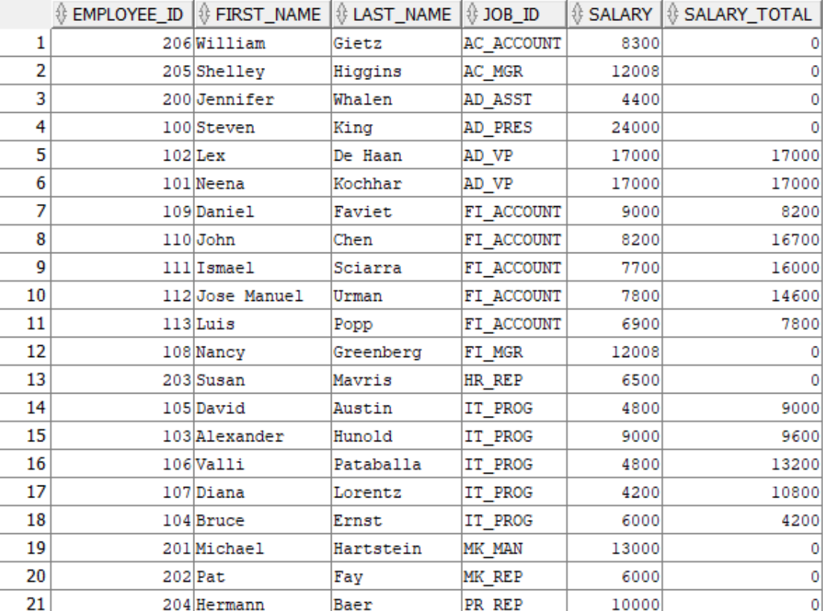

## Exercise EX -03:

**Definiton :** List employees’ salary orders in their department and exclude higest salaried employee.

(Hint: ROW_NUMBER)

**SQL:**

SELECT * FROM (

SELECT hr.employees.*,

ROW_NUMBER() OVER (PARTITION BY department_id ORDER BY salary DESC) AS salary_rank

FROM hr.employees

)

WHERE salary_rank > 1

ORDER BY department_id, salary_rank;

**Screenshot:**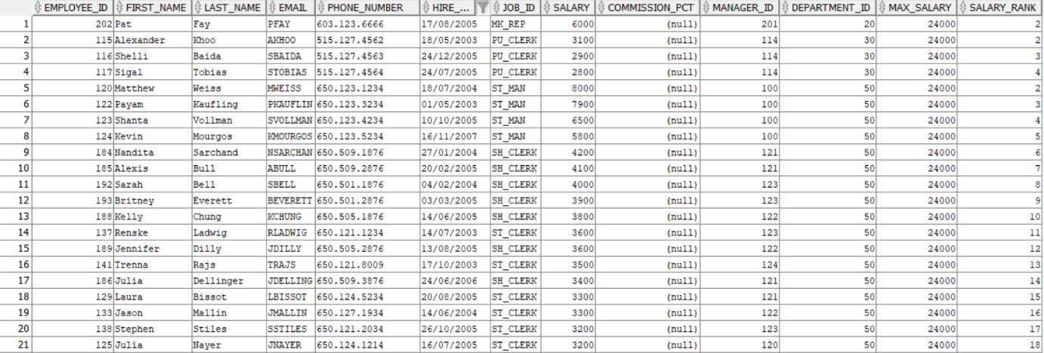

## Exercise EX -04:

**Definiton :** Listemployees’ hire order according to hiredate year value.

**SQL:**

SELECT employee_id, first_name, last_name, hire_date

FROM hr.employees

ORDER BY EXTRACT(YEAR FROM hire_date), hire_date;

**Screenshot:**

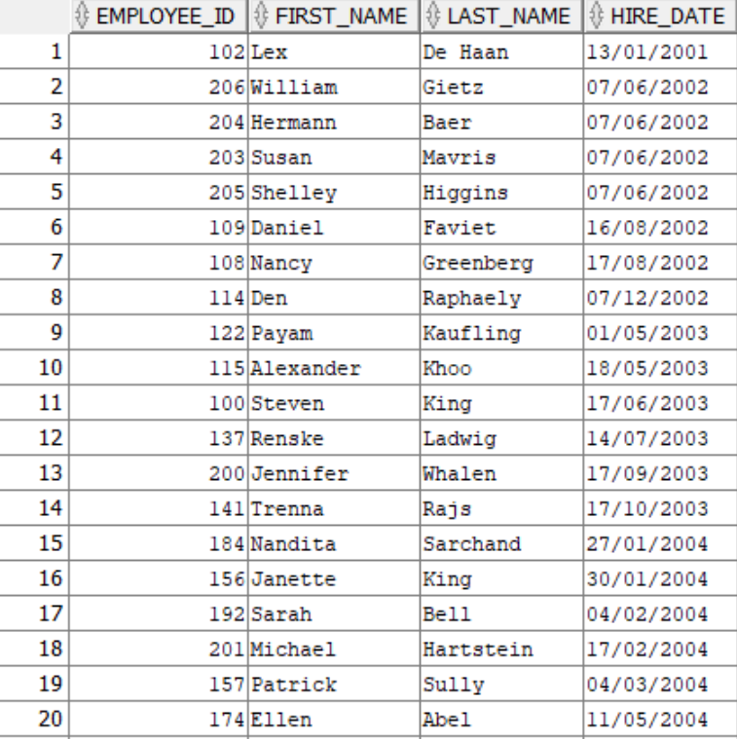

## Exercise EX -05:

**Definiton :** List employees’ firstname, lastname, salary and salaries of employees’ hired before and after this employee according to hirededate.

**SQL:**

SELECT first_name,last_name,salary,

LAG(salary) OVER (ORDER BY hire_date) AS previous_salary,

LEAD(salary) OVER (ORDER BY hire_date) AS next_salary

FROM hr.employees

ORDER BY hire_date;

**Screenshot:**

metin, menü, sayı, numara, ekran görüntüsü içeren bir resim

Açıklama otomatik olarak oluşturuldu