

**Software Engineering, Department of Computer Engineering**

**Boğaziçi University**

March 2018

By Taner Eşme

**Project - 1**

QA – Questions & Answers

Table of Contents

1. Introduction 3

2. Mockups 3

2.1 Login 3

2.2 Dashboard 4

2.3 Answers of a Question 5

2.4 Give Answer to a Question 6

2.5 Ask a New Question 7

3. Designs 8

3.1 System Logical Design 8

3.2 Software Logical Design 9

4. Workflows Diagrams 10

4.1 Login 10

4.2 New Question 11

5. Sequence Diagrams 12

5.1 Login 12

5.2 New Question 13

DB Diagrams 14

# Introduction

In this document, you will find the technical designs, user interface mockups and UML diagrams of a question – answer application.

In this application, every user that is registered to the system will ask questions and give answer to the questions that they desired.

# Mockups

## Login

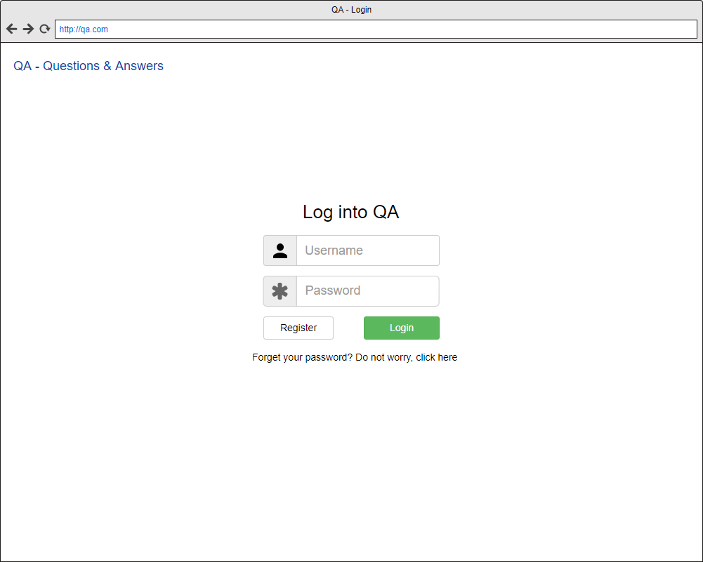

## Dashboard

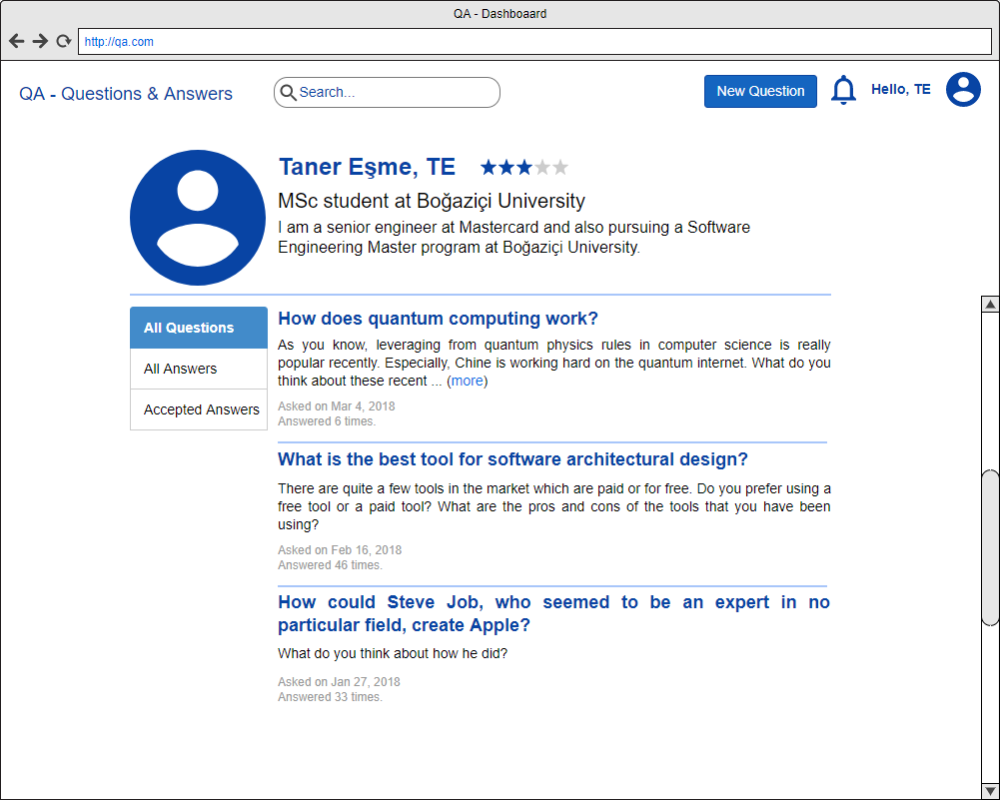

## Answers of a Question

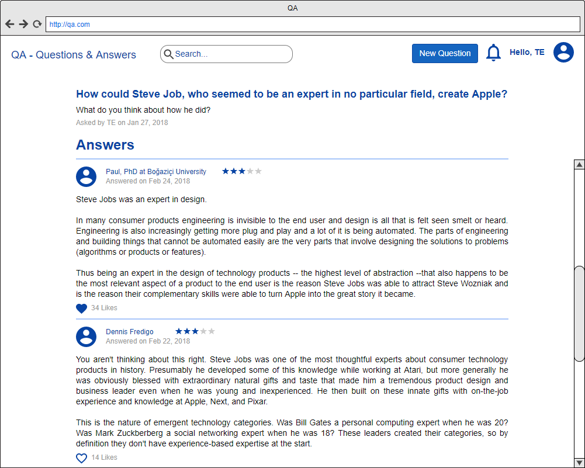

## Give Answer to a Question

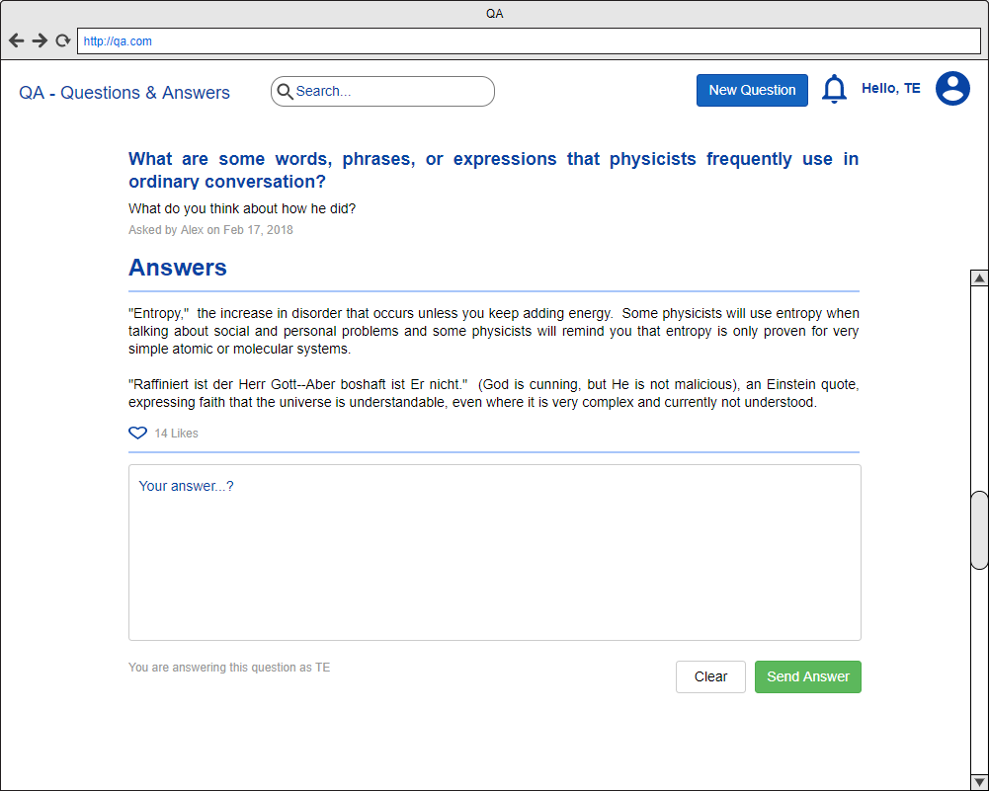

## Ask a New Question

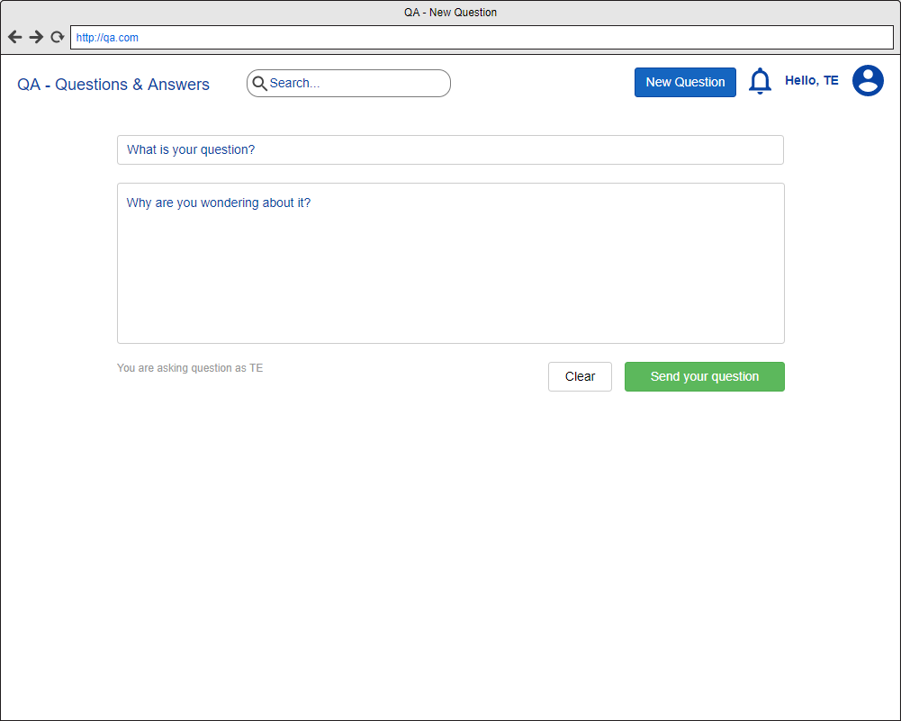

# Designs

## System Logical Design



## Software Logical Design



# Workflows Diagrams

## Login



## New Question



# Sequence Diagrams

## Login



## New Question



# DB Diagrams

