

**Software Engineering, Department of Computer Engineering**

**Boğaziçi University**

November 2018

By Taner Eşme

**KAIZEN FOR SOFTWARE**

**Contents**

1. Introduction 3

2. Kaizen Definition 3

3. Kaizen Philosophy 4

4. Kaizen Principles 5

5. 7 Types of Waste 5

6. Kaizen Event Process 7

7. How to implement Kaizen? 8

8. Conclusion 9

9. References 10

# Introduction

This report gives you information about my project of Kaizen for Software. At the beginning of the document, you will find the definition of Kaizen, its history and implementation areas in manufacturing. In the other sections, I am going to address the dynamics of Kaizen in software development and processes. The possible audience of this report is Associate Professor Alper Şen.

# Kaizen Definition

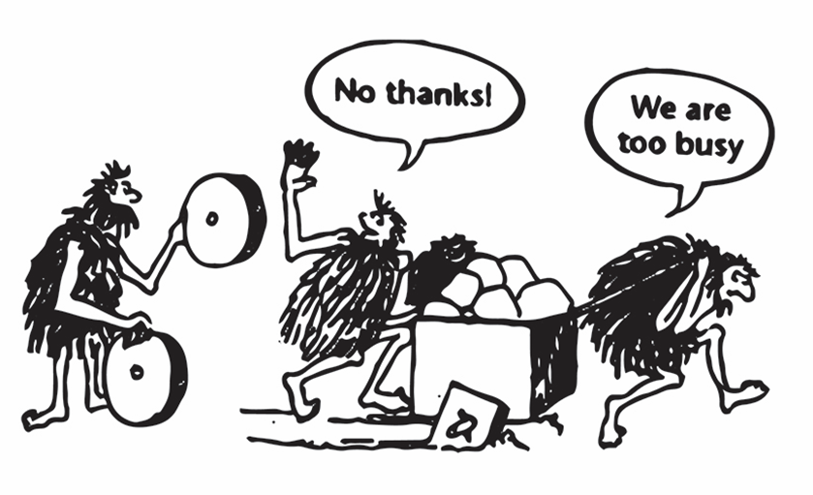

“If you are not getting better, you are getting worse!” said Pat Riley, the former NBA Coach. What we should get from this sentence is that simply you cannot stay on the same spot because your competitors are continuously getting better and better and passing you by. You also must continuously improve.

Kaizen is a Japanese word that means gradual and orderly continuous improvement. In the late 1940s, after World War II, Edward Deming, who was the architect of the improvement performed in the American manufacturing process, came to Japan to help them find the way how they can rebuild the manufacturing organizations. Edward Deming recommend they ask themselves a simple question every day to produce great products, “What extremely small step can I take to improve the process or product?”. In the following years, the Japanese adopted the Deming’s philosophy and gave it a name, Kaizen. By the implementation of Kaizen, Japan rose up from the ruins of World War II and got a powerful and competitive manufacturing country around the world.

It is an application of quality circles where the whole company from CEO to the lowest level workers involved to analyze the works they were doing on a regular basis and come up with new ideas to improve them.

Kaizen might be used in all business activities, not only in manufacturing but also in services, safety, new product development and every part of the organization. In a nutshell, it is a mindset that can be applied anywhere, at any job.

# Kaizen Philosophy

Basically, Kaizen is a way of thinking that guides individuals and organizations to higher levels of efficiency, quality, and success. It is a process-oriented thinking, as an opposite to the result-oriented one favored by the Western companies.

With a Kaizen philosophy, you are not trying to make the process perfect, you are simply trying to make it a little better. According to Kaizen, continuous improvement should be part of the daily activity of everyone and the company philosophy that guides the way every employee work.

Speaking of the improvement, it can be divided into two components such as Kaizen and innovation. It is quite obvious that improvement might be attained by innovation, but innovation means huge leaps while Kaizen is small steps.

[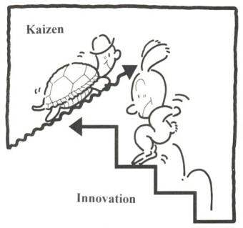](https://www.google.com/url?sa=i&rct=j&q=&esrc=s&source=images&cd=&cad=rja&uact=8&ved=2ahUKEwjn0IiRsvDeAhUYHDQIHZAhAVkQjRx6BAgBEAU&url=https://commons.wikimedia.org/wiki/File:Innovation_kaizen.jpg&psig=AOvVaw3OuOCILVCrOVkL31VzXQis&ust=1543264244844240)At first glance, the small, iterative changes in Kaizen may look insignificant, but in long-term, they are able to result in significant improvements. In contrary, with the innovation-approach for improvement, the results are seen fast, and large changes are implemented. Kaizen is continuous and a never-ending process while innovation is periodic and the changes implemented from time to time.

To make innovation, a specific qualified group of people should work on improving and rebuilding the product and services whereas in Kaizen all the individuals in the company are involved in the process of improvement. Furthermore, each of the employees working at Toyota production line is able to stop the production at any time when they see a problem or have any suggestions to the management to reduce the waste and improve the efficiency.

# Kaizen Principles

When we reduce Kaizen from philosophy to action, we need some principles to guide us.

1. **Big Picture:** Kaizen advocates that good processes result in good outputs. It is not only sufficient that one of the departments or teams do their work very well, if any of them is carrying out poorly then there is a fault with respect to the process, not people.
2. **Look for an opportunity to improve:** If there is no problem, it means that the improvement is not something possible. That’s why you should look for problems to solve and improve and get a mindset of that “There is always a better way to do something”.
3. **Teamwork:** Kaizen cannot be performed by only one person, it involves in each member of the organization. The only way to build a Kaizen environment is to first create a trust among employees and the organization.
4. **Focus on progress and not perfection:** Kaizen says that perfection should not be an objective if you believe that there is always something to be improved then the perfection is an illusion. Therefore, we cannot claim for something that it is entirely wrong or right and we should be moving forward.
5. **Debottleneck:** It is a principle, which is a called Gemba Approach, of going to the workplace and seeing in person what is happening in the business. If a manager is not going to Gemba, they cannot improve anything. Kaizen guides a business to detect improvement points and wastes through three Mus (3Mu’s).

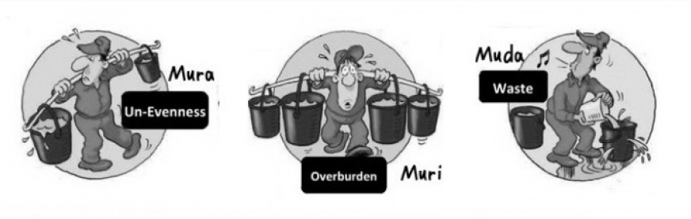

If you want to identify where you can improve in your process or practice, observe these three Mus.

# 7 Types of Waste

Kaizen provides 7 types of waste and everyone in the Gemba should be looking for those 7 things.

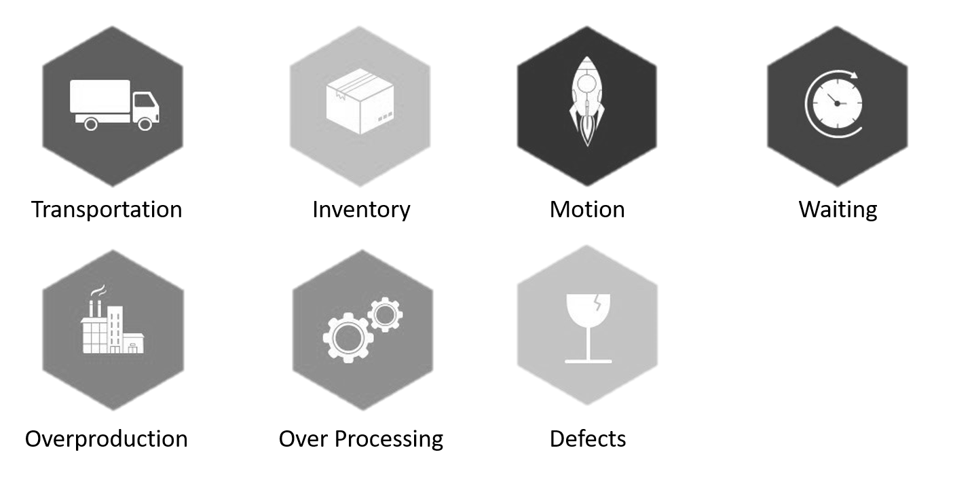

1. **Overproduction:** Overproduction can be adding in features and processes that will never be needed or not needed right away to support the current version of the software.
2. **Transportation:** Transportation is the movement of the people between desks and buildings (distance between the data centers) and the material being transported between locations. These are considered within this type of waste that does not add any value to the product. If you are able to code, build and deploy one at a time without the software transferring delays, you will have a better software product.
3. **Inventory:** Kaizen does not want us to store the materials between processes. If a material was produced it should be shipped to the customer or another process without storing. In software development, any ongoing project or a part of a project that you are taking part in might be considered as an inventory. Because it is not shipped yet and there is someone still working on it.
4. **Over-processing:** Over-processing is to do something or some of the things more than needed and expected. Writing the longer code than it needs to be done or adding extra – redundant lines of code, unnecessary steps in the software development process and also meetings are the forms of over-processing for a software developer.
5. **Motion:** Motion is the body movement of the people when they are doing something. If you have to move your hand on the keyboard more, move the piece of code you developed when building a software it is a waste of motion that costs you time (money).
6. **Waiting:** It is to wait for something to be provided or completed. The times that you are waiting for your code being compiled and running tests before viewing the results of what you did might be considered as examples of this type of waste.
7. **Defects:** Defects are the quality errors that cost you far more than you expect because every defect needs rework or replacement and it causes to waste resourced and materials. In the software development process, defects are bugs and bad code. The quality of software products can be improved at where standardization, better tools, procedures, and processes are in to prevent the defects instead of detecting them, better to prevent than try to detect them.

# Kaizen Event Process

A Kaizen event is an action performed to improve an existing process. It is a short-term effort – like 5 days – to carry out small, companywide improvements whereas Kaizen means small, short, and daily improvements.

An example of a Kaizen event would break all employees up into groups of 5 to 10 people. You call these small groups Kaizen teams. You then give all Kaizen teams the project of improving a part of some process within the company.

A Kaizen event might be focusing to achieve to:

* Reduce the number of defects by 25%
* Cut down on the time employees spend waiting for approvals from information security by 50%
* Shorten lead time for a change-request by 10%

Once a goal established and a team is convened to solve the problem or improve the process, this team spends their allocated times focusing on the current situation to solve the problem, to analyze the existing situation, sometimes 5-Whys – is a technique to get the root cause of the problem by asking “why” questions – is used.

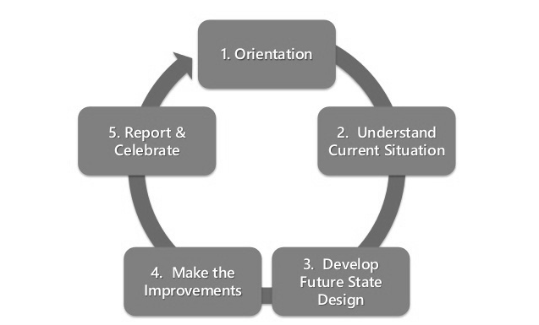

Kaizen event process might be constituting a cycle like above.

1. **Orientation:** Introduction to the Kaizen event, the organization of the Kaizen team, identification of customer and objectives are carried out as well as prioritization, determining deadlines, goals, and work requirements.
2. **Understand Current Situation:** The process is visualized and discussed by using the tools such as flowcharts to understand the current situation and also root causes for the wastes or issues and control points are identified.
3. **Develop Future State Design:** After understanding the situation and identifying the root causes, new model of the process – the improved one – can be proposed.
4. **Make the Improvement:** It is time to implement the proposed improvements. In this phase, the steps below are conducted.
5. The implementations are planned and executed.
6. Results are measured and evaluated according to the control points identified.
7. The improved process is standardized.
8. **Report & Celebrate:** After completing the improvements, all accomplishments are documented, shared, and finally the people contributing to the event are celebrated and rewarded.

# How to implement Kaizen?

If you want to implement Kaizen and attain a continuous improvement culture in your organization, here are 7 steps to be followed.

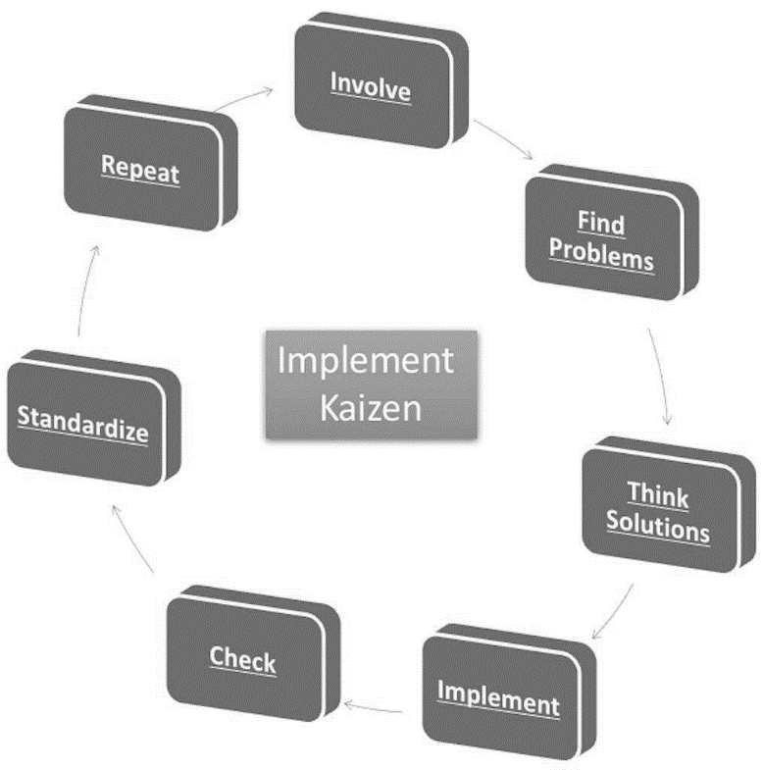

1. **Involve:** The cycle begins with analyzing the issues and problems to be improved. The involvement of the employees from the first step is very important for the feedbacks and empowerment. To implement the changes seamlessly, you need the employees motivated and a workplace allowing the changes.
2. **Find Problems:** This step is to admit and find the problems that you have in your organization by making use of the employee involvement and feedbacks. In this step, all the processes that need to be improved might be listed but all the improvement needed do not have to be implemented all together, a subset of the improvements can be selected to proceed.
3. **Think Solutions:** Managers allow the employees, who will be responsible for solving the problems, to dedicate their time to focus on the solutions in a relaxed and creative manner. During this step, all the proposed solutions should be written down because they can be used after.
4. **Implement:** Starting with small implementations is a better way to test them out and the implementations should be planned and worked first on the table before getting them off the ground. In this way, the results of the solution can be tracked and measured.
5. **Check:** After completing the implementations, the results should be checked in whether they brought any improvement or not.
6. **Standardize:** If the checked results were not positive then you should go back to step 3 and fetch another solution. If the results were positive then it is time to make the implementation as a standard part of the process across all departments so that the organization can run more efficiently. The best benefit of Kaizen is the standardization.
7. **Repeat:** We implemented the subset of the improvements that we have selected in step 2 and now we can repeat the same steps by selecting another subset of the improvements.

Over a period of time, Kaizen will be a culture in the organization to eliminate the waste and continually improve the processes by leveraging the cycle above. The Patience, empowerment, and vision of the future are crucial to the implementation of the cycle.

# Conclusion

Kaizen means continual small improvements that result in improved productivity and quality, better safety and faster delivery, lower costs and more satisfied customers. It also reduces the waste of employee skills, down-times, and unnecessary motions in the processes.

Kaizen works to improve two things: Processes and end results such as products and services. End results cannot be improved without improving the processes that create them.

Start small and take small steps!

# References

* *Continuous Improvement Quotes.* (2018). Retrieved from <http://www.1000ventures.com/business_guide/crosscuttings/quotes_improvement_continuous.html>
* *Chapter 7 SCO Terms Flashcards | Quizlet.* (2018). Retrieved from <https://quizlet.com/130537840/chapter-7-sco-terms-flash-cards/>
* *Get Better at Getting Better: The Kaizen Productivity Philosophy.* (2018). Retrieved from <https://lifehacker.com/get-better-at-getting-better-the-kaizen-productivity-p-1672205148>
* *The Programmer's Path to Kaizen - Simple Programmer.* (2018). Retrieved from <https://simpleprogrammer.com/kaizen-developers/>
* *Kaizen – Wikipedia.* (2018). Retrieved from <https://en.wikipedia.org/wiki/Kaizen>
* *Kaizen | Creative Safety Supply.* (2018). Retrieved from <https://www.creativesafetysupply.com/articles/kaizen/>
* *The Japanese philosophy of Kaizen can reinvent your daily routine — Quartz at Work.* (2018). Retrieved from <https://qz.com/work/1183536/the-japanese-philosophy-of-kaizen-can-reinvent-your-daily-routine/>
* *The principles of Kaizen. (2018).* Retrieved from <https://www.linkedin.com/pulse/principles-kaizen-kannan-ls>
* *The Secret behind Failure of Lean and Success of TPS.* (2018). Retrieved from <https://www.linkedin.com/pulse/secret-behind-failure-lean-success-tps-kannan-ls?trk=hp-feed-article-title-publish>
* *The Seven Wastes | 7 Mudas | Lean Manufacturing Tools.* (2018). Retrieved from <http://leanmanufacturingtools.org/77/the-seven-wastes-7-mudas/>
* [Productivity Games]. (2017, Mar 16). *The Kaizen Way: ONE SMALL STEP CAN CHANGE YOUR LIFE by Robert Maurer* [Video File]. Retrieved from <https://www.youtube.com/watch?v=VHkOFs67d9A>
* [Flevy.com - Business Frameworks]. (2014, Jul 16). *Kaizen Event Guide* [Video File]. Retrieved from <https://www.youtube.com/watch?v=yYGdWYmkvks>