**Software Engineering, Department of Computer Engineering**

**Boğaziçi University**

April 2018

By Taner Eşme

**PROGRESS REPORT OF THE SURVEY ON “SOFTWARE ENGINEERING FOR MESSAGE PASSING PARALLEL CLUSTERS”**

**Introduction**

This report gives you information about the progress of my survey project for SWE578. As you might remember, my survey project was an investigation on software engineering for message passing parallel clusters. This report will first present preliminary findings that I have completed so far about my survey. Then, it will address the remaining topics uncovered so far. The third section of the report is conclusion part.

**Completed Research**

First of all, I have started my research by trying to find a definition for the terms of “message-passing” and “computer clusters”. According to Wikipedia [1], message-passing is “a technique for invoking behavior (i.e. running a program) on a computer. The invoking program sends a message to a process and relies on the process and supporting infrastructure to select and invoke the actual code to run”. Besides of this definition, according to IBM [2], a computer cluster is “a group of servers and other resources that are connected through hardware, networks, and software to behave as if they were a single system”.

I have continued my research by investigating the history of cluster computers and fundamental attributes of them.

The preliminary research showed that although the date of the first cluster computer invented is unknown, it is known that the development of the cluster computers is underpinned by packet switching networks that conceptually invented by the RAND Corporation in 1962. The packet switching concept made it possible for the Internet in the manner that we know today and the Internet can be considered as the mother of all computer clusters, but the essential reason causing computer clusters to thrive is the development of Parallel Virtual Machine (PVM) software, which was an open source software based on TCP/IP communication, in 1989 [3]. The first computer cluster made out of commodity computers, which were inexpensive network PCs, was Beowulf cluster, which was a NASA project to build a supercomputer [4].

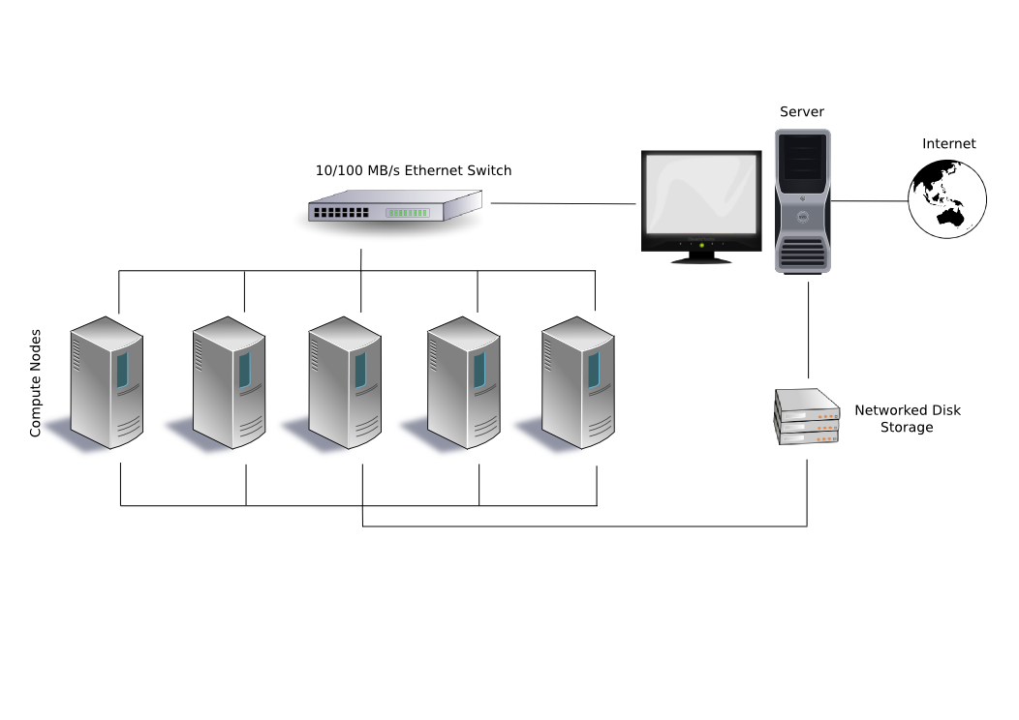

Figure 1 a typical Beowulf Cluster Configuration [5]

The Beowulf configuration that you see above is a system which constitutes of one server node, which controls the whole cluster and is a gateway to the general purpose network of the organization, and five dummy client nodes connected each other via a switch. Also, they have a disk-less configuration, they share the same storage devices. Finally, Beowulf is a technology of clustering computers to form a parallel, virtual supercomputers [6].

**Remaining Research**

First, I will granulate into the details of the attributes of computer clusters such as high availability and load balancing. Then, I will look at where and how the computer clusters are being used now to solve real-life problems.

Second, I will address the message passing approaches, which are used in the communication between computers in a cluster, such as Parallel Virtual Machine (PVM) and Message Passing Interface (MPI). I think also to put a few pseudo codes to exemplify the implementation of message passing methods.

Third, I will review the literature on the concept of testing multi-core algorithms.

**Conclusion**

This progress report updated you on the status of my survey on software engineering for message passing parallel clusters. I am on schedule so far and complete the survey by the deadline, May 14, 2018.

**References**

**[1]** *Message Passing*. (2018). Retrieved from <https://en.wikipedia.org/wiki/Message_passing>

**[2]** *Clustering: A basis 101 tutorial*. (2018). Retrieved from <https://www.ibm.com/developerworks/aix/tutorials/clustering/clustering.html>

**[3]** History of computer cluster. (2018). Retrieved from <https://en.wikipedia.org/wiki/History_of_computer_clusters>

**[4]** Overview – History (2018). Retrieved from <http://www.beowulf.org/overview/history.html>

**[5]** Computer Cluster (2018). Retrieved from <https://en.wikipedia.org/wiki/Computer_cluster>

**[6]** Beowulf Cluster (2018). Retrieved from <https://en.wikipedia.org/wiki/Beowulf_cluster>