**Software Engineering, Department of Computer Engineering**

**Boğaziçi University**

November 2017

By Taner Eşme

**PROGRESS REPORT OF THE SURVEY ON “DELIVERING SMART CITY EXPERIENCE”**

**Introduction**

This report gives you information about the progress of my survey project for SWE577. As you might remember, my survey project was an investigation on delivering smart city experience. This report will first present preliminary findings that I have completed so far about my survey. Then, it will address the remaining topics uncovered so far. The third section of the report is conclusion part.

**Completed Research**

First of all, I have started my research by trying to find a definition for the term of “smart city”. However, there is no exact definition. According to Wikipedia [1], a smart city is “an urban area that uses different type of electronic data collection sensors to supply information used to manage assets and resources efficiently”.

I have continued my research by investigating the changes in the population of cities throughout history. After obtaining some details about urbanization, I have studied the problems of cities and the people living in cities, and

The preliminary research showed interesting knowledge. For example, while the world population remains less than one billion until 1804, it increases dramatically in the following years [2]. Agricultural and Industrial Revolution, which began in England, was one of the reasons of this population growth by increasing the life expectancy of children and Industrial Revolution also accelerated the urbanization with the emergence of factories that contributed to the migration of vast number of labors from rural areas into cities in search of work in the factories [3]. Now, according to the United Nations World Urbanization Prospects report, more than half of the world population lives in cities [4]. The facilities of cities led to their challenges, which affects the quality of life of people living in cities, such as urban density, environmental impact, increased traffic congestion, overburdened healthcare system. The following six main pillars underpin the solutions of smart city approaches trying to solve these challenges [5]:

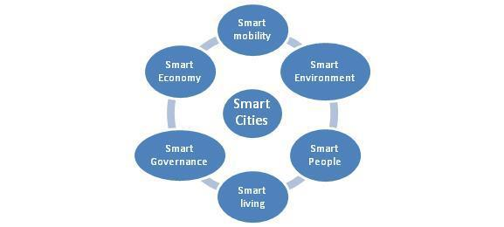

Figure 1 Six main pillars of smart cities [4]

I have also spent my most of time to identify the cases trying to solve the problems of cities by using smart city approaches and their techniques. I identified two separate cases, which are Singapore and Amsterdam, take advantages of the technological developments in order to improve the quality of their citizen’s life within the concept of smart cities.

The technologies that are used by those two cities for delivering smart city experience to their citizen are ICT (Information and Communications Technologies), IoT (Internet of Things) and Data Analysis [6].

**Remaining Research**

First, I will granulate into details of the challenges that are undergone in the cities by their citizen such as urban density, environmental impact, increased traffic congestion, overburdened healthcare system. Then, I will look at what the smart city approaches, which are the six main pillars, propose to solve these problems.

Second, I will address the two use-cases of delivering smart city experience, Singapore and Amsterdam, in the concept of what technologies they use, what kind of hardware system they utilize, what software they have and what they pay attention. If I discover the different type of technologies proposed in the smart city concept, I will discuss them as well.

**Conclusion**

This progress report updated you on the status of my survey on delivering smart city experience. I am on schedule so far and complete the survey by the deadline, December 18, 2017.

**References**

**[1]** *Smart City*. (2017). Retrieved from <https://en.wikipedia.org/wiki/Smart_city>

**[2]** *World Population*. (2017). Retrieved from <https://en.wikipedia.org/wiki/World_population>

**[3]** *Industrial Revolution*. (2017). Retrieved from <https://en.wikipedia.org/wiki/Industrial_Revolution#Factories_and_urbanisation>

**[4]** Sun, Jianjun & Yan, Jiaqi & Zhang, Kem. (2016). Blockchain-based sharing services: What blockchain technology can contribute to smart cities. Financial Innovation. 2. . 10.1186/s40854-016-0040-y.

**[5]** Augustyn, Anna. (2017). Smart Cities – brand cities of the future’. .

**[6]** [TEDx Talks]. (2015, Dec 17). *How we design and build a smart city and nation | Cheong Koon Hean | TEDxSingapore* [Video File]. Retrieved from <https://www.youtube.com/watch?v=m45SshJqOP4>