ASSIGNMENT 4

Firstname Lastname

2010-02-14

# Markdown Basics

## Favorite Foods

1. Pizza
2. Tacos
3. Pad Thai

## Images

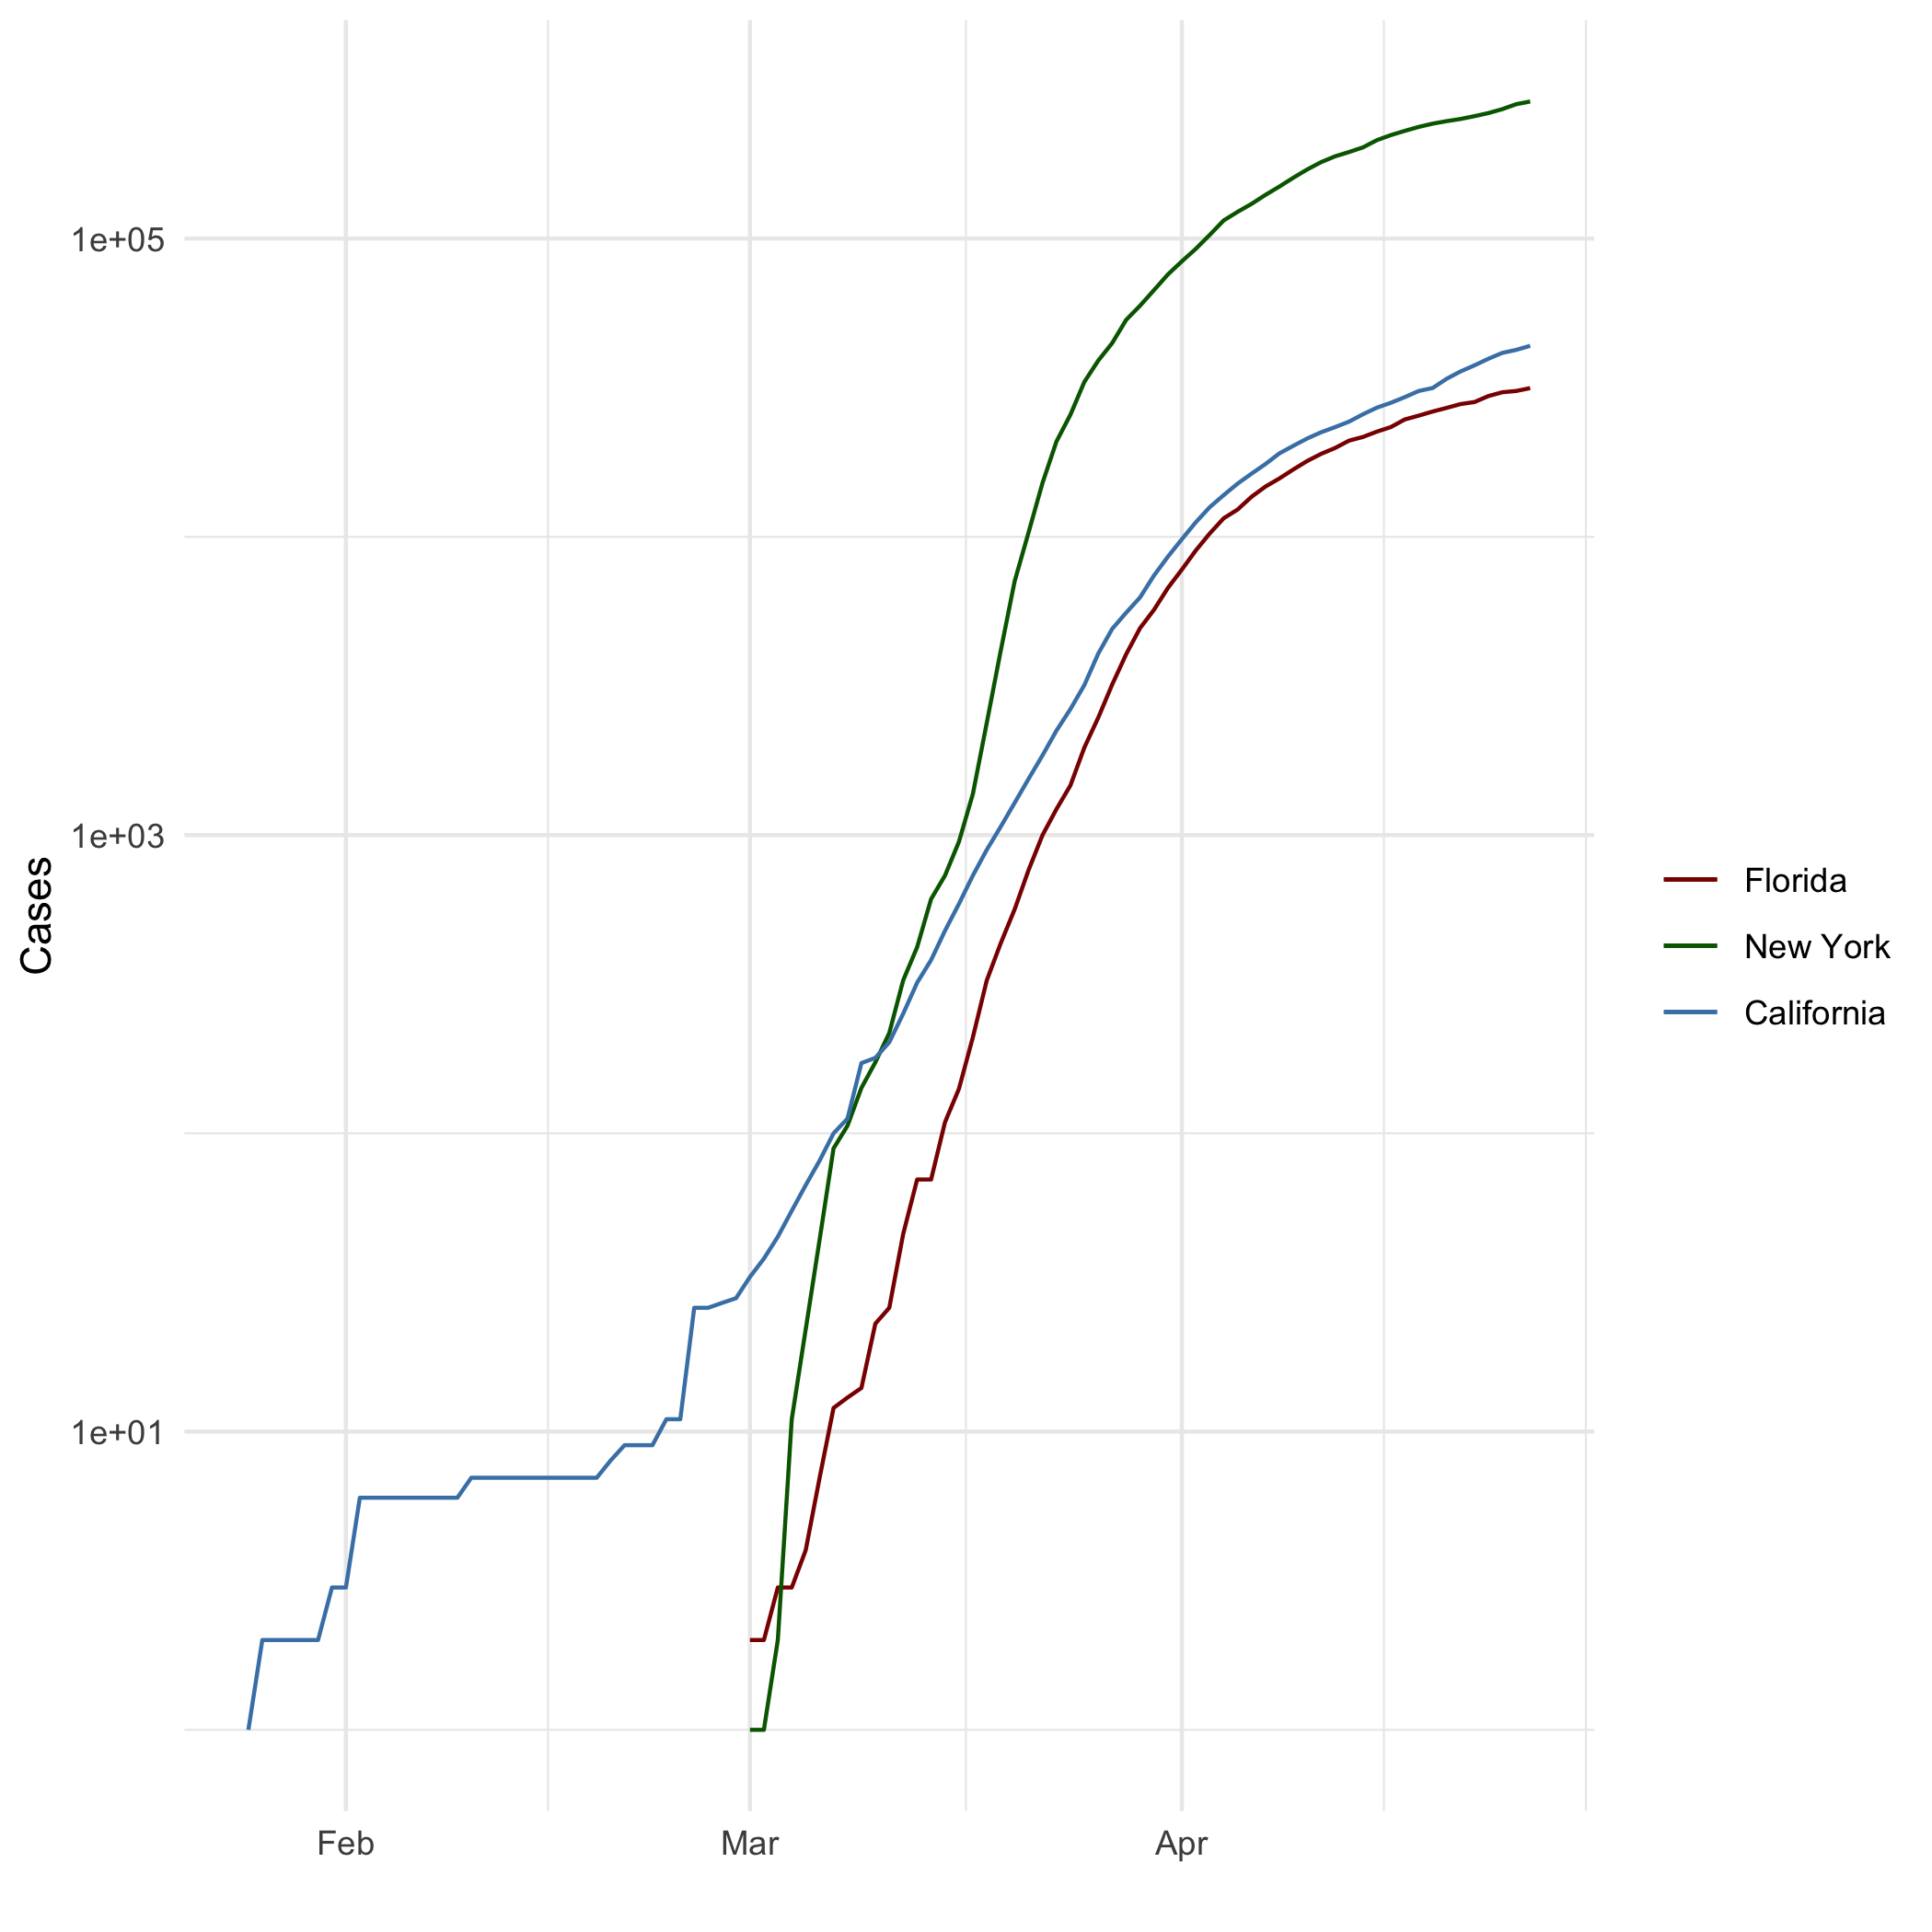

All Cases (Log Plot)

## Add a Quote

The path of the righteous man is beset on all sides by the iniquities of the selfish and the tyranny of evil men. Blessed is he who, in the name of charity and good will, shepherds the weak through the valley of darkness, for he is truly his brother’s keeper and the finder of lost children. And I will strike down upon thee with great vengeance and furious anger those who would attempt to poison and destroy My brothers. And you will know My name is the Lord when I lay My vengeance upon thee.

## Add an Equation

$P(A∣B)=\frac{P(B∣A) P(A)}{P(B)}$

## Add a Footnote

This is a footnote[1].

## Add Citations

* R for Everyone (Lander 2014)
* Discovering Statistics Using R (Field, Miles, and Field 2012)

# Inline Code

## NY Times COVID-19 Data

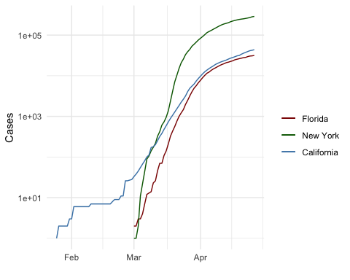

## R4DS Height vs Earnings

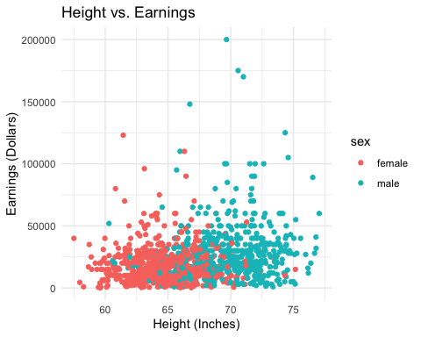

# Tables

## Knitr Table with Kable

One Ring to Rule Them All

|  |  |  |  |  |
| --- | --- | --- | --- | --- |
| name | race | in_fellowship | ring_bearer | age |
| Aragon | Men | TRUE | FALSE | 88 |
| Bilbo | Hobbit | FALSE | TRUE | 129 |
| Frodo | Hobbit | TRUE | TRUE | 51 |
| Galadriel | Elf | FALSE | FALSE | 7000 |
| Sam | Hobbit | TRUE | TRUE | 36 |
| Gandalf | Maia | TRUE | TRUE | 2019 |
| Legolas | Elf | TRUE | FALSE | 2931 |
| Sauron | Maia | FALSE | TRUE | 7052 |
| Gollum | Hobbit | FALSE | TRUE | 589 |

## Pandoc Table

|  |  |  |  |  |
| --- | --- | --- | --- | --- |
| Name | Race | In Fellowship? | Is Ring Bearer? | Age |
| Aragon | Men | Yes | No | 88 |
| Bilbo | Hobbit | No | Yes | 129 |
| Frodo | Hobbit | Yes | Yes | 51 |
| Sam | Hobbit | Yes | Yes | 36 |
| Sauron | Maia | No | Yes | 7052 |

# References

Field, A., J. Miles, and Z. Field. 2012. *Discovering Statistics Using R*. SAGE Publications. <https://books.google.com/books?id=wd2K2zC3swIC>.

Lander, J. P. 2014. *R for Everyone: Advanced Analytics and Graphics*. Addison-Wesley Data and Analytics Series. Addison-Wesley. <https://books.google.com/books?id=3eBVAgAAQBAJ>.

1. This is a footnote in R Markdown