Processing pipeline & Tools
Introduction
This section serves as a supplementary guide to assist researchers during the data processing phase. We provide practical suggestions and reference points to help streamline the workflow and improve analytical clarity. In addition, executable scripts for whole-brain voxel-wise quantitative susceptibility mapping (QSM) analysis are included, along with exemplar design matrices for statistical inference, to serve as practical templates for future studies.
1. Voxel-wise QSM processing pipeline
1.1 QSM reconstruction
For detailed examples of QSM reconstruction and associated code, please refer to the QSM consensus published by the ISMRM Electro-Magnetic Tissue Properties Study Group [1].
As recommended in the consensus, using two susceptibility references is advised to verify the stability of susceptibility estimates.
1.2 Normalization
Normalization is essential for voxel-wise analyses, as it enables inter-subject comparisons by aligning individual QSM images to a common standardized template space. The selection of normalization strategy can be guided by the following decision process:
Step1: Template Selection
- If a well-matched population template is available, use it directly.
- If no suitable template exists (e.g., in studies involving brain atrophy or special populations), a study-specific template should be constructed. Afterward, determine whether T1-weighted images (T1w) are available.
  - If T1w images are unavailable, a QSM-based template should be generated.
  - If T1w images are available, a group-level T1w template can be built.
Step2: Registration Strategy
- If T1-weighted images are available: decide whether to prioritize registration stability (or higher T1w resolution) or registration fidelity (or higher QSM resolution):
- To prioritize registration stability / higher T1w resolution: use a dual-parameter registration approach by registering the first-echo magnitude image to the T1w image, and registering the T1w image to the T1w template separately. After applying both transformation parameters, QSM images can be normalized to template space.
- To prioritize registration fidelity / higher QSM resolution: use a single-parameter registration approach by registering the individual’s T1w image to the first-echo magnitude image, followed by registering the transformed T1w image to the T1w template. The resulting single transformation can then be applied to normalize the QSM image.
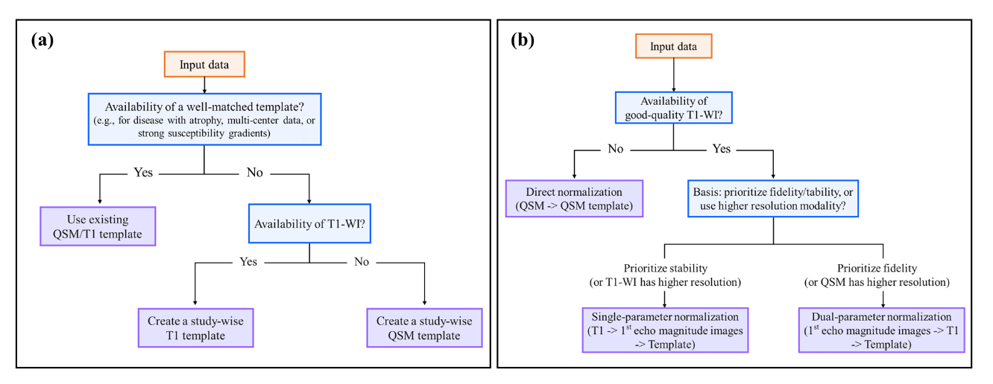
- If T1w images are unavailable, of poor quality, or exhibit poor alignment with the first-echo magnitude image: apply direct QSM-to-template registration by registering each subject’s QSM image directly to a QSM template.
Figure 1. Decision tree for template selection and QSM spatial normalization strategy. Single-parameter normalization: native T1-weighted images are first registered to the first (1st)-echo magnitude images, followed by aligning the registered T1-weighted images to a template space; the resulting transformation matrix can be directly applied to QSM images. Dual-parameter normalization: the first (1st)-echo magnitude images are first registered to native T1-weighted images, which are then aligned to a T1-weighted template; these two matrices are combined to normalize QSM images into a unified space. Direct normalization: native QSM images are directly registered to a QSM template.

1.3 Smoothing
A smoothing kernel of approximately two to three times the voxel dimension is typically recommended to meet the assumptions for voxel-wise inference. However, when investigating small anatomical structures, a smaller kernel may be preferred to preserve spatial specificity. For example, for QSM data with a 1×1×1 mm³ voxel size, a Gaussian kernel with σ = 3 mm may be used.
Smoothing compensation may also be applied by dividing the smoothed QSM image by a smoothed tissue mask, yielding a compensated map that retains smoothing benefits while reducing signal dilution [2].
1.4 Statistical mask selection
The choice between region-specific masks and whole-brain masks should be guided by biological relevance and statistical considerations. For studies focused on the cerebral cortex and deep gray-matter nuclei while excluding white matter, a gray-matter mask may be appropriate. In contrast, for fully exploratory analyses, a whole-brain mask should be employed.

2. Practical commend using QSMexplorer/ IronSmith/ QSMxT
The following sections outline general workflows for several commonly used toolboxes. Detailed operational guidelines and full step-by-step instructions can be found in their official online documentation and tutorials.
2.1 QSMexplorer [3](https://gitlab.com/acostaj/QSMexplorer)
- Operating System: Linux
- Required Software: MATLAB (https://ww2.mathworks.cn/products/matlab.html), SPM12 (http://www.fil.ion.ucl.ac.uk/spm), FSL (http://fsl.fmrib.ox.ac.uk), ANTs (http://stnava.github.io/ANTs), and DPABI (https://rfmri.org/DPABI) (optional, for visualization).
- Required data: QSM raw data and T1w images.
- Main Workflow:
  - QSM reconstruction. The QSM images need to be reconstructed using other software or platforms. Ensure the reconstructed QSM images and a matching brain mask have the same dimensions.
  - Organize input files. Convert the T1w images, magnitude images, QSM images, and QSM masks into NIfTI format, and place all files into the 00_data folder. If spatial orientations differ across modalities, adjust them accordingly.
  - Whole-brain segmentation using SPM. This step is performed within the 01_SPM directory. Batch scripts may be created to automate processing. Note that T1 images in “.nii.gz” format must be decompressed before use.
  - Optional: Build a group-specific template. Template generation is performed within the 02_ANTs directory and may improve normalization performance for study-specific cohorts.
  - Spatial Normalization, Smoothing, and Smoothing Compensation. If using the template generated in step (d), run the scripts in the 03_warp folder, which implement a dual-parameter registration strategy. If normalizing to an existing standard template or using customized ANTs-based registrations, add the relevant commands to this step.
- Script Execution: Follow the instructions in each folder’s README file and run the corresponding ‘.sh’ files sequentially.
Note:
- Quality control should focus on identifying inaccurate gray matter/white matter segmentation, misregistration, and abnormal intensity patterns.
- The provided scripts can be modified to match local file-naming conventions and adapted to study-specific needs.
2.2 Scripts in IronSmith[4] (https://github.com/vzachari/IronSmithQSM)
- Operating System: Linux (requires Singularity and a Bash shell)
- Required Software: MATLAB with Image Processing Toolbox, MEDI Toolbox (https://pre.weill.cornell.edu/mri/pages/qsm.html), the IronSmith Singularity container (including FSL, FreeSurfer, AFNI, and dcm2niix). If MEDI-based QSM reconstruction is not needed, MATLAB and MEDI Toolbox are not required.
- Required data: QSM raw data and T1w images.
- Main Workflow:
  - Run MEDI (optional). Perform QSM reconstruction using the MEDI toolbox when the “MEDI_Yes” flag is enabled in MyInputFile.csv.
  - Run 01_MPRAGE. Segment anatomical T1 images using the FreeSurfer pipeline.
  - Run 02_Create_QSM_Masks. Generate 89 anatomical regions of interest (ROIs).
  - Run 03_AlignQSM. Align each participant’s anatomical images and ROIs to their native QSM space.
  - Run 04_Erode_QSM_Masks. Erode the QSM-aligned and resampled ROIs.
  - Run MEDI_QSM_New_Ref (optional). Reconstruct two additional QSM images using lateral-ventricle or white-matter masks as the reference.
  - Run 05_Extract_QSM. Extract ROI-wise susceptibility values.
  - Run 06_QSM_SNR. Compute SNR for gray-matter ROIs and identify outlier regions based on median absolute deviation (MAD) in the RDF images.
  - Run 07_MNI_NL_WarpQSM. Warp anatomical images to MNI space (ICBM152, 1 mm, 6th generation atlas) and normalize QSM images to MNI space.
- Script Execution: Ironsmith <xx.csv> <absolute path of output folder>
<xx.csv>: configuration file with the .csv extension includes subject folders, paths to QSM raw or reconstructed data, and T1w images. The table below is an example provided on the Ironsmith website:
Column1 | Column2 | Column3 | Column4 | Column5
Subj  (Nominal subject variable,  e.g., S0001 or 01 or Xanthar_The_Destroyer) | MEDI_Yes | Either absolute path to directory with MPR/MEMPR files OR absolute path to a single NIFTI MPR/ MEMPR file  (e.g., /home/subjects/S01/MPR OR /home/subjects/S01/MPR/S01_MPR.nii.gz) | Absolute path to folder with QSM DICOM (e.g.,/home/subjects/S01/QSM_Dicom, include DICOMS for both GRE magnitude and phase) | /
Subj  (Nominal subject variable,  e.g., S0001 or 01 or Xanthar_The_Destroyer) | MEDI_No | Either absolute path to directory with MPR/MEMPR files OR absolute path to a single NIFTI MPR/MEMPR file  (e.g., /home/subjects/S01/MPR OR /home/subjects/S01/MPR/S01_MPR.nii.gz) | Absolute path including filename to QSM magnitude image (e.g./home/subjects/S01/QSM/QSM_Magnitude.nii.gz) | Absolute path including filename to QSM map (e.g./home/subjects/S01/QSM/QSM_Map.nii.gz)
Note:
- Whether to perform QSM reconstruction depends on whether the second column is set to MEDI_Yes or MEDI_No.
  - If it is set to MEDI_Yes, the entire workflow—including MEDI reconstruction—is executed.
  - If it is set to MEDI_No, the steps involving MEDI.sh and MEDI_QSM_New_Ref.sh will be skipped, and only the subsequent processing steps will be performed.
- IronSmith uses a single-parameter normalization strategy and primarily supports ROI-wise analysis. For voxel-wise analysis, IronSmith performs spatial normalization only; additional smoothing steps must be applied afterward.
2.3 Scripts in QSMxT [5] (https://github.com/QSMxT/QSMxT)
- Operating System: Neurodesk Play or Windows or Linux/Mac
- Required data: QSM raw data.
- Main Workflow and Script Execution:
  - Data preparation. Organize the dataset following the standardized DIBS structure.
    - Sort DICOM files and verify all headers: dicom-sort <name of the input folder >/ < name of the output folder >/ --check_all_files
    - Convert DICOMs/Nifti to DIBS: dicom-convert <name of the above output folder>/ <output folder>/ --auto_yes or nifti-convert <name of input folder with nifiti file>/ <output folder>/
  - QSM reconstruction and normalization.
    - Method 1: Interactive interface. Run qsmxt < name of folder with DIBS data>. And then enter a number to customize, especially in the ‘desired outputs’ panel, choose Quantitative Susceptibility Mapping (QSM): Yes and GRE/QSM template space: Yes. Finally, enter 'run' to run
    - Method 2: Command-line execution. Run qsmxt < name of folder with DIBS data> --do_qsm --premade fast --do_template --auto_yes
Note:
- For detailed QSMxT examples and code, please refer to the QSM consensus published by the ISMRM Electro-Magnetic Tissue Properties Study Group [1] and QSMxT documentation (https://github.com/QSMxT/QSMxT).
- QSMxT performs registration to a group-template space using transformation parameters derived from magnitude-based template construction.
- For voxel-wise studies, additional smoothing must be applied after the default normalization step.
3. Statistical process
3.1 Statistical index selection
It is recommended to use signed susceptibility values for primary statistical inference because they preserve the directional nature of susceptibility changes. Absolute susceptibility values may be used as a complementary sensitivity analysis to assess the robustness of findings.
To address the challenges posed by spatial smoothing—particularly in regions containing mixed tissue sources—future studies should consider incorporating susceptibility source separation or multi-contrast decomposition techniques to better disentangle underlying signals.
3.2 Build the general linear model (GLM) for inference
- Case 1: Comparison between two groups without covariates
- Method 1: Using the Command-Line Tool design_ttest2
    - Command Format: design_ttest2 <design_file_name> <number_1 > <number_2>
- <design_file_name>: name of the output design file and can be customized.
- <number_1 >: number of subjects in the first group
- <number_2 >: number of subjects in the second group
    - Example: A study comparing 20 patients (Group A) and 15 healthy controls (Group B):
- Run the command：design_ttest2 design 20 15
- The resulting design matrix is shown in the accompanying figure.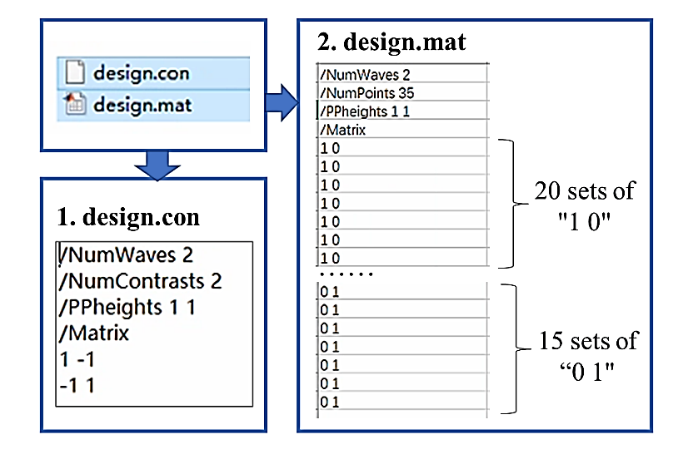
Figure 3. The results of design_ttest2
- Method 2: Using the Graphical Interface Tool Glm
- Run the following in the command line to start the GUI: Glm.
- Select "Higher-level/non-timeseries design".
- In "Inputs":
- Enter the total sample size.
- Click on Wizard→Click on "Two groups, unpaired ".
- In "Number of subjects in the first group", enter the number of subjects in the first group.
- Click the "Process" button.
- Review the design matrix:
- In the EVs panel, two explanatory variables (EVs) will be created. EV1: Group A; EV2: Group B.
- In the Contrasts & F-tests panel, set "Number of contrasts" to 2. c1: Represents "Group A > Group B" (i.e., 1 -1); c2: Represents "Group A < Group B" (i.e., -1 1).
- Save the design using the Save button in the GLM Setup panel.
- Example. For 20 healthy controls (Group A) and 15 patients (Group B), you can set up the design matrix in the FSL Glm GUI as follows:
- In “inputs”, enter 35 (the total number of subjects).
- Select Two group unpaired t‑test.
- In “Number of subjects in the first group”, enter 20.
- Click Process.
- Go to the Contrasts & F‑tests tab and set Number of contrasts to 2.
(Example design matrices are shown in the corresponding figures.)
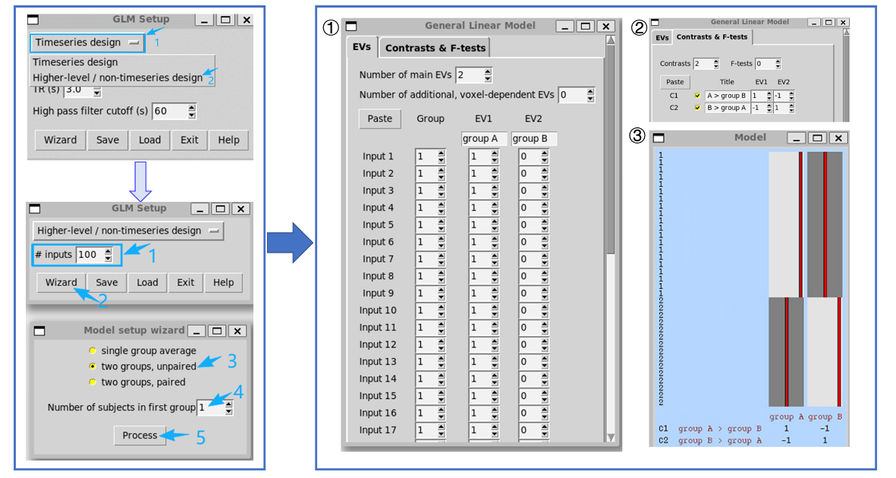
Figure 4. Graphical Interface Tool of Glm with parameter settings for two groups comparison without covariates
- Case 2: Comparison between two groups with covariates (e.g., age, sex, education level, TIV)
- Method : Using the Graphical Interface Tool Glm
- Start the GUI: Glm.
- Select "Higher-level/non-timeseries design".
- In "Inputs": Enter the total sample size.
- Click on Wizard→Click on "Two groups, unpaired ".
- In "Number of subjects in the first group", enter the number of subjects in the first group.
- Click the "Process" button.
- Review the design matrix:
  - EVs Panel: EV1: Group A; EV2: Group B. Additional EVs are required for covariates (e.g., EV3 = age, EV4 = sex), which are suggested to be demeaned before entry. Demeaning can be performed in spreadsheets such as Microsoft Excel.
  - Contrasts & F-tests Panel: Set "Number of contrasts" to 2. c1: Represents "Group A > Group B" (i.e., 1 -1 0 0); c2: Represents "Group A < Group B" (i.e., -1 1 0 0). All covariate EVs must be set to 0 in the group comparison contrasts.
- Save the design.
- Example. A study comparing 20 healthy controls (Group A) and 15 patients (Group B) with age and sex as covariates. Please refer to the demographic information of the sample in ‘Example_data.xlsx’. The operational steps are as follows:
- In “inputs”, enter 35 (the total number of subjects).
- Select “Two group unpaired t‑test”.
- “Number of subjects in the first group”, enter 20.
- Click Process.
- “Number of main EVs”, enter 4, EV3 and EV4 are covariates and values are demeaned.
- Go to the Contrasts & F‑tests tab and set Number of contrasts to 2, EV3 and EV4 are set zero.
(These steps are illustrated in the figure below)
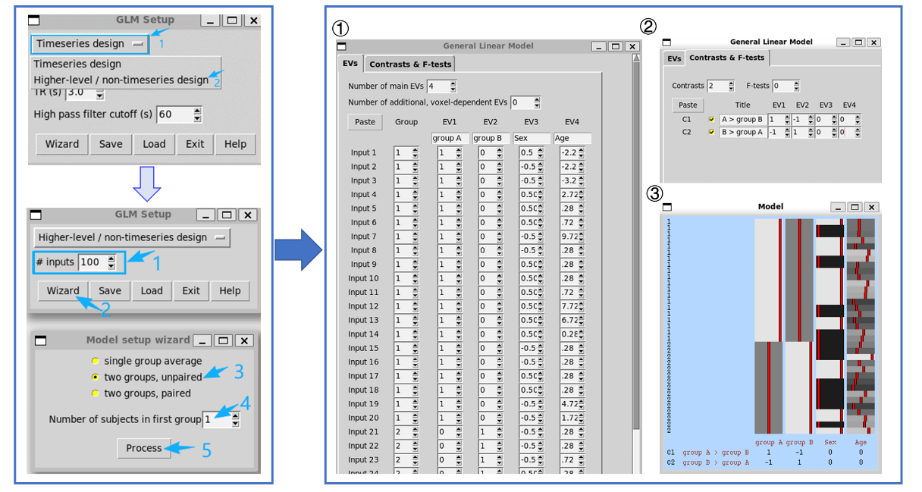
Figure 5. Graphical Interface Tool of Glm with parameter settings for two groups comparison with covariates

For additional information on GLM formulation, consult the FSL GLM documentation: (https://fsl.fmrib.ox.ac.uk/fsl/docs/statistics/glm.html). The design matrix outputs for all examples above are provided in the supplementary folder for reference.

References
1. Bilgic B, Costagli M, Chan KS, et al. Recommended implementation of quantitative susceptibility mapping for clinical research in the brain: A consensus of the ISMRM electro‐magnetic tissue properties study group. Magn Reson Med 2024;91(5):1834-1862.
2. Lee JE, Chung MK, Lazar M, et al. A study of diffusion tensor imaging by tissue-specific, smoothing-compensated voxel-based analysis. Neuroimage 2009;44(3):870-883.
3. Acosta-Cabronero J, Betts MJ, Cardenas-Blanco A, Yang S, Nestor PJ. In vivo MRI mapping of brain iron deposition across the adult lifespan. J Neurosci 2016;36(2):364-374.
4. Zachariou V, Bauer CE, Powell DK, Gold BT. Ironsmith: An automated pipeline for QSM-based data analyses. Neuroimage 2022;249:118835.
5. Stewart AW, Robinson SD, O'Brien K, et al. QSMxT: Robust masking and artifact reduction for quantitative susceptibility mapping. Magn Reson Med 2022;87(3):1289-1300.

