图片包含 物体, 时钟

已生成极高可信度的说明

|  |  |
| --- | --- |
| Name: | Zhongze Tang (zt67) |
| Title: | Description of Common Patterns and Indicators in Technical Analysis |
| Course: | 16:332:568 SE II – Web Applications |
| Professor: | Shiyu Zhou |
| Date: | Feb. 9, 2018 |

**1 Introduction**

Fundamental analysis and technical analysis are the two primary methods often used to analyze securities and make investment decisions. Fundamental analysis involves analyzing a company’s financial statements to determine the fair value of the business, while technical analysis assumes that a security’s price already reflects all publicly-available information and instead focuses on the statistical analysis of price movements.1

The technical analysts believe that all the information to analyze the stock price is included in the stock charts. So, they use many patterns and indicators to help us understand what is happening to the price of a stock. In this essay, I will introduce trend lines and channels, support and resistance, several channel patterns and indicators in technical analysis.

**2 Trend Lines and Channels2,3**

Trend maybe the most important concept in technical analysis. It’s easy to define and understand – a trend is the general direction in which a security or market is headed.

There are three types of trends: uptrend, downtrend, and sideways / horizontal trends. When there is no obvious uptrend or downtrend, we say that there is a sideways trend. It means the movements of the trend is so little that we cannot say it’s uptrend or downtrend.

Because of the complexity of prices movements, it’s not that easy to draw the trends. In another word, prices tend to go up or go down all the time. To draw the trend, we define the general direction of the peaks and troughs as trends. To be more specific, the direction of an uptrend contains the higher peaks and troughs while a downtrend includes the lower ones.

We should draw the trend line of an uptrend below the troughs of prices while drawing the lines of a downtrend above the peaks of the price. To determine the direction, we need at least two peaks or troughs for downtrends or uptrends, respectively.

Figure 1 is the stock price of Google from 8/28/2017 to 2/12/2018. I draw an uptrend line and a downtrend line. It shows clearly that the volumes tend to go down during January 2018 because the stock price of Google increases steadily. On 2/1/2018, the volumes go up suddenly because the price of Google goes down a lot, which means the stockholders want to sell them to stop their loss.

Figure 2 shows a price channel of Google stock. A channel will appear when we get two parallel trendlines. A channel consists of two trendlines that act as strong areas of support and resistance with the price bouncing around between them. The upper trendline consists of a series of highs, while the lower trendline consists of a series of lows. A channel can slope upward, downward, or sideways, but regardless of the direction, the interpretation is always the same. Traders expect the price to trade between the support and resistance trendlines until it breaks out beyond one of the two levels, in which case traders can expect a sharp move in the direction of the breakout. Along with clearly displaying the trend, channels are used to illustrate important areas of support and resistance for the stock price.

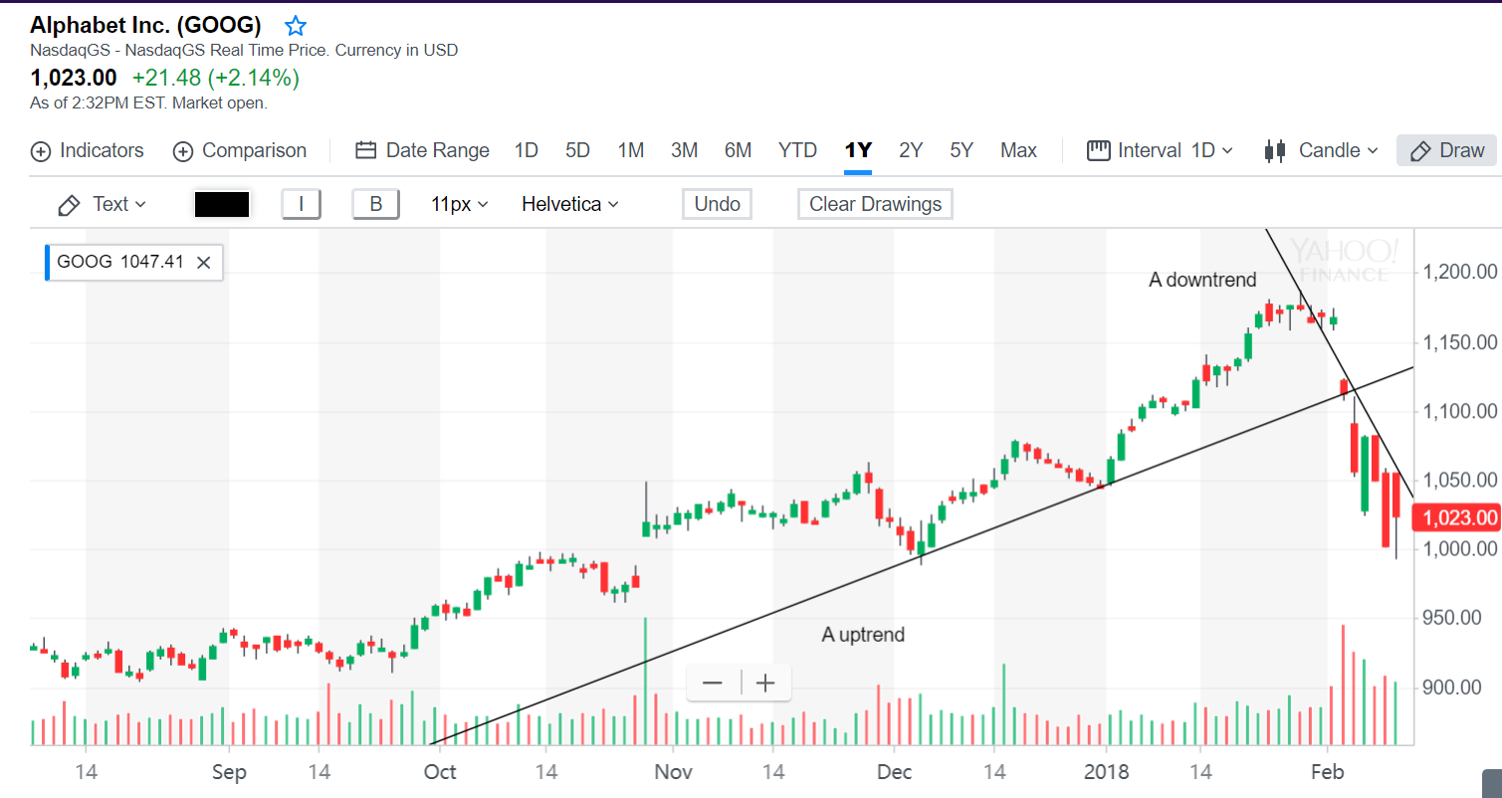

Figure 1 – Examples of an uptrend (left one) and a downtrend (right one)4

Figure 2 illustrates a nearly sideways channel where the upper trendline connects a series of highs and the lower trendline connects a series of lows. When the price breaks out from the upper trendline, the upper trendline becomes a new support level as the stock moves higher.

As we can see in figure 2, the volumes don’t change that much during the channel. It is almost the same during those days. We can safely conclude that during the uptrend the traders often want to hold their stocks to earn more profits while sell them during the downtrend to stop loss. At the same time, nothing special will happen in a channel.

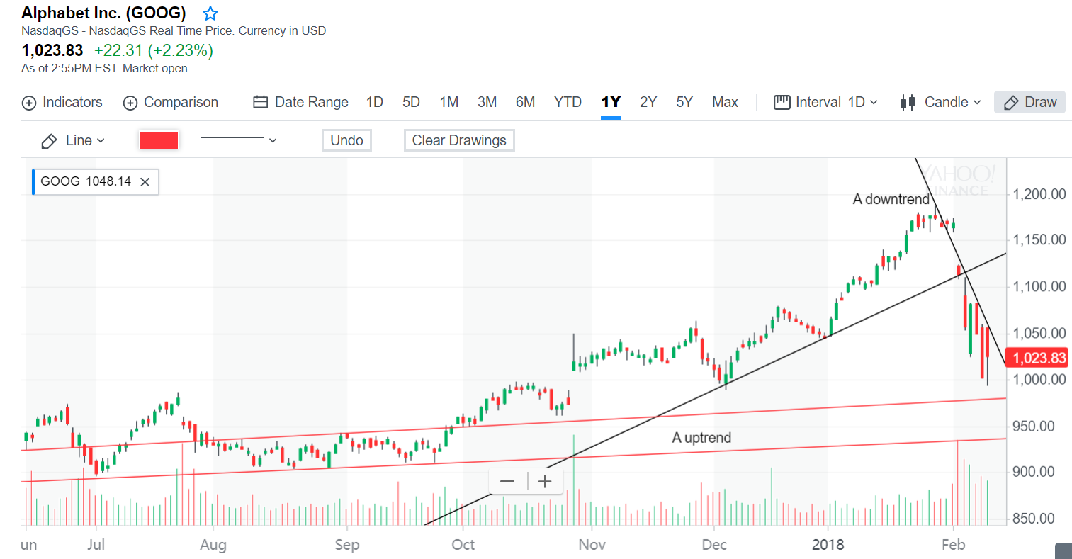

Figure 2 – Examples of channels (between the red lines)4

**3 Support and Resistance5**

Support and resistance are the next major concept after the concept of a trend. We’ll often hear technical analysts talk about the ongoing battle between bulls and bears, or the struggle between buyers (demand) and sellers (supply). The proverbial ‘battle lines’ can be defined as the support and resistance levels where the most trading occurs. Support levels are where demand is perceived to be strong enough to prevent the price from falling further, while resistance levels are prices where selling is thought to be strong enough to prevent prices from rising higher.

As we can see in Figure 2, the price channel from the previous section, the bottom trendline represents a key support level while the upper trendline represents a key resistance level. The arrows near the top and bottom trendlines show the levels where the price seldom surpassed until it broke out higher. After the breakout, the upper trendline transitioned from a resistance level to a support level for the new trend.

**4 Patterns6**

Chart patterns have an established definition and criteria, but there are no patterns that tell you with 100% certainty where a security is headed. After all, the richest man in the world would be a trader in that case rather than an investor! The process of identifying chart patterns based on these criteria can be subjective in nature, which is why charting is often seen as more of an art than a science. Here are some popular chart patterns.

**4.1 Head and Shoulders**

The Head and Shoulders is a reversal chart pattern that indicates a likely reversal of the trend once it’s completed. A Head and Shoulder Top is characterized by three peaks with the middle peak being the highest peak (head) and the two others being lower and roughly equal (shoulders). The lows between these peaks relate to a trend line (neckline) that represents the key support level to watch for a breakdown and trend reversal. A Head and Shoulder Bottom – or Inverse Head and Shoulders – is simply the inverse of the Head and Shoulders Top with the neckline being a resistance level to watch for a breakout higher.

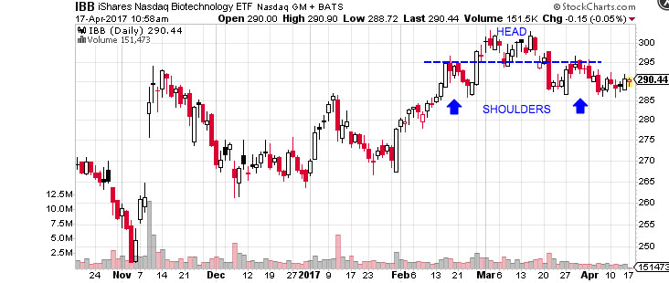

Figure 3 – Head and Shoulders Top6

There are two little peaks in the volumes in figure 3, which are corresponding to the two shoulders respectively, and the trough of volumes is corresponding to the head.

**4.2 Triangles**

Triangles are among the most popular chart patterns used in technical analysis since they occur frequently compared to other patterns. The three most common types of triangles are symmetrical triangles, ascending triangles, and descending triangles. These chart patterns can last anywhere from a couple weeks to several months.

Look at figure 4, a symmetrical triangle example. With the extension of the symmetrical triangle and contraction of the trading range, we can see that the volumes start to decrease. The traders may be waiting to see what will really happen next.

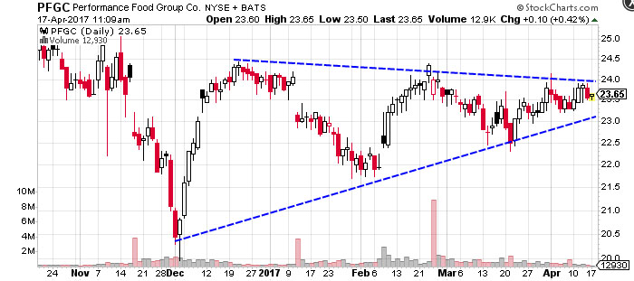

Figure 4 – Symmetrical Triangle Example6

**5 Indicators7**

Indicators represent a statistical approach to technical analysis as opposed to a subjective approach. By looking at money flow, trends, volatility, and momentum, they provide a secondary measure to actual price movements and help traders confirm the quality of chart patterns or form their own buy or sell signals.

**5.1 Accumulation/Distribution Line**

The accumulation/distribution line is one of the most popular volume indicators that measures money flow in a security. The indicator attempts to measure the ratio of buying and selling by comparing the price movement of a period to the volume for that period.

The calculation is:

*Acc/Dist = ((Close – Low) – (High – Close)) / (High – Low) * Period’s Volume*

Traders use the indicator to gain insight into the amount of buying compared to selling in a given security. If the accumulation/distribution line is trending upward, it’s a sign that there is more buying than selling and vice versa.

**5.2 Aroon**

The Aroon indicator measures whether a security is trending higher or lower as well as the magnitude of that trend. In addition, the indicator can be used to predict when a trend is just beginning to help traders capitalize on the movement.

The indicator is comprised of the ‘Aroon Up’ blue line and the ‘Aroon Down’ red line. The Aroon Up line measures the amount of time that has passed since the highest price during the time period. The Aroon Down line, on the other hand, measures the time that has passed since the lowest price during the time period. The number of periods used in the calculation depends on the timeframe that the trader wants to analyze.

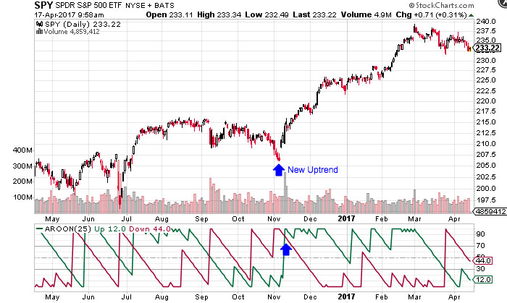

Figure 6 – Aroon Indicator7

**6 Conclusion**

As mentioned in the beginning, the technical analysts believe that we can find all the answers of a stock from the stock prices. After discussing the patterns and indicators above, I come to believe that it’s possible to observe and exploit useful regularities, just like the chaos theory saying, seemingly random processes may, in fact, have been generated by a deterministic function that is not random [Bao, et al. 2004].8 As a beginner of machine learning, I know how data and features are important. These patterns and indicators provide powerful support for those machine learning algorithms because they can be seen as features of a training set, instead of using the prices directly.

**7 References:**

[1]: Basics Of Technical Analysis, https://www.investopedia.com/university/technical/

[2]: Technical Analysis: The Use Of Trend,

https://www.investopedia.com/university/technical/techanalysis3.asp

[3]: Trend Lines, https://learn.tradimo.com/technical-analysis/trend-lines

[4]: Yahoo Finance, GOOGLE stock, https://finance.yahoo.com/chart/GOOG

[5]: Technical Analysis: Support And Resistance,

https://www.investopedia.com/university/technical/techanalysis4.asp

[6]: Technical Analysis: Chart Patterns,

https://www.investopedia.com/university/technical/techanalysis8.asp

[7]: Technical Analysis: Indicators And Oscillators,

https://www.investopedia.com/university/technical/techanalysis10.asp

[8]: Software Engineering, Ivan Marsic, Page 35-36